Wednesday Nov. 9, 2011
A long instrumental, Oaxaca, by a group named Maserati before class this afternoon.
The Experiment #3 reports have been graded and were returned in class today. You now have 2 weeks to revise your report if you want to (it's not required). The revised reports are due on or before Wednesday, Nov. 23. That's the Wednesday before Thanksgiving and there's a very good chance that I will cancel class on that day. So you'll need to either bring the reports to class on the preceding Monday or drop them off in my office.
A new Bonus 1S1P Assignment and the first of the 1S1P Assignment #3 topics are now online. There are also a couple of new Optional Assignments. One is discussed in more detail at the end of today's notes. The other is due on Wednesday next week (Nov. 16). Some of you may have thought this was an in-class assignment and turned it in at the end of class (with some of the questions left blank). We still have some more material to cover before you can expect to be able to answer all the questions. If you 'd like to give the assignment a 2nd try you can download it here.

We were working at understanding how and why winds blow the way they do around centers of high and low pressure in the northern and southern hemisphere. We have Steps #7-#10 to complete.

Here initially stationary air at Point 1 begins to move outward in responce to an outward pointing pressure gradient force (PGF). Once the air starts to move, the Coriolis force (CF) will cause the wind to turn to the right. The wind ends up blowing in a clockwise direction around the high. The inward pointing CF is a little stronger than the PGF so there is a net inward force here just as there was with the two previous examples involving low pressure. An inward force is needed to keep anything moving in a circular path.

This is a southern hemisphere upper level center of high pressure. Try to figure out how the winds will blow in this case. You’ll find the answer at the end of today’s notes.

Upper level winds blow parallel to the contour lines. Now we'll see how/why friction causes surface winds to blow across the contour lines (always toward low pressure).

The top figure shows upper level winds blowing parallel to straight contours. The PGF and CF point in opposite directions and have the same strength. The total force, the net force, is zero. The winds would blow in a straight line at constant speed. Since the CF is perpendicular and to the right of the wind, this is a northern hemisphere chart.
We add friction in the second picture. It points in a direction opposite the wind and can only slow the wind down. The strength of the frictional force depends on wind speed (no frictional force if the wind is calm) and the type of surface the wind is blowing over (less friction when wind blows over the ocean, more frictional force when the wind is blowing over land).
Slowing the wind weakens the CF and it can no longer balance the PGF (3rd figure). The stronger PGF causes the wind to turn and start to blow across the contours toward Low. This is shown in the 4th figure. Eventually the CF and Frictional force, working together, can balance out the PGF.
What we've learned from the straight contour example, namely that the winds will blow across the contours toward low pressure can be applied to a curved contour pattern. The figure below wasn't shown in class.

If you take a small little piece of a curved pattern and magnify it, it will look straight. This is shown above.

Here is Step #10. It is easy to figure out which of the figures are centers of low pressure. The winds are spiralling inward in the top and bottom examples (1 and 3). These must be surface centers of low pressure. The winds are spiraling outward from the centers of high pressure (2 and 4).
Now you probably don't want to figure out which of these are northern and which are southern hemisphere pictures. It is probably best to remember one of the pictures. Remember in 1, for example, that surface winds spin counterclockwise and spiral inward around centers of low pressure in the northern hemisphere (something we learned early in the semester). Then remember that winds spin in the other direction and blow outward around high pressure in the northern hemisphere (2). The spinning directions of the winds reverse when you move from the northern to the southern hemisphere. Thus you find clockwise spinning winds and inward motion around low pressure (3) and counterclockwise and outward spiraling winds around high pressure in the southern hemisphere.
Converging winds cause air to rise. Rising air expands and cools and can cause clouds to form. Clouds and stormy weather are associated with surface low pressure in both hemispheres. Diverging winds created sinking wind motions and result in clear skies.

Next we had a short look at the cause of the Coriolis force. Most of what follows can be found on p. 122c in the photocopied ClassNotes.

Imagine something flies over Tucson (an asteroid did fly by the earth yesterday). It travels straight from west to east at constant speed. The next figure shows the path that the object followed as it passed over the city. You would, more or less subconciously, plot its path relative to the ground.

Here's the path the moving object would appear to follow relative to the ground. Based on this straight line, constant speed trajectory you'd conclude there was no net force acting on the object (and again no net force doesn't mean there aren't any forces, just that they all cancel each other out so the total force is zero).

In this second picture the object flies by overhead just as it did in the previous picture. In this picture, however, the ground is moving (don't worry about what might be causing the ground to move). What would you say happened when viewing the flyby from the ground?

The path, relative to the ground, would look something like this. It would no longer appear to be moving from W to E but rather from the NW toward the SE. It's still straight line motion at constant speed, though, so you conclude there was no net force acting on the object.

Now the ground is moving and also spinning.

The path of the object plotted on the ground appears to be curved. But remember that's relative to the ground and the ground is spinning. We could take that into account or just ignore it. In the latter case you'd conclude that there was a net force perpendicular and to the right of the moving object. This net force would be needed to explain the curved path that the object appears to be following.

At most locations on the earth the ground IS rotating. This is most easily seen at the poles.

Imagine a piece of paper glued to the top of a globe. As the globe spins the piece of paper will rotate. A piece of paper glued to the globe at the equator won't spin, it will flip over. At points in between the paper would spin and flip, the motion gets complicated.
The easiest thing for us to do is to ignore or forget about the fact that the ground on which we are standing is rotating. We do still need to account for the curved paths that moving objects will take when they move relative to the earth's surface. That is what the Coriolis force does.
And that's the reason for another 1S1P Bonus Assignment. Foucault's Pendulum was the first demonstration that proved that the ground we're standing on (at most locations on earth) is spinning. Here's a photograph of a Foucault Pendulum at the Pantheon in Paris (Foucault conducted his demonstration apparently at the Paris Observatory).

This is a logical point to clear up a common misconception involving the Coriolis force. You might have heard that water spins in a different direction when it drains from a sink or a toilet bowl in the southern hemisphere than it does in the northern hemisphere. You might also have heard that this is due to the Coriolis force or the Coriolis effect.
The Coriolis force does cause winds to spin in opposite directions around large scale high and low pressure centers in the northern and southern hemisphere. The PGF starts the air moving (in toward low, out and away from high pressure) then the Coriolis force bends the wind to the right (N. hemisphere) or to the left (S. hemisphere).
Here's what you end up with in the case of low pressure (you'll find these figures on p. 130 in the photocopied ClassNotes):

Air starts to move inward toward low pressure (the dots show this initial motion). Then the Coriolis force causes it to turn to the right or left depending on which hemisphere you're in. You should be able to say which of the pictures above is the northern hemisphere and which is the southern hemisphere picture.

The same kind of idea applies to high pressure except that the air starts moving outward (the dots aren't included here). The Coriolis force then turns it to the right or left.
There are situations where the PGF is much stronger than the CF and the CF can be ignored. A tornado is an example. The PGF is much much stronger than the CF and the CF can be ignored. Winds can blow around Low pressure because the PGF points inward.

The wind can spin in either direction in either hemisphere.
Note that without the CF, winds can't spin around High pressure because there is nothing to provide the needed inward force.

OK, what about water draining from sinks, buckets, toilets etc.

There's just an inward pointing PGF, no CF. Water can spin in either direction in either hemisphere. What causes the inward pointing PGF? The water at the end of the spinning water is a little deeper than in the middle. Since pressure depends on weight, the pressure at the outer edge of the spinning water is higher than in the center.

Water draining from a sink or toilet can spin in either direction. It doesn't matter where you're located.
But this something we should probably checkout for ourselves, so here is one of my favorite optional assignments of the semester.

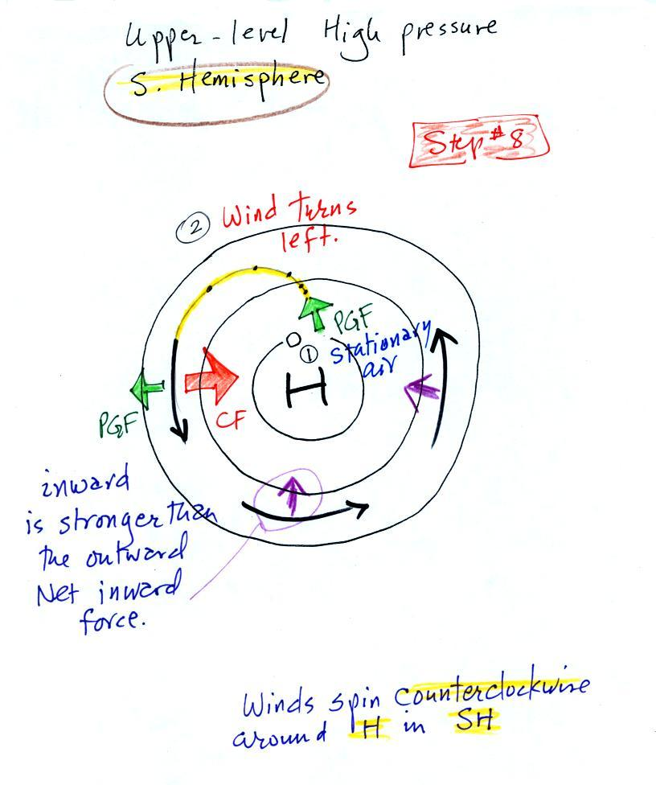
Here’s the completed analysis of a southern hemisphere upper level center of high pressure.

