Sample Questions

If you add energy to an object with a large specific heat, would you expect to observe a relatively SMALL or LARGE increase in temperature.

Air is a relatively GOOD POOR conductor of energy

Water is a liquid, soil a solid. Water has a HIGHER LOWER specific heat than soil.

Two objects sitting on a table are at room temperature. Object A is a better conductor of energy than Object B. If you touch Object A with your hand will it feel WARMER COLDER or the SAME as Object B.

People will often blow on a hot bowl of soup or a cup of hot coffee to try to cool it off. What two energy transport processes carry the most energy from the hot liquid and cause the most cooling?

A city on a sea coast will usually have WARMER COLDER summers and WARMER COLDER winters than a city located further inland.

Ocean currents transport energy from the warm tropics to colder waters at polar latitudes. This is an example of which energy transport process?

Room temperature is about 300 degrees on the _______ temperature scale
a. Celsius b. Fahrenheit c.Kelvin d. Richter

50º C is GREATER LESS EQUAL than(to) 100º F. (you don’t need a calculator to answer this question)

The energy associated with the haphazard (random) motions of the atoms or molecules in air is
a. specific heat b. kinetic energy c. latent heat d. temperature

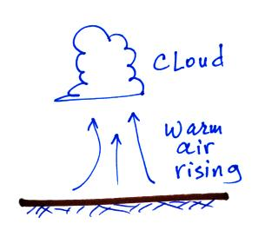
Is 0ºC or 0ºF the temperature at which ice melts? Is 100ºC or 100ºF the hotter temperature? Is 0ºC or 0ºF the colder temperature? Is 100ºC or 100ºF the boiling point of water at sea level?

Energy is being transported upward in the figure
at right. Which two energy transport processes are
clearly illustrated?

One ______________________________ is the energy required to warm 1 gram of water 1 degree Celsius.

Kinetic energy is energy of motion and has units of
a. degrees Celsius b. calories c. knots d. seconds

Metals often feel cold to the touch because metals have high
a. latent heat b. specific heat c. density d. thermal conductivity

Match each of the materials below at left with an appropriate energy transport process in the list at right (each of the processes at right should be used once)
copper _______ a. conduction
air _______ b. convection
water _______ c. latent heat

Energy added to water could be used to___________________ or __________________
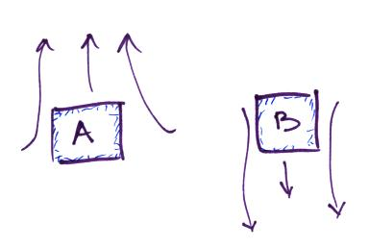
the water.

Energy is being transported from the surroundings
to Object _______ in the figure at right. Object
_______ is colder than the surrounding air. The figure
illustrates energy transport by CONDUCTION CONVECTION.

The atoms in a hot object have a lot of _______. It takes a lot of energy to warm water because water has high _______. Copper has high _______. Cold air sinks because it has _______. Water vapor contains a lot of hidden _______. (fill in the blanks with one of the choices below, each answer below should be used once)
a. kinetic energy b. density c. thermal conductivity
d. latent heat e. specific heat

Convergence and convection
are two of the processes that cause____________________________________________
Conduction and convection
are two of the processes that_________________________________________________

