Friday Nov. 5, 2010
Quiz #3 has been graded and was returned in class today.
Some video from the finish of the 2000 Tour de France stage at the summit of Mont Ventoux was shown before class today instead of music. Marco Pantani beat Lance Armstrong at the line. This is an effort for me to get motivated enough to sign up for the El Tour de Tucson (Sat., Nov. 20).
The 1S1P Assignment 2a reports and the Expt. #2 revised reports were collected today.
I hope your Sunday evening plans include the All Souls Procession
An In-class Optional Assignment was distributed in class today. If you download the assignment and turn it in at the beginning of class next Monday you can earn at least partial credit.

In the next two or three classes we will be looking at how and why surface and upper level winds blow the way they do.
Some real world examples of where this occurs are shown in the figure below. The two largest types of storm systems, middle latitude storms and hurricanes, develop around surface centers of low pressure. Winds spin counterclockwise around low in the northern hemisphere and clockwise in the southern hemisphere. Winds spin clockwise around "anticyclones" (high pressure) in the northern hemisphere and counterclockwise in the southern hemisphere.

Storm systems in the tropics (0 to 30 degrees latitude) generally move from east to west. At middle latitudes (30 to 60 degrees), storms move in the other direction, from west to east. To understand why this is true we need to learn something about the earth's global scale pressure and wind patterns. This is a topic we will be getting into next week.

I've borrowed the more carefully drawn figures below from the Spring 2009 online notes. Steps 1-8 below were on a 4 page handout distributed in class.

Upper level winds spinning around high and low pressure in the northern and southern hemispheres are shown in the first set of four pictures. The first thing to notice is that upper level winds blow parallel to the contours. We will see that 2 forces, the pressure gradient force (PGF) and the Coriolis force (CF), cause the winds to blow this way. Eventually you will be able to draw the directions of the forces for each of the four upper level winds examples. Here is an example of what you will be able to do.
The four drawings at the bottom of the page show surface winds blowing around high and low pressure in the southern hemisphere. These winds blow across the contour lines slightly, always toward low pressure. The frictional force is what causes this to occur. He is an example of what you will be able to say about surface winds blowing around low pressure in the southern hemisphere.

The main point to take from Step #2 is that a net inward force is needed anytime an object is moving in a circular path. It doesn't matter what direction the object is moving. The net force is inward anytime something moves in a circular path.
Quite a few people would say there is an outward force being exerted in the bottom picture, but the force is inward in each of the cases below.

It's just not the same amount of inward force. The amount of force is just right in the top figure, a little "too strong" in the middle figure, and "not quite strong enough" in the bottom figure.

Now we'll start to look at the forces that cause the wind to blow.

The pressure gradient force always points toward low pressure. The PGF will cause stationary air to begin to move (it will always move toward low pressure).

The Coriolis force is caused by the rotation of the earth and points perpendicular to the wind. It can only change the wind's direction, it can't cause the wind to speed up or slow down. The direction of the CF depends on whether you're in the northern or southern hemisphere. We'll look at the cause of the Coriolis force in class on Monday.

Now we start to put everything together. The PGF at Point 1 starts stationary air moving toward the center of low pressure (just like a rock would start to roll downhill). Once the air starts to move, the CF causes it to turn to the right (because this is a northern hemisphere chart). The wind eventually ends up blowing parallel to the contour lines and spinning in a counterclockwise direction. Note that the inward PGF is stronger than the outward CF. This results in a net inward force, something that is needed anytime wind blows in a circular path.

See if you can figure out what to do with this figure. When you think you have the answer click here. (the answer is shown at the end of today’s notes)

With high pressure the air starts moving outward. In this example the wind takes a right turn and ends up blowing in a clockwise direction around the high. Note there is a net inward force here just as there was with the two previous examples involving low pressure.

Try this one on your own. When you think you have the answer, click here. (the answer is at the end of today’s notes.
This is as far as we got in class on Friday. We'll look at surface winds next Monday.

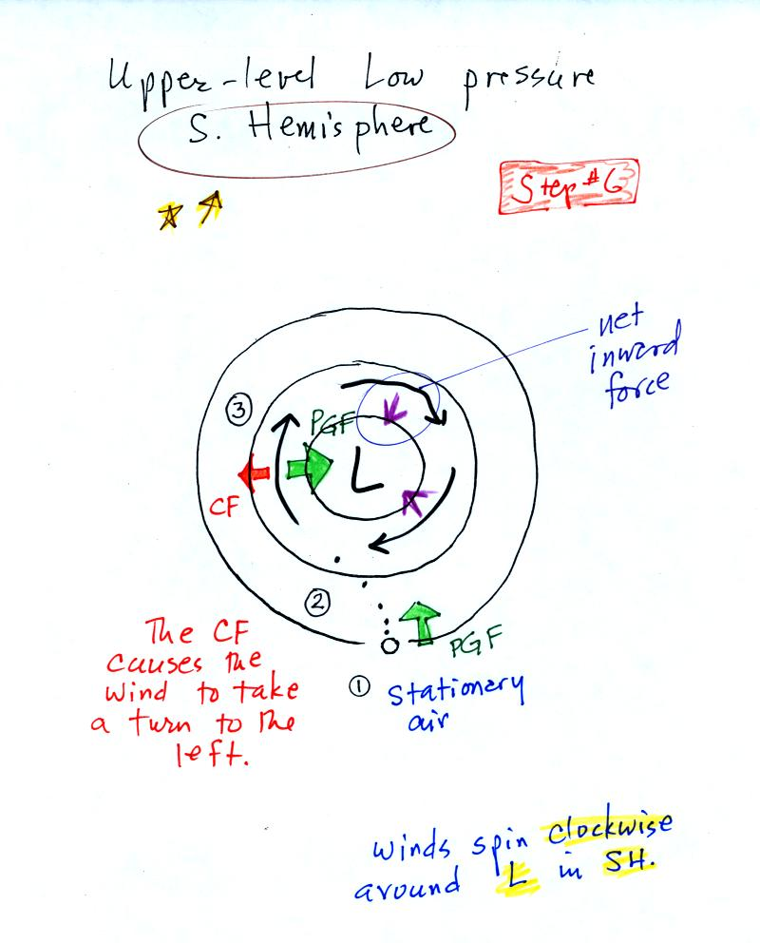
Upper level winds blowing around low pressure in the southern hemisphere

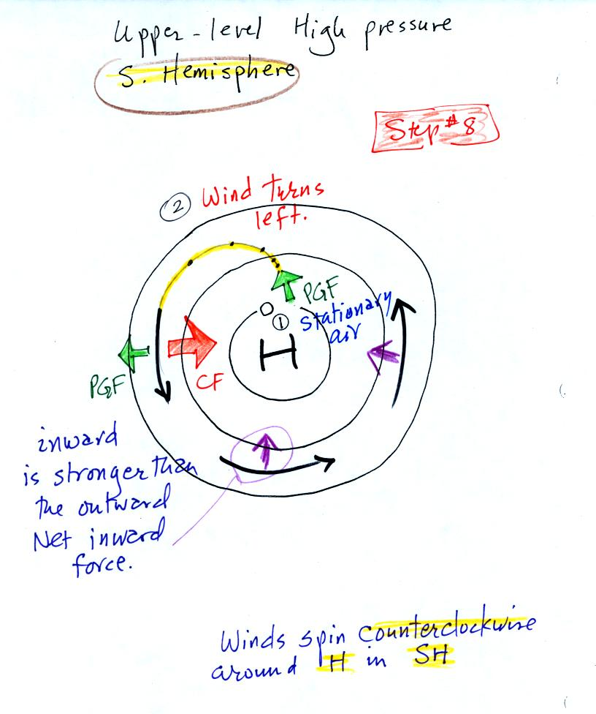

Upper level winds blowing around high pressure in the southern hemisphere.

