Monday Aug. 23, 2010
I finally settled on Reckoner from Radiohead to start this semester's before-class musical selections. For about the last year or two I have been filling the few minutes before class with some kind of music, often local talent. Music won't (usually) take up any actual class time. Hopefully you'll like at least some of the selections. Comments and ideas from students are welcome.
Today was the first day of class. We first briefly discussed the Course Information handout. There are a couple of topics (weather forecasting and climate change) that won't receive as much emphasis in this class as they might in the two other sections of Introduction to Weather and Climate (largely due to the interests and background of the instructor). Don't get the idea I'm encouraging you to change sections, I'm not.
I also teach Section 12 of this class. It meets Tue. and Thu. morning at 8:00 in ILC 140. If you ever miss a Wednesday quiz in this class, you can make it up on Thursday in the T Th section (please try to let me know ahead of time).
A textbook is not required for this class. If you want to get a more complete picture of the subject than we will be able to cover in class, you might want to purchase one of the textbooks that are being used in the other NATS 101 sections (I've also have several copies of introductory level textbooks that you would be welcome to borrow for the duration of the semester). Otherwise you should be able to do perfectly well in the class by reading the online notes and other suggested online sources.
A set of photocopied ClassNotes (available in the Student Union Bookstore) is required, you should try to purchase a copy right away as we will probably be using some of them in class soon (Wednesday perhaps, for sure by Friday) If you know someone with photocopied ClassNotes from the Spring 2010 or Fall 2009 classes they should work fine this semester also.
Neither of my two sections of NATS 101 is on D2L (though I will try to make the move sometime during the semester).
Here's something I forgot to mention in class on Monday. Examples of quizzes and a final exam (both with answers) from a previous section of the course can be downloaded here.
Next we looked at the Writing Requirements handout. You should be thinking about which of the 4 experiments (or book or scientific paper reports) you would like to do so that you can sign up in class on Friday. There aren't enough materials for everyone to do the same experiment. Distribution of the materials for the first experiment will probably begin in class on Friday this week.

Your grade in this class will depend on your quiz scores, how much extra credit you earn (from optional homework assignments), your writing grade, and (perhaps) your score on the final exam. A sample grade report from the Spring 2010 MWF Nats 101 class is shown below (this wasn't shown in class).
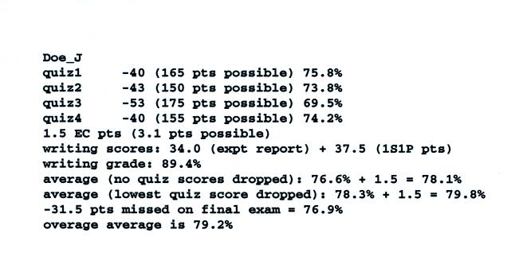
Don't worry about all the details at this point. Note that this (fictitious) student nearly earned a B in the class with Cs on the quizzes and the Final Exam. The student would have ended up with a B if he/she had earned the full 45 1S1P pts and had done two or three of the optional extra credit assignments. Be sure to do the writing assignments and try to do most of the optional extra credit assignments.

Even though this was the first day of class we did cover some actual course material; partly just to give you an idea of how lectures will work during the semester.
Ordinarily I would start by listing the 5 most abundant gases in the air we breathe, i.e. the composition of the atmosphere. However because there is a chance of thunderstorms this week (perhaps the last chance for a while) it might be worthwhile to say something about the summer monsoon (the summer thunderstorm season) and some of the characteristics features that you might see on a mature thunderstorm.
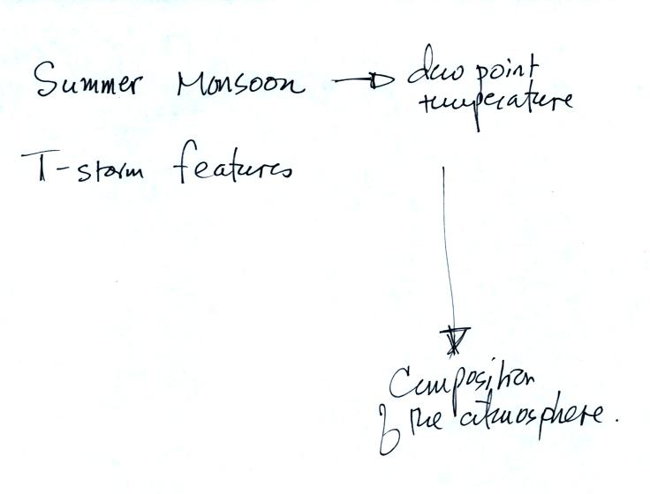
For many people the term monsoon is just another name for a thunderstorm. Thunderstorms and the summer monsoon are associated but they aren't the same thing.
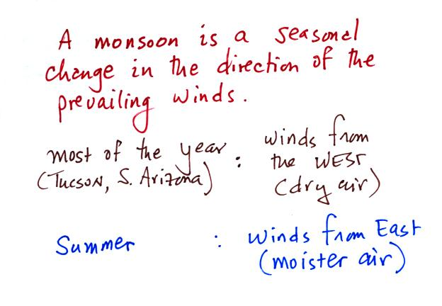
Moist air is one of the conditions needed for thunderstorm formation. So thunderstorms are usually fairly frequent during the summer monsoon season.
It used to be that the start of the summer monsoon was determined by tracking the daily average dew point temperature (we will see later in today's notes that the dew point temperature provides a measure of the amount of water vapor that is in the air).
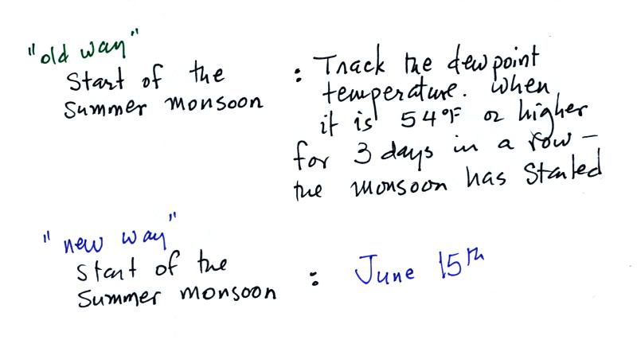
The monsoon would start once the dew point remained at or above 54 F for three days in a row. For example this year
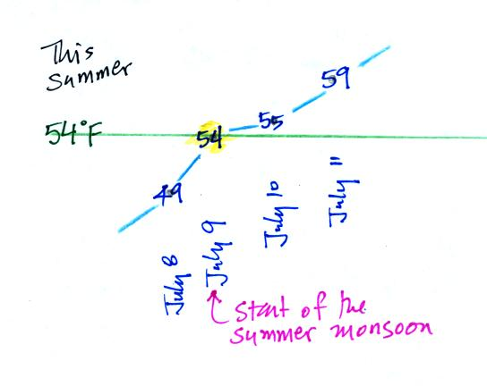
The daily average dew point was 49 on July 8. It reached 54 on July 9, was 55 on July 10, and 59 on July 11. Thus the official start of the monsoon season would have been July 9. That's if the "old way" were still being used. Now the official start of the monsoon is arbitrarily set to June 15. The data above were obtained from the Tracking the Monsoon link available from the National Weather Service webpage. If you look back at the dew point data from June you will see that the values were well below 54 F.
The figure below shows some of the features you might find on a thunderstorm (cumulonimbus) cloud and some of the weather hazards associated with thunderstorms. Here are some actual photographs of thunderstorms.
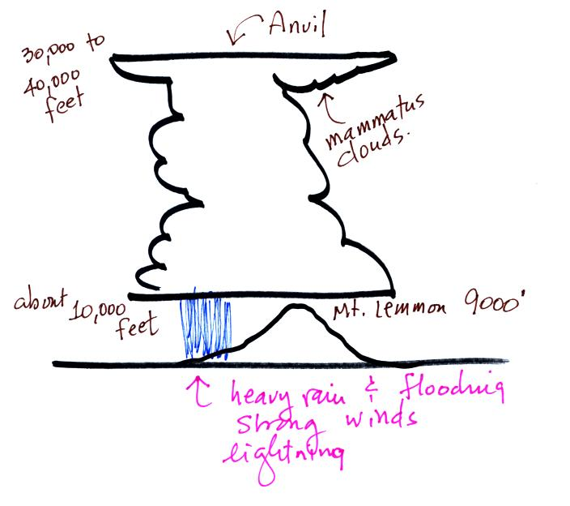
The strong winds produced by a thunderstorm downdraft can reach 100 MPH which is stronger than most tornadoes.

What is the most abundant gas in the atmosphere. I poured some of this same material (in liquid form) into a styrofoam cup.
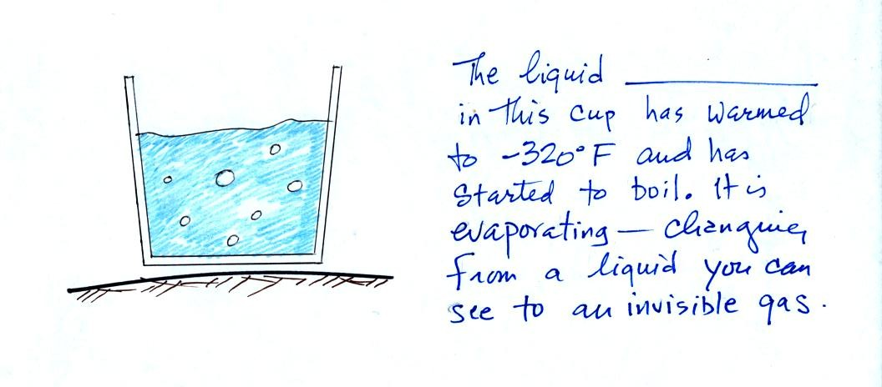

It was clear, not blue as shown in the picture. Many students knew that this was nitrogen. Nitrogen gas is invisible as are most of the other gases in the atmosphere. Nitrogen was discovered in 1772 by Daniel Rutherford (a Scottish botanist). Atmospheric nitrogen is relatively unreactive and is sometimes used to replace air in packaged foods to preserve freshness. We'll use liquid nitrogen in several class demonstration this semester.
Oxygen is the second most abundant gas in the atmosphere. Oxygen is the most abundant element (by mass) in the earth's crust, in ocean water, and in the human body. Here's a photograph of liquid oxygen. It has a (very faint) blue color (I was pretty disappointed when I saw the picture the first time because I had imagined the liquid oxygen might be a deep vivid blue).
When heated (such as in an automobile engine) the oxygen and nitrogen in air react to form compounds such as nitric oxide (NO), nitrogen dioxide (NO₂), and nitrous oxide (N₂O). Together as a group these are called oxides of nitrogen; the first two are air pollutants, the last is a greenhouse gas. More about those in class on Wednesday.
Here are the 5 most abundant gases in the earth's atmosphere.
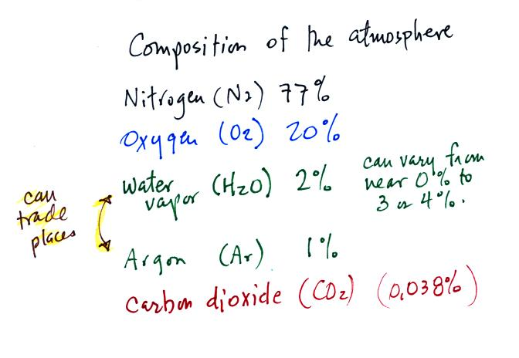
We were running out of time at this point and we either didn't cover this material or rushed through it. We'll come back to it again briefly on Wednesday.
Water vapor and argon are the 3rd and 4th most abundant gases in the atmosphere. The concentration of water vapor can vary from near 0% to as high as 3% or 4%. Water vapor is, in many locations, the 3rd most abundant gas in air. In Tucson most of the year, the air is often dry enough that argon is in 3rd position and water vapor is 4th.
Water vapor, a gas, is invisible. Clouds are visible because they are made up of small drops of liquid water or ice crystals. Water is the only compound that exists naturally in solid, liquid, and gaseous phases in the atmosphere.
Argon is an unreactive noble gas (helium, neon, krypton, xenon, and radon are also inert gases). Noble gases are often used in "neon signs."
Here's a little more explanation (from Wikipedia) of why noble gases are so unreactive. Don't worry about all these additional details. The noble gases have full valence electron shells. Valence electrons are the outermost electrons of an atom and are normally the only electrons that participate in chemical bonding. Atoms with full valence electron shells are extremely stable and therefore do not tend to form chemical bonds and have little tendency to gain or lose electrons.

Now, finally, it is time to learn what the dew point temperature is.
Water plays an important role in the formation of clouds, storms, and weather. Meteorologists are very interested in knowing and keeping track of how much water vapor is in the air at a particular place and time. One of the variables they use is the dew point temperature. The value of the dew point gives you an idea of how much water vapor is actually in the air. The higher the dew point value, the more water vapor the higher the water vapor concentration.
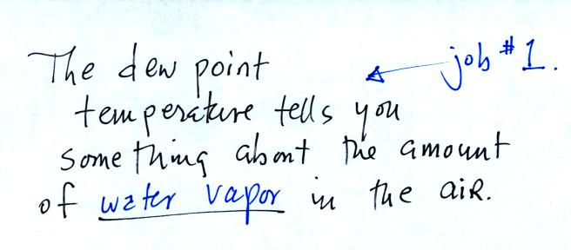
The chart below gives a rough equivalence between dew point temperature and percentage concentration of water vapor in the air.
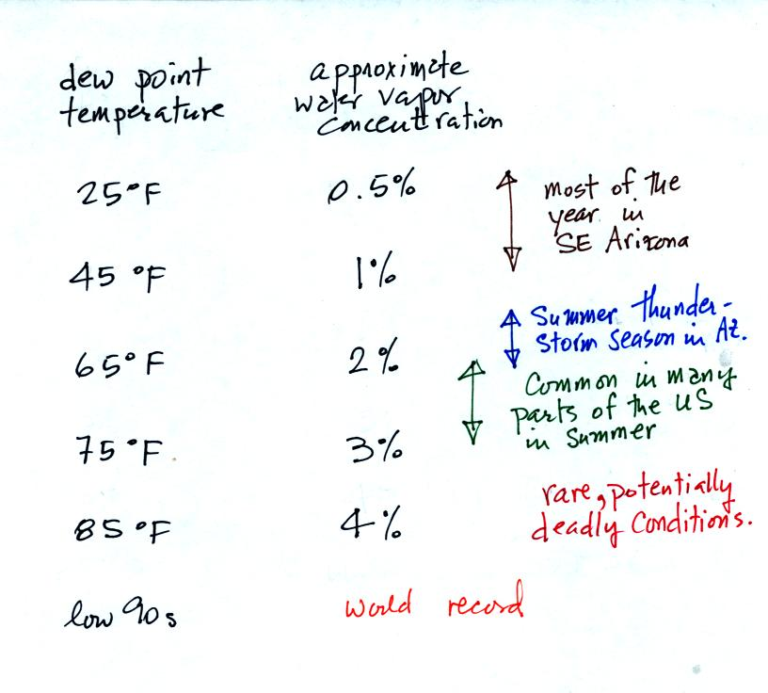
Air temperature will always be equal to or warmer than the dew point temperature. Experiencing 80º dew points would be very unpleasant (and possibly life threatening because your body might not be able to cool itself). Click here to see current dew point temperatures across the U.S.
The second job of the dew point temperature is
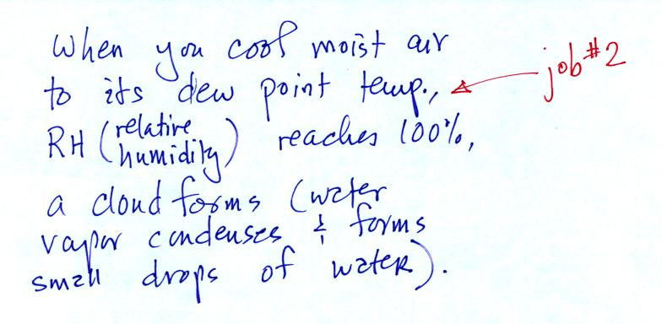
We could use the cup of liquid nitrogen to show this.
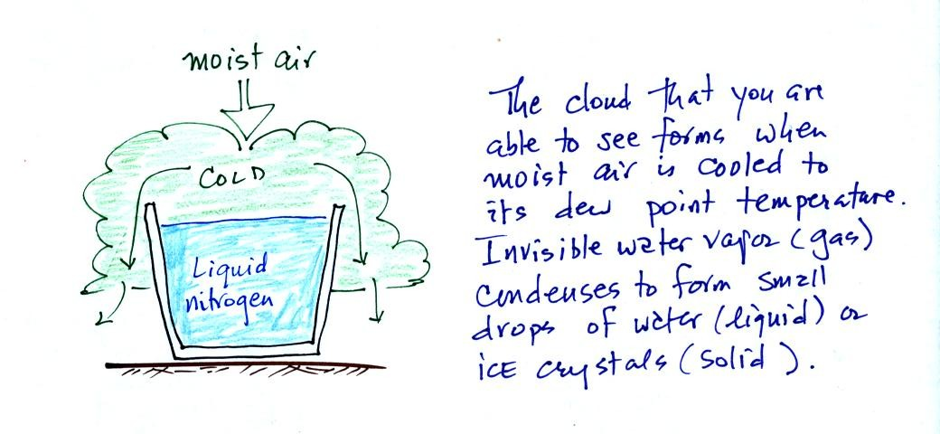
The cloud came from moisture in the air. The cloud was not made of nitrogen gas (which is invisible). Note also that a certain amount of "artistic" license was used in the figure above; liquid nitrogen is not blue and water clouds are not green.

