Estimating sinking velocity of air in subsidence regions

Once air detrains from deep convection where does it go?

In the absence of energy gained or lost from the air, the air’s potential temperature remains constant. Under these conditions, the air moves around on surfaces of constant potential temperature. These are called isentropic surfaces which are surfaces of constant entropy. In some atmospheric models, the vertical coordinate is entropy or potential temperature. This is a nice coordinate system because most of the air motion away from moist convection is along such surfaces. It is NOT a good coordinate system for the afternoon boundary layer where potential temperature does not vary with altitude.

Now the question is we know what goes up must come down because the air cannot accumulate in the upper troposphere. The air that rose up into the upper troposphere must descend somehow. So how does it do it? Basically its temperature must decrease. Otherwise it won’t come down. So how does its temperature decrease? There are basically two ways. One is by radiative cooling. The other is via evaporative cooling. There can also be mixing along a dry adiabat over limited vertical intervals but the vertical displacement is limited.
Here we focus on radiative cooling, or more quantitatively, the divergence of the radiative flux. The radiative cooling of the air is given by
$\frac{\text{dE}}{\text{dt}}={ρC}_{p}\frac{\text{dT}}{\text{dt}}\text{=-}\frac{{\text{dF}}_{\text{rad}}}{\text{dz}}$ (1)
where E is the thermal energy of the air, F_{rad} is the net radiative flux which is defined as positive upwards.
$\frac{\text{dT}}{\text{dt}}\text{=-}\frac{1}{{ρC}_{p}}\frac{{\text{dF}}_{\text{rad}}}{\text{dz}}$ (2)
To understand the sign, consider a parcel of air. When there is more radiative flux leaving the top of the parcel than there is entering the bottom of the parcel then the parcel is losing energy radiatively, dF_{rad}/dz >0, and the parcel is therefore cooling radiatively.
As the air cools, it sinks to a new level of neutral buoyancy where its density is the same as that of the surrounding air. Assuming the composition of the air is the same as the surrounding air, then the variable that changes the density is the temperature.
Note that as the air sinks, it is compressionally heated. So this effect must be included. The change in the air parcel temperature as the air parcel cools and sinks is
$DT=Dz\left({\frac{\text{dT}}{\text{dz}}}_{\text{env}}−{\frac{\text{dT}}{\text{dz}}}_{\text{dryadiabat}}\right)={DT}_{\text{rad}}=Dt{\frac{\text{dT}}{\text{dt}}}_{\text{rad}}\text{=-}\frac{Dt}{{ρC}_{p}}\frac{{\text{dF}}_{\text{rad}}}{\text{dz}}$ (3)
Note that the parcel’s temperature actually increases as it sinks because of the compressional heating. So we then solve for dz/dt
$\frac{Dz}{Dt}\text{=-}\frac{\frac{1}{{ρC}_{p}}\frac{{\text{dF}}_{\text{rad}}}{\text{dz}}}{\left({\frac{\text{dT}}{\text{dz}}}_{\text{env}}−{\frac{\text{dT}}{\text{dz}}}_{\text{dryadiabat}}\right)}$ (4)
Knowing the environmental lapse rate and the radiative divergence, the sinking velocity can be determined.
Note that if the radiative divergence is negative as it is between 12 km and 16 km in the tropics around the tropical tropopause, then the air is being heated radiatively and rises. In this altitude interval, the air is so cold that it is heated by IR from above and below.
To determine the sinking (or rising motion) from (4) in detail requires detailed radiative transfer calculations. Alternatively we can crudely estimate the radiative flux divergence as follows from the global energy budget picture.
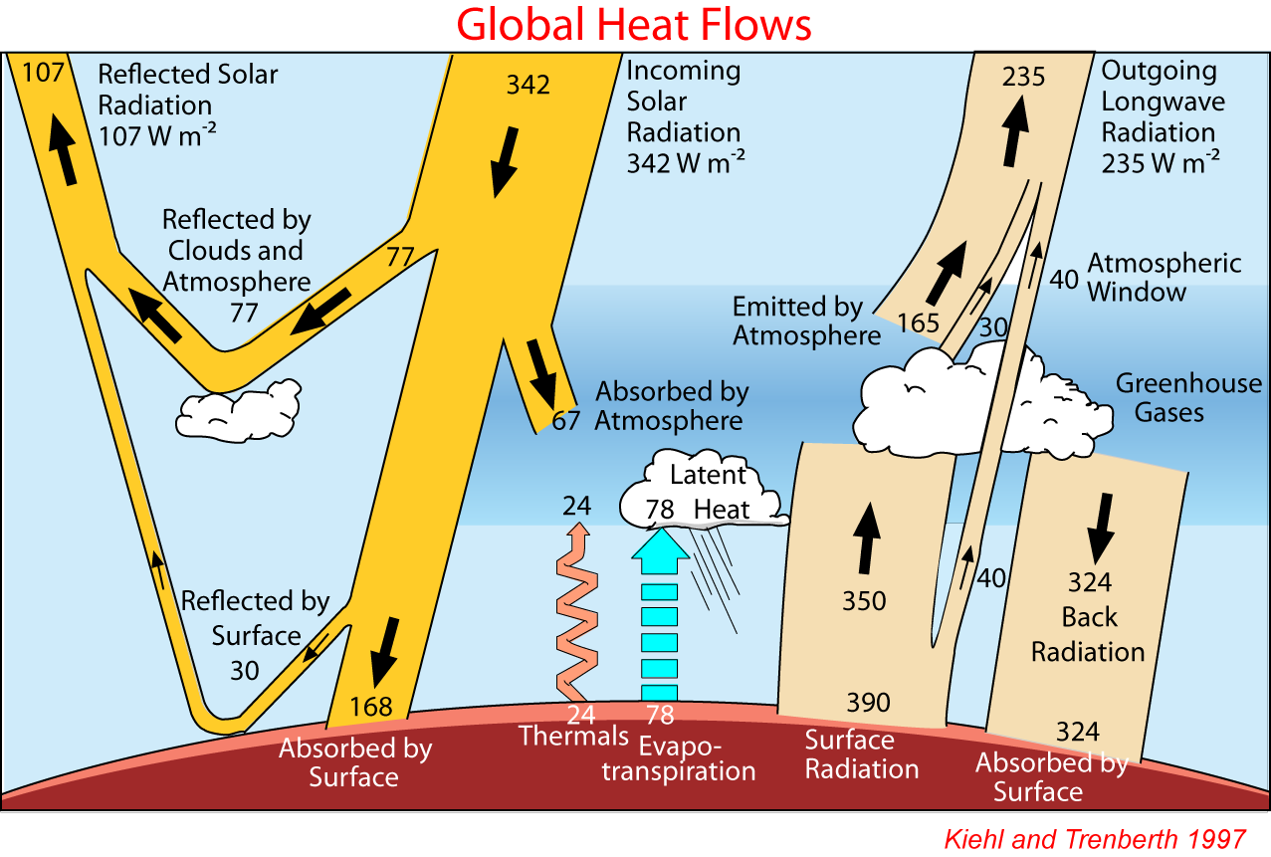

IR flux divergence:
Net IR up at surface = 390-324 =66 W/m²
Net IR at top of atmosphere = 235 W/m². So there is more IR leaving at the top of the atmosphere than IR entering at the bottom, as there should be because the atmosphere is radiating IR.

SOLAR flux divergence:
The absorption of solar radiation by the atmosphere is 67 W/m². So there is 67 w/m² more entering the top of the atmosphere than leaving the bottom of the atmosphere.

Net radiative flux divergence
ΔF = IR out – IR in – Solar in = 235-66-67 = 102 W/m². So there is 102 W/ m² more IR radiation leaving the atmosphere at the top than is entering and solar being absorbed the atmosphere.
For the altitude interval, Δz, over which the divergence is occurring, we use the surface as the bottom and as the top we use twice the height where the atmosphere reaches it radiative equilibrium temperature of 255 K starting from a surface temperature of 288. The difference is 33K/6.5K/km = 5 km. So we use Δz = 10 km.
So dF_{rad}/dz = 102/10000 = 0.01 W/m³. Notice that the units are the units of a volume heating rate.
From (1), we can determine the column-average temperature cooling rate
$\int_{0}^{z_{\text{max}}}{{ρC}_{p}\frac{\text{dT}}{\text{dt}}\text{dz}}=C_{p}\overline{\frac{\text{dT}}{\text{dt}}}\int_{0}^{z_{\text{max}}}{ρ\text{dz}}=C_{p}\overline{\frac{\text{dT}}{\text{dt}}}\frac{\left(P_{\text{surf}}−P(z_{\text{max}})\right)}{g}\text{=-}\int_{0}^{z_{\text{max}}}{\frac{{\text{dF}}_{\text{rad}}}{\text{dz}}\text{dz}}={DF}_{\text{rad}}$ (5)
$\overline{\frac{\text{dT}}{\text{dt}}}\text{=-}\frac{{DF}_{\text{rad}}}{\left(P_{\text{surf}}−P(z_{\text{max}})\right)}\frac{g}{C_{p}}$ (6)
Plugging in values, assuming the pressure at z_{max} is 300 mb, we find the column average radiative cooling rate for the troposphere is 1.2 K/day. Note this includes the warming due to solar heating. The cooling rate just due to IR is 2 K/day. Below is a plot of more detailed clear sky radiative transfer calculations.

Subsidence rates
Now we plug these into (4)
$\frac{Dz}{Dt}\text{=-}\frac{\frac{1}{{ρC}_{p}}\frac{{\text{dF}}_{\text{rad}}}{\text{dz}}}{\left({\frac{\text{dT}}{\text{dz}}}_{\text{env}}−{\frac{\text{dT}}{\text{dz}}}_{\text{dryadiabat}}\right)}$ (4)
We pick a mid troposphere level at which to estimate the sinking or subsidence rate. Pick a pressure of ~ 500 mb, temperature ~ 255 K, C_{p} =1007, and dT_{env}/dz =-6.5 K/km. The resulting speed of subsidence is 0.9 cm/sec or about 1 cm/sec. It should be faster at night and slower during the day because of the solar radiation absorbed during day which is missing at night.
This is quite slow and can’t be measured directly. For air to descend from the upper troposphere ~12 km down to the PBL ~ 2km, it will take 10 km/1 cm/sec = 10⁶ seconds which is 13 days. In reality in very dry regions where there is little water vapor in the air, the radiative flux divergence can be even smaller so that the sinking motion is even slower and it can take more than 20 days for the air to descend.

The asymmetry of upwelling air versus sinking air
If we compare the upward mass flux from convection versus the sinking air in subsidence we see that the two are very different. A convective event might have an upwelling velocity of 10 m/sec up to 100 m/sec. The subsidence regions have sinking velocities of ~1 cm/sec. Since what goes up must come down, this implies that the areas of upwelling and downwelling must be related as follows
$A_{\text{up}}w_{\text{up}}+A_{\text{down}}w_{\text{down}}=0$ (7)
so
$\frac{A_{\text{down}}}{A_{\text{up}}}=\left|\frac{w_{\text{up}}}{w_{\text{down}}}\right|$ (8)
If the typical updraft velocity is 10 m/sec and typical subsidence rate is 0.01m/sec, then the ratio of the subsidence to updraft areas is 1000. The very large difference between the rate of warming via latent heating versus cooling via radiation explains why the area of the deserts must be so large compared to the area of active convection.

When do we have adiabatic conditions?
Adiabatic conditions occur when the diabatic processes are slow in comparison to the time it takes the parcel to move vertically or to depressurize. In a convective updraft of say 10 m/sec, it takes the parcel approximately 10,000 m/ 10m/sec = 1000 seconds (~15 minutes) to reach the top of the convective tower. Radiation can’t do much in that amount of time. The rate of energy being lost from the column radiatively is roughly 100 W/m². The radiative cooling rate is ~2 K/day. So the time for a 2 K increase in temperature due to latent heating to decrease radiatively back to 0 is about a day. This is much longer than the 15 minute time to warm the atmosphere via latent heat release.
Actually it is even slower than this because the opaque clouds that form do not permit the radiation from the warm column to get to space except at the top of the column where temperatures are very cold and the radiation is relatively small. So the warmed column does not cool much radiatively.
Diffusional exchange with the environment as the warm column is rising can be much more effective at transferring heat and do something in the time for the column to rise. However, it turns out that the core of the thunderstorms apparently are unaffected by diffusion. So they reach to top of the storm pretty much undiluted by entrainment from the environment. We can tell this because the low level air in the columns rise pretty much to the potential temperature equal to their equivalent potential temperature at low levels. If there were much moxing of the cores on their way up, they would not get so high up because the potential temperature of the air on the way up is significantly lower than their equivalent potential temperature. Of there were mixing the final potential temperature would be some average of the initial equivalent potential temperature and the environmental air encountered on the way up.

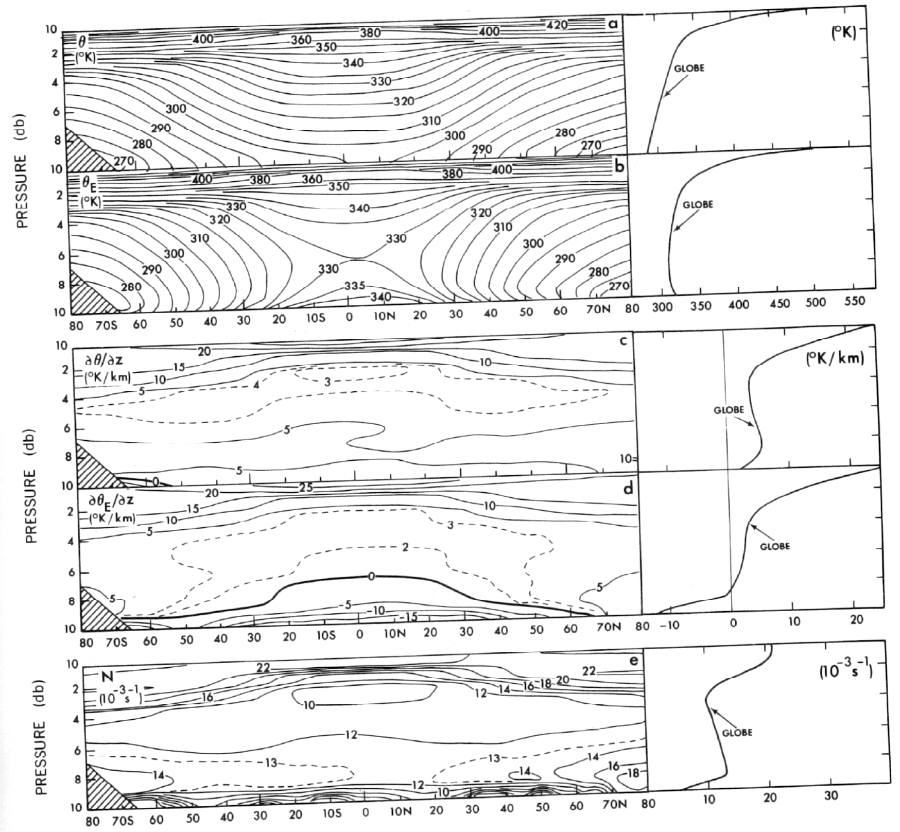

References

Clough, S. A., M. J. Iacono, and J-L. Moncet, Line-by-Line Calculations of Atmospheric Fluxes and Cooling Rates' Application to Water Vapor, Journal of Geophysical Research, Vol. 97, No. D14, Pg. 15,761-15,785, October 20, 1992.

