Water Vapor

Introduction
The constituent that makes Earth’s weather and climate so interesting and challenging to understand and model is water. Water exists on Earth in all three phases: vapor, liquid and solid. Water plays many important roles many of which are briefly summarized here:
- Water is the most important of the greenhouse gases that keep the Earth’s surface relatively warm at 288 K in comparison to its radiative equilibrium temperature of 255 K.
- Its concentrations will change via a complex feedback, generally thought to be positive overall that will amplify the effects of increasing CO₂ concentrations
- Water has a very high latent heat and as such
  - releases much energy into the atmosphere when it condenses and
  - cools the air and surface when it evaporates.
- The condensation of water provides the energy input to the atmosphere that drives much of severe weather, particularly in the warm season, such as hurricanes and tornadoes.
- Most of the vertical energy transport in the atmosphere is due to condensation of water.
- Rain falling into dry air can cause severe downdrafts such as “microbursts” that can be quite damaging. Bob Maddox, former member of our department and head of the National Severe Storms Lab (NSSL), thinks our region has the most severe downdraft in the world.
- In Sonora and Sinaloa, Mexico, the daily cycle of moist convection dramatically alters the diurnal cycle of temperature relative to the dry summer, lowering both the daytime maximum temperature and the nighttime minimum temperature via evaporative cooling
- The condensation that creates clouds and precipitation heats the air in the clouds.
- Clouds alter the radiative balance by
  - reflecting more shortwave radiation
  - absorbing and emitting more long wave radiation.
- High relative humidity (>80%) can also cause aerosol particles to grow in size altering their scattering properties.
- The type and extent of the continental biosphere is controlled largely by the amount and timing of precipitation it receives.
- Water has a very high heat capacity, particularly in the liquid form, such that the oceans store a huge amount of heat.
- The enormous amount of energy required to warm up heating of the oceans gives us time to make decisions. (Conversely, once they are warm, it will take a long time to cool them)
- The resulting land-sea temperature contrast (because land temperatures rise faster than ocean temperatures for the same amount of energy input) drives the monsoons and plays a strong role in the seasonal cycle.
- Freezing rain causes power outages and traffic accidents often in the Southeastern US.
- Increasing ice raises the Earth’s albedo, cooling the Earth. Melting ice lowers the albedo, warming the Earth.

We are going to build up several new tools to understand water and its impact on the atmosphere. These include
- Variables we use to describe atmospheric water
- The Clausius Clapeyron equation that defines how much water vapor the air can hold
- The moist adiabatic temperature lapse rate that includes the effects of latent heat.
- Virtual temperature that includes the effects of water vapor being lighter than dry air.

Several key points about the impact of water can be understood by examining the flow of moist air over orography.

There are a multiple variables that describe water vapor in the air. The reason for the multiple descriptions is none of them includes all relevant information needed.

Variables describing atmospheric water

Total water vapor amount type variables…
- Absolute humidity: ρ_{v} (g/m³, kg/m³):
The mass of water (vapor) per cubic meter of air. Absolute humidity ranges from 0 grams per cubic meter in dry air to 30 grams per cubic meter when the air is saturated at 30°C.

- Precipitable water vapor: PWV (kg/m², mm, cm)
The vertical integral of the absolute vapor mass density which yields the column water per m². This can be converted to units of precipitable mm or cm by dividing by the density of liquid water, 1 g/cc.
$\text{PWV}=\int_{0}^{¥}{ρ_{v}}\text{dz}=\int_{0}^{¥}{{qρ}_{\text{air}}}\text{dz}\text{=-}\int_{P_{s}}^{0}{\frac{q}{g}}\text{dP}=\int_{0}^{P_{s}}{\frac{q}{g}}\text{dP}$ (1)
- Precipitable water: PW (kg/m², mm, cm)
The vertical integral of the humidity, both vapor and condensed moisture, which yields the column water per m². This can be converted to units of precipitable mm or cm by dividing by the density of liquid water, 1 g/cc.

Mixing ratio type variables…
Mixing ratio type variables describe the fraction of air that is made of water vapor either in terms of mass density or number density.
Mixing ratio variables have a very important property: In the absence of water sources and sinks, these variables are conserved as air moves around. This “tracer” feature is very useful for understanding how water behaves and determining how water vapor is controlled in the atmosphere.

- Specific humidity: q (kg/kg, g/kg)
Specific humidity is the ratio of the mass of water vapor to the mass of air (including both water vapor and dry air) in a particular volume. Specific humidity ratio is expressed as a ratio of kilograms of water vapor, mw, per kilogram of mixture, mt . It is often written in g/kg to avoid the leading zeros.
- (Mass) mixing ratio: r (kg/kg, g/kg)
The (mass) mixing ratio is the ratio of the mass of water vapor to the mass of DRY air only in a particular volume. mixing ratio is expressed as a ratio of kilograms of water vapor, mw, per kilogram of dry air.
- Volume mixing ratio (%, ppmv)
Used to describe water vapor in the stratosphere.

Specific humidity is related to mixing ratio (and vice versa) by:
$q=\frac{M_{w}}{M_{d}+M_{w}}=\frac{r}{1+r}$ (2)
$r=\frac{q}{1−q}$ (3)
These two variables are very similar in magnitude.

Pressure type variables

- Partial pressure: e (mb)
The pressure of water vapor alone by itself. Note that the ideal gas law states that
P = n R* T (4)
For a gas in thermodynamic equilibrium, the gas has a well defined temperature. Therefore, all constituents of the gas have the same, well defined temperature. The molar number density of the gas is the sum of the molar densities of each constituent in the gas
$n=\sum_{i}{n_{i}}$ (5)
where n_{i} is the molar number density of the ith constituent of the gas. Plugging this in yields
$P=\sum_{i}{n_{i}}R∗T=R∗T\sum_{i}{n_{i}}$ (6)
from which we can write
$P=\sum_{i}{n_{i}}R∗T=R∗T\sum_{i}{n_{i}}=\sum_{i}{P_{i}}$ (7)
where P_{i} is known as the partial pressure of the ith constituent of the gas.
Note that this partial pressure concept works under the ideal gas law which is a very good approximation. Water is actually the least ideal of the major gases that makes up Earth’s atmosphere.

- Saturation vapor pressure: e_{s} (mb)
The partial pressure of water vapor at which the water vapor begins condensing out. This pressure is a function of temperature and is defined by the (integral of the) Clausius Clapeyron equation.
${\text{de}}_{s}=e_{s}\frac{L_{v}}{R_{v}T}\frac{\text{dT}}{T}=e_{s}\frac{L_{v}}{R_{v}T^{2}}\text{dT}$ (8)
Assuming L_{v} is constant, the integral leads to
$\int_{e_{s}\left(T_{0}\right)}^{e_{s}\left(T_{1}\right)}{\frac{{\text{de}}_{s}}{e_{s}}}=\int_{e_{s}\left(T_{0}\right)}^{e_{s}\left(T_{1}\right)}{d\text{ln}e_{s}}=\text{ln}e_{s}|_{e_{s}\left(T_{0}\right)}^{e_{s}\left(T_{1}\right)}=\text{ln}\left[\frac{e_{s}\left(T_{1}\right)}{e_{s}\left(T_{0}\right)}\right]=\int_{T_{0}}^{T_{1}}{\frac{L_{v}}{R_{v}}\frac{\text{dT}}{T^{2}}}\text{=-}\frac{L_{v}}{R_{v}T}|_{T_{0}}^{T_{1}}\text{=-}\frac{L_{v}}{R_{v}}\left[\frac{1}{T_{1}}−\frac{1}{T_{0}}\right]=\frac{L_{v}}{R_{v}}\left[\frac{T_{1}−T_{0}}{T_{1}T_{0}}\right]$
Taking exp() of both sides yields
$e_{s}\left(T_{1}\right)=e_{s}\left(T_{0}\right)\text{exp}\left[\frac{L_{v}}{R_{v}}\left[\frac{T_{1}−T_{0}}{T_{1}T_{0}}\right]\right]$ (9)
This shows that indeed the saturation vapor pressure depends exponentially of temperature. For a temperature of 250 K, L_{v}/(R_{v}T²) = 0.087 such that for every 1K change in temperature near 250 K the water saturation vapor pressure over liquid water is about 9%. For a temperature of 288 K, L_{v}/(R_{v}T²) = 0.087 such that for every 1K change in temperature near 250 K the water saturation vapor pressure over liquid water is about 7%. NOTE: discuss Gabe Vecchi’s talk on expected slowing of the circulation.

A flaw in the above derivation is it assumes the latent heat of vaporization is independent of temperature. There are a lot of different formulations that account for the temperature dependence. See http://cires.colorado.edu/~voemel/vp.html for a summary of these. As just derived, the Clausius Clapeyron suggests a simpler form for the e_{s}(T) equation relative to these more complicated forms over temperature ranges over which the latent heat, L, does not vary much with temperature.

- Relative humidity (%)
The ratio of the actual water vapor in the atmosphere relative to the amount the air could hold which is called saturation. If relative humidity is defined in terms of partial pressures then
RH = 100 x e/e_{s} (in %) (10)
One can also write RH in terms of q such that
RH = 100 x q/q_{s} (in %) (11)
where q_{s} is the specific humidity when the water vapor in the air is saturated.
$q_{s}=\frac{e_{s}}{P}\frac{m_{v}}{m_{a}}=\frac{e_{s}m_{v}}{\left(P−e\right)m_{d}+{em}_{v}}$ (12)
NOTE: There is an important subtlety when temperatures are subfreezing. The saturation vapor pressure can be either saturation vapor pressure over liquid or over ice. These differ because the latent heat of evaporation is smaller than the latent heat of sublimation. Therefore water molecules in the ice phase are more tightly bound than water molecules in the (supercooled) liquid phase. Therefore the saturation vapor pressure is lower over ice. It turns out that standard capacitive humidity sensors used in radiosondes measure relative humidity over liquid, even at subfreezing temperatures.
Temperature forms

- Dew point (ºC, ºF)
The temperature at which the water vapor in the air would equal the saturation water vapor pressure over a liquid surface. It is the temperature at which the water vapor will begin to condense out into dew. It is a measure of the absolute amount of water vapor in the air.

- Frost point (ºC, ºF)
The temperature at which the water vapor in the air would equal the saturation water vapor pressure over a water ice surface. It is the temperature at which the water vapor will begin to condense out into frost. It is a measure of the absolute amount of water vapor in the air.

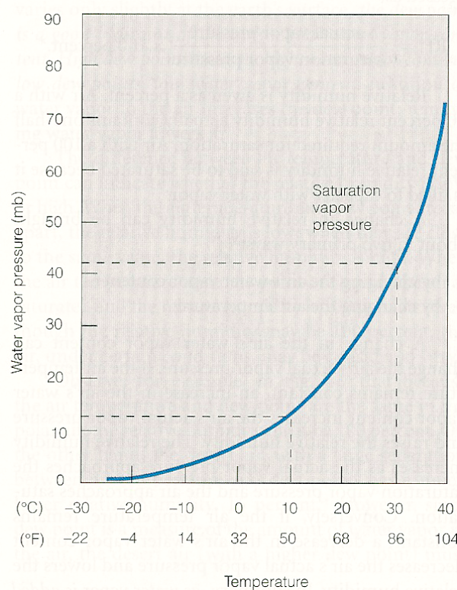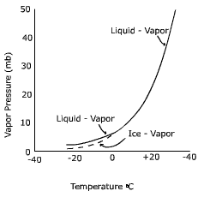
Saturation vapor pressure over liquid (left) and over liquid and ice (right)

