NAME | Venus | Earth | Mars | Jupiter | Saturn | Titan | Uranus | Neptune | Triton
Picture (visible wavelengths) | 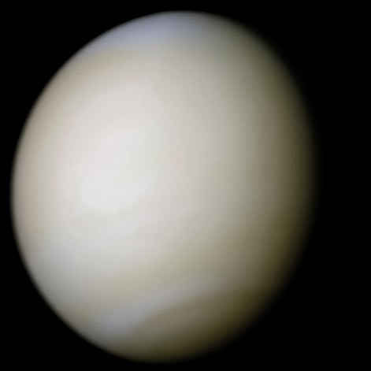 | 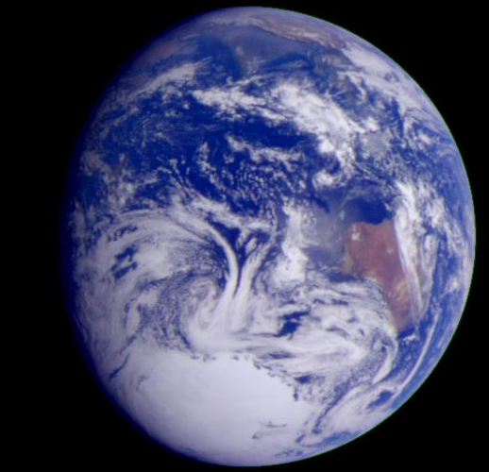 | 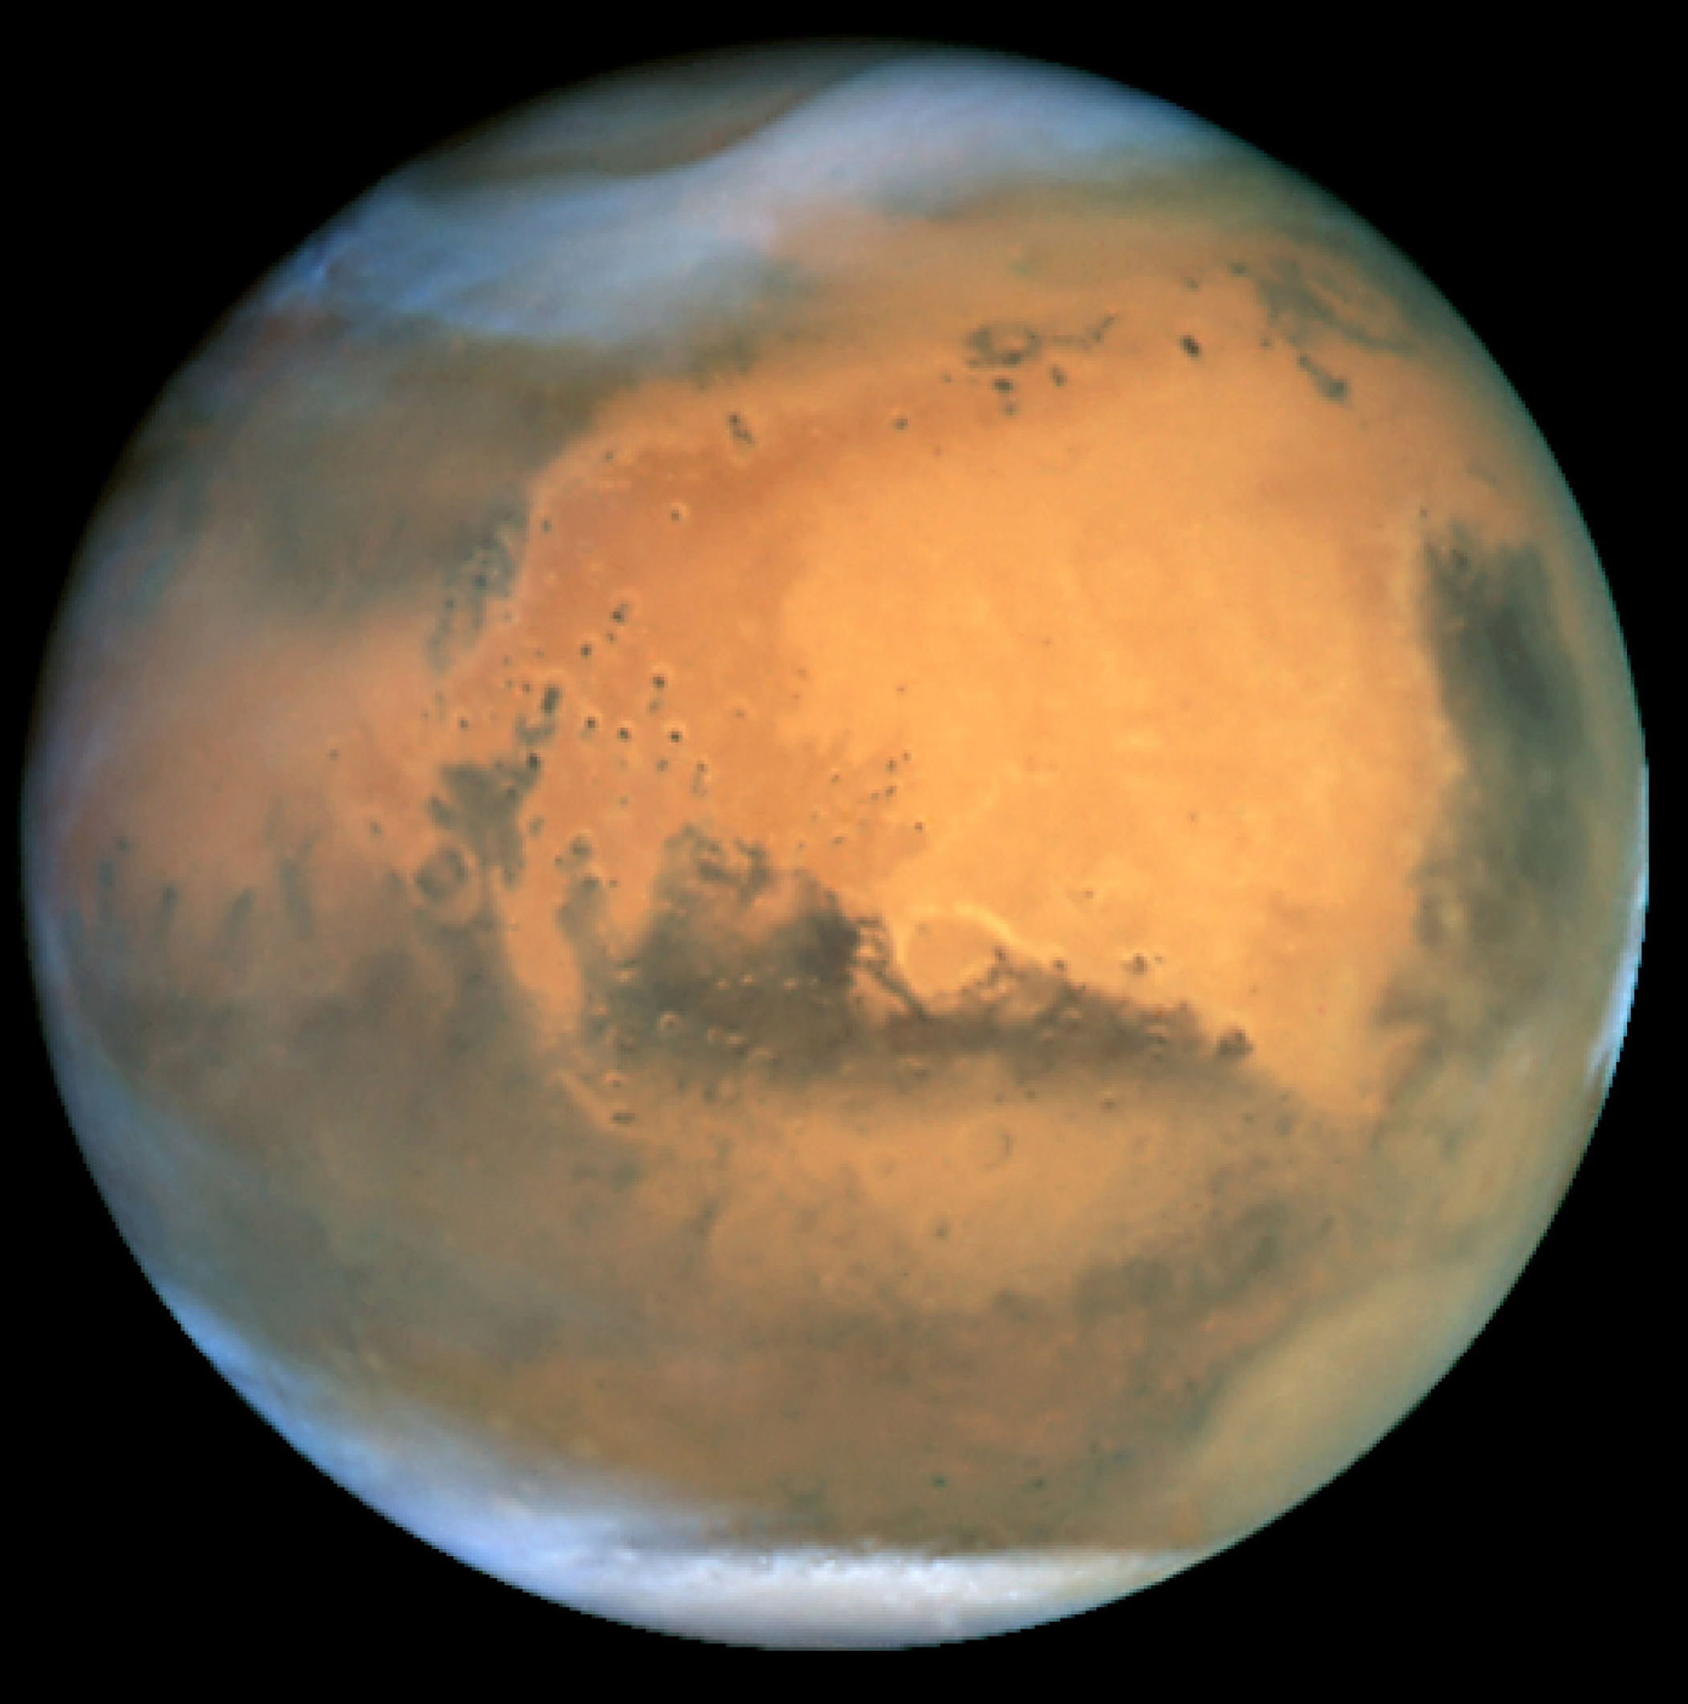 | 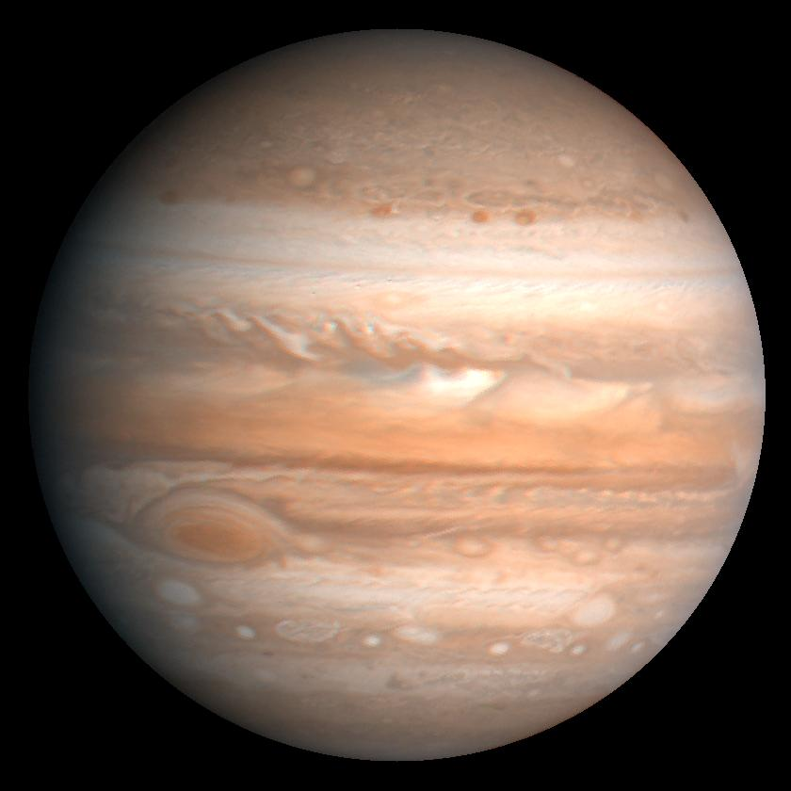 | 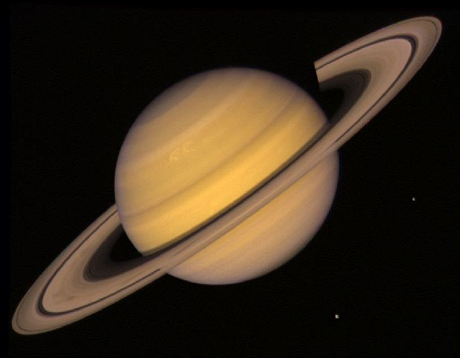 | 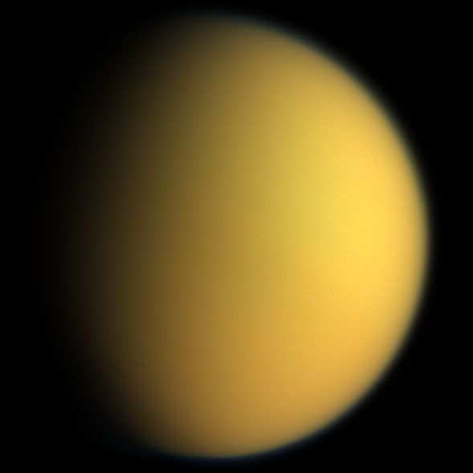 | 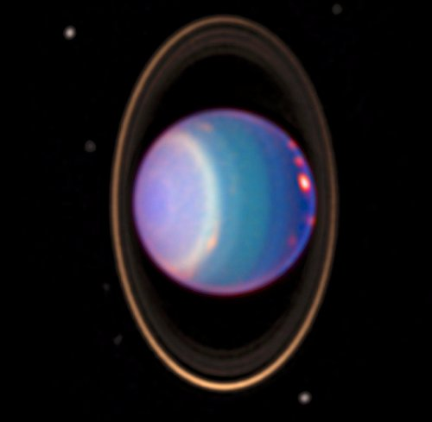 | 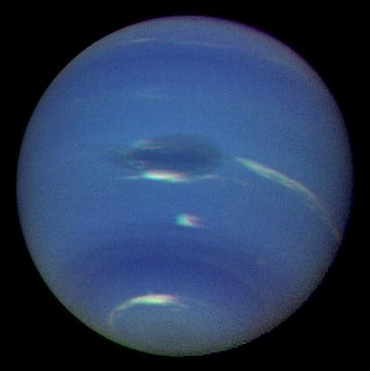 | 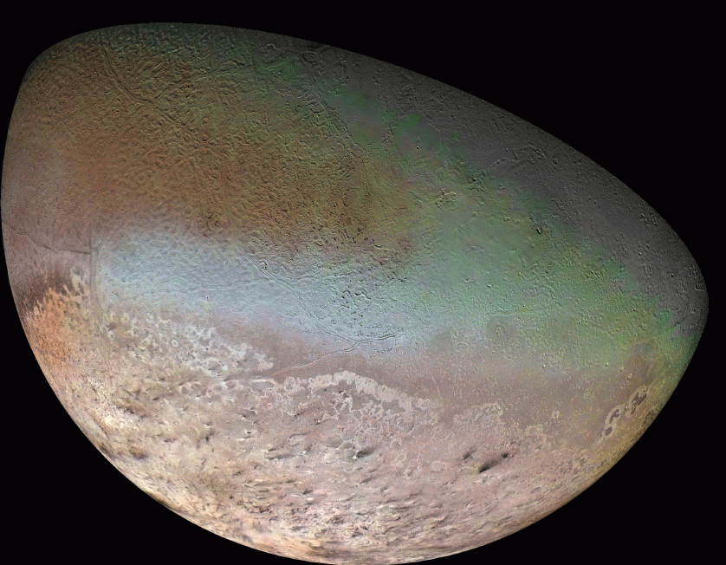
Radius (km / Rad. Earth) | 6052 / 0.95 | 6378 / 1 | 3396 / 0.53 | 70000 | 57000 | 2576 | 25600 | 24500 | 1353
Distance to sun (AU) | 0.72 | 1 | 1.38-1.66 | 5.15 | 9.58 | 9.58 | 19.2 | 30.1 | 30.1
Eccentricity | 0.0068 | 0.0167 | 0.09 | 0.0488 | 0.0557 | 0.0557 | 0.0444 | 0.0112 | 0.0112
Year (Earth years) | 0.615 | 1 | 1.88 | 11.86 | 29.66 | 29.66 | 84.3 | 164.8 | 164.8
Day (hours) | 2802 | 24 | 24.6 | 9.925 | 10.6 | 383 | 17.25 | 16.1 | 141
Axis tilt (degrees) | 177.36 | 23.45 | 25.19 | 3.13 | 26.73 | 26.73 | 97.8° | 28.32° | 28.32°
Density (g/cm³) | 5.204 | 5.5153 | 3.934 | 1.326 | 0.687 | 1.88 | 1.27 | 1.638 | 2.061
Mass (Earth mass) | 0.815 | 1 | 0.53 | 318 | 95.2 | 0.0225 | 14.5 | 17.2 | 0.0036
Surf. grav. (m/s2) | 8.87 | 9.81 | 3.69 | 24.79 | 8.96 | 1.352 | 8.69 | 11.15 | 0.779
Albedo | 0.65 | 0.3 | 0.15 | 0.52 | 0.47 | 0.22 | 0.30 | 0.29 | 0.76
ATMOSPHERE
Major constituent | CO₂ 96.5% | N₂ 78.08% | CO₂ 95.7% | H₂ 90% | H₂ ~96% | N₂ ~97% | H₂ ~83% | H₂ ~90% | N₂
2nd Constitutent | N₂ 3.5% | O₂ 20.95% | 2.7% N₂ | He 10% | He ~3% | CH₄ ~3% | He ~15% | He ~10% | CO
3rd Constituent |  | Ar 1% | Ar 1.6% |  | CH₄ ~0.4% |  | CH₄ ~2%
Trace 1 |  | H₂O 0-3%
Trace 2 (ppmv) |  | CO₂ ~385
condensibles |  | H₂O | H₂O, CO₂ | H₂O, NH₃ | H₂O, NH₃ | CH₄ | CH₄ | H₂O,NH₃,CH₄ | N₂
Surface pressure (bar) | 92 | 1.013 | 6-9 mb | NA | NA | 1.467 | NA | NA | 0.000016
Surface temp (K) | 737 | 288 | 227 (186-268) | NA | NA | 93.7 | NA | NA | 38
1 bar temp (K) |  |  | NA |  |  |  |  | 72
Rad. Eq. Temp. | 232 | 255 | 217 | 106 | 77 | 85 | 58.2 | 46.6 | 35.6
Tropospause min. T (K) |  | 190-230 |  | 110-115 | 80 | 72 | 55 | 55 | ?
Mean Molec Mass | 43.45 | 28.96 | 43.6 | 2.2 | 2.1 | 27.5 | 2.6 | 2.2 | 28
Scale height (km) | 5-16 | 7-8 | 10-12 | 16 | 34 | 20 | 21 | 19.7 | 14
Cp (J/K/kg) | 846 | 1003.5 dry | 841 | 13390 | 13900 | 1075 | 12690 | 13390 | 1040
Dry adiabat (K/km) | 10.5 | 9.8 | 4.4 | 1.85 | 0.64 | 1.26 | 0.68 | 0.83 | 0.75
Escape vel. (km/s) | 10.36 | 11.186 | 5.027 | 59.5 | 35.5 | 2.639 | 21.3 | 23.5 | 1.455

1 AU = 1.47e6 km

