Kirchhoff’s Law: Emissivity = Absorbtivity
In 1859, Kirchhoff defined a law that states that emission and absorption in heated objects are equal because if they were not, then the conservation of energy would be violated. An object with some finite temperature radiates electromagnetic energy. If it is a perfect black body (defined below), it will absorb all light that strikes it, and it will radiate energy according to the black-body radiation formula. Generalizing this a bit, one can speak of a "grey body" that radiates with an emissivity factor that is multiplied by the black-body equation. Kirchhoff's law states that when in thermal equilibrium, the emissivity of a body equals its absorptivity.
Blackbody radiation
As natural sources of radiation, we begin with thermal radiation emitted as blackbody radiation according to the Planck function. A perfect blackbody absorbs all radiation that strikes it. According to Kirchhoff’s Law, a good absorber is also a good emitter. It emits “thermal” radiation described by the Planck Function. It is so named because Max Planck was the first to produce a theoretical explanation of the observed radiation spectrum in 1901. It had been noted that Blackbody radiation can be produced by a small hole or opening in a cavity whose insides absorb all radiation striking the cavity. The radiation spectrum strongly depended on the temperature of the cavity. In order to find a function that fit the observed blackbody emission spectrum, Planck had to assume that the oscillations of the radiation field were quantized. This realization was a major step in creating the field of physics we know as quantum mechanics.
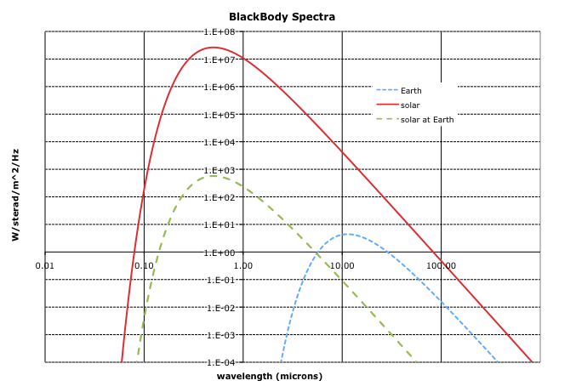

The different forms of the Planck function
There are several different forms of the Planck function. First of all, it can be written in terms of frequency, v, as B(v,T) or wavelength, λ, Β(λ,Τ). Conversion between the frequency and wavelength forms is accomplished via the equation,
B_{ν}(ν,T) dν = B_{λ}(λ,T) dλ.
Furthermore, it can be written in a radiance form (watts/steradian/m² per Hz or per wavelength), a radiant flux density (also known as spectral emittance) form (watts/m² per Hz or per wavelength) or a radiant energy density form (joules/m³ per Hz or per wavelength). There are other versions as well and you must check the units to help understand the form.
The radiance form as a function of frequency with watts/steradian/m²/Hz is
$B\left(ν,T\right)=\frac{2{hν}^{3}}{c^{2}}\frac{1}{e^{hν/\text{kT}}−1}$
Check units: J s s²/(s³m²) = J/m² = J/m²/s/Hz = W/m²/Hz. The problem is you can’t see the steradians.
The Planck function written in the radiant energy flux density form as a function of frequency form (watts/m²/Hz) is
$B_{\text{flux}}\left(ν,T\right)=\frac{2{phν}^{3}}{c^{2}}\frac{1}{e^{hν/\text{kT}}−1}$
The factor of π comes from integrating out the angular dependence (see below).
Another form is the frequency dependent form of the radiant energy density form in joules per m³ per Hz. We take the radiance form, multiply it by 4π to integrate out the steradian dependence and divide it by c because flux density equals density times the speed of propagation.
$B\left(ν,T\right)=\frac{8{phν}^{3}}{c^{3}}\frac{1}{e^{hν/\text{kT}}−1}$
Check units: J s s³/(s³ m³) = J/m³/Hz.

Elachi and van Zyl write the Planck function in terms of wavelength in the radiant flux density or spectral emittance form (watts/m²/wavelength).
$S_{\text{flux}}\left(λ,T\right)=\frac{2p{\text{hc}}^{2}}{λ^{5}}\frac{1}{e^{\text{ch}/λ\text{kT}}−1}$
Again, this form has an extra factor of π in comparison to the radiance form (watts/steradian/m²/Hz) for reasons we’ll show below.
Relation between Radiant Flux Density (watts/m²) and Radiance (watts/m²/steradian)
Suppose we want to know the upward energy flux density from a surface. Each surface element is radiating in all directions, each containing an upward component. We want to add up all of the vertical components from energy radiated in all directions. So we integrate over the upward-looking hemisphere.
$M\left(ν,T\right)=\int_{q=0}^{2p}{\int_{f=0}^{p/2}{B\left(ν,T\right)}}\text{cos}f\frac{r\text{sin}fdq\text{rd}f}{r^{2}}=B\left(ν,T\right)\int_{q=0}^{2p}{\int_{f=0}^{p/2}{\text{cos}f\text{sin}fdfdq}}$
$M\left(ν,T\right)=B\left(ν,T\right)\frac{{\text{sin}}^{2}f}{2}|_{0}^{p/2}q|_{0}^{2p}=B\left(ν,T\right)\left(\frac{1}{2}−0\right)\left(2p−0\right)=pB\left(ν,T\right)$
So the factor of π that you will see in radiant flux density equations comes from doing a hemispherical integration of the upward (or downward) component of radiance vector (which has a per steradian dependence) when the radiance vector is isotropic, that is it has no directional dependence.
Relation between Radiant Flux Density (watts/m²) and Radiance (watts/m²/steradian)
Suppose we want to know the upward energy flux density from a surface. Each surface element is radiating in all directions, each containing an upward component. We want to add up all of the vertical components from energy radiated in all directions. So we integrate over the upward-looking hemisphere.
$M\left(ν,T\right)=\int_{q=0}^{2p}{\int_{f=0}^{p/2}{B\left(ν,T\right)}}\text{cos}f\frac{r\text{sin}fdq\text{rd}f}{r^{2}}=B\left(ν,T\right)\int_{q=0}^{2p}{\int_{f=0}^{p/2}{\text{cos}f\text{sin}fdfdq}}$
$M\left(ν,T\right)=B\left(ν,T\right)\frac{{\text{sin}}^{2}f}{2}|_{0}^{p/2}q|_{0}^{2p}=B\left(ν,T\right)\left(\frac{1}{2}−0\right)\left(2p−0\right)=pB\left(ν,T\right)$
So the factor of π that you will see in radiant flux density equations comes from doing a hemispherical integration of the upward (or downward) component of radiance vector (which has a per steradian dependence) when the radiance vector is isotropic, that is it has no directional dependence.
Wien’s (displacement) law
The peak of the emission from a blackbody (in the wavelength form) and its temperature are related as
$λ_{\text{max}}=\frac{b}{T}$
where λ_{max} is the wavelength (in m) at which spectral emission is maximum and b is about 2.90×10⁻³ m K.
The peak of the frequency form of the Planck function occurs at 2.82 = hν/kT which is about a factor of 2 longer wavelength larger than the peak when the equation is written in the wavelength form.
Stephen Boltzmann law
The Stephan-Boltzmann law gives the total flux density from the Planck function integrated across the spectrum. The result is
F = σT⁴
where σ = 5.67x10⁻⁸ watts/m²/Kelvin⁴. One can remember the constant as 5678 with the last digit being the exponent and the form of mantissa being #.##.
To go from Planck function to the Stephan Boltzmann law, you integrate the Planck function across the spectrum. See: http://scienceworld.wolfram.com/physics/Stefan-BoltzmannLaw.html.
The Stephan Boltzmann law is remarkable because the form is so simple, the results depends only on temperature and the dependence on temperature is so strong. The surface of the Earth is 20 times colder at 300K than the surface of the sun (6000K) but the sun puts out 20⁴ = 1.6x10⁵ times as much radiant energy per square meter as does the Earth. Furthermore the radius of the Sun is ~10x the radius of Jupiter which is ~10x the radius of the Earth. So the total black body radiant energy emitted by the Sun is about 10⁴ x1.6x10⁵ = 1.6x10⁹ times that of the Earth.

Reflection, absorption, transmission and emission
EM radiation striking an object is either reflected, absorbed or transmitted through the object. The albedo, A, is the fraction of incident light that is reflected. The visible albedo of the Earth is about 0.3 due largely to clouds.
If the object is very thick so there is no EM transmission through the object, then the fraction of incident light absorbed, which is called absorptivity, is 1-A.

Kirchoff’s law (again):
Based on energy balance, the emissivity of an object, that is how close the object’s emission is to a perfect blackbody, must equal the absorptivity. Otherwise objects could reach infinitely high or infinity low temperatures. So a good absorber is a good emitter. A good reflector is a poor emitter.
These properties are very wavelength dependent. Snow is an excellent reflector and therefore poor absorber and emitter at visible wavelengths. However, at IR wavelengths, snow is an excellent absorber and emitter and therefore poor IR reflector.

