Atmospheric Radiative Transfer

We need to understand how energy is transferred via radiation within the atmosphere. We introduce the concept of optical depth. We will further show that the light moves approximately a distance equal to an optical depth of unity and we will use that to gain more insight into how to think about radiative transfer. We will also use the Earth as an example to show that optically thick atmospheres are convectively unstable. Note that this discussion is in terms of 1D radiative transfer in the vertical direction which is the direction of 1st order relevance to radiative transfer.

Suppose we are looking down at the atmosphere observing the IR radiation emerging from the atmosphere. For now, we assume no scattering effects. We use Beer’s Law where
$\text{dI}\text{=-}Iα\text{dz}\text{=-}Idt$ 
where I is intensity in watts/m², α is the extinction coefficient in units of inverse length, z is path length and τ is known as optical depth. α‘s units of inverse length represent how much attenuation there is per unit length.
From Kirchhoff’s law, a good absorber is a good emitter and a poor absorber is a poor emitter (at the wavelengths where it is a poor absorber). We need the equation for emission to understand how the atmosphere cools itself by emitting IR radiation.

It can be shown that the radiation emission from a height interval with thickness, dz, is
dI_{v}  vz BvT dz (1)
where B(v,T) is the Planck function (the black body curve) and α is the absorption coefficient in units of inverse length.
This emitted radiation is then attenuated by absorption as it passes through the atmosphere. The radiance from that height interval that leaves the atmosphere is therefore
${\text{dI}}_{e}\left(u,z\right)=α\left(u,z\right)B\left(u,T\right)e^{−t\left(u,z\right)}\text{dz}={\text{dI}}_{u}e^{−t\left(u,z\right)}$ 
where τ is the optical thickness above altitude of emission, z, where
$t\left(v,z\right)=\int_{z}^{¥}{α\left(v,z\right)}dz$ 

Note that τ is defined here such that τ = 0 at the top of the atmosphere. So the spectral intensity of the atmosphere is
$B_{a}\left(v\right)=\int_{0}^{¥}{α\left(v,z\right)}B\left[v,T(z)\right]e^{−t\left(v,z\right)}\text{dz}$ 
There is also a contribution from the emission from the surface, B_{s}. So the total emission seen from above the Earth is
_{t}v  _{a}(v) + B_{s} $e^{−t_{m}\left(v,z\right)}$ (5)
where τ_{m} is the total optical depth of the atmosphere from the surface to space:
$t_{m}\left(v\right)=\int_{0}^{¥}{α\left(v,z\right)}\text{dz}$ 
There is a variable, X, called the transmission through the atmosphere that is equal to $e^{−t\left(v,z\right)}$. The vertical derivative of X is then
$\frac{\text{dX}}{\text{dz}}=\frac{{\text{de}}^{−t\left(u,z\right)}}{\text{dz}}\text{=-}e^{−t\left(u,z\right)}\frac{dt}{\text{dz}}=α\left(u,z\right)e^{−t\left(u,z\right)}$ (7)
The last sign change comes from the derivative of (3) w.r.t. z. This allows B_{a} in (4) to be written somewhat more compactly as
$B_{a}\left(v\right)=\int_{0}^{¥}{B\left[v,T(z)\right]\frac{\text{dX}\left(v,z\right)}{\text{dz}}}\text{dz}$ 

The peak altitude of emission
Now lets look at the vertical level where the most emission comes from. Assuming $B\left[v,T(z)\right]$ does not vary too dramatically with altitude, then the answer is the answer to the question: at what altitude does $\frac{\text{dX}\left(v,z\right)}{\text{dz}}$ reach a maximum?
$\frac{d}{\text{dz}}\frac{\text{dX}}{\text{dz}}=0=\frac{d}{\text{dz}}\left[α\left(u,z\right)e^{−t\left(u,z\right)}\right]=\left[\frac{d}{\text{dz}}α\left(u,z\right)−α\left(u,z\right)\frac{d}{\text{dz}}t\left(u,z\right)\right]e^{−t\left(u,z\right)}$
$0=\left[\frac{d}{\text{dz}}α\left(u,z\right)+α^{2}\left(u,z\right)\right]e^{−t\left(u,z\right)}$
$\frac{d}{\text{dz}}α\left(u,z\right)\text{=-}α^{2}\left(u,z\right)$ (9)
Now, we need to remember get an equation for a is to use an approximate form for it to understand the implications of (9). (In the Hygrometer notes: )
$α=k_{v,u}=S_{v,u}f\left(u−u_{0}\right)$ 
where S is the line strength of the absorption line, f represents the shape of the absorption line, $u$ is the frequency of the measurement and $u_{0}$ is the line center of the absorption line. The line shape is due to a combination of Doppler and pressure broadening. The line strength is given as
$S_{v,u}=n_{m}\frac{g_{i}\text{exp}\left(−E_{i}/\text{kT}\right)}{Z}\frac{C_{\text{ij}}}{c}\left[1−e^{{−{hu}_{\text{ij}}}/{\text{kT}}}\right]=n\frac{n_{m}}{n}\frac{g_{i}\text{exp}\left(−E_{i}/\text{kT}\right)}{Z}\frac{C_{\text{ij}}}{c}\left[1−e^{{−{hu}_{\text{ij}}}/{\text{kT}}}\right]$ 
where n is the total number density of the bulk gas = P/k_{B}T and n_{m}/n is the volume mixing ratio of constituent m of the gas, E_{i} is the energy of the transition between two energy levels (i and j) of the molecule, $u_{0}$=$u_{\text{ij}}$, g is the number of states with Z is the partition function which is $\sum_{i}{g_{i}\text{exp}\left(−E_{i}/k_{B}T\right)}$ which is the sum of population of all of the available states at a particular temperature, T, and C_{ij} is an electromagnetic coupling factor for this particular energy transition.

The main point right now is that S is proportional to the number density of the absorber, n. This in general falls off exponentially with altitude.
So we plug a simple exponential form in for α(z) = α₀ e^{-z/H} into (9) which results in
$−\frac{α_{0}e^{{−z_{\text{max}}}/H}}{H}\text{=-}α_{0^{2}}e^{−2{z_{\text{max}}}/H}$
$e^{{z_{\text{max}}}/H}=α_{0}H$
$\frac{z_{\text{max}}}{H}=\text{ln}\left[α_{0}H\right]$
$z_{\text{max}}=H\text{ln}\left[α_{0}H\right]$ (12)
Plug (12) into (3) we find the value of τ at z_{max} at which $\frac{\text{dX}}{\text{dz}}$ reaches a maximum value
$t\left(v,z_{\text{max}}\right)=\int_{z_{\text{max}}}^{¥}{α_{0}e^{{−x}/H}}dz\text{=-}α_{0}{He}^{{−x}/H}|_{z_{\text{max}}}^{¥}=α_{0}{\text{He}}^{{−z_{\text{max}}}/H}=α_{0}H\text{exp}\left(−\frac{H\text{ln}\left[α_{0}H\right]}{H}\right)$
$t\left(v,z_{\text{max}}\right)=α_{0}H\text{exp}\left(−\text{ln}\left[α_{0}H\right]\right)=α_{0}H\frac{1}{α_{0}H}=1$ 
So indeed $\frac{\text{dX}}{\text{dz}}$ reaches a maximum value around τ = 1.

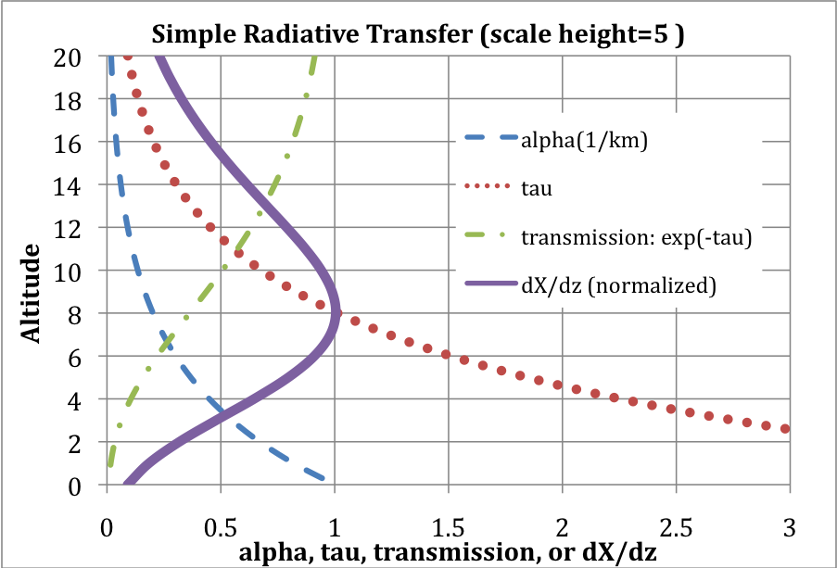

What is the (spectrally averaged) IR optical depth of Earth’s atmosphere?

We can make a simple estimate of the spectrally averaged optical depth of the Earth’s atmosphere from the Kiehl and Trenberth figure below.

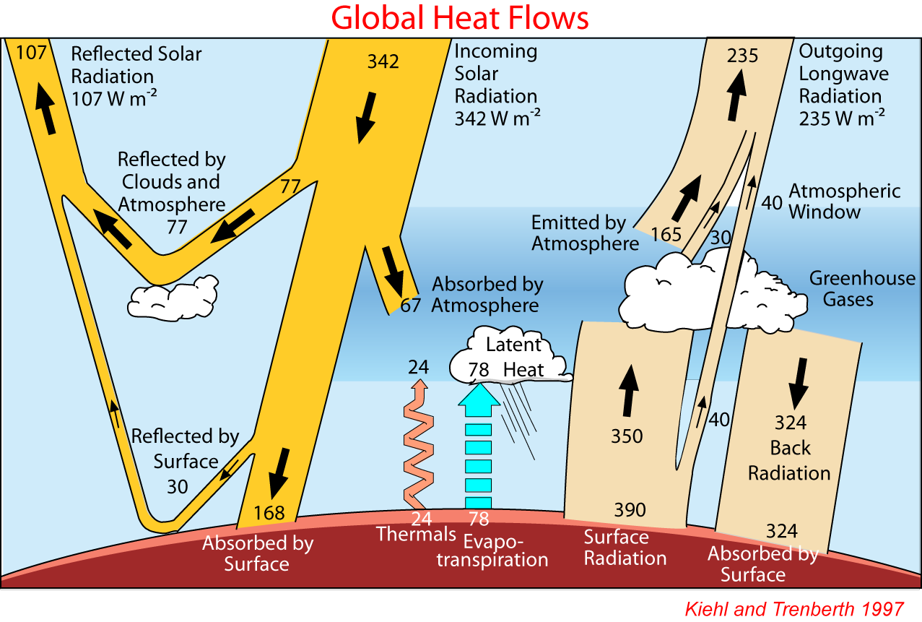
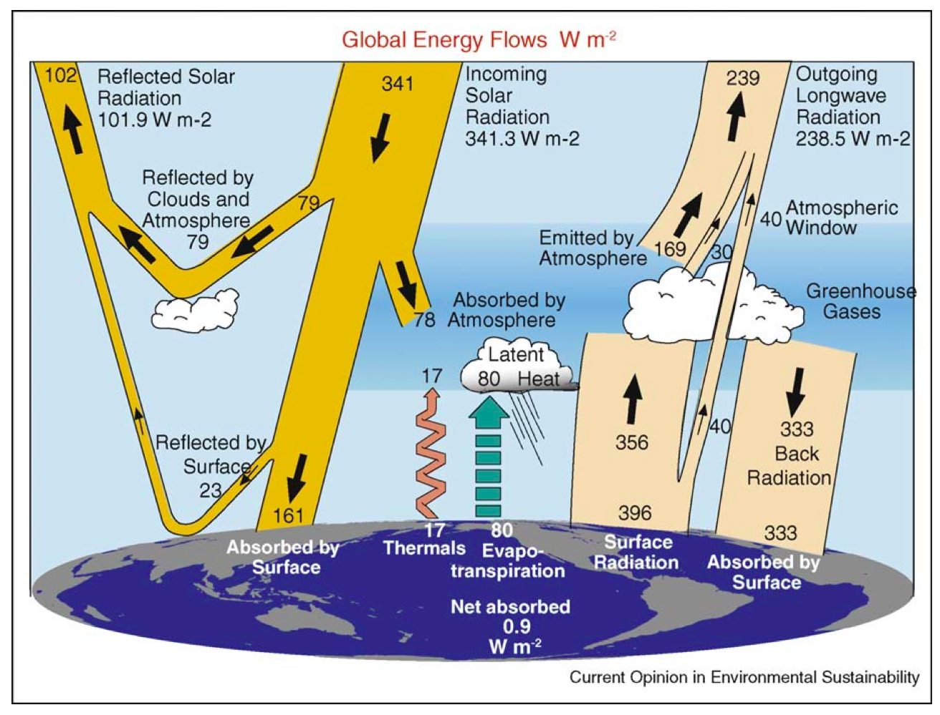
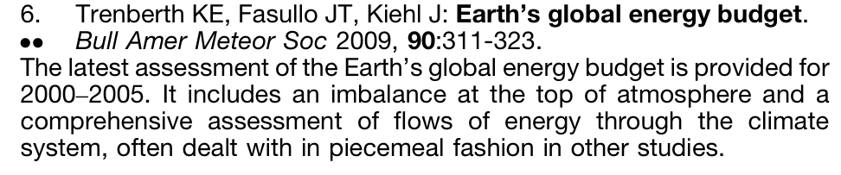

The average surface temperature of the Earth is 288K. The radiative equilibrium of the Earth is 255 K. Given an average lapse rate of 6.5K/km, the average altitude where the radiation to space is emitted is the altitude whose temperature is 255 K which is (288-255)/6.5 = 5 km. Since this is the average altitude where thermal emission from Earth is leaving into space, this must be the altitude where the spectrally averaged optical depth (measured from the top of the atmosphere) is about 1.
The downwelling IR into Earth’s surface is 324 W/m². We set this equal to σT⁴ to find the temperature level in the atmosphere where this radiation is coming from. The answer is 275K. Again, using an average surface temperature of 288 K and an average lapse rate of 6.5 K/km, we see that the altitude of this downwelling radiation is 2 km. Now when measured from the surface, this altitude corresponds to an optical depth of 1.
So we know that from space to an altitude of 5 km is approximately a spectrally averaged IR optical depth of 1 and from the surface to an altitude of 2 km, the change in IR optical depth is about 1. What is the spectrally averaged optical depth change between 2 and 5 km?
The pressure at 5 km is about 550 mb. So the amount of atmospheric mass above 5 km is about 55% of the atmosphere. The pressure change between the surface and 2 km is about 200 mb (=1000mb - 800mb) or about 20% of the atmosphere. The pressure change between 2 and 5 km is about 800 mb - 550 mb = 250 mb. So, based on this relation between optical depth and mass, my guess is the spectrally averaged IR optical depth across this interval is slightly less than unity. So the spectrally averaged IR optical depth of the entire atmosphere is about 3.
The reason the gradient of optical depth w.r.t. to atmospheric mass increases at higher pressure and temperature is a combination of increased water vapor at warmer temperatures and the fact that at higher pressure the spectral interval between the absorption lines fills in as the lines broaden.
Comment on Venus, Earth and Mars: Venus has an enormous CO₂ atmosphere. Bill Nye says because of the massive amount of CO₂ Venus has an enormous greenhouse effect. Mars has more CO₂ in the atmosphere than Earth. Does it have a big greenhouse effect? No. Why not?
Simple layered radiative transfer model for optically thick atmospheres.

Consider an atmosphere divided into vertically stratified layers. The vertical thickness of each layer is defined to be such that the change in the spectrally averaged optical thickness across the depth of the layer is unity.
We can then write the radiative transfer equilibrium solution in the following approximate way. Note that we are assuming convection and diffusional energy transfer are negligible.

Starting from the top, at optical depth 1 we have radiative equilibrium with no IR coming in from the top, radiation coming in and being absorbed from the layer below and the layer itself radiating both up and down. We can write this as
$2{sT}_{1}^{4}={sT}_{2}^{4}$
For the second layer, the energy into the layer is coming from the layers immediately above and below the 2nd layer. The layer itself again emits both up and down. So the radiative equilibrium condition is
$2{sT}_{2}^{4}={sT}_{1}^{4}+{sT}_{3}^{4}$
This generalizes to
$2{sT}_{i}^{4}={sT}_{i−1}^{4}+{sT}_{1+1}^{4}$
At the surface we have
${sT}_{n+1}^{4}={sT}_{n}^{4}+F_{\text{sol}}$
Where T_{n+1} is the surface temperature under n atmospheric layers and F_{sol} is the solar flux absorbed by the surface.
Clearly the temperature fo the top layer must be the radiative equilibrium temperature. The temperature of the second layer is 2^{1/4} T_{eq.} The temperature of the third layer is
$T_{3}={\left[2T_{2}^{4}−T_{1}^{4}\right]}^{1/4}={\left[2∗2T_{1}^{4}−T_{1}^{4}\right]}^{1/4}={\left[3T_{1}^{4}\right]}^{1/4}=3^{1/4}T_{1}$
The general solution to the vertical temperature structure is T_{i} = i^{1/4} T_{eq}.

Now we can compare this optically thick radiative-only atmospheric temperature structure with that of Earth. Temperature T₁ is 255K. Temperature T₂ is 303K and T₃ =336. As the table shows, given the altitudes of the optical depths of 1, 2 and 3 levels in the atmosphere, we can determine the lapse rates when the vertical energy exchange is via radiative only.

Optical Depth | T (K) | Altitude (km) | dT/dz (K/km)
1 | 255 | 5 | -16.1
2 | 303 | 2 | -16.2
3 | 336 | 0

The issue is that the temperature gradients are larger than the dry adiabat. So when the atmosphere move to get hot enough to radiatively transfer the absorbed solar energy back out to space, it becomes convectively unstable and begins to transfer some of the energy upward via convection. This shows that a purely radiative atmosphere is convectively unstable and is never actually achieved for atmospheres where the (spectrally averaged) IR optical depth exceeds unity. So convection kicks in and transfers energy vertically and we have a radiative-convective troposphere. This is why the tropopause on planets and moons with major atmospheres is a bit above the τ =1 level in the atmosphere.

