Latent heat of fusion and vaporization

Latent heat is the energy change associated with the phase change of a material between gas, liquid and solid. The latent heat is written as L and given in J/kg in mks units. It literally means how much heat energy must be added to a mass of material to convert its phase such as from solid to liquid (melt), liquid to vapor (evaporate) or solid to vapor (sublimate).
ΔQ = m L
When the transition occurs the other way such as vapor to liquid, the latent heat defines how much energy is released from the mass into the environment.

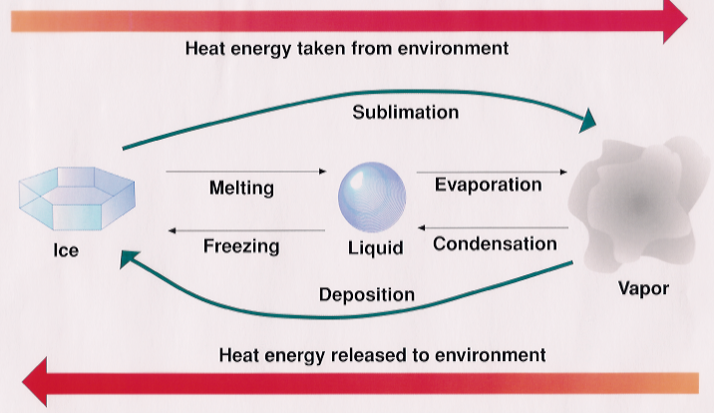
+540 cal/gm
+80 cal/gm
-540 cal/gm
-80 cal/gm
-620 cal/gm
+620 cal/gm
Surrounding air warms
Surrounding air cools
Note that 1 calorie = 4.1868 J.
Examples of Latent heats of various materials
Substance | Latent Heat Fusion kJ/kg | Latent Heat Fusion J/mole | Melting Point °C | Latent Heat Vaporization kJ/kg | Boiling Point °C at 1013 mb
Alcohol, ethyl | 108 |  | -114 | 855 | 78.3
Ammonia | 339 |  | -75 | 1369 | -33.34
Carbon dioxide | 184 |  | -57 | 574 | -78
Helium |  |  |  | 21 | -268.93
Hydrogen | 58 |  | -259 | 455 | -253
Lead | 24.5 |  | 372.3 | 871 | 1750
Methane | 58.7 |  | -182. | 510 | -161.6 °C
Nitrogen | 25.7 |  | -210 | 200 | -196
Oxygen | 13.9 |  | -219 | 213 | -183
Water | 334 |  | 0 | 2500 (at 0ºC) | 100

The magnitude of the latent heat is a measure of how strongly bound the molecules are to one another in the liquid and solid states. Note in the table above that water has the highest latent heat of vaporization. The next highest is ammonia, NH₃, which is similar in many ways to water, H₂O. Both are asymmetrical molecules with large permanent electric dipole moments that make the molecules readily and tightly bind to one another.
Molar form of the latent heat reveals more about the binding energy.

Heat required to melt and boil some water
Take 5 grams of ice initially at -20ºC. How much energy does it take to raise the water molecules in the ice to a temperature of 100ºC and fully vaporize the water molecules?

- add heat to raise the temperature of the ice to 0ºC.
- add heat to melt the ice
- add heat to raise the liquid water from 0ºC to 100ºC
- add heat to vaporize the liquid water and convert the molecules from liquid to gas phase

To make these calculations, we need to know the specific heats.
Material | C_{p} (J/g/K) | C_{p,m} (J/mol/K) | C_{V,m} (J/mol/K)
Water vapor (100 °C) | 2.080 | 37.47 | 28.03
Water liquid (25 °C) | 4.1813 | 75.327 | 74.53
Water ice (-10 °C) | 2.050 | 38.09

Given what we know about specific heats, what can we say about why these specific heats differ?

