1. Sensible heat flux
Follow the steps below to determine the surface sensible heat flux by calculating the daytime heating of the planetary boundary layer (PBL)

Below are three figures. The first two show recent radiosonde profiles at 5 am and 5 pm in Tucson. The third figure shows the two figures superimposed on top of one another to show the day versus night difference in the PBL thermal structure.

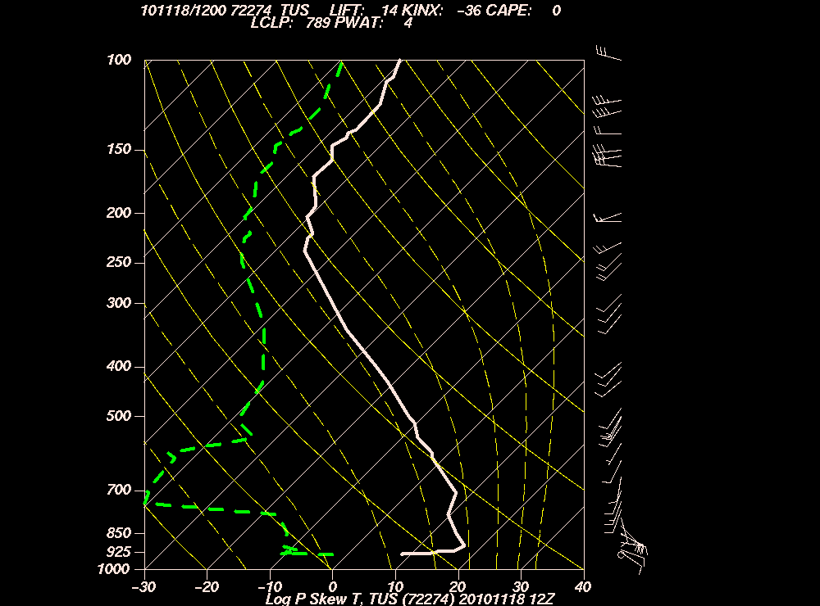

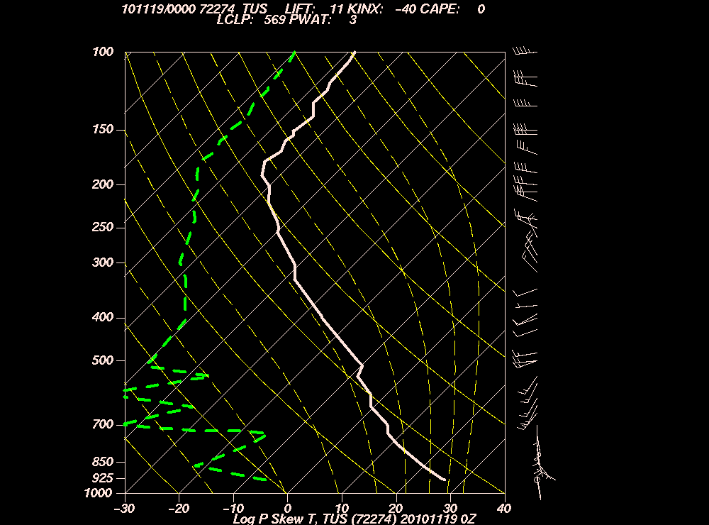

- Based on the difference between these two profiles, how deep is the daytime convective boundary layer (measured relative to the surface), in both pressure and in altitude?

- What is the temperature lapse rate in the PBL at 5 PM?

- Based on the difference between the radiosonde temperature profiles in the afternoon and morning, and assuming that all of this difference is due to sensible heat flux from the surface into the atmosphere, how much energy has been added to the lowermost troposphere from morning to late afternoon.

- Divide this by the length of time over which the atmospheric heating took place to determine the approximate average sensible heat flux from the surface into the atmosphere from sunrise to the late afternoon? (your answer should be around 200 W/m²).

2. Approximate Daytime Surface Energy Budget
For this problem, you will estimate an approximate energy budget at the surface.
From sunrise to late afternoon, the energy into the surface is absorbed solar flux and absorbed IR flux from the atmosphere. Some of this energy is lost via sensible heat flux into the atmosphere. Some is lost via IR flux out of the surface. Some goes into raising the temperature of the surface as a diffusive boundary layer forms and thickens in the soil.

The solar flux measured on the roof of PAS is given below.
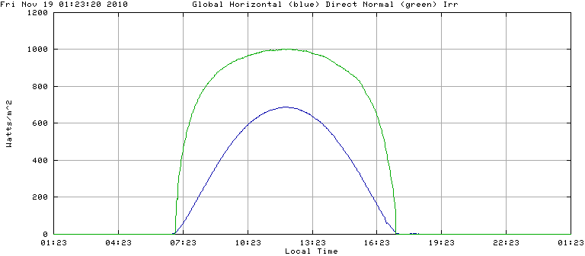

- From sunrise to late afternoon, what is the average solar radiation absorbed by the surface?
- From sunrise to late afternoon, what is the average IR flux upward out of the surface? Be careful with your average because the Stephan-Boltzmann equation is quite a nonlinear function of temperature.
- Assuming the downward IR comes approximately from an altitude of 3 km (global average is ~2 km but Tucson is quite dry so the downward IR comes from higher altitudes), what is the approximate average downward IR flux from sunrise to late afternoon?
- Energy absorbed and stored in the soil: You can estimate the energy that flows into the soil based on the increase in soil temperature multiplied by the diffusive depth of penetration into the soil. You can estimate the depth of the diffusive boundary layer from equation (16) of the Diffusion Lecture and the diffusivity and heat capacity of soil which you can find on line.
- Use the answers to parts a-d and the previous question to show what the surface energy budget is. (I get ~340 W/m² in which is balanced approximately by the energy out and the energy stored in the soil)

Below is the temperature and dew point over the same day.

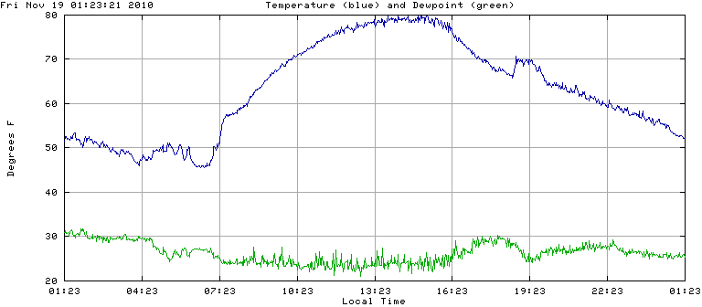

3. Nocturnal Boundary Layer Thickness
A sharply defined nocturnal boundary layer (NBL) is evident in the 5 AM radiosonde profile. You can estimate the depth of that shallow boundary layer from how long the sensible heat flux takes to heat it up and make it disappear after the sun comes up.
In the figure above, the surface temperature increased very quickly around 7 AM. The sun heated up the surface which then heated up the NBL via sensible heat transfer. Based on the rapid change in the surface temperature shortly after sunrise centered approximately on 7:23 AM in the figure, what is the depth of the nocturnal boundary layer?
To keep things simple, assume the thermal inversion is such that the atmospheric temperature across the depth of the NBL increases linearly with altitude up to the depth of the nocturnal boundary layer at sunrise. Assume an albedo and that the absorbed portion of the incident solar flux is converted directly to a sensible heat flux. (I got an answer of about 30 m.)

4. Occasional temperature gradient extremes in Tucson
Occasionally, there will be extremely different overnight temperature minima across Tucson. For example, on a clear night, minimum temperatures 4 miles north of campus near the Rillito Wash can be below freezing while the minimum temperature on campus is 50F. Thinking in terms of topography and turbulent sensible heat fluxes, explain how this is possible.

5. Aerodynamic Form
Set the daytime sensible heat flux you got in problem 1 equal to the aerodynamic form of the surface flux and determine the temperature difference θ(z) – θ(0). Use a representative value of the drag coefficient from the table below.

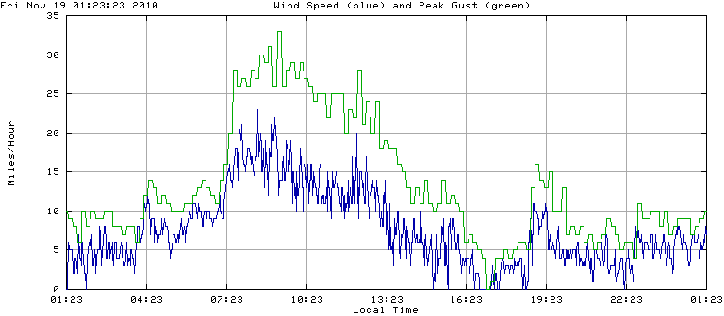
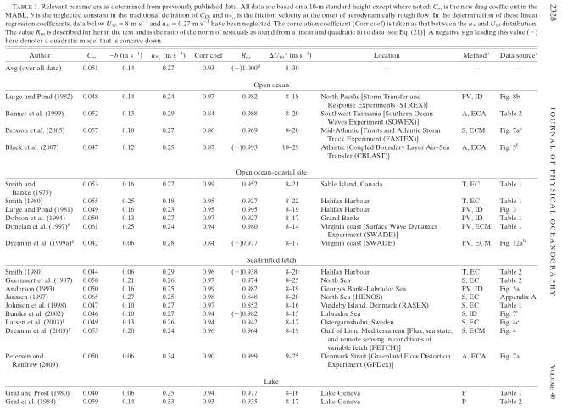
Foreman and Emeis (2010), Revisiting the Definition of the Drag Coefficient in the Marine Atmospheric Boundary Layer, p. 2325, DOI: 10.1175/2010JPO4420.1

This is the temperature difference between the surface and atmosphere typically taken as 10 m altitude that is driving the heating of the atmosphere.
Use this vertical temperature structure to determine the eddy diffusivity.

- Near surface nighttime sensible heat flux
Consider a citrus tree grove where the trees are about 5 m in height and the wind at 10 m is blowing at 2 m/sec with a surface temperature of 0ºC and pressure of 1000 mb.
Assume the temperature at 10 m is 2ºC warmer than the surface temperature
- Calculate the vertical sensible heat flux using the aerodynamic form.
- Is the flux up or down?
- Calculate an approximate eddy diffusivity.
- Assuming the scale of the eddies is the size of the trees, use the eddy diffusivity to determine what the typical vertical velocity of the eddies is.
- For the nighttime conditions in the figures in Problem 1, how large is the sensible heat flux in comparison to the net (up minus down) IR radiative flux at the surface? Assume the downward IR flux from the atmosphere comes from a level where the temperature of -10C. Is the sensible heat flux sufficient to keep the trees from freezing overnight?

- Increase in the surface evaporative flux with global warming
Suppose Earth’s surface were to warm by 2ºC while the relative humidity of the air and the winds were to remain the same. Using the aerodynamic formula for latent heat flux, determine the ratio of the new surface latent heat flux to the present surface latent heat flux.

Compare the increases in the upward surface radiative flux and surface latent heat flux in terms of W/m². Which increase is larger?

Why is this important to how much surface temperatures will increase as the downward IR flux from the atmosphere into the surface increases as GHG concentrations increase?

- Diffusion scaling:
The time to cook a hard-boiled egg is ~12 minutes. Based on your understanding of diffusion (see eq. (16) of the diffusion lecture), approximately how long should it take for a watermelon to cool down to the refrigerator temperature?

