- Show that the units of the pressure scale height, R*T/mg, are indeed units of length

mks units: R*: J/K/mole, T: K, m: kg/mole, g: m/s².

Units of $\frac{R∗T}{\text{mg}}$ are $\frac{J}{K\text{mole}}\frac{K\text{mole}}{\text{kg}}\frac{s^{2}}{m}=\frac{\text{kg}m^{2}s^{2}}{s^{2}\text{kg}m}=m$ which is indeed a unit of length.

- Use Earth’s albedo and distance from the sun to determine it’s radiative equilibrium temperature.
The equation for radiative equilibrium temperature is given from the notes as
$T_{\text{planet}}=T_{\text{sun}}{\left[\frac{r_{\text{sun}}}{2r_{\text{planet}−\text{orbit}}}\right]}^{1/2}{\left(1−A_{\text{planet}}\right)}^{1/4}$ (in K) (7)
The albedo of the Earth is 0.3, that is 30% of the sunlight incident on Earth is reflected. The radius of the Sun is 6.96×10⁵ km which is 109 times the radius of Earth. The mean distance from the Earth to the sun is 1.496×10⁸ km. The temperature of the Sun is 5,778 K.
Plugging in these terms yields:
(1-A)^{1/4} = 0.915

${\left[\frac{r_{\text{sun}}}{2r_{\text{planet}−\text{orbit}}}\right]}^{1/2}$=(6.96×10⁵ / [2*1.496×10⁸ ])^{0.5} = 0.0482

T_{rad-eq-Earth} = 5778K * 0.0482 * 0.915 = 254.90K

- Suppose the sun’s temperature were to drop by 1K, how much would Earth’s radiative equilibrium temperature change?
T_{Earth} = 5777K * 0.0482 * 0.915 = 254.86K
The decrease in Earth’s radiative temperature for a 1 degree decrease in the sun’s temperature is 0.044K. Let’s compare this to actual variations in the solar output over the 11/22 year solar cycle and expected variations in Earth’s temperature.
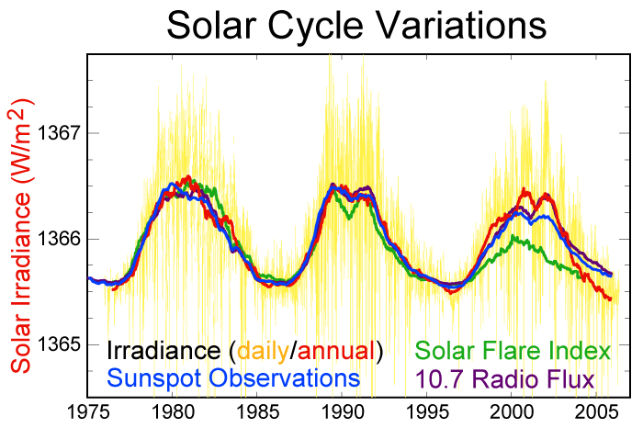
So the peak-to-peak variation in the solar output at the Earth over a typical solar cycle is about 1 W/m². Fractionally this is 1/1366 = 0.07%.
Given the Stephan Boltzmann equation: F=σT⁴.
The change in flux with change in temperature is dF = 4σT³ dT.
To get the fractional change of F with T, one can take the log: lnF = lnσ + 4 lnT
Then d(lnF) = 4 d (lnT) and $\frac{\text{dF}}{F}=4\frac{\text{dT}}{T}$
So for the solar output to change by 0.07%, the Sun’s temperature must change by ~0.018% over the solar cycle which is about 0.018% * 5778K = 1.06K.
So, this shows that over the solar cycle, Earth’s radiative equilibrium temperature should vary by about 0.044K which is quite small. The reason is the Sun’s output is remarkably stable, more stable than other similar stars.

- Suppose Earth had no atmosphere. Can its albedo be reduced to keep its temperature above freezing?
The maximum radiative equilibrium temperature of Earth which would also be its average surface temperature if it had no atmosphere would be when its albedo = 0.
$T_{\text{max}\text{planet}}=T_{\text{sun}}{\left[\frac{r_{\text{sun}}}{2r_{\text{planet}−\text{orbit}}}\right]}^{1/2}$ (K) (7)
The maximum radiative equilibrium temperature would be T_{rad eq max} = 5778 * 0.0482 = 278.7K . Since freezing is 273.15K, this maximum theoretical temperature is indeed above freezing.
For the radiative temperature to just equal freezing temperature, the albedo would be
$A_{\text{planet}}=1−{\left(\frac{T_{\text{freeze}}}{T_{\text{sun}}}\right)}^{4}{\left[\frac{2r_{\text{planet}−\text{orbit}}}{r_{\text{sun}}}\right]}^{2}$ (7)
Plugging in values gives A_{freeze} = 7.7% which is quite low. This is half of the albedo of Mars, which has the lowest albedo of any planet in the solar system at 15%.

- Suppose Earth’s temperature were the same but its atmospheric constituent makeup were the same as Jupiter. How large would a pressure scale height be?
According to the planetary atmosphere comparison table, the mean molecular mass of Jupiter’s atmosphere is 2.2 g/mole = 0.0022 kg/mole.
H_{p} = $\frac{R∗T}{\text{mg}}$= 8.3145 * 288/0.0022 = 111 km
This is enormous compared the actual Earth pressure scale heights of 7 to 8 km.
Assuming the surface pressure were 1013 mb, the 1 mb altitude would be about 770 km above the surface instead of 50 km as it is for the present atmosphere.
It is not clear that Earth’s gravity could hold on to an atmosphere that was this extended vertically.

- Derive the density scale height equation given in the notes
Show that one can derive a density scale height as:
$H_{ρ}=\frac{H_{P}}{1+\frac{\text{dT}}{\text{dz}}\frac{H_{P}}{T}}$
where H_{P} is the pressure scale height.
We defined the pressure scale height as
$H\left(z\right)\text{=-}\frac{P\left(z\right)}{\frac{\text{dP}}{\text{dz}}\left(z\right)}$
We can do the same for a density scale height.
$H\left(z\right)\text{=-}\frac{ρ\left(z\right)}{\frac{dρ}{\text{dz}}\left(z\right)}$
Begin with the hydrostatic relation,
dP=-g ρ dz

Take the derivative of the ideal gas law , P=ρRT

dP = dρ RT + ρR dT

Substitute that equation in for dP in the hydrostatic relation.

dP=dρ RT + ρR dT= - g ρ dz
$$\frac{dρ}{\text{dz}}+\frac{ρ}{T}\frac{\text{dT}}{\text{dz}}\text{=-}\frac{gρ}{\text{RT}}$$
$$\frac{dρ}{ρ\text{dz}}+\frac{1}{T}\frac{\text{dT}}{\text{dz}}\text{=-}\frac{g}{\text{RT}}\text{=-}\frac{1}{H_{p}}$$
$$\frac{dρ}{ρ\text{dz}}\text{=-}\frac{1}{H_{p}}−\frac{1}{T}\frac{\text{dT}}{\text{dz}}$$
$H\left(z\right)\text{=-}\frac{ρ\left(z\right)}{\frac{dρ}{\text{dz}}\left(z\right)}=\frac{1}{\left(\frac{1}{H_{p}}+\frac{1}{T}\frac{\text{dT}}{\text{dz}}\right)}=\frac{H_{p}}{\left(1+\frac{H_{p}}{T}\frac{\text{dT}}{\text{dz}}\right)}$
Notice that at the surface, the pressure scale height is about 8.4 km (T=288 K). If the temperature gradient is the dry adiabat, -9.8 K/km, which is the fastest temperature can fall off vertically in the atmosphere, the density scale height is then about 12 km. This means density falls off more slowly with height that does pressure in the troposphere. It also means that density falls off more quickly than pressure in the stratosphere.
In the absence of sources and sinks, the energy in atmospheric waves is conserved as they propagate upwards. If one thinks in terms of the kinetic and potential energy of the wave being conserved, the magnitude of the temperature perturbation and wind perturbation of the wave must increase with altitude as the density decreases with altitude. Therefore the temperature perturbation should increase with altitude according to the density scale height of the atmosphere.

- What is the mass density of air at 925 mb and 80°F?
T = (80-32)*5/9 + 273.15 = 299.8 K
P = ρRT,
ρ= P/RT = 92500Pa / 287 J/K/kg /299.8K = 1.07 kg/m³.
It is useful to remember as a rule of thumb that the density of air near the surface is crudely a bit higher than 1 kg/m³.

- What is the mean molecular mass of an air parcel that contains 1% water vapor by volume?
The mean molecular mass is $\bar{m}=\frac{\sum_{i}{n_{i}m_{i}}}{\sum_{i}{n_{i}}}$ where the index, i, is the index for each constituent in the atmosphere.
For dry air, $\bar{m}=\frac{\sum_{i}{n_{i}m_{i}}}{\sum_{i}{n_{i}}}$=78.083% m_{N2} + 20.945% m_{O2} + 0.933% m_{Ar} + 0.039% m_{CO2}
where m_{N2} = 28.01348 g/mole, m_{O2} = 31.9988 g/mole, m_{Ar} = 39.948 g/mole, m_{CO2} = 44.0095 g/mole,
So, m_{dry} = 28.966 g/mole.
You don’t’ need all of these digits to get an answer close to correct.
Now, for moist air containing 1% water vapor (by volume), the mean molecular weight is 99% m_{dry} + 1% m_{H2O} = 0.99 * 28.966 + 0.01 * 18.01528 = 28.856 g/mole.
So, 1% wet air is about 0.4% lighter than dry air and therefore slightly more buoyant than dry air. This effect is accounted for by the “virtual temperature” concept that we will derive.

