Diffusive Fluxes

Sensible heat flux
The density of sensible energy is
$ρ_{\text{ES}}={ρc}_{p}T@{ρc}_{p}q$ (1)
We have to be a bit careful in the vertical because of compressional effects that are not relevant to vertical energy exchange. Note that for adiabatic processes, θ is conserved and no heat is exchanged. So we need to think in terms of the vertical gradient of θ rather than T to understand the vertical flux of sensible heat.

Downgradient diffusion representation
We can write the vertical flux as a down-gradient diffusion process representation
$F_{\text{SH}}\text{=-}K_{H}ρ_{\text{ES}}\text{=-}K_{H}ρ_{a}c_{P}\frac{¶\bar{q}}{¶z}$ (2)
where $\bar{q}$ is the average of potential temperature and K_{H} is the eddy diffusivity or eddy diffusion coefficient for heat transfer. Note that this diffusivity is NOT the molecular diffusivity we derived in the previous lecture. This is the diffusivity associated with eddies in the atmosphere. It is still defined analogously to the molecular diffusivity as a length times a velocity but in this case it is a length associated with a relevant scale of the eddies and a velocity associated with the eddies as we will see below.

Bulk aerodynamic or drag coefficient representation
$F_{\text{SH}}\text{=-}ρ_{a}c_{p}C_{H}\left|U\right|\left[q(z)−q(0)\right]$ (3)
where C_{H} is the coefficient of drag for sensible heat transfer. By setting (2) and (3) equal, we can see that
$C_{H}\left|U\right|\left[q(z)−q(0)\right]=K_{H}\frac{¶\bar{q}}{¶z}=K_{H}\frac{\left[q(z)−q(0)\right]}{z}$ (4)
$C_{H}\left|U\right|=\frac{K_{H}}{z}$
$K_{H}=z\left|U\right|C_{H}$ (5)
One can think of z |U| being the maximum possible eddy diffusivity for the given wind speed and C_{H} is an efficiency factor < 1 likely indicating the size of the eddies relative to the height, z.

Eddy correlation approach
Any variable can be decomposed into its mean and the variations about the mean. This can be written in the following way
$q=\bar{q}+q'$ (6)
where $\bar{q}$ is the mean and θ’ are the variations about the mean. Turbulent fluxes involve the variations in both the quantity and the wind.
$F_{\text{SH}}=ρ_{a}c_{P}\overline{w'q'}@ρ_{a}c_{P}\overline{w'T'}$ (7)
units: kg m⁻³ J kg⁻¹ K⁻¹ m s⁻¹ K = J m⁻²s⁻¹.

So, setting (7) and (2) equal yields
$F_{\text{SH}}=ρ_{a}c_{P}\overline{w'q'}\text{=-}K_{H}ρ_{a}c_{P}\frac{¶\bar{q}}{¶z}$ (8)
Setting (2), (3) and (7) equal yields
$\overline{w'q'}\text{=-}K_{H}\frac{¶\bar{q}}{¶z}\text{=-}z\left|U\right|C_{H}\frac{¶\bar{q}}{¶z}$ (9)

Surface Moisture flux and latent heat flux
Evaporation, E, can be treated similarly. Again we want to use a variable that is conserved unless there are sources or sinks. In the case of water vapor, such a variable is the specific humidity, q. The eddy correlation method yields
$E=ρ_{a}\overline{w'q'}$ (10)
The gradient flux form is
$E\text{=-}K_{W}ρ_{a}\frac{¶\bar{q}}{¶z}$ (11)
The bulk aerodynamic form is
$E\text{=-}ρ_{a}C_{W}\left|U\right|\left[q(z)−q(0)\right]$ (12)
These can easily be converted to latent heat fluxes as well by simply multiplying the evaporative flux equations by L_{v}.
$F_{\text{LH}}=ρ_{a}L_{v}\overline{w'q'}$ (13)
$F_{\text{LH}}\text{=-}K_{W}ρ_{a}L_{v}\frac{¶\bar{q}}{¶z}$ (14)
$F_{\text{LH}}=ρ_{a}L_{v}C_{W}U\left(q_{s}−q_{a}\right)$ (15)
where F is the flux of water vapor from (or onto) the surface, ρ_{a} is the density of air, U is the near surface wind speed, q_{s} is the surface mixing ratio and q_{a} is the mixing ratio of the air just above the surface and C_{W} is the turbulent exchange coefficient of latent heat.

Distributions of surface heat and moisture fluxes

Comparison of latent heat flux field estimates from The Japanese Ocean Flux Data Sets with use of Remote Sensing Observations (J-OFURO) with the Hamburg Ocean–Atmosphere Parameters and Fluxes from Satellite Data (HOAPS), the Goddard Satellite-Based Surface Turbulent Fluxes (GSSTF), ECMWF, NCEP–NCAR reanalysis (NCEP1), and da Silva et al.’s fields.

See Joint NASA Argentina Ocean Salinity Mission: Aquarius to launch in 2011

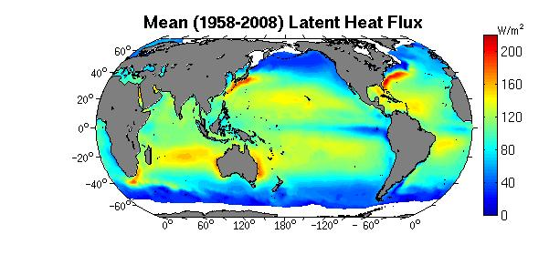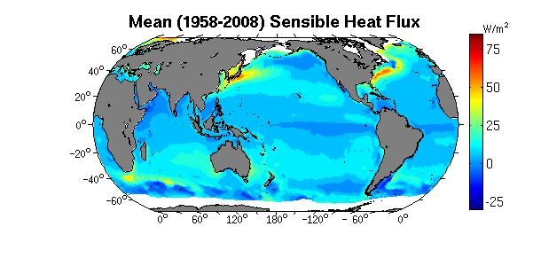
from http://oaflux.whoi.edu/

