BOUNDARY LAYERS

Boundary layers are fluid layers that form at boundaries (hence the name: boundary layer) that impede flow across the boundary such as the boundaries between the atmosphere and land or atmosphere and ocean. Boundary layers come in a wide range of sizes depending on the situation.

Diffusive boundary layers determined by the diffusivity tend to be quite thin. The Planetary Boundary Layer (PBL) is a convective boundary layer that can be kilometers thick.

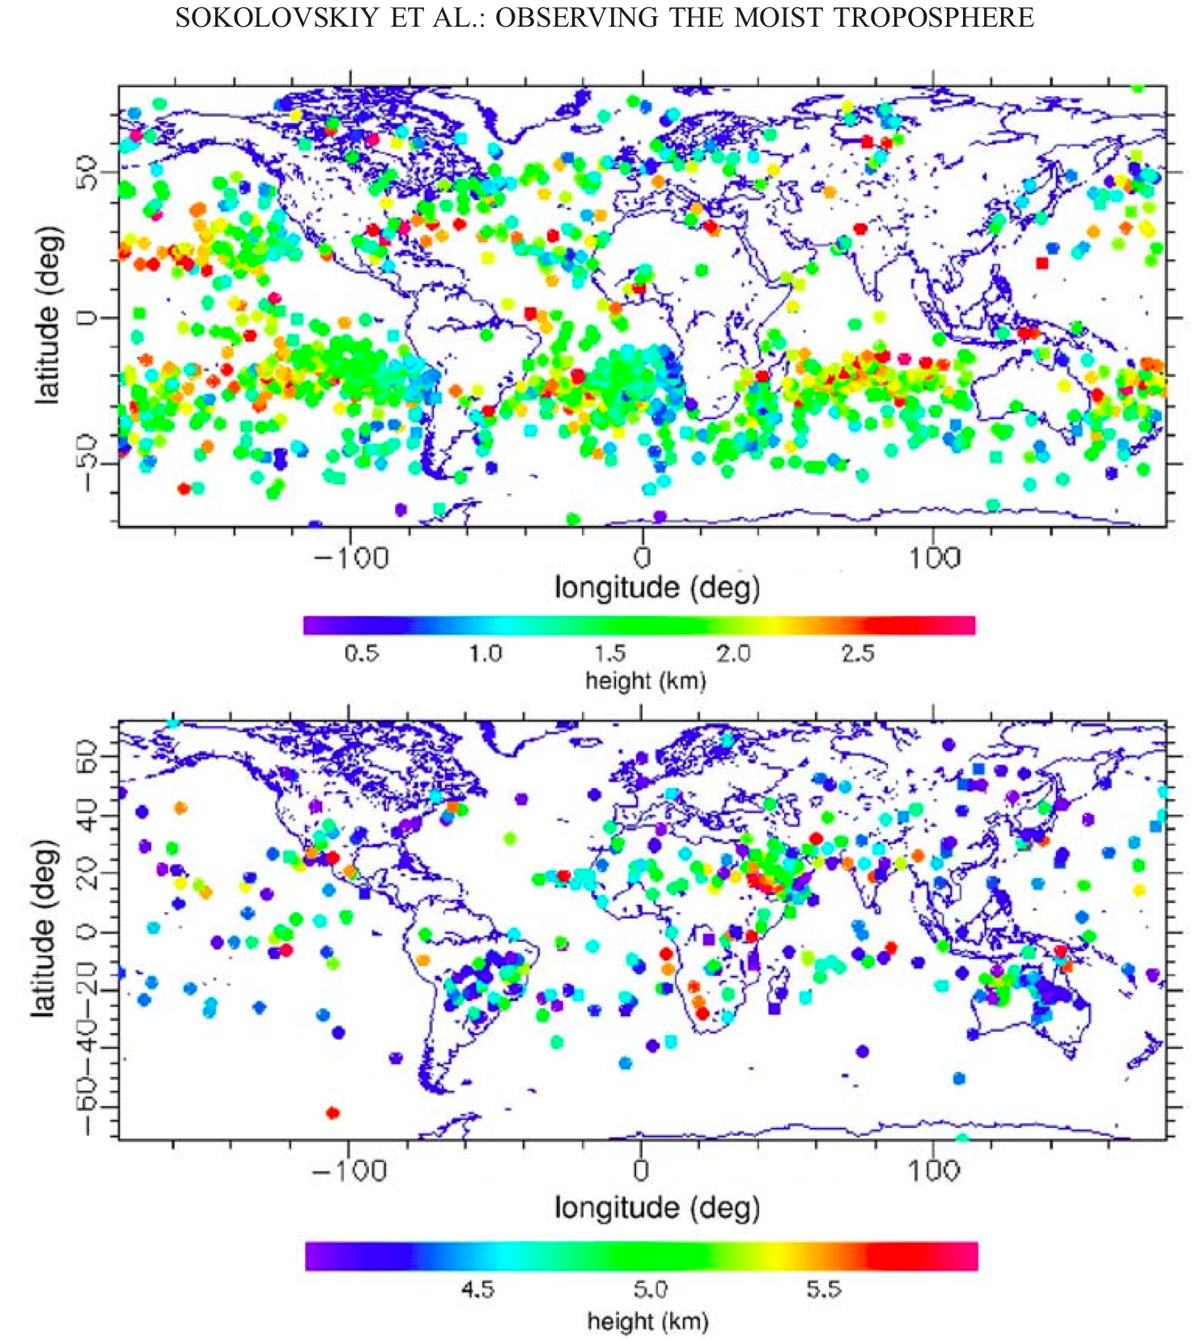

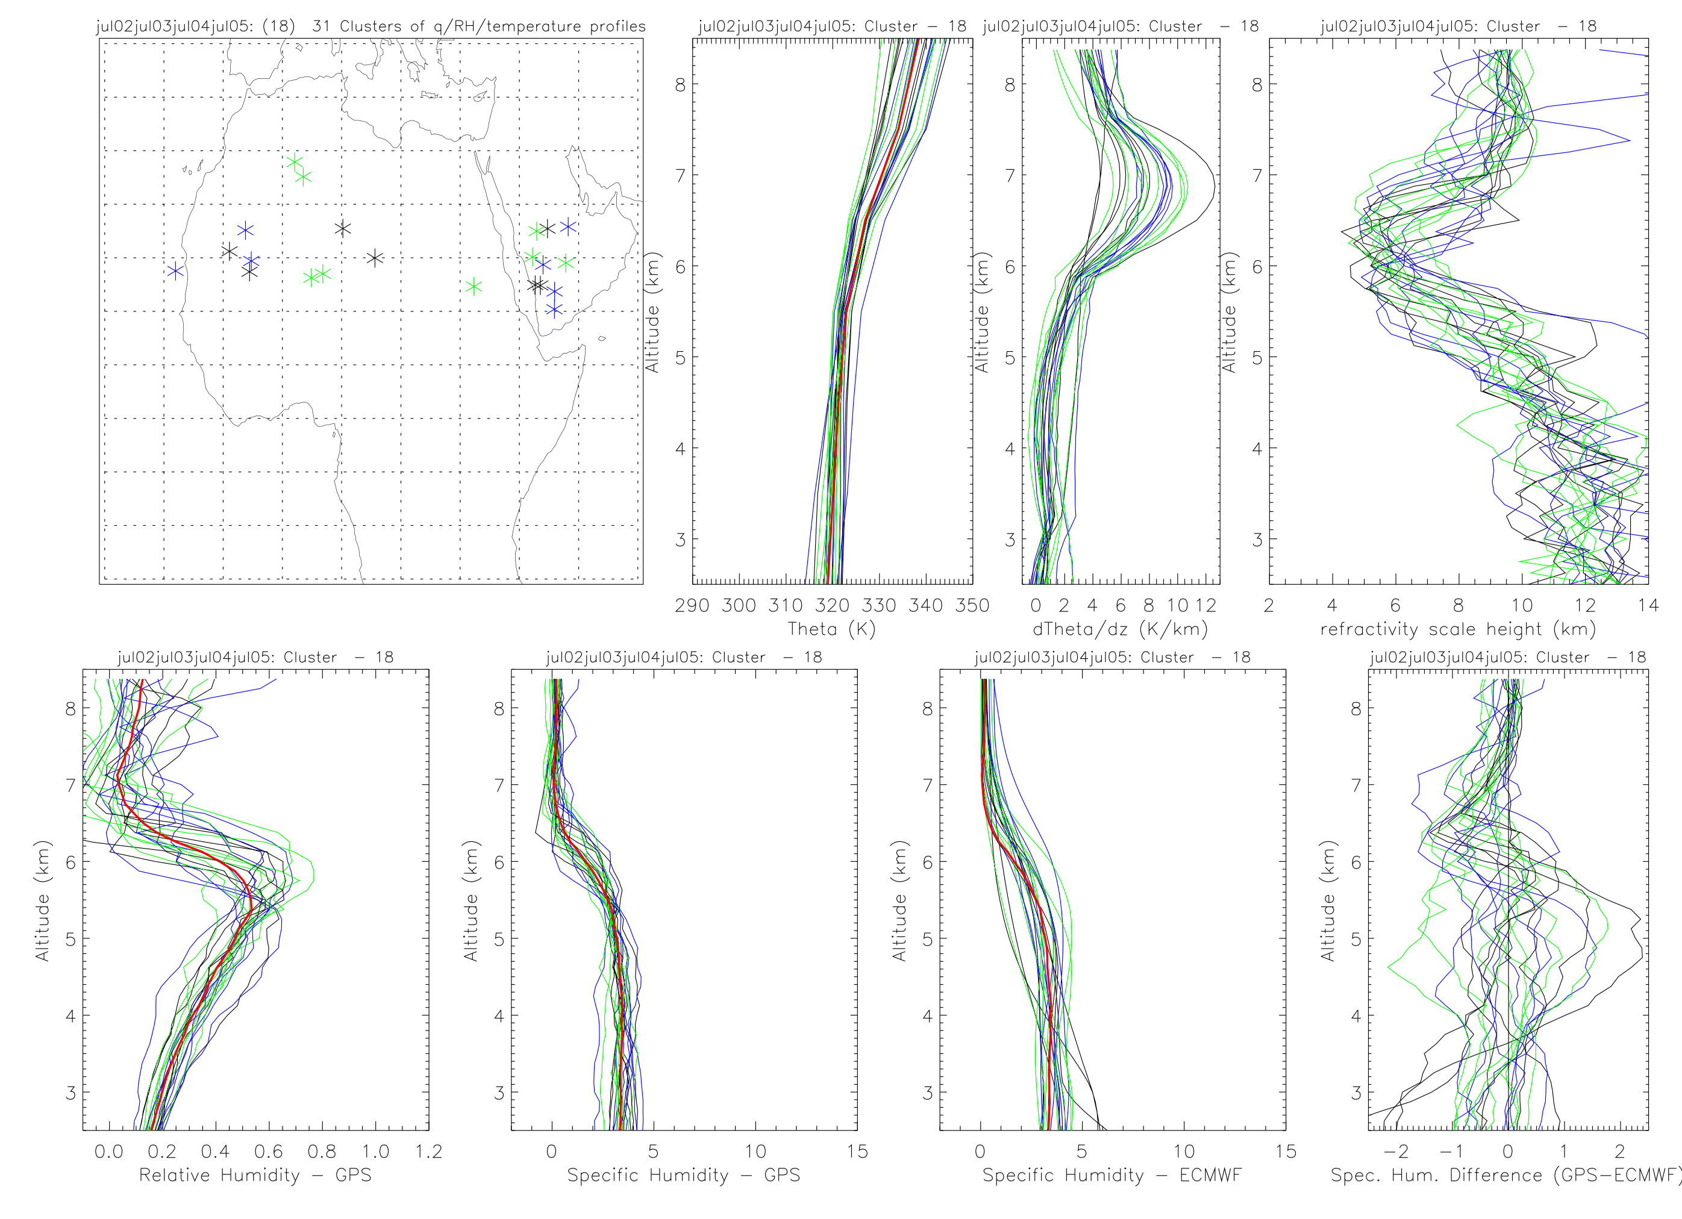
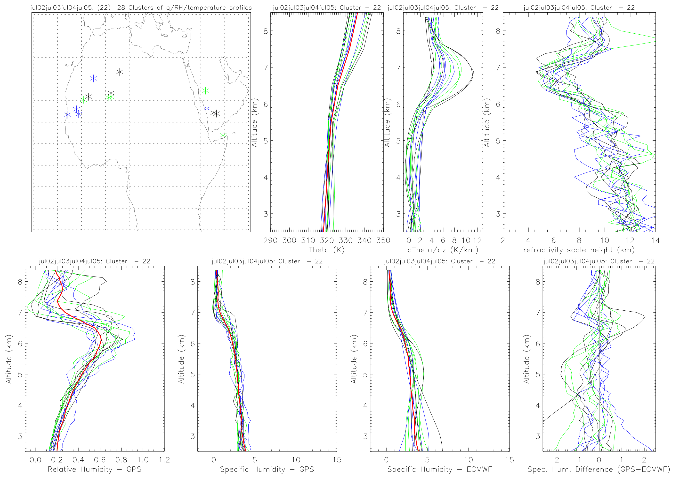
Examples of deep convective layers observed over North Africa and the Arabian Peninsula.

Diffusive Boundary Layer Example
How fast does water evaporate from a puddle? We can do a quick calculation.

The flux of water vapor molecules from the puddle surface into the atmosphere is related to the saturation vapor pressure. The flux per unit area is a number density times a velocity.
F_{evap} = n_{H2O} v_{H2O} (1)
Where n_{H2O} is the number density of the water vapor molecules and v_{H2O} is a representative velocity of those molecules. The number density (in moles/m³) is related to the saturation vapor pressure via the ideal gas law
$e_{s}\left(T\right)=n_{s}R∗T$ (2)
so that the number density at saturation is
$n_{s}=\frac{e_{s}\left(T\right)}{R∗T}$ (3)
The velocity of the molecules is related to the thermal velocity. Remember from the discussion on the kinetic pressure of a gas that
$\frac{1}{2}m\overline{v^{2}}=\bar{K}=\frac{3}{2}k_{B}T$ (4)
So
$\overline{v^{2}}=3\frac{k_{B}T}{m}$ (5)
Next, remember that the mean-square velocity of the molecules, $\overline{v^{2}}$, can be written as
$\overline{v^{2}}=\overline{v_{x}^{2}}+\overline{v_{y}^{2}}+\overline{v_{z}^{2}}$ (6)
Assuming no bulk motion of the gas, all directions are equally likely. Therefore, $\overline{v_{x}^{2}}=\overline{v_{y}^{2}}=\overline{v_{z}^{2}}$
and $\overline{v^{2}}=3\overline{v_{x}^{2}}$ so
$\overline{v_{x}^{2}}=\frac{\overline{v^{2}}}{3}$ (7)
So
$v_{x−\text{rms}}=\sqrt{\overline{v_{x}^{2}}}=\sqrt{\frac{\overline{v^{2}}}{3}=}\sqrt{\frac{3k_{B}T}{3m}}=\sqrt{\frac{k_{B}T}{m}}$ (8)
So the flux from the surface is
$F_{\text{evap}}=n_{s}v_{x−\text{rms}}=\frac{e_{s}\left(T\right)}{R∗T}\sqrt{\frac{k_{B}T}{m}}=\frac{e_{s}\left(T\right)}{R∗}\sqrt{\frac{k_{B}}{\text{mT}}}$ (9)

Now, how fast does the puddle evaporate given (9). (9) is a loss of moles of water from the surface. This thickness of the puddle divided by the flux gives the time for the puddle to evaporate.

