NATS 101 Name________ANSWERS_____________
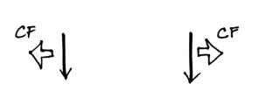
Optional Assignment

1. Circle the figure at right that shows winds
blowing in the southern hemisphere.
CF is perpendicular and to the left of the
wind in the right figure (turn the page
upside down so that you are looking in the direction the wind is blowing

2. Sinking air inhibits cloud formation. You would therefore expect to find clear skies and infrequent rainfall at (select 3 of the following).
a. belts of high pressure b. 30º latitude c. doldrums
d. belts of low pressure e. 60º latitude f. horse latitudes
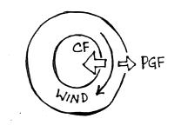
3. The direction of the PGF in the figure at right
tells you that this is a center of HIGH LOW
pressure. The direction of the CF is the the
RIGHT LEFT of the wind which indicates that
this is a NORTHERN SOUTHERN hemisphere
chart. Winds blowing parallel to the contours
mean this is a(n) SURFACE UPPER-LEVEL map.

4. You observe a large storm system on a satellite photograph that is moving from east to west and spinning in a clockwise direction. This would most likely indicate (circle 3 choices below)
a. northern hemisphere b. middle latitude c. anticyclone
c. southern hemisphere d. tropical e. cyclone
the east to west motion tells you this is a hurricane (tropical cyclone) instead of a middle latitude storm (extratropical cyclones move from west to east). Hurricanes and middle latitude storms have low pressure cores. Winds spin clockwise around low in the southern hemisphere. Cyclone means winds spinning around low pressure (anticyclone refers to high pressure)

5a. In the figure below (showing surface winds in two different portions of the 3-cell model), you would expect to find a belt of low pressure at
a. A only b. B only c. both A and B d. neither A or B

5b. Would you expect to find wind pattern A or wind pattern B at the intertropical convergence zone?
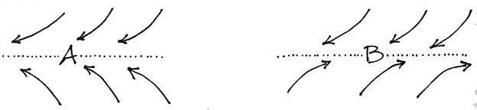

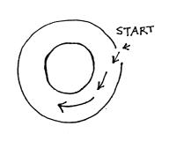
6. The direction of the initial motion in the figure
at right means this is a center of HIGH LOW
pressure. Rather than go straight toward the
center of the picture, the wind starts to turn toward
the left. The direction of this bending indicates
that this is a NORTHERN SOUTHERN
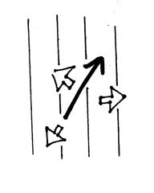
hemisphere map.

7. Does the figure at right show SURFACE or UPPER-LEVEL
winds. Identify the three forces shown on the figure. Is low
pressure found at the TOP RIGHT BOTTOM or LEFT
side of the figure? Is this a NORTHERN or SOUTHERN
hemisphere map?
The wind is blowing across the contours so this is a surface map.
The PGF force is pointing toward the right (it is the only force
that is perpendicular to the contours on the map). Since the PGF
always points toward low, low pressure is on the right. The CF is
perpendicular and to the left of the wind (the CF points toward the upper left of the
figure). The frictional force is pointing toward the lower left and is pointing in a
direction opposite the wind.

8. In the northern hemisphere clouds are associated with RISING SINKING air motions found in LOW HIGH pressure centers. In the southern hemisphere you find cloud produced by RISING SINKING air motions associated with centers of LOW HIGH pressure.
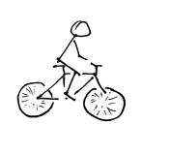
9. You’re riding your bicycle along a flat level road
and you stop pedaling. Will you continue to move in
a straight line at constant speed? If not, draw an arrow
on the picture at right to show the direction of the net
force that would be exerted on the bicycle. What is
the name or cause of this force? Friction would slow
the cyclist and eventually bring the bicycle to a stop.
Friction (with the road surface and wind resistance)
points in a direction opposite the motion.
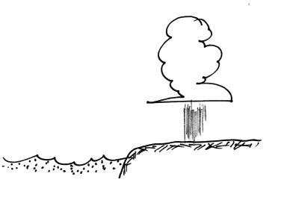
10. Assume that the cloud and showers in the picture are
being produced by a thermal circulation. Would the
surface winds blow from the SEA or the LAND?
Would you expect to find that the land is WARMER
or COLDER than the ocean water. Would clouds
like this be more likely during the DAY or at NIGHT?

