NATS 101 Name_______________________________
Optional Assignment #1

1. Bicycle tires on a “road” bike are normally inflated to a pressure of 90 psi or so. About how many bars of pressure would that be?
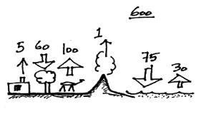

2. The figure at right shows fluxes of carbon
dioxide into and out of the atmosphere.
Based on the information in the figure would
you expect the atmospheric CO₂ concentration
to INCREASE, DECREASE or remain
CONSTANT over time?

3. Average sea level pressure is about ____________ millibars which is about 30 inches of mercury. A pressure reading of 900 mb (10 % lower) would be about ____________ inches of mercury.

4. Water vapor is an invisible gas. We can see clouds because clouds are composed of
____________________ and/or ____________________ which scatter light.

5. During combustion, fossil fuels and _______ react to form _______ and _______.
a. nitrogen b. oxygen c. argon
d. water vapor e. carbon dioxide f. ozone

6. The amount of carbon dioxide in the air varies slightly over the course of a year. Near the ground it also changes slightly during the day. Would you expect to observe the highest CO₂ concentration during the DAY or at NIGHT?

7. The combustion of coal would probably not produce any _______.
a. CO₂ b. CO c. O₃ d. SO₂ e. H₂O

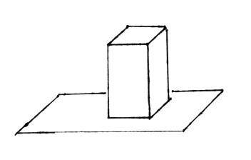
8. The figure at right shows a brick standing on
its end. If you multiplied the area of the end of
the brick by the height of the brick you would
get the brick’s _______________. If you divided
the mass of the brick by its volume you would
get the brick’s _______________. The weight
of the brick divided by the area of the end of the
brick would be the _______________ exerted by
the brick on the surface supporting it.

9. The liquids in the bottles of mercury and water passed around in class had the same
a. density b. mass c. volume d. weight
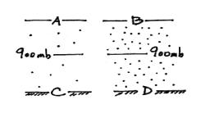
10. Based on the air density information shown in the
figure at right, the air pressure at Point A is
GREATER EQUAL LESS than(to) the pressure
at Point B. The pressure at Point C is GREATER
EQUAL LESS than(to) the pressure at Point D.

11. Photodissociation of molecular oxygen O₂ + UV light → O + O
is the first step in
a. the formation of stratospheric ozone b. the formation of acid rain
c. photosynthesis d. the greenhouse effect
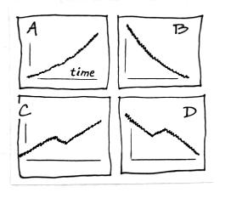

12. Figure _______ at right best describes how the
atmospheric CO₂ concentration has changed since
the mid-1800s. Figure _______ best describes
the change in global annual average surface
temperature on the earth during the same period.

13. _______________ is the leading cause of lung cancer among non smokers in the United States. (ref: www.epa.gov/radon)

14. The concentration of ____________________ in the air can range from near 4% in the tropics to a small fraction of a percent in cold polar regions.

15. Pressure DECREASES INCREASES with increasing altitude in the atmosphere. Is the rate of change at ground level GREATER than the SAME as LESS than at higher altitude?

16. Does an object with a volume of 3 cm³ and a mass of 4.5 grams have a HIGHER a LOWER or the SAME density than(as) an object with a mass of 15 grams and a volume of 6 cm³?

