Thursday Nov. 19, 2009
Maybe four songs from the Beatles in class today ("I Saw Her Standing There", "I'll Follow the Sun", "Octopus's Garden", and "Back in the USSR").
The 1S1P Assignment #2 reports were collected today. By the time you see these notes, Assignment #3 should be online. And also, hopefully, a new Optional Assignment.
The Experiment #4 reports and the Scientific Paper reports turned in last week have been graded and were returned in class today. Revised reports are due by Thu. Dec. 3. Please return your original report when you turn in a revised report. I should be able to return any remaining ungraded reports in class next Tuesday.

Here's a pretty nice photograph of a wall cloud and a tornado ( from the University Corporation for Atmospheric Research ).

Class started (I believe) with a simple demonstration that I wasn't able to do last Tuesday. The demonstration will give you an idea of what a microburst might look like.

A large plastic tank was filled with water, the water represents air in the atmosphere. Then a colored mixture of water and glycerin, which is a little denser than water, was poured into the tank. This represents the cold dense air in a thunderstorm downdraft. The colored liquid sinks to the bottom of the tank and then spreads out horizontally. In the atmosphere the cold downdraft air hits the ground and spreads out horizontally. These are the strong winds that can reach 100 MPH.
The demonstration was followed by a time-lapse video of an actual microburst that occurred in the Santa Catalina mountains.We discussed the structure of severe thunderstorms in class on Tuesday. This seemed like a good place to briefly discuss supercell thunderstorms.

Here is a relatively simple drawing showing some of the key features on a supercell thunderstorm. In a supercell the rotating updraft (shown in red above) is strong enough to penetrate into the stratosphere. This produces the overshooting top or dome feature above. A wall cloud and a tornado are shown at the bottom of the mesocyclone. In an ordinary thunderstorm the updraft is unable to penetrate into the very stable air in the stratosphere and the upward moving air just flattens out and forms an anvil. The flanking line is a line of new cells trying to form alongside the supercell thunderstorm.

Here is a second slightly more complicated drawing of a supercell thunderstorm. A typical air mass thunderstorm (purple) has been drawn in for comparison.
A short segment of video was shown at this point. The video first showed some good quality video of a close tornado. We will be covering tornadoes in class on Friday. This was followed by photographs of a distant supercell thunderstorm and photographs of the bases of nearby supercell thunderstorms. Here you could see the spectacular wall cloud that often forms at the base of these storms. Finally a computer simluation showed some of the complex motions that form inside supercell thunderstorms, particularly the tilted rotating updraft. Researchers have a pretty good understanding of how supercell thunderstorms develop. The exact process that initiates tornado development is still unknown, however.

Thunderstorms with rotating updrafts often have a distinctive radar signature.
We haven't discussed weather radar in this class. In some ways a radar image of a thunderstorm is like an X-ray photograph of a human body. The Xrays pass through the flesh but are partially absorbed by bone.

The radio signals emitted by radar pass through the cloud itself but are reflected by the much larger precipitation particles. The intensity of the reflected signal (the echo) is color coded. Red means an intense reflected signal and lots of large precipitation particles. The edge of the cloud isn't normally seen on the radar signal.

Thunderstorms with rotating updrafts produce a very characteristic hook shaped echo on radar. Here are a couple of examples:

The colors provide an idea of precipitation intensity (red is the heaviest precipitation).

This is the radar image of a very strong tornado that hit Oklahoma City in May 1999
( http://www.spc.noaa.gov/faq/tornado/radscel.htm ). The hook echo is visible near the lower left hand corner of the picture. A very strong tornado. It is possible that winds in the tornado may have exceeded 300 MPH.

The United States has more tornadoes in an average year than any other country in the world (over 1000 per year). The central US has just the right mix of meteorological conditions.
In the spring, cold dry air can move all the way from Canada and collide with warm moist air from the Gulf of Mexico to form strong cold fronts and thunderstorms.
Tornadoes have been observed in every state in the US, but tornadoes are most frequent in the central plains, a region referred to as "Tornado Alley" (highlighted in red, orange, and yellow above). The map at right above can be found on p. 161 in the photocopied ClassNotes.

Here are some basic tornado characteristics (the figure above is found on p. 161 in the photocopied class notes).
1. About 2/3rds of tornadoes are F0 or F1 tornadoes (see the Fujita scale below) and have spinning winds of about 100 MPH or less. Microburst winds can also reach 100 MPH. Microbursts are much more common in Tucson in the summer than tornadoes but can inflict the same level of damage.
2. A very strong inwardly directed pressure gradient force is needed to keep winds spinning in a circular path. The PGF is much stronger than the Coriolis Force (CF) and the CF can be neglected. The pressure in the center core of a tornado can be 100 mb less than the pressure in the air outside the tornado. This is a very large pressure difference in such a short distance.
3. Tornadoes can spin clockwise or counterclockwise, though counterclockwise rotation is more common.
4, 5, 6. Tornadoes usually last only a few minutes, leave a path on the ground that is a few miles long, and move at a few 10s of MPH. We will look at an exception below.
7, 8. Most tornadoes move from the SW toward the NE. This is because tornado-producing thunderstorms are often found just ahead of a cold front. Winds ahead of a cold front often blow from the SW. Most tornadoes have diameters of a few hundred yards but tornadoes with diameters over a mile have been observed.
9, 10. Tornadoes are most frequent in the Spring. The strongest tornadoes also occur at that time of year. Tornadoes are most common in the late afternoon when the atmosphere is most unstable.

At the present time about 75 people are killed every year in the United States. Lightning and flash floods (floods are the most serious severe weather hazard) kill slightly more people. Hurricanes kill fewer people on average than tornadoes. Heat in the summer and cold in the winter kill many more people than floods, tornadoes, lightning, and hurricanes.

Most tornadoes last only a few minutes and leave a path a few miles long on the ground. There are of course exceptions. One is discussed below.

The path of the 1925 "Tri-State Tornado" is shown above. The tornado path (note the SW to NE orientation) was 219 miles long, the tornado last about 3.5 hours and killed 695 people. The tornado was traveling over 60 MPH over much of its path. It is the deadliest single tornado ever in the United States.
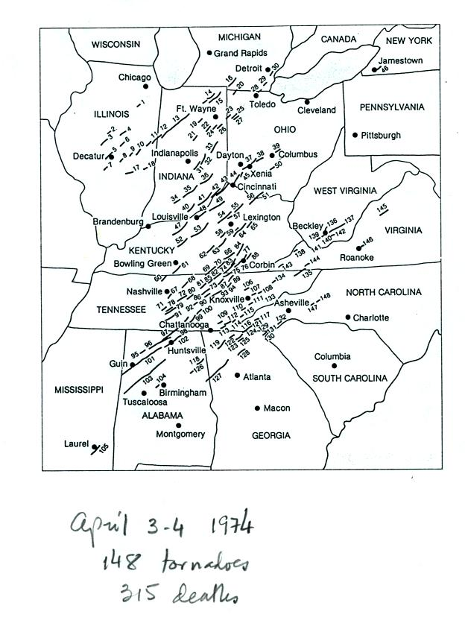 | 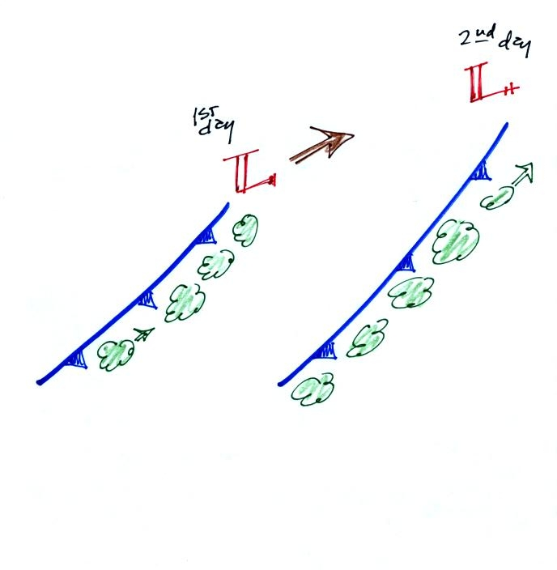

Tornadoes often occur in "outbreaks." The paths of 148 tornadoes during the April 3-4, 1974 "Jumbo Tornado Outbreak" are shown above. Note the first tornadoes were located in the upper left corner of the map. The tornadoes were produced by thunderstorms forming along a cold front. During this two day period the front moved from the NW part toward the SE part of the figure. Note that all the tornado paths have a SE toward NE orientation.

Tornadoes begin in and descend from a thunderstorm. You might see a funnel cloud dropping from the base of the thunderstorm. Spinning winds will probably be present between the cloud and ground before the tornado cloud becomes visible. The spinning winds can stir up dust at ground level. The spinning winds might also be strong enough at this point to produce some minor damage. We saw an example of this in a video tape of a tornado in Oklahoma.
In Stage 2, moist air moves horizontally toward the low pressure in the core of the tornado. This sideways moving air will expand and cool just as rising air does (see figure below). Once the air cools enough (to the dew point temperature) a cloud will form.
Tornadoes can go from Stage 2 to Stage 3 (this is what the strongest tornadoes do) or directly from stage 2 to stage 5. Note a strong tornado is usually vertical and thick as shown in Stage 3. "Wedge tornadoes" actually appear wider than they are tall.
The thunderstorm and the top of the tornado will move faster than the surface winds and the bottom of the tornado. This will tilt and stretch the tornado. The rope like appearance in Stage 5 is usually a sign of a weakening (though still a dangerous) tornado.

The tornado cloud forms when moist air moves into lower pressure in the core of the tornado. The air expands and cools to the dew point and a cloud forms. This is just like the cloud that forms when air rises.

At about this point we watched a short video segment that illustrated well the first 3 steps in the formation of a tornado (dust swirl stage up to mature stage). The tornado was photographed near Luverne Oklahoma in May 1991. It was eventually rated an F3 tornado.

The Fujita Scale is used to rate tornado strength and damage potential. It is very hard to actually measure the speed of the rotating winds in a tornado. Researchers usually survey the damage caused by the tornado to come up with a Fujita Scale rating. Above is a simplified, easy to remember, version of the Fujita Scale.
This was followed by another short video with images of several different tornadoes. Descriptions of the tornadoes are given in the table below (the numbers in the left most column were used on the video to identify each tornado)
54a | F3 | Grand Island, NE | Mar. 13, 1990 | tornado cloud is pretty thick and vertical
61f | F3 | McConnell AFB KS | Apr. 26, 1991 | this is about as close to a tornado as you're ever likely to get. Try to judge the diameter of the tornado cloud. What direction are the tornado winds spinning?
52 | F5 | Hesston KS | Mar. 13, 1990 | Watch closely, you may see a tree or two uprooted by the tornado winds
51 | F3 | North Platte NE | Jun. 25, 1989 | Trees uprooted and buildings lifted by the tornado winds
65 | F1 | Brainard MN | Jul. 5, 1991 | It's a good thing this was only an F1 tornado
57 | F2 | Darlington IN | Jun. 1, 1990 | Tornado cloud without much dust
62b | F2 | Kansas Turnpike | Apr. 26, 1991 | It's sometimes hard to run away from a tornado. Watch closely you'll see a van blown off the road and rolled by the tornado. The driver of the van was killed!
47 | F2 | Minneapolis MN | Jul. 18, 1986 | Tornado cloud appears and disappears.

Here are some written descriptions of the kinds of damage tornadoes of various intensities can cause

And here are some representative photographs of tornado damage

The buildings on the left suffered light roof damage. The barn roof at right was more heavily damaged.

More severe damage to what appears to be a well built house roof.

F1 tornado winds can tip over a mobile home if it is not tied down (the caption states that an F1 tornado could blow a moving car off a highway). F2 level winds (bottom photo above) can roll and completely destroy a mobile home.

Trees, if not uprooted, can suffer serious damage from F1 or F2 tornado winds.

F2 level winds have completely removed the roof from this building. The outside walls of the building are still standing.

The roof is gone and the outer walls of this house were knocked down. This is characteristic of F3 level damage. In a house without a basement or storm cellar it would be best to seek shelter in an interior closet or bathroom (plumbing might help somewhat to keep the walls intact).

In some tornado prone areas,
people construct a small closet or room inside their home made of reinforced concrete.
A better solution might be to have a storm cellar located underground.

All of the walls were knocked down in the top photo but the debris is left nearby. This is characteristic of F4 level damage. All of the sheet metal in the car body has been removed in the bottom photo and the car chasis has been bent around a tree. The tree has been stripped of all but the largest branches.

An F5 tornado completely destroyed the home in the photo above and removed most of the debris.
Only bricks and a few pieces of lumber are left.

Several levels of damage are visible in the photograph above. It was puzzling initially how some homes could be nearly destroyed while a home nearby or in between was left with only light damage. One possible explanation is shown below (from the bottom of p. 164 in the photocopied ClassNotes.

Some big strong tornadoes may have smaller more intense "suction vortices" that spin around the center of the tornado. Tornado researchers have actually seen the scouring pattern shown at right in the figure above that the multiple vortices can leave behind.

The sketch above shows a tornado located SW of a neighborhood.
As the tornado sweeps through the neighborhood, the suction vortex will rotate around the core of the tornado.
The homes marked in red would be damaged severely. The others would receive less damage (remember, however, that there would probably be multiple suction vortices in the tornado).
At this point we watched the last of the tornado video tapes. It showed a tornado that occurred in Pampa, Texas. Near the end of the segment, video photography showed several vehicles (pick up trucks and a van) that had been lifted 100 feet or so off the ground that were being thrown around at 80 or 90 MPH by the tornado winds. Winds speeds of about 250 MPH were estimated from the video photography.

