NATS 101 Name_______________________________
Optional Assignment

1. Show at right how the following weather
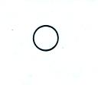
observations would be plotted using the
station model notation.
Temperature = 75º F cloud cover = 5/8
Pressure = 996.4 mb dew point = 57º F
Wind direction & speed = south at 20 knots
Low clouds = stratocumulus clouds
High altitude clouds = filaments of cirrus clouds
Dust or sand raised by the wind at the time
of observation.
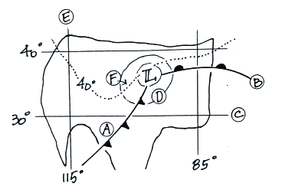
2. Find an example of each of the following on
the surface weather map at right.

line of constant latitude_______

isobar_______ warm front_______

cold front_______ isotherm_______

line of constant longitude_______

3. The large L symbol that you see on a surface weather map indicates a region of low _______.
a. altitude b. air density c. air pressure d. air temperature

4. Use the figure at right to fill in the values of the following weather variables.
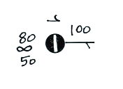
Temperature_________ cloud cover_________

Pressure____________ dew point_________

Wind direction__________ Wind speed__________

Present weather conditions__________

5. Which of the following does not produce rising air motions?
a. cold front b. surface high pressure c. surface low pressure d. warm front
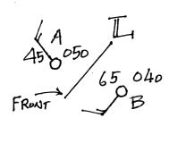
6. Weather conditions at two cities and a front are shown in
the figure at right. Using what you know about the direction
the winds blow around surface centers of low pressure, would
you expect the front to be moving toward CITY A or CITY B?
Would this be a COLD or WARM front?
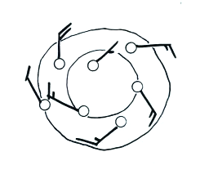
7. Are the winds spinning in a CLOCKWISE or
COUNTERCLOCKWISE direction in the figure
at right. Are the winds CONVERGING or
DIVERGING. Does the figure show a surface
LOW or HIGH pressure center?

8. Upper air weather data are collected (using radiosondes) twice each day, at 00Z and 12Z.

00Z is __________ MST and 12Z is __________MST
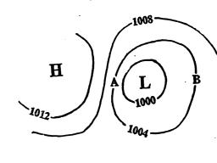
9. Would the surface winds blow from the north at
POINT A or POINT B in the figure at right?
Would the strongest winds be found at POINT A
or POINT B? Would you expect to find the
warmest temperatures at POINT A or POINT B?

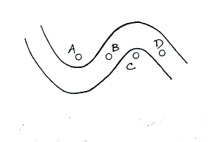

10. Point_______on the upper level chart at right is in a
trough. The warmest air would probably be found
below Point _______.

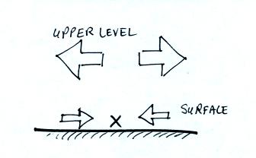
11. Surface winds are converging and the upper level winds
are diverging in the crossectional figure at right. Would
you expect to find surface LOW or HIGH pressure at
Point X in the figure? Based on the relative amounts of
convergence and divergence would you expect the pressure
at Point X to INCREASE or DECREASE? Would you
expect the surface convergence to STRENGTHEN or
WEAKEN given the expected change in pressure at Point X?

12. _______ below is the symbol for a northern hemisphere hurricane. _______ is the symbol for a southern hemisphere tropical storm.
