Physical Properties of the Atmosphere

Thin as a piece of paper…
The atmosphere is a very thin layer above the solid Earth and its oceans. This is true of the atmospheres of all of the terrestrial planets. In contrast, the gas giants like Jupiter may be essentially entirely gaseous becoming liquid at very high pressures in the interior with perhaps a small solid planet somewhere very deep inside.
Earth’s atmosphere is very thin. The altitude at which transcontinental planes fly is about 30,000 ft or 10 km. The pressure at this altitude is about 250 mb which is roughly 25% of the surface pressure. So 75% of the atmosphere lies between the surface and 10 km. The radius of the Earth is about 6400 km. So the thickness of 75% of the atmosphere is about 0.15% of the thickness of the Earth. The analogy has been made that if the Earth were the size of a basketball, the thickness of the atmosphere would be less than the thickness of a sheet of paper. This is the world in which we live.

Average vertical temperature structure of Earth’s atmosphere

The figure above shows the cartoon version of the vertical structure of Earth’s atmosphere. We will be developing the tools needed to understand this structure. Right now it is use to understand how the vertical structure of Earth’s atmosphere is divided up.

Some key variables
There are several variables that are key in describing planetary atmospheres. These include the
- composition,
- gravity
- amount of gas present which is closely related to the gravity and surface pressure.
- temperature which is tied to first order to the amount of sunlight absorbed,
Note that the temperature varies with the seasons depend on
- the tilt of the planet’s spin axis relative to its orbital plane and
- the orbital eccentricity which affects how the planet’s distance from the sun varies.
From a dynamics standpoint two other important factors are
- rate at which the planet rotates
- size of the planet.

Atmospheric composition
A planetary atmosphere is a gas which is a compressible fluid that encompasses at least the outer part of many planets. The gas is made up of different molecules that depend on the planet’s evolutionary history. Earth’s atmosphere is made up of about 78% molecular nitrogen, N₂, and 21% molecular oxygen, O₂ and 1% argon, Ar, plus trace species. Water vapor can be present in concentrations ranging anywhere from 0 to 5%. CO₂ is present at about 385 ppmv and is increasing about 2 ppm per year due to fossil fuel burning and other anthropogenic sources.

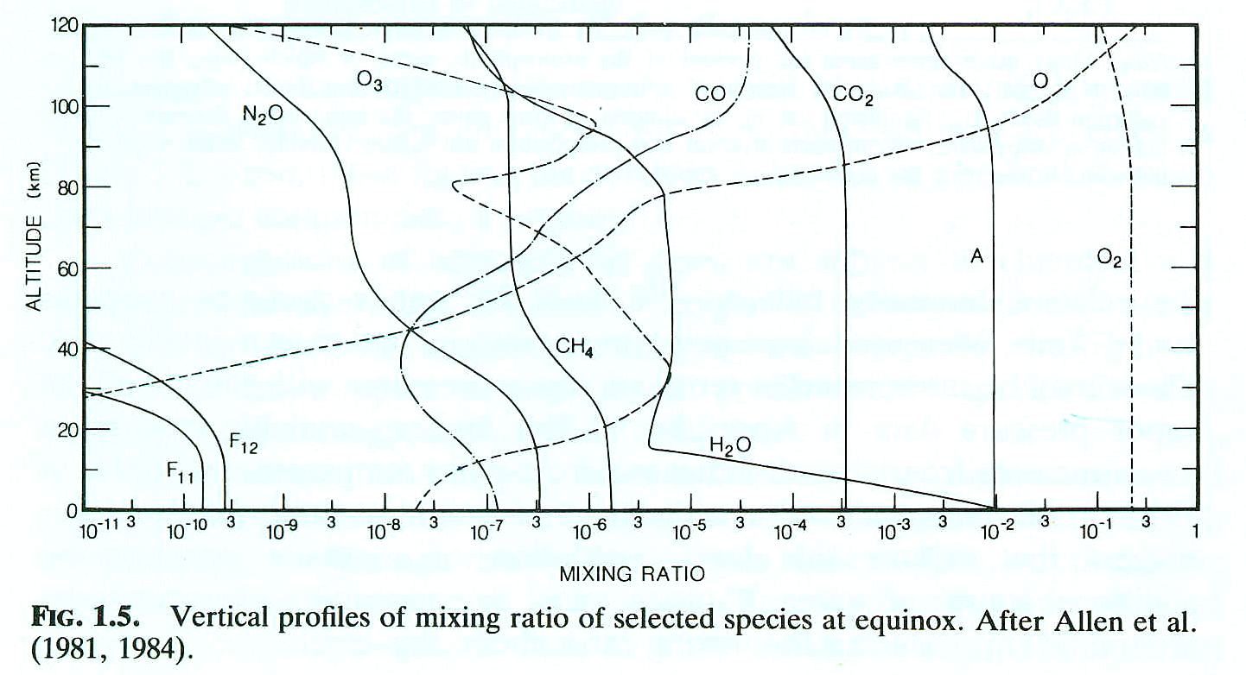
From Goody & Yung

Mixing ratio Definitions
Volume mixing ratio: number of molecules of a particular species per unit volume divided by the total number of molecules in the air per unit volume
Mass Mixing ratio: mass density of a particular species divided by the total mass density of the air.

Gravity
Gravity is a critical variable in understanding planetary atmospheres because the atmosphere is held to the planet by gravity and compressed under its own weight due to gravity. The larger the gravitational acceleration the more compressed the atmosphere. Small objects with small gravitational acceleration cannot hold onto atmospheres unless the atmospheres are very cold and not very energetic. Otherwise the molecules in the atmospheres will fly off into space. The reason why the D/H ratio on Mars is so high compared to Earth may be that a large number of hydrogen atoms have flown into space over the lifetime of Mars.
On the other hand, very cold atmospheres may simply condense out into liquid or solids into the surface leaving very few molecules in the gas phase as dictated by the Classius-Clapeyron equation. This equation defines the vapor pressure of a gas in equilibrium over a surface of that same molecule in either the liquid or solid condensed phase. The thin atmospheres of Mars and Neptune’s large moon Triton and probably Pluto are in vapor pressure equilibrium with ice on their surfaces with their atmospheric pressures depending in large part on the temperature of the ice on the surface. We will discuss the Classius-Clapeyron equation in far more detail when we discuss humidity and water vapor in Earth’s atmosphere.

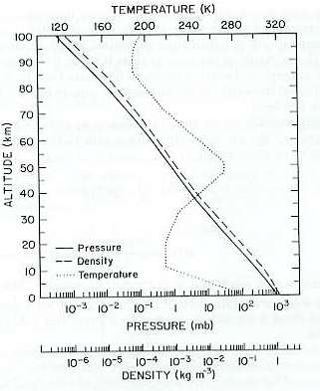
Pressure, density & temperature for US Standard Atmosphere, from Salby

The vertical structure of the atmosphere.
Gravity and compressibility of gases combine to make the vertical length scale of the atmosphere much smaller than its horizontal length scales. As a result, the pressure and density of atmospheres decrease approximately exponentially with altitude. The rapidness of that decrease with altitude depends on gravity, temperature and the composition of the atmosphere. Specifically, the variation of pressure, P, with altitude, z, can be written approximately as
P(z) ~ P(0) e^{–z/H}
Where, as we will derive in a moment, the pressure scale height, H, equals R*T/mg where R* is the ideal gas constant, T is the atmospheric temperature in K, m is the mean molecular mass of the gas in kg/mole and g is the gravitational acceleration.
If we stop for a moment to think about it, gravity is continually pulling the atmosphere down toward the surface and yet the atmosphere is not in continuous free fall, like water in a waterfall, accelerating rapidly down toward the surface. This means there must be a force pushing the atmosphere upward that is counterbalancing the downward force of gravity. The missing upward force is associated with atmospheric pressure.
To first order, the gas pressure at the bottom of an atmospheric column balances the downward force of gravity on the column. This is called hydrostatic balance. Remember from Newton’s second law that Force equals mass times acceleration, F = m a. In the case of gravity, a = g. If we think about an infinitesimally thick layer of atmosphere of vertical thickness, dz, and area, A. The mass density of the layer is ρ so that the mass of that layer is dm = ρ A dz. The gravitational force on that layer is therefore F_{g} = -g ρ A dz.
To balance the downward gravitational force on this infinitesimally thick layer, the pressure at the bottom of the layer must be higher than the pressure at the top of the layer such that it balances the downward force of gravity on the layer. Since pressure is force per unit area, the pressure at the bottom of the layer must be higher than the pressure at the top of the layer by an amount such that
dP(z) A = F_{g} = -g ρ A dz
So the equation for hydrostatic balance is
dP(z) = -g(z) ρ(z) dz (1)
where P is pressure of the air, z is height, g is the gravitational acceleration and ρ is mass density of the air. This means that as you add a layer of atmosphere of density ρ, that is dz thick, the pressure at the bottom of the layer is higher than the pressure at the top of the layer by dP. The minus sign is because gravity is pulling down while the component of pressure that is balancing gravity is pointing upward.

Units
Consider the units on the right side. We will normally evaluate equations in mks units. g has units of acceleration: m/s². ρ is mass density and has mks units of kg/m³. dz is an increment in height and has units of m. Therefore the right hand side of the equation has units of kg m/s² /m² which are units of force per unit area. Pressure is defined as force per unit area so from a units’ standpoint, the equation is correct.
The mks units of force per unit area are kg m/s² per m² which is called a ‘pascal’ or Pa for short. In atmospheric science, pressure units are typically bars or millibars. The conversion is 1 mb = 100 pascals. 1 bar = 1000 mb ~ 1 ‘atmosphere’ because the average surface pressure of Earth’s atmosphere is 1013 mb.

The Ideal Gas Law
Gases are compressible. The equation of state for an ideal gas in microscopic units is
P = N k_{B} T (2)
where N is the number density of the gas in units of molecules per unit volume, k_{B} is Bolzmann’s constant: 1.3806503 x10⁻²³ in joules/K and T is the temperature of the gas in Kelvin.
The macroscopic version of the ideal gas law is
P = n R* T (3)
where n is the gas number density expressed in moles per unit volume where a mole is 6.0221415 × 10²³ gas molecules and R* is the gas constant 8.314472 J/mole/K. A mole is a very useful number because 1 mole of hydrogen atoms has a mass of 1 gram and 1 mole of oxygen atoms has a mass of 16 grams, making calculations such simpler than in the microscopic form.
The gas law is often written in terms of mass. Writing the gas law in terms of mass density rather than number density yields
P = nM/M R* T = ρ R*/M T = ρ R T (4)
where M is the mass of one mole of gas molecules in kg and R is the gas constant for this particular gas. M is called the mean molecular mass because air in the Earth’s atmosphere is made up of N₂, O₂, Ar, H₂O, CO₂, etc. The average mass of a mole of dry air is given by the sum of the mass of each molecule times its number fraction in the atmosphere
$M=\bar{M}=\frac{\sum{n_{i}}M_{i}}{\sum{n_{i}}}$ (5)
For Earth, the sum is approximately
M_{dry} = n%_{N2} M_{N2} + n%_{O2} M_{O2} + n%_{Ar} M_{Ar}
= 78% 28g/mole + 21% 32 g/mole + 1% 40 g/mole
= 28.96 g/mole

This value of 28.96 g/mole is true for dry air that contains no water vapor in the homosphere. The homosphere is the part of the atmosphere where turbulence is sufficient to keep the long lived molecules well mixed. The homosphere extends up to the altitude of the homopause (about 100 km) above which turbulence is no longer sufficient to keep the molecules well mixed at higher altitudes, and their concentration with increasing height decays with height by weight. This upper atmosphere region is called the Heterosphere.
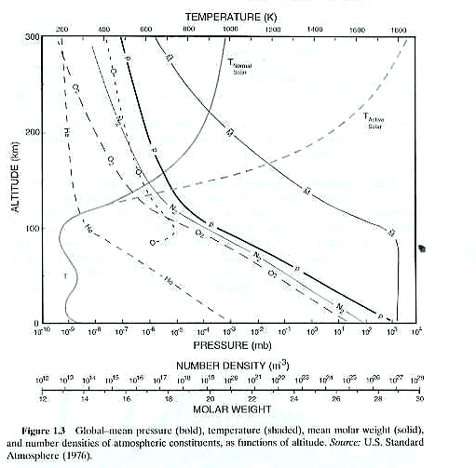
from Salby

Strictly speaking the mean molecular mass of air in the homosphere varies because the concentration of the water in the air varies. Since water has a molecular weight of 18 g/mole, which is lighter than 28.96 g/mole, adding water to an air parcel in Earth’s atmosphere lightens it a bit (In Jupiter’s atmosphere it makes the parcel heavier. Why?). Therefore, changing the amount of water in the atmosphere will affect on the buoyancy of air parcels. Water can make up as much as 4% of the air molecules in tropical, near-surface conditions. For wet air in the homosphere, the sum is approximately
M_{wet} = n%_{H2O} M_{H2O} + n%_{dry} M_{dry}
= n%_{H2O} 18 g/mole + (1- n%_{H2O}) 28.97 g/mole
If n%_{H2O} = 1.5% then M_{wet} = 1.5% 18 g/mole + 98.5% 28.97 g/mole = 28.80 g/mole

CO₂ concentrations are also increasing and is slightly increasing the mean molecular mass but this is a subtler effect as CO₂ mixing ratios are smaller ~ 385 ppm.

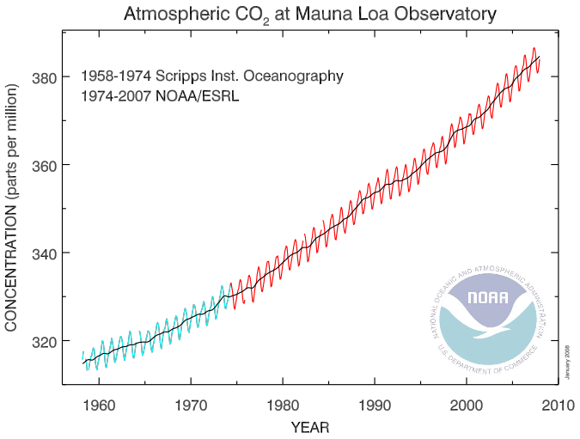

Pressure Scale Height

Plugging (4) into (1) we get
$\text{dP}(z)\text{=-}\frac{g(z)M(z)}{R∗T(z)}P(z)\text{dz}$
Rewriting this yields
$\frac{\text{dP}}{P}\left(z\right)=d\text{ln}\left(P\left(z\right)\right)=−\frac{g\left(z\right)M\left(z\right)}{R∗T\left(z\right)}\text{dz}=−\frac{\text{dz}}{H\left(z\right)}$ (6)
where H(z) = H_{P}(z) = R*T/Mg = RT/g which is known as the pressure scale height.
Integrating (6) we get
$P(z_{2})=P(z_{1})\text{exp}\left[−\int_{z_{1}}^{z_{2}}{\frac{dx}{H(x)}}\right]$
So pressure decays approximately exponentially with altitude with a scale height of H. Atmospheric density behaves similarly.
A typical pressure scale height in the mid-troposphere is approximately
8.3 x 250 /0.02896 /9.81 ~ 7,000 m = 7 km.
At the surface where temperatures are higher, pressure scale heights are ~8 km.
Note that the warmer the atmosphere is, the larger H is which causes pressure to decay more slowly with altitude. At lower temperatures, H is smaller and pressure decays more rapidly with altitude.
Pressure height as a thermometer: Therefore, accurately measuring the height of a pressure surface can provide a very accurate measure of the average temperature at lower altitudes which can be quite useful for observing climate change.
Winds: This also means that when a warm air mass sits next to a cold air mass, the pressures aloft will be higher over the warm air mass causing a horizontal pressure gradient aloft. At latitudes greater than about 10º, this pressure gradient will cause a wind. So the ability to remote sense such horizontal pressure gradients yields an indirect measure of winds.

Strictly speaking the vertical pressure structure is exactly exponential only if atmospheric temperature does not change with altitude (‘isothermal’), but the exponential behavior is crudely true because atmospheric temperatures only vary from ~200K to 300K.
Another subtlety is that g decreases gradually with altitude. We’ll go through this more when we dicuss gravity in more detail.
Pressure as a vertical coordinate: Pressure decreases monotonically with altitude and so can be used as a vertical coordinate and in fact is used as such in equations describing atmospheric dynamics because it simplifies the equations. Passive nadir sounders, that is atmospheric sounders that measure thermal emission from the atmosphere determine temperature and atmospheric composition and winds as a function of pressure, not altitude, based on the spectral width of absorption lines that depends on pressure as we shall see shortly.

Approximate Pressure versus altitude
The height of a pressure surface depends on the surface pressure and the average temperature of the atmosphere between the surface and the pressure level. There is an average or typical relation between pressure and altitude which is useful for going back and forth between pressure and altitude approximately.

Pressure altitude above mean sea level (msl)
100 mb 16 km
200 mb 12 km
300 mb 9 km
500 mb 5.5 km
700 mb 3 km
800 mb 2 km
900 mb 1 km
1000 mb 0 km

At colder temperatures the pressures will correspond to somewhat lower altitudes. At higher temperatures, the pressures will correspond to slightly higher altitudes.

Temperature change with altitude
Because temperatures generally decrease with altitude in the troposphere, the term temperature lapse rate has been defined where lapse rate = -dT/dz.
The dry adiabatic temperature lapse rate is g/C_{p} ~ 10K/km. Adiabatic means that as an air parcel is lifted or sinks, there is no heat exchanged with the environment. EvZ gives the derivation.
Except right at the surface, the dry adiabat is the most extreme temperature decrease with altitude that is physically permissible. If the decrease in temperature with altitude were to become momentarily even more extreme, then the atmosphere will correct because lighter air sits below denser air and any perturbation will cause the atmosphere to turn over (hot air rising and cold air sinking) and correct back to the dry adiabat. This causes turbulence.
Usually vertical temperature gradients in the atmosphere are more stable because of 2 reasons. First, latent heat released as water vapor condenses out of the air as air cools as it rises makes the temperature decrease with altitude smaller. Second, except in convection, most sinking air sinks rather slowly, losing energy radiatively as it sinks. So as it sinks it compressionally heats but loses energy as well so it warms at a slower vertical rate than the dry adiabat.
When in doubt, the standard vertical termperature gradient in the troposphere is -6.5 K/km.
In the stratosphere, temperatures generally increase with altitude.
Average vertical temperature structure of Earth’s atmosphere

Linear change in temperature with altitude

It is useful to note for more quantitative applications, a more accurate equation for pressure versus altitude over short vertical intervals uses the fact that temperature varies linearly with altitude.
T(z₂) = T(z₁) + dT/dz (z₂-z₁)
So, over an altitude interval where changes in temperature are linearly proportional to changes in altitude we can substitute changes in T for changes in z. Defining dT/dz = $\overset{˙}{T}$, we get from (5)
dln(P(z)) = -g(z) m(z)/(RT(z)) dz =-g(z) m(z)/(RT(z))/$\overset{˙}{T}$ dT
If the interval is short we can assume g and m do not change over the vertical interval so that
$d\text{ln}\left(P\right)\text{=-}\frac{\text{gm}}{R\overset{˙}{T}}\frac{\text{dT}}{T}\text{=-}\frac{\text{gm}}{R\overset{˙}{T}}d\text{ln}\left(T\right)$ (6)
$\text{ln}\left(P\right)|_{P_{1}}^{P_{2}}\text{=-}\frac{\text{gm}}{R\overset{˙}{T}}\text{ln}\left(T\right)|_{T_{1}}^{T_{2}}$ (6)
Raising each side to exp gives
$\frac{P_{2}}{P_{1}}=\text{exp}\left[−\frac{\text{gm}}{R\overset{˙}{T}}\text{ln}\left(\frac{T_{2}}{T_{1}}\right)\right]=\text{exp}\left[\text{ln}\left({\left[\frac{T_{1}}{T_{2}}\right]}^{\frac{\text{gm}}{R\overset{˙}{T}}}\right)\right]={\left[\frac{T_{1}}{T_{2}}\right]}^{\frac{\text{gm}}{R\overset{˙}{T}}}$ (6)
So we have a power law relation between P and T (or equivalently changes in altitude) over intervals where the vertical temperature gradient (= − temperature lapse rate) is constant and the gravity and mean molecular mass do not change much over the interval. IF $\overset{˙}{T}$=0, we have an isothermal atmosphere and then the exponential form is exactly correct.
To estimate –gm/R$\overset{˙}{T}$, assume a typical lapse rate of 6.5K/km. (Be warned, the “lapse rate” is –dT/dz, defined so because in the troposphere the temperature usually decreases with height.) –gm/R$\overset{˙}{T}$ = 9.81x0.02897/8.3144/0.0065 ~ 10x3x10⁻²x1.2x10⁻¹/6.5x10⁻³ ~ 0.5x10¹⁻²⁻¹⁺³ = 5.
Assume T₁= 250K and T₂ = 243.5K (1 km higher) and the pressure P₁ = 500 mb. Then P₂ = 500mb (243.5/250)⁵ = 435 mb.
Had we used the exponential form using the average temperature between the two levels so the pressure scale height would be RT/mg = 7.2 km, the answer would have been 500mb exp(-1/7.2) = 435 mb.
So the difference is subtle but for precise determinations of pressure versus altitude, this power law relation is more accurate. Note that for wind determination, we want to know pressure versus height to a few meters if possible.

Density scale height
When temperature varies with altitude, one can derive a density scale height:
$H_{ρ}=\frac{H_{P}}{1+\frac{\text{dT}}{\text{dz}}\frac{H_{P}}{T}}$
So, in the troposphere where dT/dz <0, the density scale height is larger than the pressure scale height (as much as ~13 km with an adiabatic lapse rate and warm conditions at the surface). So density falls off more slowly with altitude than pressure. In the stratosphere, where dT/dz > 0, the density scale height is smaller than the pressure scale height and so density decreases more rapidly with altitude than pressure.

