OZONE CHEMISTRY (Reading S+P Chap. 5)

The most useful platform from which we can launch a discussion of applications of chemistry to the atmosphere is ozone. Ozone in the stratosphere is necessary to life as we know it because it absorbs energetic UV radiation. Ozone in the troposphere is toxic due to its reactive oxidizing capabilities. It is also responsible for production of hydrogen radicals (HOx) in the troposphere, which is an important oxidant. Its chemistry integrates several principles discussed in Chapter 3 of S+P including photochemical reactions, PSSA in termolecular reactions, chemical families, and catalytic reactions.

It’s best to start with a few key facts to provide a canvas for the more detailed work to be discussed below.
- The ozone number concentration peaks at about 7x10¹⁶ molecules cm⁻³ at 30 km altitude, which is well into the stratosphere.
- The NAAQS standard for tropospheric ozone is 75 ppb. For comparison, the peak mixing ratio in the stratosphere measures in the ppm range.
- Unlike CO₂, ozone varies strongly with season, latitude, and altitude. Plots below illustrate the vertical and seasonal variations in ozone with latitude.
- The observed ozone concentration does not follow the production rate – rather it is produced primarily in the tropics, where UV light is most abundant. Stratospheric dynamics move the ozone around to produce the observed high abundances.
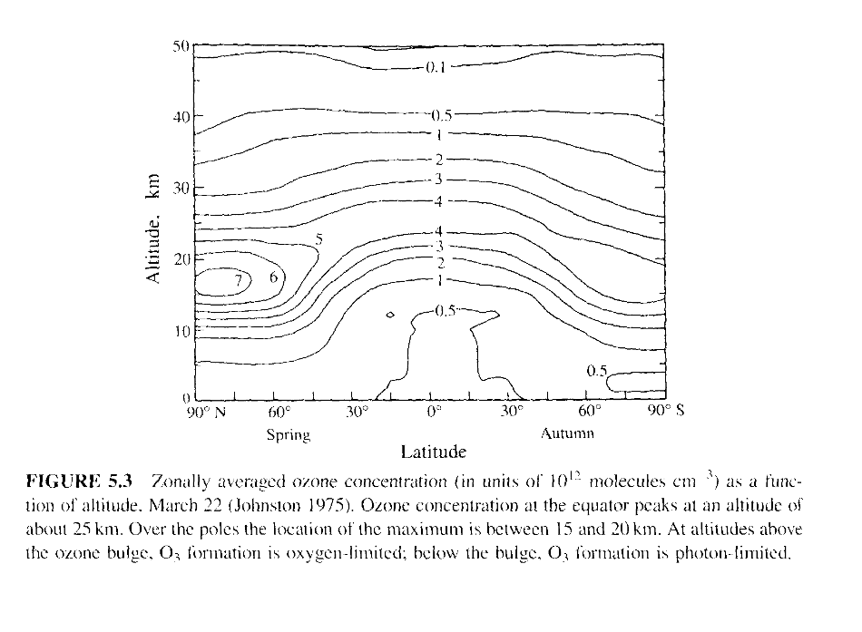
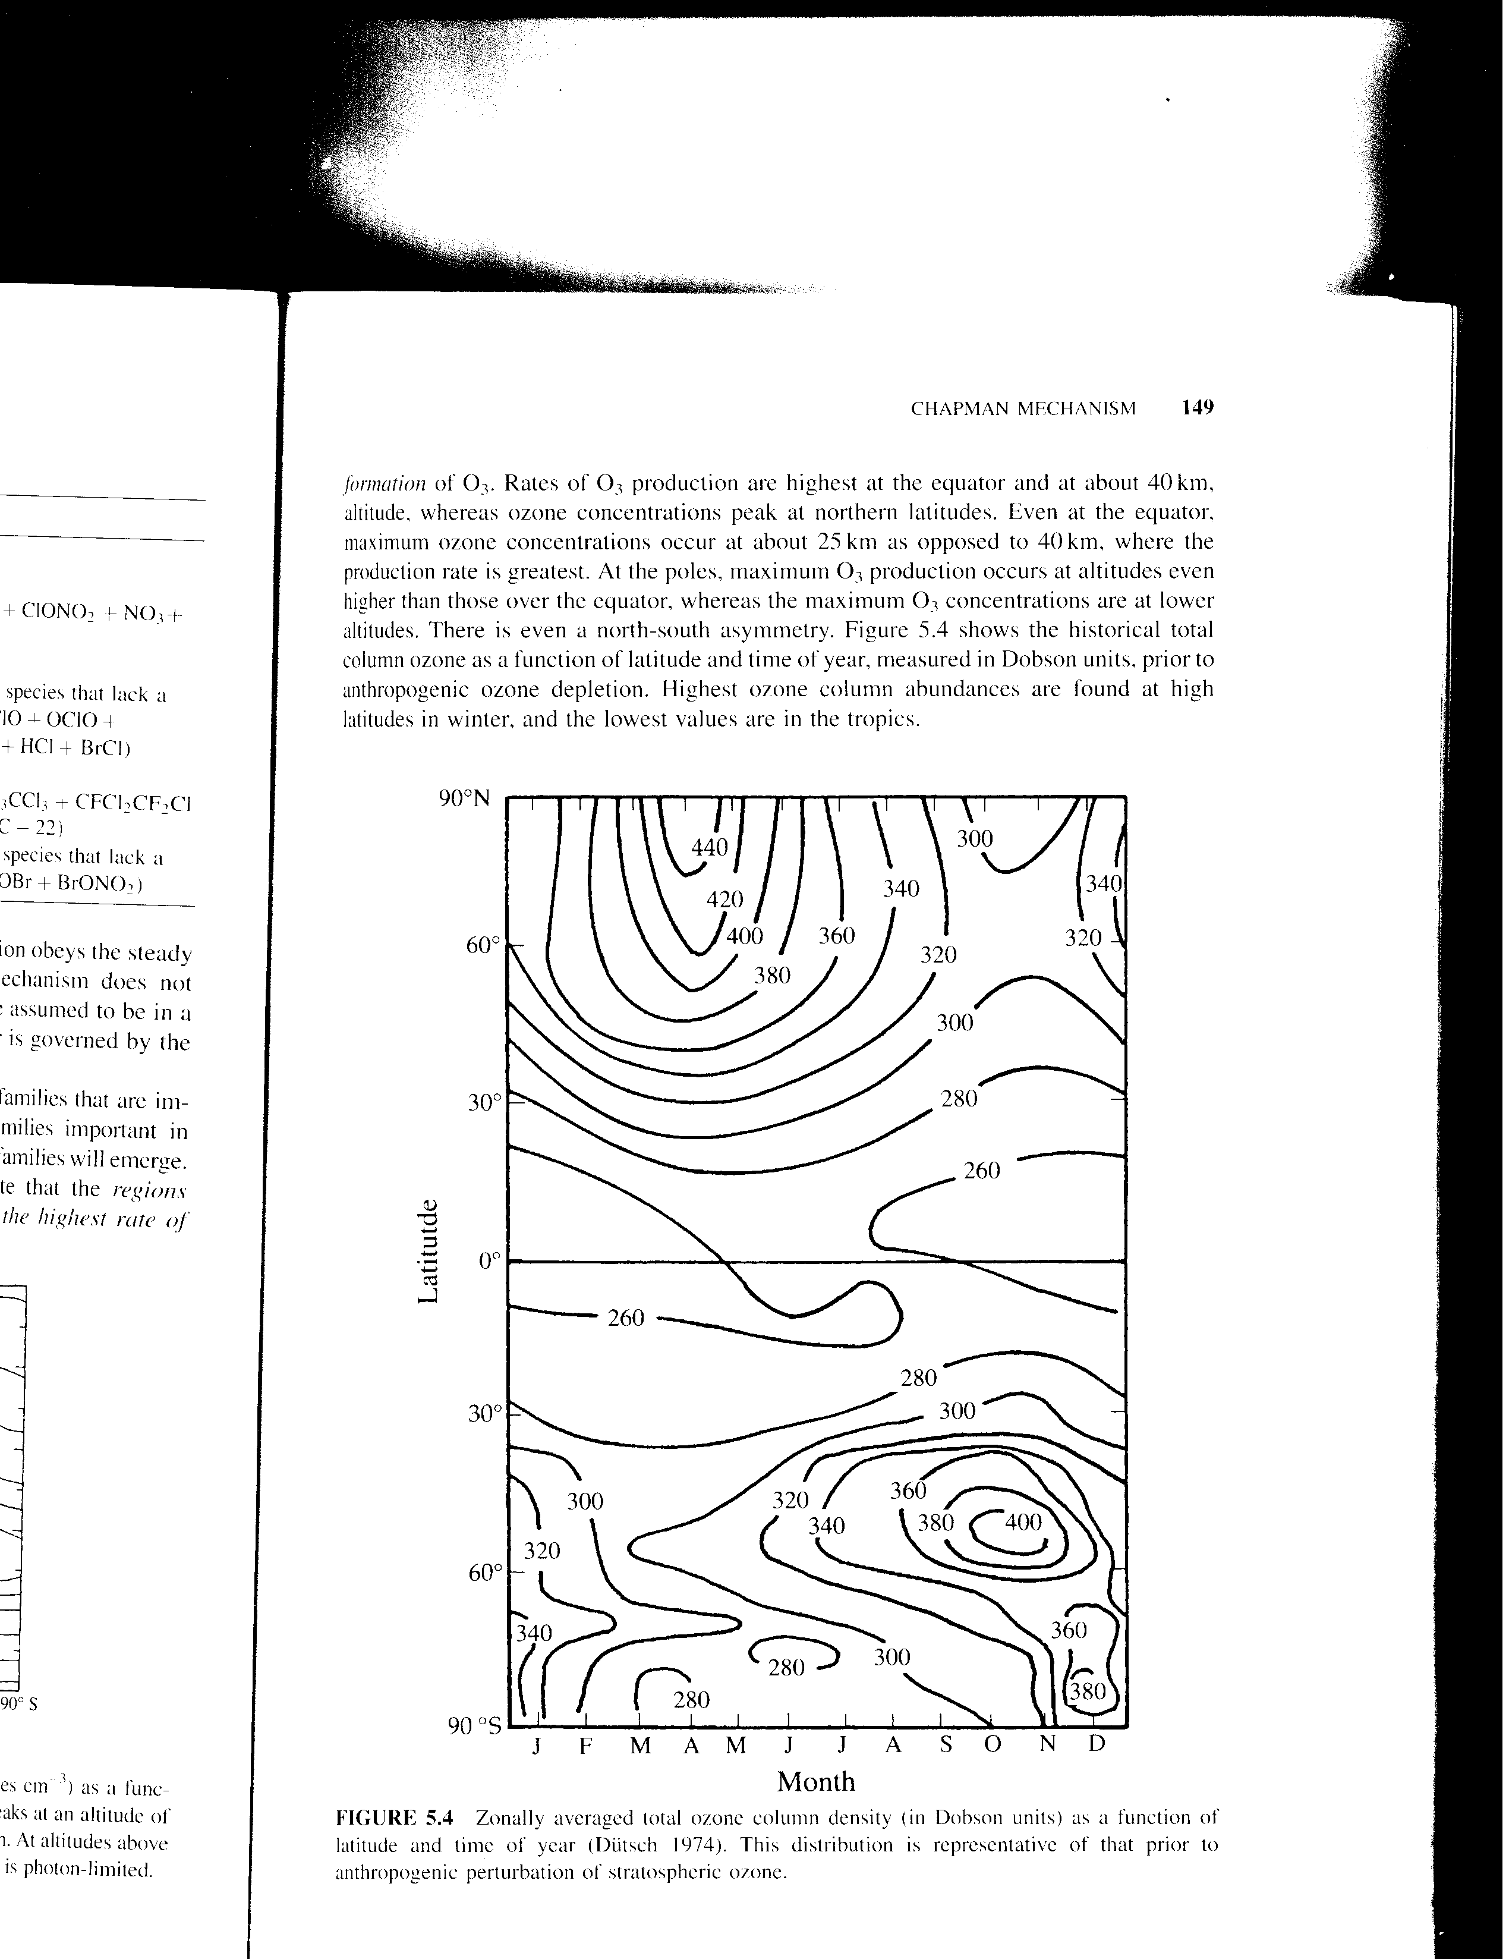
Dobson units are a column measure of ozone amount, based on measurements of UV light transmitted to the surface. One Dobson unit of ozone is equal to a .01 mm thick layer of pure ozone gas at surface pressure and 0 °C. To compare the total column abundance to that in the troposphere, and to get a feel for tropospheric variability, see the below figure from W+H.

Ozone Production

The only significant mechanism for ozone production in the atmosphere is the following termolecular reaction

O₂ + O + M → O₃ + M k₂ = 6.0x10⁻³⁴ (300/T)^{2.4} cm⁶ molecule⁻² s⁻¹ (re. 2)

Now the form of the rate coefficient does not follow that discussed in collision theory, but instead has power-law dependence on temperature (as opposed to the exponential dependence in the Arrhenius form). Why?. This is a termolecular reaction, which is related to the pseudo-steady-state reactions discussed before. The reaction really consists of the following three reactions

O₂ + O → O₃* (2a)
O₃* → O₂ + O (2b)
O₃* + M → O₃ + M (2c)

Note that reaction (2b) doesn’t involve any collisions. So its rate coefficient won’t look like the classical k = Aexp(-A’/T) form that we got from collision theory. Remember, that O + O₂ acts like two billiard balls elastically colliding off one another. O₃* is nothing more than the O and O₂ being close to each other (but unbound) while they are colliding. So the higher T is, the faster the molecules are, and thus the shorter the time is that O and O₂ are “close”. In quantum-speak, they are in an excited vibrational state that has too much energy to exist for longer than one vibrational period. As a result, k_{2b} is strongly temperature dependent. (2c) also doesn’t follow the standard temperature dependence from collision-theory, since we’re not interested in an energy barrier, but rather the likelihood for M to take away the excess reaction and collision energies. The PSSA approximation in this case assumes that [O₃*] is cycled very rapidly after an initial, brief, equilibrating period.

$\begin{aligned}\frac{d[O_{3}^{}]}{\text{dt}}=k_{2a}[O][O_{2}]−\left(k_{2b}+k_{2c}[M]\right)[O_{3}^{}] \\ \frac{d[O_{3}^{}]}{\text{dt}}\text{<<}\left(k_{2b}+k_{2c}[M]\right)[O_{3}^{}]\end{aligned}$ (3a,b)

This yields

$\begin{aligned}[O_{3}^{}]=\frac{k_{2a}[O][O_{2}]}{k_{2b}+k_{2c}[M]} \\ \frac{d[O_{3}]}{\text{dt}}=\frac{k_{2c}k_{2a}[O][O_{2}][M]}{k_{2b}+k_{2c}[M]} \\ k_{2}=\frac{k_{2c}k_{2a}}{k_{2b}+k_{2c}[M]}\end{aligned}$ (4a-c)

Now you see that k₂ has a more complicated form than our simple collision theory would predict. k₂ has low and high pressure limits. At low pressures, k₂ has only a temperature dependence, but no [M] dependence. This is the case throughout the atmosphere, and is the limit shown in (2) above. At high pressures, the [M] in the denominator cancels that in the rate equation, yielding a bimolecular rate that only depends on [O] and [O₂], but not on [M] anymore. However, because k_{2b} is so large, we are virtually never in the high pressure case for the ozone production reaction.

The Convention (Table B.2) is to express

Low pressure limit:
O₂ + O + M → O₃ + M ; k₂ = 6.0x10⁻³⁴ (300/T)^{2.4} cm⁶ molecule⁻² s⁻¹

High pressure limit:
O₂ + O → O₃ ; k_{2h} = k_{∞,300} (300/T)^{m} cm³ molecule s⁻¹

We don’t have a high pressure limit for ozone production, but we will for other termolecular reactions.

Sources of Free Oxygen – the precursor to ozone

Stratosphere. It is seen that ozone is produced by free oxygen. Where does this come from? In the stratosphere, where there is plenty of light from the sun, UV photons below 242 nm cause the following photochemical reaction.

O₂ + hν → O + O (re. 1)

The rate equation for (re. 1) is

R₁ = j_{O2}[O₂] (5)

The amount of UV light is strongly dependent on the season, latitude, and altitude. The season and latitude determine length-of-daylight and solar zenith angle. The solar zenith angle determines the depth of penetration of the UV through these absorbing O₂ layers. The greatest photochemical O production occurs where the greatest amount of sunlight per unit area (solar irradiance) reaches the Earth. Annually averaged, this is at the Equator. But during summer, the increase in length-of-day makes peak O production at fairly high latitudes.

Troposphere. Virtually all of the O₂-dissociating UV radiation is depleted above 30 km. In the lower stratosphere and the troposphere, ozone is not produced at nearly the same rate due to a depletion of new free oxygen. However, a key source of O in the polluted troposphere (and a minor source in the stratosphere) comes from the photochemical dissociation of NO₂ by photons below 420 nm, which are plentiful throughout the atmosphere.

NO₂ + hν → NO + O (NO_{x} re. 3)

R₂ = j_{NO2}[NO₂] (6)

We will discuss the important NO_{x} cycles later.

Completing the Cycle -- Sinks of O₃ in the Stratosphere

Chapman Mechanism

Let’s go back to the stratosphere. We know the source of O, and the production rate of O₃ from res. 1 and 2 above. Now the question becomes, where does the O₃ go? Without a sink, O₃ would simply continue accumulating with no end.

The first sink is given by the photodissociation of ozone.

O₃ + hν → O₂ + O (re. 3a,b)
O₃ + hν → O₂ + O(¹D)

As discussed before, the first reaction can be achieved with fairly low frequency light (nominally 500nm – 700nm), of which there is an abundance throughout the stratosphere and troposphere. The second reaction requires higher energy photons (< 300 nm), and doesn’t occur nearly as often in the troposphere as it does in the stratosphere – particularly the upper stratosphere.

Below are figures of the photolysis rate (j) of ozone and oxygen, and how this depends on solar zenith angle and altitude.

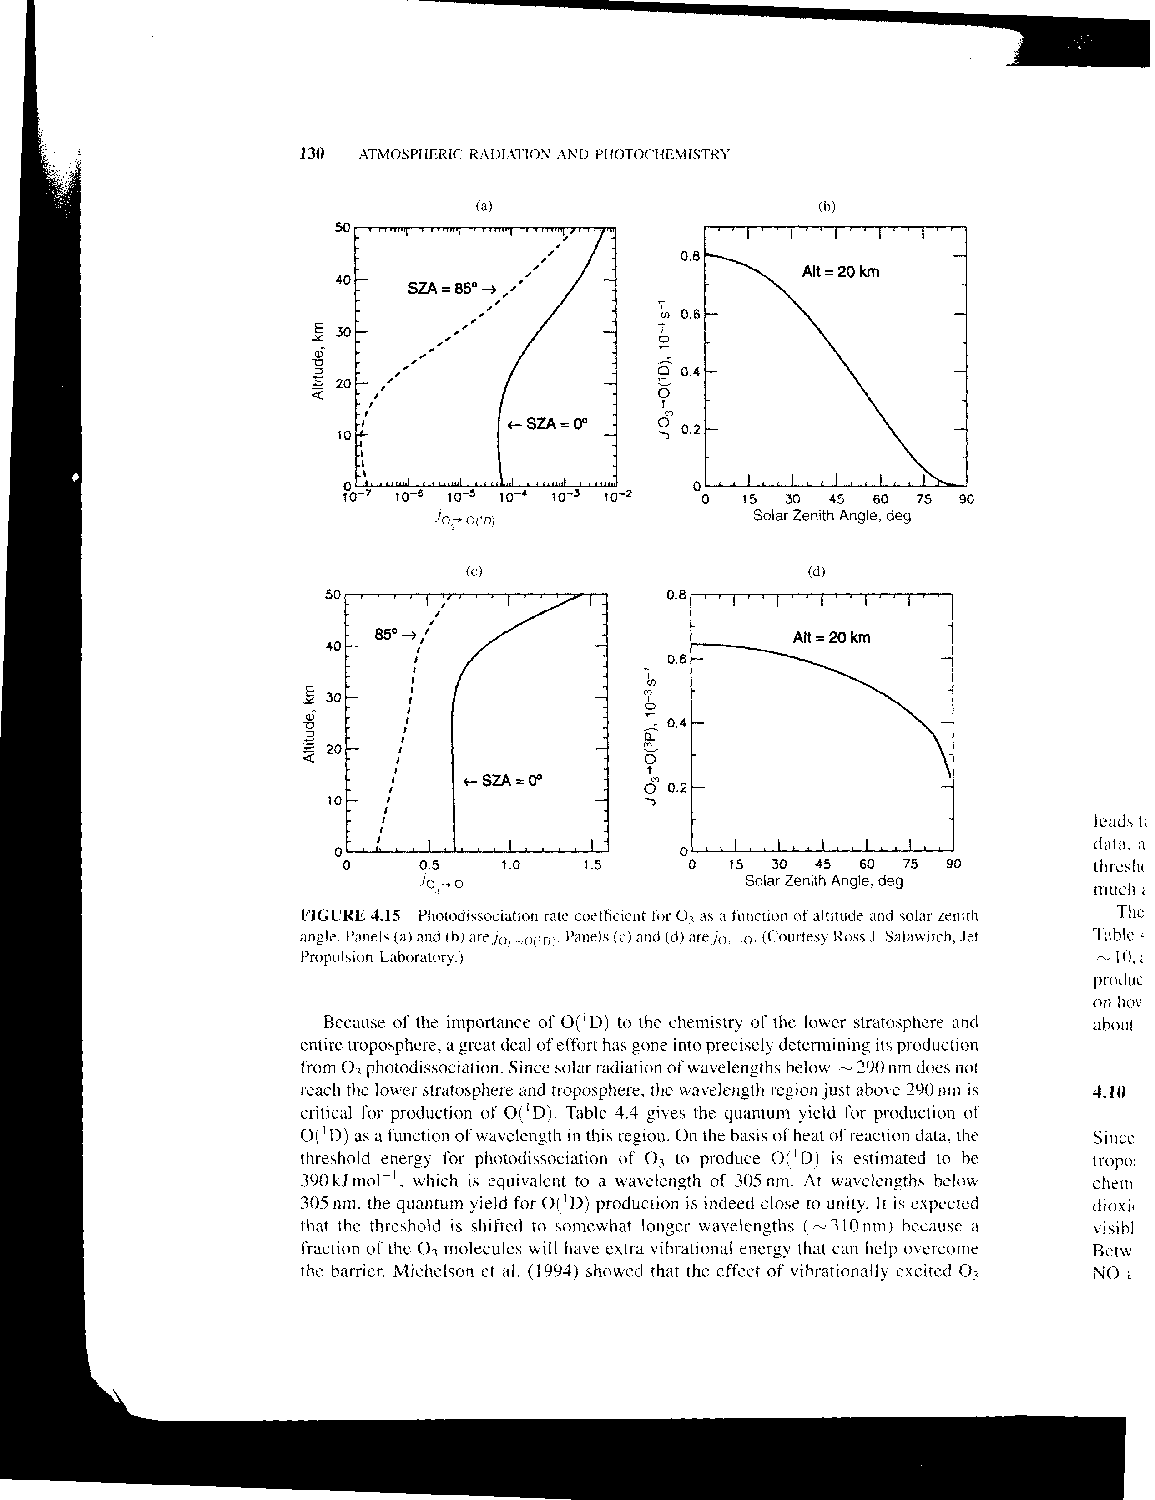

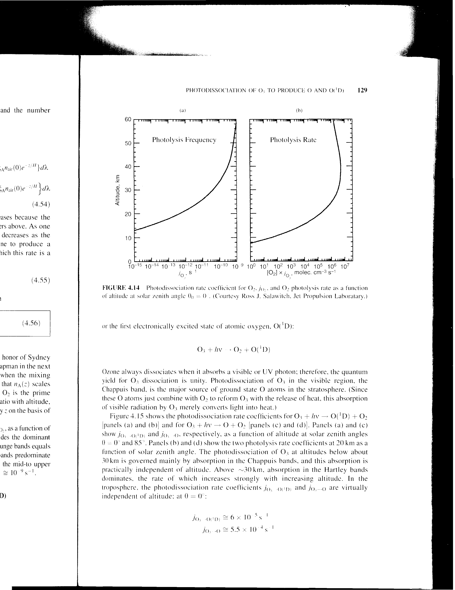

First, a brief comment on the production of O(¹D) by O₃ dissociation. Once it is created, its lifetime is short. If it collides with N₂, O₂, Ar, or most other atmospheric gases, it will simply “quench” back down to O, releasing its exitation energy as heat (O(¹D) + M → O). However, should it happen to find an H₂O (or CH₄ or H₂), it will produce the OH radical, which is particularly important in the troposphere and stratosphere. Should it find an N₂O molecule, it will react to form 2 NO molecules, which is the main source for NO_{x} in the stratosphere. Only 10% of the N₂O in the atmosphere is destroyed by this reaction. The other 90% is directly photylized in the stratosphere, forming O(¹D). We will discuss NO_{x} after O₃.

Back to the main thread… So now we have identified a sink of O₃ by photolysis. The problem, here, is that our sink simply produces a gas, O, that was the original source for O₃. So this really doesn’t complete the cycle. Destroying O₃ by photolysis simply aids in its own production. It’s more useful to think of O and O₃ together as a “chemical family”, called odd-oxygen (O_{x} = O + O₃). While reaction (1) produces odd-oxygen, (2) and (3) have no effect on it. Instead, (2,3) comprise a “null cycle”, since each reaction simply cancels the chemical effect of the other. [The only differences are that a photon is consumed in (3) and a chaperone is needed in (2).] If (2) and (3) were the only reactions going on, you’d end up with an equilibrium just like with a reversible reaction.

$\begin{aligned}\frac{d[O]}{\text{dt}}=0=−k_{2}[O][O_{2}][M]+j_{O_{3}}[O_{3}] \\ [O]=[O_{3}]\frac{j_{O_{3}}}{k_{2}[O_{2}][M]}\end{aligned}$ (7a,b)

We can immediately state what this equilibrium ratio is, since we know all the terms in the ratio of (7b). j_{O3} varies a bit, but we’ll use a nighttime value of 0 and a daytime value of ~1/(30 minutes) based on the plots. The denominator is 0.2*k₂*[M]² = ~5x10⁴ s⁻¹ at the surface, and ~5 s⁻¹ at 100 mb. In either case, we can see that [O] << [O₃].

To complete the ozone cycle, we need a sink of odd oxygen. There are a number of important sinks of odd oxygen. One of the simplest, since it only involves O atoms, was identified by Chapman

O₃ + O → 2O₂ k₄ = 8.0x10⁻¹²exp(-2060/T) (re. 4)

The complete Chapman mechanism comprises reactions (1-4) above.

O₂ + hν → O + O (re. 1)
O₂ + O + M → O₃ + M (re. 2)
O₃ + hν → O₂ + O (re. 3)
O₃ + O → 2O₂ (re. 4)

Because (4) includes only one of many sinks of odd oxygen, it overpredicts the lifetime of O₃ in the stratosphere pretty significantly (and hence its abundance). Regardless, it is a simple starting point to study O₃ chemistry.

Combining re. 1-4 we get the following rate equations

$\begin{aligned}\frac{d[O]}{\text{dt}}=2j_{O_{2}}[O_{2}]−k_{2}[O][O_{2}][M]+j_{O_{3}}[O_{3}]−k_{4}[O][O_{3}] \\ \frac{d[O_{3}]}{\text{dt}}=k_{2}[O][O_{2}][M]−j_{O_{3}}[O_{3}]−k_{4}[O][O_{3}]\end{aligned}$ (8a,b)

Adding (8a,b) yields the cycle of odd oxygen

$\frac{d[O_{x}]}{\text{dt}}=2j_{O_{2}}[O_{2}]−2k_{4}[O][O_{3}]$ (9)

In (1)-(4) above, O_{x} is produced only by the photolysis of O₂, and it is destroyed only by collisions among O and O₃. Note that reaction (4) depends on the collision between two very trace gases: O and O₃ . This is pretty rare. We can assume (and later verify) that it’s a lot more common for an O to find an O₂ and proceed w/ reaction (2) than it is for it to find an O₃ and proceed with reaction (4). Based on this, we’ll assert that the sources and sinks of odd oxygen (1) and (4) are really small compared to the cycling of odd oxygen through the “null cycle” (2) and (3). That is,

$\left(k_{2}[O][O_{2}][M]\text{\sim }j_{O_{3}}[O_{3}]\right)\text{>>}\left(k_{4}[O][O_{3}][M]\text{\sim }2j_{O_{2}}[O_{2}]\right)=\text{or}>\frac{d[O]}{\text{dt}}$ (10)

If this is the case, then assumption (10) used with (8a,b) yields (7a,b) – the O, O₃ equilibrium discussed above. This is a form of a PSSA, in which the null cycle is presumed to be very fast compared with the creation and destruction of odd oxygen in (9).

Now is a good time to bring up lifetimes – j_{O3} gives the rate at which O₃ cycles through O_{x}. Through the trop and strat, the value is on the order of 1/2 hour.

Side Note: At nighttime, when O is no longer being produced, all the O will combine with O₂, yielding O₃ as the main O_{x} reservoir. With no light, there’s no (1) or (3), no O, and thus (4) gets shut down as well. So the Chapman mechanism predicts that shortly after the sun goes down, O₃ concentrations stabilize for the night. Then when the sun comes up, (3) kicks in and creates O; (4) starts up again with the presence of O; and (1) ramps up to maintain and build O_{x} concentrations against (4). This is particularly important in polar regions, where the nights can be days long in the fall and winter. During these polar nights, other, slower, reactions become very important.

We have been asserting that the destruction of O₃ by (4) is much slower than the cycling through (3). Acknowledging that [O] << [O₃], we get τ_{Ox} = 1/(2k₄[O]) = months in lower stratosphere, and days in the upper stratosphere. So clearly our assumption of PSSA for [O_{x}] was correct.

So let’s examine the overall situation. There’s quite a bit of ozone up there. During the daytime, some dissociates into O, which then leads to destruction of the O₃. But the lifetime of O₃ is much longer than the lifetime of the O, so this does not constitute a large day-night change in O₃ concentration. Over time, the destruction by O + O₃ reaches an equilibrium with the production of O_{x} by daytime O₂ photodissociation. But again, since the lifetime of O_{x} is so long, the diurnal cycle in O production by O₂ also doesn’t contribute a significant diurnal cycle. The primary cycle will be seasonal.

Given that we are concerned with longer timescales, let’s examine what the equilibrium concentration will be over time. This is done by setting Eq (9) = 0, and employing the PSSA approximation (7b).

$[O_{3}]_{\text{SS}}=\sqrt{\frac{j_{O_{2}}k_{2}[M]}{j_{O_{3}}k_{4}}}[O_{2}]$ (11)

We’ve already mentioned that if you plot this vs. altitude, you get a much larger concentration than what is observed. This is because we are only considering (re. 4) for losses in O_{x}. To get the observed O₃ concentrations, we need to consider the other losses.

NO_{x} Cycles

Oxidized nitrogen is very important for ozone chemistry in the stratosphere and in the troposphere. The key stratospheric reactions in which [NO_{x}] = [NO] + [NO₂] are significantly involved are given by reactions NO_{x} reactions 1-3 below, and a complete cycle can be created by adding re. 4.

NO + O₃ → NO₂ + O₂ k₁ = 3.0x10⁻¹²exp(-1500/T) (NO_{x} re. 1)
NO₂ + O → NO + O₂ k₂ = 5.6x10⁻¹²exp(180/T) (NO_{x} re. 2)
NO₂ + hν → NO + O (NO_{x} re. 3)
O₂ + O + M → O₃ + M (NO_{x} re. 4)

The original source for NO in the troposphere is pollution, lightning, and soils. This form of nitrogen generally gets oxidized, rained out and doesn’t reach the stratosphere. In the stratosphere, NO comes from the reaction of O(¹D) with N₂O, which is unreactive in the troposphere and has natural and anthropogenic sources.

(1) and (2) cycle NO with NO₂ . Both reactions destroy O_{x}. The nitrogen species are grouped into a family because of their rapid cycling [NO_{x}] = [NO] + [NO₂]. On the other hand, NO₂ also creates odd-oxygen through (3) and (4). These are competing effects. We will see that NO_{x} creates O₃ pollution in the troposphere, but NO_{x} destroys ozone in the stratosphere.

In steady state, we reach an equilibrium [NO]/[NO₂] concentration, just as we did for [O]/[O₃] when discussing the Chapman mechanism. This yields

$[\text{NO}]=\frac{k_{2}[O]+j_{{\text{NO}}_{2}}}{k_{1}[O_{3}]}[{\text{NO}}_{2}]$ (12)

The destruction rate of odd oxygen can then be given as

$\begin{aligned}\frac{d[O_{x}]}{\text{dt}}|_{{\text{NO}}_{X}}=j_{{\text{NO}}_{2}}[{\text{NO}}_{2}]−k_{1}[\text{NO}][O_{3}]−k_{2}[{\text{NO}}_{2}][O] \\ =−2k_{2}[{\text{NO}}_{2}][O]\end{aligned}$ (13a,b)

(13b) can be thought of as just another odd-oxygen removal to be added to (9). It turns out that the efficiency of reaction 2 is so much greater than the efficiency of reaction (4) from the Chapman mechanism that NO_{x} becomes more efficient a removal mechanism than Chapman supposed.

It’s worthwhile mentioning that lower stratosphere chemistry is very different than upper stratosphere chemistry due to the depletion of O-producing UV radiation. Likewise, tropospheric chemistry is very different because of increased pressures and the addition of humidity, among other reasons.

Other Catalytic Cycles

Other very important families enter into ozone destruction in the stratosphere. The first is HO_{x}, which comprises OH + HO₂. The second is the halogen cycle, in which Br or Cl participate in similar cycles with their radials Cl and ClO (and Br and BrO). Each of these destroy odd-oxygen following the same cycle as NO_{x}. If we use “X” for Cl, Br, OH, or NO, we end up with the same form for the catalytic destruction cycles

X + O₃ → XO + O₂
XO + O → X + O₂

When free oxygen (O) is very scarce (for example, at night), the following reactions continue the catalytic cycles, albeit very slowly, by regenerating X in the absence of O

XO + O₃ → X + 2O₂
XO + O₃ → XO₂ + O₂
XO + YO + hν → X + YO₂ → X + Y + O₂

The stratosphere is very non uniform vertically. Pressure-limited reaction rates decrease with height. Photon-limited reactions increase with height. Also, various species interact in their cycles in complex ways. As a result, the factors that control the net ozone sink vary considerably with altitude (See Figure below from S+P).
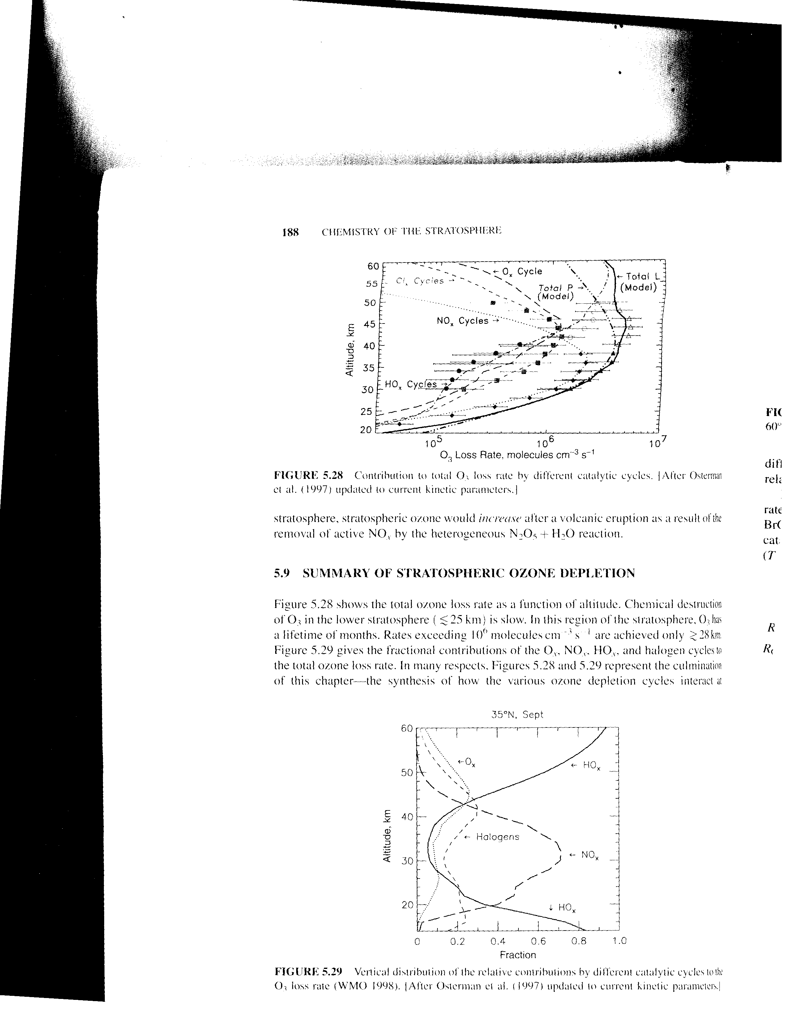
We briefly mentioned OH. As mentioned above, it is created by the combination of an O(¹D) with H₂O, CH₄, or H₂. It’s counterpart, HO₂ is created when OH reacts with O₃, or when the H radical (one source is O(¹D) + H₂ → H + OH) reacts with O₂.

Ozone Hole

Free chlorine atoms destroy ozone through two reactions that occur in a catalytic cycle. Cl + O₃ → ClO + O₂, and ClO + O → Cl + O₂. While the sun is shining, O₃ itself produces the O radicals needed to “recharge” the ClO back to Cl. When night falls, all the O → O₃, and all the Cl → ClO, and the destruction of ozone virtually halts because there is no photolytic regeneration of the destructive species. Under normal circumstances, when the sun rises again, everything starts up again.

It has been observed that, when the sun rises in Antarctic Spring after the long polar night, there is a rapid destruction of the ozone that had been stably sitting around all winter long. Why? The answer relates to NO_{x}’s moderating effect on the Cl cycle and the ability of polar winter clouds to remove the NO_{x}.

The amount of free Cl in the stratosphere is limited because it gets stored in two major chemical reservoirs – Cl + CH₄ → HCl + CH₃, and ClO + NO₂ + M → ClONO₂ + M. In Antarctic winter, some of what little water vapor that exists in the stratosphere cools enough to produce polar stratospheric clouds that are rich in nitric acid and water and store much of the HCl. Heterogeneous reactions between the ClONO₂ in the air and the HCl and H₂O in the clouds releases the Cl in non-reactive (with O₃) forms (Cl₂, ClO, ClNO₂) to the atmosphere, leaving behind much of the NO₂ in the cloud particle in the form of nitric acid, HNO₃. Some of the cloud particles settle out of the stratosphere, denitrifying the stratosphere, while leaving the Cl behind.

When the sun finally rises in the spring, the non-reactive forms of chlorine left behind are photolyzed, releasing the Cl radial. Without as much NO₂ around to act as a reservoir, the abundance of free Cl greatly exceeds that seen in the previous Fall, and as a result, the ozone level rapidly decreases, creating the so-called ozone hole.

This entire scenario plays out within a tight vortex that forms over the Antarctic continent during winter. As the Spring warms things up, the vortex breaks up and mixing disperses the enhanced Cl and the reduced NO_{x}, and the ozone hole disappears.

The Montreal protocol, which was agreed upon in 1987, enforced starting 1989, and modified through the ‘90s, eliminated the continued production of CFCs, which are the source of an estimated 85% of stratospheric Cl. CFC levels in the troposphere are now decreasing. NOAA’s latest assessment report indicates that stratospheric chlorine has started to decrease from its peak value in the late ‘90s as well. (This stands in contrast with the statement in W+H that the stratospheric Cl is continuing to increase, so there may be some room for error here.). Like N₂O, the main sink for atmospheric CFCs is photolysis in the stratosphere, and so they have very long atmospheric lifetimes. When CFCs are photylized in the stratosphere, they release their halogens as radicals in the stratosphere. It takes months to years for the free halogens to cycle back into the troposphere. The main sink for Cl is the formation of HCl by reaction with methane, and the ultimate wet removal of the soluble HCl. It is likely going to be decades for the Cl levels in the stratosphere to return to pre-Montréal Protocol levels.

The legislation that led to the international ban on CFCs was considered a triumph in global cooperation to address a common risk. However, there was very little cost to industry to eliminate CFCs, since ready industrial alternatives (e.g. short-lived HCFCs) had already been found. Other air pollution issues have larger hurdles.

