ATMOSPHERIC CHEMISTRY – Composition of the Atmosphere

What is atmospheric chemistry?

A study of the chemical composition of the atmosphere, how this varies in space and time, and the processes that determine these properties.

Key research activities:
- Precise observations of the composition of gases and aerosols at various regions in the troposphere and stratosphere
- Laboratory studies of specific chemical reactions
- Program what we know into complex numerical models so we can interpret observations and make chemical forecasts.

Why do we care?

- It’s fundamentally interesting (at least to some of us)
Atmospheric Composition is a key component of our environment having broad interactions with other parts of our environment. Life as we know it is tailored to our environment, and rapid changes in this can have adverse effects on life (as we know it). Furthermore, the properties of the atmosphere are very sensitive to small changes in atmospheric composition
Sensitivity: The atmosphere is extremely important because it is the environment for terrestrial life, and the outermost layer of the Earth, shielding the surface from space, filtering the Sun’s radiation, and radiatively “blanketing” the surface. However, the atmosphere is extremely thin (small mass) when compared with the oceans and the surface, and the key species exist in trace quantities. As a result of this disparity, the atmosphere is relatively easy to change, and thus its important role is particularly sensitive to such changes. The most relevant examples follow:

- Air Pollution – A situation in which substances that result from anthropogenic activities are present at concentrations sufficiently high above their normal ambient levels to produce a measurable effect on humans, animals, vegetation, or materials. ‘Nuff said. Some things in the atmosphere can be poisonous and corrosive, particularly those emitted by certain industrial activities.

- Ozone Depletion – Ozone absorbs UV radiation that would otherwise cause unwanted chemical reactions in our cells. The amount of ozone in the stratosphere is controlled by very complex processes that can be perturbed by changes in the abundance and distribution of trace gases

- Global Climate – The primary components of the atmosphere (N₂, O₂, Ar) are mostly transparent to both solar and infrared radiation (and mostly chemically inert, too). Most of the action is due to key trace components (H₂O, CO₂, CH₄, O₃, CFCs, N₂O, others). These absorb infrared radiation, but are mostly transparent to solar radiation. This causes a “greenhouse effect” which warms the planet’s surface to the present comfortable level. Changes in the abundance of greenhouse gases will strengthen or weaken this warming effect.

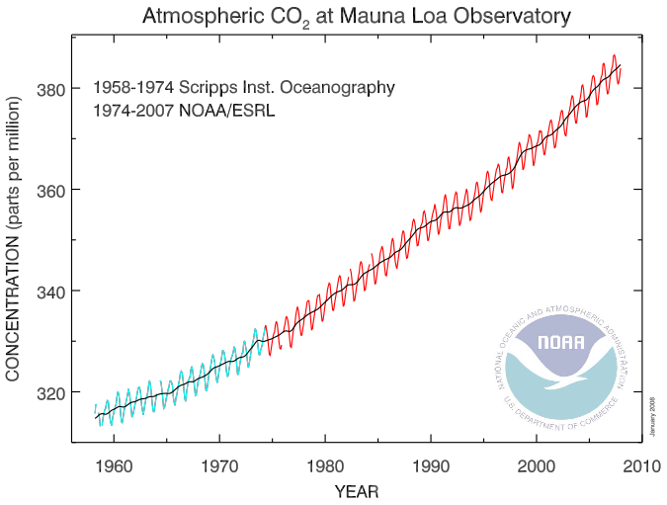
A familiar example of the sensitivity of atmospheric composition.

- Aerosols – Technically an aerosol is a dilute mixture of condensed particles within a gas. When we say “aerosol”, we generally refer to the particles themselves – the atmosphere around them is a given. They are an important component of the atmosphere, and often result from complex chemical processes. Aerosols have a crucial physical and chemical role to play in biogeochemical cycles, radiation, and cloud physics. Some people think of aerosol science as a subset of atmospheric chemistry, but in fact the physics of aerosols is as interesting, important, and complex as their chemistry.

In the remainder of this section, we will discuss the key constituents of the atmosphere, their relevance, where they come from, and what their lifetimes in the atmosphere are.

Table 5.1 from Wallace + Hobbs gives a fairly detailed view of some important gases.

There are two useful ways to categorize atmospheric species.
- Relevance – Are they important greenhouse gases? Pollutants? Stratospheric components relevant to ozone? Are they central to a chain of reactions that control some other important species?
- By the key elements (we will highlight the most important species: Carbon, Nitrogen, Sulfur, and the Halogens. It is not as useful to trace Oxygen and Hydrogen, except for some select applications) – This is a process-based perspective. Since the mass of a given element in the Earth system is basically conserved, it is useful to keep track of how it moves and transforms chemically. It is useful to trace an element from its emission into the atmosphere, through whatever chemical transformations that take place once it gets there, through to its eventual removal back to the surface (either the land or oceans).

Biogeochemical Cycles: The transport and transformation of substances through the various components of the Earth system (atmosphere, oceans, cryosphere, biosphere, and lithosphere), through processes that are often cyclical in nature.

The lifetime of a given species:
- Sources:
  - Surface
    - Biological
    - Land/Ocean surface
    - Anthropogenic
  - Atmospheric Reactions
    - Gas phase reactions
    - Aqueous reactions (within aerosols/droplets)
    - Heterogeneous reactions (on surface of dry aerosol/ice)
- Transport (in order of increasing timescale)
  - Local diffusion throughout boundary layer
  - Regional transport and mixing through column
  - Hemispheric dispersion
  - Interhemispheric (global) transport
- Sinks
  - Deposition
    - Dry -- Direct contact with surface
    - Wet – Scavenged by precipitation
  - Atmospheric Reactions

Before we go into the various species in detail, first let’s examine some key approaches to quantifying them.

We will use the notation from Seinfeld + Pandis, since those of you taking Dr. Betteron’s course will be using this text as well.

Definitions for the amount of a gas species in the atmosphere
Molar Concentration: c_{i} = N_{i}/V, where N_{i} is the number of moles of species i, and V is the volume under consideration. Remember that 1 mol = N_{A} = 6.022x10²³ molecules.
Volume Mixing Ratio: ξ_{i} = c_{i}/c_{total}, where c_{total} is the total molar concentration, (also denoted by n in the ideal gas law, p = nR*T.)

Since mixing ratios are constant with expansion of the gas, they are more useful in mass budget applications. For a “well mixed gas” the mixing ratio is constant throughout the homosphere.

To get rid of pesky 10^{-X} notation for trace species when expressing mixing ratios, we use the familiar units:

% - percent: 10⁻²
‰ – permil: 10⁻³ – not to be confused with…
ppm – parts per million: 10⁻⁶
ppb – parts per billion: 10⁻⁹
ppt – parts per trillion: 10⁻¹² – not to be confused with parts per thousand

For example, Current CO₂ levels have increased from a pre-industrial level of 280 ppm to a present level of 385 ppm. At 925 mb and 20 °C, what was the pre-industrial molar concentration? The mass concentration?

ξ = 280 ppm = 2.8x10⁻⁴ mol/mol
c = ξn = ξp/(RT)
c = 0.01 mol m⁻³

Mass conentration: ρ_{i} = c_{i}M_{i}
Where M_{i} is the molecular weight of species i = 44 g/mol for CO₂ = .044 kg/mol in SI units.

ρ_{i} = 4x10⁻⁴ kg/m⁻³

To get the values of each of these for present day levels, just multiply times 385/280.

Also, if we’re only concerned with the Carbon mass, you would multiply times the fraction of the CO₂ mass which is carbon (i.e. 12/44).

Problem 1: Assuming an average surface pressure of 1000 mb, an average tropospheric temperature of 255 K, and a global CO₂ mixing ratio of 385 ppb, what is the current atmospheric Carbon reservoir (in units of kg m⁻²)? Compare your approximation with Table 2.3 in W+H. Hint: You will need to think about the “well mixed” nature of CO₂ and use hydrostatic profile concepts earlier this semester.

Mass Conservation

The concentration of a species in the atmosphere is controlled by its source (the rate it is emitted into or created in the atmosphere), and its sinks (the rate at which it is removed). Consider a finite region of the atmosphere (a parcel). We need to decide whether the parcel encloses a fixed region of space (Eulerian) or whether the boundaries move with the local mean flow (Lagrangian). The conservation of a chemical species within the parcel can be written as (S+P notation here):

$\frac{\text{dQ}}{\text{dt}}=P−R+(F_{\text{in}}−F_{\text{out}})$ (1)

Where Q is the total mass of the substance in the parcel, and hence dQ/dt is the rate of accumulation of the species in the parcel. P (kg/s) is the rate at which the substance is being produced by the sources described above, and R (kg/s) is the rate at which it is being removed by the described sinks. F_{in} is the rate at which the substance is crossing into the boundary from neighboring atmospheric parcels, and F_{out} is the rate at which it is crossing out across the boundary to neighboring parcels.

F_{in} and F_{out} are purely diffusive if we think of our volume in a material, or Lagrangian, sense. In this case the derivative in (1) is a “material” derivative. If we change to an Eulerian representation, then we have to consider how much of the species is carried in and out of the volume by flow (advection) across the boundaries. In this case, the derivative in (1) should be interpreted as a partial derivative (∂Q/∂t), and we account for both diffusive and advective terms in F_{in} and F_{out}. You should be familiar with the relationship between Lagrangian vs. Eulerian derivatives from Dynamics. For a finite volume, we have

$\frac{\text{dQ}}{\text{dt}}=\frac{∂Q}{∂t}+\oint{u⋅∇q}\text{dV}$.

where q is the density of Q (q = dQ/dV). The second term on the right hand side is the advective contribution to (F_{out} – F_{in}). !!!The discussion in S+P assumes an Eulerian framework!!!

Atmospheric Lifetime

The removal rate usually increases with the concentration of the species itself. So if we start with a situation where the source strength is greater than the sink strength, this leads to an increase in the concentration. This increases the sink rate until it is strong enough to balance the source. At this point, dQ/dt = 0, and we have a steady-state situation, where

$$R+F_{\text{out}}=P+F_{\text{in}}$$

The average lifetime, τ_{i}, of a species in the parcel is given by the ratio of its total mass to the rate at which it is removed.

$$τ=\frac{Q}{R+F_{\text{out}}}$$

If we consider the entire atmosphere as our parcel, then there are no boundaries to worry about, and F_{in,out} = 0. In this case,

$$τ=\frac{Q}{R}$$

Additionally, if the substance is in approximate steady state, then

$$τ=\frac{Q}{P}$$

Before, we mentioned that the sink rate increases with the concentration. In many cases, we can approximate this with

R = λQ

It is clear that λ has units of s⁻¹. Using (2) and (3), we see

τ = λ⁻¹.

for the atmospheric budget on the whole. To understand how timescale relates to changes in the atmospheric concentration of a species, let’s use (1), and relax the steady state assumption that P=R.

$$\begin{aligned}\frac{\text{dQ}}{\text{dt}}=P−R \\ =P−λQ\end{aligned}$$

The solution to this simple differential equation (solve by changing variables to
S = P-λQ)

$$\begin{aligned}\frac{\text{dS}}{\text{dt}}=−λS \\ S=S_{0}e^{−λt} \\ P−λQ=(P−{λQ}_{0})e^{−λt} \\ Q=\frac{P}{λ}+\left(Q_{0}−\frac{P}{λ}\right)e^{−λt}\end{aligned}$$

This just illustrates that if you have a sink rate that is proportional to the species mass, you asymptotically approach a mass of P/λ with a relaxation timescale of τ = λ⁻¹, regardless of what the starting mass, Q₀, is. The interpretation of this is that if you are in steady state with some emission P, your atmospheric concentration will be P/λ. If you then suddenly (“impulsively”) increase production to a new P’, then the atmospheric concentration will gradually approach a new level P’/λ on a timescale of λ⁻¹.

Example: Atmospheric Carbon budget

This figure comes from the IPCC’s Climate Change 2001: Working Group I: The Scientific Basis. The numbers in brackets are total masses of atmospheric carbon in units of PgC, and the numbers by arrows are the source/removal/exchange rates in PgC/year. These masses and fluxes are dominated by CO₂ (see table above). You can see that the removal of carbon from the land is 120 PgC/year, and that from the ocean is 90 PgC/year. Let’s calculate what the residence time of a CO₂ molecule in the atmosphere is. [Q = 730 PgC, R = 120 PgC/yr + 90 PgC/yr = 210 PgC/yr, τ = 730/210 yr = 3.4 yr. Compare this to the stated atmospheric residence time in W+H Table 2.3. However, discussions of climate change give a larger value of 50 – 100 ys for the relaxation time of atmospheric carbon to an imposed source. Why?

Now, consider a larger reservoir that includes the atmosphere plus all land plants and animals, 300 PgC in surface detrius, and the uppermost 100 m of the ocean (say, 1000 PgC). Fluxes across the boundaries of this box include only a < 20 PgC/year conversion to soil carbon (perhaps much less than this) and a 44 PgC/year flux to the deeper layers of the oceans. What is the residence time of CO₂ in this larger reservoir? Q = (730 + 500 + 300 + 1000) PgC, R = (44 + (0 to 20)) PgC/yr. τ = 40 to 60 years.

The IPCC estimates that humans currently (circa. 2000) emit 7.1 PgC/yr above the natural level (perhaps a bit less due to reforestation). Let’s use our simplified model above to explore some implications. Suppose this 7.1 PgC/yr increase didn’t happen gradually, but instead happened “impulsively”, or were turned on like a switch. We would expect that with a timescale of about 3.4 years, that the atmospheric burden of Carbon would asymptote to an increased burden of 7.1 x 3.4 = 24 PgC above the background level of ~540 PgC, or a ~4% increase. The assumption here is that the surface oceans (and biosphere) are responding to the increased atmospheric CO₂ burden and increase their drawdown rate to reach the new equilibrium. After a few decades of this, the carbon accumulation in the surface will result in increased emissions to the atmosphere. We expect the surface+atmosphere reservoir of 1900 PgC (pre-industrial assumption) to increase to a new equilibrium level of 7.1 x 50 = 355 PgC, or about 20% above the pre-industrial level over the 50 year timescale of this larger reservoir. The assumption now is that increased fluxes to the deep ocean eventually compensate for the increased anthropogenic flux. Since the actual emissions have not been impulsive, but instead have increased steadily since the dawn of the industrial era, our back of the envelope calculation will be larger than the more realistic emissions scenario. Observations show a 35% increase in CO₂ concentration in the atmosphere since pre-industrial times, which is much larger than even our 20% impulsive scenario. This shows that our assumption of a “linearly responsive” (R = λQ) surface is probably an overly aggressive one – at least on the timescales under consideration. In fact we know that only part of the surface system responds to the increase in atmospheric CO₂. But the above example illustrates the basic concept.

Factors governing spatial distributions of trace constituents.

The spatial scale of an atmospheric trace constituent will depend on its source distribution, its residence timescale, and the atmospheric transport timescale. First consider a localized source, such as a smokestack that has a continual emission rate. The following table describes approximate timescales for the emissions by the smoke stack to be carried and mixed by the atmosphere over various scales

Spatial Scale | Mixing Time
Boundary Layer (~1 km deep) | hours
Mesoscale (~200 km across) | 1-2 days
Synoptic (~1000 km) | several days
hemispheric | weeks
inter-hemispheric | several months

You can imagine that if the species emitted by the smokestack had a lifetime of only hours, then the vertical distribution would only be within the boundary layer and horizontally within 10s of km of the source. On the other-hand, if the stack were emitting a substance like atmospheric aerosols, with a lifetime of about a week, the plume would extend downwind for 1000s of km, and could be lofted to higher altitudes. The lower bound for the distribution spatial scale is that of the emission source. For example, the oceans emit a number of long and short lived species. These are evenly distributed over the oceans, although the short-lived species (e.g. sea salt aerosol) do not make it very far over land. Species produced by photochemical processes will disappear at night if they have short lifetimes. This is an issue for the ozone hole, where polar “night” lasts months.

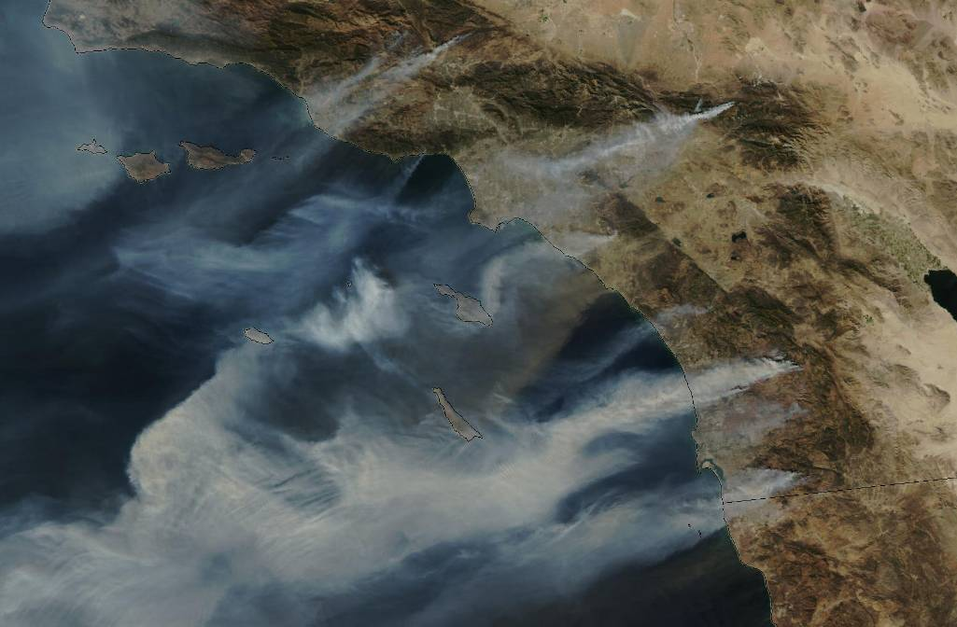
Smoke has a lifetime of several days, and so atmospheric dispersal produces strong gradients in its distribution.

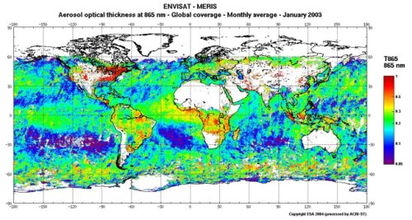
Above is a map of global aerosol distribution. Note the strong spatial concentration near and downwind of industrial and dust emission sources. Compare this to the same distribution of CO₂.

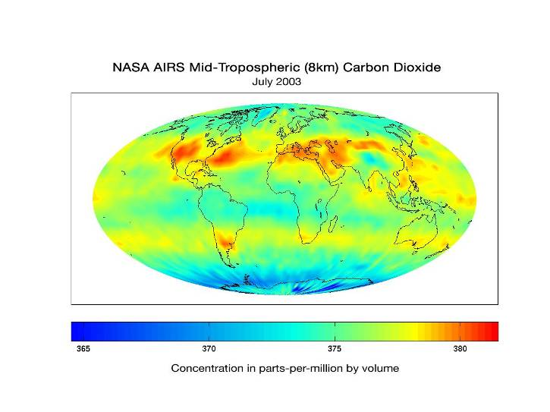
While there is some spatial variation shown here, note that the scale goes from 365 – 381 ppm, as opposed to the aerosol scale which begins at zero.

