Basic Chemistry Review

Stoichiometry and chemical reaction notation

6O₂(g) + C₆H₁₂O₆(s)→ 6CO₂(g) + 6H₂O(g)

This is a straightforward chemical reaction (burning of glucose). Reactions must be balanced meaning in this case that the mass of carbon, hydrogen, and oxygen are the same on both sides of the reaction. The arrow goes in one direction, indicating which are the precursor molecules, and which are the products. (g) = gas, (l) = liquid, (s) = solid, (aq) = aqueous.

CO₂(aq) + H₂O(l) ↔ H₂CO₃(aq)

This is a representation of two separate but opposite reactions (denoted by the bi-directional arrow). Both the forward and backward reactions can happen, and they can happen at different rates. Only if the species concentrations are in equilibrium will the two reactions will occur at the same rate. This example describes the interconversion of CO₂ and carbonic acid in a water solution. It is also balanced.

H₂CO₃(aq) ↔ H⁺ + HCO₃⁻

This is an “acid-base” reaction, in which the dissolved carbonic acid splits into a hydrogen ion and a bicarbonate ion. The reverse reaction happens as well. Ions are electrically charged molecules because they don’t have the same number of electrons as protons.

O₃ + hν → O₂ + O

This is a photochemical reaction, in which hν represents a photon of light, usually within a specified range of frequencies, ν. (in this case, 400 nm < λ < 600 nm, where λ is the wavelength of the light = speed of light, c, divided by frequency, ν). It is irreversible. O is called “free oxygen”. Note that there is no “conservation of mass” for photons – so there is no hν on the right hand side of the reaction.

O₃ + hν → O₂ + O(¹D)

This is a related photochemical reaction (restricted to higher values of ν → λ < 300 nm), in which the free oxygen molecule is produced in an excited electronic state (i.e. one of the valence electron is in a d orbital instead of the usual p orbital.)

NO₂ + OH + M → HNO₃ + M

This is a termolecular reaction, meaning 3-molecule. The use of “M” for the third molecule means it could be anything. The third molecule is required because the energy released in the reaction would make the newly created HNO₃ unstable without some 3rd agent to carry the excess energy away. This notation is only necessary in gas-phase chemistry – in the condensed phases, there’s always something around to carry away excess reaction energy.

Reaction Rates

Electronegativity and Ionic vs. Covalent Bonds

Chemical bonds hold atoms together in a molecule. Energy is released when a bond is formed in a chemical reaction, and it takes energy to break a bond. Bonds can be either ionic or covalent. Ionic bonds are formed due to the mutual electrical attraction of two oppositely charged ions. The two ions remain ions even after the bond is formed. Covalent bonds are formed when two atoms share electrons. The “perfect” covalent bond happens when the electrons are shared equally, as is the case with diatomic elements, such as N₂ and O₂. The degree to which an atom is “selfish” with its electrons is quantified by its electronegativity. The difference in electronegativity (Δx) between two bonded atoms determines whether the bond is covalent (Δx < 0.4), ionic (Δx > 2.0), or in between, which is covalent with partially ionic behavior. The most electronegative element is Fluorine, followed by Oxygen. The least electronegative elements are those on the left side of the periodic table, such as K and Na. Ionic bonds dissolve to varying degrees in water, whereas covalent bonds generally are resistant to dissolution.

Example: OF₂ is a covalent compound because Δx = 0.54. One might imagine an ionic compound of OF₆, where the fluorine completely ionizes the oxygen’s valence shell (defined below). This is energetically unstable – oxygen might share a couple of its valence electrons, but it won’t give them up entirely, and certainly not the other four! When ionizing an atom, each additional ionization requires more energy than the last, so beware of applying the electronegativity test to more than 2 electrons.

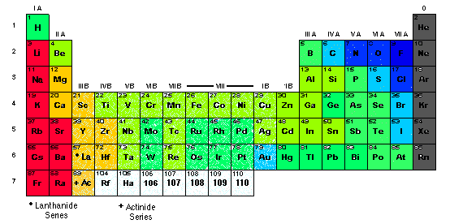

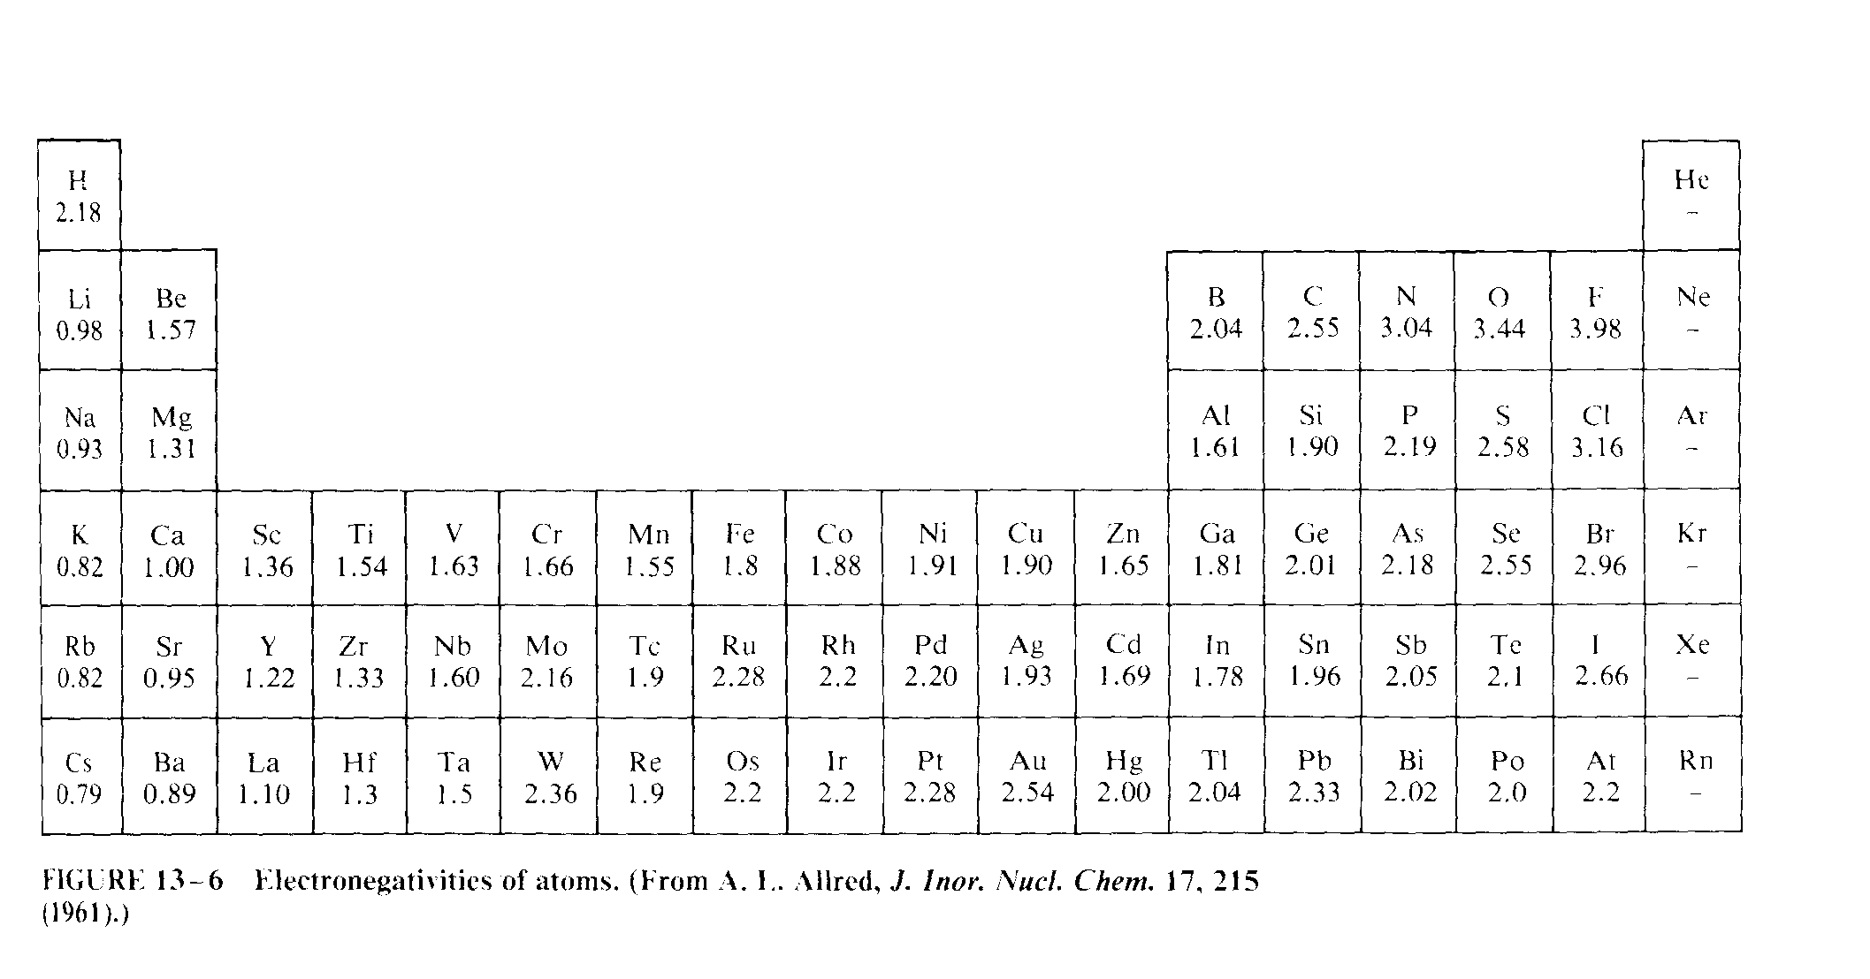

Atomic Nuclei and the Periodic Table

Above is the familiar periodic table. The colors (red → blue) correspond to increasing values of electronegativity (the scanned table has the #s). We all know that atomic number corresponds to the number of protons (and hence the positive charge) of the nucleus, and increases from left to right, top to bottom.

Atomic weight, which corresponds to the mass of the nucleus, also generally increases with atomic number, but includes the mass of the neutrons in the nucleus. While all atoms of an element have the same number of protons (by definition), there are different isotopes of each element corresponding to variations in the number of neutrons in the nucleus. For example, 99.8% of oxygen atoms have 8 protons and 8 neutrons. In isotope terminology it is called ¹⁶O for the 16 “nucleons” (protons + neutrons) in the nucleus. But about 0.2% of oxygen atoms have 9 or 10 neutrons, and these are called ¹⁷O, and ¹⁸O, respectively. Although they are the same element, the heavier atoms are more sluggish in certain phase and chemical transformations.

Electronic Structures of Atoms and Bonds

A neutral atom (i.e. no net electric charge) is surrounded by as many negatively charged electrons as the nucleus has protons. If the atom has an extra electron, it is negatively charged, and if it has one too few electrons, it is positively charged. For example, a neutral hydrogen atom is denoted as H, but one that is stripped of its electron is denoted H⁺. Charged atoms and molecules are called “ions”.

Electrons surround any nucleus in “shells” of increasing energy, momentum, and distance from the nucleus. The first shell comprises two electrons distributed spherically about the nucleus in what are called “1s” orbitals. The next complete shell comprises 8 electrons, two of which are in higher energy “2s” orbitals, and six of which are in “2p” orbitals. The p orbitals have angular momentum. They are not spherically symmetric, but instead are elongated along one of the three Cartesian axes (for a complete p shell, there is one pair of electrons along each Cartesian axis). The next shell also has 8 electrons, two in 3s orbitals and six in 3p orbitals. Electrons about an atom fill each shell in sequence. The outermost shell is called the “valence shell”. If the valence shell of a neutral atom is complete, the atom is very stable. If it is not complete, the atom is more stable when it forms molecules by bonding with other atoms.

When stable molecules are formed, the atoms within usually end up with stable valence configurations (i.e. complete outer shells). They achieve this differently with ionic vs. covalent bonds. Consider NaCl as an example of ionic bonding. Neutral Na has one “valence electron”, and neutral Cl has all but one electron in its valence shell. In the salt NaCl, the sodium atom gives its valence electron to complete Cl’s outermost shell, yielding Na⁺ and Cl⁻ ions which form an ionic bond. Energy is released in this bond formation. Now consider H₂ as an example of covalent bonding. A single free hydrogen atom is missing one electron from its valence shell. H₂ is a state where two hydrogen atoms share their two electrons, which form a complete shell about them in a single bond drawn symbolically as H—H. N₂ can be thought of as being in a state where each atom keeps its own “2s” electrons but shares its 3 “2p” electrons with the other (this is very roughly speaking – I won’t get into hybrids, anti-bonds, or formal charges here). So each atom has filled its entire shell, counting the electrons it shares with the other atom in covalent bonds. This triple-bond is denoted by N≡N. With covalent bonds, each shared electron is double-counted as satisfying the valence shell for each participating atom. In ionic bonds, the more electronegative atom gets the electrons, they are not double counted.

Oxidation State

Every element in a molecule can be given an oxidation number based on the following set of rules:

1) The oxidation number of a pure element (e.g. O₂) is zero.
2) The oxidation numbers of the atoms in a molecule must sum to the molecule’s net charge.
3) Alkali metal atoms (the 1st row of the periodic table) have an oxidation # of +1, and alkaline earth atoms (the 2nd row) are +2.
4) F is always -1
5) H is always +1 except when this violates rule (3) (e.g. LiH)
6) O is always -2 unless this violates rule 4 OR an O-O bond exists and 3 or 5 would be violated (e.g. Na₂O₂)

The key rules that we’re concerned with are highlighted in bold. (2) is obvious, and the other rules come in every so often, but 1, 5, and 6 are the key ones for atmospheric chemistry. Note that for atoms w/ ionic bonds, the oxidation state is simply the ionization state.

Examples: The most common mechanism for “oxidation” is when elemental oxygen steals electrons from other elements. The classical example is the initial rusting of iron: 4Fe(s) + 3O₂ → 2Fe₂O₃. In this reaction, Fe goes from an oxidation state of 0 to +3. It has been “oxidized”. Likewise, the oxidation state of O in this reaction goes from 0 to -2. It has been “reduced”. Another classical example in atmospheric science is when NO + O + M → NO₂ + M, in which the free oxygen is reduced from 0 to -2, and the N is oxidized from +2 to +4. In OF₂, even though the bonds are covalent, we still consider the oxygen to have been oxidized(!) by the more electronegative fluorine to +2, a rare state (for oxygen). Fluorine is in its typical oxidation state of -1.

Note that oxidation state is more about bookkeeping than what is actually going on with the valence electrons. It does not tell you the charge on an atom within a covalent compound. In the atmosphere, which is an oxidizing environment, elements tend to go through reactions that increase their oxidation state, typically leading to polar compounds that dissolve readily in aerosols and cloud water, where they are precipitated out.

When we go into the biogeochemical cycles of various elements, we see that individual elements change oxidation state quite a bit. Consider various forms of nitrogen and the oxidation state of the nitrogen atom(s) within them:

NH₃ – ammonia -- -3 (The nitrogen is highly reduced)
N₂ – elemental nitrogen – 0
N₂O – Nitrous oxide -- +1
NO – Nitric oxide -- +2
NO₂⁻ -- Nitrite Ion -- +3
NO₂ – Nitrogen dioxide -- +4
NO₃⁻ – Nitrate ion -- +5 (This form of nitrogen is highly oxidized)

Note that when we loosely interpret oxidation state in terms of the “ownership” of valence electrons, we see that oxidation state for nitrogen spans the range from “owning” a complete 2nd electron shell (ammonia) to being completely stripped of it (nitrate ion). I reiterate again that this is more of a bookkeeping exercise than an actual interpretation of the nature of the bonds.

The Periodic Table Revisited

Given the rules discussed above, elements in the periodic table are divided into groups that have similar chemical properties. Elements from Column I on the left (alkali metals) have a single valence electron, are very weakly electronegative, and thus readily form singly charged positive ions. Column II elements (alkaline earth metals) have two valence electrons, are still weakly electronegative, and in most compounds get fully oxidized to form dually charged positive ions. On the opposite side of the chart, the elements with complete valence shells (Column VIII -- noble gases) are chemically inert. Column VII elements just to their left (halogens) are missing one valence electron, and thus oxidize other elements readily to complete their shells, normally becoming singly negatively charged ions. Column VII elements, including Oxygen and Sulfur, are called chalcogens, and have properties similar to oxygen, normally being in the -2 oxidation state when in compounds with less electronegative elements. (Note that Oxygen readily oxidizes Sulfur to varying degrees, forming compounds like SO₂ and SO₄⁼.) Elements with intermediate numbers of valence electrons often exist in covalent structures with varying oxidation states. The fourth period (row) of elements is 10-elements longer than the previous two periods due to the the filling of an additional 10 orbitals (3d orbitals). This allows for the transition elements, which have metallic properties, and are not going to be of much importance in atmospheric chemistry.

Lewis Structures

Lewis structures are useful in determining the bonding and configuration of stable molecules. I have already given some examples above, for H₂ and N₂.

The Lewis structure for a single atom is simple – one simply writes the chemical symbol surrounded by one dot for each valence electron. Two dots together imply a paired set of electrons. Typically, s orbitals are filled first, and p orbitals are filled, first with one spin for each of the three orbitals, and then these are paired with the other spin. Examples are below:

For stable diatomic molecules, the strategy is for each element to have a filled valence shell, where electrons within a bond are counted by each atom. Examples for H₂, O₂, and CO are included below.

Note that H only needs to fill the 1st valence shell, which has just 2 electrons. O₂ needs a double bond to fill each of the atom’s shells, and CO needs a triple bond. Normally, we replace each pair of dots representing a bond with a line connecting the atoms.

A formal strategy for determining the number of bonds in a more complicated molecule is to
1) Add the total number of electrons needed to complete each atom’s valence shell
2) Subtract from this the total number of electrons in the molecule
3) The difference divided by two is the number of covalent bonds needed.
4) Try to minimize the formal charge on each atom when assigning bonds. That is, while each bond contributes two electrons to an atom’s “valence quota” it only contributes one electron to its “formal charge”. The formal charge of an atom is its number of protons minus its number of unbonded electrons, minus the number of covalent bonds it shares with other atoms. For example, in H₂ and O₂, the formal charge for each atom is zero, and the number of valence electrons is 2 for the H atoms, and 8 for the O atoms. In CO, however, while the number of valence electrons is eight for each atom, the formal charge for O is +1, and the formal charge for C is -1.

Exercise: Using the above rules, determine the molecular structure for Cl₂CO. Hint: C is at the center.

Free Radicals

A free radical is a molecule with an unpaired electron and thus an incomplete valence shell. It is NOT an ion, since it is electrically neutral. The classical examples in atmospheric chemistry are the OH and HO₂ radicals (important oxidizing agents in the troposphere and stratosphere), the Cl radical (critical for O₃ destruction in the polar spring), and NO_{x}, (shorthand for NO and NO₂), which happens to be relatively stable as free radicals go…

Free radicals tend to have short atmospheric lifetimes, because they are reactive. They generally don’t react with N₂, O₂, Ar, or CO₂, but do react with a number of trace species.

Below I will write in some Lewis Structures for the above Radicals

When you get used to this, you can drop all the paired electrons, and simply write lines for the bonds and a single dot to indicate the radical atom. Try to calculate the formal charge on each of the elements in the above diagram. Another comment about NO₂: It is normally considered to be a simultaneous superposition of the asymmetric structure above and its mirror image. Ozone also has a similar superimposed structure, called “resonance” structures. Try to do a dot structure for ozone analogous to that for NO₂ (Hint: It’s NOT three triangular bonds).

If this isn’t coming back to you like you’d hoped, I suggest pulling out your old freshman chemistry text. I also found the following problem set appropriate:
http://www.chm.uri.edu/cbrown/chm191/Prob_Chap10.pdf

Gas-Liquid Interface Physics

Some atmospheric gases are in equilibrium with their corresponding aqueous phases in aerosols or cloud droplets. We already mentioned that CO₂ dissolves in water to form H₂CO₃. We will consider the equilibrium of water between its gaseous and solution phases H₂O(g) ↔ H₂O(l) when we study droplet activation and the Clausius-Clapyron equation.

Raoult’s LawRevisited

At a flat surface of a dilute solution, the equilibrium vapor pressure of water is equal to its saturation value times the molar fraction of water in the solution.

$e'=e_{s}(T)\frac{n_{0}}{n+n_{0}}$

where n₀ is the number concentration of water molecules, and n is the number concentration of all other species in solution with the water. e’ is smaller than e_{s}(T) due to the presence of the solute. Please revisit earlier notes for definitions. This expression works only for 1) ideal solutions (rarely a good assumption with water), or 2) when the solution is very dilute – i.e. water is the main constituent of the droplet. (n << n₀.)

Henry’s Law

In Henry’s Law, we look at condensation to the same droplet, but focus on the vapor phase of a solute species instead of the solvent, which is water. In terms of dilution, we’re at the opposite extreme. Consider a gas (say CO₂) at equilibrium with its dissolved concentration in liquid water (in the form H₂CO₃). Because the gas is only a very minor constituent of the droplet, Henry’s Law applies, not Raoult’s Law. To be consistent with atmospheric chemistry notation (as opposed to some chemistry texts), we write

$$[H_{2}{\text{CO}}_{3}(\text{aq})]=H_{{\text{CO}}_{2}}p_{{\text{CO}}_{2}}$$

Where [H₂CO₃(aq)] is the concentration of carbonic acid in M (i.e. mol L⁻¹), H_{CO2} is the Henry’s Law coefficient for CO₂ at the temperature of the water (=3.4x10⁻² M atm⁻¹ at 298 K), and p_{CO2} is the partial pressure of atmospheric CO₂.

Problem: What is the equilibrium concentration of H₂CO₃ in a freshwater lake, neglecting other processes, given modern-day CO₂ mixing ratio of 385 ppm?

Challenge Problem: How ideal is the water/carbonic acid solution? That is, rewrite Henry’s law using the same units as for Raoult’s law (i.e. mole fraction), and compare the “inferred” value for the saturation vapor pressure of CO₂ with the observed value of ~70 atm.

Answer to challenge problem: To convert Henry’s Law to have the same form as Raoult’s Law, divide both sides by H_{CO2.} We then need to convert our measure of [H₂CO₃] from units of M (mol H₂CO₃ / L H₂O) to units of mole fraction (effectively, mol H₂CO₃ / mol H₂O). We do this by converting H_{CO2} to these units. We use the relation that 1 L of H₂O = 1 kg H₂O = 1000 g H₂O = 1000/18 mol H₂O. Therefore H_{CO2} = .034 M atm⁻¹ = 6.1x10-4 (mol H₂CO₃ per mol H₂O) atm⁻¹. Inverting this yields 1600 atm as the “inferred” saturation vapor pressure for CO₂. This is way above the observed value of 70 atm. Thus the CO₂-H₂O solution is highly non-ideal. If the inferred value turned out to be 70 atm, then could have just used Raoult’s for the entire range of mixtures from pure CO₂(l) to pure water, and the mixture would have been considered ideal.

Problem: Dissolution of SO₂ into cloud drops is important to the sulfur cycle, because oxidation to sulfate occurs more efficiently in the aqueous phase than in the gaseous phase. The National Ambient Air Quality Standards have set annual average limits of 0.03 ppm for SO₂. Using the Henry’s Law coefficient from S+P Table 7.2, find the approximate equilibrium concentrations (in M) of the solution species, H₂SO₃ in cloud drops at this mixing ratio. Assume a temperature of 25 °C, and a pressure of 925 mb.

