Infrared Radiation

Key properties of the atmosphere in the infrared spectrum (4.0-100 μm):
- Relatively opaque compared with solar
- Negligible scattering – consider emission and absorption ε_{ν} = α_{ν}.
- Key spectral regions
  - 4-8 μm CO₂ and H₂O absorption (mostly H₂O)
  - 8-13 μm (window, contaminated by O₃, CFCs, CH₄, N₂O.
  - 13-20 μm CO₂ and the beginning of the H₂O rotation band
  - 20 – 100 μm H₂O rotation band
  - Clouds are effectively blackbodies in the infrared, and have their greatest effect on energy budget when very high and cold (i.e. cirrus). Low clouds can moderate radiative cooling of the surface, but have comparatively little effect on outgoing longwave because they are warm like the surface.
  - Aerosols have a negligible effect in the IR, excepting clouds of large dust particles, particularly when they are lofted high in the troposphere due to dry convection over deserts.

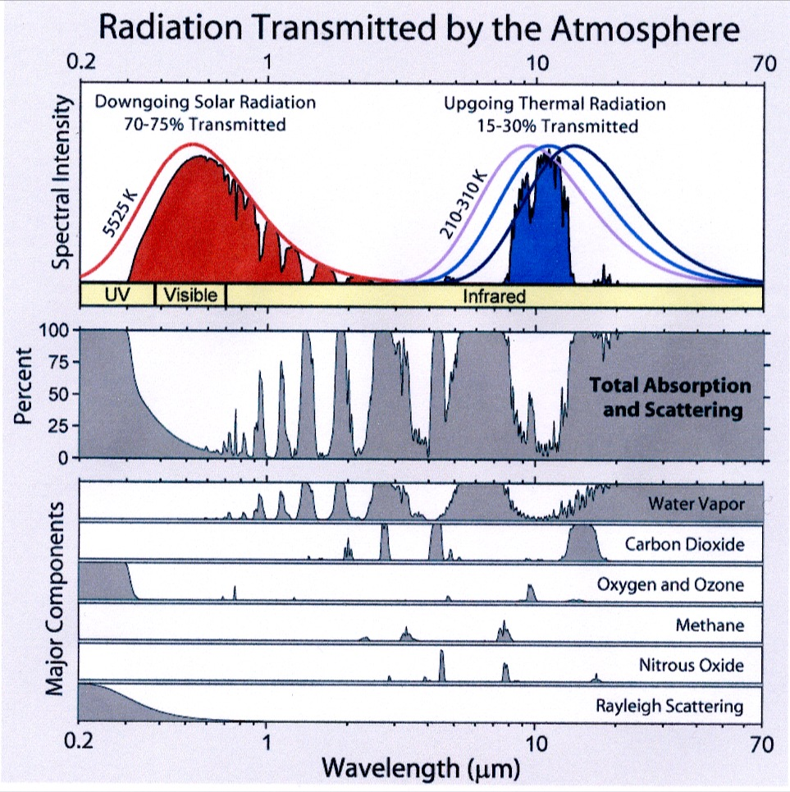
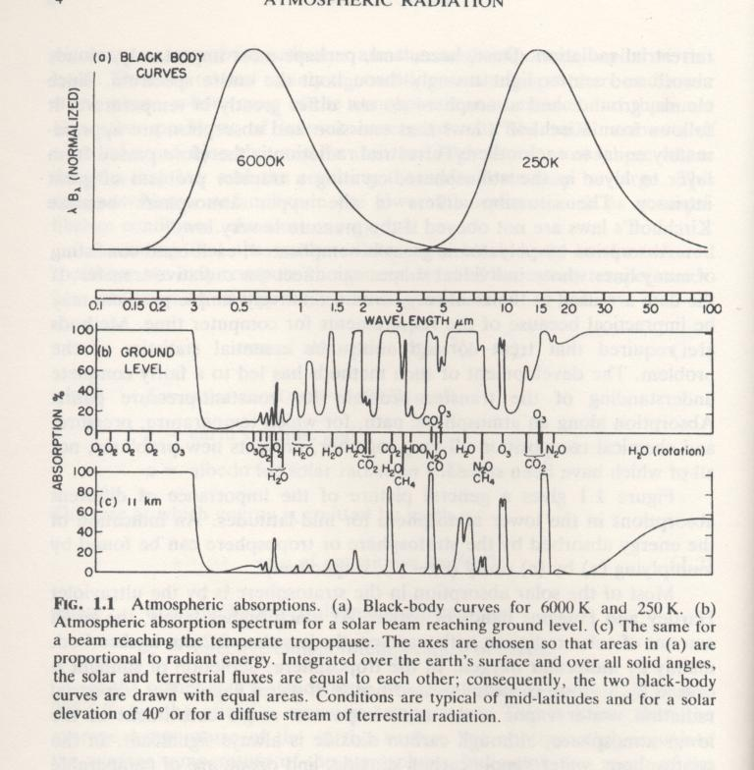

The graph above illustrates the difference between the absorptivity of the total atmosphere(above) and that of just the stratosphere (below). A combination of reduced column mass (100 mb vs 1000 mb); less pressure broadening, and low water vapor mixing ratios combines to produce a handful of important bands.

The LW portion of energy budget:

We did some simple calculations of the LW impact of the atmosphere, assuming that the entire infrared part of the spectrum had a constant emissivity (i.e. graybody assumption). Here is a more accurate picture of how the 70% of solar radiation absorbed by the planet is returned to space in the infrared. Remember this 70% is divided such that 19% goes into the atmosphere, and 51% into the surface. On the other hand, of the 70% returned to space, only 6% comes from the surface directly, through the 8-13 μm window. The remaining 64% is emitted upward by the atmosphere itself. This is the greenhouse effect. The way the surface gets the additional 45% to the atmosphere is through three heat transfer mechanisms. The first, accounting for 15% of the total solar insolation, is through the excess net IR radiation at the surface (surface upward minus atmosphere downward). The remaining 30% is carried upward through evaporation (23%) and conduction (7%). The atmosphere emits down to the surface, but this is not shown in this graph. Instead it shows that the difference between the upward emission by the surface and the downward emission by the atmosphere yields a net return of 15% out of the needed 51%. The remainder is emitted by clouds and greenhouse gases in the atmosphere.
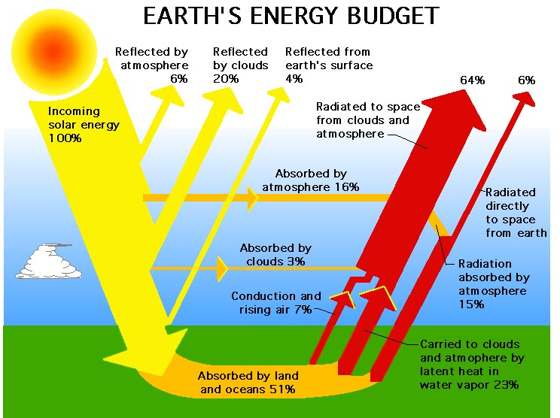

Kiehl and Trenberth, 1997
Remember, since heat transfer (radiative or otherwise) only occurs from high to low temperatures, we can use the radiative heat transfer as a proxy for temperature difference between the surface and the atmosphere. Thus we have defined the greenhouse effect as the excess radiation the surface emits to the atmosphere beyond what is needed to be emitted to space to balance the solar absorption (Ramanathan et al, 1989).

G = F(surface) – F(TOA) = σT_{S}⁴ - σT_{E}⁴.

The value of G = 155 W m⁻². In a very loose sense, we can break down the present day greenhouse effect (assuming a fixed temperature profile) into the role that each greenhouse gas and clouds play in this quantity. H₂O is responsible for 51 Wm⁻², Clouds 30 Wm⁻², CO₂, 24 Wm⁻², O₃ 7 Wm⁻², and the trace GHGs 4 Wm⁻². It is useful to break this down spectrally, to see how the various absorption bands in the IR carry this out. It is important NOT to interpret these numbers as the “greenhouse effect” of those gases, since there are many complicated feedbacks that control surface-atmosphere temperature differences, and the greenhouse effect is, in its essence, linked to a temperature difference between the surface and atmosphere, not to the longwave flux per se, which is chosen as a convenient measure of temperature difference. A better way to understand what these numbers mean is to explore the spectral “radiative forcing of the atmosphere” in the infrared.

G_{λ} = F_{λ}(surface) – F_{λ}(TOA).

First we show the spectrum at the TOA (for clear+cloudy conditions) compared with that at the surface. Data are from Kiehl + Trenberth (BAMS, 1997)

The upper curve is that emitted by the surface, globally averaged, which is very close to the Planck curve for average surface temperature. The planetary emission varies all over the place, simply because emission in optically thick regions (τ >> 1) comes from those layers of the atmosphere where τ ~1, but not those layers where τ >> 1. (The transmission from the lower, warmer layers will only be exp(-τ*1.66), which will be very small as τ >> 1. As a result of this, we see the atmosphere radiating much less in the CO₂ and O₃ bands, simply because the upper, colder parts of the atmosphere are responsible for this emission. In the 8-13 μm window, the emission comes from a combination of the surface and the tops of clouds, averaging to be a colder temperature than the surface, but warmer than that of the strong bands of the greenhouse gases.

Taking the difference between the two curves, we have the spectral greenhouse effect, called a radiative forcing by Kiehl and Trenberth. Despite that H₂O has so many strong absorption bands, its effect is limited compared to that of CO₂ because it is concentrated in the lower, warmer regions of the atmosphere.

Now let’s examine in detail what controls the effective emitting temperature of these various spectral regions. This is important not only for understanding the greenhouse effect and energy budget, but also for remote sensing of the atmospheric temperature profile.

We begin by considering the transfer equation in the infrared, including only emission and absorption. This is very similar to the transmission equation used to derive Beer’s law, but we will include the emission by the layer in addition to the extinction. We have

dI_{ν} = -I_{ν}dτ_{ν}/μ + B_{ν}(T)dτ_{ν}/μ

This equation simply states that a beam traversing (downward) through a thin layer will be reduced by the extinction of the layer, but then the beam will also be increased by the emission by the layer. (Because we are in LTE, α_{ν} = ε_{ν}, and we can use optical depth for both the emissivity and the absorptivity.)

Now let’s consider the perspective of a satellite in space looking downward. For this case μ = cosθ < 0, because the radiation is going upward. We have

$$\frac{{\text{dI}}_{ν}}{{dτ}_{ν}}+\frac{I_{ν}}{μ}=\frac{B_{ν}(T)}{μ}$$

Since we are used to thinking about μ > 0, let’s just rewrite this

$$\frac{{\text{dI}}_{ν}}{{dτ}_{ν}}−\frac{I_{ν}}{|μ|}=−\frac{B_{ν}(T)}{|μ|}$$

The solution to the homogeneous equation is just Beer’s law

$$I_{ν0}=I_{ν}e^{{−τ}/|μ|}$$

where we can think about this as solving for the TOA radiance given the upward emission at some level τ. Still treating I_{ν} = I_{ν}(τ), and taking the cue from the homogeneous solution, we get

$$\begin{aligned}I_{ν}e^{{−τ}/|μ|}=I_{ν0} \\ \frac{d\left(I_{ν}e^{{−τ}/|μ|}\right)}{dτ}=0 \\ \frac{{\text{dI}}_{ν}}{dτ}e^{{−τ}/|μ|}−\frac{I_{ν}}{|μ|}e^{{−τ}/|μ|}=0\end{aligned}$$

we find the solution to the inhomogeneous equation

$$\begin{aligned}\frac{{\text{dI}}_{ν}}{{dτ}_{ν}}e^{{−τ}/|μ|}−\frac{I_{ν}}{|μ|}e^{{−τ}/|μ|}=−\frac{B_{ν}(T)}{|μ|}e^{{−τ}/|μ|} \\ \frac{d\left(I_{ν}e^{{−τ}/|μ|}\right)}{{dτ}_{ν}}=−\frac{B_{ν}(T)}{|μ|}e^{{−τ}/|μ|}\end{aligned}$$

This can be integrated if we know T(τ), our temperature profile

$$\begin{aligned}I_{ν}(τ_{ν})e^{−τ\text{'/}|μ|}|_{0}^{τ}=−\int_{0}^{τ}{\frac{B_{ν}(T)}{|μ|}e^{−τ\text{'/}|μ|}dτ'_{ν}} \\ I_{ν0}=I_{ν}(τ_{ν})e^{{−τ}/|μ|}+\int_{0}^{τ}{\frac{B_{ν}(T)}{|μ|}e^{−τ\text{'/}|μ|}dτ'_{ν}}\end{aligned}$$

We now examine our “real” boundary condition, which is at τ=τ_{s}, for which I_{ν} = ε_{s}B_{ν}(T_{s})

$$I_{ν0}=B_{ν}(T_{s})e^{{−τ_{s}}/|μ|}+\int_{0}^{τ_{s}}{\frac{B_{ν}(T)}{|μ|}e^{−τ\text{'/}|μ|}dτ'_{ν}}$$

This solution is one we could have obtained from a much more intuitive path. It simply says that the emission out the TOA is simply the emission from each layer reduced by the transmission of the atmosphere above that layer.

This expression is nothing more than a weighted average Planck emission, where the weighting is given by exp(-τ/μ). For spectral regions where dτ/dz is very large (i.e. large k_{ν}), the averaging region will be restricted to the upper regions of the atmosphere. When k_{ν} is smaller, the lower atmosphere and the surface will play greater relative roles.

We can use this behavior to remotely sense the vertical profile of temperature in the atmosphere and of the surface. By choosing a region where τ~=0 (typically near 11 μm), one can infer the temperature of the surface, as long as ε_{s} is known. The vertical temperature profile is obtained by choosing a handful of spectral regions where k_{ν} is well known as a function of pressure, and for which the gas profile is well known. An example comes from the book.

At each chosen wavelength, an intensity is observed that represents a vertically weighted average Planck intensity. This intensity can be converted by the Planck function directly into an “effective radiating” temperature for that wavelength, seen in figure 4.33a. The variation in this temperature from one wavelength to another is entirely controlled by the weighting function for that wavelength (determined by k_{ν}) and the temperature of the atmosphere in the regions corresponding to that weighting function.

If you know the weighting functions and the temperature profile, you can calculate the expected intensity. Likewise, by inverting the weighting functions, you can calculate a temperature profile given known intensities, depending on the eigenvalues associated with the of the principal components of the set of weighting functions, which control the robustness of the inversion. This “retrieved” temperature profile is not going to be a unique solution, and is subject to large uncertainties related to the orthogonality of the weighting functions and the uncertainties in the problems. That is, there are going to be multiple temperature profiles that could reproduce the observed intensities, within the uncertainties. However, a proper inversion technique will produce a coarse, average vertical profile with appropriate uncertainties at each level. (And if the analyst is good, it will also include the co-variance of uncertainties in the profiles, which can be used to infer uncertainties in important average quantities, such as overall lapse rate or integrated heat content. Take Chris Castro’s statistics class for details on these inversion techniques.

The outgoing radiative flux is simply the outgoing intensity averaged over all upward-directed intensities (weighted by μ, of course). For the same reason that increasing k_{ν} produces smaller TOA radiances, decreasing μ also produces smaller TOA radiances at slant angles. This is called limb darkening. You are essentially choosing a path that is longer through the upper atmosphere than if you were looking straight down.

Due to the isotropy of blackbody radiation, the radiative transfer of Flux density can be done in a similar manner as for intensity, but including an average value of 1.66 for 1/μ. This is simply a weighted average value of μ that simulates transfer through optically thick atmospheric layers well.

For a better understading of how IR and solar radiative transfer affects Earth’s energy budget, including the important effects of clouds, I recommend reading the following two articles:

Ramanathan et al., Physics today, 1989
Kiehl and Trenberth, BAMS, 1997.

Both of these will be posted on the course web-directory.

