L19 – Sources of Radiation

Blackbody Radiation

A blackbody is a surface that doesn’t reflect any of the radiation incident upon it – that is, the radiation emitted outward from the surface is completely independent of the radiation incident on that surface. Black paint attempts to achieve this – at least across the visible spectrum. The more classic example is a cavity – a small opening to a much, much larger chamber. Any light entering that cavity will have a minimal chance of ever finding its way back out again before being absorbed in the interior.

The term “blackbody” does NOT mean that the surface doesn’t emit any radiation. Quite to the contrary, all surfaces emit some radiation (unless they are perfectly reflective – which will be discussed later). In fact, a blackbody is in a state of thermodynamic equilibrium, and emits radiation according to its thermodynamic temperature T. By the 2nd law, we understand that the temperature of the radiation in a cavity must equal the temperature of the walls, if they are in equilibrium.

We start with the Planck function, which describes the distribution of blackbody radiation with the wavelength of light. If you consider some small range of wavelengths between λ and λ + dλ, then the intensity (W m⁻² Sr⁻¹) emitted by a blackbody in that range is given by

$$B_{l}(T)dλ=\frac{2{\text{hc}}^{2}}{λ^{5}\left(e^{{\text{hc}}/{kλT}}−1\right)}dλ$$

letting dλ → 0, we have the spectral flux density (W m⁻² m⁻¹), where the extra m⁻¹ comes from the “per unit wavelength”. h is Planck’s constant = 6.626 x 10 ⁻³⁴ J s, and k and c are the familiar Boltzmann constant and the speed of light. It is often convenient to rewrite this as:

$$B_{l}(T)dλ=\frac{c_{1}λ^{−5}}{π\left(e^{{c_{2}}/{λT}}−1\right)}dλ$$

where c₁ = 3.74x10⁻¹⁶ W m² Sr⁻¹ and c₂ = 1.45x10⁻² m K.

The shape of this function for a few very hot temperatures is given in figure 4.6 of W+H.

There are several properties of the Planck function that are important.
1) At ALL wavelengths, the Planck function is an increasing function of T.
2) At short wavelengths, λ << hc/kT, it is a very, very strong increasing function of T.
3) This plays out such that at any given temperature, there is a maximum in B_{λ}. that occurs at

$$λ_{m}=\frac{\text{2897}\text{ K }μm}{T}$$

This is called Wien’s displacement law. We see this in the warming of an oven coil as it ranges from deep red through orange.

4) The total flux emitted, F, is obtained by integrating the Planck function over all wavelengths (and over the emitting hemisphere, weighted by μ)

$$\begin{aligned}F=π\int_{0}^{∞}{B_{l}(T)dλ}=\int_{0}^{∞}{\frac{c_{1}λ^{−5}}{π\left(e^{{c_{2}}/{λT}}−1\right)}dλ} \\ ={σT}^{4}\end{aligned}$$

where σ = 5.6696 x 10⁻⁸ W m⁻² K⁻⁴ is the Stefan-Boltzman Constant, corresponding to this Stefan-Boltzmann Law

Note how the very rapid increase with temperature of the shorter wavelengths plays out into a T⁴ dependence on temperature for the total flux emitted.

We can estimate the temperature of the radiating part of the Sun’s surface (the photosphere) in two ways. One is to look at where the peak spectral density is, using Wien’s law, and the second is to estimate it from the Stefan-Boltzmann’s law. Doing so yields temperatures of 6100 K and 5800 K, respectively. Although the Sun’s surface is not a Blackbody, we can get a clear idea of its temperature from these measurements.

The ocean surface is also behaves very much like a blackbody, but at much, much colder temperatures. The warmest open-ocean sea surface temperatures are 303 K, for which the emission is 480 W m⁻².

Emission and absorption by non-blackbodies.

A surface that reflects or transmits some of the radiation incident upon it is not a blackbody. The fraction that is absorbed is called the absorptivity, α. This may be a function of wavelength, giving the object some color, i.e. α = α_{λ}.

Non-blackbodies always emit a smaller amount of radiation than a blackbody does. We define the ratio of a body’s thermal emission to the blackbody emission as the body’s emissivity, ε_{λ}.

I_{λ} = ε_{λ}B_{λ}(T)

Kirchoff’s Law (see separate handout) tells us that for non-black bodies, α_{λ}.= ε_{λ}.

This is not the same thing as saying that the emission equals the absorption. Just the fraction of incident radiation absorbed equals the fraction of a blackbody radiation that will be emitted.

The classical example of this important difference is that of a planet. On climate timescales, a planet will absorb about as much radiation as it emits, unless it has some significant internal heat source, such as Jupiter. The amount it absorbs is given by the absorptivity πR_{p}²αS₀, where S₀ is the solar flux at that planet’s mean distance from the Sun, and R_{p} is the radius of the planet. The amount the planet emits is equal to its blackbody emission, times the emissivity, times the total surface area of the planet. In equilibrium,

πR_{p}²<α>S₀ = 4π R_{p}²<ε>σΤ⁴

Since we don’t really know the emissivity of a planet’s radiating surface, we define an effective radiating temperature for a planet, which assumes that the emissivity is unity. This radiating temperature usually approximates the temperature of the atmosphere or surface. Thus we have

σΤ⁴ = <α>S₀/4

for a planet in equilibrium. For the earth we know that S₀ = 1368 Wm⁻². For other planets, we need to be aware of the 1/r² law for radiative fluxes – the farther away and more reflective a planet is, the cooler its radiating temperature will be.

Note that assuming emissivity = 1 does not require that <α> = 1. This is because the Earth emits in a different part of the spectrum than it absorbs, so this doesn’t violate the requirement that α_{λ} = ε_{λ}.

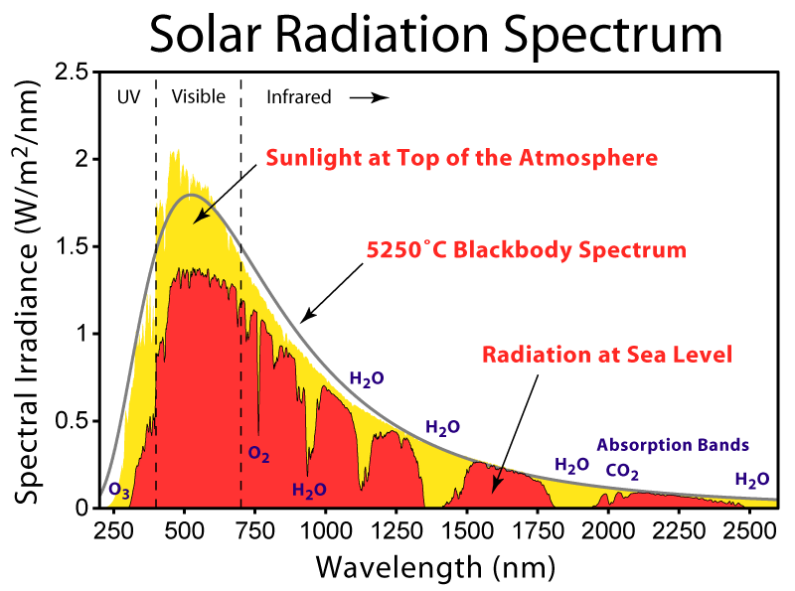

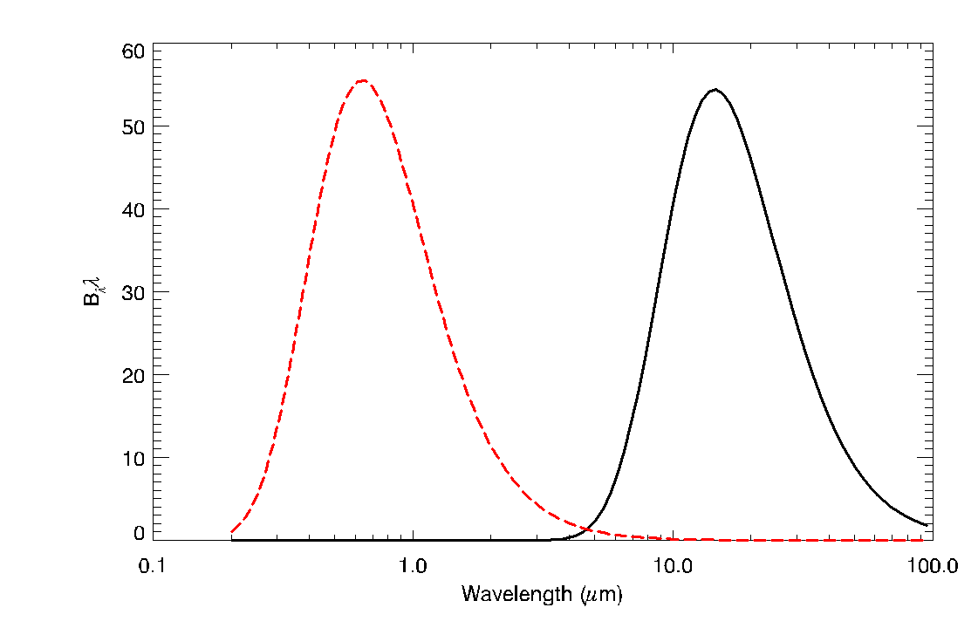

Above is the Planck function of 255 K along with the Planck function of the Sun, after the solar irradiance has been normalized by a factor of (α/4)(R_{s}/D_{ES})², for reasons discussed above. Note that when plotting B_{λ} on a log-scale, the area under the curve is no longer proportional to the flux density. That is, dF = B_{λ}dλ is the flux density from λ → λ + dλ, and the area under the curve from λ + dλ is B_{λ}dlnλ = B_{λ}dλ/λ. For this reason, we really want to plot B_{lnλ}dlnλ on this curve, so the area under each curve is proportional to the flux density of the emission or absorption. B_{lnλ}dlnλ = B_{λ}dλ = dF.  From this identity we get B_{lnλ} = B_{λ}λ., which is what we plotted above.

That the atmosphere absorbs differently in the infrared than it does in the visible is called ‘selective absorption’. It allows the Sun’s heat (in the form of solar energy) to transport through the atmosphere directly to the Earth’s surface, but does not allow the Earth’s radiative heat (in the form of longwave, or terrestrial) energy to return this energy back out to space without first being absorbed by the atmosphere. Due to this heat transfer barrier, the Earth’s surface must transfer the heat to the atmosphere, and then the atmosphere can return it to cold space. The only way for heat to transfer from the surface to the atmosphere is if the surface is warmer than the atmosphere. This phenomenon is called the greenhouse effect – selective absorption makes the atmosphere more transparent to solar radiation than infrared radiation, and thus the surface must be warmer than the atmosphere.

We can construct an energy balance model that assumes that on climate timescales the Earth’s surface and Atmosphere are in “radiative equilibrium”, meaning that they absorb as much radiation as they emit. The simplest model is discussed in the book and will be derived in class.

