Basic Properties of the Atmosphere

What are the key factors that make Earth and its atmosphere different from other planets?

The list you come up with may include the following properties (but not in order).
- Composition
- Total Mass
- Pressure
- Gravity
- Thickness
- Radiation
- Temperature
- Cloudiness / precipitation
- Surface – Land vs. Ocean, etc.
- Size of Planet
- Rotation Rate

We’ll talk about these in a descriptive sense at first – highlighting the interrelationships among them – and then develop our understanding of their properties and behavior more deeply in subsequent lectures.

Atmospheric Compostition

The atmosphere is a mixture of gases, aerosol particles, and “hydrometeors” (aka clouds and precipitation). We divide these constituents into “permanent” and “variable” types.

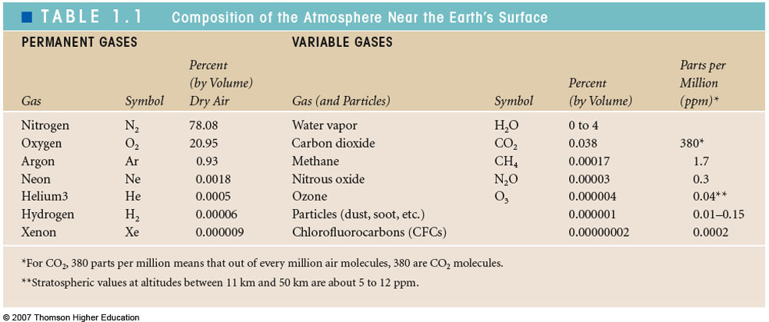

Each gas, whether labeled permanent or variable, has sources and sinks. The permanent ones are “permanent” because the amount introduced or removed from the atmosphere is a tiny fraction of the total residing in the atmosphere. As a result, their relative concentrations remain constant. In fact, we can define an atmospheric lifetime, τ, for any atmospheric component based on the rate at which it is cycled through the atmosphere. We define

$$τ=\frac{Q}{R}$$

where

$$\frac{\text{dQ}}{\text{dt}}=P−R$$

Q is the total mass of the substance in the atmosphere (say, in teragrams), P corresponds to the amount of a substance introduced to the atmosphere per unit time (teragrams per year, say), R is the removal rate. You can think about τ as the time it would take to remove the species from the atmosphere if the source were suddenly stopped but the removal rate, R, remained constant. Alternatively, τ is the average lifetime of a molecule of the species if P and R are constant in time.

The lifetime of the permanent gases is geological. The lifetimes of the variable gasses ranges from decades to as little as hours. For example, a CO₂ molecule only resides in the atmosphere for a few years before it is absorbed by the oceans or land plants. H₂O molecules evaporated from the surface last in the atmosphere for a week or so before condensing in a cloud and precipitating out as rain.

Of the variable gases, H₂O is, by far, the most abundant. Near warm bodies of water, H₂O can comprise 4% of the air’s mass. In very cold places, like the tropical tropopause, or the Antarctic continent, only fractions of a percent of water will remain. This is due to the “Clausius-Clapyron” thermodynamic relation, which we will discuss in later weeks. The rest of the variable gases combined don’t even contribute 0.1% of the atmosphere’s mass. It is useful to remember that about 280 ppm (parts per million, by volume) of CO₂ was around before the industrial revolution. Today we are pushing 390 ppm.

Even though the variable gases make up such a small part of our atmosphere, they are the most critical for determining conditions on the Earth’s surface. The permanent gases are much more boring. N₂ plays a very minor role in the atmosphere, despite its dominant abundance. It doesn’t absorb any sunlight except in the ionosphere, where it filters out some of the sun’s most high-energy photons. It doesn’t act as a greenhouse gas. It doesn’t often react with any other chemical species in the troposphere, except during lightning strikes and within internal combustion engines. Tiny bacteria in soils have managed to unlock its triple bond to create other forms of nitrogen that can be used in protein synthesis and other biological processes, but this is slow. O₂, despite its reputation as being highly flammable, and a key component of animal’s energy needs, is also remarkably inert in the atmosphere. The main “reactivity” of Oxygen in the troposphere occurs when it is split up in the upper stratosphere creating free O atoms (called “radicals”) that combine with another O₂ to form ozone (O₃). So O₂ is mainly of concern in biological processes. O₂ is also pretty minor when it comes to the absorption and emission of radiation, except high in the stratosphere and ionosphere, where it absorbs very high energy UV photons. Argon (Ar) is a “noble gas” meaning it sits on the rightmost column of the periodic table and has a full complement of valence electrons (a full electron shell). This makes it radiatively and chemically inert. So it and the other noble gases in the atmosphere (Ne, He, Xe) really don’t come up too often. Perhaps the most obvious direct roles of the permanent gases (besides oxygen’s role in sustaining life) are: 1) contributing mass, weight, and heat capacity to the atmosphere, and 2) scattering light and creating our “blue sky”.

On the other hand, the trace gases are the most interesting for atmospheric radiation and atmospheric chemistry. Most of the greenhouse effect is due to H₂O (NOT CO₂!). H₂O is also a critical component in a number of tropospheric chemical reactions. Without H₂O vapor, we wouldn’t have clouds and precipitation, which sustain life on land and add considerably to the atmosphere’s reflectivity and greenhouse effect. CO₂ is also a greenhouse gas, and it is important because its abundance in the climate system can be influenced by human activities. O₃ is responsible for the temperature structure of the stratosphere, shielding the Earth’s surface from harmful UV radiation, and causing serious air quality problems in some urban areas. It is also an important greenhouse gas. We will also talk about CH₄, N₂O and NO₂ when we get into atmospheric radiation and chemistry, as these trace species and their byproducts also play critical and complex roles in both the greenhouse effect and in atmospheric chemistry.

Atmospheric aerosols are measured in μgs m⁻³ (air is measured in kgs m⁻³ and seawater is ~1000 kg/m⁻³). Despite their very low concentration, they are just the right size to scatter light more efficiently (per unit mass) than any other substance in the atmosphere. They contribute to haze and reductions in visibility. They can be a health hazard in high concentrations. As mentioned last lecture, they are also the seeds upon which all cloud drops form, and thereby have an enormous effect on the formations of clouds and precipitation. Like CO₂, their atmospheric abundance is strongly affected by human activities, and thus are an important mechanism for climate change through their effect on clouds and sunlight.

Quantifying atmospheric composition

Suppose we label each relevant molecular species in the atmosphere with an index i. We measure the total “number concentration” of each species (units molecules m⁻³) as c_{i}. The mass concentration, or gas density, is denoted ρ_{i}. and has units of kg m⁻³. Each molecular species has a unique molecular mass, m_{i}, such that ρ_{i}. = m_{i} c_{i}. This is the mass of the molecule, and is incredibly small. For convenience of scale, we will often consider the mass and concentration of 6.022x10²³ molecules, which is known as the “molecular weight”, M_{i}. This number of molecules, called the Avogadro number, N_{A}, is equivalent to one mole. We will sometimes use # molecules, and sometimes moles, depending on the application. The molar concentration, n_{i}, is related to # concentration by c_{i} = N_{A} n_{i}. Likewise, ρ_{i}. = M_{i} n_{i}.

Avogadro’s number is chosen so that 1 mole of C-12 is exactly 12 g (0.012 kg). Atmospheric N₂ weighs just about 28 g/mole, and O₂ weighs about 32 g/mol. The molecular weight of air is an average of the molecular weights of each of its constituents (see W+H Eq. 1.7). The average is done so that the “average” molecular weight properly relates the density with the concentration. For “dry air”, we have

$$M_{d}=\frac{ρ_{d}}{n_{d}}=\frac{\sum{n_{i}M_{i}}}{\sum{n_{i}}}$$

What is the “effective” molecular weight of moist air (i.e. air having some water vapor)? What quantities do you need to have on hand, and how would your represent this?

Gravity and Pressure

We will discuss gravity in some detail in later lectures, but first let’s examine some first order effects.

Throughout the troposphere, the “weight” of an object (i.e. the force on the object due to gravity) is well represented by the following approximation:

F_{g} = -mg

where F_{g} is measured in Newtons, m is the object’s mass, and g is the familiar (downward) gravitational acceleration which is about 9.8 m s⁻². [We will later refine this in three ways: 1) g depends on where your location is on the earth, since it’s not spherically symmetric; 2) an object’s perceived “weight” also includes the centrifugal acceleration due to the rotation of the Earth; and 3) g will also depend weakly on altitude in the atmosphere due to Newton’s 1/r² law of gravity]

Pressure is defined as a force exerted on a surface divided by the area of that surface. So a cubic meter tank of water sitting on the ground has a mass of 1000 kg, a weight of 9,800 N, and exerts an average pressure on the ground of 9,800 N/m² = 9,800 Pa. In atmospheric science we often express pressure with units of millibars, which is equal to 1 hPa (hecto = 100x). So the pressure under the tank is 98 mb. Air pressure is the force that the atmosphere constantly exerts on any surface in contact with it, per unit area of the surface. Sea level pressure is about 1013 mb (1.013 x 10⁵ Pa), and air pressure here in Tucson is ~925 mb. Because air is a fluid, the pressure is the same in ALL directions. For solids, this is not true.

Air has mass, and so air also feels the downward pull of gravity. So why don’t all the air molecules just come crashing down to the earth’s surface? There are some subtle answers to this question using thermodynamic arguments. But the simple answer involves the “pressure gradient” force. Consider a column of atmosphere perfectly at rest. Since the air is not falling due to gravity, we know that another force must oppose this. Consider some small parcel of air within this column of height dz and of area A (i.e. 1 m²). We know the mass of this column to be m = ρV = ρAdz. Thus the gravitational force is F_{g} = -gρAdz. We also know that the air beneath our parcel exerts an upward force on the lower boundary of p(z)A, and the air above our parcel exerts a downward force on the parcel of -p(z+dz)A. For the air to remain at rest, we must have no net force.

-gρAdz –p(z+dz)A + p(z)A = 0

rearranging, we get

$$\frac{p(z+\text{dz})−p(z)}{\text{dz}}=−ρg$$

Choosing dz to be arbitrarily small, the left hand side (LHS) is equal to dp/dz

Thus,

$$\frac{\text{dp}}{\text{dz}}=−ρg$$

Integrating from some altitude z to the top of the atmosphere (where p = 0), we have

$$p=\int_{z}^{∞}{ρ\text{gdz}}'$$

This basically says that the pressure at any altitude is equivalent to the weight of the air in a column above it, divided by the area of that column – if we can assume the air is at rest and isn’t feeling any other major forces. Thus pressure decreases monotonically with height. Each step you take upward relieves you of the weight of the air you just rose above.

Assuming g is constant and dividing both sides, you end up with the mass of the column above you (per unit area) being equal to p/g. Taking a mean surface pressure of 985 mb and integrating over all columns above the Earth’s surface (R = 6371 km), you end up with: a total mass of the atmosphere of 5.1x10¹⁸ kg. Compare this number to the total mass of the Earth: 6x10²⁴ kg and that of the oceans: 1.4x10²¹ kg.

This is the simplest form of the “hydrostatic” equation. For the oceans, where ρ is practically constant, it predicts that water pressure will rise linearly with depth. In the atmosphere, density depends on pressure itself (and temperature), via the ideal gas law.

p = ρRT

where R is the gas constant for air. At lower altitudes, where pressure is higher, we know that the density will also be higher. That means each unit of height will carry more weight, making the pressure gradient even steeper. The math makes it plain:

$$\frac{\text{dp}}{\text{dz}}=−ρg=−\frac{\text{pg}}{\text{RT}}$$

Noting the identity that

$$\frac{1}{p}\frac{\text{dp}}{\text{dz}}=\frac{d\text{ln}p}{\text{dz}}$$

We end up with

$$\frac{d\text{ln}p}{\text{dz}}=−\frac{g}{\text{RT}}=−\frac{1}{H}$$

Where we define H as the “scale height” of the atmosphere. This simply says that the log of the pressure decreases linearly with height (for constant temperature). If consider an isothermal atmosphere (i.e. constant temperature) we can integrate and yield

$p=p_{0}\text{exp}\left(−\frac{z}{H}\right)$; for constant temperature

Now since temperature (and H) aren’t constants, then we know that this is just an approximation. But temperature does fall within a fairly narrow range, and thus this “hypsometric equation” does a fair job for 0th order purposes.

