Below is a copy of Friday’s weather sounding. We’ll go over a few of its features with respect to static stability. It is plotted on a “skew-T/Log-p” plot. Essentially, it plots temperature on the horizontal axis, log pressure on the vertical axis and then tilts the plot to account for the rapid decrease of temperature that occurs through the troposphere.

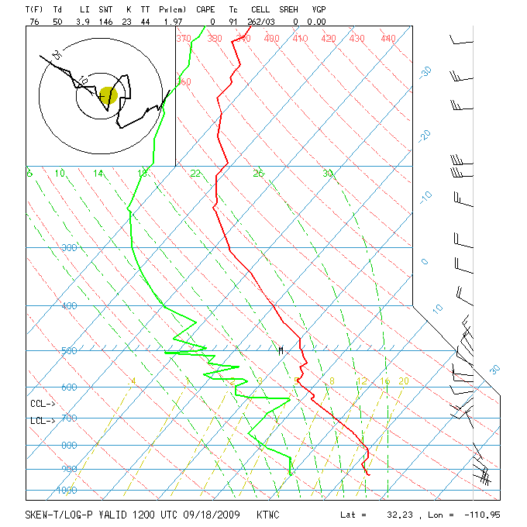
Red line – observed temperature; green line – observed dewpoint temperature; horizontal blue lines – pressure; diagonal blue lines – constant temperature; red-dashed – lines of constant potential temperature (following a dry adiabat); green-dashed – lines following a moist adiabat; light dashed line is (I guess) lines of constant specific humidity, where if you pick a spot on the green line and lift it along the light green dashed line to the red line, you would have found the lifting condensation level for that parcel.. When the observed temperature is parallel to the dry adiabat, the air is likely to have recently been well mixed. The stratosphere begins when the observed temperature gets isothermal (follows the diagonal blue lines). You almost never see a case where the red line crosses the red-dashed line from above, because this would represent an unconditionally unstable case, which blows up very rapidly.

Moisture

Up to this point we’ve talked about moisture content in terms of the mass of moisture, m_{v} (kg), its density, ρ_{v}, (kg m⁻³) and the molar concentration of vapor, n_{v} (mol m⁻³). Because water vapor is tri-atomic, and light, it also has a higher heat capacity than that of dry air,

c_{v,w} = (n/2)R*/ M_{w} = 1463 J/(kg K)
c_{p,w} = (n/2+1)R* / M_{w} = 1952 J/(kg K)

Note that three free atoms would have 9 degrees of freedom. Bound together as H₂O, the effective value to use for number of degrees of freedom is about 6.3, greater than the diatomic value of 5 used for N₂ and O₂. The extra 1.3 degrees of freedom in this diatomic molecule is related to a third axis of rotation, plus a little energy that can be stored in vibrational modes (bending and stretching).

The total heat capacity of air is then

c_{p,a} = (c_{pw}m_{v} + c_{p}m_{d})/m

It becomes convenient to define other measures of water vapor in air. The one we will use most heavily is specific humidity, q = m_{v}/m = ρ_{v}/ρ. Because specific humidity relates the amount of vapor to the amount of dry air, it doesn’t change when pressure or temperature change—it only changes when the parcel mixes with other air, or if there are moist processes causing evaporation or condensation.

We often see specific humidity in units of g/kg, typically with single or double digit values.

Another very important measure is the partial pressure, which can be derived from the other parameters using the ideal gas law

e = n_{v}R*T = (ρ_{v}/M_{v})R*T

We can also relate the partial pressure of water vapor to the ambient pressure

e = (ρ_{v}/M_{v})R*T = (qρ/M_{v})R*T
= q(M_{A}/M_{v})p

At its essence, the partial pressure is the total pressure times the mole (or volume) fraction due to water vapor. Its unique importance is that the Clausius-Clapyron equation gives a thermodynamic relationship between the partial pressure at the surface of water and the temperature of the water. This is very important, because surfaces of water abound in the atmosphere and at the surface, and thus constitute a very firm boundary condition (source and sink) on the vapor content of water in the atmosphere.

The Clausius Clapyron relation tells us that an interface between liquid water and water vapor is in equilibrium when the vapor pressure above the water is equal to e_{s}(T). The formula is

$$\frac{{\text{de}}_{s}}{\text{dT}}=e_{s}\frac{L_{C}M_{v}}{R∗T^{2}}'$$

L_{C} is the latent heat released when water vapor is condensed into liquid. It is a function of temperature, albeit a fairly weak one. Over short temperature intervals, we can treat it as a constant having a value of 2.5x10⁶ kg. Integrating yields the approximation

$$\begin{aligned}e_{s}(T)=e_{s}(T_{0})\text{exp} \\ \end{aligned}$$

We will discuss entropy in a later lecture, and will see how this comes about.

One thing important about this relationship is that it shows a very rapid increase in humidity with temperature. The fractional change in saturation vapor pressure per degree change in temperature is about 6%. (i.e. (5400 K)/T²). This means that a simple increase of 1 degree in global mean surface temperature will cause a ~6% increase in water vapor at that lower boundary. If this perturbation were to increase proportionately throughout the atmosphere, we would expect a much stronger greenhouse effect and perhaps a stronger hydrological cycle. It is unclear how dynamics might change the relative humidity in response to a global temperature change, however.

Water vapor “staturation”, S, is defined as the ratio of vapor pressure to saturation vapor pressure.

S = e/e_{s}(T).

Relative humidity is the same thing as saturation, but is conventionally expressed in units of %. Convince yourself you would get the same value of saturation if you took the ratio of ambient to saturated: vapor density (ρ_{v}/ρ_{vs}), specific humidity (q_{v}/q_{vs}), or molar concentration (n_{v}/n_{vs}).

Illustration: What is the increase in relative humidity with height for a parcel rising at the dry adiabatic lapse rate?

We have dT/dz = -Γ_{d}. RH = e/e_{s}(T). So dRH/dz = (dRH/dT)(dT/dz) by the chain rule
Also by the chain rule, we get dRH/dT = dRH/de_{s}(T))(de_{s}(T)/dT). In the end, we get

dS/dz = -Γ_{D}(-e/es(T)²)(e_{s}(T)(5400 K)/T²)
= Γ_{D}S[(5400 K)/T²]

This basically says that dRH/dz = RH * (0.06 m⁻¹), or about 1% relative increase in RH per 17 meters. So air at 50% RH will be 50.5% if adiabatically lifted by 17 m.

The inverse of the Clausius-Clapyron equation yields the dewpoint temperature function. e = e_{s}(T_{d}). This is simply the temperature at which ambient humidity would be in saturation. Dewpoint is often reported by weather stations using a dewpoint hygrometer.

Wet bulb temperature is the lowest temperature air can be cooled to via evaporation of water into it. Note that this is different from dewpoint temperature. The psychrometer – a thermometer with a wetted piece of cotton on the bottom – is used to measure wet-bulb temperature. We don’t use this very often.

The final measure of water vapor to be discussed is the column water vapor, usually measured in cm or kg m⁻². 25 kg m⁻² is the measured global average value of water vapor, which converts to 2.5 cm if it were all precipitated out (note that HW#1, based on a HW problem in W+H, is off by a factor of 4 with respect to a global average value). Since ½ the Earth’s area is Equatorward of 30°, the tropics are responsible for the majority of this average value.

Below is a 1992 estimate of global and annual average water vapor, measured in mm.
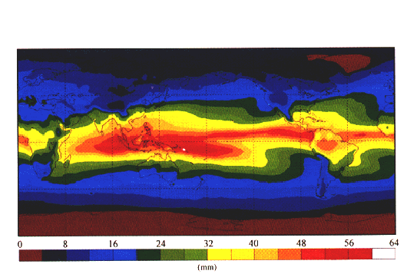

The spatial distribution of column precipitable water largely follows the surface temperature distribution, due to the Clausius-Clapyron relation (remember – a ~6% increase in water vapor per 1 K increase in temperature). The fact that temperature decreases with height in the troposphere causes saturation vapor pressure to decrease with height. The presence of aerosol particles in the atmosphere allows water vapor to condense at ~100% RH, starting cloud formation and eventually precipitation. Thus the decrease in temperature with height due to adiabatic expansion is also responsible for precipitation through the decrease in saturation vapor with height.

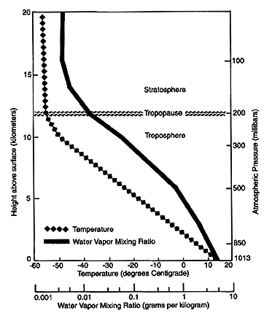

Water vapor releases heat when it condenses. This is called the latent heat of vaporization in W+H, although you will also see it called the latent heat of condensation. The amount of heat released is a weak function of temperature, with a value of about 2.5x10⁶ J/kg at 0°C, and 2.25 x 10⁶ J/kg at 100°C.

When we include moist energy in our treatment of the heat of a parcel, we write

dQ = ρ c_{p}dT - dp + ρ L_{c}dq

In hydrostatic equilibrium, we can write

dQ = ρ c_{p}dT + ρgdz + ρ L_{c}dq

First lets consider the adiabatic cases, when dQ = 0. If dq is also 0, as is the case for cloud-free parcels, this reduces to the familiar expression for the dry adiabatic lapse rate, where an increase in z leads to a decrease in T. Let’s consider a different adiabatic case, in which dz = 0, but dq < 0. This corresponds to condensation at fixed altitude. In this case, dT > 0, indicating that the condensation heats the parcel. A rather artificial case is where dT = 0, dz < 0 and dq > 0, which says that if the parcel is rising isothermally, there must be enough condensation to provide energy for work of expansion.

In the general adiabatic case, dz > 0, dT < 0 and dq < 0. We need an additional constraint on the problem and this is provided by the assertion that dq = dq_{s}(T), which is the same thing as saying that RH = 100%. (We will learn later that this is merely an approximation, but it is a good one for coarse purposes). For RH to equal 100% as temperature is decreasing, there must be a corresponding decrease in saturation vapor pressure, which is achieved by condensation.

The saturation specific humidity is the ratio of the saturation density to air density.
q_{s} = ρ_{s}/ρ_{a}

The saturation density is obtained from the saturation vapor pressure using the ideal gas law.
ρ_{s} = n_{sv}M_{w}
n_{sv} = e_{s}(T)/(R*T)

Using the ideal gas law to relate air density to air pressure, we get
ρ_{a} = pM_{w}/(R*T)

These lead to the following simplification for q_{s}

q_{s} = (M_{w}/M_{A})(e_{s}(T)/p)

Now our goal is to find dq_{s}, which is more easily manipulated through its log…
dq_{s} = q_{s}dlnq_{s} = q_{s}(dlne_{s} – dlnp)
[Note that we have conveniently neglected the sensitivity of molecular weight of air to vapor pressure, which will contribute a very minor term.]

The first term shows that saturation mixing ratio will increase if saturation vapor pressure increases. Note the second term that shows that saturation specific humidity will increase with a decrease in ambient pressure. This might seem counterintuitive, since we know that q doesn’t change with changes in pressure. However, q_{s} is a different beast than q. Whereas q keeps track of the mass of vapor in a given mass of air, q_{s} tracks the mass of water vapor that would be in equilibrium with a flat surface of water per unit mass of air. As pressure goes up and down, saturation vapor pressure doesn’t notice. It is only sensitive to temperature. However, the dry air mass is fluctuating with pressure, causing the constant saturation vapor pressure to be a relatively larger fraction of the air pressure as pressure goes down. To explore this further, consider a chamber that is partially filled with water and is held at temperature T. In equilibrium, the total pressure will be p_{d} + e_{s}(T), where p_{d} is the pressure due to the dry air. Now we evacuate the chamber of half the air. At this very instant the pressure will be p_{d} /2 + e_{s}(T)/2, and q will be the same as before since there has been no condensation or evaporation (yet). But the water surface will still have a vapor pressure of e_{s}(T). So over time, water will evaporate and q will increase to a new, higher equilibrium value, qs(T,p_{f}).

Now we go back to the moist parcel that is ascending adiabatically. From Clausius-Clapyron, we have
dlne_{s} = L_{c}M_{w}/(R*T²) dT

And hydrostatic pressure for ideal gases can be written as:
dlnp = -dz/H

Where H is the scale height of the atmosphere = R*T/(M_{A}g). Thus our expression for dq_{s} can be written in terms of dT and dz, which are the same independent variables used in our dry adiabatic equation.
dq_{s} = q_{s}(L_{c}M_{w}/(R*T²) dT + dz/H)

Subbing all this into the energy conservation equation yields,

0 = c_{p}dT + gdz + L_{c}q_{s}[L_{c}M_{w}/(R*T²) dT + dz/H]

Now we can solve for dT/dz = -Γ_{M}, which is called the moist adiabatic lapse rate…

dT/dz = - (g + L_{c}q_{s}/H) / [c_{p +} L_{c}q_{s}(L_{c}M_{w}/(R*T²))]

At this point, it is useful to note the g/c_{p} is the dry adiabatic lapse rate, Γ_{D}, and that H is a function of gravity. After some algebra, we get,

$$Γ_{M}=Γ_{D}\frac{1+\frac{L_{C}q_{s}M_{A}}{R∗T}}{1+\frac{L_{C}q_{s}}{c_{p}}\frac{L_{C}M_{W}}{R∗T^{2}}}$$

When all is said and done, we see that there are two terms that make the moist adiabatic lapse rate different from the dry value. The numerator contains a term that came from the pressure dependence of saturation specific humidity (as discussed above). The denominator has a term that came from the temperature dependence of saturation specific humidity through the Clausius Clapyron relation, and this is the dominant term. While both terms are important to getting the right value, the CC term dominates.

At 0°C and mean sea level pressure (MSL) the denominator is 1.68 and the numerator is 1.12, with that the moist lapse rate is (6.5 K/km), about 2/3 the value of the dry lapse rate. At 15°C, the numerator is 1.312 and the denominator increases to 2.630, for a moist lapse rate of 4.9 – half the value of the dry lapse rate.

This addition of the 2nd term in the denominator signifies that that both kinetic and latent energy sources are used to do work on the environment as it expands, thus slowing the cooling relative to the case when only kinetic energy is used. The modifier in the numerator accounts for the evaporation (and hence cooling) that happens independently of temperature as air depressurizes, due to the drop in vapor pressure at fixed specific humidity. Because it represents a cooling with height, it increases the magnitude of the lapse rate, but only slightly relative to the CC effect.

Supplemental comments on the various types of water vapor measurement

Quantification of water vapor in air:
m_{v} = mass of water vapor (kg) -- Conserved in dry processes for a Lagrangian parcel
ρ_{v} = density of water vapor (kg m⁻³) -- a function of volume, and hence p, T.
q_{v} = specific humidity (kg H₂O / kg air) – unchanged during dry processes
e = ρ_{v}(R*/M_{v})T -- partial pressure of water vapor (Pa) – important for condensation and
= q_{v}p (M_{A}/M_{v}) evaporation. A function of pressure and specific humidity.
T_{d} = dewpoint temperature (K) = Uniquely related to e through CC relation
w = mixing ratio (kg H₂O / kg dry air) – Uniquely related to q_{v} by w = q_{v}/(1-q_{v})
T_{w} = wet-bulb temperature (K) = a simple measurement with sensitivity to Td, T, and p via CC. There is no simple expression for T_{w} in terms of these parameters, but we can invert e from T_{w}, T, and p:

c_{p}T + L_{C}q_{v} = c_{p}T_{w} + L_{C}q_{s}(T_{w})
c_{p}T + (M_{w}/M_{a})L_{c}e/p = c_{p}T_{w} + (M_{w}/M_{a})L_{c}e_{s}(T_{w})/p
e = e_{s}(T_{w}) - p(M_{a}/M_{w})(c_{p}/L_{c})(T – T_{w})

Consider how the various measures of water vapor change under the following circumstances:
Since q_{v} is unchanged without condensation or evaporation, it is our “anchor” for quantifying humidity during processes.
A parcel with q_{v} is moved from a location with p₁ to p₂ at constant T. How do ρ_{v}, e, T_{d}, and w change?
A parcel with q_{v} remains at constant p, but temperature changes from T₁ to T₂. How do the other variables change?
A parcel with q_{v} is moved adiabatically from p₁, T₁ to p₂. What is T₂, and how do the various measures of moisture change?

Measures of water vapor relevant to condensation:
e_{s}(T) – Saturation vapor pressure (Pa). It is solely a function of temperature, not humidity or pressure
q_{vs}(T,p) = (e_{s}(T)M_{w})/(pM_{a}) – Saturation specific humidity. A function of both temperature and pressure. Captures all the temperature and pressure dependence of relative humidity for a given airmass.
RH(q_{v};T,p) = e_{s}(T)/e = q_{v}/q_{vs}(T,p) – Relative humidity (%) or saturation (S ; unitless). A measure of humidity expressed as a fraction of saturation. Not a very good measure of vapor amount, or density due to large range in q_{vs}.

Consider the following clean problem.

The following examples are based on a tropical boundary layer air parcel rising to the top of the troposphere. It starts at 303 K, 80% relative humidity, 1000 mb, and rises adiabatically to the top of the troposphere at 18 km. The ambient profile has a fixed lapse rate of 6.5 K/km.

Part I: Calculate the lifting condensation level – i.e. the altitude at which the parcel, when rising adiabatically, will saturate.

Calculate its temperature at the top.
A) First, we must find the specific humidity, which is conserved in the process

q_{v} = Sq_{s}(T)
= (0.8)e_{s}(303 K)/p*(M_{w}/M_{A})
=

