Buoyancy and Static Stability

Archimedes’ Principle: An object immersed in a [static] fluid experiences an upward [pressure] force equal to the weight of the fluid displaced.

This is a consequence of hydrostatic equilibrium. We derived hydrostatic equilibrium based on the fact that the pressure force in a fluid at rest is set up to balance the gravity of that fluid. (Otherwise the fluid woudn’t be at rest). So any parcel experiences an upward force by the fluid around it that balances its own downward force of gravity. The mechanism for this upward force is the change in pressure in the fluid with height – the vertical pressure gradient.

Now let’s replace the parcel with some other object (anchored to be at rest). The surrounding fluid will still apply the same upward force irrespective of the density of the object within. As far as the fluid is concerned, the object only has a surface that surrounds some volume V. So the integral of the pressure force around this surface will still equal the weight of fluid that would have been there F_{b} = ρgV. Now if the object has some different density, ρ’, the gravity will be F_{g} = -ρ’gV. So the NET force acting on the object will be

F_{n} = (ρ - ρ’)gV (1)

This is the main concept behind balloon lift. Suppose we have a balloon with a slack surface. This means that the mean pressure within the balloon will be the same as the pressure outside. The goal is to get the balloon to have a lower density than the surrounding air. Suppose the pressure is p₀ both in and out of the balloon. We can re-write the net force on the gas in the balloon as

$F_{n}=\frac{p_{0}\text{gV}}{R∗}\left(\frac{M_{a}}{T}−\frac{M'}{T'}\right)$ (2)

where the molecular weight and temperature of the gas in the balloon is given by M’ and T’, respectively.

It is clear that the way to give the balloon lift is to have a small molecular weight (e.g. 4 g/mol for He vs. 29 g/mol for air) or a higher temperature.

Now let’s consider that the balloon also has to lift the material surrounding it and a payload. Let’s just add some mass m to the balloon. Now the net force is given by

$F_{n}=\frac{p_{0}\text{gV}}{R∗}\left(\frac{M_{a}}{T}−\frac{M'}{T'}\right)−\text{mg}$ (3)

Here we see that, as pressure outside the balloon goes down, the lift will also go down relative to the fixed payload, presuming volume is fixed (as in a hot air ballon). On the other hand, if this balloon were like a weather balloon, with variable volume but fixed amount of gas inside, N’, we would rewrite things as

$F_{n}=N'{\text{gM}}_{a}\left(\frac{T'}{T}−\frac{M'}{M_{a}}\right)−\text{mg}$ (4)

In this case the balloon would rise indefinitely. (Ultimately there is a limit to which the balloon material will stretch, after which there will be a significant pressure difference between the ambient air and the interior of the weather balloon. This will either restrict further expansion of the balloon or cause it to burst.)

Static Stability

Things get a little more hazy when we think about the stability of parcels of air. The easiest thing to do is to consider the balloon case without the payload – we understand the buoyancy of the air within from (2). If it has a different temperature or molecular weight, it will feel a force upward or downward. When talking about air parcels, however, we usually consider the force per unit volume, so we’ll change the units of F here for consistence with W+H Sec. 3.6 and drop the n subscript so you can tell the difference.

$F=\frac{p_{0}g}{R∗}\left(\frac{M_{a}}{T}−\frac{M'}{T'}\right)$ (5)

Now let’s consider a short altitude range in the atmosphere with temperature of T(z) = T(z₀) - Γ(z-z₀). In HW#1, you considered the pressure profile for this atmosphere. We consider this atmosphere to be horizontally extensive.

Now consider some disturbance which lifts a parcel from its original location at z₀ to some higher location z₀ + z’. At first, the parcel had the same temperature, molecular weight, and density as its surroundings – so it had neutral buoyancy. If the disturbance is relatively quick, the process will be adiabatic. That is, the change in the parcel’s temperature as it rises will NOT follow the ambient lapse rate, but will rather be determined by the adiabatic expansion of the parcel. We can make the crude approximation that the change in the temperature of the parcel will be given by the dry adiabatic lapse rate, Γ_{d}. In this case, (5) yields.

$\begin{aligned}F=\frac{\left(p_{0}+\text{dp}\right){\text{gM}}_{a}}{R∗}\left(\frac{1}{T_{o}−Γz'}−\frac{1}{T_{0}−Γ_{D}z'}\right)=\frac{\left(p_{0}+\text{dp}\right){\text{gM}}_{a}}{R∗T_{0}^{2}}\left(Γ−Γ_{D}\right)z' \\ \frac{ρ_{0}g}{T_{0}}\left(Γ−Γ_{D}\right)z'\end{aligned}$ (5)

The first thing we see is that the force will be negative if the lapse rate is smaller than the dry adiabatic lapse rate. This is called conditional stability, because the force will act against any original displacement. (The conditional part comes in when we talk about moist thermodynamics). If the lapse rate is greater than the dry adiabatic lapse rate, then we have static instability. This is the case where, as the parcel rises it cools at the dry adiabatic lapse rate, but suddenly finds itself surrounded by air more dense than itself (due to a more rapid cooling in the surroundings). It will now experience a force causing its rise to accelerate. If we now note that F = ρa, where a is acceleration, we can write,

$ρ_{0}\frac{d^{2}z'}{{\text{dt}}^{2}}=\frac{ρ_{0}g}{T_{0}}\left(Γ−Γ_{D}\right)z'$

which is solved by the equation

$z'(t)=Δz\text{cos}\left(t\sqrt{\frac{g}{T_{0}}\left(Γ_{D}−Γ\right)}\right)$

for Γ_{d} > Γ and

$z'(t)=Δz\text{exp}\left(t\sqrt{\frac{g}{T_{0}}\left(Γ_{D}−Γ\right)}\right)$

for the unstable (very unstable) case.

The radical has units of angular frequency, and is called the Brunt-Vaisala frequency. It is frequently observed in gravity waves; for instance, when air flows over a mountain, it induces vertical disturbances that continue to oscillate as the air continues to flow downstream of the range. The windspeed divided by the observed wavelength will be approximately equal to the Brunt-Vaisala frequency of the disturbance. From this, the ambient lapse rate of that layer can be inferred.

Regions of the atmosphere that are unstable rapidly become well mixed – the warmer air from below rises very quickly, causing turbulent mixing to take place with surrounding air. After some time, the mixture will become homogeneous, meaning that the stability will be neutral. This occurs when the ambient lapse rate is equal to the dry adiabatic lapse rate. This does NOT mean that the temperature becomes homogeneous. Rather, the potential temperature does.

Below is a copy of today’s weather sounding. We’ll go over a few of its features with respect to static stability. It is plotted on a “skew-T/Log-p” plot. Essentially, it plots temperature on the horizontal axis, log pressure on the vertical axis and then tilts the plot to account for the rapid decrease of temperature that occurs through the troposphere.
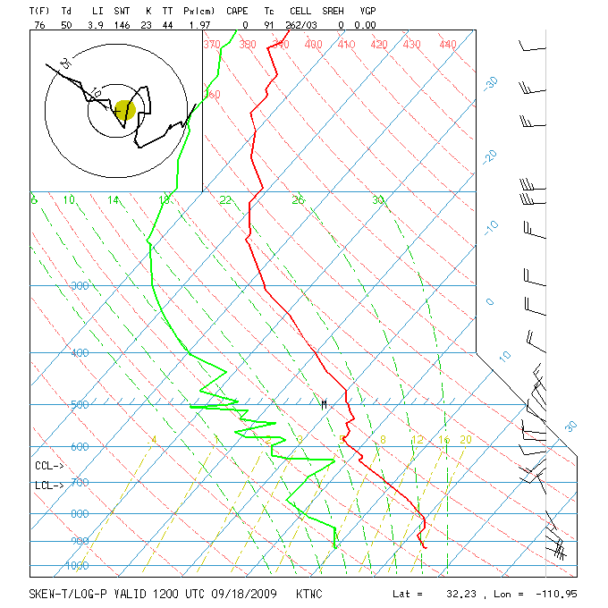
Red line – observed temperature; green line – observed dewpoint temperature; horizontal blue lines – pressure; diagonal blue lines – constant temperature; red-dashed – lines of constant potential temperature (following a dry adiabat); green-dashed – lines following a moist adiabat; light dashed line is (I guess) lines of constant specific humidity, where if you pick a spot on the green line and lift it along the light green dashed line to the red line, you would have found the lifting condensation level for that parcel.. When the observed temperature is parallel to the dry adiabat, the air is likely to have recently been well mixed. The stratosphere begins when the observed temperature gets isothermal (follows the diagonal blue lines). You almost never see a case where the red line crosses the red-dashed line from above, because this would represent an unconditionally unstable case, which blows up very rapidly.

Moisture

Up to this point we’ve talked about moisture content in terms of the mass of moisture, m_{v}, or the molar concentration of vapor, n_{v}. This has been useful when determining the effective molecular weight for the ideal gas law. Because water vapor is tri-atomic, and light, it also has a higher heat capacity than that of dry air,

c_{v,w} = (n/2)R*/ M_{w} = 1463 J/(kg K)
c_{p,w} = (n/2+1)R* / M_{w} = 1952 J/(kg K)

The effective value to use for number of degrees of freedom is about 6.3, indicating that there is an extra degree of freedom in this diatomic molecule related to a third axis of rotation, plus a little energy that can be stored in vibrational modes.

The total heat capacity of air is then

c_{p,a} = (c_{pw}m_{v} + c_{p}m_{d})/m

It becomes convenient to define other measures of water vapor in air. The one we will use most heavily is specific humidity, q = m_{v}/m = ρ_{v}/ρ. Because specific humidity relates the amount of vapor to the amount of dry air, it doesn’t change when pressure or temperature change—it only changes when the parcel mixes with other air, or if there are moist processes causing evaporation or condensation.

We often see specific humidity in units of g/kg, typically with single or double digit values.

Another very important measure is the partial pressure, which can be derived from the other parameters using the ideal gas law

e = n_{v}R*T = (ρ_{v}/M_{v})R*T

We can also relate the partial pressure of water vapor to the ambient pressure

e = (ρ_{v}/M_{v})R*T = (qρ/M_{v})R*T
= q(M_{A}/M_{v})p

At its essence, the partial pressure is the total pressure times the mole (or volume) fraction due to water vapor. Its unique importance is that the Clausius-Clapyron equation gives a thermodynamic relationship between the partial pressure at the surface of water and the temperature of the water. This is very important, because surfaces of water abound in the atmosphere and the surface, and thus constitute a very firm boundary condition (source and sink) on the vapor content of water in the atmosphere.

The Clausius Clapyron relation tells us that an interface between liquid water and water vapor is in equilibrium when the vapor pressure above the water is equal to e_{s}(T). The formula is

$$\frac{{\text{de}}_{s}}{\text{dT}}=e_{s}\frac{L_{C}M_{v}}{R∗T^{2}}'$$

L_{C} is the latent heat released when water vapor is condensed into liquid. It is a function of temperature, albeit a fairly weak one. Over short temperature intervals, we can treat it as a constant having a value of 2.5x10⁶ kg. Integrating yields the approximation

$$\begin{aligned}e_{s}(T)=e_{s}(T_{0})\text{exp} \\ \end{aligned}$$

We will discuss entropy in a later lecture, and will see how this comes about.

What is particularly important about this equation is that it shows a very rapid increase in humidity with temperature. The fractional change in saturation vapor pressure per degree change in temperature is about 6%. (i.e. 5400/T²). This means that a simple increase of 1 degree in global mean surface temperature will cause a 6% increase in water vapor at that lower boundary. If this perturbation were to increase proportionately throughout the atmosphere, we would expect a much stronger greenhouse effect and perhaps a stronger hydrological cycle. It is unclear at this point how dynamics might change the relative humidity in response to a global temperature change, however.

