NATS 101 Name_______________________________
Hidden Optional Assignment

I mentioned in class that next week was a big, important week (and I wasn't thinking of the Quiz). I forgot that next Monday, Sept. 22, was the Fall (Autumnal) Equinox. You can't get much bigger than that. So here are a few short questions about the equinox.
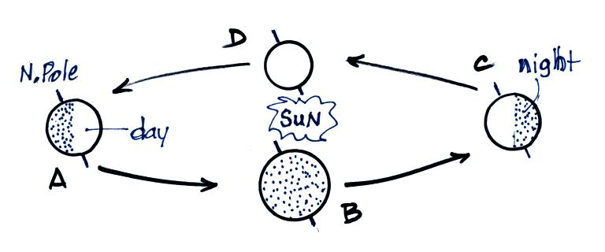

1. The figure at right shows the earth
orbiting the sun. On the Fall Equinox
next Monday, the earth will be at
Point __________ in the figure.

2. On the equinox the sun will be directly overhead at __________ degrees latitude at noon.

3. On the equinox, the days and nights are each __________ hours long. That's true everywhere on the earth (except, perhaps, at the N. and S. Poles)

4. On the equinox the sun will rise exactly in the __________ and set exactly in the __________ (fill in each blank with a direction). This is something you really should check out for yourself. In Tucson, sunrise is around 6:30 am and sunset occurs around 6:30 pm.

And here are two more questions you don't have to answer if you don't want to

1. How should one dress, what should one wear on the Fall Equinox? (It's a stupid question, but NATS 101 students are sometimes very imaginative and creative and I'm curious to see what some of you might come up with)

2. I mentioned that two of my three favorite shows will starting their new seasons next week. What two shows do you think they are?
a. COPS (Fox) b. NOVA (PBS) c. CSI (CBS)
d. The Amazing Race (CBS) e. Law & Order (NBC) f. Mystery (PBS)
g. Heroes (NBC) h. Survivor (CBS) i. Lost (ABC)
j. Bones (Fox) k. Desperate Housewives (ABC) l. House (Fox)

