NATS 101 Name_______________________________
Optional Assignment

1. The Gulf Stream is a warm ocean current that flows from south to north along the east coast of the U.S. The Gulf Stream is an example of which of the following energy transport processes. (hints: is this random or organized motion, are any phase changes occurring)
a. conduction b. convection c. latent heat d. electromagnetic radiation

2. A temperature change of 1ºF is LARGER EQUAL SMALLER than(to) a change of 1ºC. Is a temperature of 50ºF WARMER COLDER or EQUAL than(to) 50ºC.
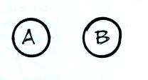
3. Object A in the picture at right has a smaller mass than Object B.
When equal amounts of energy are added to each object, both objects
experience the same temperature change. Object A must have
HIGHER, LOWER the SAME specific heat than(as) Object B.

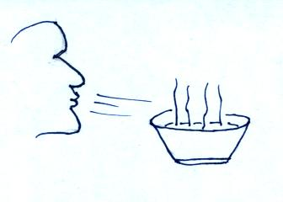
4. People sometimes float and sometimes sink in water. To determine what a particular person would do you would need to know their _______.
a. mass b. volume c. weight d. density e. age

5. People often blow on a hot bowl of soup or a cup of coffee
to try to cool it. What two energy transport processes do
you think are causing the most cooling? (sorry about the
freakish head. Please draw me a better one if you can.)

6. The formation of frost _______________, the formation of a cloud _______________,
and the sublimation of dry ice ______________ energy to(from) the surrounding air.
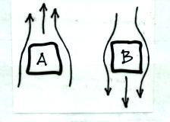
(fill in each blank with RELEASES or TAKES)

7. Convective air motions around two objects are shown at
right. Object _______ is probably colder than the
surrounding air. Energy is being transported from the
surrounding air to object _______.

8. The atoms in a hot object have a lot of _______. It takes a lot of energy to warm or cool water because water has a high _______. Copper has a high _______. Cold air sinks because it has higher _______ than the surrounding air. Water vapor contains a lot of
hidden _______. (each of the answers below should be used once)
a. kinetic energy b. density c. thermal conductivity d. latent heat e. specific heat

9. One _________________________ is the energy needed to warm 1 gram of water 1º C.
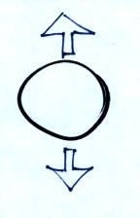
10. The strength of the UPWARD DOWNWARD force
acting on the balloon at right depends on the air inside.
11. We are able to see the moon at night because it ABSORBS EMITS REFLECTS TRANSMITS visible light.

12. It generally stays warmer on a cloudy night than on a clear night because
a. clouds form when warm air rises b. cloud formation releases latent heat
c. clouds are good absorbers of IR light d. clouds are good reflectors of visible light

13. Sunlight is _______. The electromagnetic radiation emitted by the earth is _______.
a. VIS light b. about equal amounts of UV, VIS, and IR light
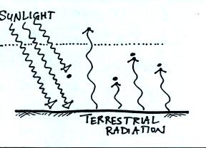
c. most VIS & IR with a little UV light d. IR light

14. To be in radiative equilibrium, the atmosphere in the
figure at right would need to emit _______ unit(s) of
energy into space and _______ unit(s) of energy toward
the ground (fill in each blank with 1, 2, or 3; answers
can be used more than once)

16. The atmosphere is pretty nearly completely transparent to _______ light and pretty nearly completely opaque to _______ light.
a. UV b. VIS c. UV & VIS d. VIS & IR e. IR
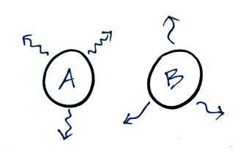
15. The wavelength of peak emission (λ_{MAX}) for Object A is
1 μm. λ_{MAX} for Object B is 2 μm. Object A must be
_______ times hotter than Object B. Object A is emitting
EM radiation at a rate that is _______ times higher than
Object B.
a. 1/4 b. 1/2 c. 1 d. 2 e. 4 f. 8 g. 16

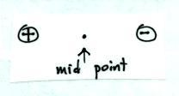
18. Microwave radiation has LONGER SHORTER wavelength and is a MORE LESS energetic form of radiation than infrared (IR) light.

17. Would an electric charge placed exactly halfway between the two
charges in the picture at right MOVE or remain STATIONARY?

19. The number of sunspots visible on the surface of the sun reaches a peak about every _______ years. Is there a very STRONG or relatively WEAK correlation between sunspot activity and climate on the earth?
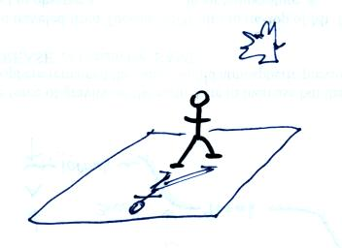
20. A rough rule-of-thumb is that when the length of your shadow
is LONGER SHORTER than you are tall, you should stay
out of the sun because it is too intense and it would be easy to
get a sunburn.

