NATS 101 Name_______________________________
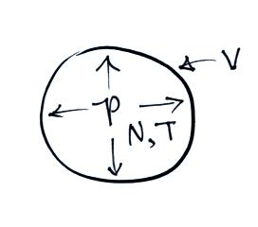
Optional Assignment

1. The ideal gas law equation shows the relationship between
the number (N), temperature (T), and pressure (P) of the
air molecules in a volume (V):

P V = N k T

k is a constant. If N, V, and T were all to increase by a factor of 2 the pressure would
a. increase by 2 b. increase by 4 c. decrease by 2 d. decrease by 4
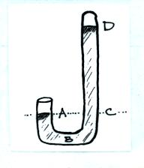

2. The pressure at Point A and at Point ________
on the mercury barometer at right would be equal.
The pressure at Point _______ should be zero.

3. Show how the following weather observations would by plotted on a surface weather map using the station model notation (see Appendix C on pps 525-527 in the text)

3/8ths of the sky covered with clouds
(cirrostratus clouds not increasing and
not covering the entire sky)
Temperature = 75º F, Dew Point = 43º F
Winds from the SE at 15 knots
Pressure 998.3 mb

4. Would the 2 pm weather observations in Tucson be plotted on the 2:00 Z
7:00 Z 9:00 Z 14:00 Z or 21:00 Z surface weather map?
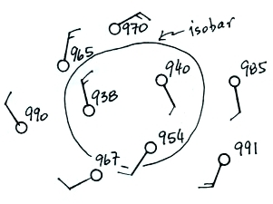

5. Are the winds spinning in a CLOCKWISE or
COUNTERCLOCKWISE direction on the map
at right? Are the winds spiraling INWARD or
OUTWARD? Are the winds CONVERGING
or DIVERGING?

6. Absorption of UV light by ozone in the STRATOSPHERE
TROPOSPHERE is part of the reason why temperature there INCREASES DECREASES with increasing altitude.
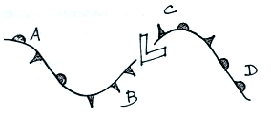
7. A cold front is shown at Point _______ in the figure
at right. A warm front is shown at Point _______.
An occluded front is shown at Point _______ and at
Point _______ there is a stationary front.

8. Use the altitude and pressure data in the figure below to (i) determine the station pressure at Point A, (ii) to determine the sea level pressure for Station B, and (iii) determine the altitude of Point C (you can assume that pressure decreases at a rate of 1 mb for every 10 m of altitude gain)
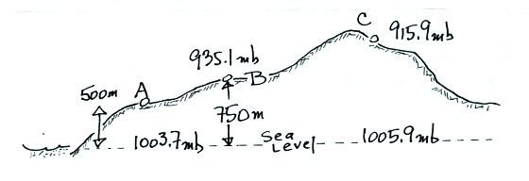

9. Tucson is found at about 32º N LATITUDE LONGITUDE. Isotherms are contour lines of PRESSURE TEMPERATURE sometimes found on surface weather maps.

10. Use the weather information plotted at right
to fill in the blanks below (some of the information
requested might not be shown on the figure)
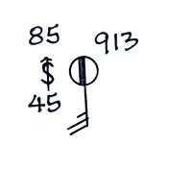
temperature __________ pressure __________

altitude __________ relative humidity __________

wind direction and speed ____________________

weather __________ cloud cover __________

dew point __________

11. Upper level CONVERGENCE DIVERGENCE will cause the surface pressure to increase. Surface convergence will cause RISING SINKING air motions.

12. Closely spaced isobars on a surface weather map would indicate a STRONG WEAK pressure gradient and would produce FAST SLOW winds.

