Tuesday Sept. 30, 2008
Today's music La Voce Del Silenzio was sung by Andrea Bocelli and Elisa and was from the Vivere Live in Tuscany DVD.
Quiz #1 was returned in class today. Please carefully check to see that your work was graded correctly and that the points missed were added up correctly. A small 5 pt grading error that will affect about 1/3 of the students in the class was brought to my attention after class. More about that in class on Thursday.
Many people did very well on the quiz, others didn't do so well. Remember you can drop one quiz score in this class, so if you are in the 2nd group, you haven't done any permanent damage to your semester grade. I would suggest you come and talk with me after class or during office hours so that we can figure out why you didn't do better on Quiz #1. I feel pretty cofident that with a few changes in your study habits you can raise your grade on the remaining quizzes.
The 1S1P Bonus Assignment was also returned today. You could earn up to 10 pts on this report: up to 6 pts on content and 4 pts on writing quality. Both numbers should be written on your paper (the content grade comes first). Don't think of your score as being a percentage grade. Don't think of 6 out of 10 as 60% or a D. You can earn a maximum of 45 1S1P pts, so if you earned 6 pts on this assignment, you 39 pts left to go.
Be sure not to throw away any graded work that is returned to you during the semester. This is just in case there is an error computing your semester grade or some question later about your grade.
All of the Experiment #2 materials have been checked out. Please collect your data as soon as you can and return your materials so that they can be checked out to people on the waiting list. The Experiment #1 reports should be graded by Thursday.

We'll be working in Chapters 2 and 3 between now and the next quiz. Here's some new reading. We'll cover material in the highlighted section this week and start electromagnetic radiation next week.
Chapters 2&3 is concerned with energy, temperature, heat, energy transport, and energy balance between the earth, atmosphere, and space.
It is easy to lose sight of the main concepts because there are so many details. The following (found on pps 43&44 in the photocopied Class Notes) is meant to introduce some of what we will be covering in class from Chapter 2. I stole the pictures below from a previous semester because they're drawn more clearly. They might differ slightly from what we did in class.

We will learn the names of several different types or forms of energy. Kinetic energy is energy of motion. Some examples are mentioned and sketched above. It is a relatively easy to visualize and understand form of energy.
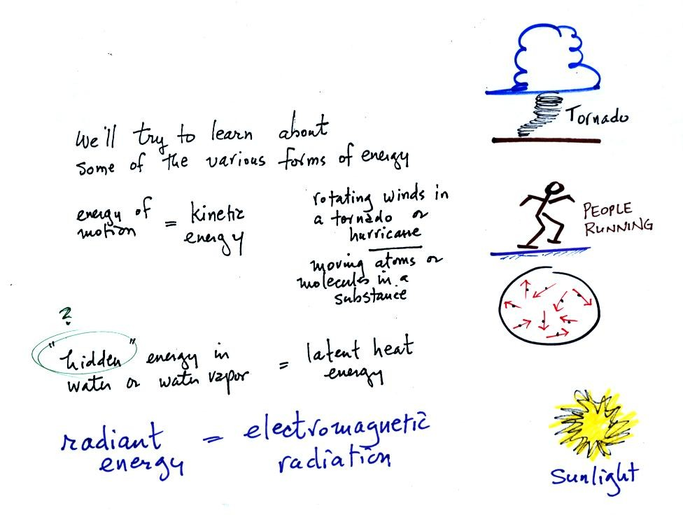
Latent heat energy is perhaps the most underappreciated and most confusing type of energy. The word latent refers to energy that is hidden in water and water vapor. The hidden energy emerges when water vapor condenses or water freezes.
Radiant energy is a very important form of energy. Sunlight is an example of radiant energy that we can see and feel (you feel warm when you stand in sunlight). There are many types of radiant energy that are invisible.
Four energy transport processes are listed below.
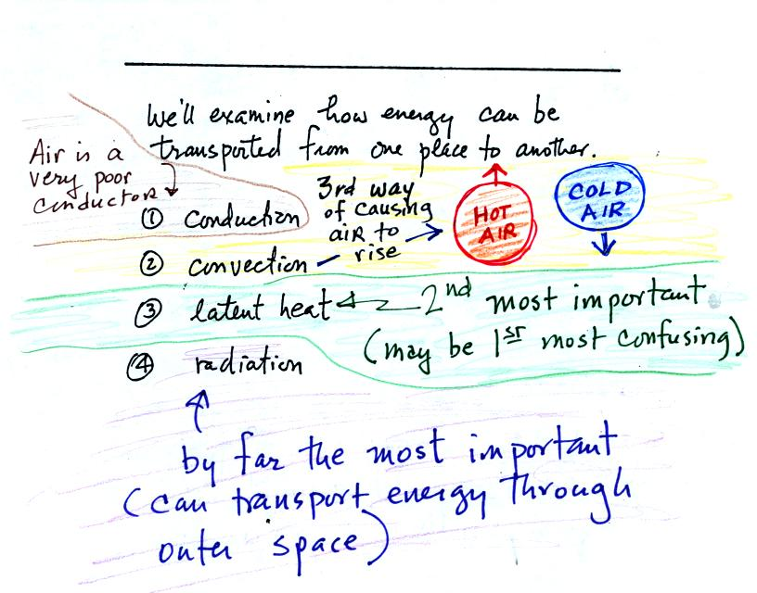
By far the most important process is electromagnetic radiation (light is a common form of electromagnetic radiation). This is the only process that can transport energy through empty space. Electromagnetic radiation travels both to the earth (from the sun) and away from the earth into space. Electromagnetic radiation is also responsible for about 80% of the energy transported between the ground and atmosphere.
You might be surprised to learn that latent heat is the second most important transport process.
Rising parcels of warm air and sinking parcels of cold air are examples of free convection. Because of convection you feel colder or a cold windy day than on a cold calm day. Ocean currents are also an example of convection. Ocean currents transport energy from the warm tropics to colder polar regions.
Note that convection is a 3rd way of causing rising air motions in the atmosphere (convergence into centers of low pressure, and fronts were the other two ways). This is a topic we are really going to beat to death. Archimedes law will also make an appearance when we cover convection.
Conduction is the least important energy transport at least in the atmosphere. Air is such a poor conductor of energy that it is generally considered to be an insulator.
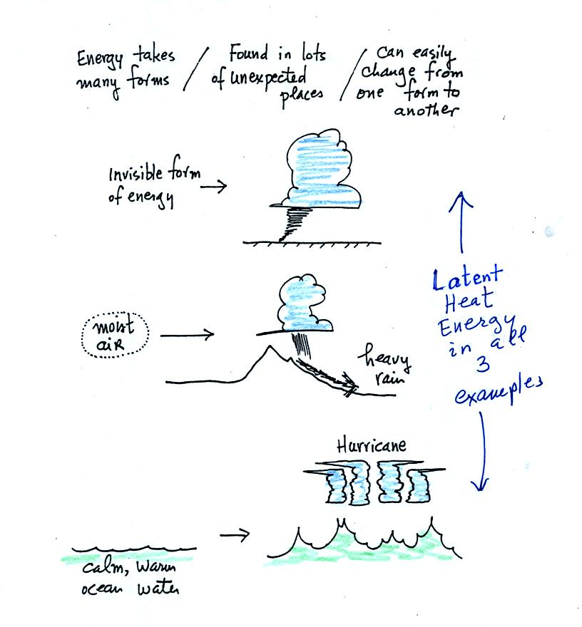
Water vapor is a form of invisible energy. When water vapor condenses to produce the water droplets (or ice crystals) in a cloud, an enormous amount of latent heat energy is released into the atmosphere.
It is hard to visualize or appreciate the amount of energy released into the atmosphere during condensation. You can imagine the work that you would do carrying a gallon of water (8 pounds) from Tucson to the top of Mt. Lemmon. To accomplish the same thing Mother Nature must first evaporate the water and (if my calculations are correct) that requires about 100 times the energy that you would use to carry the 8 pounds of water to the summit of Mt. Lemmon. And Mother Nature transports a lot more than just a single gallon.
The next picture shows energy being transported from the sun to the earth in the form of electromagnetic radiation.
We are aware of this energy because we can see it (sunlight also contains invisible forms of light) and feel it. With all of this energy arriving at and being absorbed by the earth, what keeps the earth from getting hotter and hotter? The answer is that the earth also sends energy back into space (the orange and pink arrows in the figure below)
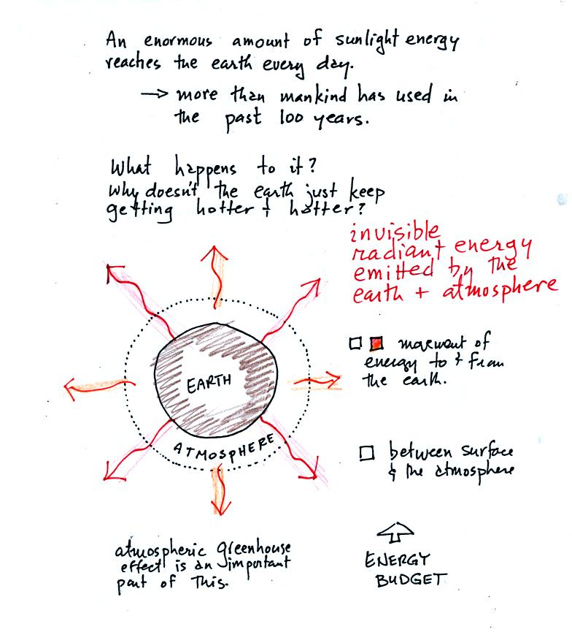
This infrared light is an invisible form of energy (it is weak enough that we don't usually feel it either). A balance between incoming and outgoing energy is achieved and the earth's annual average temperature remains constant.
We'll be talking about energy budgets and energy balance a lot in the next week or so. Thinking about a bank account balance with money being deposited and withdrawn (or spent) might make it easier to understand this material.
We will also look closely at energy transport between the earth's surface and the atmosphere. This is where latent heat energy transport and convection and conduction operate (they can't outside the atmosphere into outer space).
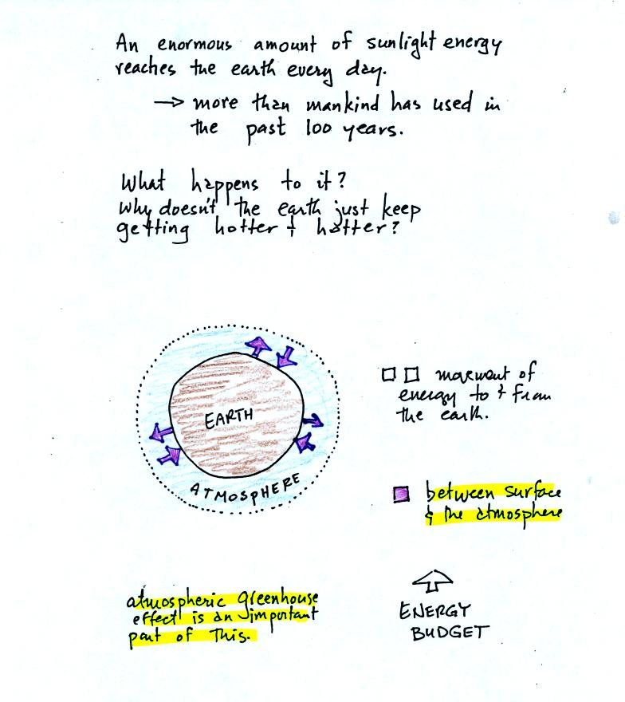
That is also where the atmospheric greenhouse operates. That will be a important goal - to better understand how the atmospheric greenhouse effect works.
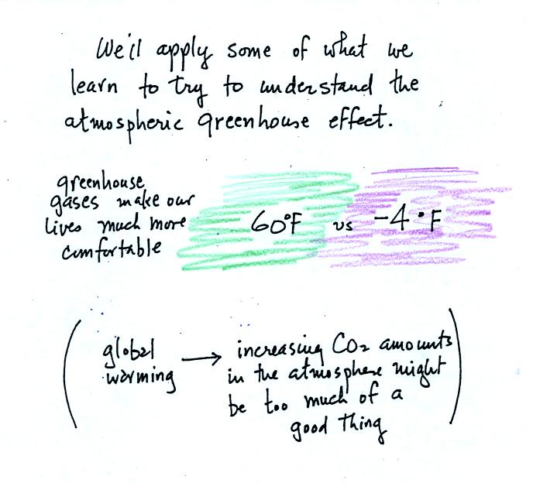
Remember that without the greenhouse effect, the global annual average surface temperature on the earth would be about 0º F rather than 60º F.
The topic of Buddhist monks should come up next week. I don't really know anything about Buddhist monks but am fascinated by some of the things they are able to do. Also you may hear a storm or two (perhaps see a picture or two) of my cats. They have taught me a lot of what I know about static electricity, which is something we will use to understand electromagnetic radiation.

At this point we took a little bit of a detour to watch a short 10 minute segment from a video tape (from a PBS program called The Adventurers). The video was an account of Auguste Piccard's 1931trip into the stratosphere by balloon. Auguste Piccard together with Paul Kipfer, his assistant, were the first two people to do that. You'll find some of this discussed on pps 31 & 32 in the photocopied ClassNotes.
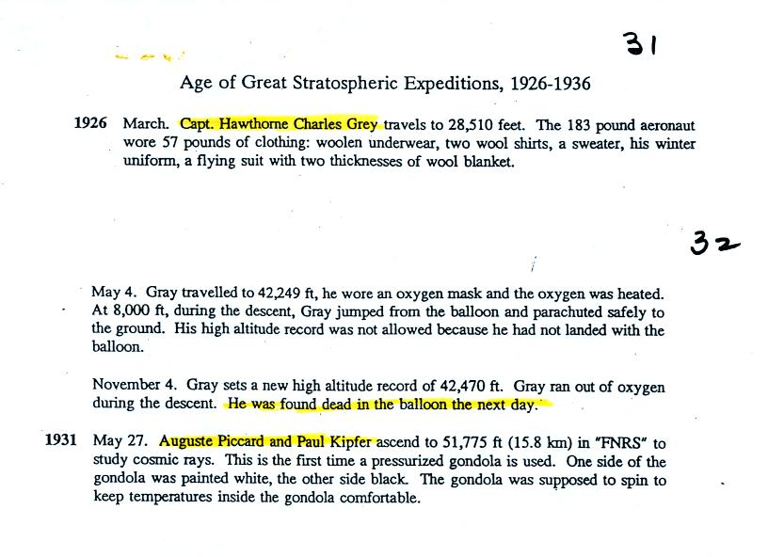
Auguste's son, Jacques, would later be part of the first descent to the bottom of the ocean (35,000 feet deep) in a bathyscaph. Jacques' son, Bertrand, would be part of the two man team that first circled the globe non-stop in a balloon. That took place in March 1999. I'll show video segments from Jacques and Bertrand's voyages.
After the video, a short recommendation for Into Thin Air by Jon Krakauer. The book is about the 1996 climbing season on Mt. Everest (I was surprised at the quiz reviews last week by the number of people that hadn't heard of it). Reading and writing a report on this book is something you can do in place of an experiment report in this class.
I showed a few photographs from a National Geographic book about Mt. Everest in class. I've taken them off the online notes so as to not violate any copyright laws. You're welcome to borrow the National Geographic book from me if you are interested.

Back to energy, temperature and heat, p. 45 in the photocopied ClassNotes.
When you add energy to an object, the object will usually warm up (conversely when you take energy from an object the object will cool). It is relatively easy to come up with an equation that allows you to figure out what the temperature change will be.

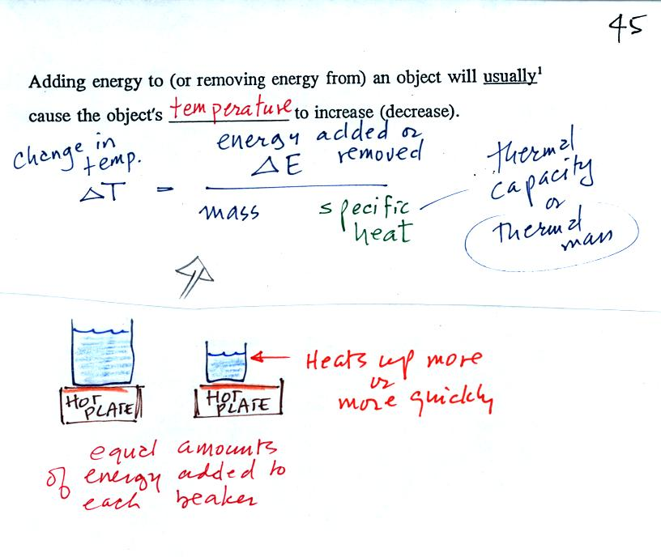
The temperature change will first depend on how much energy was added. This is a direct proportionality, so delta E is in the numerator of the equation.
When you add equal amounts of energy to large and small pans of water, the small pan will heat up more quickly. The temperature change, delta T, will depend on the mass. A small mass will mean a large delta T, so mass should go in the denominator of the equation.
Different materials react differently when energy is added to them. A material with a large specific heat will warm more slowly than a material with a small specific heat. Specific heat behaves in the same kind of way as mass. Specific heat is sometimes called "thermal mass" or "thermal capacity."
Here's an important example that will show the effect of specific heat (middle of p. 45)
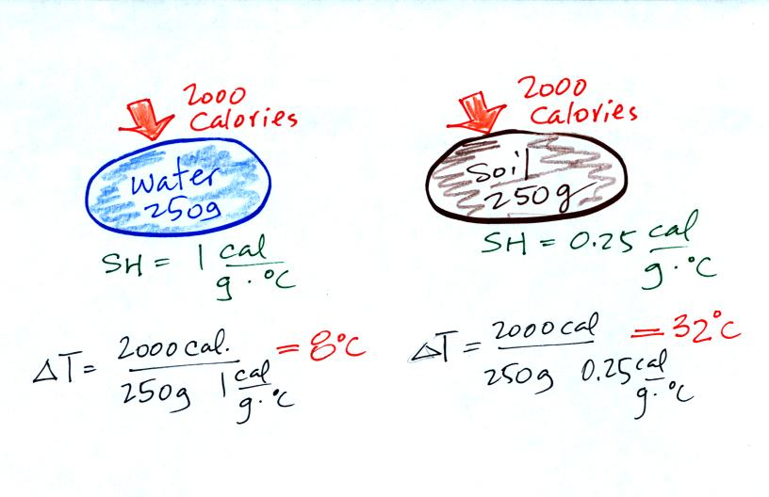
Equal amounts of energy (note that calories are units of energy) are added to equal masses of water and soil. We use water and soil in the example because most of the earth's surface is either ocean or land. Water has a higher specific heat than soil, it only warms up 8º C. The soil has a lower specific heat and warms up 32º C, 4 times more than the water.
These different rates of warming of water and soil have important effects on regional climate. This figure wasn't shown in class.
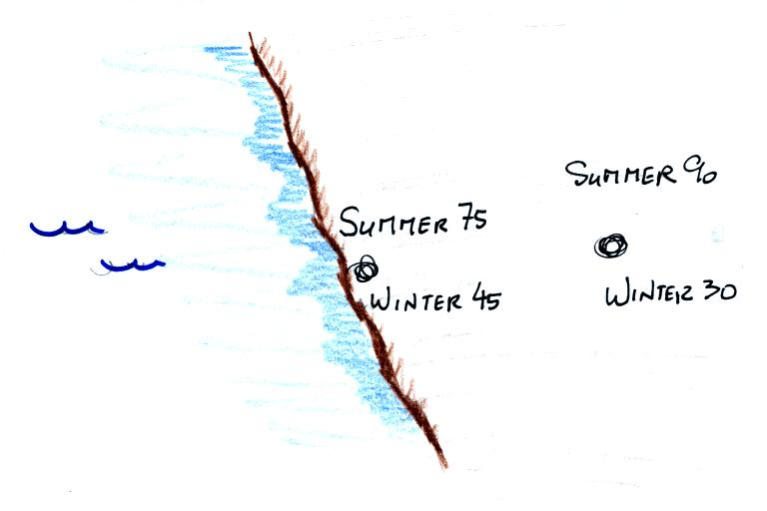
Oceans moderate the climate. Cities near a large body of water won't warm as much in the summer and won't cool as much during the winter compared to a city that is surrounded by land.
The city above on the coast has a 30º F annual range of temperature. The city further inland (assumed to be at the same latitude and altitude) has an annual range of 60º F. Note that both cities have the same 60º F annual mean temperature.

Adding energy to an object will usually cause it to warm. But there is another possibility (bottom p. 45), the object could change phase (change from solid to liquid or gas). Adding energy to ice might cause the ice to melt. Adding energy to water could cause it to evaporate.
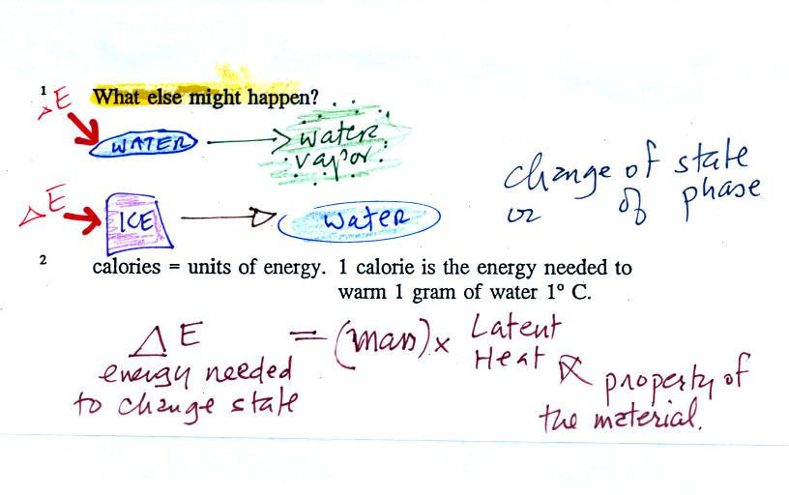
The equation at the bottom of the figure above allows you to calculate how much energy is required to melt ice or evaporate water or sublimate dry ice. You multiply the mass by the latent heat, a variable that depends on the particular material that is changing phase. We used this equation in an experiment conducted at the end of class. We'll also use the equation relating delta T and delta E that we discussed earlier. The figure below wasn't shown in class.
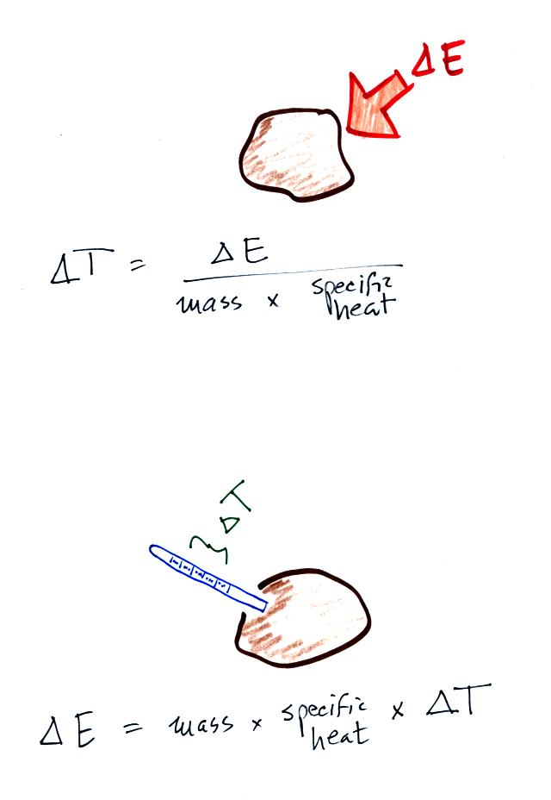
Rather than trying to calculate delta T (top figure) we are going to measure temperature change, delta T, and use the second equation (bottom figure) to measure energy flow.
The object of the experiment was to measure the latent heat of vaporization of liquid nitrogen. That just means measuring the amount of energy needed to evaporate a gram of liquid nitrogen. The students that are doing Experiment #2 are measuring the latent heat of fusion of ice, the energy needed to melt one gram of ice. A student in the 8:00 class also performed this liquid nitrogen experiment. You'll find the following figure on p. 45a in the photocopied Classnotes.
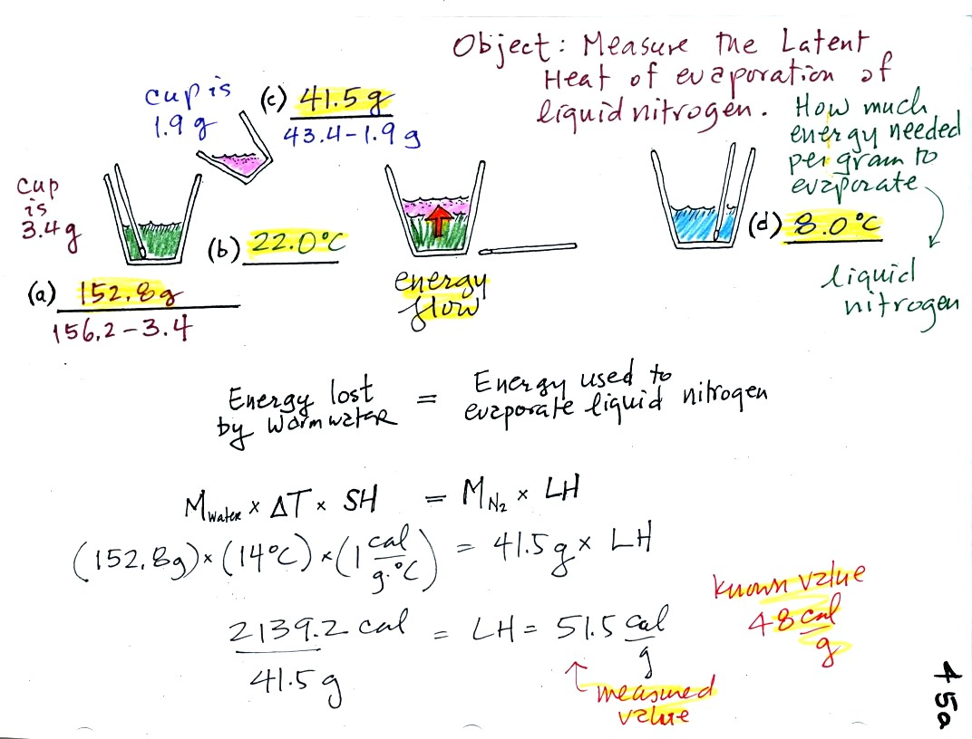
(a) Some room temperature water poured into a styrofoam cup weighed 156.2 g. The cup itself weighed 3.4 g, so we have 152.8 g of water.
(b) The water's temperature was 22.0 C..
(c) 41.5 g of liquid nitrogen was poured into the cup of water.
It takes energy to turn liquid nitrogen into nitrogen gas. The needed energy came from the water. This flow of energy is shown in the middle figure above. We assumed that because the experiment is performed in a styrofoam cup that there is no energy flowing between the water in the cup and the surounding air.
(d)
After the liquid nitrogen had evaporated we remeasured the water's temperature. It had dropped to 8.0 C. That is a temperature drop of 14 C.
Because we knew how much water we started with, its temperature drop, and water's specific heat we can calculate how much energy was taken from the water. That is the 2139.2 calorie figure above. This was used to evaporate 41.5 grams of liquid nitrogen. So we divided 2139.2 calories by 41.5 grams to get 51.5 calories needed per gram. That is our measured value of the latent heat of vaporization of nitrogen. A trustworthy gentleman informed us that the known value is 48 cal/g, so our measurement was pretty darn close.

When you add energy to an object and the object warms, what exactly is happening inside the object?
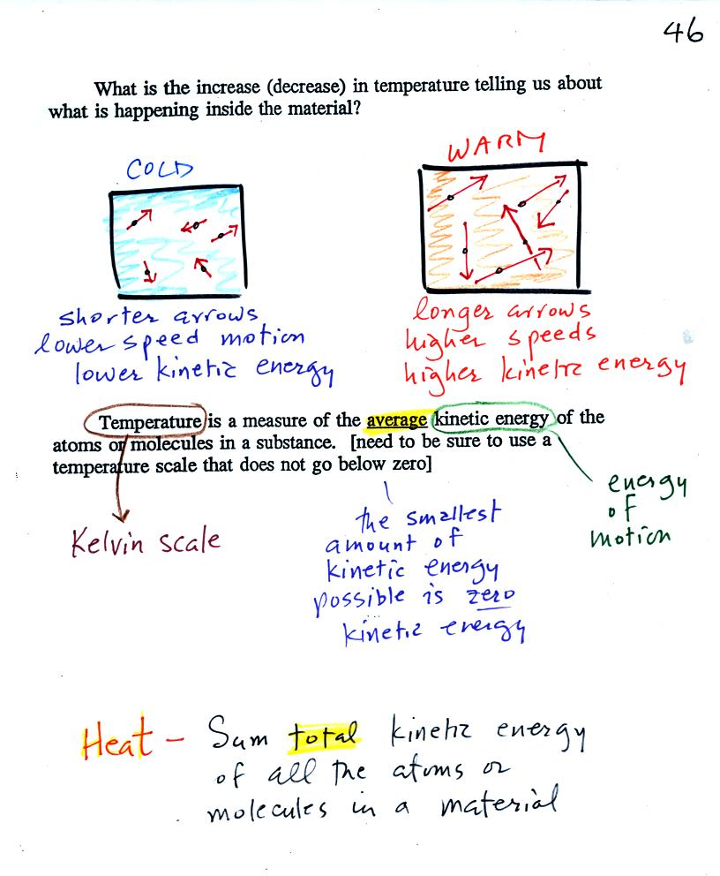
The figure above is on p. 46 in the photocopied Class Notes. Temperature provides a measure of the average kinetic of the atoms or molecules in a material. The atoms or molecules in a cold material will be moving more slowly than the atoms or molecules in a warmer object.
You can think of heat as being the total kinetic energy of all the molecules or atoms in a material. The next figure might make the distinction between temperature (average kinetic energy) and heat (total kinetic energy) clearer. None of the following three figures was shown in class on Tuesday.
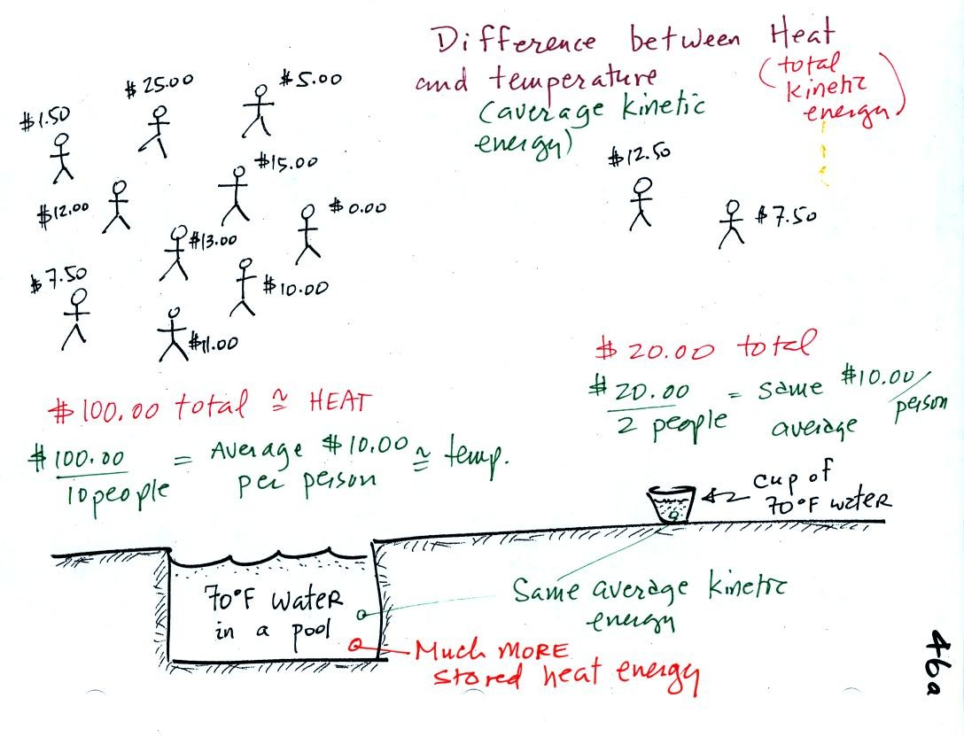
A cup of water and a pool of water both have the same temperature. The average kinetic energy of the water molecules in the pool and in the cup are the same. There are a lot more molecules in the pool than in the cup. So if you add together all the kinetic energies of all the molecules in the pool you are going to get a much bigger number than if you sum the kinetic energies of the molecules in the cup. There is a lot more stored energy in the pool than in the cup. It would be a lot harder to cool (or warm) all the water in the pool than it would be the cup.
In the same way the two groups of people shown have the same average amount of money per person. The $100 held by the larger group at the left is greater than the $20 total possessed by the smaller group of people on the right.
You need to be careful what temperature scale you use when using temperature as a measure of average kinetic energy. You must use the Kelvin temperature scale because it does not go below zero (0 K is known as absolute zero). The smallest kinetic energy you can have is zero kinetic energy. There is no such thing as negative kinetic energy.

Speaking of temperature scales.
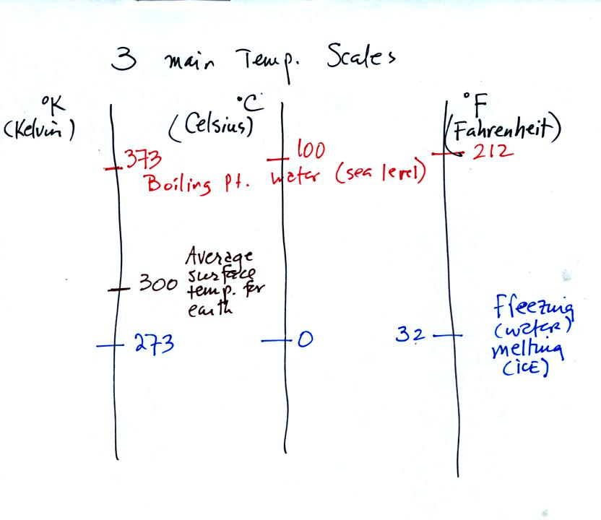
You should remember the temperatures of the boiling point and freezing point of water on the Fahrenheit, Celsius, and Kelvin scales. 300 K is a good easy-to-remember value for the global annual average surface temperature of the earth.
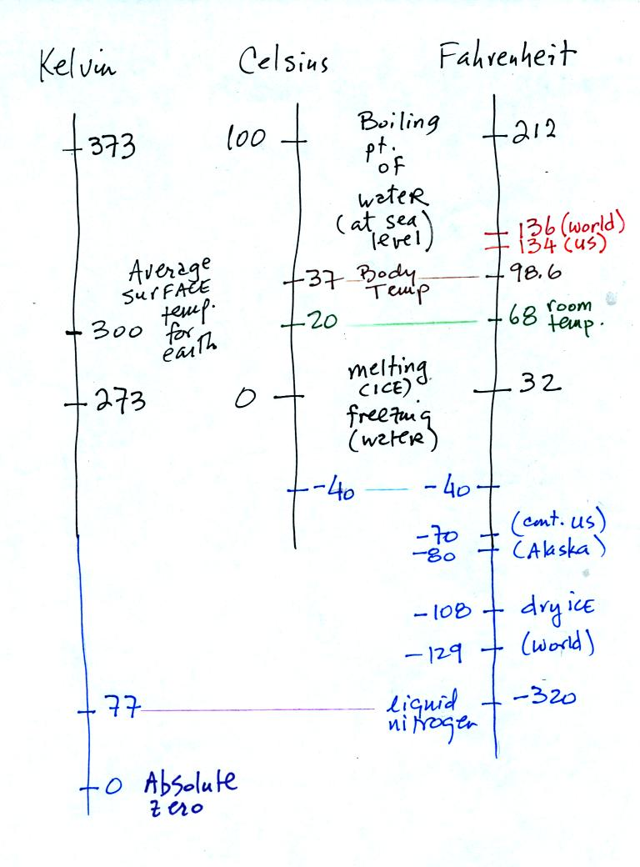
You certainly don't need to try to remember all these numbers. The world high temperature record was set in Libya, the US record in Death Valley. The continental US cold temperature record of -70 F was set in Montana and the -80 F value in Alaska. The world record -129 F was measured at Vostok station in Antarctica. This unusually cold reading was the result of three factors: high latitude, high altitude, and location in the middle of land rather than being near or surrounded by ocean. You'll find more record high and low temperature data Liquid nitrogen is cold but it is still quite a bit warmer than absolute zero.

