Tuesday Sept. 16, 2008
All this week in NATS 101 we'll be featuring a local band, Calexico, and Luz de Luna, a Tucson Mariachi band. Today is Mexican Independence Day and you heard "Cancion Del Mariachi" and "Aires Del Mayab." Calexico and Luz de Luna were appearing at the Barbican Theater in London. Incidentally Calexico (and Luz de Luna, perhaps) will be appearing at the Rialto Theater in Tucson this coming Saturday night.
The Practice Quiz from last Thursday was returned in class today.
The 1S1P Bonus Assignment is due on Thursday (Sept. 18). An In-class Optional Assignment was handed out in class today, it was collected at the end of the period. If you download the assignment, answer the questions, and turn in the assignment at the beginning of class on Thursday you can earn partial credit.
An Optional homework Assignment was distributed in class and will be due next Tuesday. You should complete this assignment before coming to class and have it ready to turn in at the beginning of class. You can earn extra credit by completing and turning in optional assignments like this.
Finally, 1S1P Assignment #1 has been posted on the class webpage. Reports are due on or before Thur. Oct. 2.

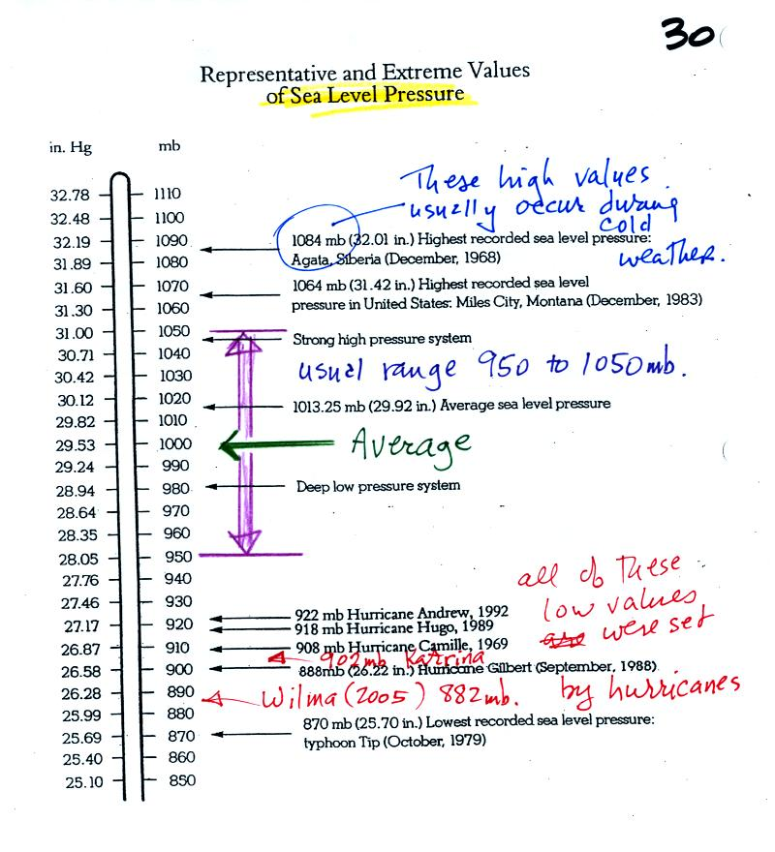
The figure above (p. 30 in the photocopied Class Notes) first shows average sea level pressure values. 1000 mb or 30 inches of mercury are close enough in this class.
Sea level pressures usually fall between 950 mb and 1050 mb.
Record high sea level pressure values occur during cold weather.
Record low pressure values have all been set by intense hurricanes (the record setting low pressure is the reason these storms were so intense). Hurricane Wilma in 2005 set a new record low sea level pressure reading for the Atlantic. Hurricane Katrina had a pressure of 902 mb. You'll find a list of the most intense, destructive, and deadly hurricanes on p. 146a in the photocopied ClassNotes.

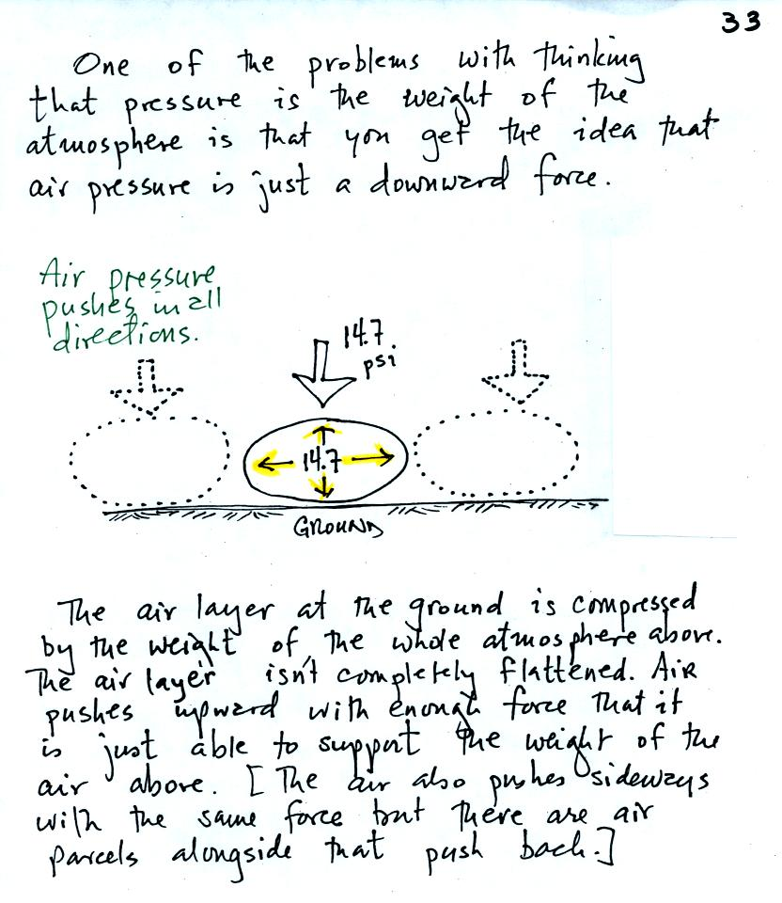
Air pressure is a force that pushes downward, upward, and sideways. If you fill a balloon with air and then push downward on it, you can feel the air in the balloon pushing back (pushing upward). You'd see the air in the balloon pushing sideways as well.
The air pressure in the four tires on your automobile pushes down on the road (that's something you would feel if the car ran over your foot) and pushes upward with enough force to keep the 1000 or 2000 pound vehicle off the road.
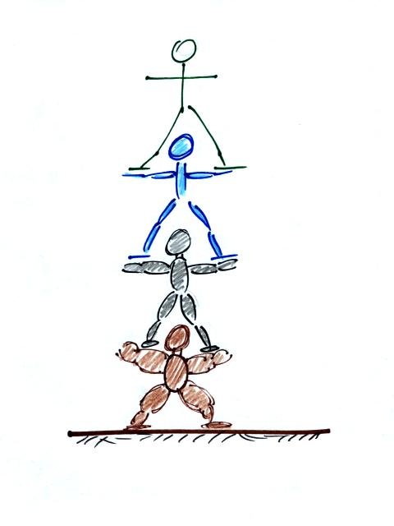
A "people pyramid" might help you to understand what is going on in the atmosphere (this is a little more carefully drawn figure than was done in class). If the bottom person in the stack above were standing on a scale, the scale would measure the total weight of all the people in the pile. That's analogous to sea level pressure being determined by the weight of the atmosphere above. The bottom person in the picture above must be strong enough to support the weight of all the people above. That equivalent to the bottom layer of the atmosphere having enough pressure, pressure that points up down and sideways, to support the weight of the air above.
You can use a stack of bricks to try to understand that pressure at any level in the atmosphere is determined by the weight of the air overhead. Now we will imagine a stack of matresses to understand why air density decreases with increasing altitude.
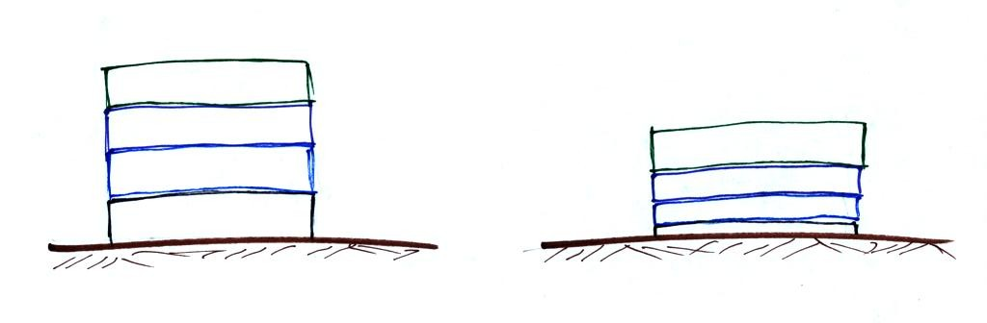
This is a more carefully drawn version of what was shown in class. Mattresses are compressible. The mattress at the bottom of the pile is compressed the most by the weight of all the mattresses above. The mattresses higher up aren't squished as much because their is less weight remaining above.
In the case of the atmosphere layers of air behave in just the same way as matresses. (The figure was redrawn after class for improved clarity)
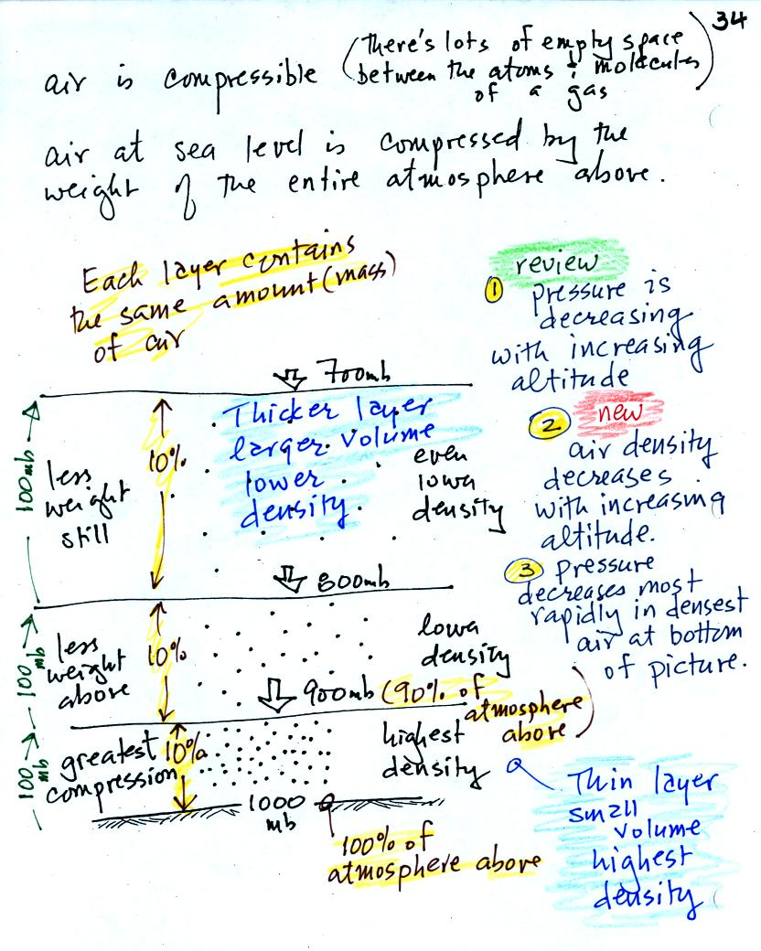
There's a lot of information in this figure that you'll miss if you don't spend a minute or two looking at and thinking about the figure.
1. You can first notice and remember (and understand) that pressure decreases with increasing altitude.
Each layer of air contain the same amount (mass) of air. You can tell because the pressure decrease is the same (100 mb) as you move upward through each layer.
2. The densest air is found in the bottom layer because the air is squeezed into a smaller volume than the other layers. Air density decreases with increasing altitude.
3. You again notice something that we covered earlier: the most rapid rate of pressure decrease with increasing altitude is in the densest air in the bottom air layer.

We took a little detour at this point.
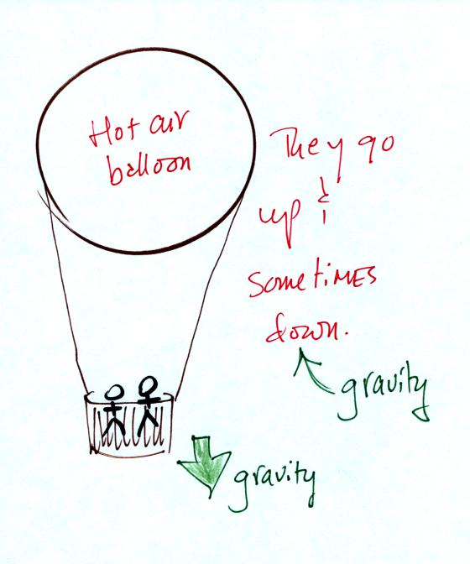
Hot air balloons can go up or down. Most everyone in the classroom knows that gravity is the force that would cause a hot air balloon to sink. Nobody was willing to suggest a force that might cause a hot air balloon to rise. We'll come back to this picture later.

Class continued with a demonstration of the upward force caused by air pressure.
The demonstration is summarized on p. 35a in the photocopied Classnotes.
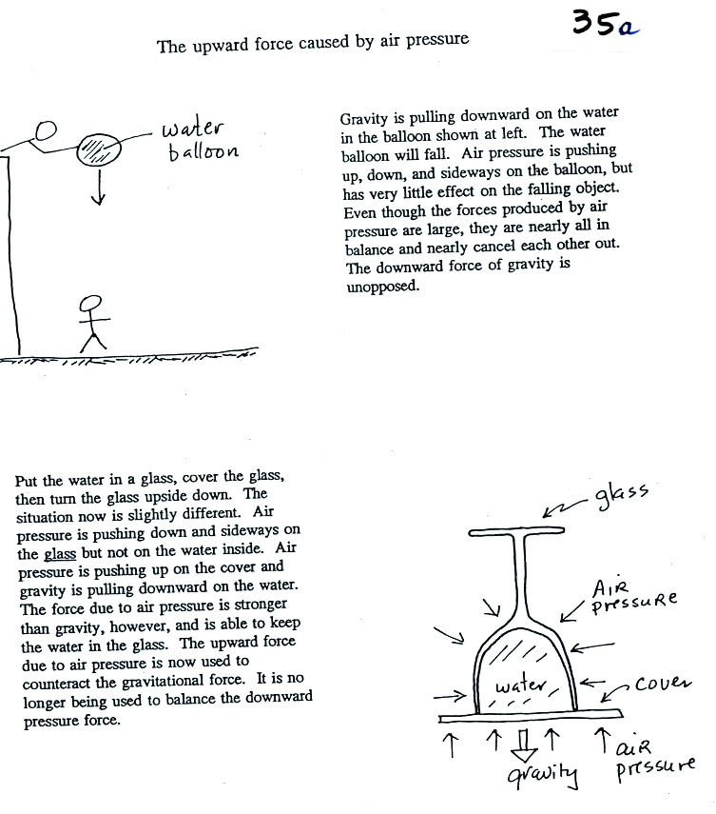
Here's a little bit more detailed and more complete explanation of what is going on. First the case of a water balloon.
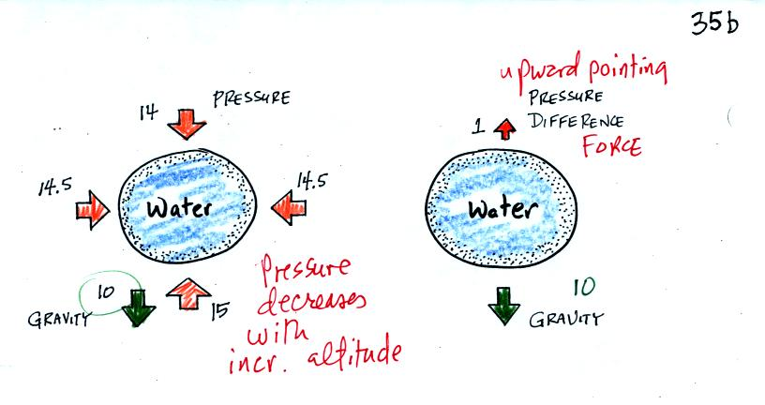
The figure at left shows air pressure (red arrows) pushing on all the sides of the balloon. Because pressure decreases with increasing altitude, the pressure pushing downward on the top of the balloon is a little weaker (strength=14) than the pressure pushing upward at the bottom of the balloon (strength=15). The two sideways forces cancel each other out. The total effect of the pressure is a weak upward force (1 unit of upward force shown at the top of the right figure, you might have heard this called a bouyant force). Gravity exerts a downward force on the water balloon. In the figure at right you can see that the gravity force (strength=10) is stronger than the upward pressure difference force (strength=1). The balloon falls as a result.
In the demonstration a wine glass is filled with water. A small plastic lid is used to cover the wine glass. You can then turn the glass upside down without the water falling out.
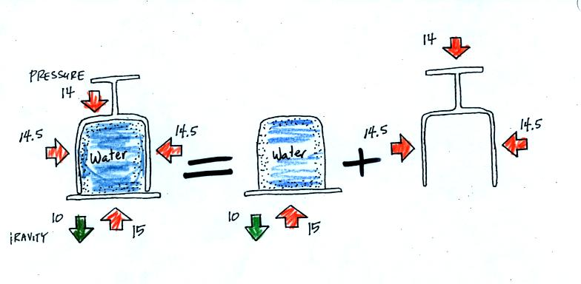
All the same forces are shown again in the left most figure. In the right two figures we separate this into two parts. First the water inside the glass isn't feeling the downward and sideways pressure forces (because they're pushing on the glass). Gravity still pulls downward on the water but the upward pressure force is able to overcome the downward pull of gravity. The upward pointing pressure force is used to overcome gravity not to cancel out the downward pointing pressure force.
The demonstration was repeated using a 4 Liter flash (more than a gallon of water, more than 8 pounds of water). The upward pressure force was still able to keep the water in the flask (much of the weight of the water is pushing against the sides of the flask which the instructor was supporting with his arms).

Look back at the hot air balloon. Can you now think of an upward force that might cause the balloon to rise?

So far we have looked at how pressure and air density change with increasing altitude. Now we should have looked at how air temperature changes with altitude. I completely forgot to do that, we will have to come back to this on Thursday. Here are the two pictures that I drew in the other section of the class - you can get a head start on this material.
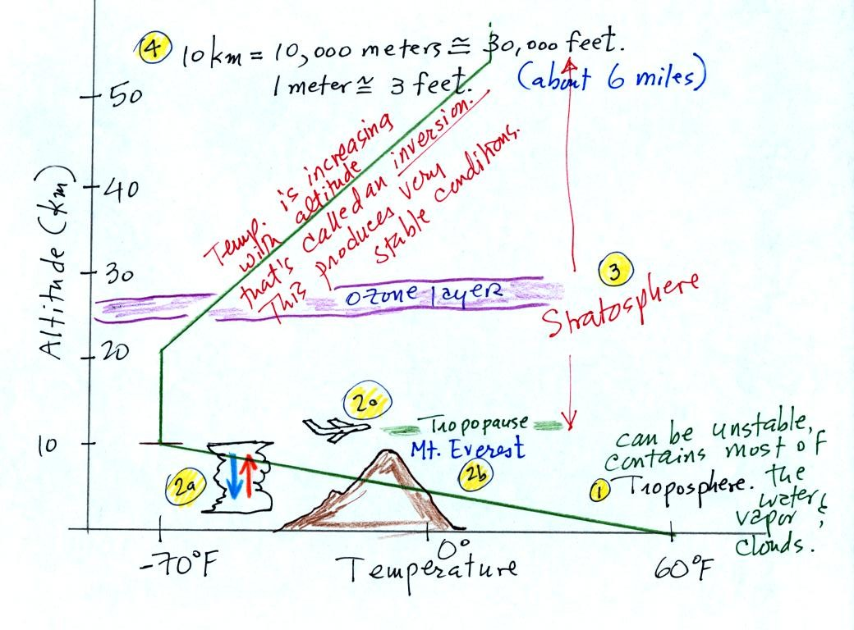
The atmosphere can be split into layers depending on whether temperature is increasing or decreasing with increasing altitude. The two lowest layers are shown in the figure above. There are additional layers (the mesosphere and the thermosphere) above 50 km but we won't worry about them.
1. We live in the troposphere. The troposphere is found, on average, between 0 and about 10 km altitude, and is where temperature usually decreases with increasing altitude. [the troposphere is usually a little higher in the tropics and lower at polar latitudes]
The troposphere contains most of the water vapor in the atmosphere (the water vapor comes from evaporation of ocean water) and is where most of the clouds and weather occurs. The troposphere can be stable or unstable (tropo means to turn over and refers to the fact that air can move up and down in the troposphere).
2a. The thunderstorm shown in the figure indicates unstable conditions, meaning that strong up and down air motions are occurring. When the thunderstorm reaches the top of the troposphere, it runs into the stable stratosphere. The air can't continue to rise into the stable stratosphere so the cloud flattens out and forms an anvil (anvil is the name given to the flat top of the thunderstorm). The flat anvil top is something that you can go outside and see and often marks the top of the troposphere.
2b. The summit of Mt. Everest is a little over 29,000 ft. tall and is close to the top of the troposphere.
2c. Cruising altitude in a passenger jet is usually between 30,000 and 40,000, near or just above the top of the troposphere.
3. Temperature remains constant between 10 and 20 km and then increases with increasing altitude between 20 and 50 km. These two sections form the stratosphere. The stratosphere is a very stable air layer. Increasing temperature with increasing altitude is called an inversion. This is what makes the stratosphere so stable.
4. A kilometer is one thousand meters. Since 1 meter is about 3 feet, 10 km is about 30,000 feet. There are 5280 feet in a mile so this is about 6 miles.
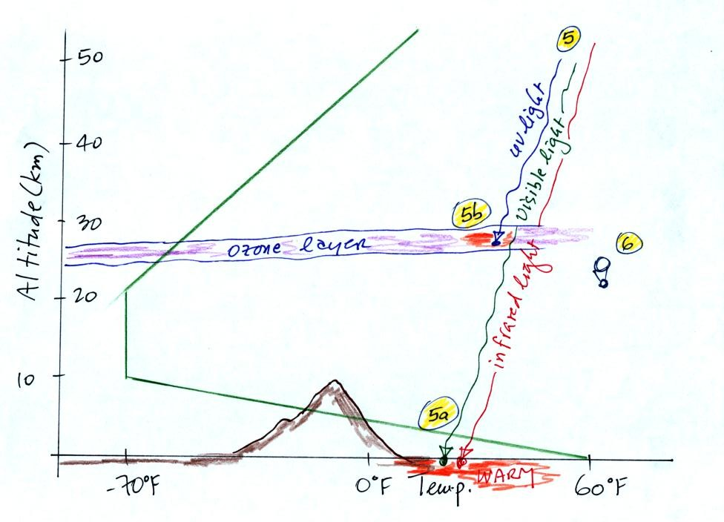
5. Sunlight is a mixture of ultraviolet, visible, and infrared light. We can see the visible light.
5a. Much of the sunlight arriving at the top of the atmosphere passes through the atmosphere and is absorbed at the ground. This warms the ground. The air in contact with the ground is warmer than air just above. As you get further and further from the warm ground, the air is colder and colder. This explains why air temperature decreases with increasing altitude.
5b. How do you explain increasing temperature with increasing altitude in the stratosphere.
The ozone layer is found in the stratosphere (peak concentrations are found near 25 km altitude). Absorption of ultraviolet light by ozone warms the air in the stratosphere and explains why the air can warm. The air in the stratosphere is much less dense (thinner) than in the troposphere. It doesn't take as much energy to warm this thin air as it would to warm denser air closer to the ground.
6. That's a manned balloon; Auguste Piccard and Paul Kipfer are inside. They were to first men to travel into the stratosphere (see pps 31 & 32 in the photocopied Class Notes). We'll see a short video showing part of their adventure at some point in the next week or so.

We're well into the semester and are now ready to move into the last part of Chapter 1. I hope you aren't unhappy with the slow progress we're making (if you are you can send me an email and let me know about it).
This week and next we'll learn how weather data are entered onto surface weather maps and learn about some of the analyses of the data that are done and what they can tell you about the weather. We will also (time permitting) have a brief look at upper level (higher altitutde) weather maps.
Much of our weather is produced by relatively large (synoptic scale) weather systems. To be able to identify and characterize these weather systems you must first collect weather data (temperature, pressure, wind direction and speed, dew point, cloud cover, etc) from stations across the country and plot the data on a map. The large amount of data requires that the information be plotted in a clear and compact way. The station model notation is what meterologists use (you'll find the station model notation discussed in Appendix C, pps 525-529, in the textbook).
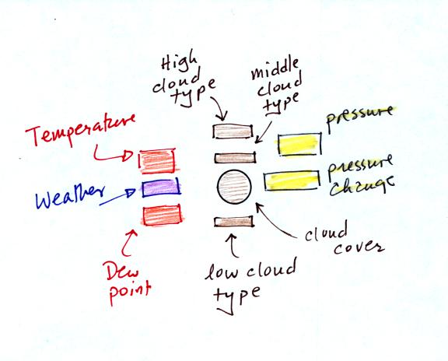
The figure above wasn't shown in class.
A small circle is plotted on the map at the location where the weather measurements were made. The circle can be filled in to indicate the amount of cloud cover. Positions are reserved above and below the center circle for special symbols that represent different types of high, middle, and low altitude clouds (I didn't mention these in class but they are in the textbook). The air temperature and dew point temperature are entered to the upper left and lower left of the circle respectively. A symbol indicating the current weather (if any) is plotted to the left of the circle in between the temperature and the dew point (you can choose from close to 100 different weather symbols included in the textbook ). The pressure is plotted to the upper right of the circle and the pressure change (that has occurred in the past 3 hours) is plotted to the right of the circle.
Here's the actual example we worked on in class.
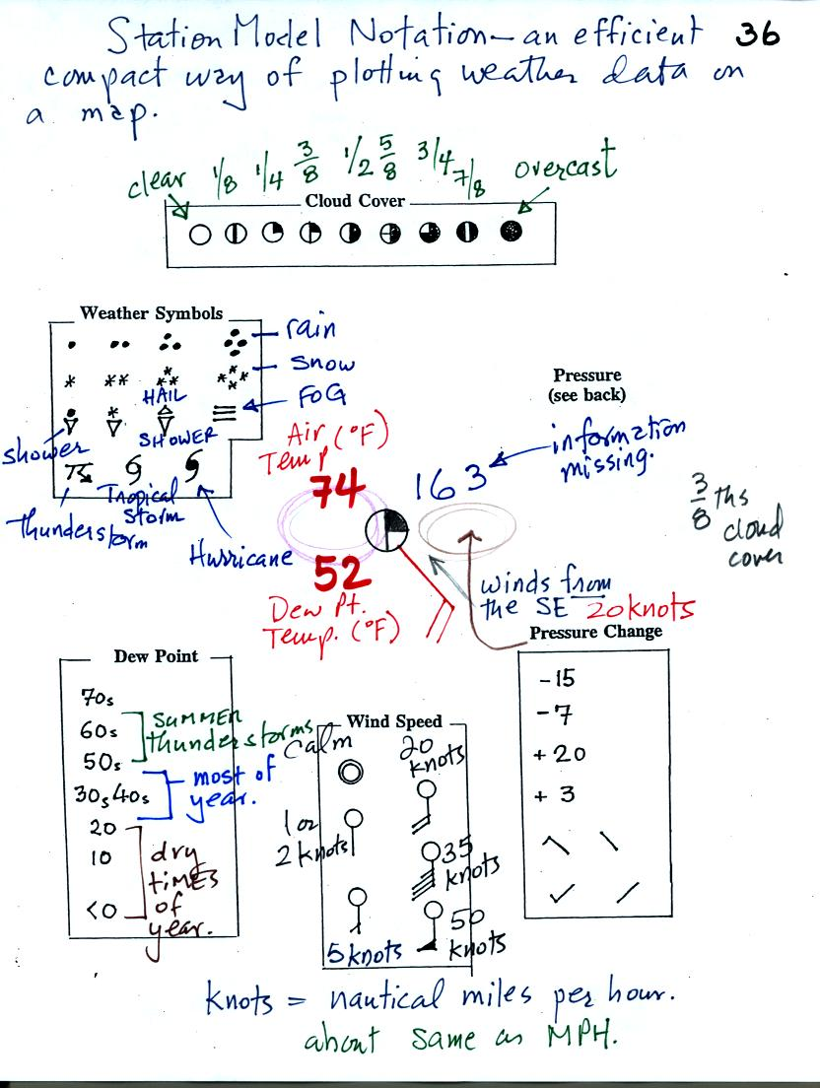
This is frankly a mess and would be very hard to unscramble if you are seeing it for the first time. So we'll work through another example one step at a time.
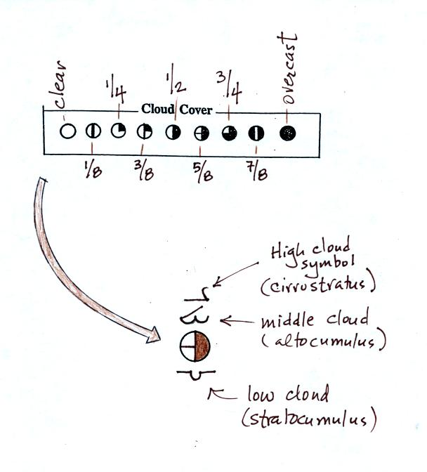
The center circle is filled in to indicate the portion of the sky covered with clouds (estimated to the nearest 1/8th of the sky) using the code at the top of the figure. Then symbols (not drawn in class) are used to identify the actual types of high, middle, and low altitude clouds (the symbols can be found in Appendix C in the textbook).
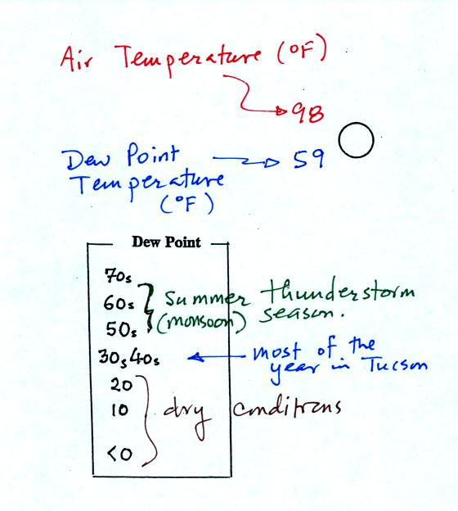
The air temperature in this example was 98º F (this is plotted above and to the left of the center circle). The dew point temperature was 59º F and is plotted below and to the left of the center circle. The box at lower left reminds you that dew points are in the 30s and 40s during much of the year in Tucson. Dew points rise into the upper 50s and 60s during the summer thunderstorm season (dew points are in the 70s in many parts of the country in the summer). Dew points are in the 20s, 10s, and may even drop below 0 during dry periods in Tucson.
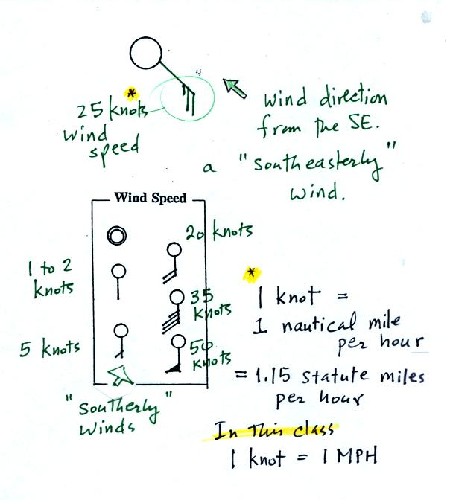
A straight line extending out from the center circle shows the wind direction. Meteorologists always give the direction the wind is coming from. In this example the winds are blowing from the SE toward the NW at a speed of 25 knots. A meteorologist would call these southeasterly winds. Small barbs at the end of the straight line give the wind speed in knots. Each long barb is worth 10 knots, the short barb is 5 knots. Knots are nautical miles per hour. One nautical mile per hour is 1.15 statute miles per hour. We won't worry about the distinction in this class, you can just pretend that one knot is the same as one mile per hour.
Here are some additional wind examples that weren't shown in class:
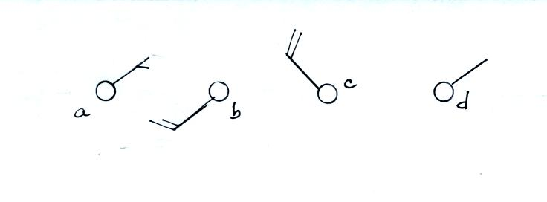
In (a) the winds are from the NE at 5 knots, in (b) from the SW at 15 knots, in (c) from the NW at 20 knots, and in (d) the winds are from the NE at 1 to 2 knots.
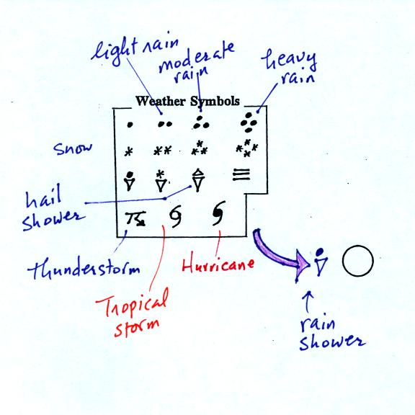
A symbol representing the weather that is currently occurring is plotted to the left of the center circle. Some of the common weather symbols are shown. There are about 100 different weather symbols that you can choose from.
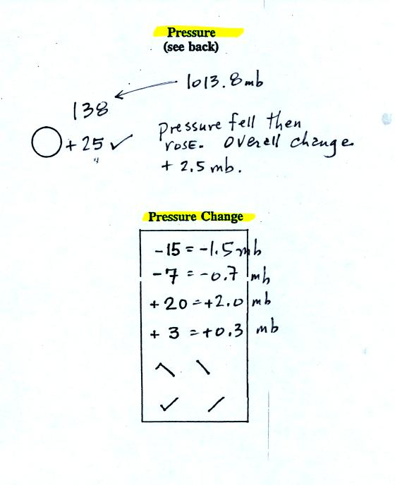
The sea level pressure is shown above and to the right of the center circle. Decoding this data is a little "trickier" because some information is missing. Decoding the pressure is explained below and on p. 37 in the photocopied notes.
Pressure change data (how the pressure has changed during the preceding 3 hours and not covered in class) is shown to the right of the center circle. You must remember to add a decimal point. Pressure changes are usually pretty small.

Here are some links to surface weather maps with data plotted using the station model notation: UA Atmos. Sci. Dept. Wx page, National Weather Service Hydrometeorological Prediction Center, American Meteorological Society.

The pressure data requires quite a bit of further discusssion (see p. 37 in the photocopied ClassNotes).
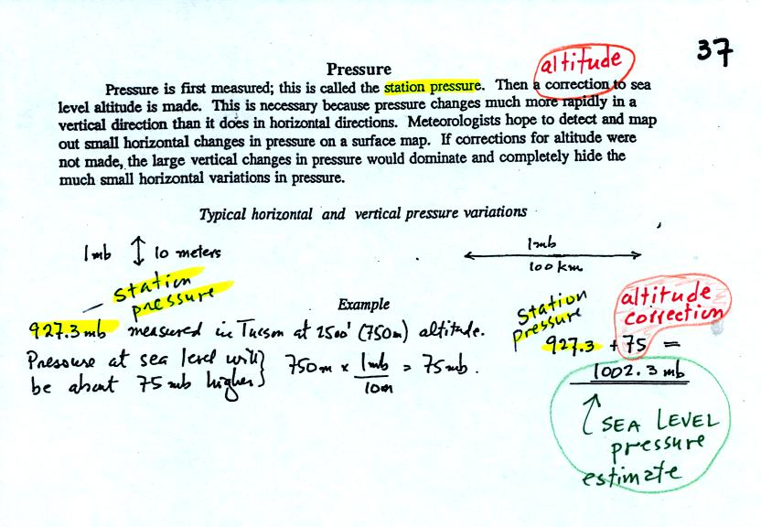
Meteorologists hope to map out small horizontal pressure changes on surface weather maps (that produce wind and storms). Pressure changes much more quickly when moving in a vertical direction. The pressure measurements are all corrected to sea level altitude to remove the effects of altitude. If this were not done large differences in pressure at different cities at different altitudes would completely hide the smaller horizontal changes.
In the example above, a station pressure value of 927.3 mb was measured in Tucson. Since Tucson is about 750 meters above sea level, a 75 mb correction is added to the station pressure (1 mb for every 10 meters of altitude). The sea level pressure estimate for Tucson is 927.3 + 75 = 1002.3 mb.
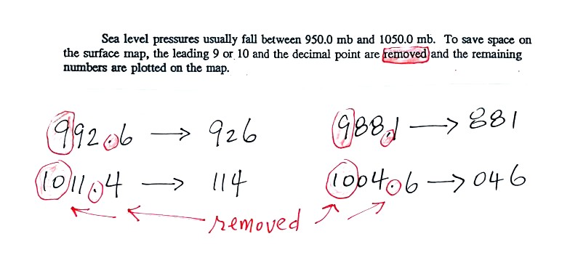
To save room, the leading 9 or 10 on the sea level pressure value and the decimal point are removed before plotting the data on the map. For example the 9 and the . in 992.6 mb would be removed; 926 would be plotted on the weather map (to the upper right of the center circle). Some additional examples are shown above.
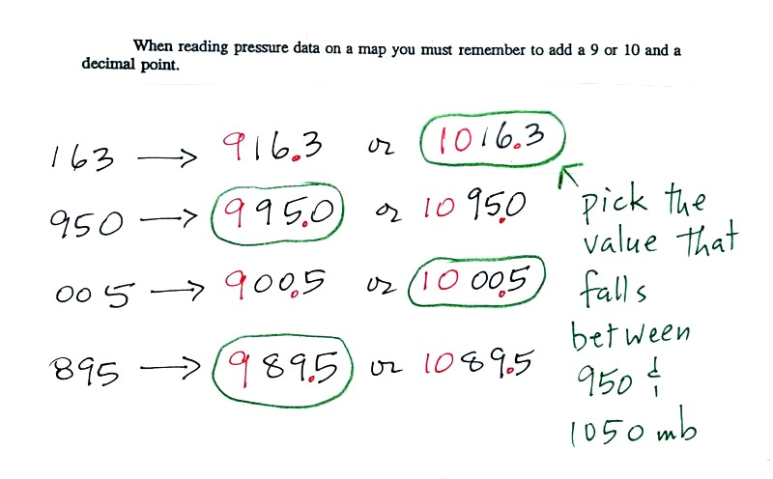
When reading pressure values off a map you must remember to add a 9 or 10 and a decimal point. For example
163 could be either 916.3 or 1016.3 mb. You pick the value that falls between 950.0 mb and 1050.0 mb (so 1016.3 mb would be the correct value, 916.3 mb would be too low).
Another important piece of information that is included on a surface weather map is the time the observations were collected. Time on a surface map is converted to a universally agreed upon time zone called Universal Time (or Greenwich Mean Time, or Zulu time). That is the time at 0 degrees longitude. There is a 7 hour time zone difference between Tucson (Tucson stays on Mountain Standard Time year round) and Universal Time. You must add 7 hours to the time in Tucson to obtain Universal Time.
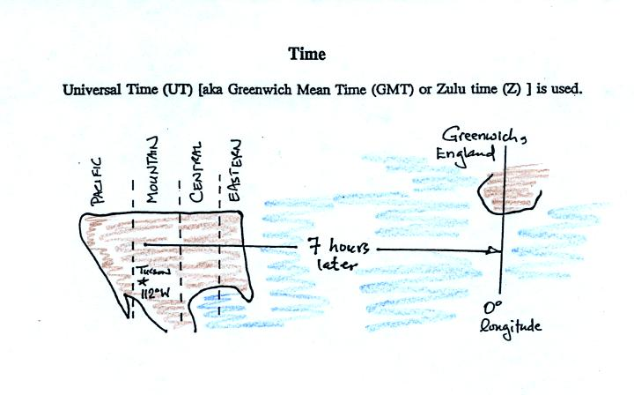
Here are some examples (only the first example was worked in class):
9:05 am MST:
add the 7 hour time zone correction ---> 9:05 + 7:00 = 16:05 UT (4:05 pm in England)
2 pm MST:
first convert 2 pm to the 24 hour clock format 2:00 +12:00 = 14:00 MST
then add the 7 hour time zone correction ---> 14:00 + 7:00 = 21:00 UT (9 pm in Greenwich)
18Z:
subtract the 7 hour time zone correction ---> 18:00 - 7:00 = 11:00 am MST
02Z
if we subtract the 7 hour time zone correction we will get a negative number. We will add 24:00 to 02:00 UT then subtract 7 hours
02:00 + 24:00 = 26:00
26:00 - 7:00 = 19:00 MST on the previous day
2 hours past midnight in Greenwich is 7 pm the previous day in Tucson

