Thursday Oct. 30, 2008
El Cuarto de Tula was the name of the song played before class today. It was from the Buena Vista Social Club.
Answers to the Humidity Optional Assignment were handed out today. The assignments themselves will be returned next Tuesday.
The Quiz #3 Study Pt. 1 , Pt. 2 , and Pt. 3 are now all available online.
The revised Expt. #1 reports will be returned next Tuesday. The Expt. #3 reports are due next Tuesday. If you haven't returned your materials, you can bring them by my office (PAS 588) on Friday or next Monday and pick up the Supplementary Information sheet.
The 1S1P Assignment #2 reports are also due next Tuesday.
Next Tuesday is Election Day. If you haven't done so already, be sure to vote.
I spend a good part of Wednesday entering grades into my computer and printing out midterm grade summaries. You'll find some explanation of the information on the grades summaries at the end of today's notes.

Naming and identifying clouds was covered in class on Tuesday. This is a logical time to learn a little bit about the 2 most common types of satellite photographs. You'll find this discussed on pps 99-100 in the photocopied ClassNotes. The figures below were on a handout distributed in class.
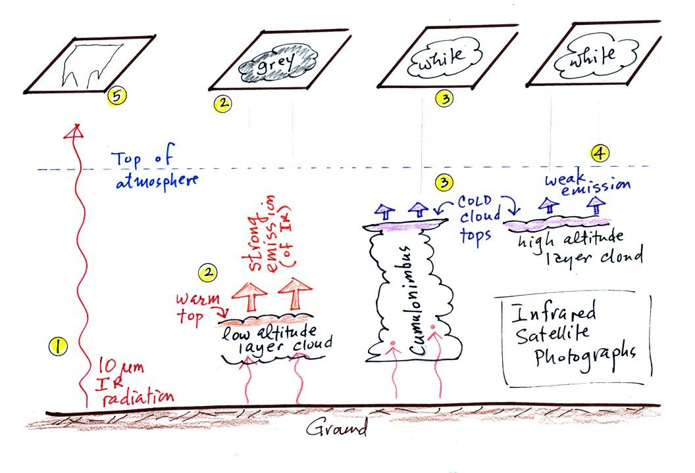
1. An infrared satellite photograph detects the 10 um IR radiation actually emitted by the ground, the ocean and by clouds. You don't depend on seeing reflected sunlight, so clouds can be photographed during the day and at night. You may recall that 10 um radiation is in the middle of the atmospheric window, so this radiation is able to pass through air without being absorbed.
2. Clouds absorb 10 um radiation and then reemit IR radiation. The top surface of a low altitude cloud will be relatively warm. Warmer objects emit IR radiation at a greater rate or at higher intensity (the Stefan Boltzmann law). This is shown as grey on an IR satellite photograph. A grey unimpressive looking cloud on an IR satellite photograph may actually be a thick nimbostratus cloud that is producing a lot of rain or snow.
3. Cloud tops found at high altitude are cold and emit IR radiation at a lower rate or at lower intensity. This shows up white on an IR photograph.
4. Two very different clouds (a thunderstorm and a cirrostratus cloud) would both appear white on the satellite photograph and would be difficult to distinquish. Meteorologists are interested in locating tall thunderstorms as they can produce severe weather.
5. The ground changes temperature during the course of the day. On an infrared satellite animation you can watch the ground change from black (afternoon when the ground is warmest) to grey (early morning when the ground is cold) during the course of a day. The ocean right alongside doesn't change temperature much during the day and remains grey throughout the day. Here's a link to an IR satellite photograph loop on the UA Atmospheric Sciences Dept. webpage.
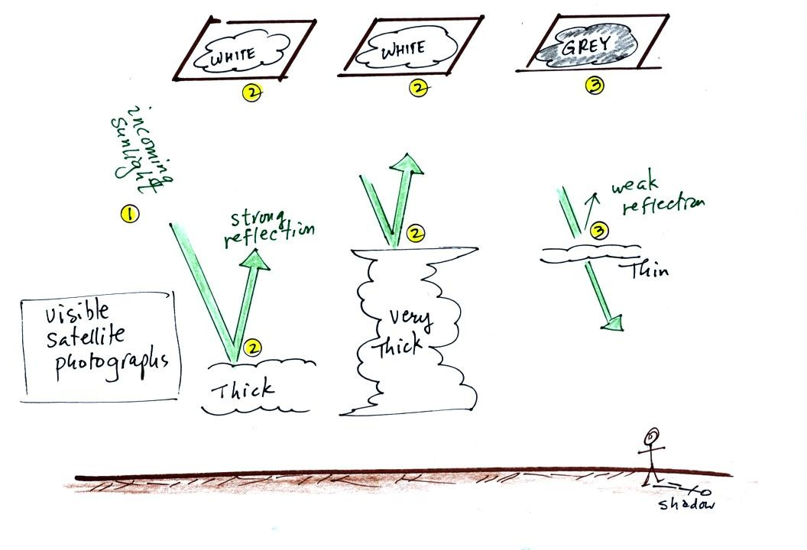
A visible satellite photograph photographs sunlight that is reflected by clouds. You won't see much on a visible satellite photograph at night. Thick clouds are good reflectors and appear white. Thinner clouds don't reflect as much light and appear grey. The low altitude layer cloud and the thunderstorm would both appear white on this photograph and would be difficult to distinquish.
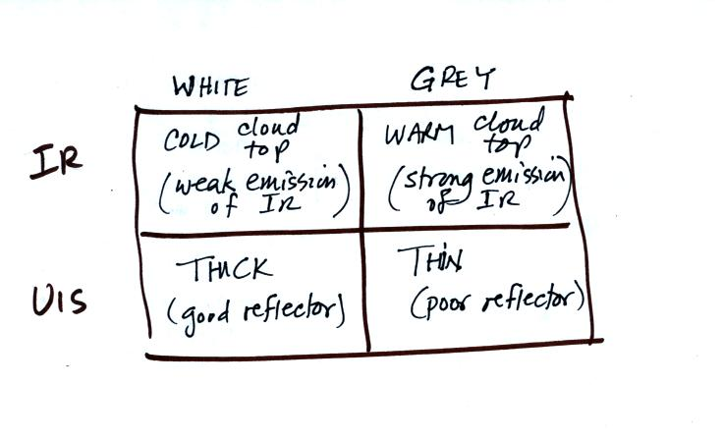
Here's a summary of what we have learned so far.
The figure below shows how if you combine both visible and IR photographs you can begin to distinquish between different types of clouds.
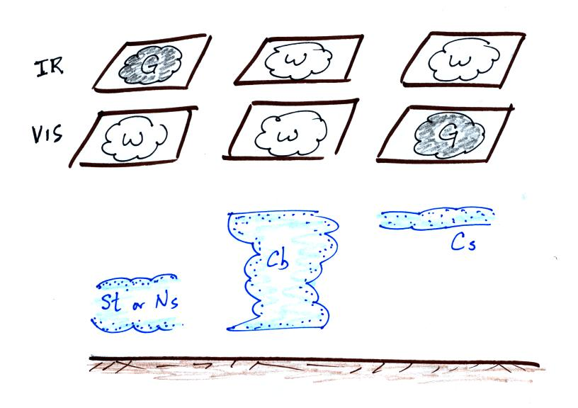

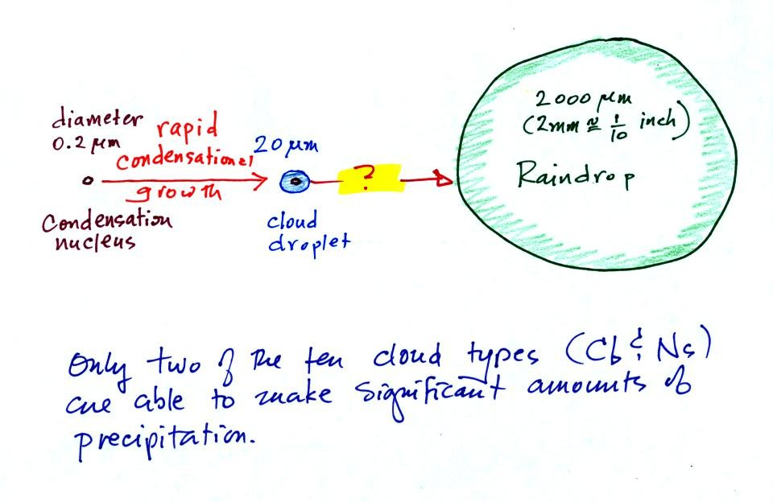
The last big topic we will cover before next week's quiz is precipitation formation and types of precipitation. Only two of the 10 main cloud types (nimbostratus and cumulonimbus) are able to produce significant amounts of precipitation.
This figure shows typical sizes of cloud condensation nuclei (CCN), cloud droplets, and raindrops (a human hair is about 50 um thick for comparison). As we saw in the cloud in a bottle demonstration it is relatively easy to make cloud droplets. You cool moist air to the dew point and raise the RH to 100%. Water vapor condenses pretty much instantaneously onto a cloud condensation nucleus to form a cloud droplet. It would take much longer (a day or more) for condensation to turn a cloud droplet into a raindrop. You know from personal experience that once a cloud forms you don't have to wait that long for precipitation to begin to fall.
Part of the problem is that it takes quite a few 20 um diameter cloud droplets to make one 2000 um diameter raindrop. How many exactly? Before answering that question we will look at a cube (rather than a sphere).
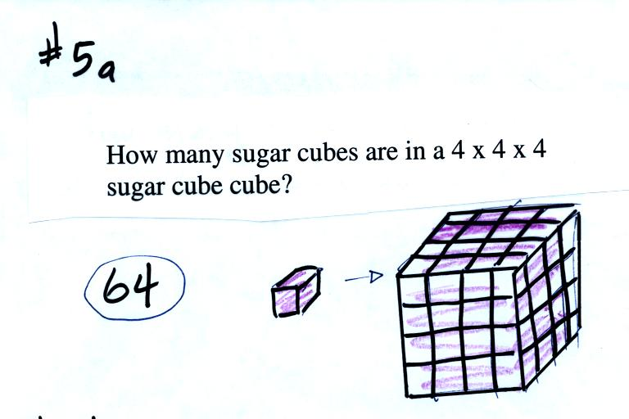
It would take 64 individual sugar cubes to make a 4 cube x 4 cube x 4 cube cube. That is because the bigger cube is 4 times wider, 4 times deeper, and 4 times taller. Volume is 3 dimensions.
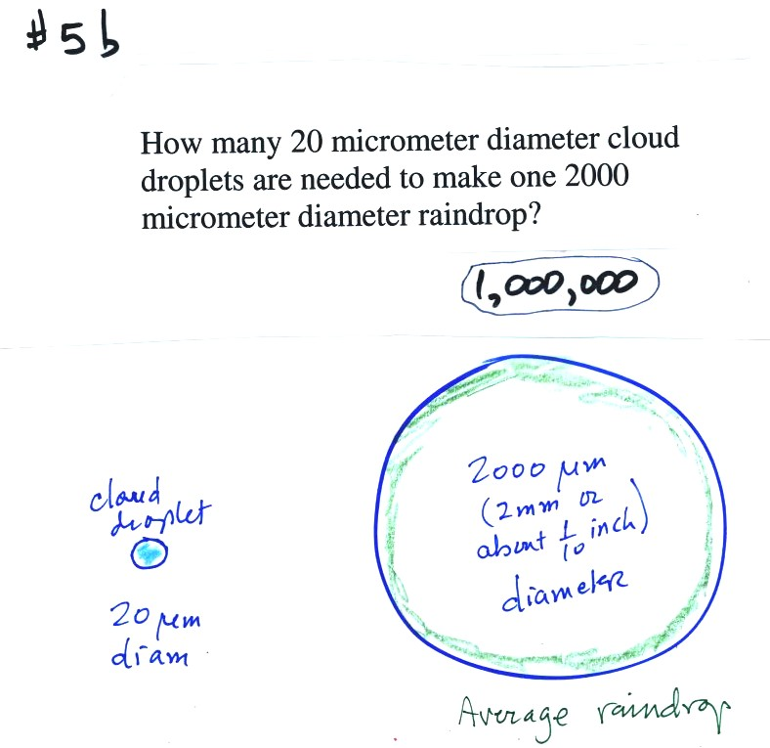

The raindrop is 100 times wider, 100 times deeper, and 100 times taller than the cloud droplet. The raindrop has a volume that is 100 x 100 x 100 = 1,000,000 (one million) times larger than the volume of the cloud droplets.
Fortunately there are two processes capable of quickly turning small cloud droplets into much larger precipitation particles in a cloud.
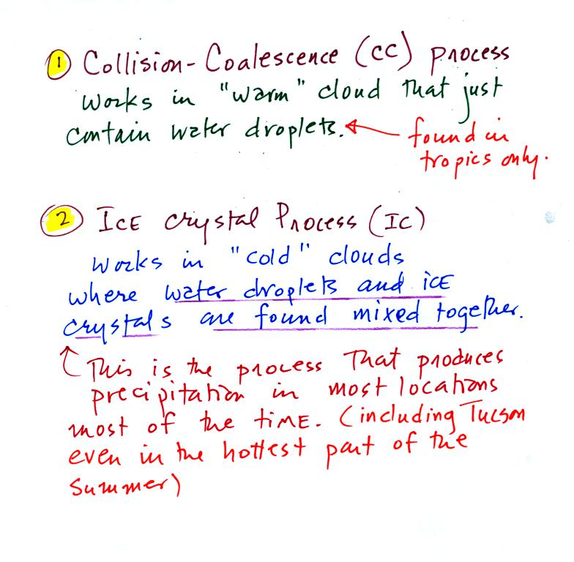
The collision coalescence process works in clouds that are composed of water droplets only. Clouds like this are only found in the tropics. We'll see that this is a pretty easy process to understand. This process will only produce rain.
The ice crystal process produces precipitation everywhere else. This is the process that makes rain in Tucson, even on the hottest day in the summer. There is one part of this process that is a little harder to understand. This process can produce a variety of different kinds of precipitation particles (rain, snow, hail, etc).

Here's what you might see if you looked inside a warm cloud with just water droplets:
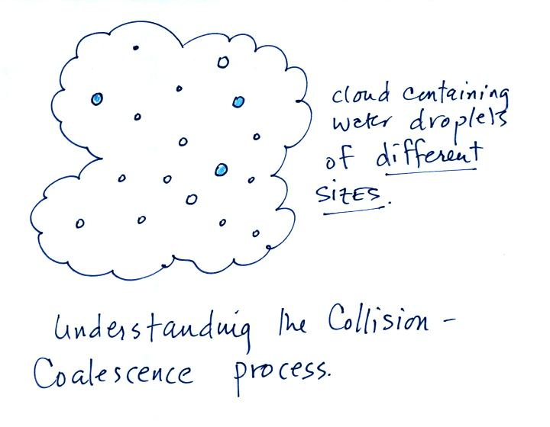
The collision coalescence process works best in a cloud filled with cloud droplets of different sizes. A short video shows that the larger droplets fall faster than the small droplets. A larger than average cloud droplet will overtake and collide with smaller slower moving ones.
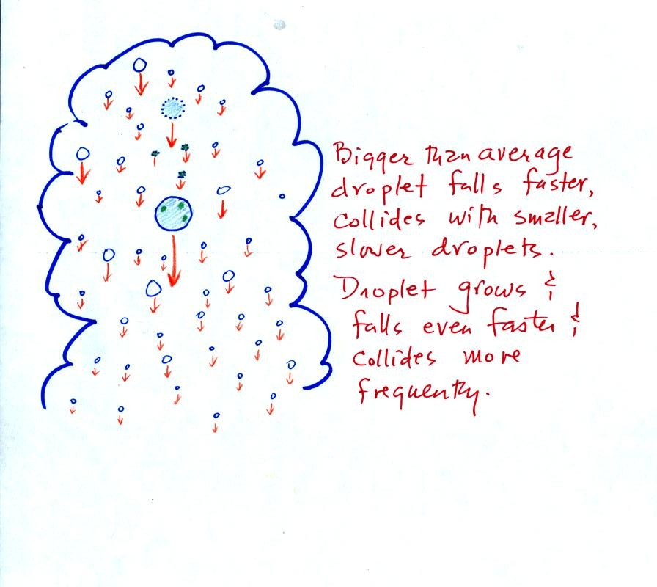
This is an acclerating growth process. The falling droplet gets wider, falls faster, and sweeps out an increasingly larger volume inside the cloud. The bigger the droplet gets the faster it starts to grow.
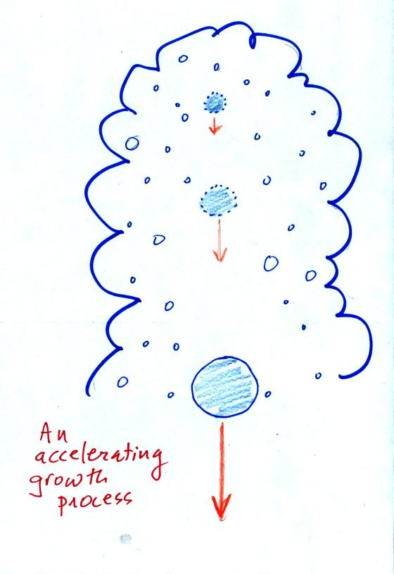

The figure below shows the two precipitation producing clouds: nimbostratus (Ns) and cumulonimbus (Cb). Ns clouds are thinner and have weaker updrafts than Cb clouds. The largest raindrops fall from Cb clouds because the droplets spend more time in the cloud growing. In a Cb cloud raindrops can grow while being carried upward by the updraft and also when falling in the downdraft.
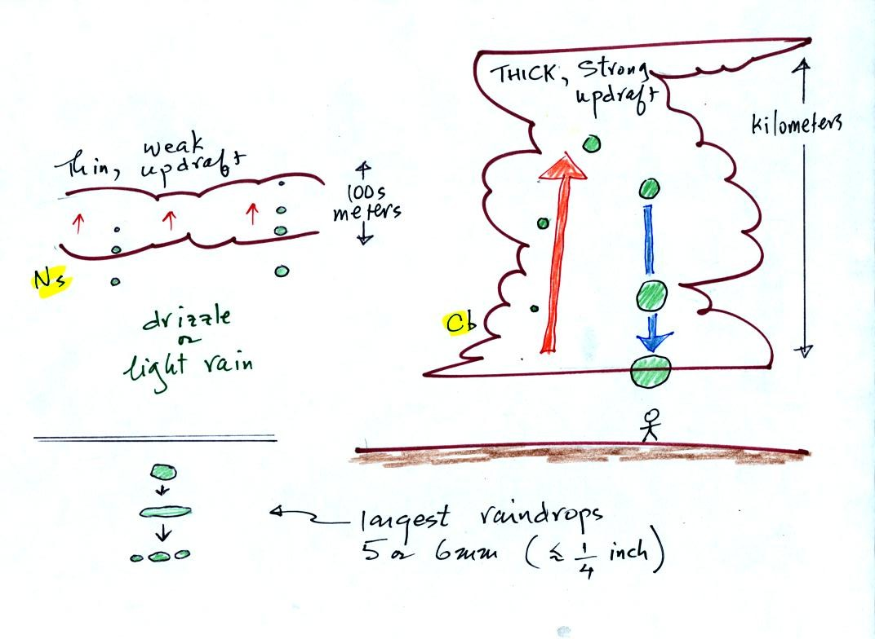
Raindrops grow up to about 1/4 inch in diameter. When drops get larger than that, wind resistance flattens out the drop as it falls toward the ground. The drop begins to "flop" around and breaks apart into several smaller droplets. Solid precipitation particles such as hail can get much larger (an inch or two or three in diameter).

Before learning about the second precipitation producing process, the ice crystal process, we need to look at the structure of cold clouds. The figure below is a redrawn version of what was drawn in class.
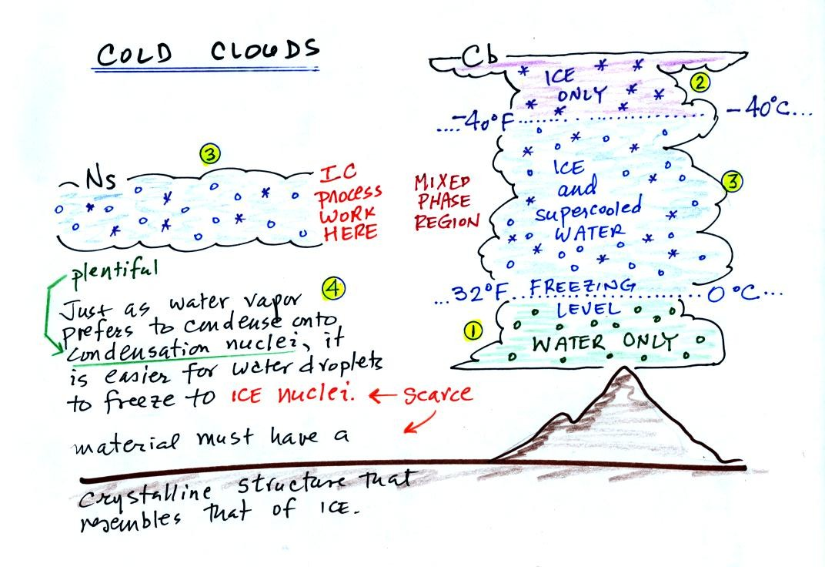
The bottom of the thunderstorm, Point 1, is warm enough (warmer than freezing) to just contain water droplets. The top of the thunderstorm, Point 2, is colder than -40 C and just contains ice crystals. The interesting part of the thunderstorm and the nimbostratus cloud is the middle part, Point 3, that contains both supercooled water droplets (water that has been cooled to below freezing but hasn't frozen) and ice crystals. This is called the mixed phase region. This is where the ice crystal process will be able to produce precipitation. This is also where the electrical charge that results in lightning is generated.
The supercooled water droplets aren't able to freeze even though they have been cooled below freezing. At Point 4 we see this is because it is much easier for small droplets of water to freeze onto an ice crystal nucleus or for water vapor to be deposited onto an ice crystal nucleus (just like it is easier for water vapor to condense onto condensation nuclei rather than condensing and forming a small droplet of pure water). Not just any material will work as an ice nucleus however. The material must have a crystalline structure that is like that of ice. There just aren't very many ice crystal nuclei in the atmosphere. It is hard for water droplets to freeze unless they're really cold (colder than -40 C)

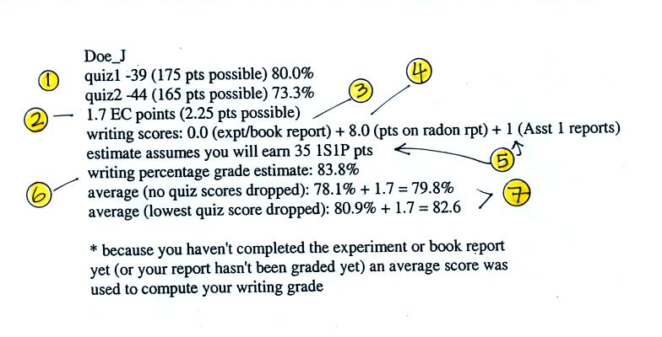
Here's an example of a grade summary.
1. These are your Quiz #1 and Quiz #2 scores and the percentage grades. There is a small error in the Quiz #1 percentage grade: it should be 77.7% instead of 80.0%. The error will be corrected on the next grade summary.
2. The number of extra credit points (from the optional assignments) that you have earned so far.
3. If you have completed an experiment report, the grade should appear here. If not, then an average grade was used during the grade estimate calculations to show the effect of the writing grade on your overall average. Don't get the idea that you don't have to do any experiment report, you do.
4. This is the grade you received on your Bonus 1S1P report on Radon.
5. Because some of the reports haven't been graded yet, none of the 1S1P Assignment #1 grades have been used in the grade summary. Instead the computer "guessed" at how many 1S1P pts you will have at the end of the semester. If you have turned in two Assignment #1 reports so far, the computer assumed you would continue writing reports and would earn 45 pts by the end of the semester (45 is the maximum number of 1S1P pts you can earn during the semester). If you only turned in 1 report, the computer assumed you would end up with 35 pts. And if you haven't turned in any 1S1P reports, the computer started to wonder about that and assumed you might have decided not to write very many 1S1P reports.
It is important to understand that even if you haven't written any 1S1P reports yet, there is still time to catch up and earn 45 pts (the maximum number of points allowed). But you need to get started now. The next assignment is due next week and you should plan on turning in two reports.
It is also important to realize that the number of 1S1P pts you have been given by the computer for the purposes of this grade estimate aren't real points. At the end of the semester the computer will only use points that you have actually earned on reports that you have turned in.
6. The writing score percentage grade is obtained by adding the experiment report points (maximum of 40 pts) and the 1S1P pts (maximum of 45 pts), dividing by 80, and multiplying the result by 100%.
7. This is the computer's guess at what you overall average grade will be at the end of the semester if you keeping doing as you've done so far. The average is based on quiz scores and your writing percentage grade. The extra credit points have been added in. The first average (no quiz grades dropped) is the one that has to be 90.0 or above to get out of the final.
Please check your grade report and make sure the grades are correct. If you have any questions then come and check with me.

