Thursday, Oct. 23, 2008
I was a little surprised that so many people seemed to like today's music from Fishtank Ensemble. At least one person had seem them in a live concert. They're a little unusual, but that's often good.
After a herculean effort the Experiment #2 reports were finally graded (at least the first group of reports) and were returned in class today. You are allowed to revise your report, the revised reports will be due in two weeks, on Thu., Nov. 6 (that is also the date for Quiz #3). Please return your original report with your revised report. You only need to revise portions of your report where you want to earn additional credit.
The revised Experiment #1 reports were due today.
Experiment #4 materials were also distributed in class today. There are a few remaining sets of materials, I'll have them in class next Tuesday.
Some students chose to prepare a report on a Scientific Paper instead of doing an experiment report. The Scientific Paper that I had in mind is now available online (I will bring you a copy of the paper and report guidelines if you send me a request by email).

I mentioned having visited one of the other NATS 101 sections on Wednesday morning. Many of the students weren't paying any attention at all to the lecture but were working on homework from other classes, surfing the internet, or working on a crossword or Sudoku puzzle. I didn't want anyone in my class to find themselves without anything to keep themselves occupied so I handed out a "humidity puzzle." This isn't an assignment.
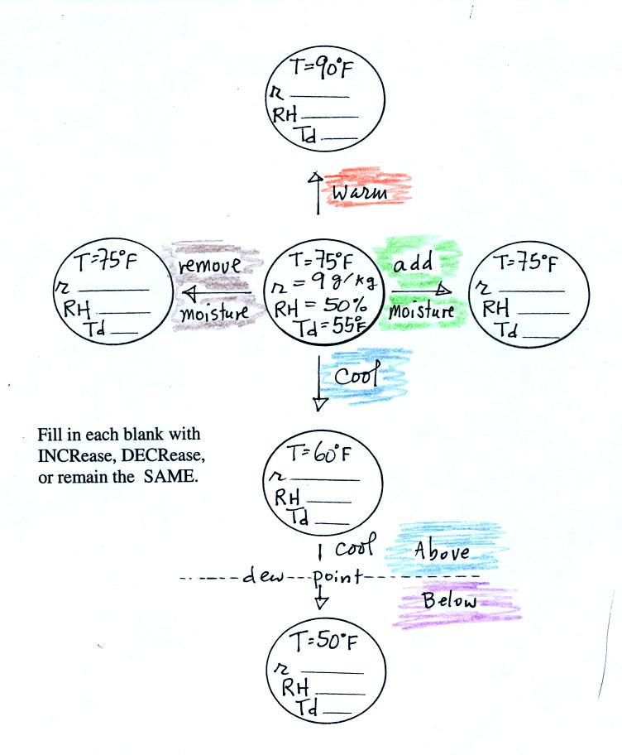
You'll find answers to these questions at the end of today's notes.

Here's something I forgot to mention in class on Thursday.
We can use results from humidity problems #1 and #2 worked in class on Tuesday to learn a useful rule.
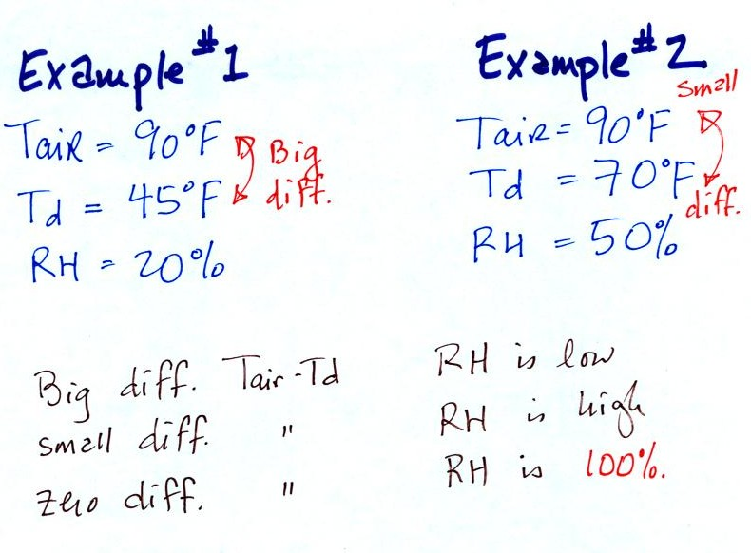
In the first example the difference between the air and dew point temperatures was large (45 F) and the RH was low. In the 2nd problem the difference between the air and dew point temperatures was smaller (20 F) and the RH was higher. The easiest way to remember this rule is to remember the case where there is no difference between the air and dew point temperatures. The RH then would be 100%.
Next we will use what we have learned about humidity variables (what they tell you about the air and what causes them to change value) to learn something new. The figure below is on p. 87 in the photocopied ClassNotes. The figure was redrawn after class.
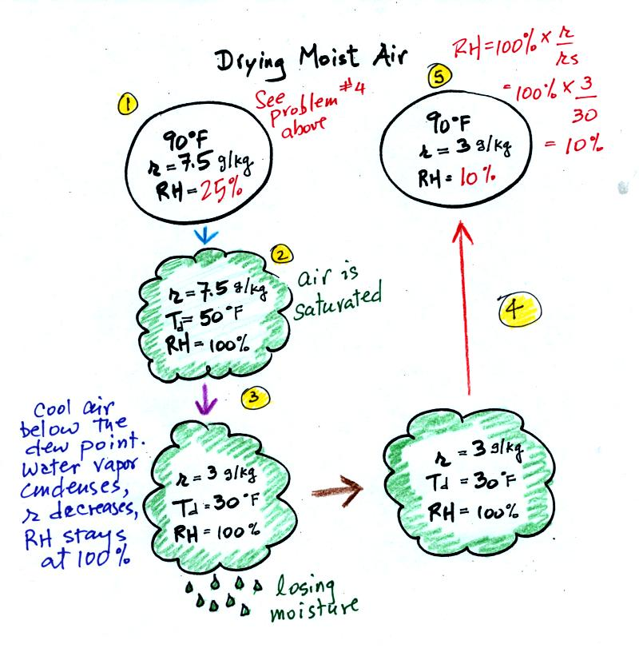
At Point 1 we start with some 90 F air with a relative humidity of 25%, fairly dry air (these data are the same as in Problem #4 on Monday). Point 2 shows the air being cooled to the dew point, that is where the relative humidity would reach 100% and a cloud would form. Then the air is cooled below the dew point, to 30 F. Point 3 shows the 30 F air can't hold the 7.5 g/kg of water vapor that was originally found in the air. The excess moisture must condense (we will assume it falls out of the air as rain or snow). When air reaches 30 F it contains 3 g/kg, less than half the moisture (3 g/kg) that it originally did (7.5 g/kg). Next, Point 4, the 30 F air is warmed back to 90 F, the starting temperature, Point 5. The air now has a RH of only 10%.
Drying moist air is like wringing moisture from a wet sponge.
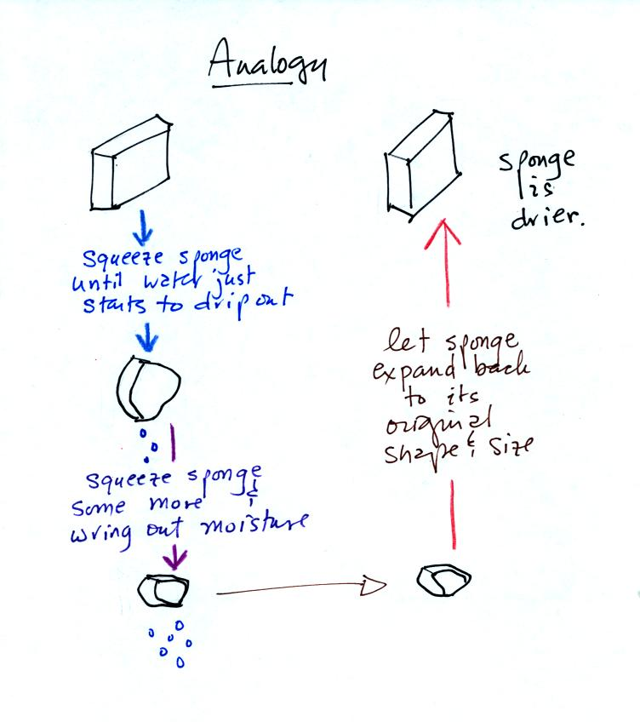
You start to squeeze the sponge and nothing happens at first (that's like cooling the air, the mixing ratio stays constant as long as the air doesn't lose any water vapor). Eventually water will start to drop from the sponge (with air this is what happens when you reach the dew point and continue to cool the air below the dew point). Then you let go of the sponge and let it expand back to its orignal shape and size (the air warms back to its original temperature). The sponge (and the air) will be drier than when you started.
This sort of process ("squeezing" water vapor out of moist air by cooling the air below its dew point) happens all the time. Here are a couple of examples (p. 87 again)
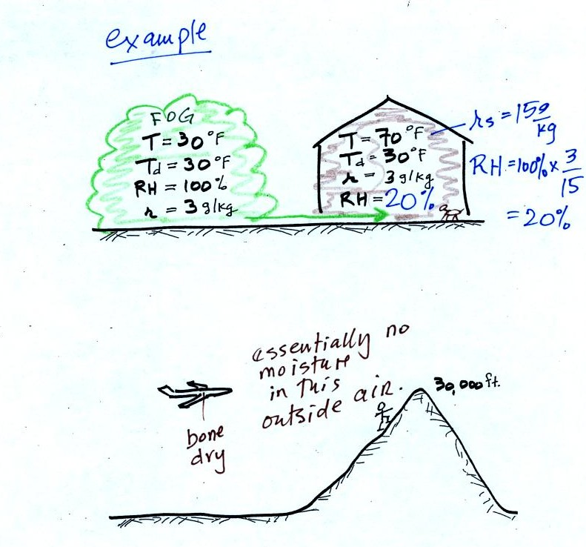
In the winter cold air is brought inside your house or apartment and warmed. Imagine 30 F air with a RH of 100% (this is a best case scenario, the cold winter air usually has a lower dew point and is drier). Bringing the air inside and warming it will cause the RH to drop from 100% to 20%.. Air indoors during the winter is often very dry.
The air in an airplane comes from outside the plane. The air outside the plane can be very cold (-60 F perhaps) and contains very little water vapor (even if the -60 F air is saturated it would contain essentially no water vapor). When brought inside and warmed to a comfortable temperature, the RH of the air in the plane will be very close 0%. Passengers often complain of becoming dehydrated on long airplane flights. The plane's ventilation system probably adds moisture to the air so that it doesn't get that dry.
Here's a very important example, the rain shadow effect (the figure, p. 88 in the ClassNotes, was redrawn after class for clarity).
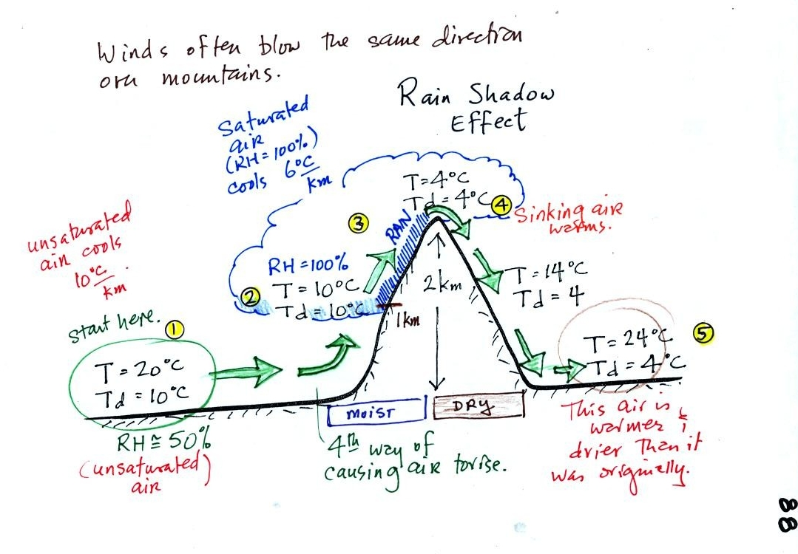
We start with some moist but unsaturated air (RH is about 50%) at Point 1. As it is moving toward the right the air runs into a mountain and starts to rise (see the note below). Unsaturated air cools 10 C for every kilometer of altitude gain. This is known as the dry adiabatic lapse rate. So in rising 1 km the air will cool to 10 C which is the dew point.
The air becomes saturated at Point 2, you would see a cloud appear. Rising saturated air cools at a slower rate than unsaturated air. We'll use a value of 6 C/km (an average value). The air cools from 10 C to 4 C in next kilometer up to the top of the mountain. Because the air is being cooled below its dew point at Point 3, some of the water vapor will condense and fall to the ground as rain.
At Point 4 the air starts back down the right side of the mountain. Sinking air is compressed and warms. As soon as the air starts to sink and warm, the relative humidity drops below 100% and the cloud evaporates. The sinking air will warm at the 10 C/km rate.
At Point 5 the air ends up warmer (24 C vs 20 C) and drier (Td = 4 C vs Td = 10 C) than when it started out. The downwind side of the mountain is referred to as a "rain shadow" because rain is less likely there than on the upwind side of the mountain. Rain is less likely because the air is sinking and because the air on the downwind side is drier than it was on the upslope side.
Most of the year the air that arrives in Arizona comes from the Pacific Ocean. It usually isn't very moist by the time it reaches Arizona because it has travelled up and over the Sierra Nevada mountains in California and the Sierra Madre mountains further south in Mexico. The air loses much of its moisture on the western slopes of those mountains.
NOTE: The figure above illustrates orographic or topographic lifting. It is one of 4 ways of causing air to rise. We have already run into the other three in class this semester. They were: convergence (surface winds spiral into centers of low pressure), convection (warm air rises), and fronts. Rising air is important because rising air expands and cools. Cooling moist air raises the relative humidity and a cloud might form.

The next topic in our potpourri of topics today was measuring humidity. One of the ways of measuring humidity is to use a sling (swing might be more descriptive) psychrometer.
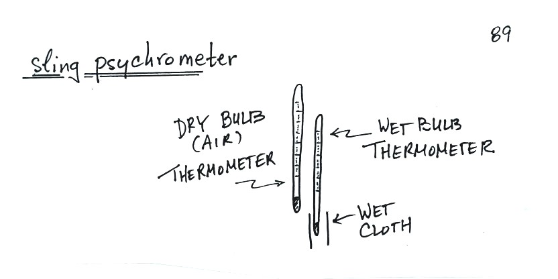
A sling psychrometer consists of two thermometers mounted side by side. One is an ordinary thermometer, the other is covered with a wet piece of cloth. To make a humidity measurement you swing the psychrometer around for a minute or two and then read the temperatures from the two thermometers. The dry - wet thermometer (dry and wet bulb) temperature difference can be used to determine relative humidity and dew point (see the tables on pps. 139 and 140 in the textbook).
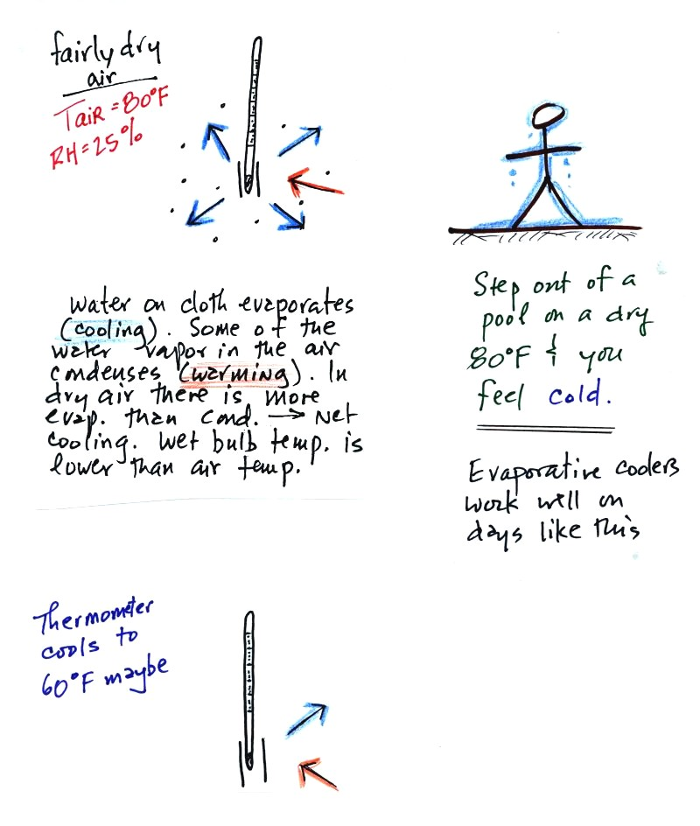
The figure at upper left shows what will happen as you start to swing the wet bulb thermometer. Water will begin to evaporate from the wet piece of cloth. The amount or rate of evaporation will depend on the water temperature (the 80 F value was just made up in this example). Warm water evaporates at a higher rate than cool water.
The evaporation is shown as blue arrows because this will cool the thermometer. The same thing would happen if you were to step out of a swimming pool on a warm dry day, you would feel cold. Swamp coolers would work well on a day like this.
The figure at upper left also shows one arrow of condensation. The amount or rate of condensation depends on how much water vapor is in the air surrounding the thermometer. In this case (low relative humidity) there isn't much water vapor. The condensation arrow is orange because the condensation will release latent heat and warm the thermometer.
Because there is more evaporation (4 arrows) than condensation (1 arrow) the wet bulb thermometer will drop.
The wet thermometer will cool but it won't cool indefinitely. We imagine that the wet bulb thermometer has cooled to 60 F. Because the wet piece of cloth is cooler, there is less evaporation. The wet bulb thermometer has cooled to a temperature where the evaporation and condensation are in balance. The thermometer won't cool any further.
You would measure a large difference (20 F) between the dry and wet bulb thermometers on a day like this when the air is relatively dry.
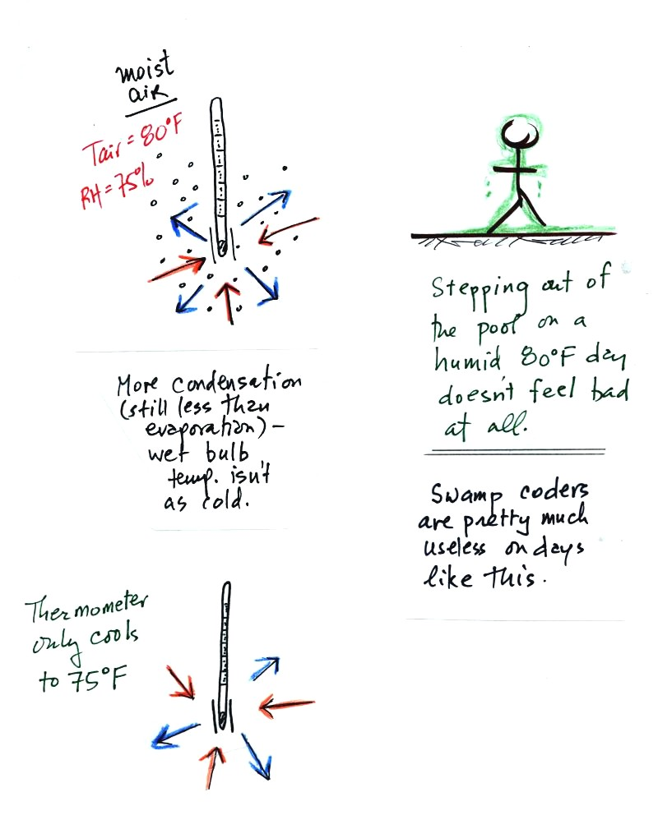
The air temperature is the same in this example, but there is more water vapor in the air. You wouldn't feel as cold if you stepped out of a pool on a warm humid day like this. Swamp coolers wouldn't provide much cooling on a day like this.
There are four arrows of evaporation (because the water temperature is still 80 F just as it was in the previous example) and three arrows now of condensation (due to the increased amount of water vapor in the air surrounding the thermometer). The wet bulb thermometer will cool but won't get as cold as in the previous example.
The wet bulb thermometer might well only cool to 75 F. This might be enough to lower the rate of evaporation (from 4 arrows to 3 arrows) enough to bring it into balance with the rate of condensation.
You would measure a small difference (5 F) between the dry and wet bulb thermometers on a humid day like this.
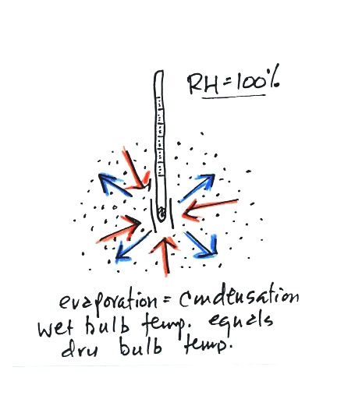
There won't be any difference in the dry and wet bulb temperatures when the RH=100%. The rates at which water is evaporating and water vapor is condensing are equal. That's one of the things that happens when air is saturated. The dry and wet bulb thermometers would both read 80 F.

The next thing we covered was the formation of dew, frost, and something called frozen dew.
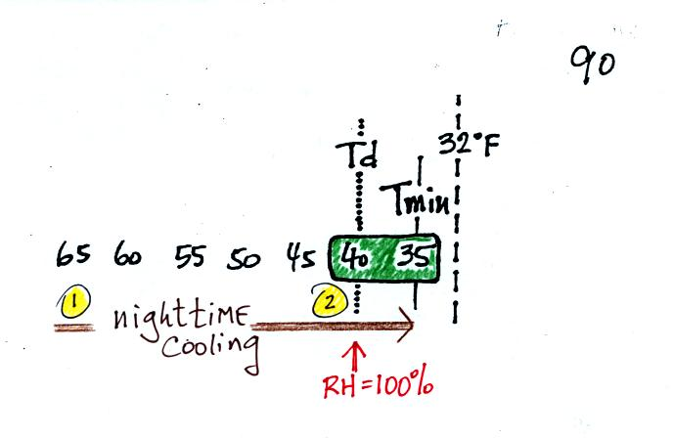
It might be a little hard to figure out what is being illustrated here. Point 1 is sometime in the early evening when the temperature of the air at ground level is 65. By the next morning the air has cooled to 35 F. When the air temperature reaches 40 F, the dew point, the relative humidity reaches 100% and water vapor begins to condense onto the ground. You would find your newspaper and your car covered with dew the next morning.
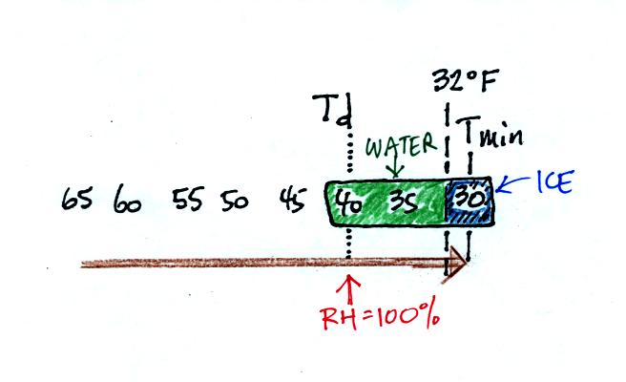
The next night is similar except that the nighttime minimum temperature drops below freezing. Dew forms and first covers everything on the ground with water. Then the water freezes and turns to ice. This isn't frost, rather frozen dew. Frozen dew is often thicker and harder to scrape off your car windshield than frost.
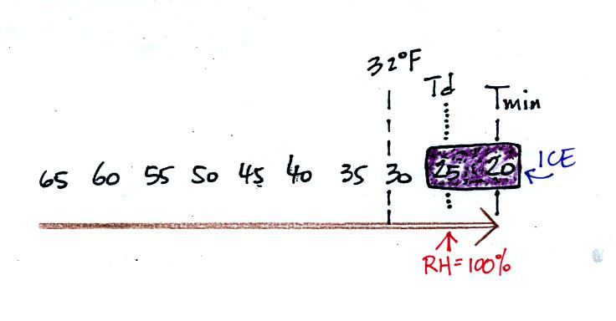
Now the dew point and the nighttime minimum temperature are both below freezing. When the RH reaches 100% water vapor turns directly to ice (deposition). This is frost.
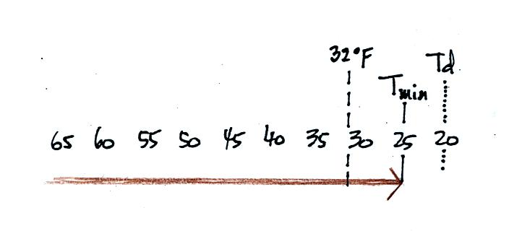
What happens on this night (what important point is not reached? You'll find the answer at the very bottom of today's notes)

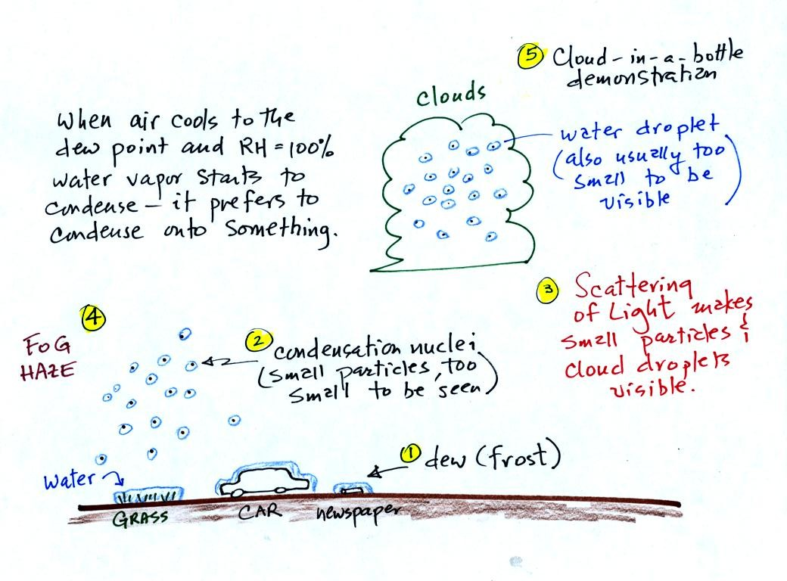
When moist air next to the ground is cooled to and below the dew point, water vapor condenses onto (or is deposited onto) the ground or object on the ground. This is dew, frozen dew, and frost.
Air above the ground can also be cooled to the dew point. When that happens it is much easier for water vapor to condense onto something rather than just forming a small droplet of pure water (you'll find some discussion of this on p. 92 in the photocopied Class Notes, that's optional reading). In air above the ground water vapor condenses onto small particles in the air called condensation nuclei.
You can learn why it is so hard to form small droplets of pure water by reading the top of p. 92 in the photocopied class notes.
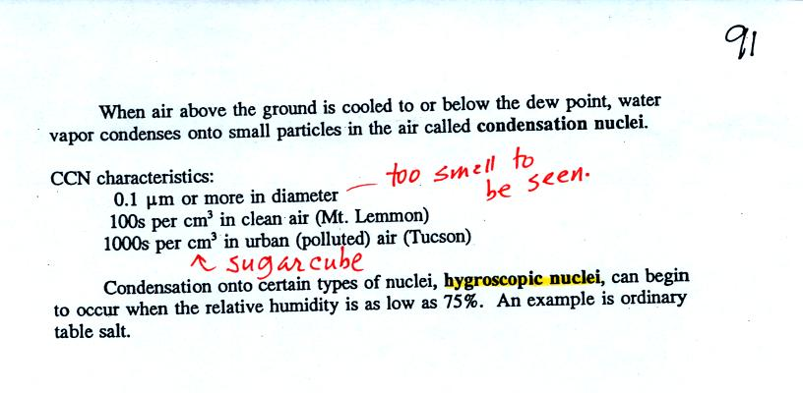
Water vapor will condense onto certain kinds of condensation nuclei even when the relative humidity is below 100% (again you will find some explanation of this on the bottom of p. 92). These are called hygroscopic nuclei.
A short video showed how water vapor would, over time, preferentially condense onto small grains of salt rather than small spheres of glass. The figure below wasn't shown in class.
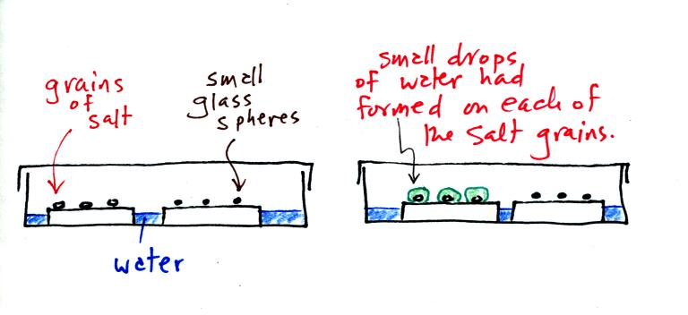
The start of the video at left showed the small grains of salt were placed on a platform in a petri dish containing water. Some small spheres of glass were placed in the same dish. After about 1 hour small drops of water had formed around each of the grains of salt (shown above at right).
In humid parts of the US, water will condense onto the grains of salt in a salt shaker causing them to stick together. Grains of rice apparently will keep this from happening and allow the salt to flow freely out of the shaker when needed.
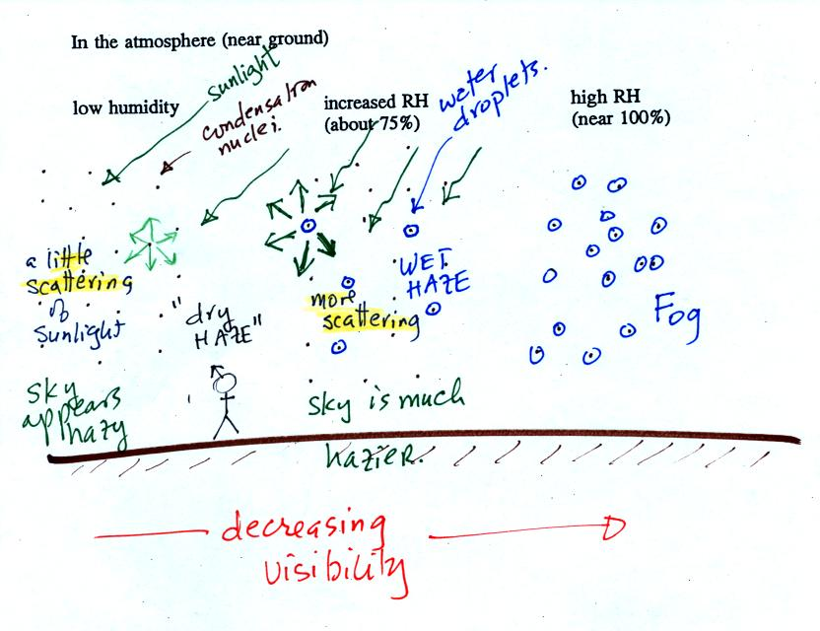
This figure (bottom of p. 91) shows how cloud condensation nuclei and increasing relative humidity can affect the appearance of the sky and the visibility.
The air in the left most figure is relatively dry. Even though the condensation nuclei particles are too small to be seen with the human eye you can tell they are there because they scatter sunlight. When you look at the sky you see the deep blue color caused by scattering of sunlight by air molecules mixed together with some white light scattered by the condensation nuclei. This changes the color of the sky from a deep blue to a bluish white color. The more particles there are the whiter the sky becomes. This is called "dry haze."
The middle picture shows what happens when you drive from the dry southwestern part of the US into the humid southeastern US. One of the first things you would notice is the hazier appearance of the air and a decrease in visibility. Because the relative humidity is high, water vapor begins to condense onto some of the condensation nuclei particles (the hygroscopic nuclei) in the air and forms small water droplets. The water droplets scatter more sunlight than just small particles alone. The increase in the amount of scattered light is what gives the air its hazier appearance. This is called "wet haze."
Finally when the relative humidity increases to 100% fog forms. Fog can cause a severe drop in the visibility. The thickest fog forms in dirty air that contains lots of condensation nuclei. We will see this effect in the cloud-in-a-bottle demonstration coming up next.

Cooling air and changing relative humidity, condensation nuclei, and scattering of light are all involved in this demonstration.
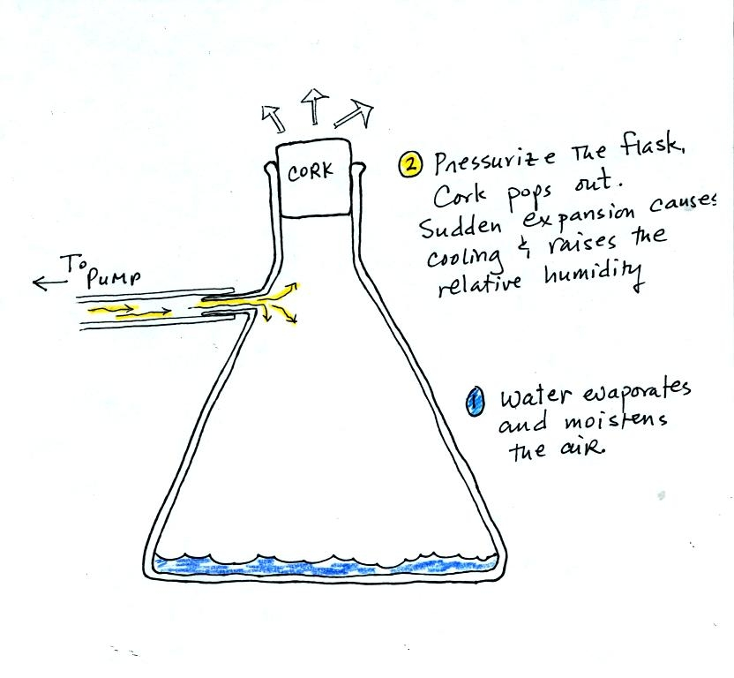
We used a strong thick-walled 4 liter flask (flasks like this are designed to not implode when all of the air is pumped out of them, they aren't designed to not explode when pressurized). There was a little water in the bottom of the flask to moisten the air in the flask. Next we pressurized the air in the flask. At some point the pressure blows the cork out of the top of the flask. The air in the flask expands outward and cools. This sudden cooling increases the relative humidity of the moist air in the flask to 100% (probably more than 100%) and water vapor condenses onto cloud condensation nuclei in the air. A cloud became visible (barely) at this point. The cloud droplets are too small to be seen with the human eye. You can see the cloud because the water droplets scatter light.
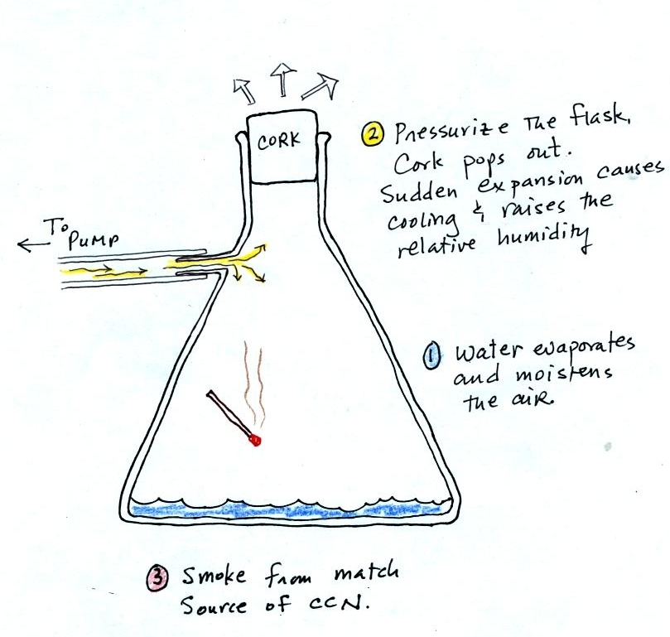
The demonstration was repeated an additional time with one small change. A burning match was dropped into the bottle. The smoke from the match added lots of very small particles, condensation nuclei, to the air in the flask. The cloud that formed this time was quite a bit "thicker" and much easier to see.

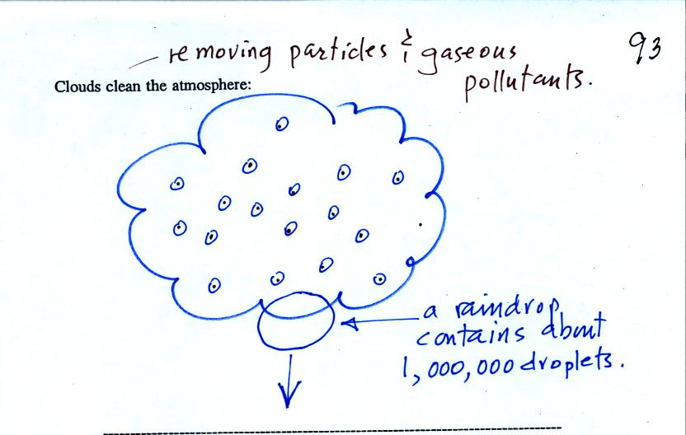
Clouds are one of the best ways of cleaning the atmosphere (cloud droplets form on particles, the droplets clump together to form a raindrop, and the raindrop carries the particles to the ground). A raindrop can contain 1 million cloud droplets so a single raindrop can remove a lot of particles from the air. You may have noticed how clear the air seems the day after a rainstorm. Gaseous pollutants can dissolve in the water droplets and be carried to the ground by rainfall also.
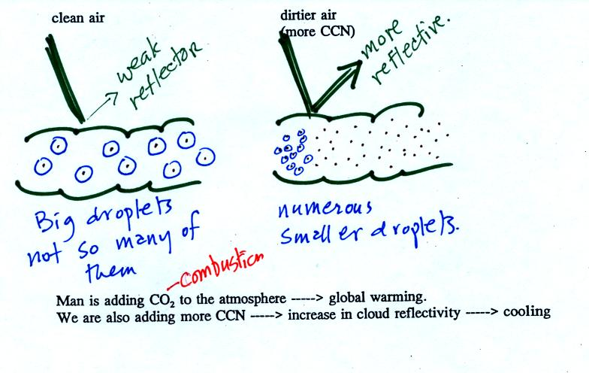
A cloud that forms in dirty air is composed of a large number of small droplets (right figure above). This cloud is more reflective than a cloud that forms in clean air, that is composed of a smaller number of larger droplets (left figure). Just like in the cloud-in-a-bottle demonstration, the cloud that was created when the air was full of smoke particles was much more visible than the cloud made with cleaner air.
This is has implications for climate change. Combustion of fossil fuels adds carbon dioxide to the atmosphere. There is concern that increasing carbon dioxide concentrations will enhance the greenhouse effect and cause global warming. Combustion also adds condensation nuclei to the atmosphere (just like the burning match added smoke to the air in the flask). More condensation nuclei might make it easier for clouds to form, might make the clouds more reflective, and might cause cooling. There is still quite a bit of uncertainty how clouds might change and how this might affect climate (remember too that clouds are good absorbers of IR radiation).

Here are the answers to the handout distributed at the beginning of class.


The air temperature never reaches the dew point (or frost point) and the RH nevers reaches 100%. So nothing forms. This is sometimes called "black frost" (frost that you can't see ... because it isn't there)

