Tuesday Oct. 21, 2008
Rupa and the April Fishes were featured before class today. You'll find the two songs played in class ("Maintenant" and "Poder") at their MySpace webpage. You might also want to check out Une Americaine a Paris on YouTube.
The quizzes have been graded and were returned in class. The average score was a little lower than Quiz #1. Check your quiz carefully for grading erros.
An Optional Assignment turned in last week before Quiz #2 was returned in class today. Because it covered material that was on the last quiz it wasn't carefully graded. You probably checked the answers while you were preparing for last week's quiz.
One group of the 1S1P Topic #3 reports has been graded and was returned in class today. You can check to see which 1S1P reports have been graded at this link.
1S1P Assignment #2 is now online. Reports are due in two weeks, on or before Tuesday Nov. 4 (election day).
A new Optional Assignment on humidity is available online. I forgot to bring copies of the assignment to class, I 'll have them on Thursday. The assignment is due at the start of class next Tuesday Oct. 28.
The Experiment #2 reports should be graded by Thursday. The revised Expt. #1 reports are due on Thursday. Please return the original report if you turn in a revised report. Please take advantage of the exceptional weather we are now experiencing and do Expt. #3. Return the materials, make them available for another student, and pick up the supplementary information sheet.

The following is an introduction to an important new topic: humidity (moisture in the air). The beginning of Chapter 5 (pps 123-133) can be a little overwhelming and confusing. I would suggest you skim through that material. We reviewed this material very quickly at the start of class.
We will be mainly interested in 4 variables, what they are and what can cause their values to change. The variables are : mixing ratio, saturation mixing ratio, relative humidity, and dew point. You will find much of what follows on page 83 in the photocopied ClassNotes.
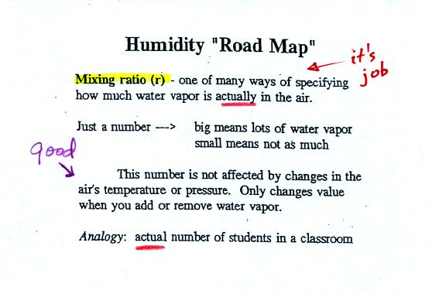
Mixing ratio tells you how much water vapor is actually in the air. Mixing ratio has units of grams of water vapor per kilogram of dry air (the amount of water vapor in grams mixed with a kilogram of dry air). It is basically the same idea as teaspoons of sugar mixed in a cup of tea.
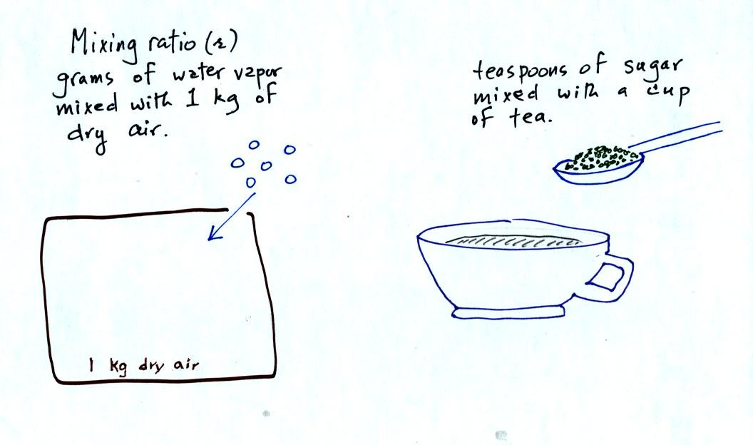
The value of the mixing ratio won't change unless you add water vapor to or remove water vapor from the air. Warming the air won't change the mixing ratio. Cooling the air won't change the mixing ratio (unless the air is cooled below its dew point temperature and water vapor starts to condense).
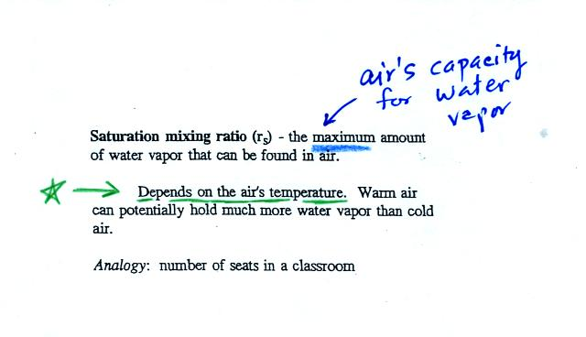
Saturation mixing ratio is just an upper limit to how much water vapor can be found in air, the air's capacity for water vapor. It's a property of air, it doesn't say anything about how much water vapor is actually in the air (that's the mixing ratio's job). Warm air can potentially hold more water vapor than cold air. This variable has the same units: grams of water vapor per kilogram of dry air. Saturation mixing ratio values for different air temperatures are listed and graphed on p. 86 in the photocopied class notes.
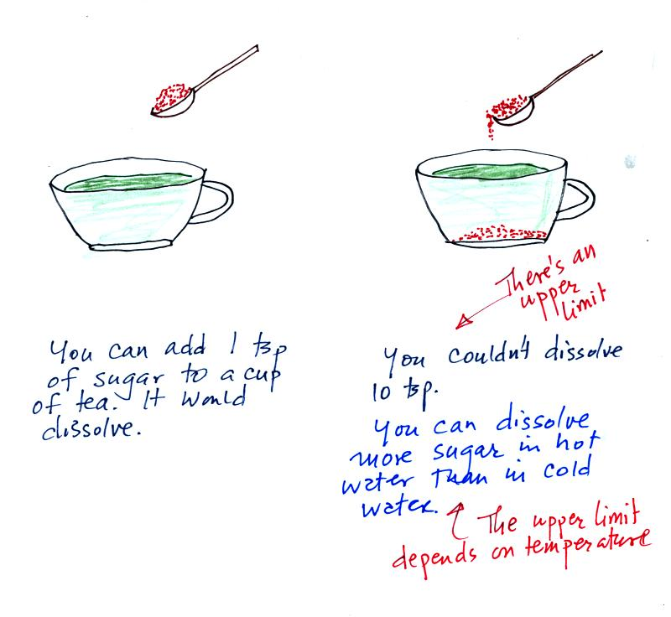
Just as is the case with water vapor in air,
there's a limit to how much sugar can be dissolved in a cup of hot water. You can dissolve more sugar in hot water than in cold water.
The dependence of saturation mixing ratio on air temperature is illustrated below:
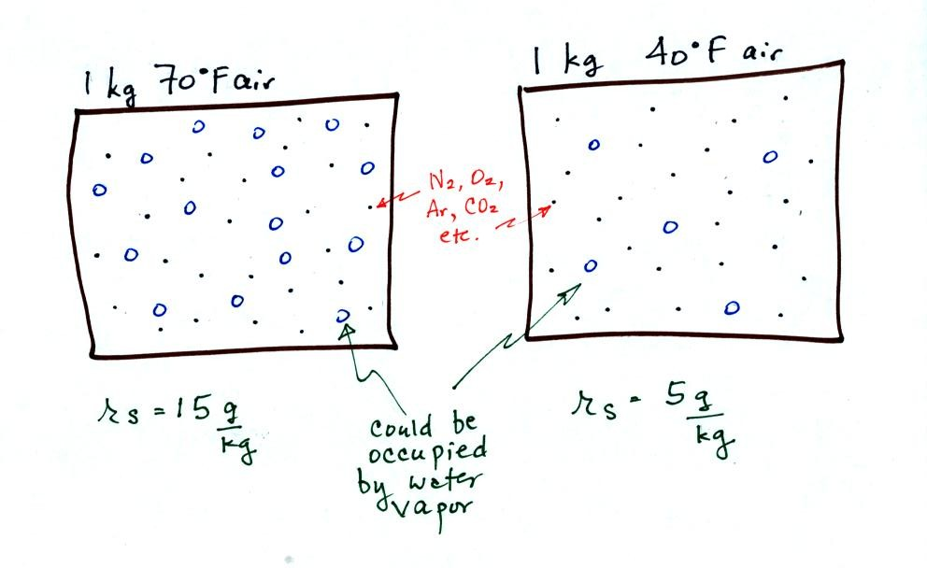
The small specks represent all of the gases in air except for the water vapor. Each of the open circles represents 1 gram of water vapor that the air could potentially hold. There are 15 open circles drawn in the 1 kg of 70 F air; each 1 kg of 70 F air could hold up to 15 grams of water vapor. The 40 F air only has 5 open circles; this cooler air can only hold up to 5 grams of water vapor per kilogram of dry air.
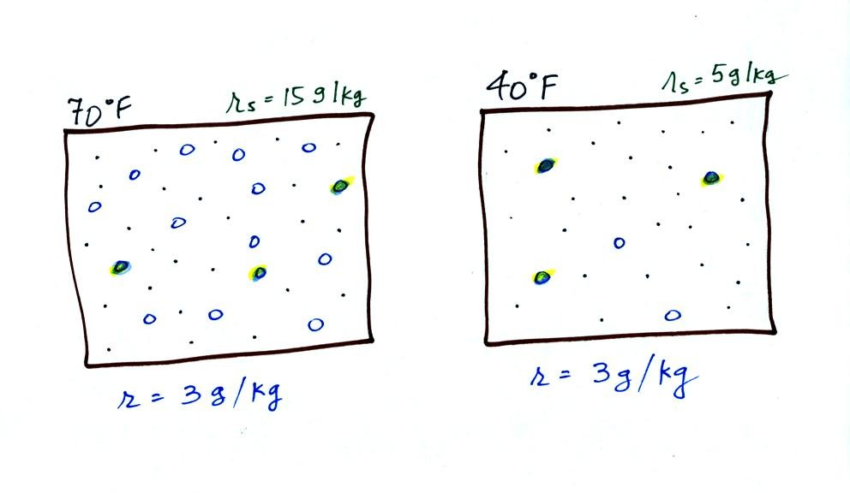
Now we have gone and actually put some water vapor into the volumes of 70 F and 40 F air. 3 grams of water vapor have been added to each volume of air. The mixing ratio, r, is 3 g/kg in both cases.

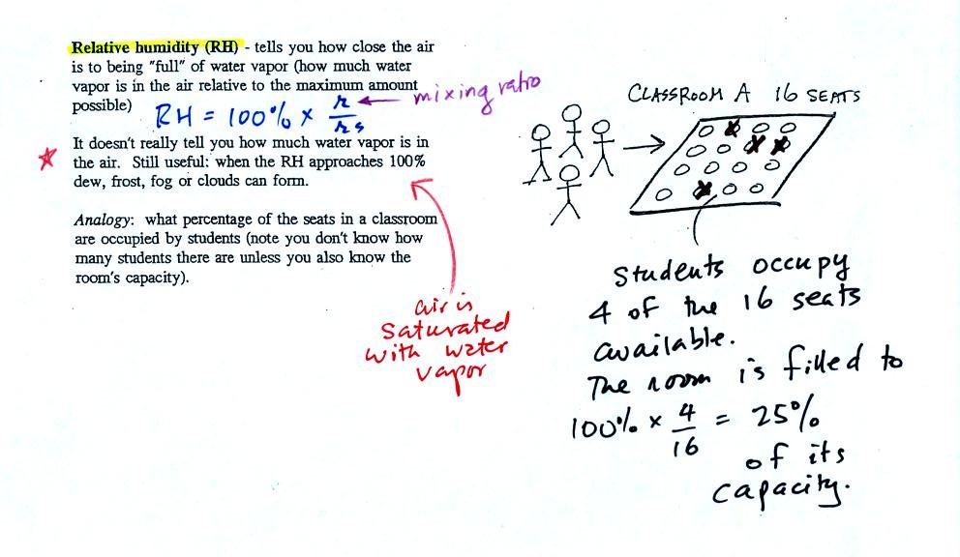
The relative humidity is the variable most people are familiar with, it tells you how "full" the air is with water vapor.
In the analogy (sketched on the right hand side of p. 83 in the photocopied notes) 4 students wander into Classroom A which has 16 empty seats. Classroom A is filled to 25% of its capacity. You can think of 4, the number of students, as being analogous to the mixing ratio. The classroom capacity is analogous to the saturation mixing ratio. The percentage occupancy is analogous to the relative humidity.
Instead of students and a classroom you could think of the 70 F and 40 F air that could potentially hold 15 grams or 5 grams, respectively of water vapor.
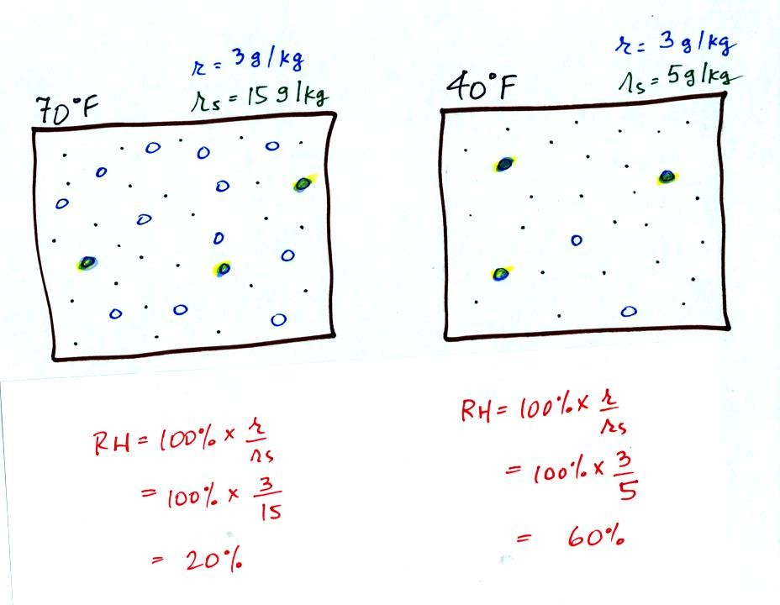
Here are the relative humidities of the 70 F and 40 F air that each contain 3 grams of water vapor. The 70 F air has a low RH because this warm air's saturation mixing ratio is large. The RH in the 40 F is higher even though it has the same actual amount of water vapor because the 40 F air can't hold as much water vapor and is closer to being saturated. Here is a hidden Optional Assignment that covers this introductory material on humidity variables. The assignment will be due at the start of class next Tuesday.
Something important to note: RH doesn't really tell you how much water vapor is actually in the air. The two volumes of air above contain the same amount of water vapor (3 grams per kilogram) but have different relative humidities. You could just as easily have two volumes of air with the same relative humidities but different actual amounts of water vapor.

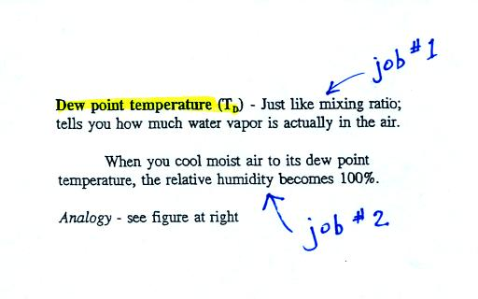
The dew point temperature has two jobs. First it is a measure of the actual amount of water vapor in the air. In this respect it is just like the mixing ratio. If the dew point temperature is low the air doesn't contain much water vapor. If it is high the air contains more water vapor.
Second the dew point tells you how much you must cool the air in order to cause the RH to increase to 100% (at which point a cloud, or dew or frost, or fog would form).
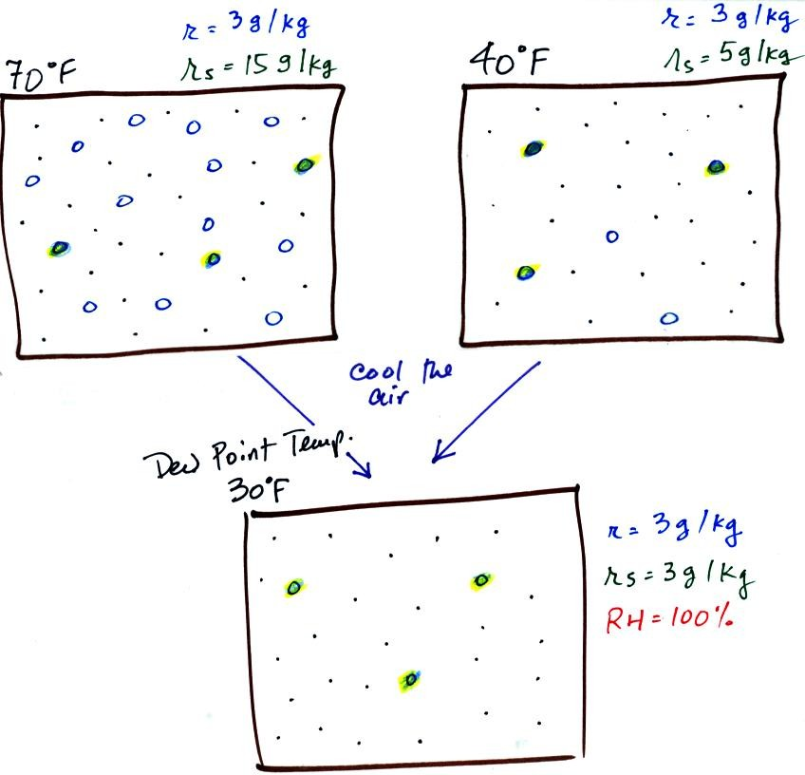
If we cool the 70 F air or the 40 F air to 30 F we would find that the saturation mixing ratio would decrease to 3 grams/kilogram. Since the air actually contains 3 g/kg, the RH of the 30 F air would become 100%. The 30 F air would be saturated, it would be filled to capacity with water vapor. 30 F is the dew point temperature for 70 F air that contains 3 grams of water vapor per kilogram of dry air. It is also the dew point temperature for 40 F air that contains 3 grams of water vapor per kilogram of dry air.Because both volumes of air had the same amount of water vapor, they both also have the same dew point temperature.
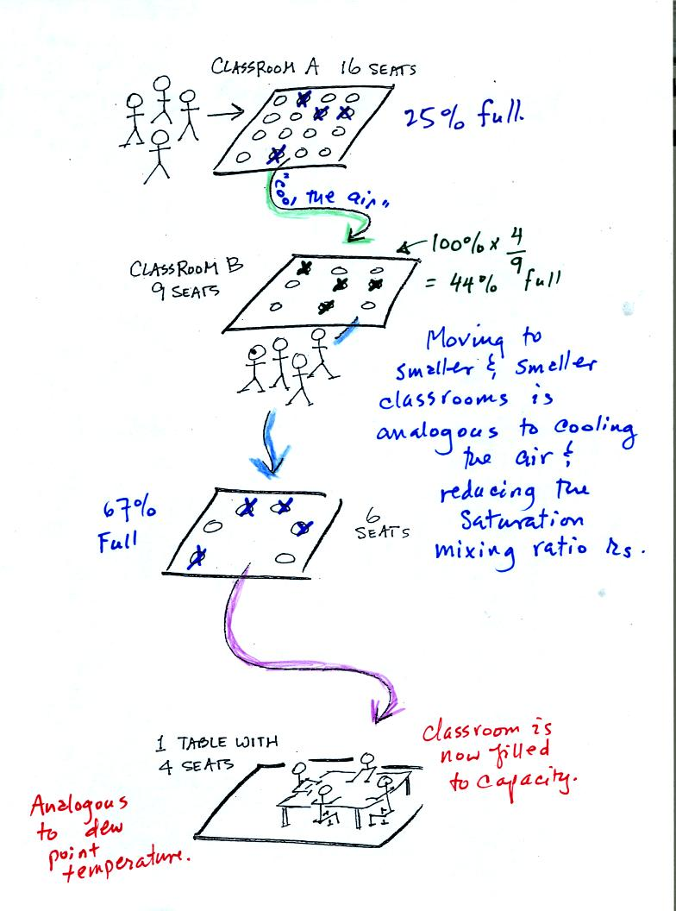
Now back to our students and classrooms analogy on the righthand side of p. 83. The 4 students move into classrooms of smaller and smaller capacity. The decreasing capacity of the classrooms is analogous to the decrease in saturation mixing ratio that occurs when you cool air. Eventually the students move into a classroom that they just fill to capacity. This is analogous to cooling the air to the dew point temperature, at which point the RH becomes 100% and the air is filled to capacity, the air is saturated with water vapor.

Today's class featured a Survivor-like Reward Challenge. Several students were able to win prizes by answering a few relatively simple questions in class. Here's the first part of the first question.
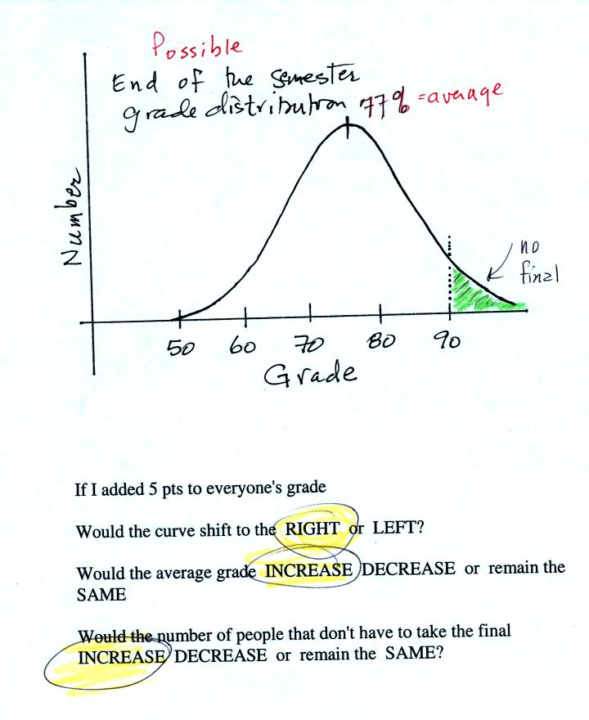
The graph shows a reasonable distribution of end-of-semester grades. The average appears to be about 77%. Students with grades equal to or greater than 90.0% are exempt from the final. A student in the class was asked the three questions at the bottom of the figure. If 5 pts were added to everyone's overall grade, the curve and the average grade would both shift to the right. This rightward shift would increase the number of students that wouldn't have to take the final exam.
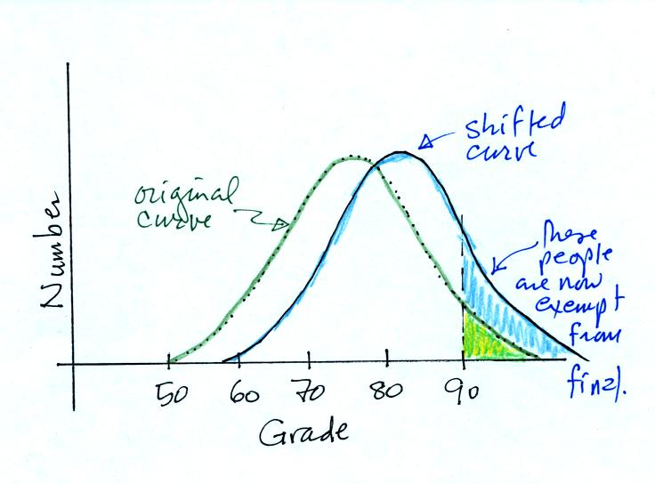
This is the shifted curve.
The student answered the first three questions correctly and was able to proceed to the second part of the question.
The next figure shows the distribution of the kinetic energies of water molecules in a glass of water. It looks just like the grade distribution graph. There's an average and some of the water molecules (the ones at the far right end of the curve) have enough kinetic energy that they can evaporate (similar to students that are exempt from the final exam).
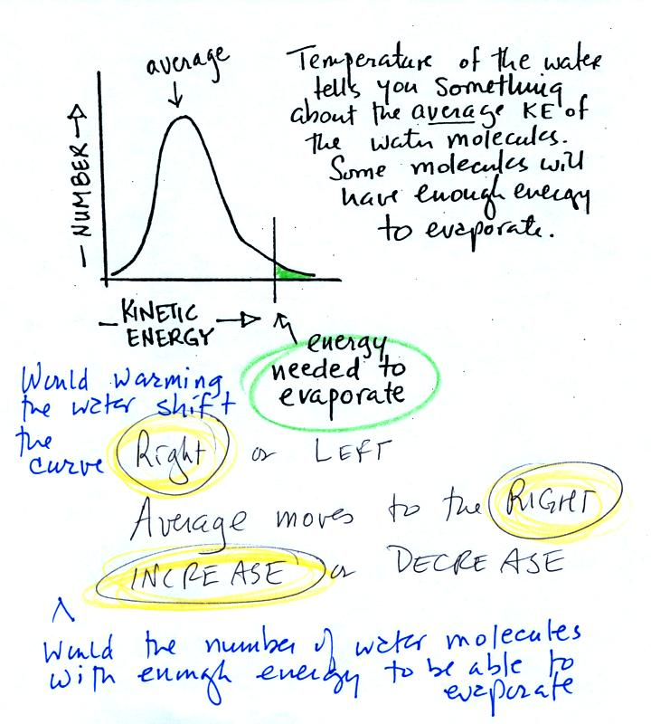
The student was asked three additional questions about this kinetic energy distribution graph. If the water were heated, would the curve shift to the right or the left. Would the average kinetic energy move to the right or left. Would the number of water molecules, with enough kinetic energy to be able to evaporate, increase, decrease, or remain the same? The student's three correct answers are shown above. The shifted curve is shown below
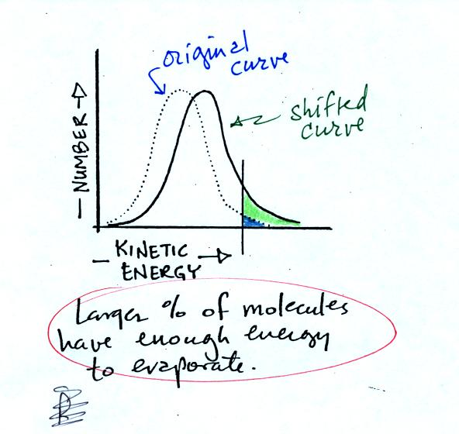
The student won a prize (a plastic raingauge if I remember correctly - which I hope wasn't too much of a disappointment).
Now what we have been able to understand (in what was hopefully a little more entertaining than normal) is that warm water evaporates more rapidly than cold water. This is summarized om p. 84 in the photocopied ClassNotes.
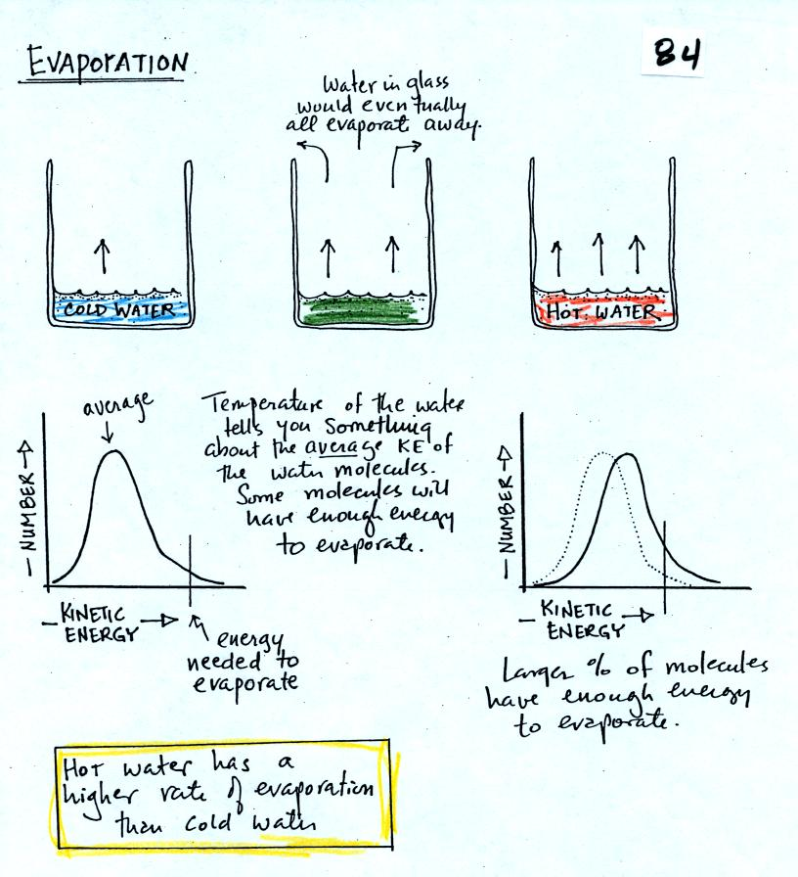

It was time for another student and a new question (the 2nd question). A two part question. The set up is shown below.
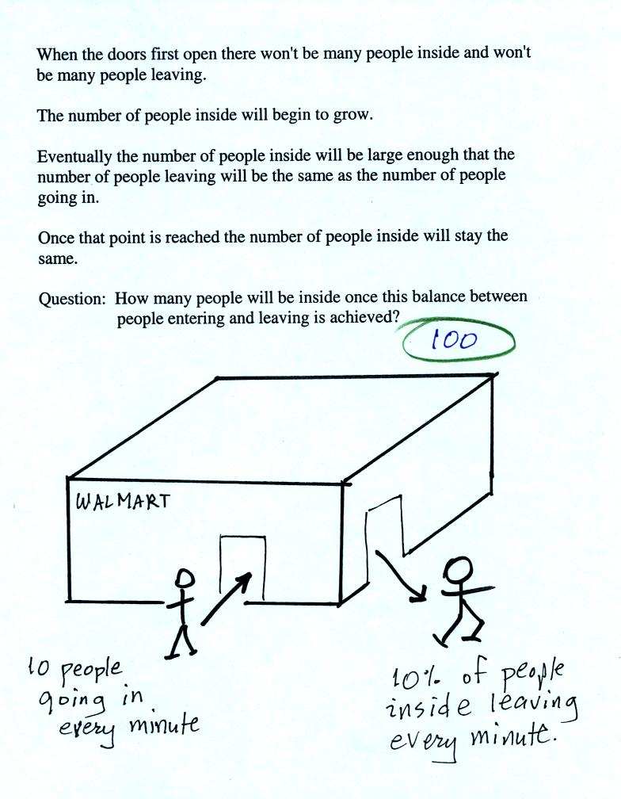
It was basically a question about how many people would have to be inside the Walmart in order for the rates at which people enter (10 people per minute) and at which people leave (10% of the people inside leave every minute) to equal. Once this balance is reached the number of people inside the store will remain constant.
The student answered the question correctly (the details are shown below). The student also answered a follow up question about how the answer would change if 20 people per minute were entering the store. The correct answer was that the number inside would increase to 200 before the rates of people entering and leaving became equal. This student won some catfood for her cat if I remember correctly.
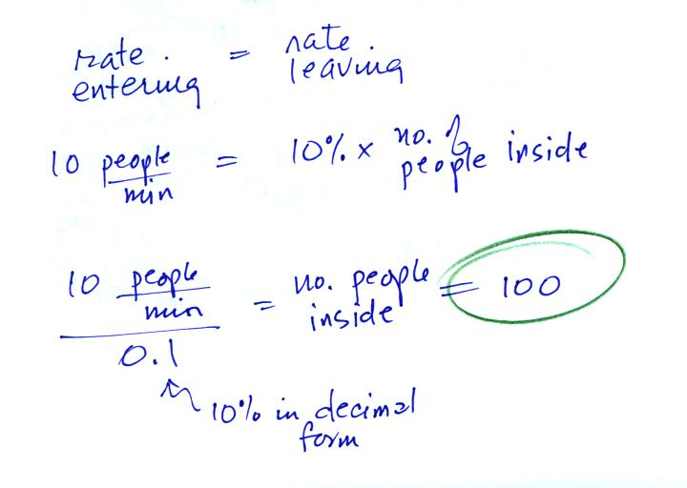
The Walmart problem is very similar to saturation of air with water vapor which is shown on p. 85 in the photocopied ClassNotes. What does it mean to say that air is saturated with water vapor. Why does the saturation amount depend on temperature?
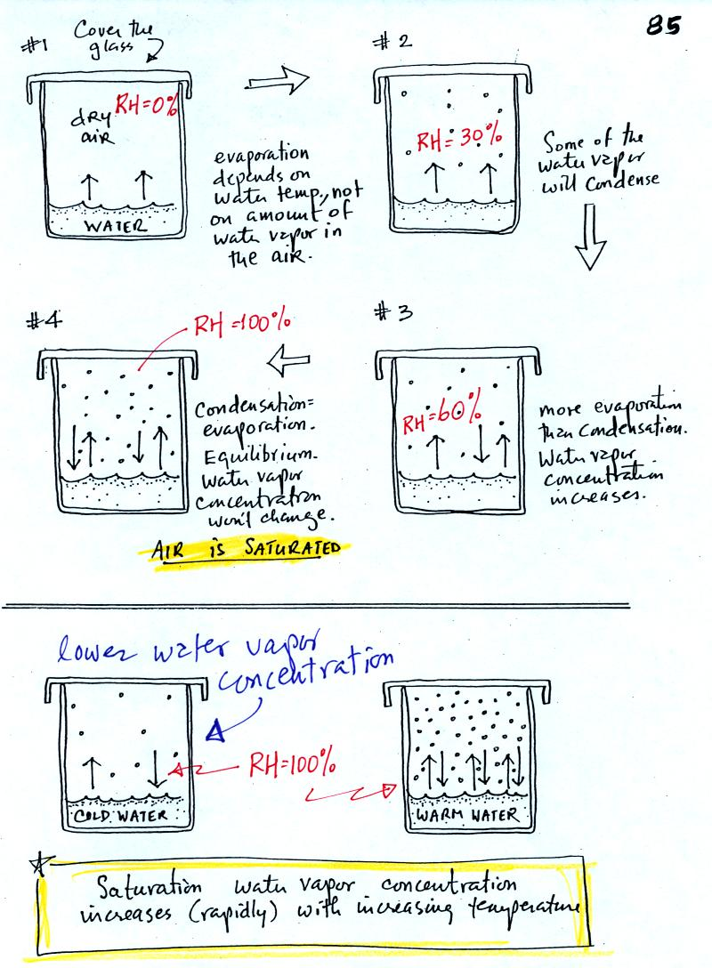
The evaporating water in Picture 1 is analogous to people entering a Walmart store. The amount of water vapor in the air in the covered glass will begin to increase. Some fraction of the water vapor molecules will condense (even though it has just evaporated). The water vapor concentration will build until the rate of condensation balances evaporation. The air is saturated at that point. The water vapor concentration won't increase further. Saturated air has a relative humidity (RH) of 100%. The relative humidity values in the figure above were added after class.
Cups filled with cold and warm water are shown at the bottom of the figure. Because of different rates of evaporation (slow in cold, rapid in warm water) the water vapor concentrations at saturation are different. Cold saturated air won't contain as much water vapor as warm saturated air.

Now we are ready for 4 example problems.
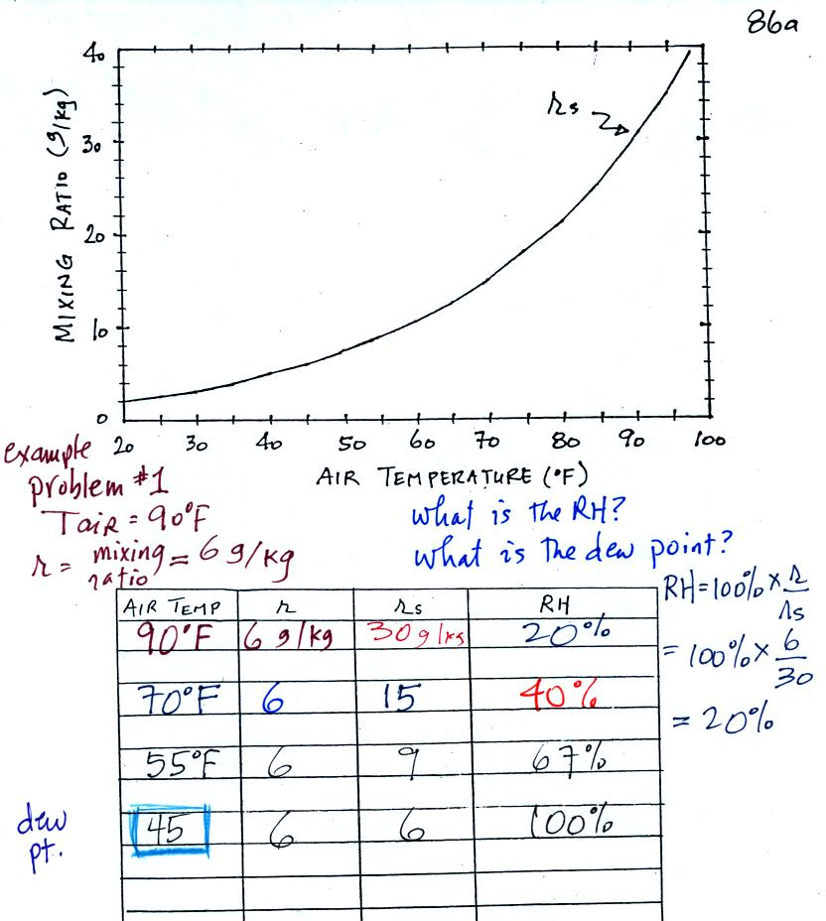
Here is the first sample problem that we worked in class. You might have a hard time unscrambling this if you're seeing it for the first time. The series of steps that we followed are retraced below:
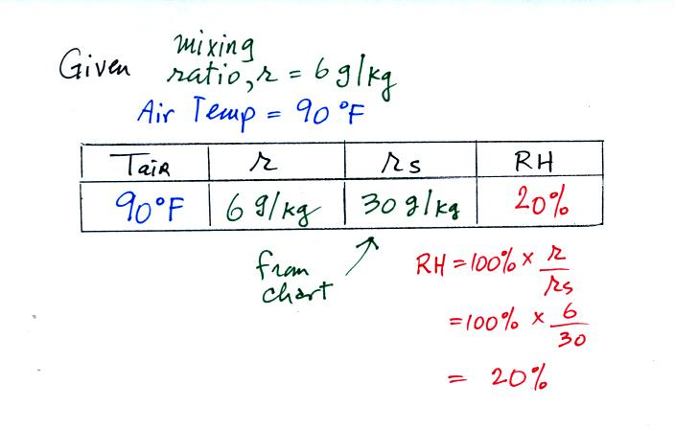
We're given an air temperature of 90 F and a mixing ratio (r) of 6 g/kg. We're supposed to find the relative humidity (RH) and the dew point temperature.
We start by entering the data we were given in the table. Once you know the air's temperature you can look up the saturation mixing ratio value; it is 30 g/kg for 90 F air. 90 F air could potentially hold 30 grams of water vapor per kilogram of dry air (it actually contains 6 grams per kilogram in this example). The saturation mixing ratio values are on p. 86 in the ClassNotes.
Once you know mixing ratio and saturation mixing ratio you can calculate the relative humidity (you divide the mixing ratio by the saturation mixing ratio, 6/30, and multiply the result by 100%). The RH is 20%.
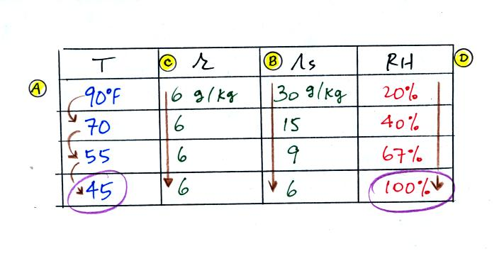
The numbers we just figured out are shown on the top line above.
(A) We imagined cooling the air from 90F to 70F, then to 55F, and finally to 45F.
(B) At each step we looked up the saturation mixing ratio and entered it on the chart. Note that the saturation mixing ratio values decrease as the air is cooling.
The next question (3rd question) in the class Reward Challenge was what happens to the mixing ratio when you cool the air. A student answered this correctly (the mixing ratio doesn't change) and won a can of Red Bull energy drink I think.
(C) The mixing ratio doesn't change as we cool the air. The only thing that changes r is adding or removing water vapor and we aren't doing either.
(D) Note how the relative humidity is increasing as we cool the air. The air still contains the same amount of water vapor it is just that the air's capacity is decreasing.
Finally at 45 F the RH becomes 100%. This is kind of a special point. You have cooled the air until it becomes saturated. The 4th question of the Reward Challenge was what was the name given to this temperature. The answer is dew point temperature.
The dew point temperature in this problem is 45 F.
The student that answered this question won a compact fluorescent light bulb.
The following question wasn't asked in class. What would happen if we cooled the air further still, below the dew point temperature?
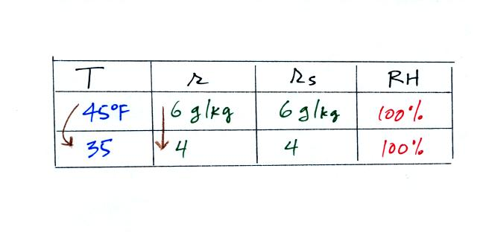
35 F air can't hold the 6 grams of water vapor that 45 F air can. You can only "fit" 4 grams of water vapor into the 35 F air. The remaining 2 grams would condense. If this happened at ground level the ground would get wet with dew. If it happens above the ground, the water vapor condenses onto small particles in the air and forms fog or a cloud. Now because water vapor is being taken out of the air (and being turned into water), the mixing ratio will decrease from 6 to 4.
In many ways cooling moist air is liking squeezing a moist sponge (this figure wasn't shown in class)
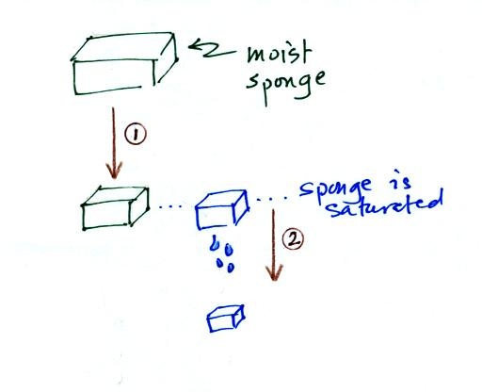
Squeezing the sponge and reducing its volume is like cooling moist air and reducing the saturation mixing ratio. At first when you sqeeze the sponge nothing happens, no water drips out. Eventually you get to a point where the sponge is saturated. This is like reaching the dew point. If you squeeze the sponge any further (or cool air below the dew point) water will begin to drip out of the sponge (water vapor will condense from the air).

Here's the 2nd problem we worked:
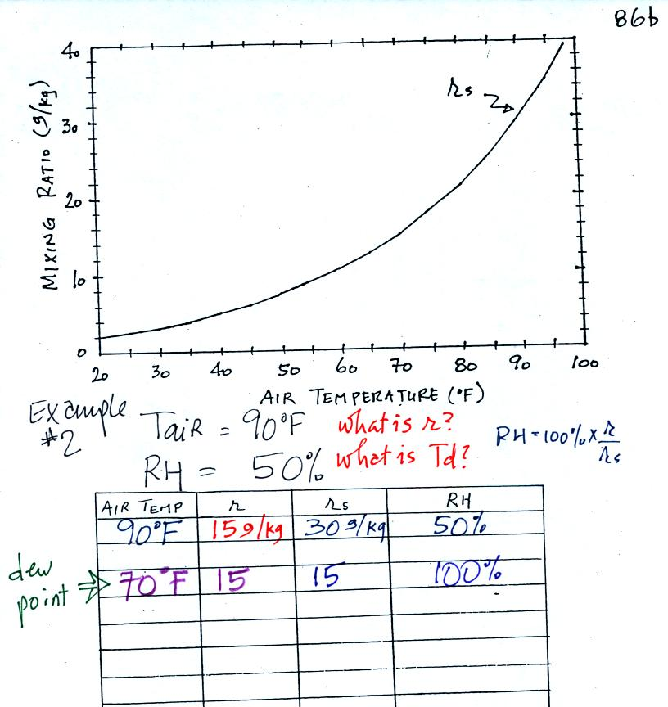
The work that we did in class is shown above. Given an air temperature of 90 F and a relative humidity of 50% you are supposed to figure out the mixing ratio (15 g/kg) and the dew point temperature (70 F). The problem is worked out in detail below:
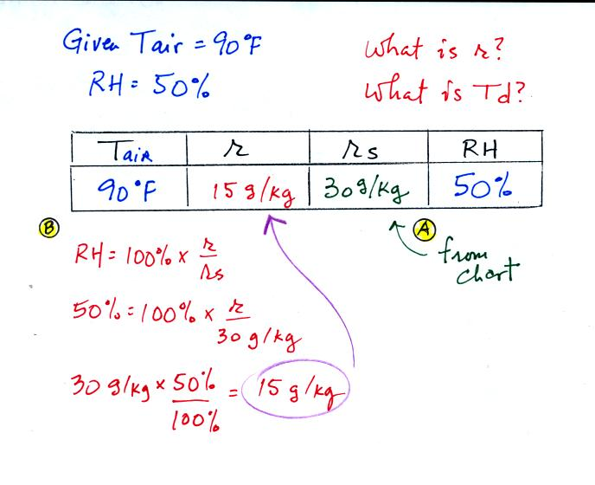
First you fill in the air temperature and the RH data that you are given.
(A) since you know the air's temperature you can look up the saturation mixing ratio (30 g/kg).
(B) Then you can substitute into the relative humidity formula and solve for the mixing ratio (15 g/kg).
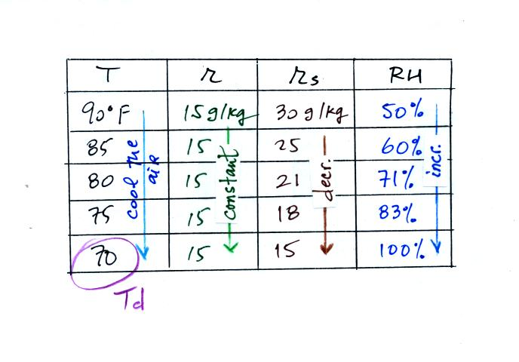
Finally you imagine cooling the air. Cooling causes the saturation mixing ratio to decrease, the mixing ratio stays constant, and the relative humidity increases. In this example the RH reached 100% when the air had cooled to 70 F. That is the dew point temperature.

Here's the 3rd example problem. Now that we had run out of prizes this isn't much fun anymore. Fortunately once you've worked a couple of problems they go much faster.
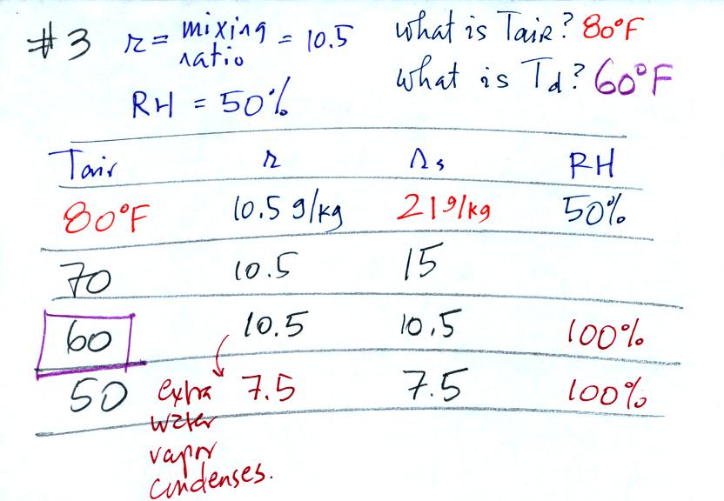
Here's the play by play solution to the question
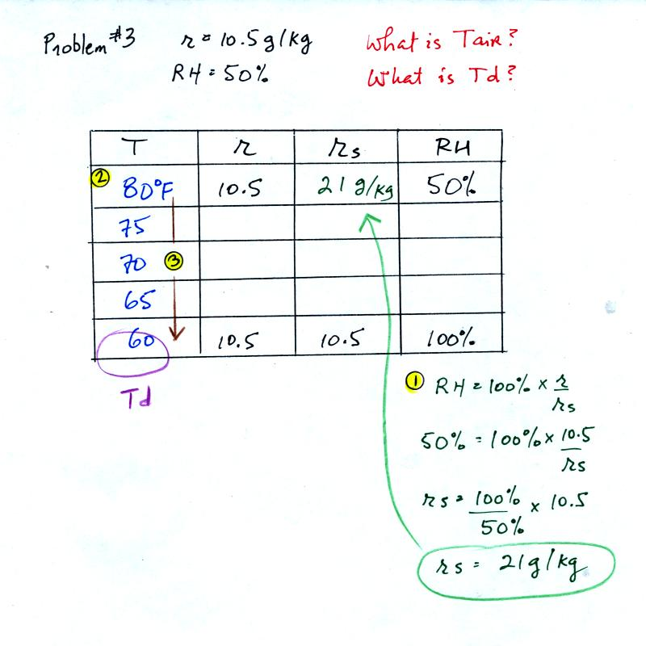
You are given a mixing ratio of 10.5 g/kg and a relative humidity of 50%. You need to figure out the air temperature and the dew point temperature.
(1) The air contains 10.5 g/kg of water vapor, this is 50%, half, of what the air could potentially hold. So the air's capacity, the saturation mixing ratio must be 21 g/kg (you can either do this in your head or use the RH equation following the steps shown).
(2) Once you know the saturation mixing ratio you can look up the air temperature in a table.
(3) Then you imagine cooling the air until the RH becomes 100%. This occurs at 60 F. The dew point is 60 F.

Problem #4 is probably the most difficult of the bunch.
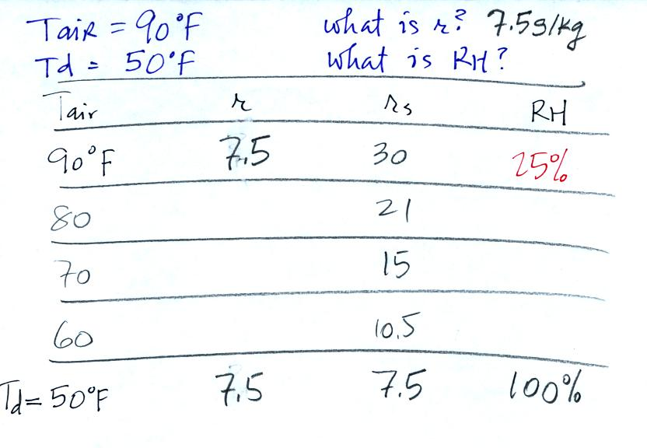
Here's what we did in class, we were given the air temperature and the dew point temperature. We were supposed to figure out the mixing ratio and the relative humidity. An attentive student pointed out that I had misread the saturation mixing ratio value for 50 F air. It should be 7.5 not 9. The error is corrected above and the correct saturation mixing ratio is used below.
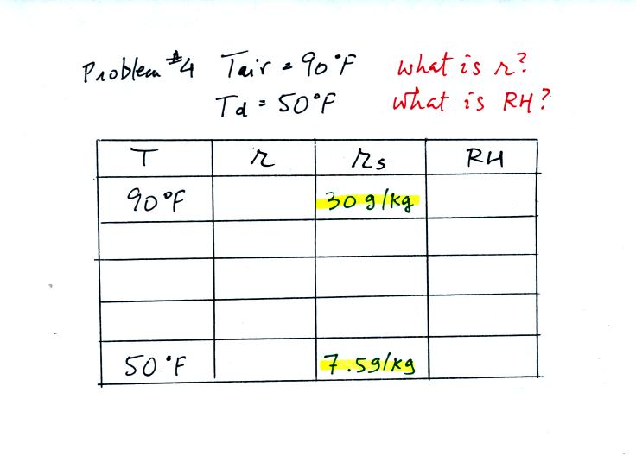
We enter the two temperatures onto a chart and look up the saturation mixing ratio for each.
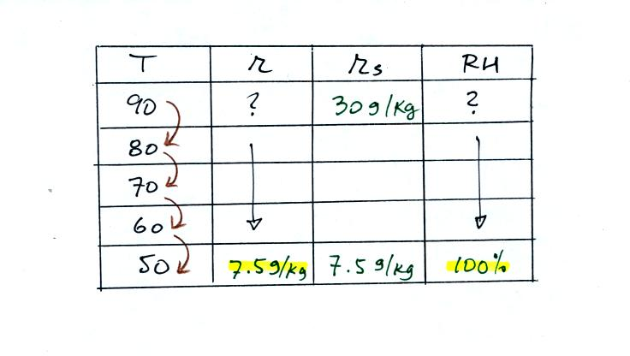
We ignore the fact that we don't know the mixing ratio. We do know that if we cool the 90 F air to 50 F the RH will become 100%. We can set the mixing ratio equal to the value of the saturation mixing ratio at 50 F, 7.5 g/kg. A student was able to figure all of this out in the last question of the challenge and won a box of colored pencils (the best prize of the day in my opinion).
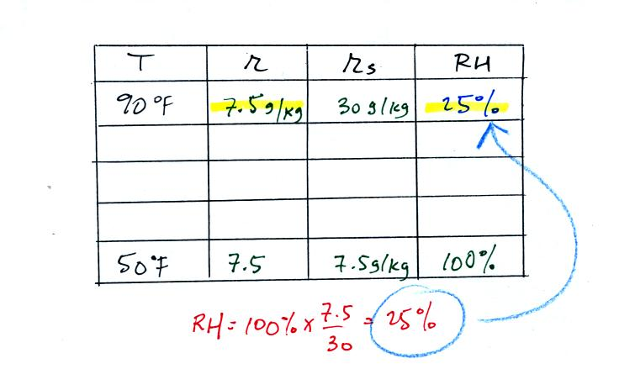
Remember back to the three earlier examples. When we cooled air to the the dew point, the mixing ratio didn't change. So the mixing ratio must have been 7.5 all along. Once we know the mixing ratio in the 90 F air it is a simple matter to calculate the relative humidity, 25%.

I don't know about you but I enjoyed the Reward Challenge and would like to do it again. If you have any good ideas for prizes let me know.
I mentioned how I would like to offer a really big prize at the end of the semester (a 5 night all expenses paid trip to Paris for two or something like that). That is becoming more and more attractive especially because one of the conditions in the fine print would be the requirement that your NATS 101 instructor be the 2nd person.

