Tuesday Oct. 14, 2008
A problem of some kind delayed the music this morning and we were able to only listen to one song (Choctaw Hayride) from the 2002 Alison Krauss + Union Station Live CD. That's not a fair sampling, you'll probably get some more before the quiz on Thursday.
The Optional Assignment and the Experiment #2 reports were collected today. You'll find the answers to the Optional Assignment here. Answers to an In-class Optional Assignment given in the MWF class last Friday are here. I owe the T Th people a bonus optional assignment of some kind. I'll probably mention a "hidden" assignment before the quiz on Thursday. Most likely that will involve reading some online notes over the weekend and turning in the short assignment at the start of class next Tuesday.
The Expt. #3 materials should be distributed in class on Friday.
A small number of Topic 1 1S1P reports were returned.

There has been a big change in the weather in the past few days. What happened? A strong cold front moved through the region early in the afternoon last Saturday. We are now in the cold air mass behind that front.
We spent a little time at the beginning of class looking at weather conditions ahead of and behind a cold front.
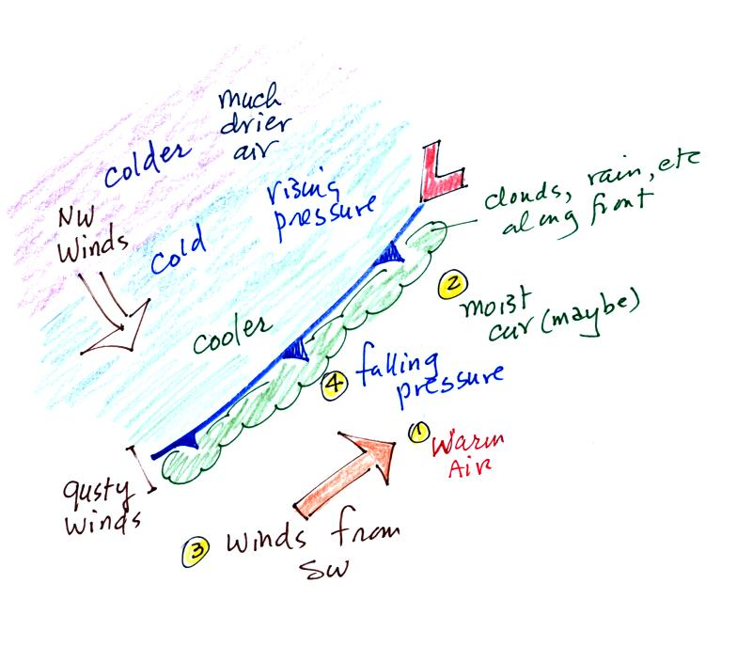
The air ahead of an approaching cold front is warmer and often moist (not always true in the desert southwest). Saturday began with warm temperatures and with dew points in the low 60s. Winds generally blow from the southwest and pressure falls as the front approaches.
Winds often get gusty as the front is actually passing. Also the clouds associated with a cold front (remember the front will lift the warm low density air ahead of the front) are often found in a narrow band along the front. This is when you get rain or snow showers (as in the video shown in class).
Once the front passes through, winds shift to the northwest, pressure begins to rise, and temperatures drop. The air behind a cold front is often much drier (in Tucson dew points dropped into the single digits at one point). Note that the coldest air arrives a day or two after the frontal passage. Also with dry air and few clouds, nighttime temperatures can really drop. Tucson broke a low temperature record on Monday morning with a low of 38 F (this beat the old record by 5 F, so this really was an unusually strong and cold front for this time of year).
We watched a video of a dramatic cold front passage recorded in Tucson on Easter Sunday morning in 1999. You can watch the video yourself by clicking on the following link (it may take some time for the video to load): cold front video

Next we reviewed the following two figures that were stuck onto the end of last Thursday's notes. They weren't discussed in class last week.
The greenhouse effect makes the earth's surface warmer than it would be otherwise.
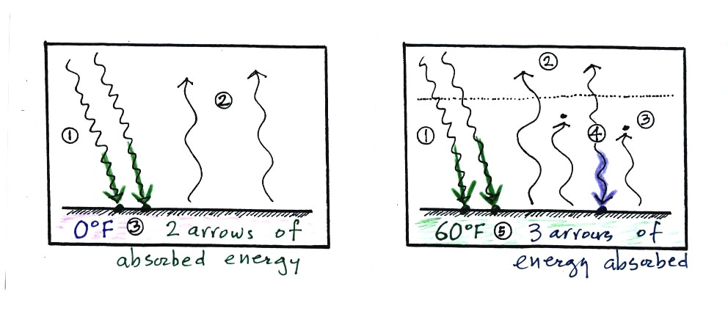
Here's one explanation of why that is true. At left (energy balance on the earth without an atmosphere or at least without greenhouse gases) the ground is getting 2 units of energy. At right it is getting three, the extra one is coming from the atmosphere. Doesn't it make sense that ground that absorbs 3 units of energy will be warmer than ground that is only absorbing 2.
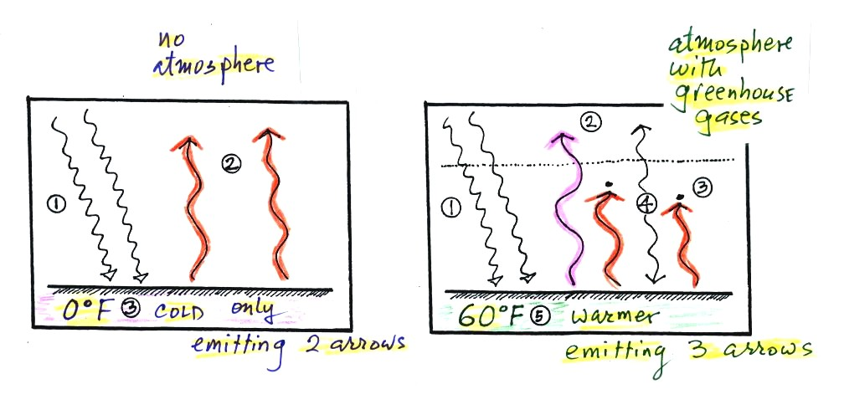
Here's another line of reasoning. At left the ground is emitting 2 units of energy, at right the ground is emitting 3 units. Remember that the amount of energy emitted by something depends on temperature. The ground must be warmer to be able to emit 3 arrows of energy rather than 2 arrows.

Next we had a more realistic look at energy balance (Figs. 3-7, 3-8, and 3-10 in the textbook).
First what happens to sunlight.
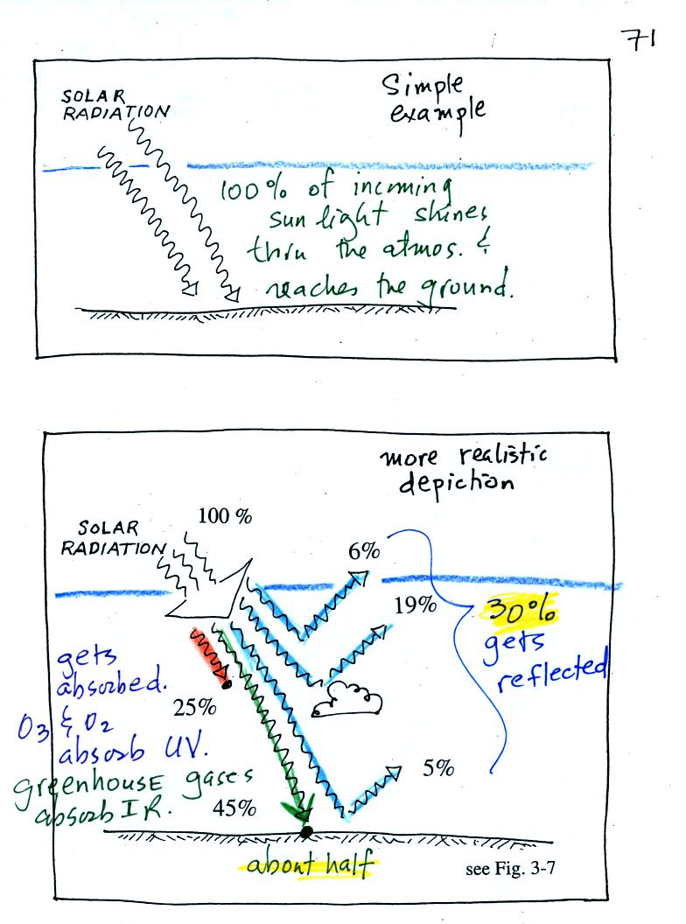
The top figure shows what we assumed in our simplified version of the greenhouse effect. We assumed that 100% of the sunlight arriving at the earth passed through the atmosphere and got absorbed by the ground.
In reality about half (45%) of the incoming sunlight is transmitted and gets absorbed by the ground. About 30% is reflected (colored blue above) by clouds, by the ground, or scattered by air molecules. About 25% is absorbed (UV is absorbed by ozone & oxygen, certain wavelengths of IR are absorbed by greenhouse gases).
The complete picture of energy balance is more complicated. The top figure below is our simplified version of the greenhouse effect. Green is incoming sunlight. Orange and red is IR emitted by the ground (red passes through the atmosphere, orange is absorbed by greenhouse gases in the atmosphere). Pink is IR radiation emitted by the atmosphere upward and downward.
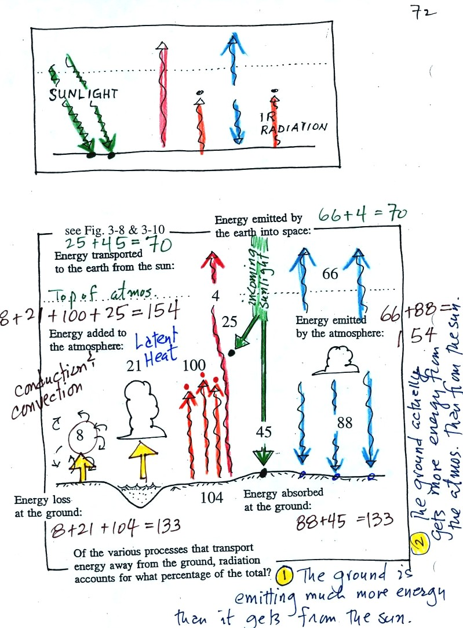
At the bottom is a more realistic version.
First in green is the incoming sunlight. 25 units are absorbed in the atmosphere, 45 units is absorbed by the ground (these are the same numbers that were in the previous picture, p. 71 in the photocopied ClassNotes).
The ground emits a total of 104 units (orange and red). Only 4 of these pass through the atmosphere, the remaining 100 get absorbed.
The atmosphere emits 66 units upward into space & 88 units downward toward the ground. It may be that the bottom of the atmosphere is warmer than the upper parts of the atmosphere (warmer objects emit more energy than colder objects). Or it may just be that there is more air in the lower atmosphere that is able to emit more radiation.
The 8 and 21 units at left are energy transported from the ground up into the atmosphere by conduction & convection, and by latent heat, respectively.
You can check for energy balance at three different points in the figure.
First just above the top of the atmosphere. There are 25+45 = 70 units of incoming sunlight (we have left out the 30 units of reflected sunlight). This is balanced by 4+66 = 70 units being emitted by the ground and atmosphere upward into space.
Next the atmosphere itself. 8 (conduction & convection) + 21 (latent heat) + 100 (IR from the ground) + 25 (sunlight) = 154 units are being absorbed. The atmosphere emits 66+88 = 154 units. The atmosphere is in energy balance.
At the ground. The ground emits 104 units and transports 8 + 21 units to the atmosphere (conduction & convection). That's a total of 133 units. The ground absorbs 45 (sunlight) + 88 (atmosphere) = 133 units. So the ground is in balance also.
A couple more things to note.
1. The atmosphere actually gets more energy from the atmosphere than it does from the sun. Part of the reason is that the atmosphere is emitting energy 24 hours a day while the sun is only in the sky part of the day. Some sunlight is absorbed by the atmosphere, then the atmosphere radiates energy upward and downward. So some of the energy arriving at the ground from the atmosphere was originally sunlight.
2. The ground emits more energy than it gets from the sun. How can the ground do that and still be in energy balance? The answer is because the ground also gets energy from the atmosphere.

You can use the simplified picture of radiative equilibrium to understand the effects of clouds on nighttime low and daytime high temperatures. You'll find this discussed on pps 72a and 72b in the Classnotes.
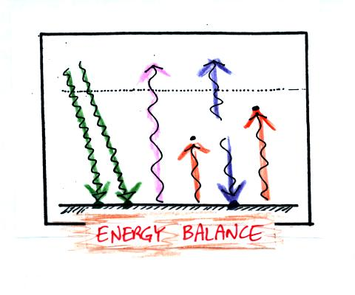
Here's the simplified picture of radiative equilibrium (something you're probably getting pretty tired of seeing). By now you should be able to identify each of the colored arrows in the figure above and explain what they represent.
The two pictures below show what happens at night when you remove the two green rays of incoming sunlight.
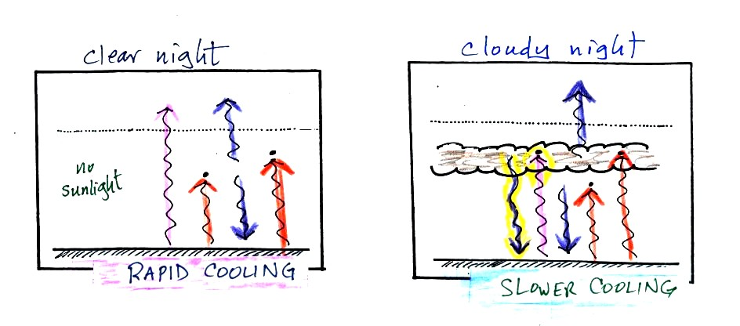
The picture on the left shows a clear night. The ground is losing 3 arrows of energy and getting one back from the atmosphere. That's a net loss of 2 arrows. The ground cools rapidly and gets cold during the night.
A cloudy night is shown at right. Notice the effect of the clouds. Clouds are good absorbers of infrared radiation. If we could see IR light, clouds would appear black, very different from what we are used to (because clouds also emit IR light, the clouds might also glow). Now none of the IR radiation emitted by the ground passes through the atmosphere into space. It is all absorbed either by greenhouse gases or by the clouds. Because the clouds and atmosphere are now absorbing 3 units of radiation they must emit 3 units: 1 goes upward into space, the other 2 downward to the ground. There is now a net loss at the ground of only 1 arrow.
The ground won't cool as quickly and won't get as cold on a cloudy night as it does on a clear night.
The next two figures compare clear and cloudy days.
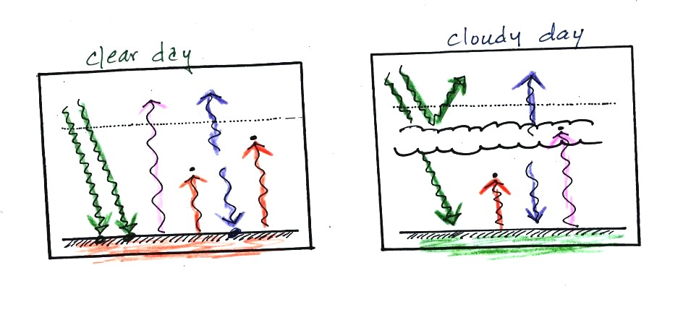
Clouds are good reflectors of visible light. The effect of this is to reduce the amount of sunlight energy reaching the ground in the right picture. With less sunlight being absorbed at the ground, the ground doesn't need to get as warm to be in energy balance.
It is generally cooler during the day on a cloudy day than on a clear day.
Clouds raise the nighttime minimum temperature and lower the daytime maximum temperature.
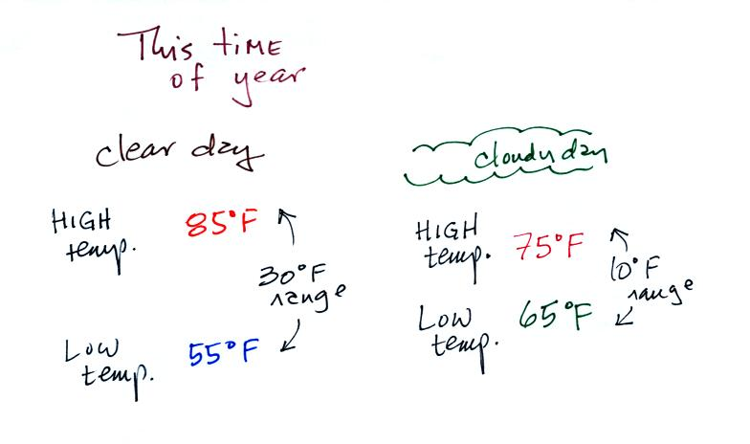
Typical daytime highs and nighttime lows in Tucson for this time of year. Note how the clouds reduce the daily range of temperature.

We'll use our simplified representation of radiative equilibrium to understand enhancement of the greenhouse effect and global warming.
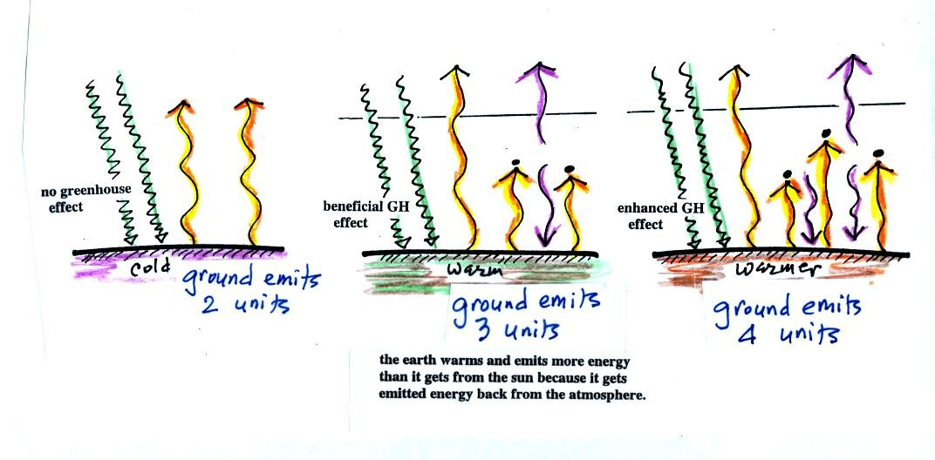
The figure (p. 72c in the photocopied Class Notes) on the left shows energy balance on the earth without an atmosphere (or with an atmosphere that doesn't contain greenhouse gases). The ground achieves energy balance by emitting only 2 units of energy to balance out what it is getting from the sun. The ground wouldn't need to be very warm to do this.
If you add an atmosphere and greenhouse gases, the atmosphere will begin to absorb some of the outgoing IR radiation. The atmosphere will also begin to emit IR radiation, upward into space and downard toward the ground. After a period of adjustment you end up with a new energy balance. The ground is warmer and is now emitting 3 units of energy even though it is only getting 2 units from the sun. It can do this because it gets a unit of energy from the atmosphere.
In the right figure the concentration of greenhouse gases has increased even more (due to human activities). The earth would find a new energy balance. In this case the ground would be warmer and would be emitting 4 units of energy, but still only getting 2 units from the sun. With more greenhouse gases, the atmosphere is now able to absorb 3 units of the IR emitted by the ground. The atmosphere sends 2 back to the ground and 1 up into space.
The next figure shows a common misconception about the cause of global warming.
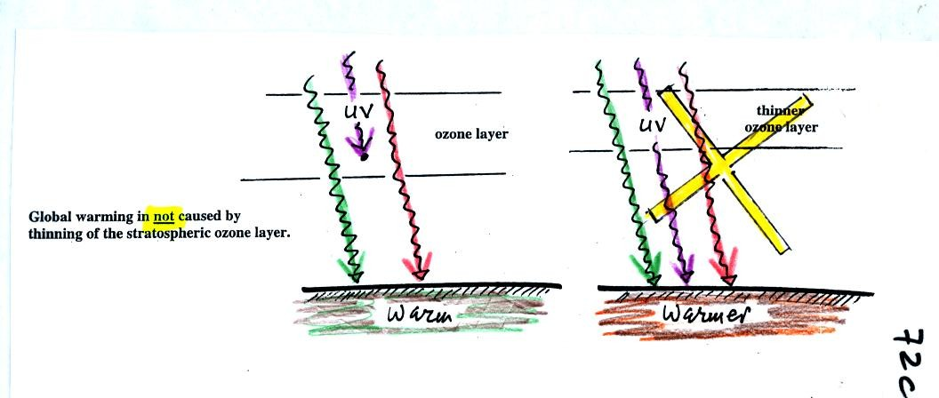
Many people know that sunlight contains UV light and that the ozone absorbs much of the dangerous type of high energy radiation. People also know that release of chemicals such as CFCs are destroying stratospheric ozone and letting some of this UV light reach the ground. That is all correct.
They then conclude that it is this additional UV energy reaching the ground that is causing the globe to warm. This part is not correct. There isn't much UV light in sunlight in the first place and the small amount of additional UV light reaching the ground won't be enough to cause global warming. It will cause cataracts and skin cancer and those kinds of problems but not global warming.

We finished class with a short discussion of Archimedes Law. You'll find this discussed on pps 53a and 53b in the photocopied Classnotes.
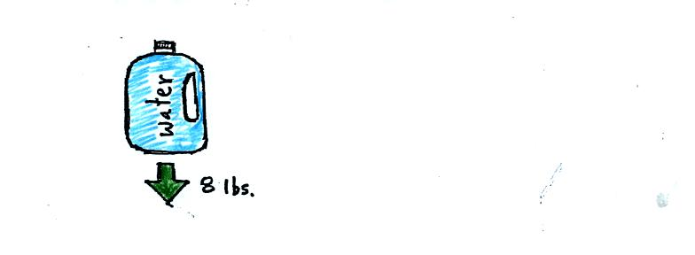
A gallon of water weighs about 8 pounds (lbs).
If you submerge a 1 gallon jug of water in a swimming pool, the jug becomes, for all intents and purposes, weightless. Archimedes' Law (see figure below) explains why this is true.
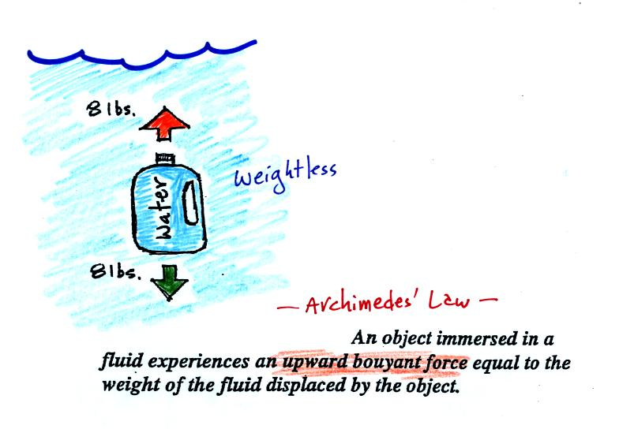
The upward bouyant force is really just another name for the pressure difference force covered earlier (higher pressure pushing up on the bottle and low pressure at the top pushing down, resulting in a net upward force). A 1 gallon bottle will displace 1 gallon of pool water. One gallon of pool water weighs 8 pounds. The upward bouyant force will be 8 pounds, the same as the downward force on the jug due to gravity. The two forces are equal and opposite.
Now we imagine pouring out all the water and filling the 1 gallon jug with air. Air is about 1000 times less dense than water; the jug will weigh practically nothing.
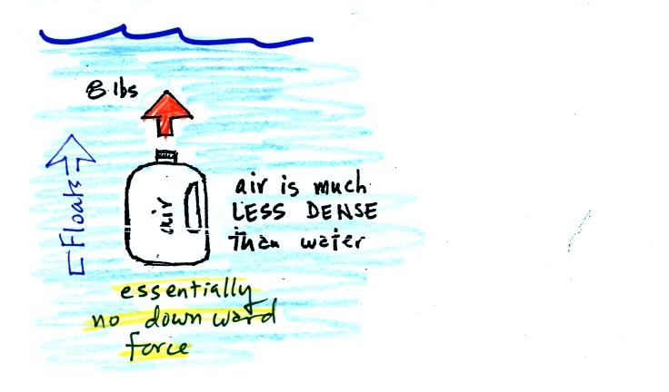
If you submerge the jug in a pool it will displace 1 gallon of water and experience an 8 pound upward bouyant force again. Since there is no downward force the jug will float.
One gallon of sand (which is about 1.5 times denser than water) jug will weigh 12 pounds.
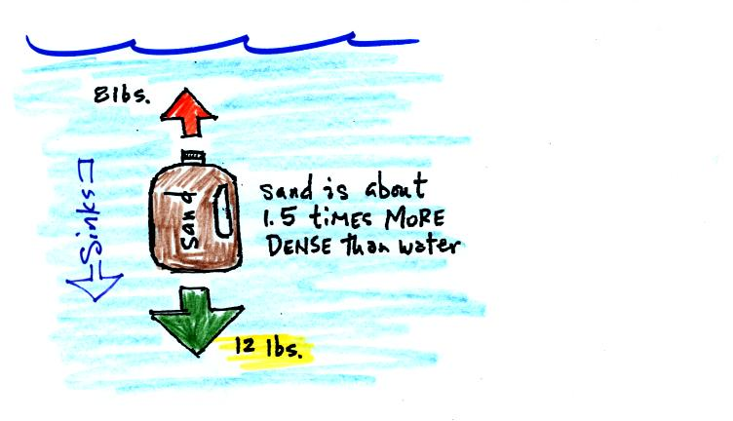
The jug of sand will sink because the downward force is greater than the upward force.
You can sum all of this up by saying anything that is less dense than water will float in water, anything that is more dense than water will float in water.
The same reasoning applies to air in the atmosphere.
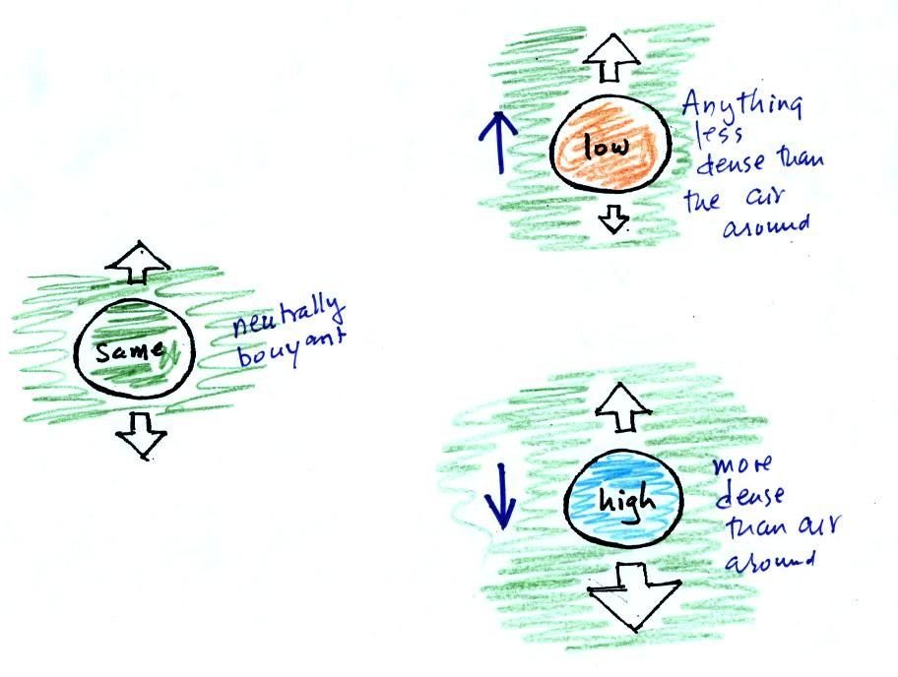
Air that is less dense (warmer) than the air around it will rise. Air that is more dense (colder) than the air around it will sink.
Here's a little more information about Archimedes which wasn't covered in class.

It was time for a colorful demonstration involving water and objects that either float or sink in water.
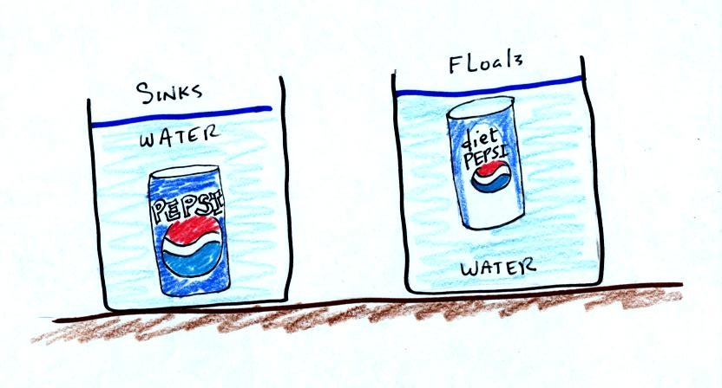
A can of regular Pepsi was placed in a beaker of water. The can sank. We repeated the demonstration with Coke and Diet Coke (Coke now has the exclusive franchise at The University).
Both cans are made of aluminum which has a density almost three times higher than water. The drink itself is largely water. The regular Pepsi also has a lot of high-fructose corn syrup, the diet Pepsi doesn't. The mixture has a density greater than plain water. Both cans contain a little air (or perhaps carbon dioxide gas) or neither one would float. This is much less dense than water.
The average density of the can of regular Pepsi (water&sugar + aluminum + air) ends up being slightly greater than the density of water. The average density of the can of diet Pepsi (water + aluminum + air) is slightly less than the density of water.
In some respects people in swimming pools are like cans of regular and diet Pepsi. Some people float (they're a little less dense than water), other people sink (slightly more dense than water). The next figure wasn't shown in class.
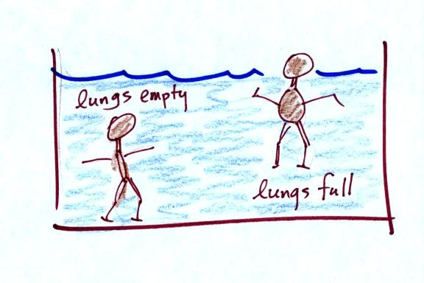
Many people can fill their lungs with air and make themselves float, or they can empty their lungs and make themselves sink.
People must have a density that is about the same as water.

