Thursday Oct. 9, 2008
Today's music was Hibernian Rhapsody by DeDannan. It was a celtic version of a rock classic Bohemian Rhapsody by Queen.
Here are the answers to the Controls of Temperature Optional Assignment.
The Quiz #2 Study Guide is now finished.
There's an Optional Assignment due at the start of class next Tuesday. The Experiment #2 reports are also due next Tuesday (unless you picked up the materials late and were given some extra time). If you haven't returned your materials you can stop by my office (PAS 588) on Friday or Monday.

We learned a little bit about the climate in Pohnpei on Tuesday. Pohnpei has a Tropical Wet climate (Af). This refers to the Koeppen Climate Classification System that is described in Chapter 15 in the text. Basically it is a tropical rainforest climate where the average monthly temperature nevers drops below 64 F and there is no dry season.
Today it was back to electromagnetic radiation. We began with a quick review of the Stefan Boltzmann law and Wien's law.
A bulb connected to a dimmer switch can be used to demonstrate the rules above (see p. 66 in the photocopied Classnotes). We'll be interested in and looking at the EM radiation emitted by the tungsten filament in the bulb.
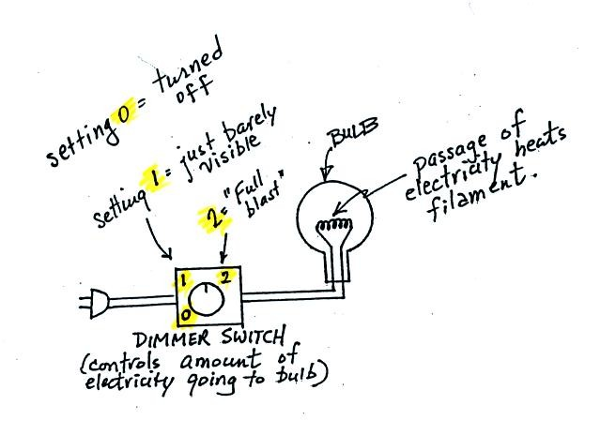
The bottom of p. 66 has been redrawn below for clarity:

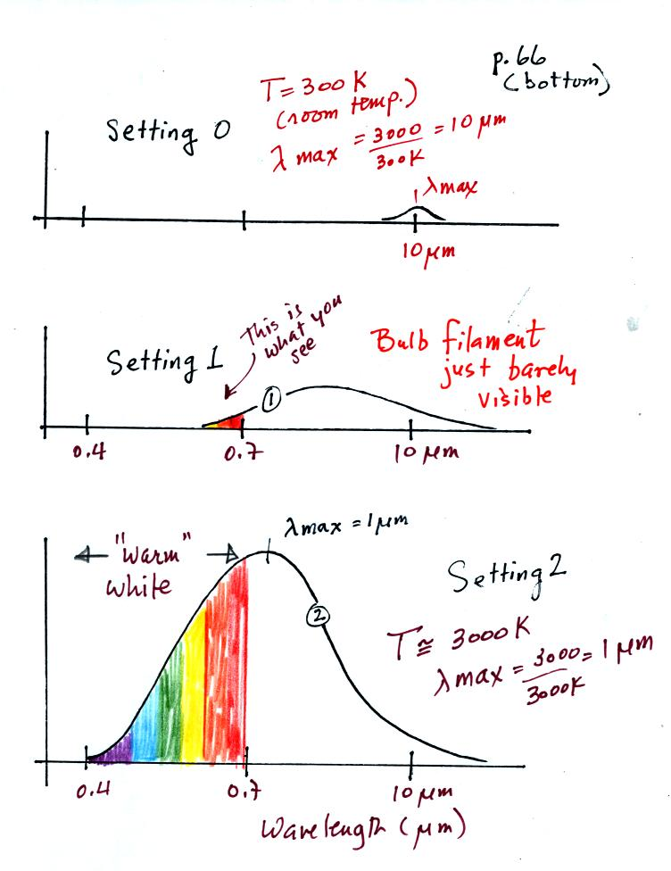
We start with the bulb turned off (Setting 0). The filament will be at room temperature which we will assume is around 300 K (remember that is a reasonable and easy to remember value for the average temperature of the earth's surface). The bulb will be emitting radiation, it's shown on the top graph above. The radiation is very weak (the curve in the figure is very small) so we can't feel it. It is also long wavelength far IR radiation so we can't see it. The wavelength of peak emission is 10 micrometers.
Next we use the dimmer switch to just barely turn the bulb on (the temperature of the filament is now about 900 K). The bulb wasn't very bright at all and had an orange color. This is curve 1, the middle figure. Note the far left end of the emission curve has moved left of the 0.7 micrometer mark - into the visible portion of the spectrum. That is what you are able to see, the small fraction of the radiation emitted by the bulb that is visible light (but just long wavelength red and orange light). Most of the radiation emitted by the bulb is to the right of the 0.7 micrometer mark and is invisible IR radiation (it is strong enough now that you could feel it if you put your hand next to the bulb).
Finally we turn on the bulb completely (it was a 200 Watt bulb so it got pretty bright). The filament temperature is now about 3000K. The bulb is emitting a lot more visible light, all the colors, though not all in equal amounts. The mixture of the colors produces a warm white light. It is warm because it is a mixture that contains a lot more red, orange, and yellow than blue, green, and violet light. It is interesting that most of the radiation emitted by the bulb is still in the IR portion of the spectrum (lambda max is 1 micrometer). This is invisible light. A tungsten bulb like this is not especially efficient, at least not as a source of visible light.
You were able to use one of the diffraction gratings to view all the colors that make up visible light.
When you looked at the bright white bulb filament through one of the diffraction gratings the colors were smeared out to the right and left as shown below:
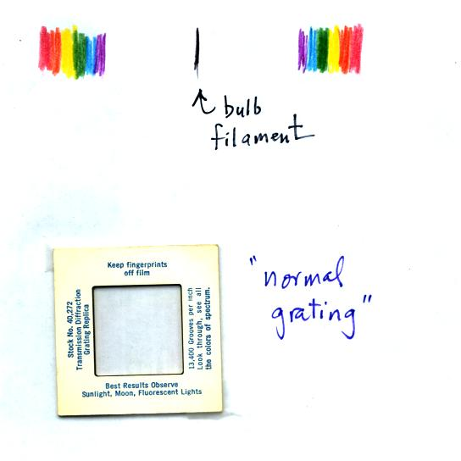
Some of the gratings behaved a little differently as shown below:
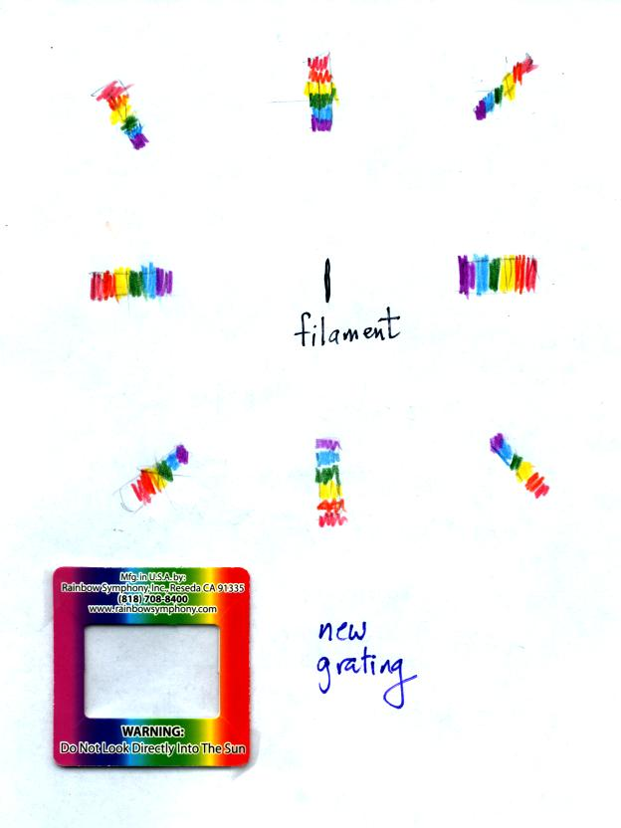

The sun emits electromagnetic radiation. That shouldn't come as a surprise since you can see it and feel it. The earth also emits electromagnetic radiation. It is much weaker and invisible. The kind and amount of EM radiation emitted by the earth and sun depend on their respective temperatures.
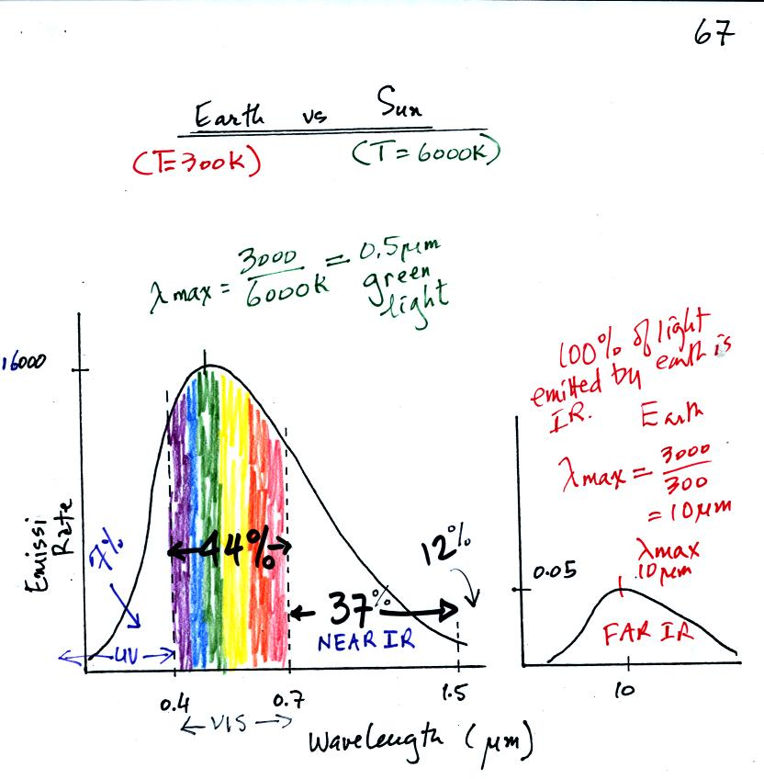
The curve on the left is for the sun. We first used Wien's law and a temperature of 6000 K to calculate lambda max and got 0.5 micrometers. This is green light; the sun emits more green light than any other kind of light. The sun doesn't appear green because it is also emitting lesser amounts of violet, blue, yellow, orange, and red - together this mix of colors appears white. 44% of the radiation emitted by the sun is visible light, 49% is IR light (37% near IR + 12% far IR), and 7% is ultraviolet light. More than half of the light emitted by the sun is invisible.
100% of the light emitted by the earth (temperature = 300 K) is invisible IR light. The wavelength of peak emission for the earth is 10 micrometers.
Because the sun (surface of the sun) is 20 times hotter than the earth a square foot of the sun's surface emits energy at a rate that is 160,000 times higher than a square foot on the earth. Note the vertical scale on the earth curve is different than on the sun graph. If both the earth and sun were plotted with the same vertical scale, the earth curve would be too small to be seen.

We saw earlier that tungsten bulbs produce a lot of wasted infrared light (wasted in terms of not lighting up a room). They also produce a warm white color. Energy efficient compact fluorescent lamps (CFLs) are designed to mimic the visible light output of a tungsten bulb without producing a lot of wasted infrared light. CFLs come with different color temperature ratings.
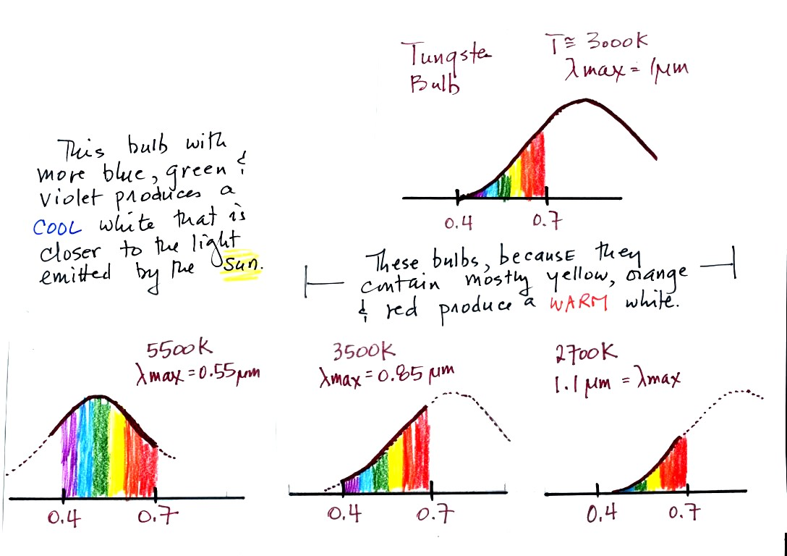
The bulbs with the hottest temperature rating (5500 K ) in the figure above emits more purples, blues, and greens and produces a cooler, bluish white. This is much closer to the light emitted by the sun.
The tungsten bulb (3000 K) and the CFLs with temperature ratings of 3500 K and 2700 K produce a warmer white.
Three CFLs with the temperature ratings above were set up in class so that you could see the difference between warm and cool white light. Personally I find the 2700 K bulb "too warm" and a room seems gloomy at night. The 5500 K bulb is "too cool" and creates a stark austere atmosphere. I prefer the 3500 K bulb in the middle.
This figure below is from an article on compact fluorescent lamps in Wikipedia for those of you that weren't in class and didn't see the bulb display.. You can see a clear difference between the cool white bulb on the left in the figure below and the warm white light produced by a tungsten bulb (2nd from the left) and 2 CFCs with low temperature ratings (3rd and 4th from the left).
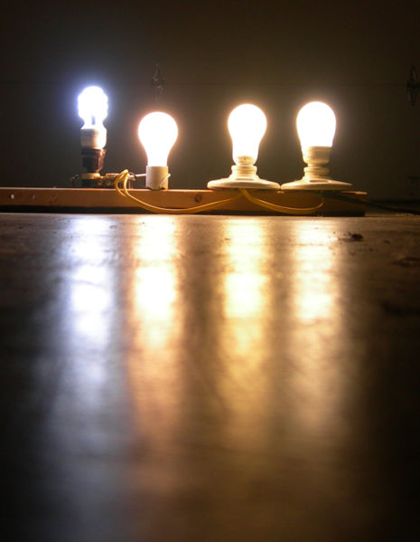

We now have most of the tools we will need to begin to study energy balance on the earth. It will be a balance between incoming sunlight energy and outgoing energy emitted by the earth. We will look at the simplest case first, the earth without an atmosphere (or at least an atmosphere without greenhouse gases) found on p. 68 in the photocopied Classnotes. 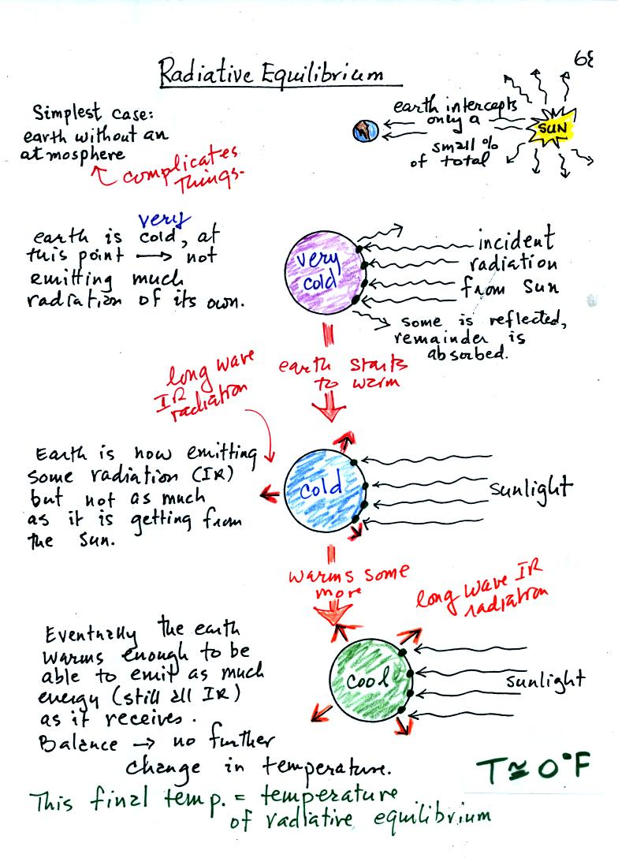
You might first wonder how, with the sun emitting so much more energy than the earth, it is possible for the earth (with a temperature of around 300 K) to be in energy balance with the sun (6000 K). The earth is located about 90 million miles from the sun and therefore only absorbs a very small fraction of the energy emitted by the sun.
To understand how energy balance occurs we start, in Step #1, by imagining that the earth starts out very cold and is not emitting any EM radiation at all. It is absorbing sunlight however so it will begin to warm. This is like opening a bank account, the balance will be zero. But then you start making deposits and the balance starts to grow.
Once the earth starts to warm it will also begin to emit EM radiation, though not as much as it is getting from the sun (the slightly warmer earth in the middle picture is now colored blue). Once you find money in your bank account you start to spend it. Because the earth is still gaining more energy than it is losing the earth will warm some more.
Eventually it will warm enough that the earth (now shaded green) will emit the same amount of energy (though not the same wavelength energy) as it absorbs from the sun. This is radiative equilibrium, energy balance. The temperature at which this occurs is about 0 F. That is called the temperature of radiative equilibrium. You might remember this is the figure for global annual average surface temperature on the earth without the greenhouse effect.

Before we start to look at radiant energy balance on the earth we need to learn about filters. The atmosphere will filter sunlight as it passes through the atmosphere toward the ground. The atmosphere will also filter IR radiation emitted by the earth as it trys to travel into space.
We will first look at the effects simple blue, green, and red glass filters have on visible light. This figure wasn't shown in class.
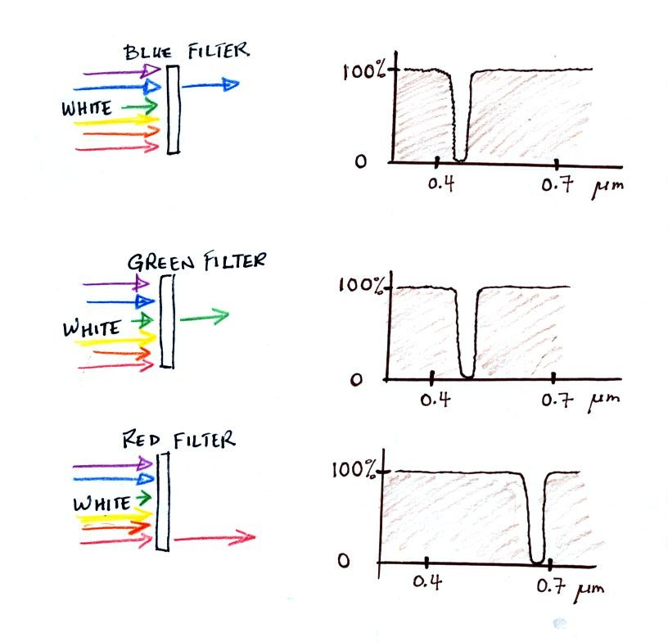
If you try to shine white light (a mixture of all the colors) through a blue filter, only the blue light passes through. The filter absorption curve shows 100% absorption at all but a narrow range of wavelengths that correspond to blue light. Similarly the green and red filters only let through green and red light.
The following figure is a simplified easier to remember representation of the filtering effect of the atmosphere on UV, VIS, and IR light (found on p. 69 in the photocopied notes). The figure below was redrawn after class for improved clarity.
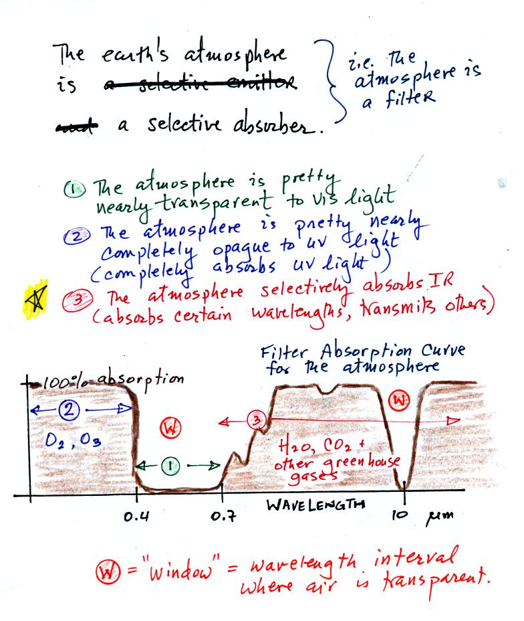
You can use your own eyes to tell you what the filtering effect of the atmosphere is on visible light. Air is clear, it is transparent. The atmosphere transmits visible light.
In our simplified representation oxygen and ozone make the atmosphere a pretty good absorber of UV light.
Greenhouse gases make the atmosphere a selective absorber of IR light - it absorbs certain IR wavelengths and transmits others. It is the atmosphere's ability to absorb (and also emit) certain wavelengths of infrared light that produces the greenhouse effect and warms the surface of the earth.
Note "The atmospheric window" centered at 10 micrometers. Light emitted by the earth at this wavelength will pass through the atmosphere. Another transparent region, another window, is found in the visible part of the spectrum.
You'll find a more realistic picture of the atmospheric absorption curve on p. 70 in the photocopied Classnotes, but the simplified version above will work fine for our needs.

Here's the outer space view of radiative equilibrium on the earth without an atmosphere. The important thing to note is that the earth is absorbing and emitting the same amount of energy (4 arrows absorbed balanced by 4 arrows emitted).
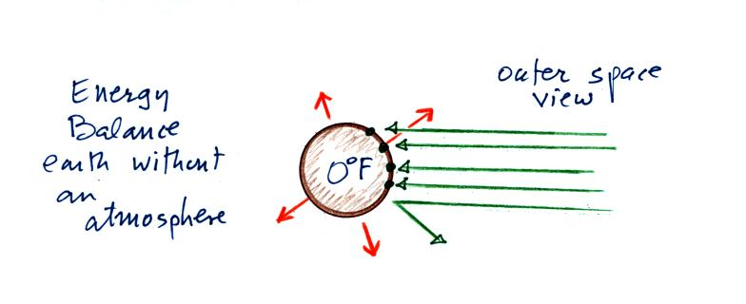
We will be moving from an outer space vantage point of radiative equilibrium (above) to the earth's surface (below).
Don't let the fact that there are
4 arrows are being absorbed and emitted in the top figure and
2 arrows absorbed and emitted in the bottom figure
bother you
We'll be adding a lot more arrows to the bottom figure
It would get too complicated if we had more than 2 arrows of incoming sunlight.
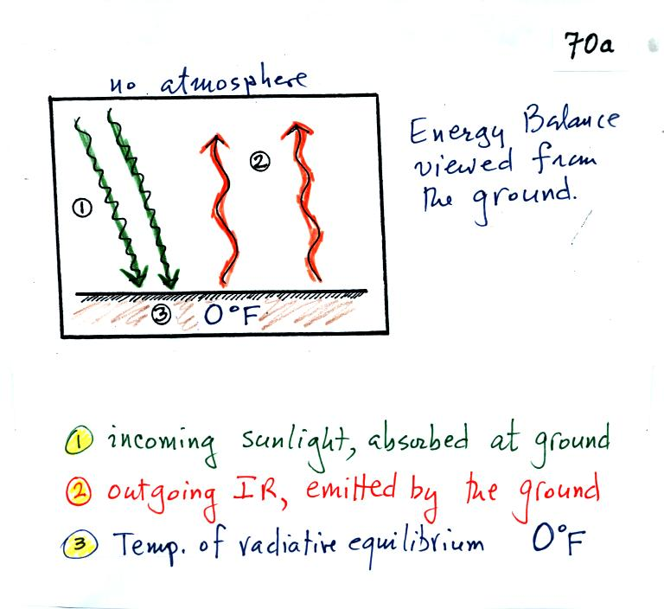

The next step is to add the atmosphere.
We will study a simplified version of radiative equilibrium just so you can identify and understand the various parts of the picture. Keep an eye out for the greenhouse effect. We will look at a more realistic version later.
Here's the figure that we ended up with in class
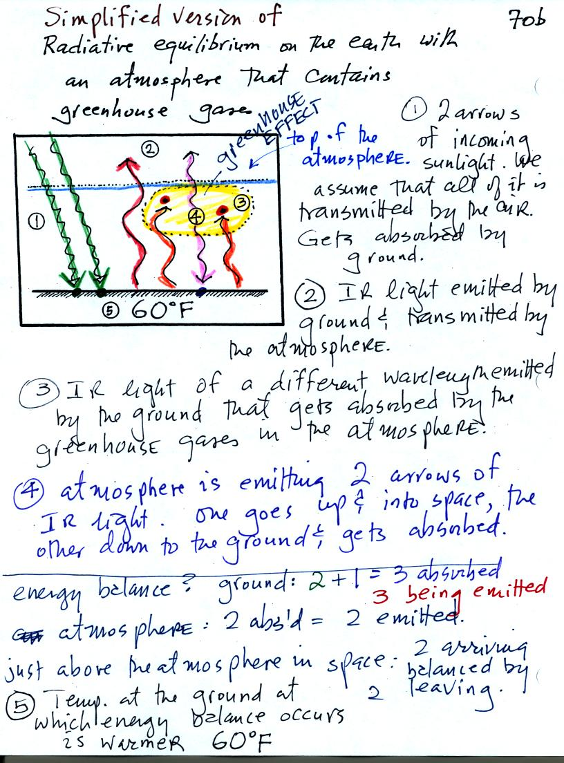
It would be hard to sort through all of this if you weren't in class (and maybe even if you were) to see how it developed. So below we will go through it again step by step (which you are free to skip over if you wish).
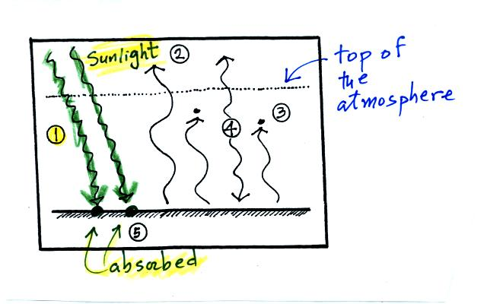

The figure shows two rays of incoming sunlight that pass through the atmosphere, reach the ground, and are absorbed. 100% of the incoming sunlight is transmitted by the atmosphere (this is not a very realistic assumption).
The ground is emitting 3 rays of IR radiation.
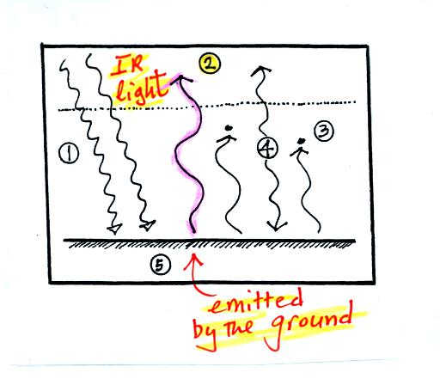
One of these is emitted by the ground at a wavelength that is NOT absorbed by greenhouse gases in the atmosphere. This radiation passes through the atmosphere and goes out into space.
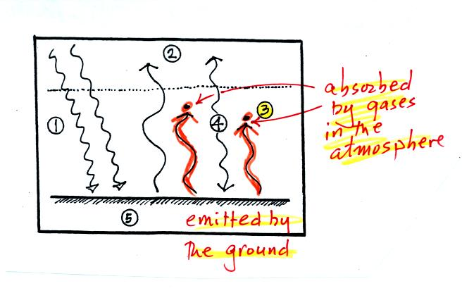
The other 2 units of IR radiation emitted by the ground are absorbed by greenhouse gases is the atmosphere.
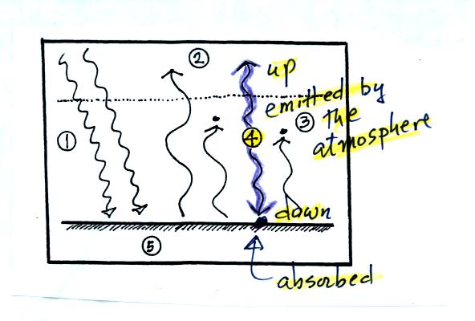
The atmosphere is absorbing 2 units of radiation. In order to be in radiative equilibrium,the atmosphere must also emit 2 units of radiation. 1 unit of IR radiation is sent upward into space, 1 unit is sent downward to the ground where it is absorbed.
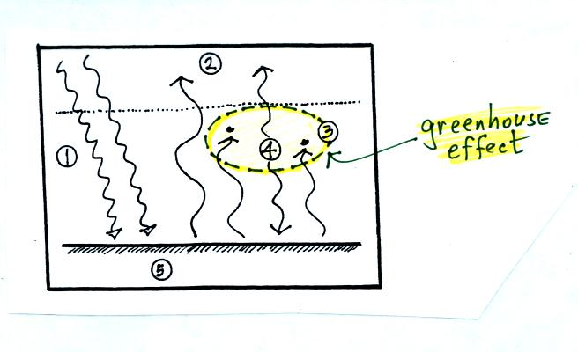
The greenhouse effect is found in this absorption and emission of IR radiation by the atmosphere. Here's how you might put it into words:
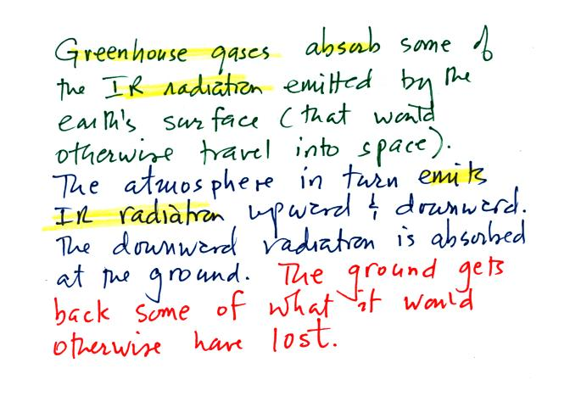
Before we go any further we will check to be sure that every part of this picture is in energy balance.
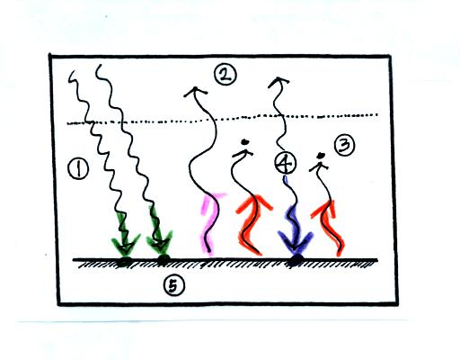
The ground is absorbing 3 units of energy and emitting 3 units of energy
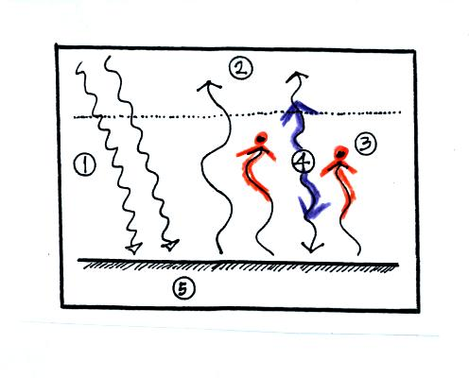
The atmosphere is absorbing 2 units of energy and emitting 2 units of energy
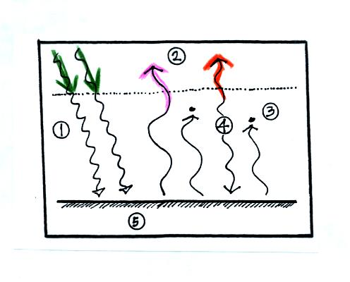
2 units of energy arrive at the earth from outer space, 2 units of energy leave the earth and head back out into space.

The following figures weren't shown in class. This is fairly subtle and will be reviewed at the beginning of class on Tuesday.
The greenhouse effect makes the earth's surface warmer than it would be otherwise.
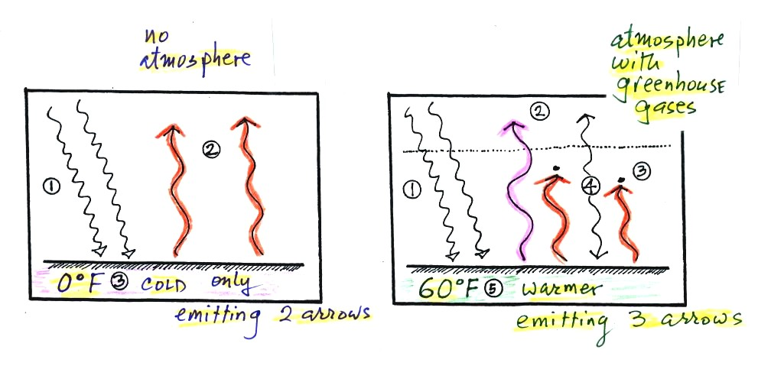
Energy balance with (right) and without (left) the greenhouse effect. At left the ground is emitting 2 units of energy, at right the ground is emitting 3 units. Remember that the amount of energy emitted by something depends on temperature. The ground must be warmer to be able to emit 3 arrows of energy rather than 2 arrows.
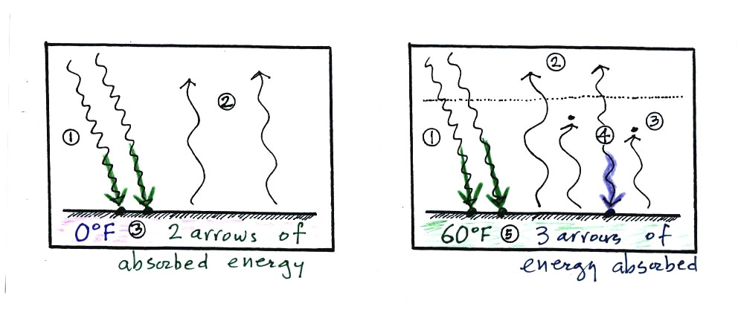
Here's another explanation. At left the ground is getting 2 units of energy. At right it is getting three, the extra one is coming from the atmosphere. Doesn't it make sense that ground that absorbs 3 units of energy will be warmer than ground that is only absorbing 2.
That's plenty for today. Have a nice weekend.

