Thursday Oct. 2, 2008
YouTube is amazing; I was able to find a good recording of today's song Vivere with Andrea Bocelli and Laura Pausini on YouTube.
The Experiment #1 reports are graded and were returned in class today. You are allowed to revise your reports if you want to. You don't have to rewrite you entire report, only the sections where you want to improve your grade. Please return your original report with your revised report. Revised reports are due on or before Thu., Oct. 16. The Optional Assignment #1 papers were also returned today.
A new Optional Assignment is now available. To find the optional assignment go first to the Controls of Temperature topic. Read through the short section on Controls of Temperature all the way to the very end. You'll find a link to the optional assignment somewhere in the middle.
There was a small grading error made on some of the Quiz #1 papers. 5 pts were added to the quiz scores for the following people. The error was made on Question #12.

Conduction is the first of four energy transport processes that we will cover. The figure below illustrates this process. A hot object is stuck in the middle of some air. Some of the figures that follow have been borrowed from the MWF class.
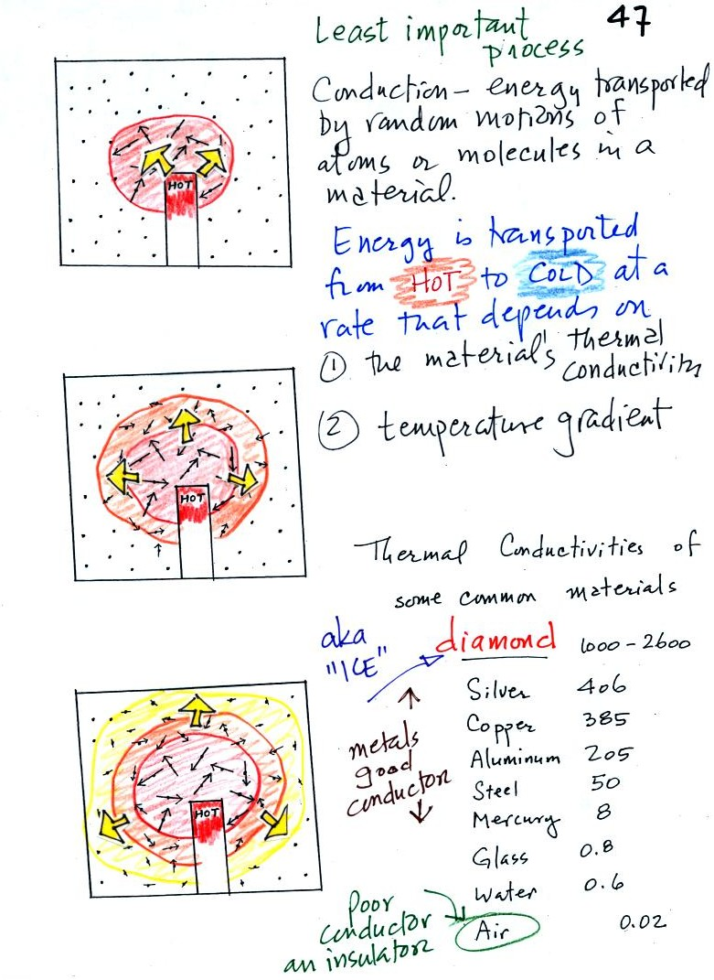
In the top picture some of the atoms or molecules near the hot object have collided with the object and picked up energy from the object. This is reflected by the increased speed of motion or increased kinetic energy of these molecules or atoms (these guys are colored red).
In the middle picture the initial bunch of energetic molecules have collided with some of their neighbors and shared energy with them (these are orange). The neighbor molecules have gained energy though they don't have as much energy as the molecules next to the hot object.
In the third picture molecules further out have now (the yellow ones) gained some energy. The random motions and collisions between molecules is carrying energy from the hot object out into the colder material.
Conduction transports energy from hot to cold. The rate of energy transport depends first on the material (air in the example above). Thermal conductivities of some common materials are listed. Air is a very poor conductor of energy. Air is generally regarded as an insulator. Water is a little bit better conductor. Metals are generally very good conductors (sauce pans are often made of stainless steel but have aluminum or copper bottoms to evenly spread out heat when placed on a stove). Diamond has a very high thermal conductivity. Diamonds are sometimes called "ice." They feel cold when you touch them. The cold feeling is due to the fact that they conduct energy very quickly away from your warm fingers when you touch them.
The rate of energy transport also depends on temperature difference. If the object in the picture had been warm rather than hot, less energy would flow or energy would flow at a slower into the surrounding material.
The following two figures show a demonstration that was performed in class. Curry powder was used instead of acetic acid (concentrated acetic acid is too dangerous; contact with the vapor causes eye burns and irreversible eye damage, severe irritation of the respiratory tract, and corrosion of the digestive tract).
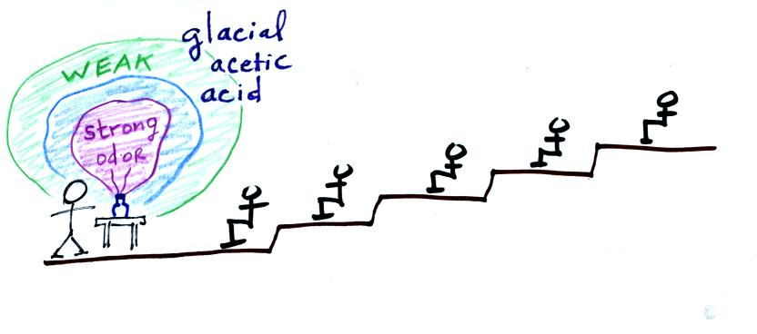
The idea was that as the smell of the curry got into the air, small random wind motions in the room would being to move the smell toward the back of the room. Unfortunately the smell didn't get very far. Maybe I'll try incense next semester.
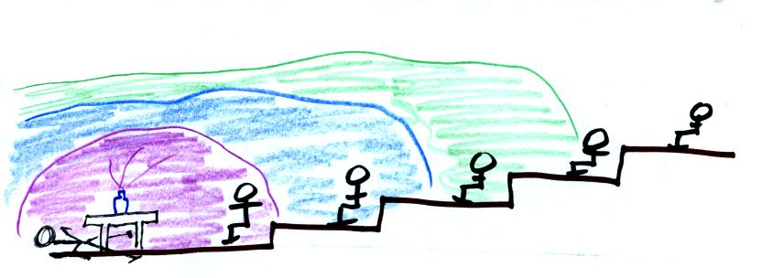
If acetic acid had been used, the instructor and perhaps the front row of students would have been in a little bit of trouble by this point.

Because air has such a low thermal conductivity it is often used as an insulator. It is important, however, to keep the air trapped in small pockets or small volumes so that it isn't able to move and transport energy by convection (we'll look at convection shortly). Here are some examples of insulators that use air:

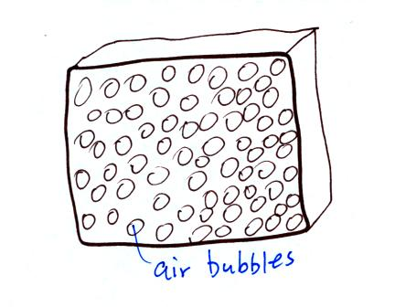
Small bubbles of air trapped in foam
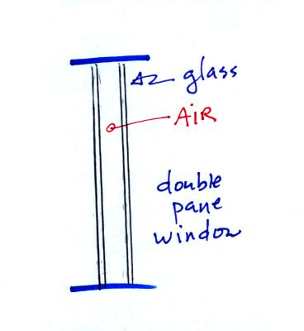
Thin insulating layer of air in a double pane window
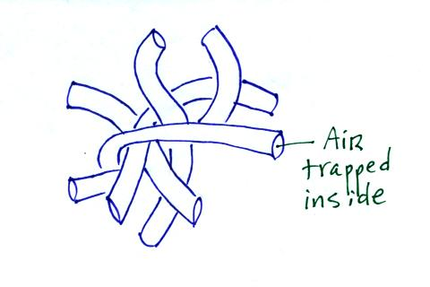
Hollow fibers (Hollofil) filled with air used in sleeping bags and winter coats. Goose down works in a similar way

Convection was the next energy transport process we had a look at. Rather than moving about randomly, the atoms or molecules move as a group. Convection works in liquids and gases but not solids.
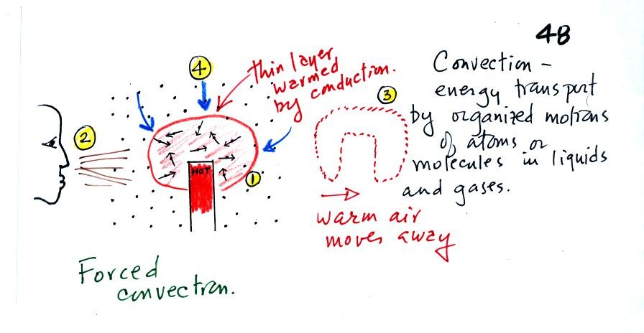
At Point 1 in the picture above a thin layer of air surrounding a hot object has been heated by conduction. Then at Point 2 a person (yes that is a drawing of a person's head) is blowing the blob of warm air off to the right. The warm air molecules are moving away at Point 3 from the hot object together as a group (that's the organized part of the motion). At Point 4 cooler air moves in and surrounds the hot object and the cycle can repeat itself.
This is forced convection. If you have a hot object in your hand you could just hold onto it and let it cool by conduction. That might take a while because air is a poor conductor. Or you could blow on the hot object and force it to cool more quickly. If I had put a small fan behind the curry powder it would probably have spread the smell further out into the classroom.
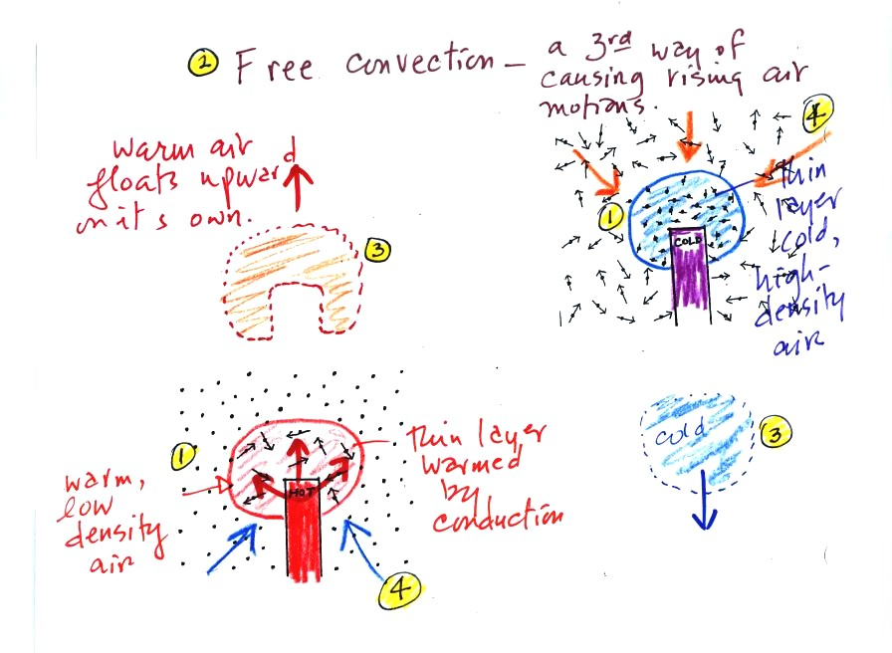

A thin layer of air at Point 1 in the figure above (lower left) is heated by conduction. Then because hot air is also low density air, it actually isn't necessary to blow on the hot object, the warm air will rise by itself (Point 3). Energy is being transported away from the hot object into the cooler surrounding air. This is called free convection and represents another way of causing rising air motions in the atmosphere (rising air motions are important because rising air expands as it moves into lower pressure surroundings and cools. If the air is moist, clouds can form). Cooler air moves in to take the place of the rising air at Point 4 and the process repeats itself.
The example at upper right is also free convection. The sinking air motions that would be found around a cold object have the effect of transporting energy from the warm surroundings to the colder object.
In both examples of free convection energy is being transported from hot toward cold.

We've never really answered the question of why warm air rises and cold air sinks. We did that next. This is covered on p. 53 in the photocopied ClassNotes.
The air parcel shown in the top figure below has the same temperature, pressure, and density as the air around it. Under these conditions there's no reason for the air to rise or sink, the parcel will remain stationary, it is neutrally bouyant.

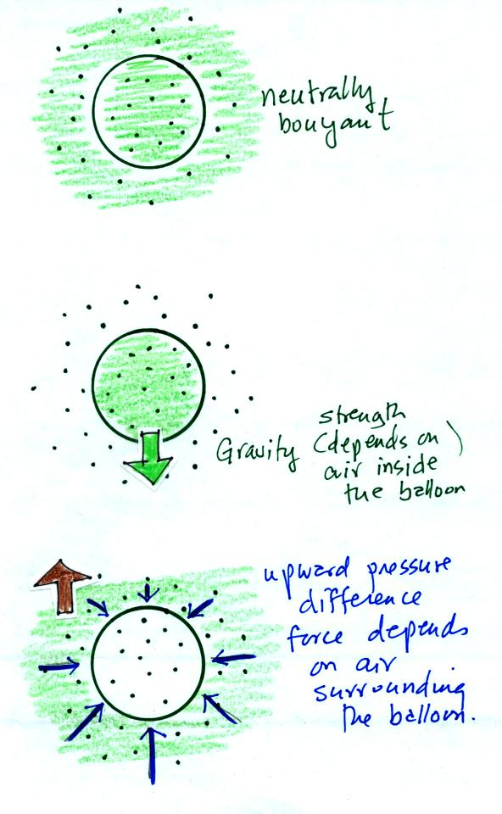

Air has mass weight, so gravity is pulling downward on the balloon of air (middle picture). The strength of the gravity pull (the weight) depends on the amount of air inside the balloon.
There must be an upward force of the same strength in order for the balloon to remain stationary. The origin of this force is the pressure of the air surrounding the balloon. Because air pressure decreases with increasing altitude, the forces at the top of the balloon (pushing down) are a little weaker than the forces at the bottom (pushing up). The net result is an upward pointing pressure difference force. The strength of this force is determined by the air surrounding the balloon.

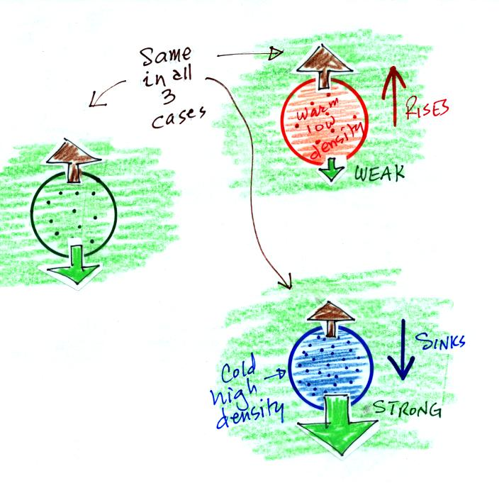

Now we compare the forces on the neutrally bouyant balloon (the green one at left) with balloons that are filled with warm low density and cold high density air.
If the balloon is filled with warm, low density air the gravity force will weaken (there is less air in the balloon so it weighs less). The upward pressure difference force (which depends on the surrounding air) will not change. The upward force will be stronger than the downward force and the balloon will rise.
Conversely if a balloon is filled with cold high density air, the balloon gets heavier. The upward pressure difference force doesn't change. The net force is now downward and the balloon will sink.

To demonstrate free convection we modified the Charles Law demonstration that we did a week or two ago. We used balloons filled with hydrogen instead of air (see bottom of p. 54 in the photocopied Class Notes). Hydrogen is less dense than air even when the hydrogen has the same temperature as the surrounding air. A hhydrogen-filled balloon doesn't need to warmed up in order to rise.
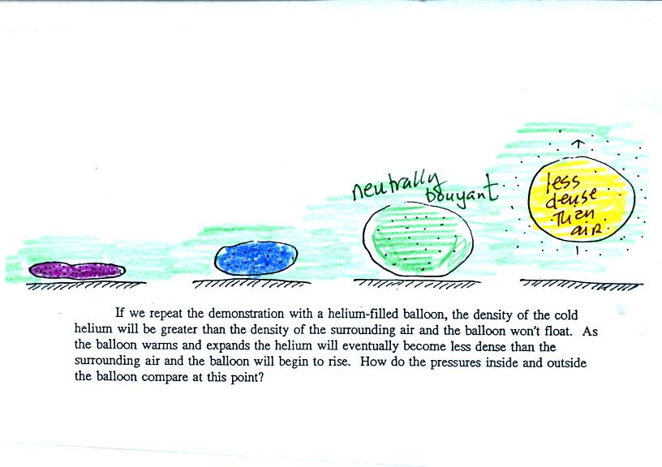
We dunked the helium-filled balloon in some liquid nitrogen to cool it and to cause the density of the helium to increase. When removed from the liquid nitrogen the balloon didn't rise, the gas inside was denser than the surrounding air (the purple and blue balloons in the figure above). As the balloon warms and expands its density decreases. The balloon at some point has the same density as the air around it (green above) and is neutrally bouyant. Eventually the balloon becomes less dense that the surrounding air (yellow) and floats up to the ceiling.

Now some practical applications of what we have learned about conductive and convective energy transport. Energy transport really does show up in a lot more everyday real life situations than you might expect.
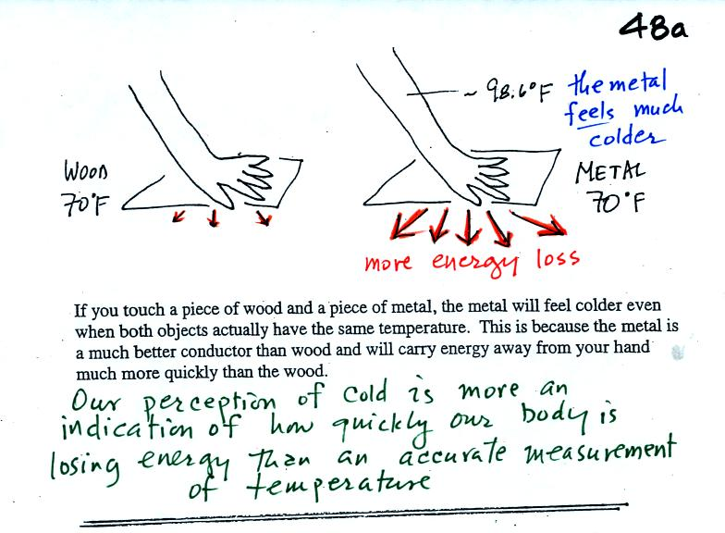
Note first of all there is a temperature difference between your hand and a 70o F object. Energy will flow from your warm hand to the colder object. Metals are better conductors than wood. If you touch a piece of 70 F metal it will feel much colder than a piece of 70 F wood, even though they both have the same temperature.
A piece of 70 F diamond would feel even colder because it is an even better conductor than metal. Something that feels cold may not be as cold as it seems. Our perception of cold is more an indication of how quickly our hand is losing energy than a reliable measurement of temperature.
Here's a similar situation.
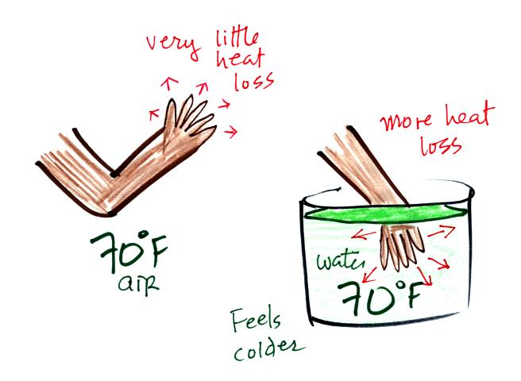
You can stand outside in 70 F without any problem. You probably wouldn't feel cold. But if you jump into 70 F pool water you will feel cold, at least until you "get used" to the water temperature (your body might reduce blood flow to your extremeties and skin to try to reduce energy loss)
Air is a poor conductor. If you out in 40 F weather you will feel colder largely because there is a larger temperature difference between you and your surroundings.
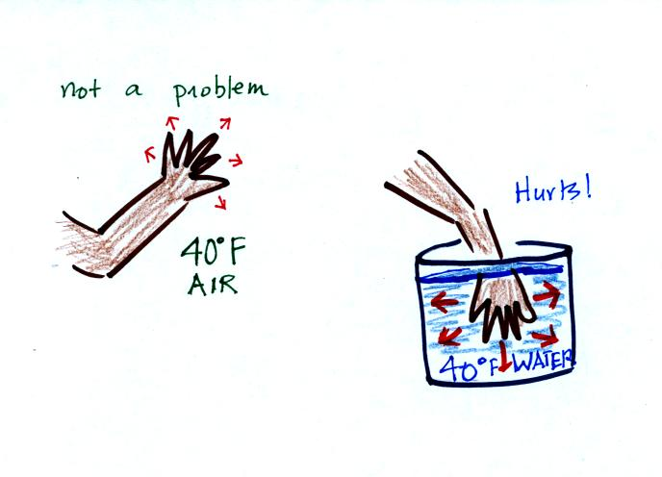
If you stick your hand into a bucket of 40 F water, it will feel very cold (your hand will actually soon begin to hurt). Water is a much better conductor than air. Energy flows much more rapidly from your hand into the cold water.
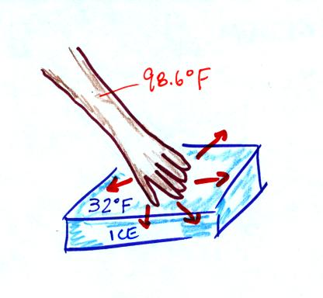
Ice feels cold even though ice is not a particularly good conductor. In this case your hand loses a lot of energy because there is a large temperature difference between you hand and the ice.
What about sticking your hand in liquid nitrogen. You can do that if you're careful to do it quickly. The following figure wasn't shown in class.
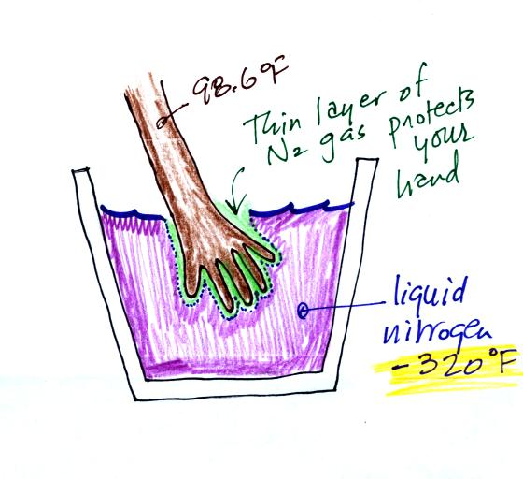
The liquid nitrogen doesn't feel wet and it doesn't feel particularly cold. That is because a thin layer of nitrogen gas forms and surrounds you hand when you stick it into the ice chest. This briefly insulates your hand from the cold.

Now we're in a perfect position to understand wind chill.
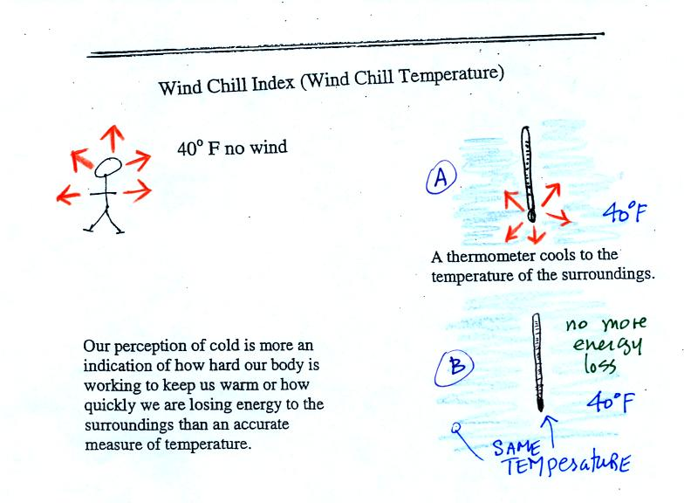
If you go outside on a 40 F day (calm winds) you will feel cool; your body is losing energy to the colder surroundings (by conduction mainly). Your body works hard to keep its core temperature around 98.6 F. A thermometer behaves differently. It actually cools to the temperature of the surroundings. Once it reaches 40 F it won't lose any additional energy.
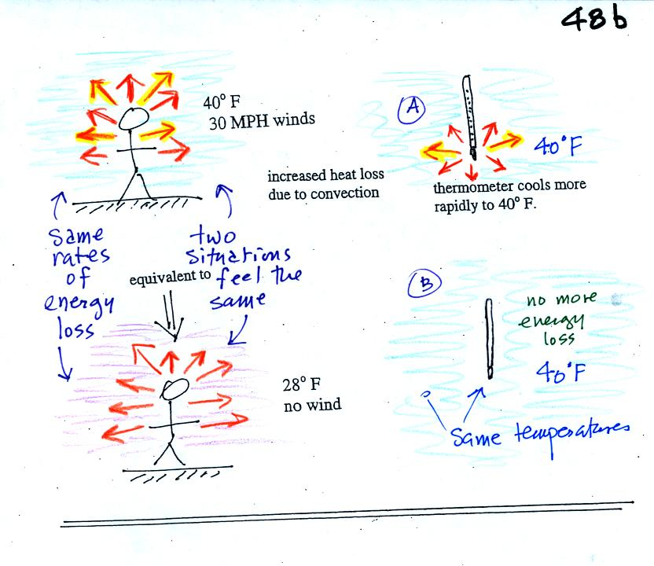
If you go outside on a 40 F day with 30 MPH winds your body will lose energy at a more rapid rate (because convection together with conduction are transporting energy away from your body). This higher rate of energy loss will make it feel colder than a 40 F day with calm winds.
Actually, in terms of the rate at which your body loses energy, the windy 40 F day would feel the same as a calm 28 F day. Your body is losing energy at the same rate in both cases. The combination 40 F and 30 MPH winds results in a wind chill temperature of 28 F.
The thermometer will again cool to the temperature of its surroundings, it will just cool more quickly on a windy day. Once the thermometer reaches 40 F there won't be any additional energy flow. The thermometer would measure 40 F on both the calm and the windy day.
Standing outside on a 40 F day is usually not a life threatening situation. Falling into 40 F water is.
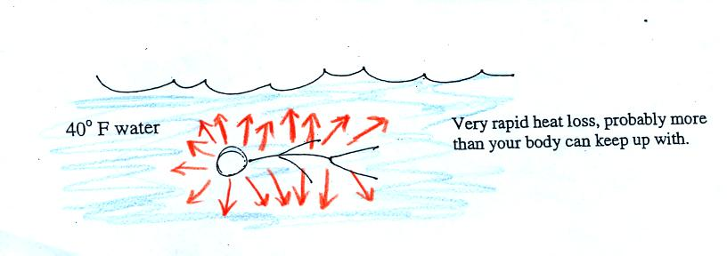
Energy will be conducted away from your body more quickly than your body can replace it. Your core body temperature will drop and bring on hypothermia. Be sure not to confuse hypothermia with hyperthermia which can bring on heatstroke and which is also a serious outdoors risk in S. Arizona.

Latent heat energy transport was the final topic of the day.
Energy transport in the form of latent heat is the second most important energy transport process (second only to electromagnetic radiation). This process is sometimes a little hard to visualize or understand because the energy is "hidden" in water vapor or water.
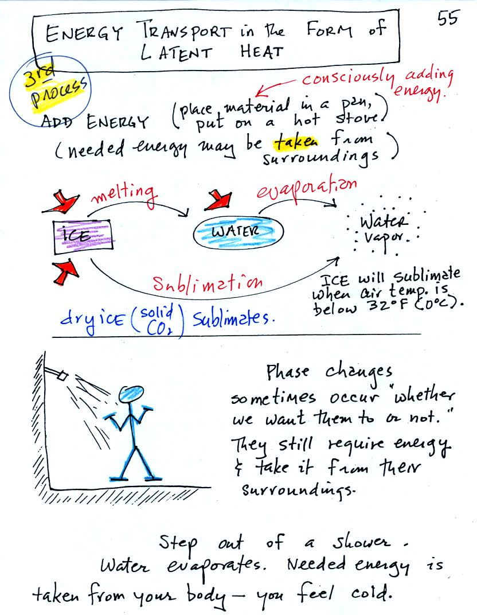
Latent heat energy transport is associated with changes of phase (solid to liquid, water to water vapor, that sort of thing) A solid to liquid phase change is melting, liquid to gas is evaporation, and sublimation is a solid to gas phase change (dry ice sublimates when placed in a warm room, it turns directly from solid carbon dioxide to gaseous carbon dioxide).
In each case energy must be added to the material changing phase. You can consciously add or supply the energy (such as when you put water in a pan and put the pan on a hot stove) or the needed energy will be taken from the surroundings (from your body when you step out of a shower in the morning).
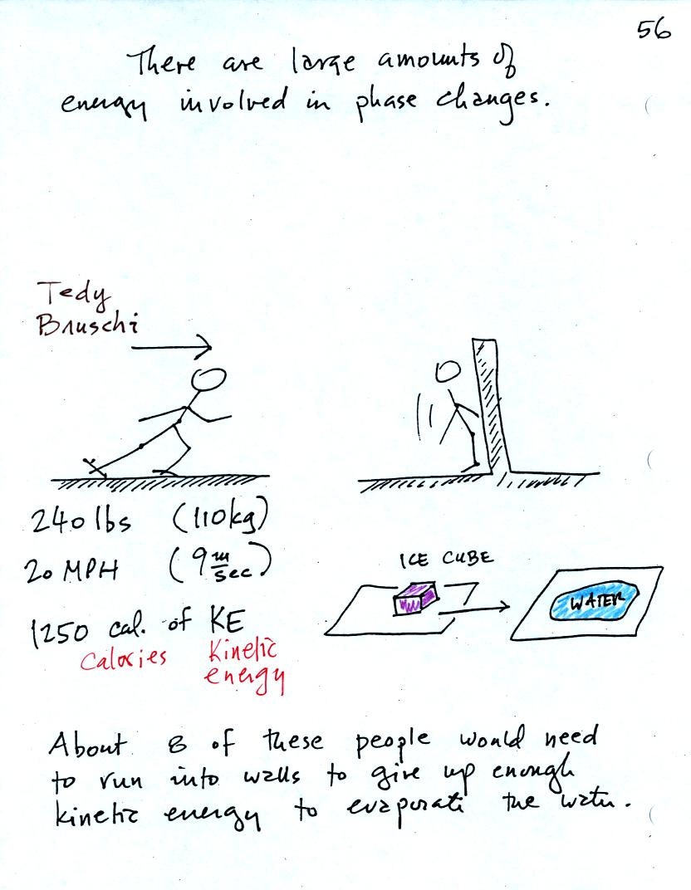

A 240 pound man (or woman) running at 20 MPH has just enough kinetic energy (if you could somehow capture it) to be able to melt an ordinary ice cube. It would take 8 people to evaporate the resulting water.
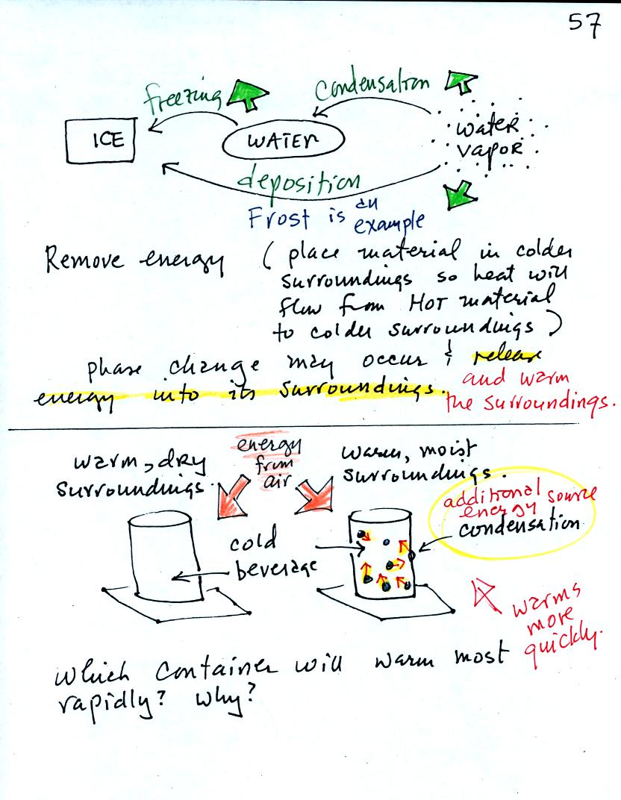

You can consciously remove energy from water vapor to make it condense or from water to cause it to free (you could put water in a freezer; energy would flow from the relatively warm water to the colder surroundings). Or if one of these phase changes occurs energy will be released into the surroundings (causing the surroundings to warm). Note the energy arrows have turned around and are pointing from the material toward the surroundings.
A can of cold drink will warm more quickly in warm moist surroundings than in warm dry surroundings. Heat will flow from the warm air into the cold cans in both cases. Condensation of water vapor is an additional source of energy and will warm that can more rapidly. The condensation may actually be the dominant process.
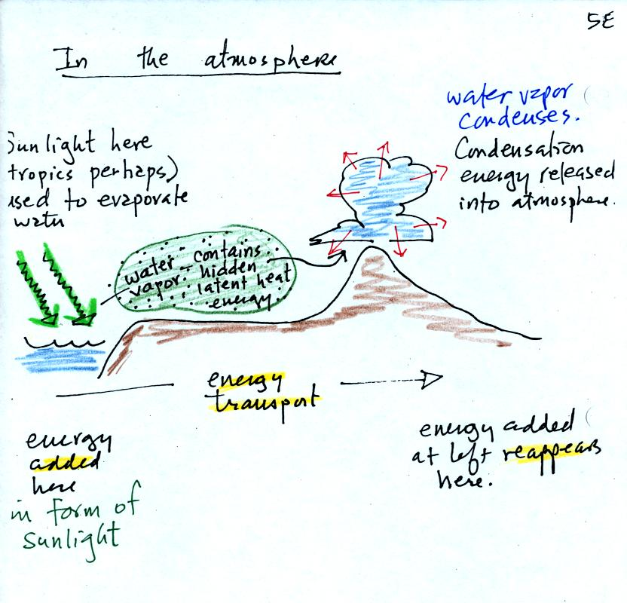
The story starts at left in the tropics where there is often an abundance or surplus of energy; sunlight evaporates ocean water. The resulting water vapor moves somewhere else and carries hidden latent heat energy with it. This hidden energy reappears when something (air running into a mountain and rising, expanding, and cooling) causes the water vapor to condense. The condensation releases energy into the surrounding atmosphere.
Energy arriving in sunlight in the tropics could ultimately be transported to the atmosphere in Tucson.

