Tuesday Nov. 25, 2008
Music today was from the Olds 97s (from their Blame it on Gravity CD). I jumped around a little bit and don't remember exactly what songs were played.
1S1P reports were collected today. My plan is to make a superhuman effort to get most of this work graded by the time you all return from Thanksgiving. Of course there's always the possibility that I'll fail miserably.
By the time today's notes appear online, the Quiz #4 Study Guide pt. 1 and pt. 2 will be available. This is all you will need to prepare for next week's quiz.
Time is pretty tight in this NATS 101 section. That isn't the case in the MWF class, so I have been spent 5 or 10 minutes showing photographs of my cats and photographs of my winter vegetable garden, just to break up the routine a little bit. You can check them out on your own if you are curious.

We have a little bit of material on tornadoes to finish before starting a new section on hurricanes.
The Fujita Scale is used to rate tornado strength or severity.
Simplified, Easy-to-Remember version of the Fujita Scale
winds < 100 MPH
F0
F1 | roof damage,  mobile home tipped over
microburst winds can cause this degree of damage
winds 100 to 200 MPH
F2 | roof gone,  outside walls still standing
F3 | outside walls gone,  inside walls intact
winds 200 to 300 MPH
F4 | home destroyed,  debris nearby
F5 | home destroyed,  debris carried away
Here are some photographs of tornado damage
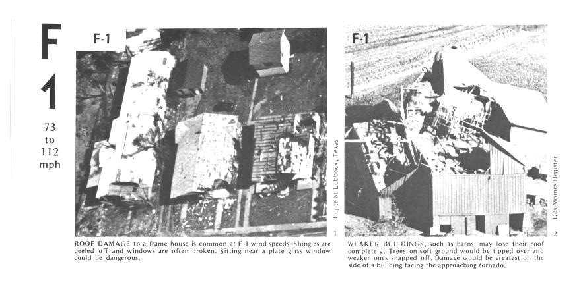
The buildings on the left suffered light roof damage. The barn roof at right was more heavily damaged.
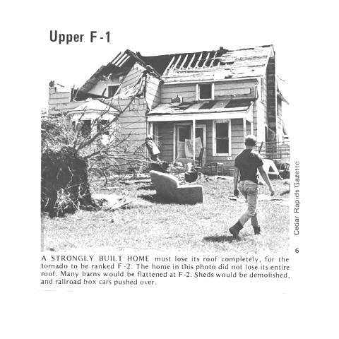
More severe damage to what appears to be a well built house roof.

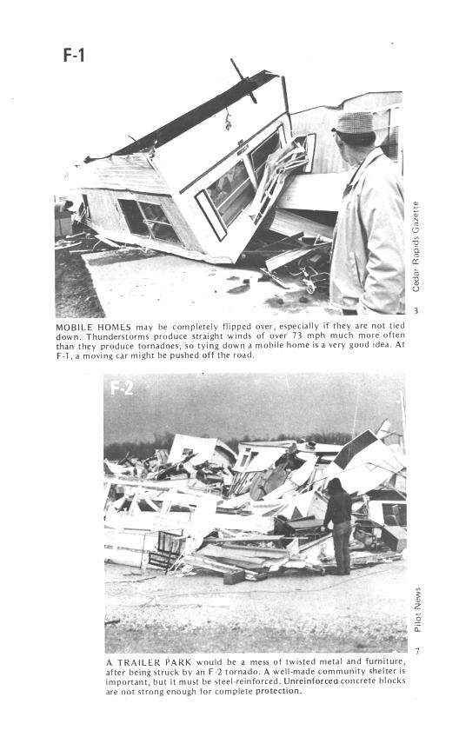
F1 tornado winds can tip over a mobile home if it is not tied down (the caption states that an F1 tornado could blow a moving car off a highway). F2 level winds (bottom photo) can roll and completely destroy the mobile home.
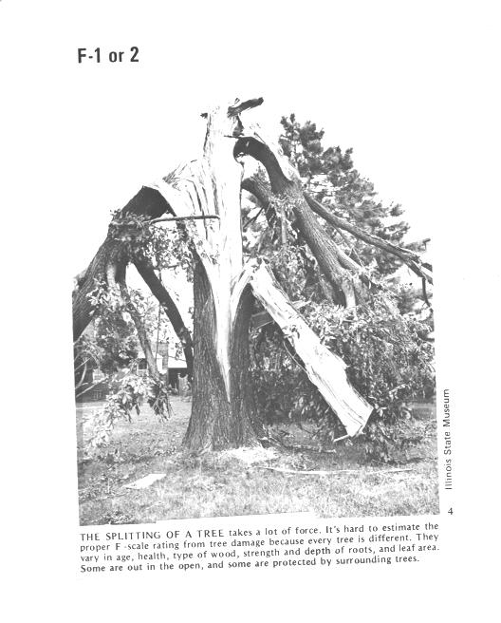
Trees, if not uprooted, can suffer serious damage from F1 or F2 tornado winds.
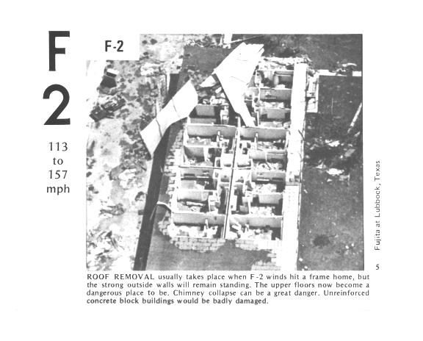
F2 level winds have completely removed the roof from this building. The outside walls of the building are still standing.
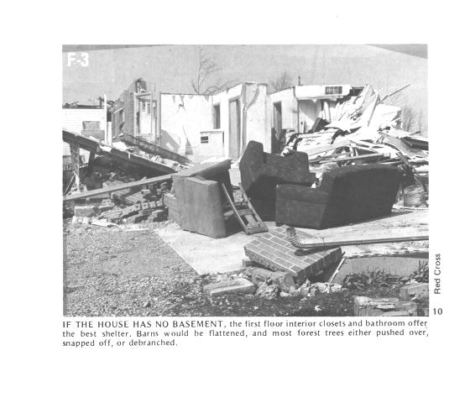
The roof is gone and the outer walls of this house were knocked down. This is characteristic of F3 level damage. In a house without a basement or storm cellar it would be best to seek shelter in an interior closet or bathroom.
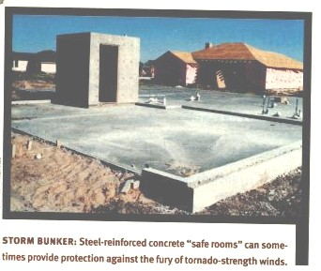
In some tornado prone areas,
people construct a small closet or room inside their home made of reinforced concrete.
A better solution might be to have a storm cellar located underground.
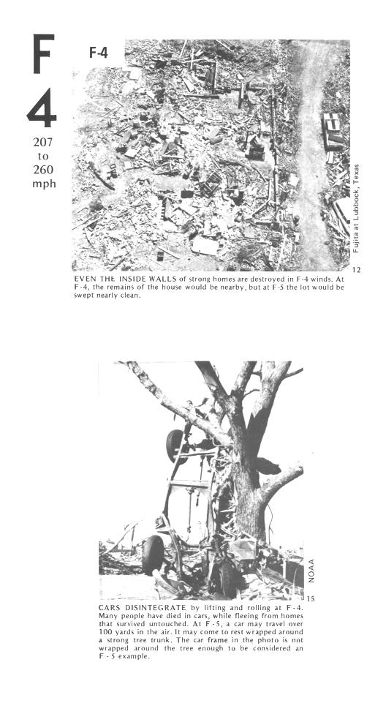
All of the walls were knocked down in the top photo but the debris is left nearby. This is characteristic of F4 level damage. All of the sheet metal in the car body has been removed in the bottom photo and the car chasis has been bent around a tree. The tree has been stripped of all but the largest branches.
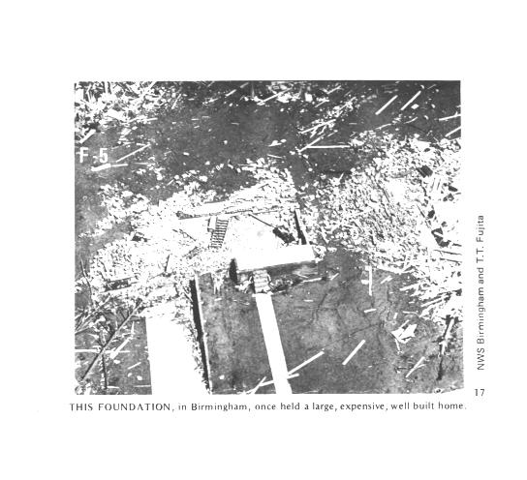
An F5 tornado completely destroyed the home in the photo above and removed most of the debris.
Only bricks and a few pieces of lumber are left.

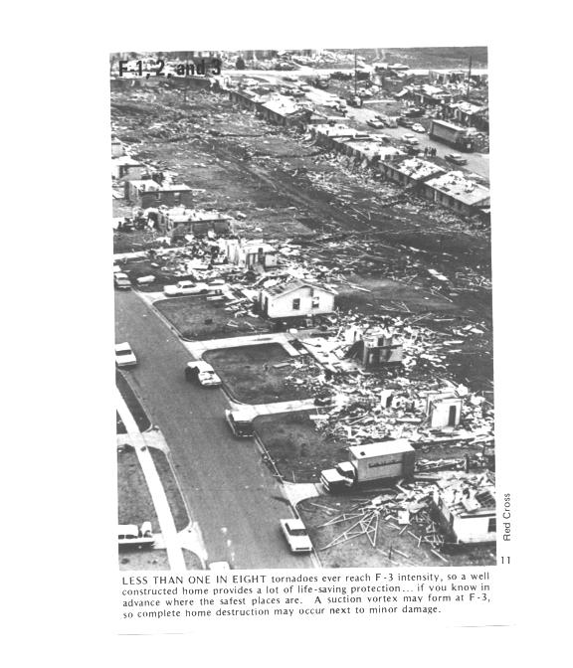
Several levels of damage are visible in the photograph above. It was puzzling initially how some homes could be nearly destroyed while a home nearby or in between was left with only light damage. One possible explanation is shown below
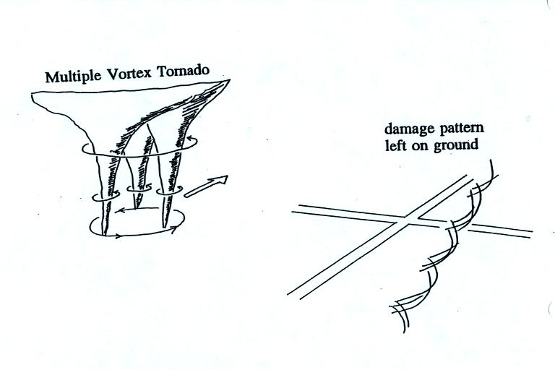
Some big strong tornadoes may have smaller more intense "suction vortices" that spin around the center of the tornado. Tornado researchers have actually seen the scouring pattern shown at right in the figure above that the multiple vortices can leave behind.
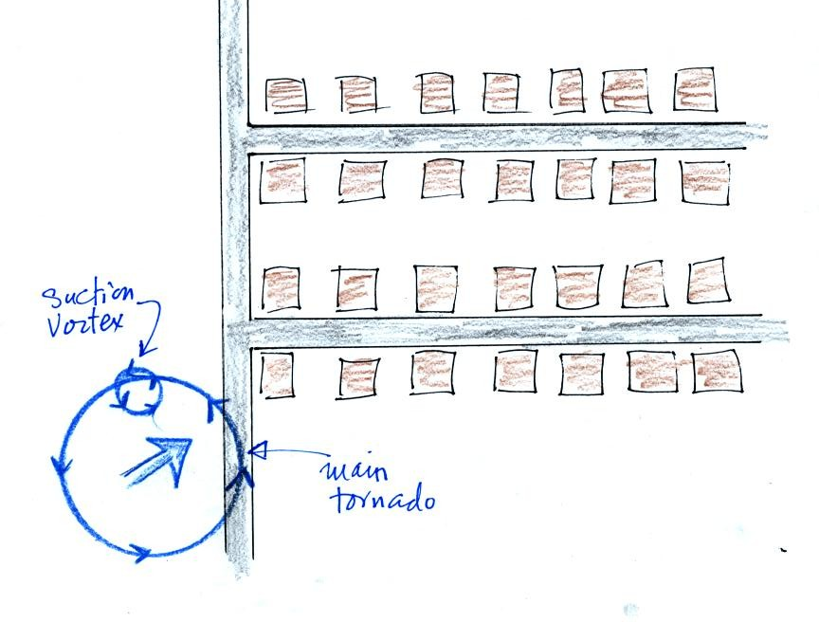
The sketch above shows a tornado located SW of a neighborhood.
As the tornado sweeps through the neighborhood, the suction vortex will rotate around the core of the tornado.
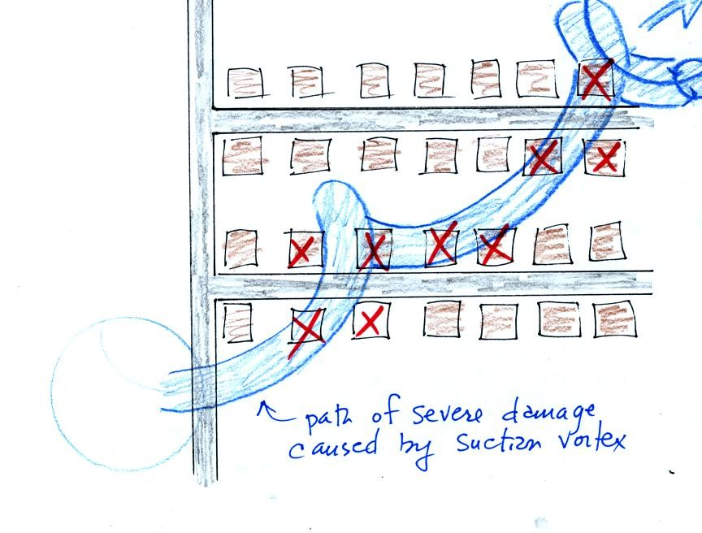
The homes marked in red would be damaged severely. The others would receive less damage (remember, however that there would probably be multiple suction vortices in the tornado).

OK now it is on to hurricanes.
A good place to begin is to compare hurricanes (tropical cyclones) with middle latitude storms (extratropical cyclones). The following figure was on a handout distributed in class.
A good place to begin is to compare hurricanes (tropical cyclones) with middle latitude storms (extratropical cyclones). The following figure was on a handout distributed in class.
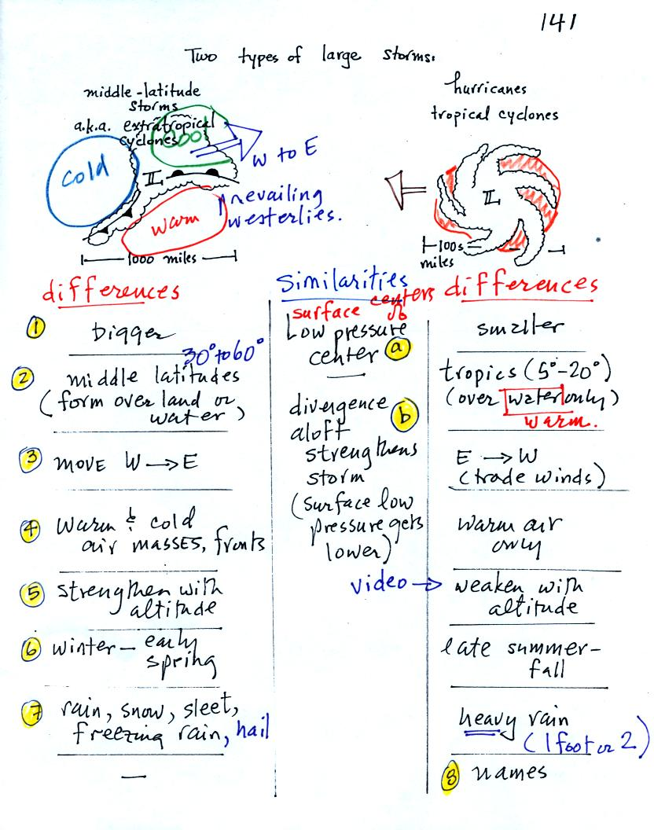
1. Middle latitude storms (MLS) are generally bigger than hurricanes. A large middle latitude storm might cover half of the United States. A big hurricane might fill the Gulf of Mexico.
2,3. MLS can form over land or water. At middle latitudes they are in the prevailing westerly wind belt and move from West toward East. Hurricanes can only form over warm ocean water (80 F or above). The trades winds cause hurricanes to move from east to west.
a. Both MLS and hurricanes from around surface centers of low pressure (that is why the term cyclone appears in the names of both types of storms).
b. Upper level divergence can lower the surface pressure which then can cause both types of storms to intensify.
4. Warm and cold air masses collide along fronts in MLS. You only find warm moist air in a hurricane.
5. MLS intensify with altitude. Hurricanes weaken with altitude - the low pressure at the bottom center of the storm actually becomes high pressure at the top center of the storm. The fact that hurricanes weaken with altitude came up in the video tape shown at the end of class. In the video a NOAA reconnaisance plane was flying into the center of a very strong hurricane. Normally the plane would fly in at an altitude of 5,000 feet. This particular hurricane was so strong however that they decided to play it safe and to fly in at 10,000 feet altitude.
6. The strongest MLS form in the winter and early spring. The peak of hurricane season is already behind us.
7. MLS can produce a variety of types of precipitation. Hurricanes mostly just produce very large amounts of rain.
8. Hurricanes receive names (when they reach tropical storm strength). The names now alternate male and female. The names of particularly strong or deadly hurricanes (such as Katrina) are retired, otherwise the names repeat every 6 years.

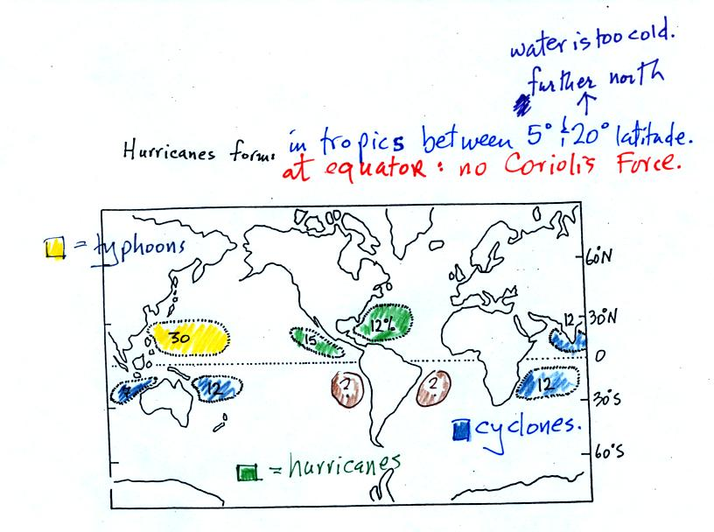
The figure above shows the relative frequency of tropical cyclone development in different parts of the world. The name hurricane, cyclone, and typhoon all refer to the same type of storm (tropical cyclone is a general name that can be used anywhere). In most years the ocean off the coast of SE Asia is the world's most active hurricane zone. Hurricanes are very rare off the east and west coasts of South America.
Hurricanes form between 5 and 20 degrees latitude, over warm ocean water, north and south of the equator. The warm layer of water must be fairly deep to contain enough energy to fuel a hurricane and in order that mixing doesn't bring cold water up to the ocean surface. The atmosphere must be unstable so that thunderstorms can develop. Hurricanes will only form when there is very little or no vertical wind shear (changing wind direction or speed with altitude). Hurricanes don't form at the equator because there is no Coriolis force there (the Coriolis force is what gives hurricanes their spin and it causes hurricanes to spin in opposite directions in the northern and southern hemispheres.
Note that more tropical cyclones form off the west coast of the US than off the east coast. The west coast hurricanes don't generally get much attention, because they move away from the coast and usually don't present a threat to the US (except occasionally to the state of Hawaii). The moisture from these storms will sometimes be pulled up into the southwestern US where it can lead to heavy rain and flooding.
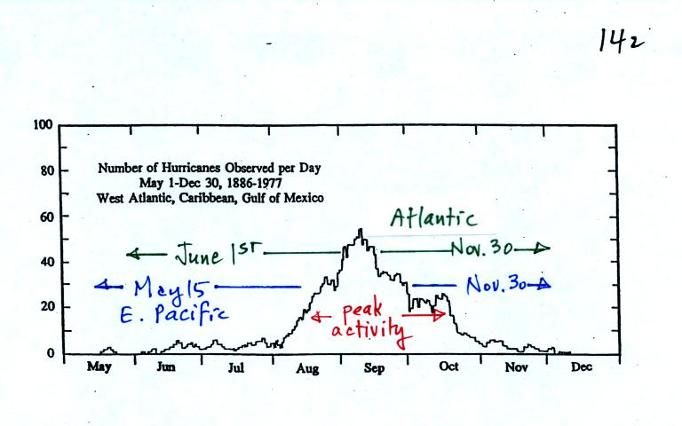
Hurricane season in the Atlantic officially runs from June 1 through to November 30. The peak of hurricane season is in September. In 2005, an unusually active hurricane season in the Atlantic, hurricanes continued through December and even into January 2006. Hurricane season in the Pacific begins two weeks earlier on May 15 and runs through Nov. 30.

Some kind of meteorological process that produces low level convergence is needed to initiate a hurricane. One possibility, and the one that fuels most of the strong N. Atlantic hurricanes, is an "easterly wave." This is just a "wiggle" in the wind flow pattern. Easterly waves often form over Africa or just off the African coast and then travel toward the west across the N. Atlantic. Winds converge as they approach the wave and then diverge once they are past it . The convergence will cause air to rise and thunderstorms to begin to develop.
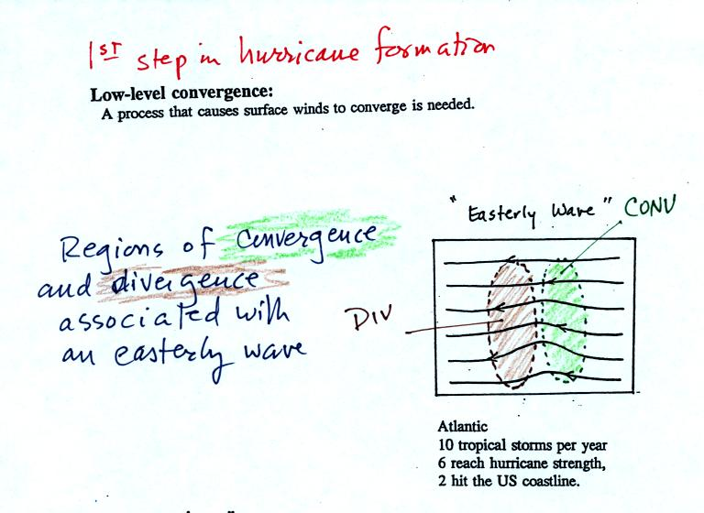

In an average year, in the N. Atlantic, there will be 10 named storms (tropical storms or hurricanes) that develop during hurricane season. 2005 was, if you remember, a very unusual year. There were 28 named storms in the N. Atlantic in 2005. That beat the previous record of 21 names storms that had been set in 1933. Of the 28 named storms, 15 developed into hurricanes.
In some ways winds blowing through an easterly wave resembles traffic on a multi-lane highway. Traffic will back up as it approaches a section of the highway with a closed lane. Once through the "bottleneck" traffic will begin to flow more freely.
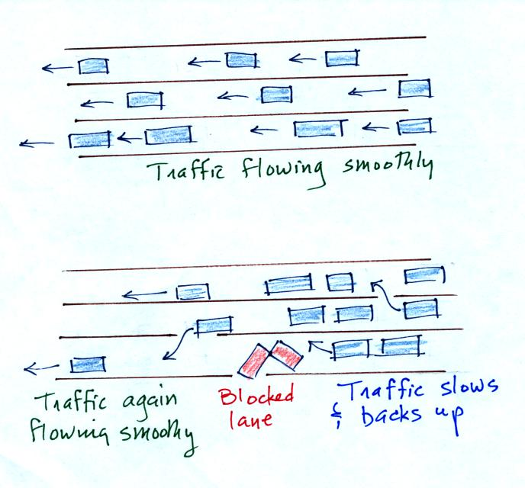
Another process that causes surface winds to converge is a "lee side low."
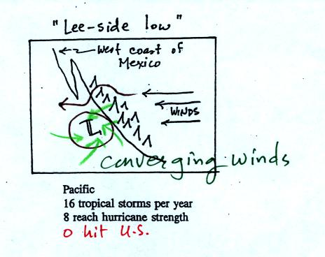

Winds blowing over mountains on the west coast of Mexico will sometimes form a surface low on the downwind side of the mountains. Surface winds will spiral inward toward the center of the low. Note there are generally a few more tropical storms and hurricanes in the E. Pacific than in the N. Atlantic. They generally move away from the US coast, though the Hawaiian Islands are sometimes affected.

This figure tries to explain how a cluster of thunderstorms can organize and intensify into a hurricane.
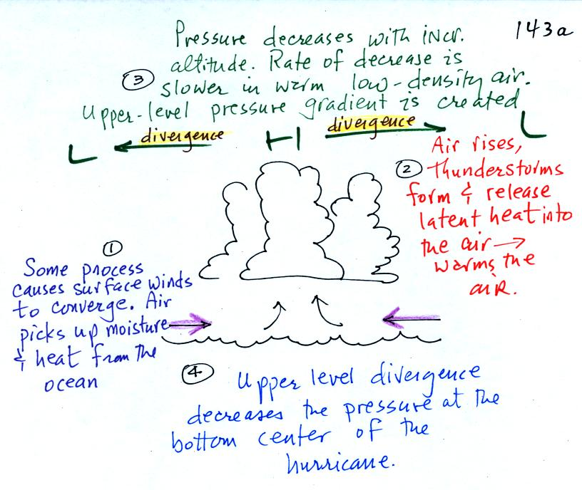
1. Converging surface winds pick up heat and moisture from the ocean. These are the two mains sources of energy for the hurricane.
2. Rising air cools and thunderstorm clouds form. The release of latent heat during condensation warms the atmosphere. The core of a hurricane is warm.
3. Pressure decreases more slowly with increasing altitude in the warm core of the hurricane. The result is that pressure at the top center of the hurricane is higher than the pressure at the top edges of the hurricane (pressure at the top center is still lower than the pressure at the bottom center of the hurricane). Upper levels winds diverge and spiral outward from the top center of the hurricane.
4. The upper level divergence will cause the surface pressure at the center of the hurricane to decrease. The speed of the converging surface winds increases and the storm intensifies. The converging winds pick up additional heat and moisture which warms the core of the hurricane even more. The upper level high pressure and the upper level divergence increase. The increased divergence lowers the surface pressure even more.
Here's another illustration of hurricane intensification ( not shown in class ).
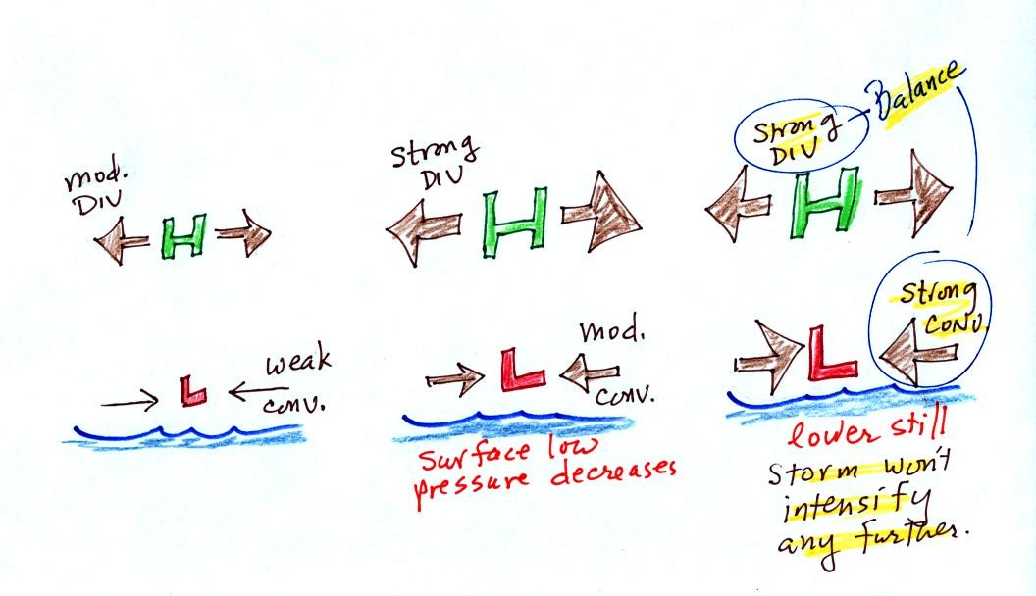
In the figure at left the upper level divergence is stronger than the surface convergence. The surface low pressure will decrease. The decrease in surface pressure will cause the converging surface winds to blow faster.
In the middle picture, the surface low pressure is lower, the surface convergence is stronger. The upper level divergence has also been strengthened a little bit. The upper level divergence is still stronger than the surface convergence so the surface low pressure will decrease even more.
In the right figure the surface low pressure has decreased enough that the surface convergence now balances the upper level divergence. The storm won't strengthen any more.
Generally speaking the lower the surface pressure at the center of a hurricane the stronger the storm and the faster the surface winds will blow.
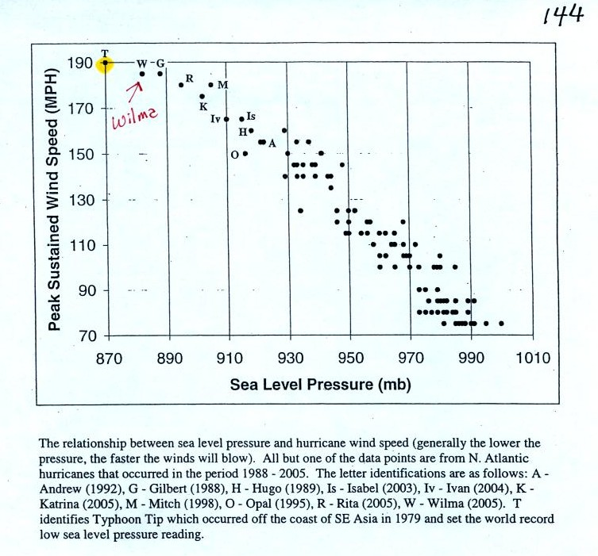
This figure tries to show the relationship between surface pressure and surface wind speed. The world record low sea level pressure reading, 870 mb, was set by Typooon Tip off the SE Asia coast in 1979. Sustained winds in that storm were 190 MPH. Three 2005 Atlantic hurricanes: Wilma, Rita, and Katrina had pressures in the 880 mb to 900 mb range and winds ranging from 170 to 190 MPH.
The stages of storm development that lead up to a hurricane are shown at the bottom of p. 143a in the photocopied ClassNotes.
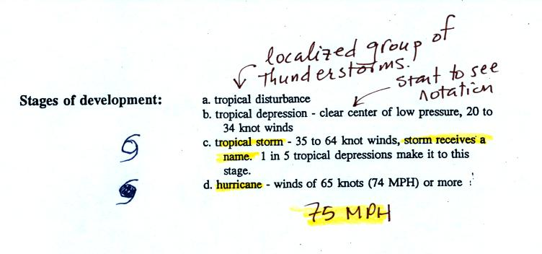
A tropical disturbance is just a localized cluster of thunderstorms that a meterologist might see on a satellite photograph. But this would merit observation because of the potential for further development. Signs of rotation would be evidence of organization and the developing storm would be called a tropical depression.
In order to be called a tropical storm the storm must organize a little more, and winds must increase to 35 knots. The storm receives a name at this point. Finally when winds exceed 75 MPH (easier to remember than 65 knots or 74 MPH) the storm becomes a hurricane.

That was about all the new material we had time to cover in class because a 20 minute segment from a NOVA program (PBS network) on hurricanes was shown. A film crew was on board a NOAA reconnaissance plane as it flew into the narrow eye of hurricane GILBERT. Gilbert set the record low sea level pressure reading for the Atlantic ocean (888 mb). That record stood until the 2005 hurricane season when WILMA set a new record of 882 mb. The world record low sea level pressure, 870 mb, was set in a SE Asian typhoon in 1979.
The following two figures (on the back of the handout distributed in class) explain material mentioned during the video tape.

One of the most distinctive features of a hurricane is the clear eye in the center. The eye is produced by sinking air. Once in the eye, the people in the NOAA plane where able to see blue sky when they looked and and saw the ocean surface when they looked down. The eye of a hurricane is something that very few people will ever see. The eye is surrounded by the eye wall, a ring of strong thunderstorms.
