Thursday Nov. 20, 2008
The music today was from Jovert, a local (Tucson High School based) steel drum band.
Sorry about the trollish sounding voice today, I should have given you some advance warning. I really hope it is gone by next week.

Here's a quick reminder of the microburst demonstration that I showed in class last Tuesday. The blue colored mixture of water and glycerin represents cold dense air in a thunderstorm downdraft. When the cold air hits the ground it spreads out horizontally. Surface winds can sometimes reach 100 MPH.
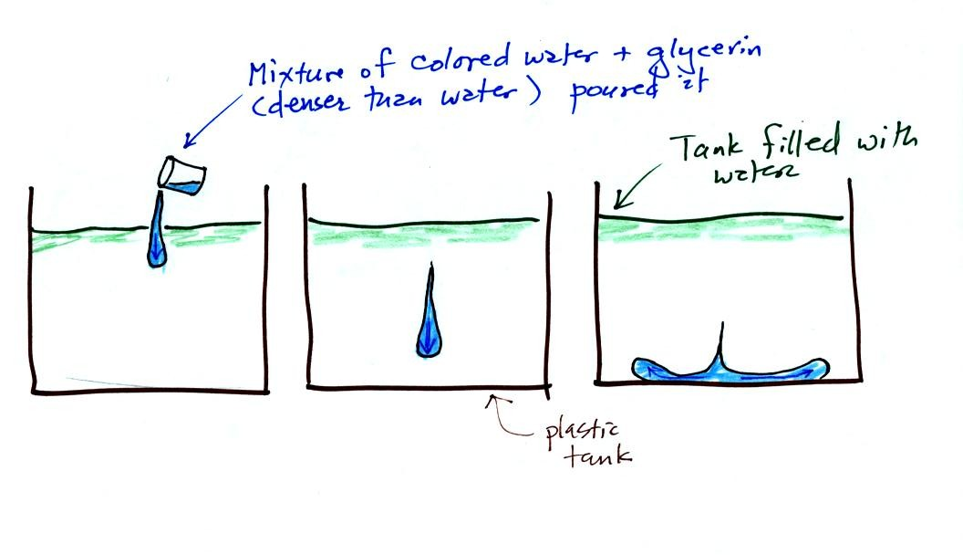
A short time-lapse video of an actual wet microburst over the Catalina mountains was showed in class. A sudden downward gush of rain was visible on the video. Surface winds may have been strong enough to blow over or uproot a few trees in the forest.
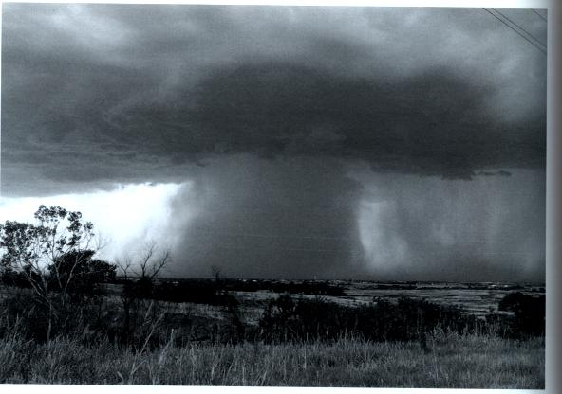
Here's a still photograph of heavy localized rain falling from a thunderstorm. This might easily have produced a microburst and strong surface winds.

Here's a quick review of the 3 stage life cycle of an ordinary air mass thunderstorm.
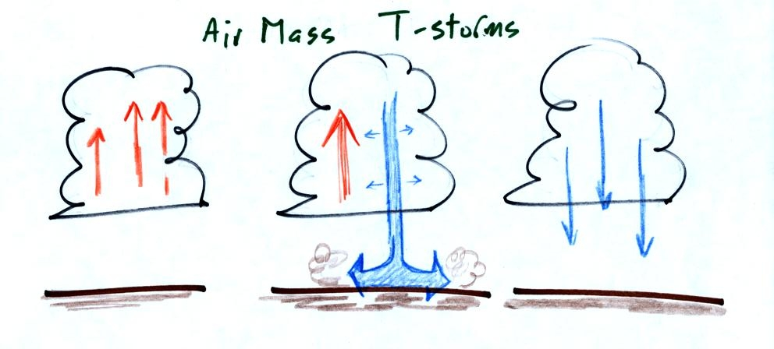
Once the downdraft forms in the middle (mature) stage, it begins to spread horizontally in the interior of the cloud. The downdraft eventually chokes off the updraft and the storm begins to weaken and dissipate.
Under certain conditions the thunderstorm will move and the updraft will tilt. This is shown in the following figure.
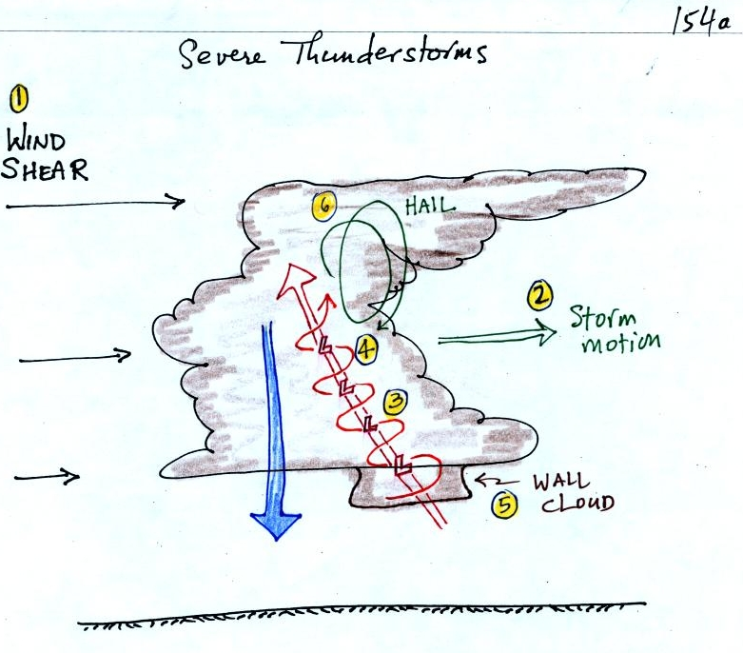
Severe storms are more likely to form when there is vertical wind shear. Wind shear (pt 1) is changing wind direction or wind speed with distance. In this case, the wind speed is increasing with increasing altitude, that is vertical wind shear.
The thunderstorm itself will move in this kind of an environmen, at an average of the speeds at the top and bottom of the cloud (pt. 2). The thunderstorm will move to the right more rapidly than the air at the ground which is where the updraft begins. Rising air that is situated at the front bottom edge of the thunderstorm will find itself at the back edge of the storm when it reaches the top of the cloud. This produces a tilted updraft (pt. 3). The downdraft is situated at the back of the ground. The updraft is continually moving to the right and staying away from the downdraft. The updraft and downdraft coexist and do not "get in each others way."
Sometimes the tilted updraft will begin to rotate. A rotating updraft is called a mesocyclone (pt. 4). Meso refers to medium size (thunderstorm size) and cyclone means winds spinning around low pressure. Low pressure in the core of the mesocyclone creates an inward pointing pressure gradient force needed to keep the updraft winds spinning in circular path (low pressure also keeps winds spinning in a tornado). The cloud that extends below the cloud base and surrounds the mesocyclone is called a wall cloud (pt. 5). The largest and strongest tornadoes will generally come from the wall cloud.
Note (pt. 6) that a tilted updraft provides a way of keeping growing hailstones inside the cloud. Hailstones get carried up toward the top of the cloud where they begin to fall. But they then fall back into the strong core of the updraft and get carried back up toward the top of the cloud.
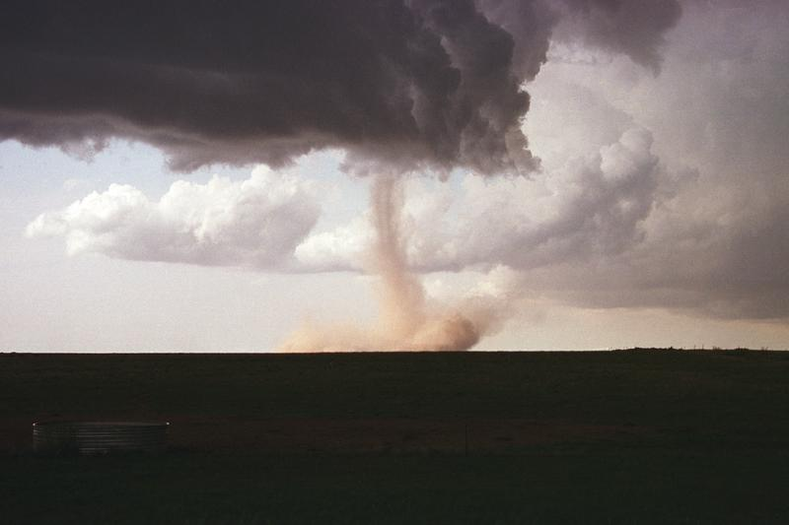
Here is a particularly nice photograph of a wall cloud and a tornado. An even better photograph was in a book passed around in class. The book was titled "Storm Chaser" and was written by Warren Faidley, a local photographer.

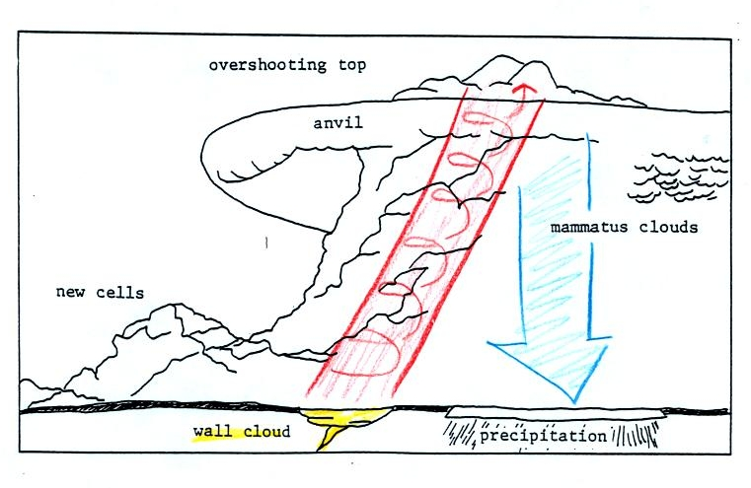
Here is a relatively simple drawing showing some of the key features on a supercell thunderstorm. In a supercell the rotating updraft (shown in orange above) is strong enough to penetrate a short ways into the stratosphere. This produces the overshooting top or dome feature above. A wall cloud and a tornado are shown at the bottom of the mesocyclone. In an ordinary thunderstorm the updraft is unable to penetrate into the very stable air in the stratosphere and the upward moving air just flattens out and forms an anvil. The flanking line is a line of new cells trying to form alongside the supercell thunderstorm.

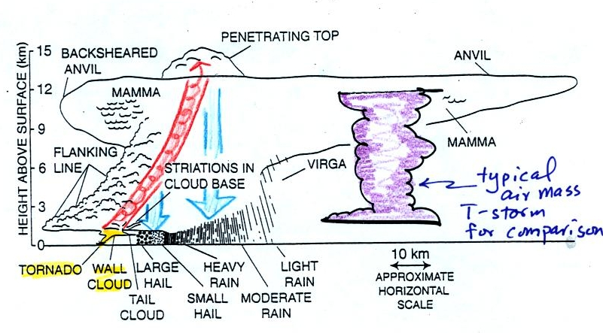
Here is a second slightly more complicated drawing of a supercell thunderstorm. A typical air mass thunderstorm (purple) has been drawn in for comparison.
Supercell thunderstorms also often produce a very distinctive signature on weather radar called a "hook echo." We haven't covered weather radar in this class this semester. But, in some respects a radar picture of a thunderstorm is similar to an X-ray photograph of a human body.
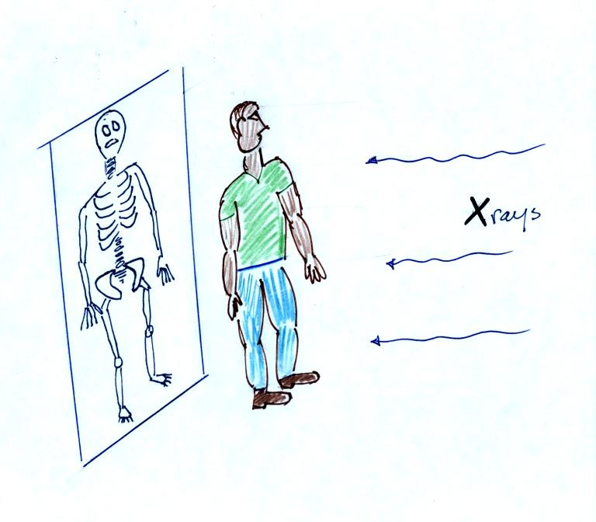
X-rays are high energy electromagnetic radiation that passes right through the flesh in a human body (the fat, muscle etc.). Bone does absorb some of the X-rays, however. So if you take an X-ray of a person you see only part of what is inside their body, you see the skeleton.
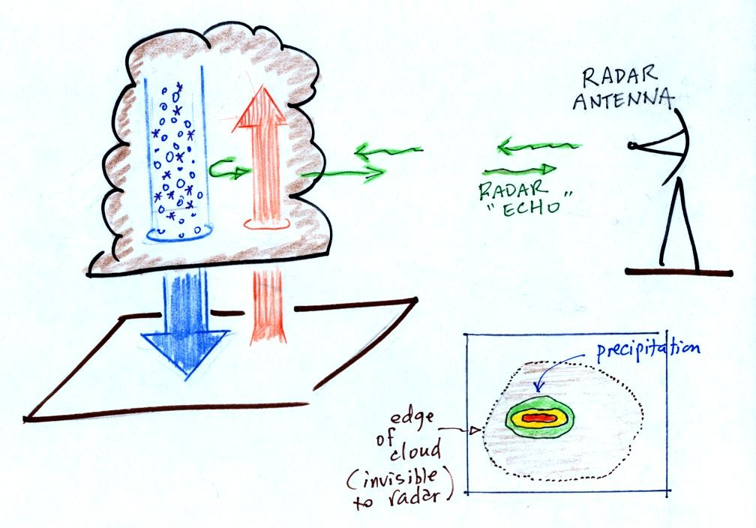
A radar emits microwave radiation. This radiation passes right through the cloud itself but is reflected by the larger precipitation particles (rain, graupel, etc). This reflected radiation is detected by the radar. A radar image of a cloud is usually just a horizontal slice through the cloud. In the picture above the radar would slice through the middle of the cloud and would detect only the column of precipitation. The intensity of the precipitation (determined by the size and number of precipitation particles) is color coded on the radar display (red would be heavy precipitation, green light precipitation).
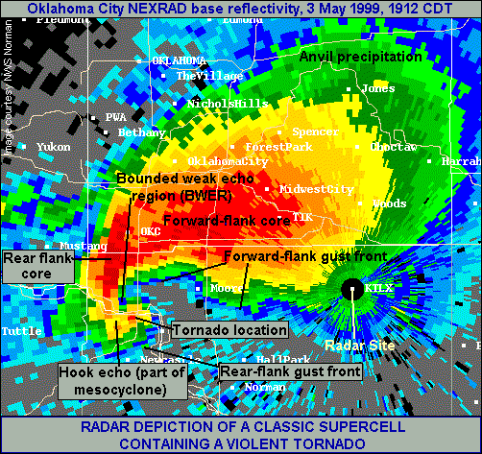
We watched a short video segment at this point. It showed a photograph of a distant supercell thunderstorm with a distinctive dome. The video showed the wall clouds at the bottoms of 2 or 3 other much closer supercells. And finally a computer simulation of the air motions inside a supercell thunderstorm was shown. Researchers understand the development of a supercell pretty well. The exact process that initiates tornado development is still unknown, however.

With all this talk of spinning updrafts in thunderstorms, the next logical topic is tornadoes.
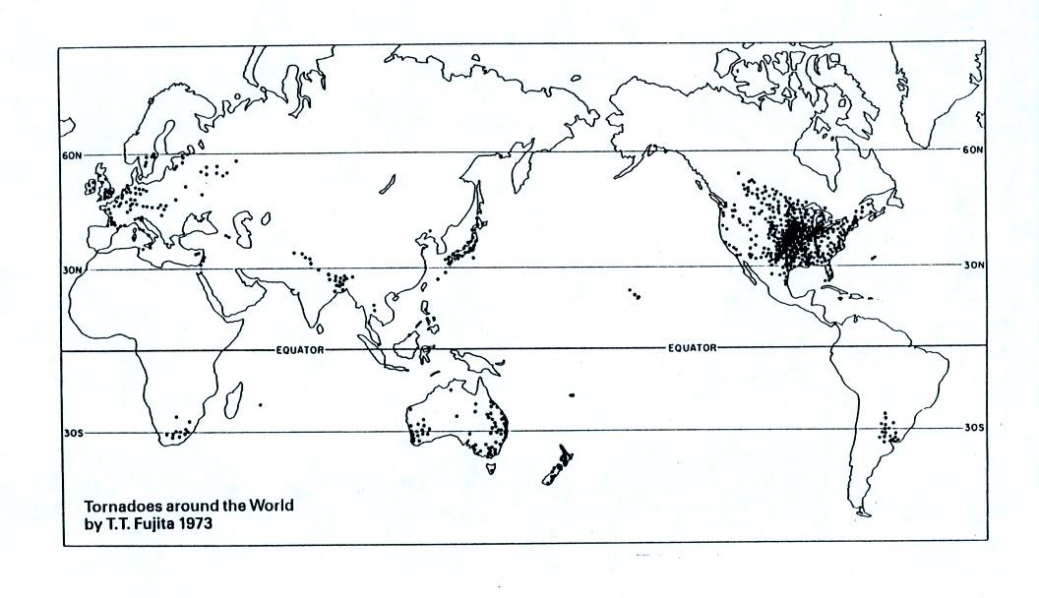
The United States has more tornadoes in an average year than any other country in the world (over 1000 per year). The central US has just the right mix of meteorological conditions.

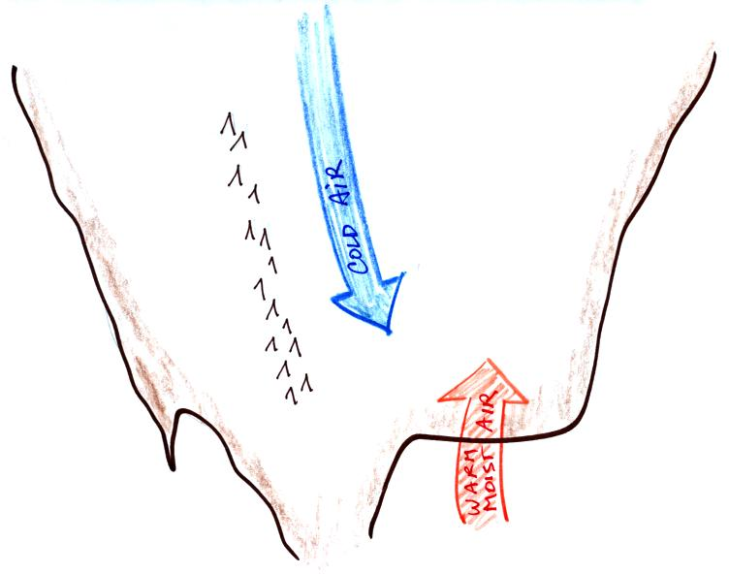 | 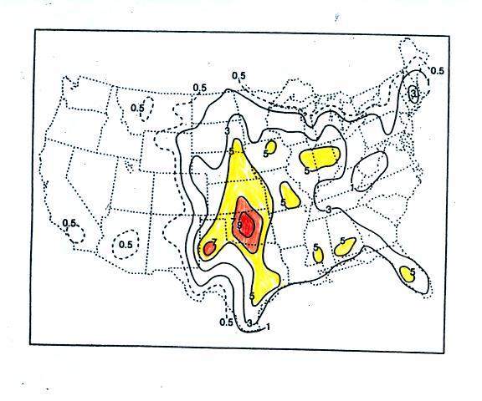

In the spring, cold dry air can move all the way from Canada (without being blocked by mountains) and collide with warm moist air from the Gulf of Mexico to form strong cold fronts and thunderstorms.
Tornadoes have been observed in every state in the US, but tornadoes are most frequent in the central plains, a region referred to as "Tornado Alley" (highlighted in red, orange, and yellow above). The map at right above can be found on p. 161 in the photocopied ClassNotes.
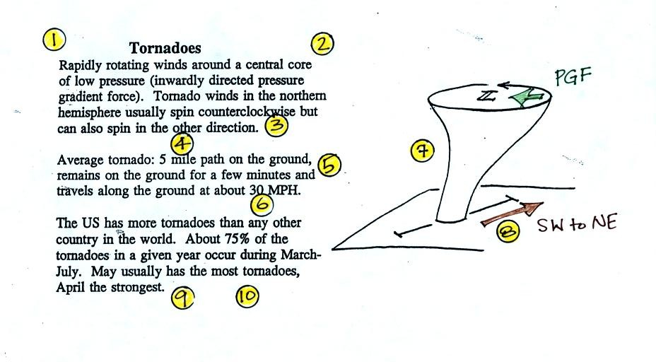
Here are some basic tornado characteristics (the figure above is found on p. 161 in the photocopied class notes).
1. About 2/3rds of tornadoes are F0 or F1 tornadoes (see below) and have spinning winds of about 100 MPH or less. Microburst winds can also reach 100 MPH. They are a lot more common in Tucson in the summer than tornadoes but can inflict some of the same kinds of damage.
2. A very strong inwardly directed pressure gradient force is needed to keep winds spinning in a circular path. The PGF is much stronger than the Coriolis Force (CF) and the CF can be neglected. The pressure in the center core of a tornado can be 100 mb less than the pressure in the air outside the tornado. This is a very large pressure difference in a short distance.
3. Tornadoes can spin clockwise or counterclockwise, though counterclockwise rotation is more common.
4, 5. Tornadoes usually last only a few minutes and leave a path on the ground that is a few miles long. We will look at an exception below.
6, 7, 8. Most tornadoes move from the SW toward the NE at a few 10s of MPH. Most tornadoes have diameters of hundreds of feet, but tornadoes with diameters over a mile have been observed.
9, 10. Tornadoes are most frequent in the Spring. The strongest tornadoes also occur at that time of year. Tornadoes are most common in the late afternoon when the atmosphere is most unstable.
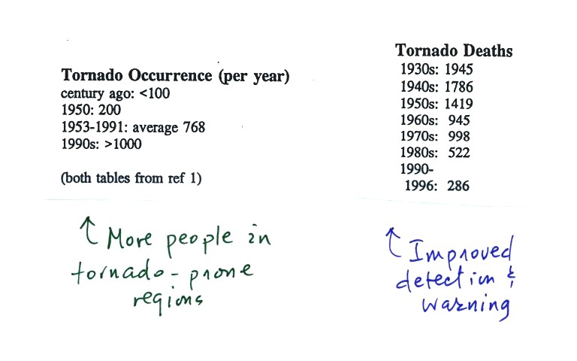

At the present time about 75 people are killed every year in the United States. Lightning and flash floods (floods are the most serious severe weather hazard) kill slightly more people. Hurricanes kill fewer people on average than tornadoes. Heat in the summer and cold in the winter kill many more people than floods, tornadoes, lightning, and hurricanes.
Most tornadoes last only a few minutes and leave a path a few miles long on the ground. There are of course exceptions. One is discussed below.
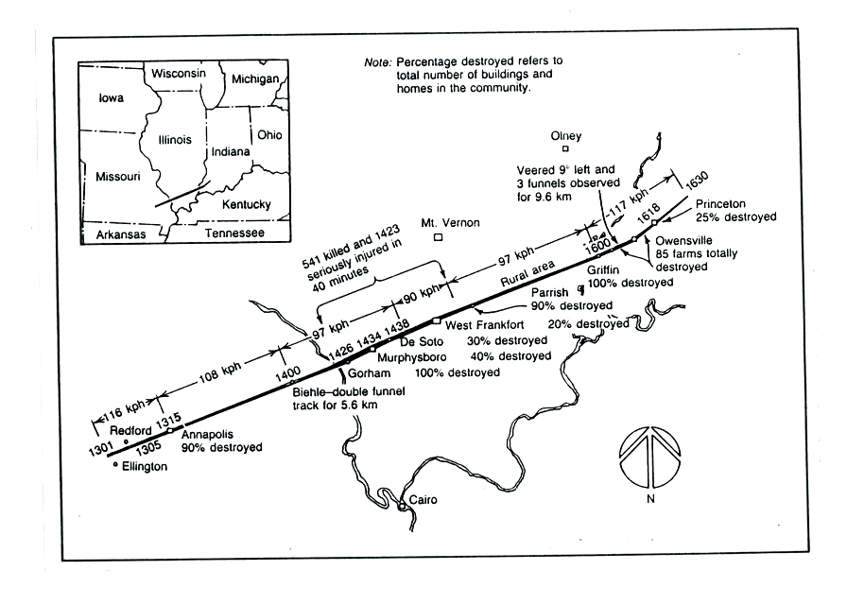
The path of the 1925 "Tri-State Tornado" is shown above. The tornado path (note the SW to NE orientation) was 219 miles long, the tornado last about 3.5 hours and killed 695 people. The tornado was traveling over 60 MPH over much of its path. It is the deadliest single tornado ever.
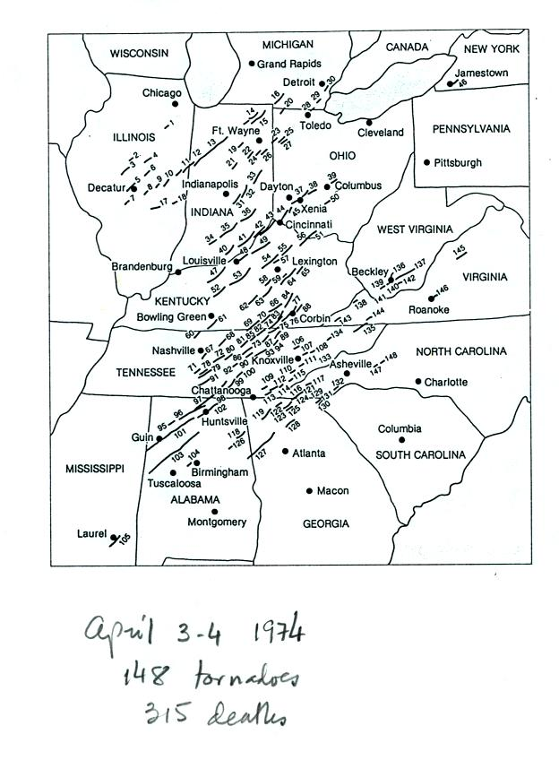 | 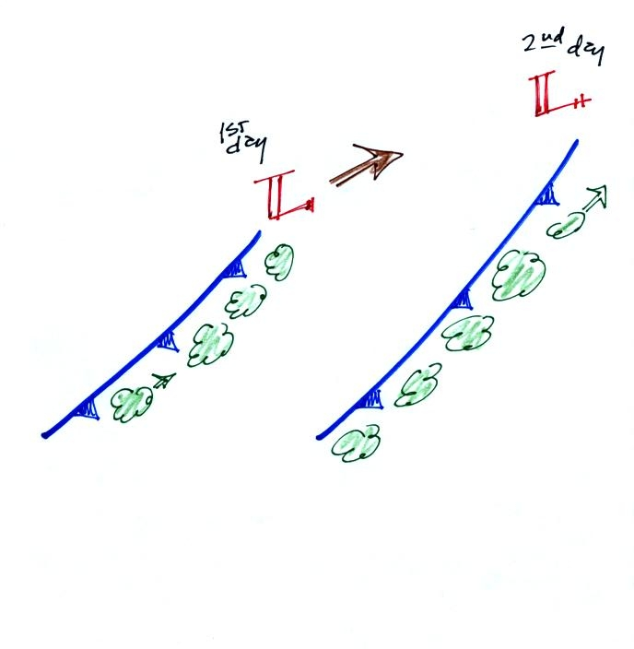
Tornadoes often occur in "outbreaks." The paths of 148 tornadoes during the April 3-4, 1974 "Jumbo Tornado Outbreak" are shown above. Note the first tornadoes were located in the upper left corner of the map. The tornadoes were produced by thunderstorms forming along a cold front. During this two day period the front moved from the NW part toward the SE part of the figure. Note that all the tornado paths have a SE toward NE orientation.

Before looking at another tornado video, here's an easy to remember version of the Fujita Scale used to rate tornado intensity. Because it is so hard to make measurements of tornado wind speeds, intensity estimates are usually based on an examination of the damage caused by the tornado.
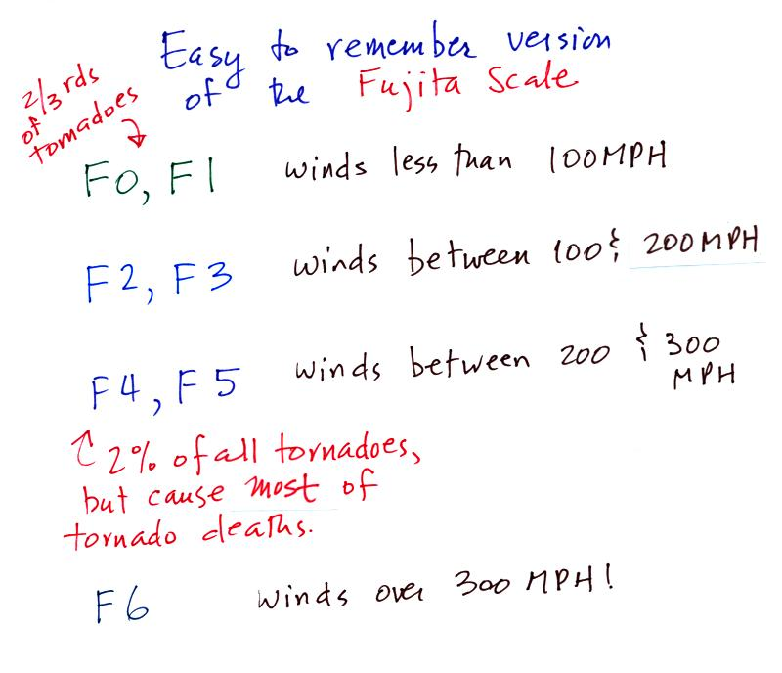
At this point another short video with images of several different tornadoes was shown. Descriptions of the tornadoes are given in the table below.
54a | F3 | Grand Island, NE | Mar. 13, 1990 | tornado cloud is pretty thick and vertical
61f | F3 | McConnell AFB KS | Apr. 26, 1991 | this is about as close to a tornado as you're ever likely to get. Try to judge the diameter of the tornado cloud. What direction are the tornado winds spinning?
52 | F5 | Hesston KS | Mar. 13, 1990 | Watch closely, you may see a tree or two uprooted by the tornado winds
51 | F3 | North Platte NE | Jun. 25, 1989 | Trees uprooted and buildings lifted by the tornado winds
65 | F1 | Brainard MN | Jul. 5, 1991 | It's a good thing this was only an F1 tornado
57 | F2 | Darlington IN | Jun. 1, 1990 | Tornado cloud without much dust
62b | F2 | Kansas Turnpike | Apr. 26, 1991 | It's sometimes hard to run away from a tornado. Watch closely you'll see a van blown off the road and rolled by the tornado. The driver of the van was killed!
47 | F2 | Minneapolis MN | Jul. 18, 1986 | Tornado cloud appears and disappears.

The figure below shows the steps in the formation, intensification, and weakening of a tornado. This is sometimes referred to as the tornado life cycle. Don't worry about learning the names of the various stages. The idea is for you to be able to recognize an unusually strong tornado if you ever see one in person or on video tape. You might also be able to tell from a tornadoes appearance whether it is near the beginning or end of its life cycle.
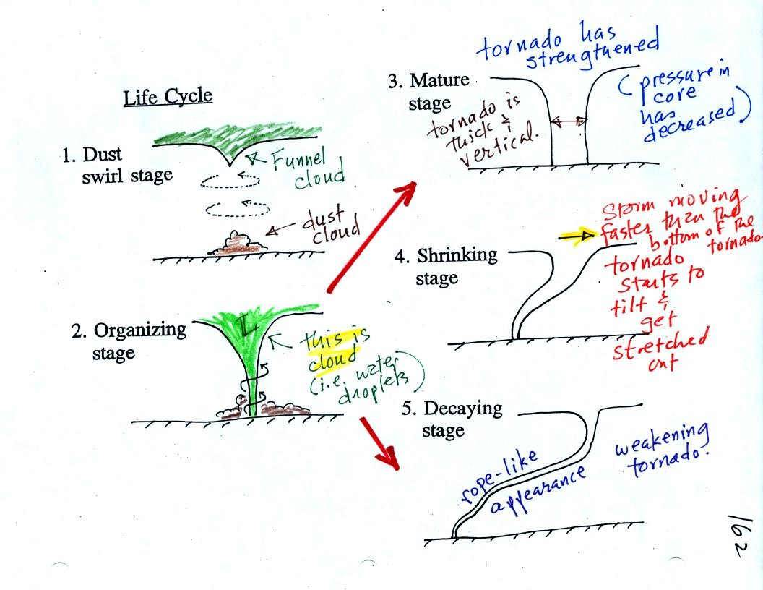
Tornadoes begin in and descend from a thunderstorm. You might see a funnel cloud dropping from the base of the thunderstorm. Spinning winds will probably be present between the cloud and ground before the tornado cloud becomes visible. The spinning winds can stir up dust at ground level. The spinning winds might also be strong enough at this point to produce some minor damage.
In Stage 2, moist air moves horizontally toward the low pressure in the core of the tornado. This sideways moving air will expand and cool just as rising air does (see figure below). Once the air cools enough (to the dew point temperature) a cloud will form.
Tornadoes can go from Stage 2 to Stage 3 (this is what the strongest tornadoes do) or directly from stage 2 to stage 5. Note a strong tornado is usually vertical and thick as shown in Stage 3. "Wedge tornadoes" actually appear wider than they are tall.
The thunderstorm and the top of the tornado will move faster than the surface winds and the bottom of the tornado. This will tilt and stretch the tornado. The rope like appearance in Stage 5 is usually a sign of a weakening tornado.
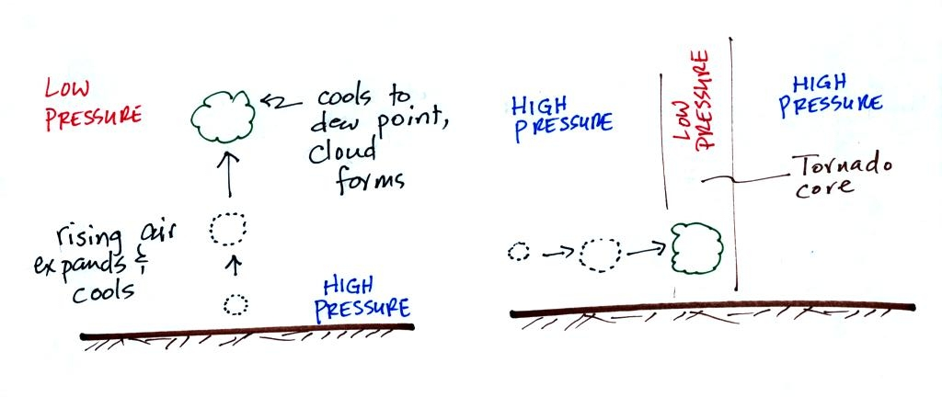
The tornado cloud forms when moist air moves into lower pressure in the core of the tornado. The air expands and cools to the dew point and a cloud forms. This is just like the cloud that forms when air rises.
At this point we watched another couple of video tapes. The first illustrated well the first 3 steps in the formation of a tornado (dust swirl stage up to mature stage). The tornado was photographed near Luverne Oklahoma in May 1991. It was eventually rated an F3 tornado.
The 2nd tape showed a tornado that occurred in Pampa, Texas. Near the end of the segment, video photography showed several vehicles (pick up trucks and a van) that had been lifted 100 feet or so off the ground that were being thrown around at 80 or 90 MPH by the tornado winds. Winds speeds of about 250 MPH were estimated from the video photography.

