Tuesday Nov. 18, 2008
There was time for two songs, "Don't Say a Word" and "You can Never Leave," from Crooked Fingers, a group I just discovered.
The Experiment #4 reports have been graded and were returned in class. Revised reports are due by Tue., Dec. 2, though if you could get them to me before Thanksgiving I would be grateful. Please return your original report with your revised report.
Last week's in-class Optional Assignment was returned today together with the Surface Weather Map worksheet from 1S1P Assignment #2.
Quiz #4 Study Guide Pt. 1 is now available online.

The "Toilet Experiment"/Optional Assignment is in full swing. I've had responses from about 10% of the class at this point. I received several emails like this over the weekend:

But only one of the following, from a student that might well be preparing a PhD dissertation on the topic:
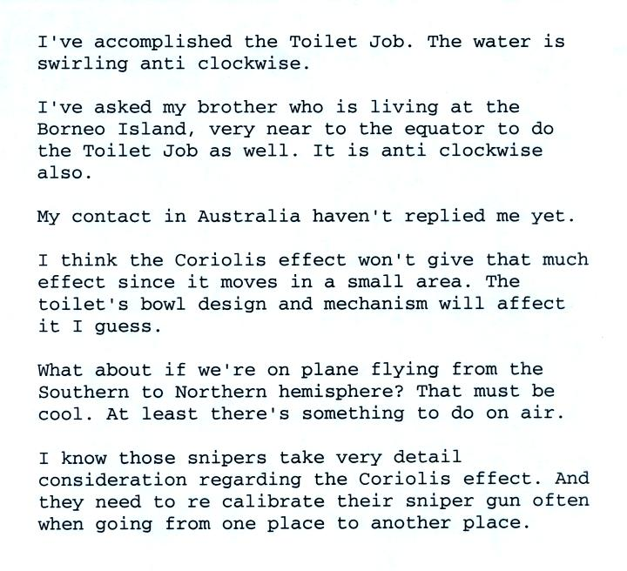

The winds that spin around large high and low pressure centers change directions in the northern and southern hemispheres because of the Coriolis force. We learned rules for the direction and strength of the Coriolis force last week, but didn't really learn anything about what causes it. We spent a little time in class today doing that. Most of what follows can be found on p. 122c in the photocopied ClassNotes.
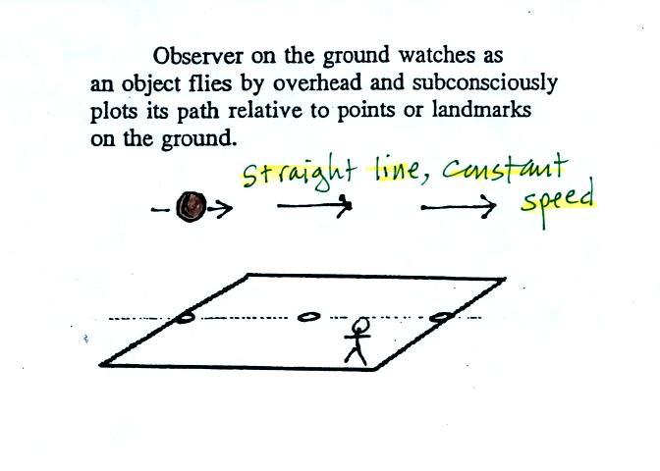

Imagine something flies over Tucson. It travels straight from west to east at constant speed. The next figure shows the path that the object followed as it passed over the city. More or less subconciously you would plot its path relative to reference points on the ground.
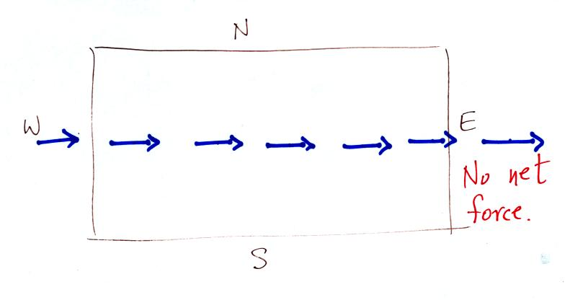
It would appear to be moving in a straight line at constant speed. You would conclude there was zero net force acting on the moving object (Newton's first law of motion).
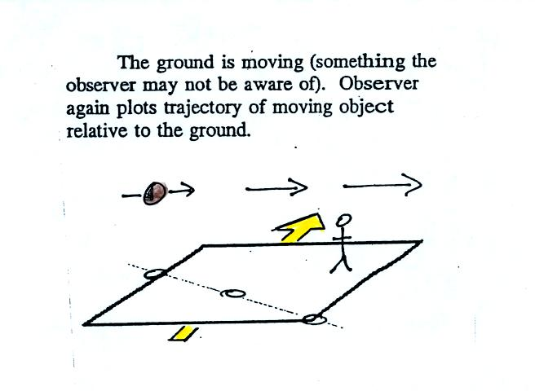
In this second picture the object flies by overhead just as it did in the previous picture. In this picture, however, the ground is moving (don't worry about what might be causing the ground to move).
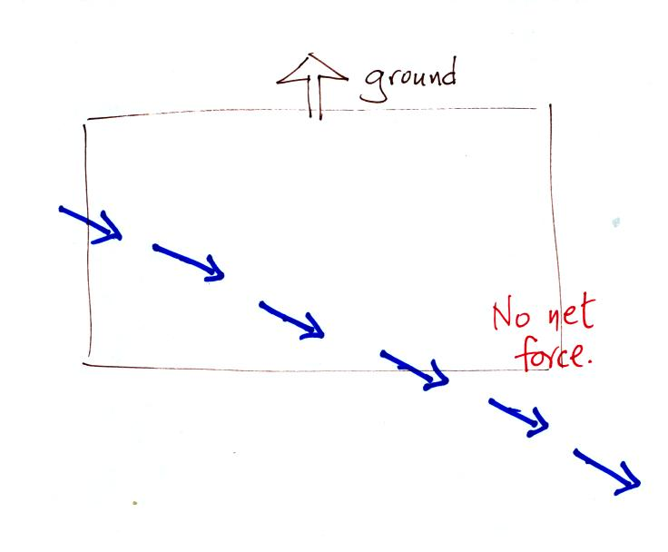
This is the path that you would see relative to the ground in this case. Even though the object flew from west to east it appears to have been traveling from the NW toward the SE because the ground was moving as the object passed overhead. Because the motion is still in a straight line at constant speed, you would conclude the net force acting on the object was zero.
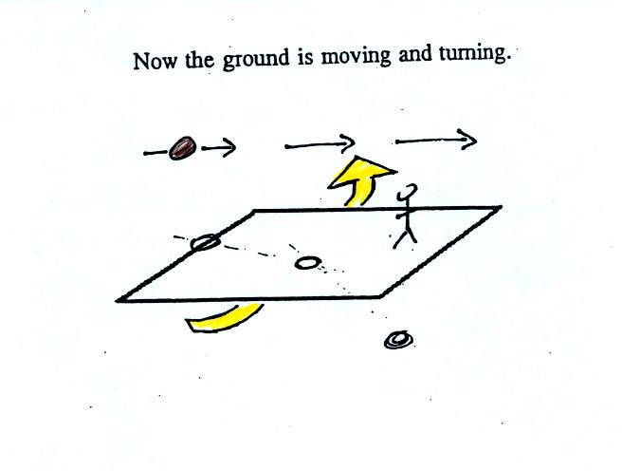
In this last figure the object flies by again from west to east. In this case however the ground is rotating.

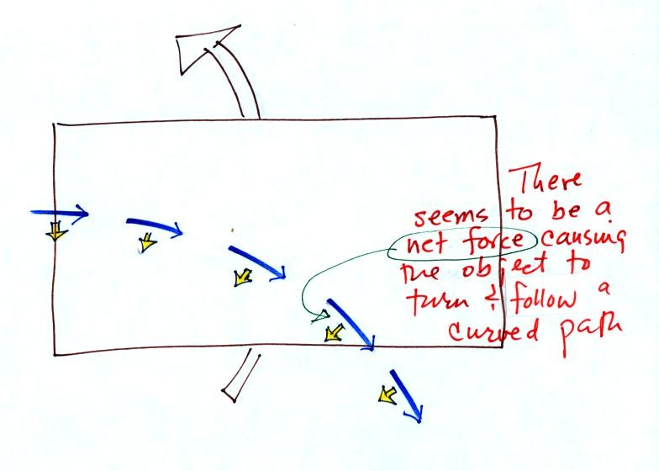

In this case, judging from the path the moving object appeared to follow relative to the ground we do conclude a net force was present.
At most locations on the earth the ground IS rotating (we're just not aware of it). This is most easily seen at the poles.
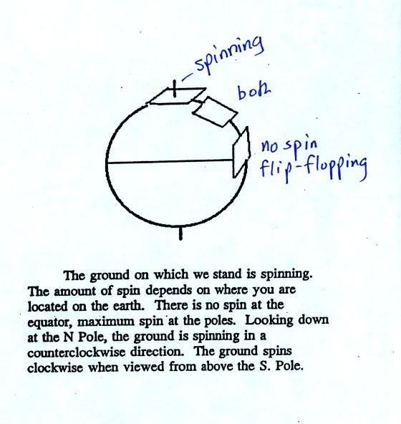
Imagine a piece of paper glued to the top of a globe. As the globe spins the piece of paper will rotate. A piece of paper glued to the globe at the equator won't spin, it will flip over. At points in between the paper would spin and flip, the motion gets complicated.
The easiest thing for us to do is to ignore the fact that the ground on which we are standing is rotating. However, if we do that we need to account for the curved paths that moving objects will take when they move relative to the earth's surface. That is what the Coriolis force does.

You might already have heard that water spins in a different direction when it drains from a sink or a toilet bowl in the southern hemisphere than it does in the northern hemisphere. You might also have heard that this is due to the Coriolis force or the Coriolis effect.
The Coriolis force does cause winds to spin in opposite directions around high and low pressure centers in the northern and southern hemisphere. The PGF starts the air moving (in toward low, out and away from high pressure) then the Coriolis force bends the wind to the right (N. hemisphere) or to the left (S. hemisphere).
Here's what you end up with in the case of low pressure:
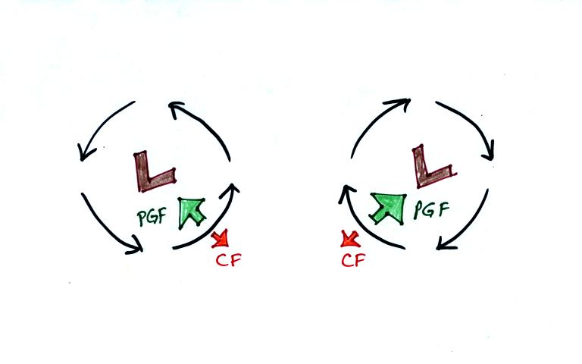
Wind motions around an upper level low. The example at left would be found in the northern (the CF is pointing to the right of the wind)? The PGF is stronger than the CF. This results in a new inward force, something that is needed for wind to blow in a circular path.
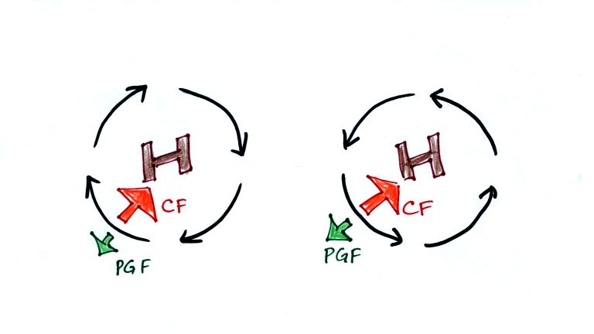
Winds also spin around high pressure. The CF is absolutely essential in this case. The CF is stronger than the PGF and the CF points inward. The CF is what provides the needed inward force needed to keep the winds blowing in a circular path.
There are situations where the PGF is much stronger than the CF; the CF can be ignored.

Winds can still spin around LOW. The PGF supplies the necessary net inward force. This is the case with tornadoes, for example. Tornado winds spin around a core of very low pressure.
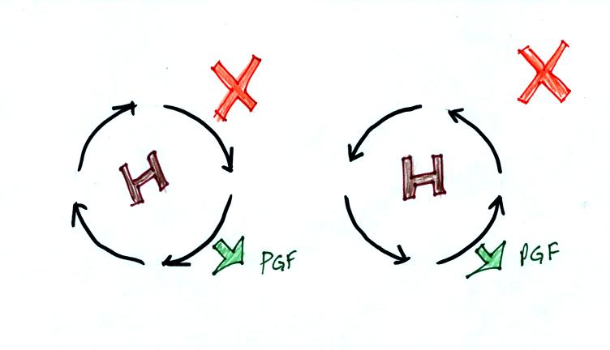
Winds can't blow around high pressure without the CF. The PGF points outward with high pressure. Without the CF, there isn't any inward force. Without an inward force the winds can't blow in a circular path.
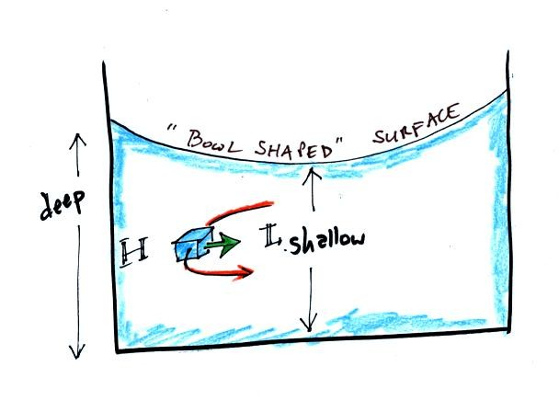
When water spins and drains from a sink or a toilet, the water is a little deeper on the outside than on the inside. This creates an inward pointing pressure difference force. There needs to be an inward force in order for the water to spin. Water can spin clockwise or counterclockwise when draining from a sink in the northern hemisphere. It can spin in either direction in the southern hemisphere also.
Now we watched a short video segment that seemed to show otherwise. Don't believe everything you see on video. The gentleman in the video was just very good at getting the draining water to spin one direction or another as he moved on opposite sides of the equator. Probably the most difficult part would be to get the water to drain without spinning, which is what he was able to do when standing right on the equator.

Between now and the next quiz we will try to cover Thunderstorms, Tornadoes, Lightning, and Hurricanes. You'll find a pretty good discussion of this material in Chapters 11 and 12 in the textbook. That's quite a bit of reading, so I would recommend that you initially skim through the textbook. Look at the illustrations and concentrate on sections that cover the same material that we go over in class.
We'll start today with thunderstorms. Here is a brief introduction.
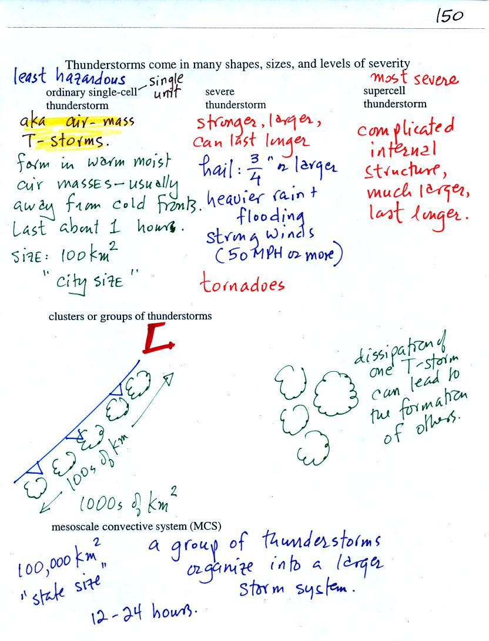
Thunderstorms come in different sizes and levels of severity. We will mostly be concerned with ordinary single-cell thunderstorms (also referred to as air mass thunderstorms). Most summer thunderstorms in Tucson are this type. At the other end of the spectrum are supercell thunderstorms. We'll watch a short video next week that shows a computer simulation of the complex air motions inside a supercell thunderstorm.
The following somewhat tedious material was intended to prepare you to better appreciate a time lapse video movie of a thunderstorm developing over the Catalina mountains. I don't expect you to remember all of the details given below. The figures below are more carefully drawn versions of what was done in class.
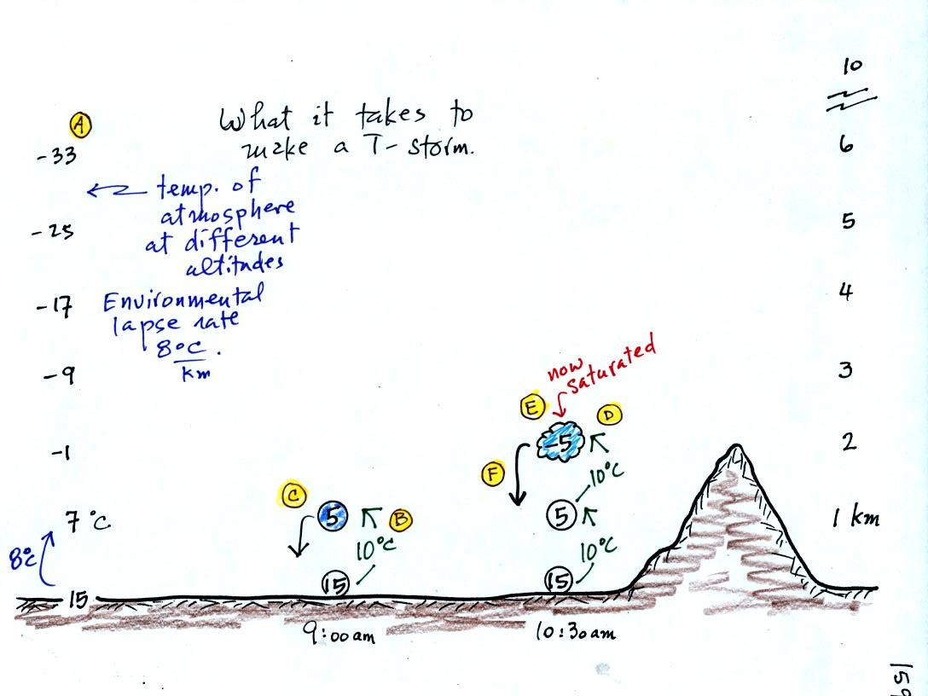
Refer back and forth between the lettered points in the figure above and the commentary below.
The numbers in Column A show the temperature of the air in the atmosphere at various altitudes above the ground (note the altitude scale on the right edge of the figure). On this particular day the air temperature was decreasing at a rate of 8 C per kilometer. This rate of decrease is referred to as the environmental lapse rate. Temperature could decrease more quickly than shown here or less rapidly. Temperature in the atmosphere can even increase with increasing altitude (a temperature inversion).
At Point B, some of the surface air is put into an imaginary container, a parcel. Then a meterological process of some kind lifts the air to 1 km altitude (in Arizona in the summer, sunlight heats the ground and air in contact with the ground, the warm air becomes bouyant). The rising air will expand and cool as it is rising. Unsaturated (RH<100%) air cools at a rate of 10 C per kilometer. So the 15 C surface air will have a temperature of 5 C once it arrives at 1 km altitude.
At Point C note that the air inside the parcel is slightly colder than the air outside (5 C inside versus 7 C outside). The air inside the parcel will be denser than the air outside and, if released, the parcel will sink back to the ground.
By 10:30 am the parcel is being lifted to 2 km as shown at Point D. It is still cooling 10 C for every kilometer of altitude gain. At 2 km, at Point E the air has cooled to its dew point temperature and a cloud has formed. Notice at Point F, the air in the parcel or in the cloud (-5 C) is still colder and denser than the surrounding air (-1 C), so the air will sink back to the ground and the cloud will disappear. Still no thunderstorm at this point.
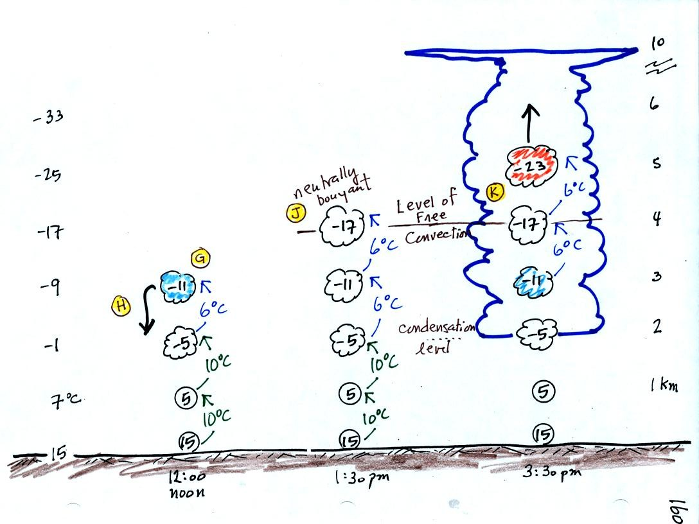
At noon, the air is lifted to 3 km. Because the air became saturated at 2 km, it will cool at a different rate between 2 and 3 km altitude. It cools at a rate of 6 C/km instead of 10 C/km. The saturated air cools more slowly because release of latent heat during condensation offsets some of the cooling due to expansion. The air that arrives at 3km, Point H, is again still colder than the surrounding air and will sink back down to the surface.
By 1:30 pm the air is getting high enough that it becomes neutrally bouyant, it has the same temperature and density as the air around it (-17 C inside and -17 C outside). This is called the level of free convection, Point J in the figure.
If you can, somehow or another, lift air above the level of free convection it will find itself warmer and less dense than the surrounding air as shown at Point K and will float upward to the top of the troposphere on its own. This is really the beginning of a thunderstorm. The thunderstorm will grow upward until it reaches very stable air at the bottom of the stratosphere.

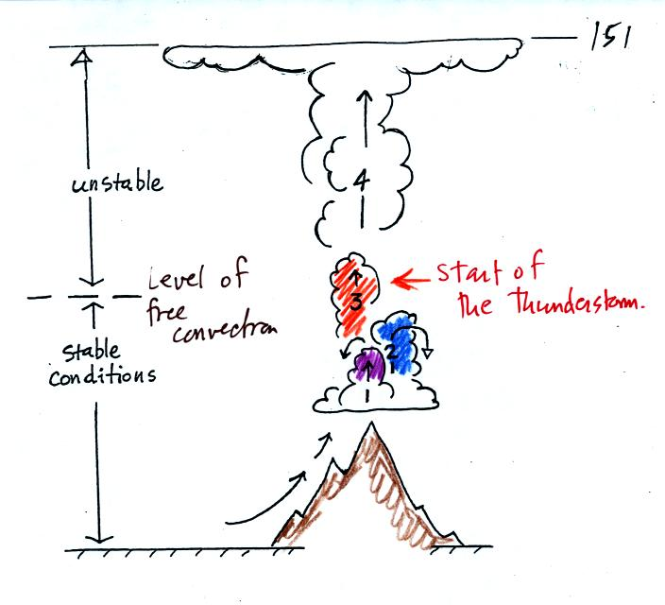
The top portion of this figure summarizes what we just covered: it takes some effort and often a good part of the day before a thunderstorm forms. The air must be lifted to just above the level of free convection. Once air is lifted above the level of free convection it finds itself warmer and less dense that the air around it and floats upward on its own. The is the moment at which the air mass thunderstorm begins.
The thunderstorm then goes through 3 stages.
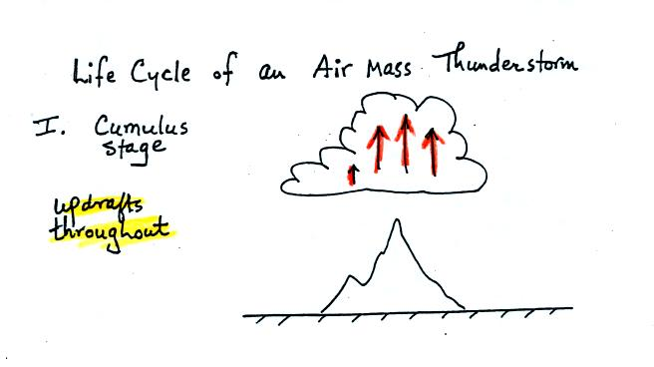
In the first stage you would only find updrafts inside the cloud.

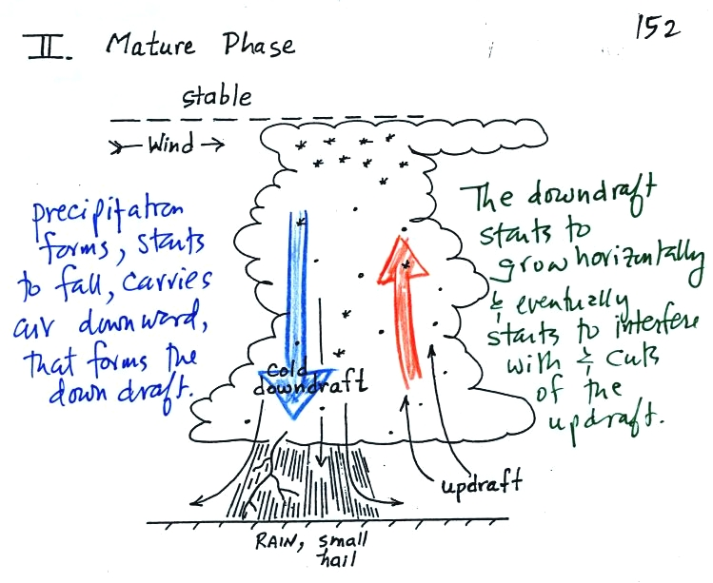
Once precipitation has formed and grown to a certain size, it will begin to fall and drag air downward with it. This is the beginning of the mature stage where you find both an updraft and a downdraft inside the cloud. The falling precipitation will also pull in dry air from outside the thunderstorm (this is called entrainment). Precipitation will mix with this drier air and evaporate. The evaporation will strengthen the downdraft (the evaporation cools the air and makes it more dense). The thunderstorm is strongest in the mature stage. This is when the heaviest rain, strongest winds, and most of the lightning occur.
Eventually the downdraft spreads horizontally throughout the inside of the cloud and interferes with or cuts off the updraft. This marks the beginning of the end for this thunderstorm.
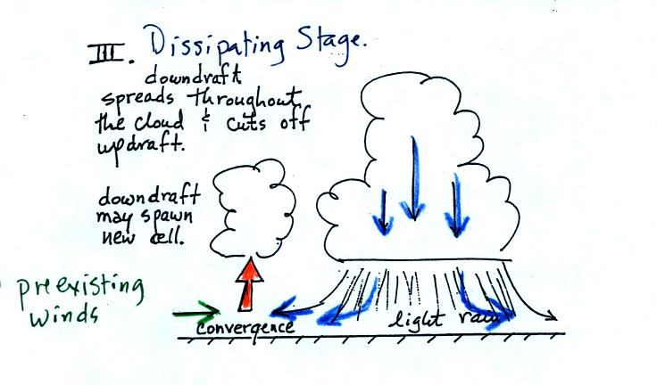
In the dissipating stage you would only find weak downodrafts throughout the interior of the cloud.
Note how the winds from one thunderstorm can cause a region of convergence on one side of the original storm and can lead to the development of new storms. Preexisting winds refers to winds that were blowing before the thunderstorm formed.

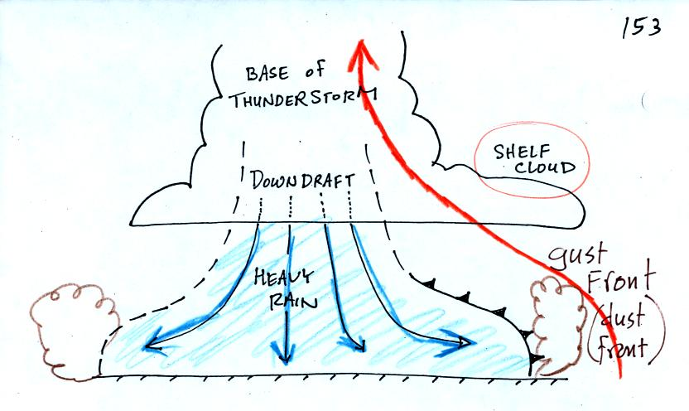
The cold downdraft air spilling out of a thunderstorm hits the ground and begins to move outward from underneather the thunderstorm. The leading edge of this outward moving air is called a gust front. You can think of it as a dust front because the gust front winds often stir up a lot of dust here in the desert southwest.
Warm moist air lifted by the gust front can form a shelf cloud.
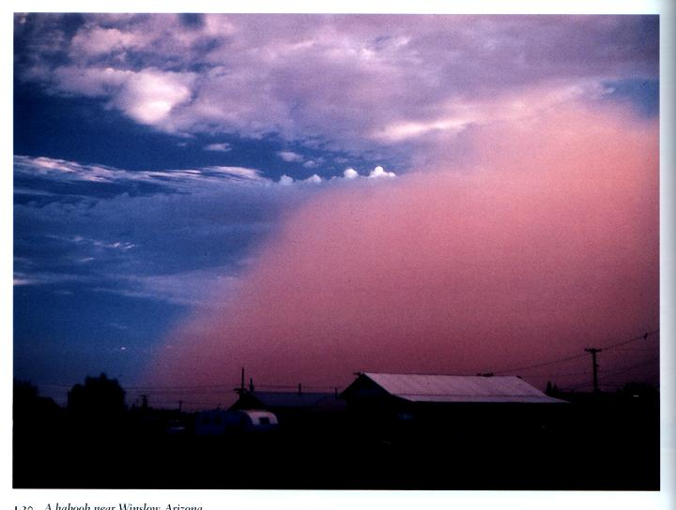
This is a picture of a dust cloud stirred up by thunderstorm gust front winds (taken near Winslow, Az). The gust front is moving from the right to the left. Visibility in the dust cloud can drop to near zero which makes this a serious hazard to automobile traffic. Dust storms like this are sometimes called haboobs.
The following picture shows a shelf cloud.
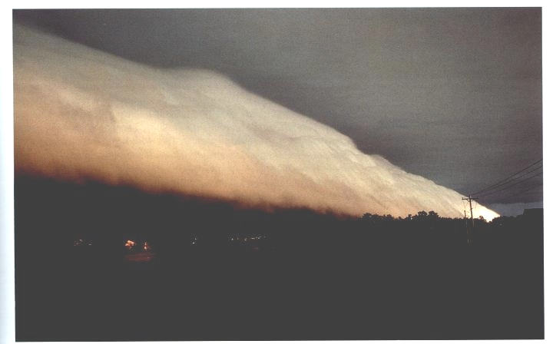
The gust front is moving from left to right in this picture. The shelf cloud is very close to the ground, so the warm air that was lifted by the gust front must have been very moist. It didn't have to rise and cool much before it became saturated and a cloud formed. This actually appears to be the same picture as Fig. 11-15 in the textbook.

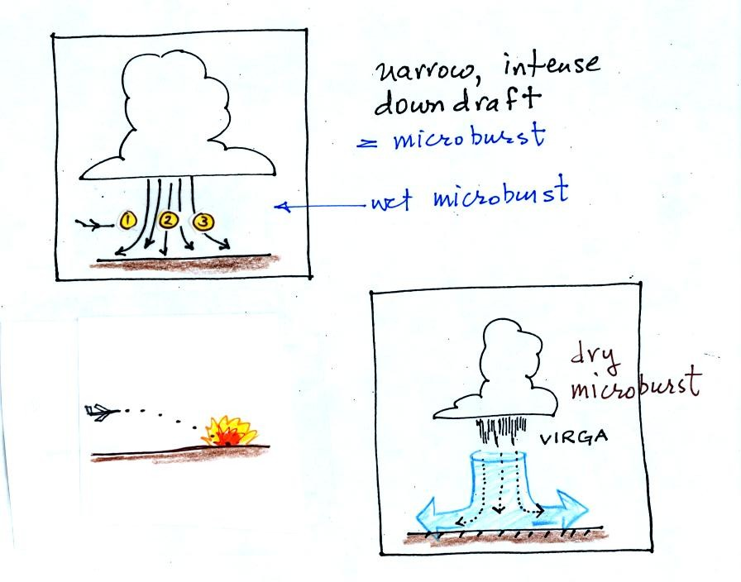
A narrow intense downdraft is called a microburst. At the ground microburst winds will sometimes reach 100 MPH (over a limited area); most tornadoes have winds of 100 MPH or less. Microburst winds can damage homes (especially mobile homes that aren't tied to the ground), uproot trees, and seem to blow over a line of electric power poles at some point every summer in Tucson.
Microbursts are a serious threat to aircraft especially when they are close to the ground during landing or takeoff (see Fig. 11-20 in the text). An inattentive pilot encountering headwinds at Point 1 could cut back on the power. Very quickly the plane would lose the headwinds (Point 2) and then encounter tailwinds (Point 3). The plane might lose altitude so quickly that it would crash into the ground before corrective action could be taken.
Falling rain could warn of a (wet) microburst. In other cases, dangerous dry microburst winds might be invisible (the virga, evaporating rain, will cool the air, make the air more dense, and strengthen the downdraft winds).
A simple demonstration can give you an idea of what a microburst might look like. A large plastic tank was filled with water, the water represents air in the atmosphere. Then a colored mixture of water and glycerin, which is a little denser than water, is poured into the tank. This represents the cold dense air in a thunderstorm downdraft. The colored liquid sinks to the bottom of the tank and then spreads out horizontally. In the atmosphere the cold downdraft air hits the ground and spreads out horizontally. These are the strong winds that can reach 100 MPH.

