Thursday Nov. 13, 2008
Today's song was Goodbye Earl performed by The Dixie Chicks live at the Kodak Theater.
Quiz #3 was returned in class today. There were 155 pts possible on the quiz, the average grade was -43 (72%). Please check your quiz carefully for grading errors.
The Experiment #3 reports have been graded and were returned in class today. You now have just under two weeks to revise your report. Revised reports are due on or before Tuesday Nov. 25. Please return your original report with your revised report.
The Experiment #4 reports were due today also, I believe. If you haven't finished your report please turn it in as soon as you can. Some people were also given extended due dates.
1S1P Assignment #3 is now online. You can write 0, 1, or 2 reports. If you plan to do two reports, at least one of them is due by Tue., Nov. 25. Because this is rather short notice, you can turn in one report on Tue., Dec. 2.
There was an In-class Optional Assignment today. If you complete the assignment and turn it in at the beginning of class next Tuesday you will earn partial (perhaps full) credit.

Today we will be learning about why upper level and surface winds blow the way they do.
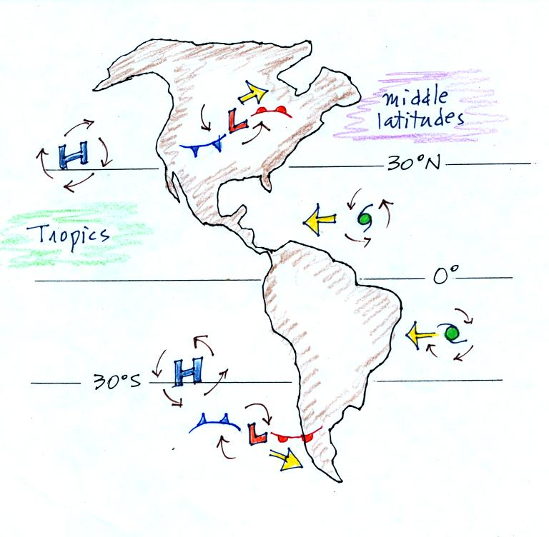
Why, for example, do winds blow counterclockwise around low pressure in the northern hemisphere but clockwise around high pressure? Why do the wind directions change in the southern hemisphere?
Most of what follows was on handouts that were distributed in class.
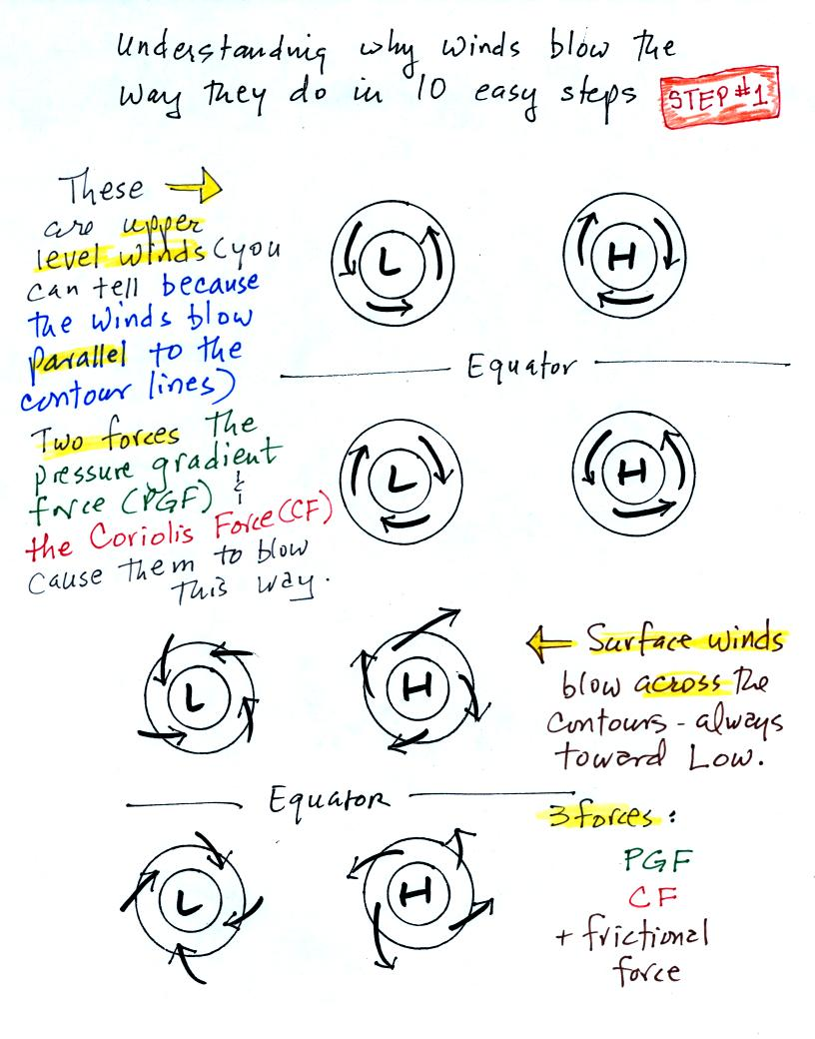
Upper level winds spinning around high and low pressure in the northern and southern hemispheres are shown in the first set of four pictures. The first thing to notice is that upper level winds blow parallel to the contours. We will see that 2 forces, the pressure gradient force (PGF) and the Coriolis force (CF), cause the winds to blow this way. Eventually you will be able to draw the directions of the forces for each of the four upper level winds examples. Here is an example of what you will be able to do. Note I am saying will, with a little effort and thought, be able to do and not should be able to do.
The four drawings at the bottom of the page show surface winds blowing around high and low pressure in the southern hemisphere. These winds blow across the contour lines slightly, always toward low pressure. The frictional force is what causes this to occur. He is an example of what you will be able to say about surface winds blowing around low pressure in the southern hemisphere.
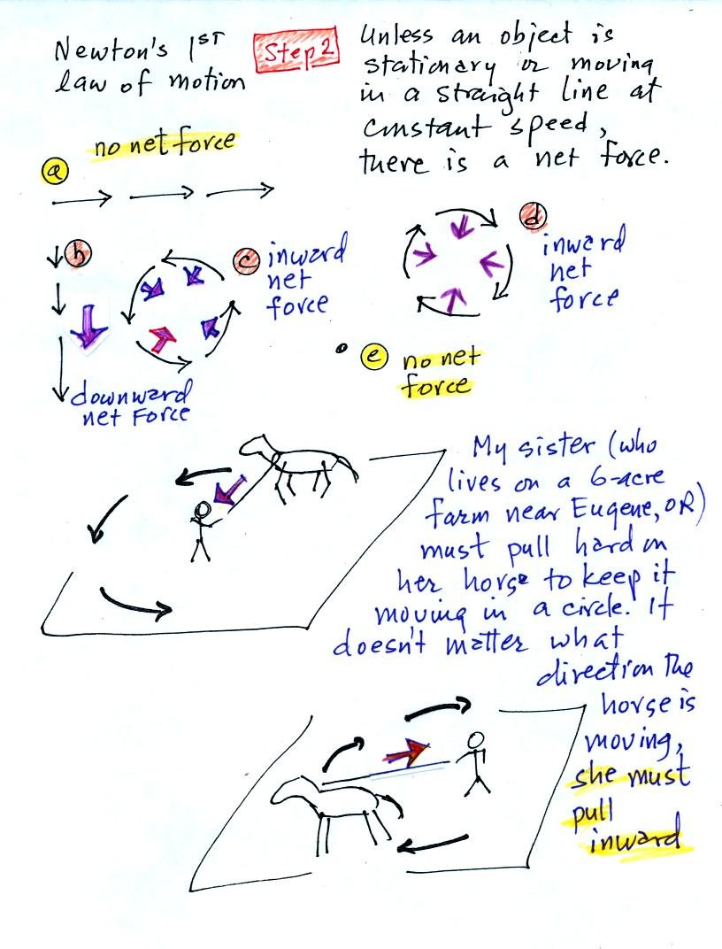
The main point to take from Step #2 is that a net inward force is needed anytime an object is moving in a circular path. It doesn't matter what direction the object is moving. The net force is inward anytime something moves in a circular path.
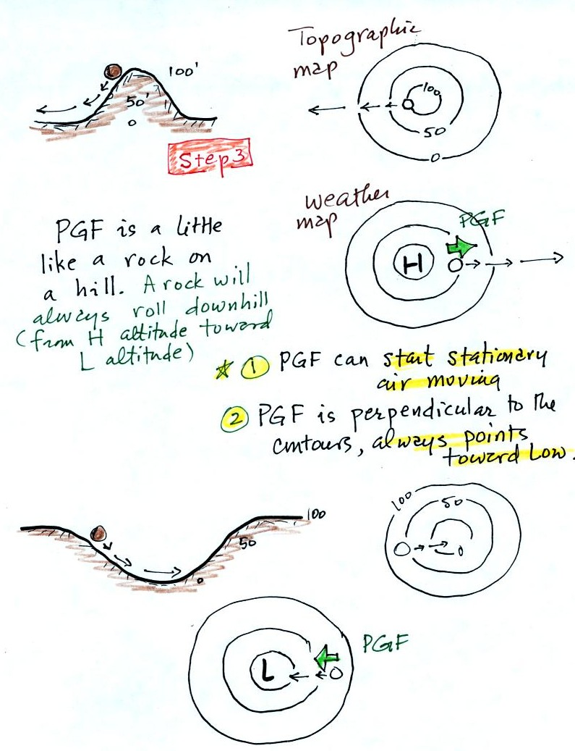
The pressure gradient force always points toward low pressure. The PGF will cause stationary air to begin to move (it will always move toward low pressure).
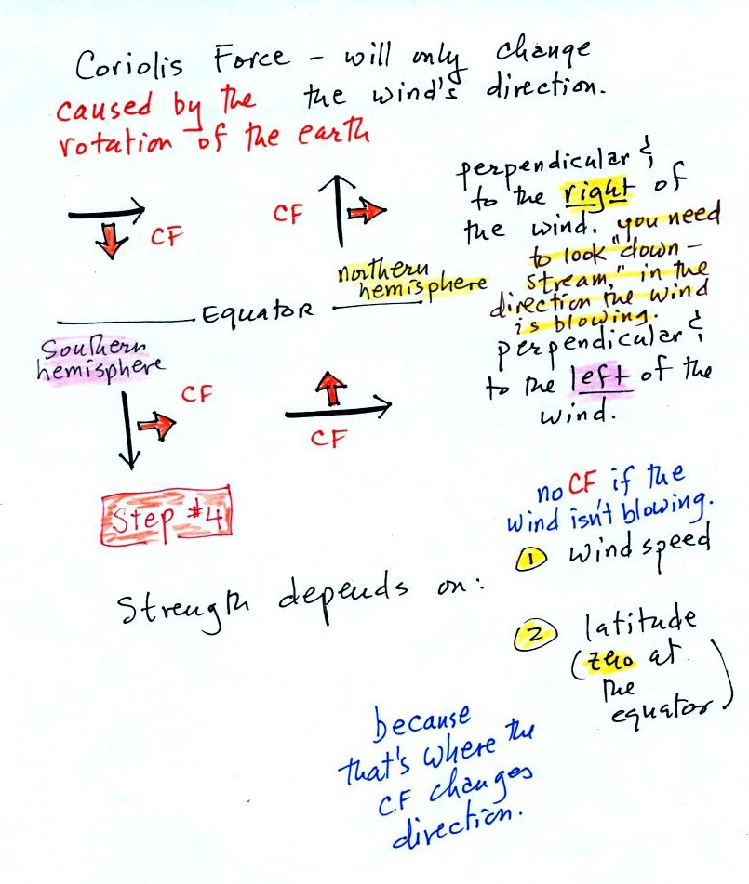
The Coriolis force is caused by the rotation of the earth and points perpendicular to the wind. It can only change the wind's direction, it can't cause the wind to speed up or slow down. The direction of the CF depends on whether you're in the northern or southern hemisphere. There will be a little more explanation of what causes the Coriolis force in class on Monday.
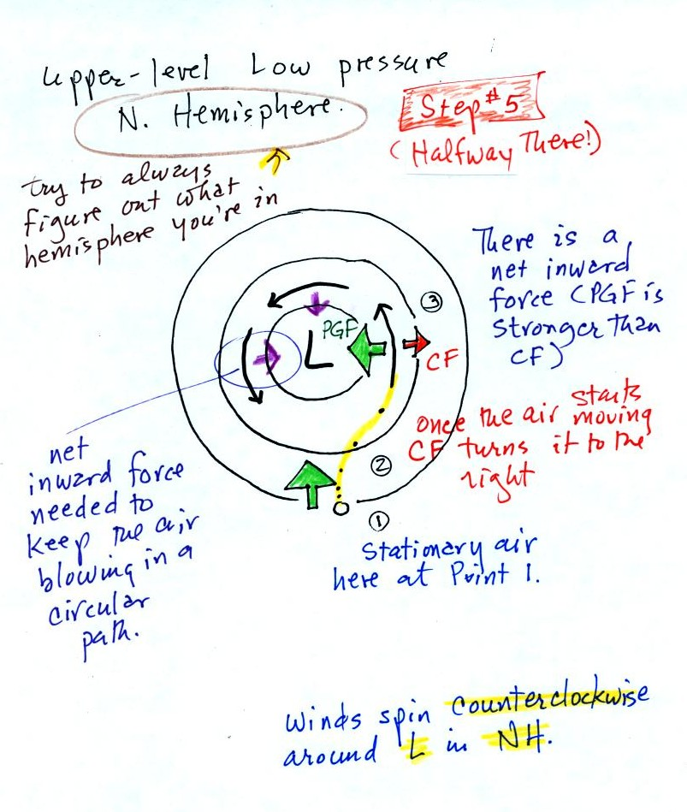
Now we start to put everything together. The PGF at Point 1 starts stationary air moving toward the center of low pressure (just like a rock would start to roll downhill). Once the air starts to move, the CF causes it to turn to the right (because this is a northern hemisphere chart). The wind eventually ends up blowing parallel to the contour lines and spin in a counterclockwise direction. Note that the inward PGF is stronger than the outward CF. This results in a net inward force, something that is needed anytime wind blows in a circular path.

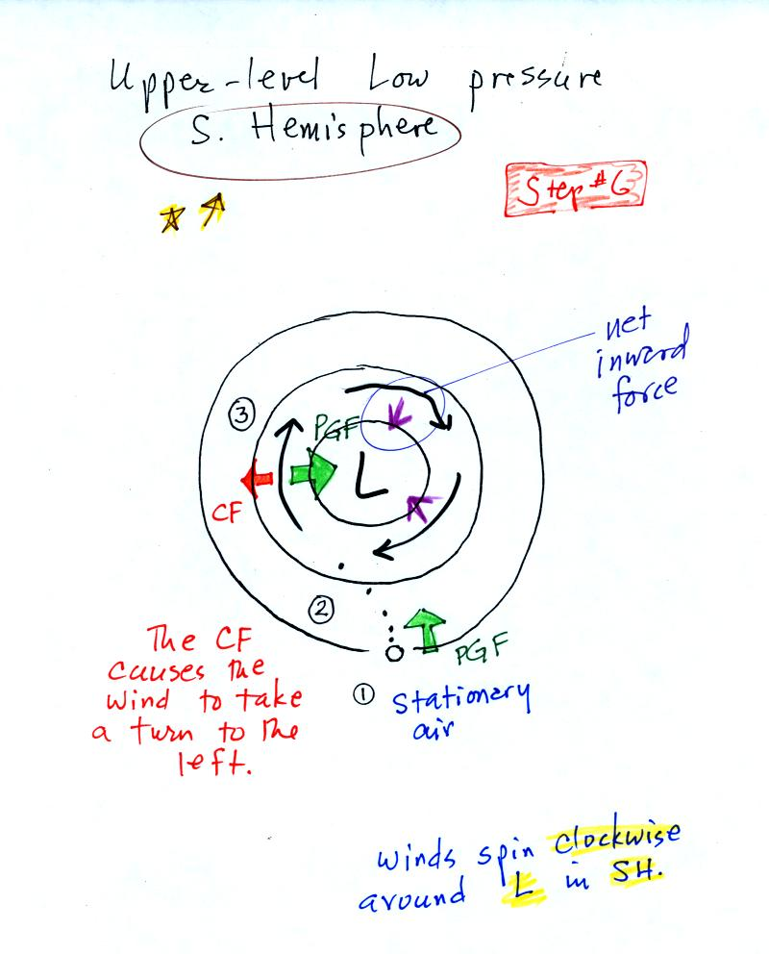.

The PGF starts the stationary air at Point 1 moving toward the center of the picture. The CF then causes the wind to turn to the left. The wind ends up blowing in a clockwise direction. This is the opposite of what happens in the northern hemisphere. Note the net force is again inward.
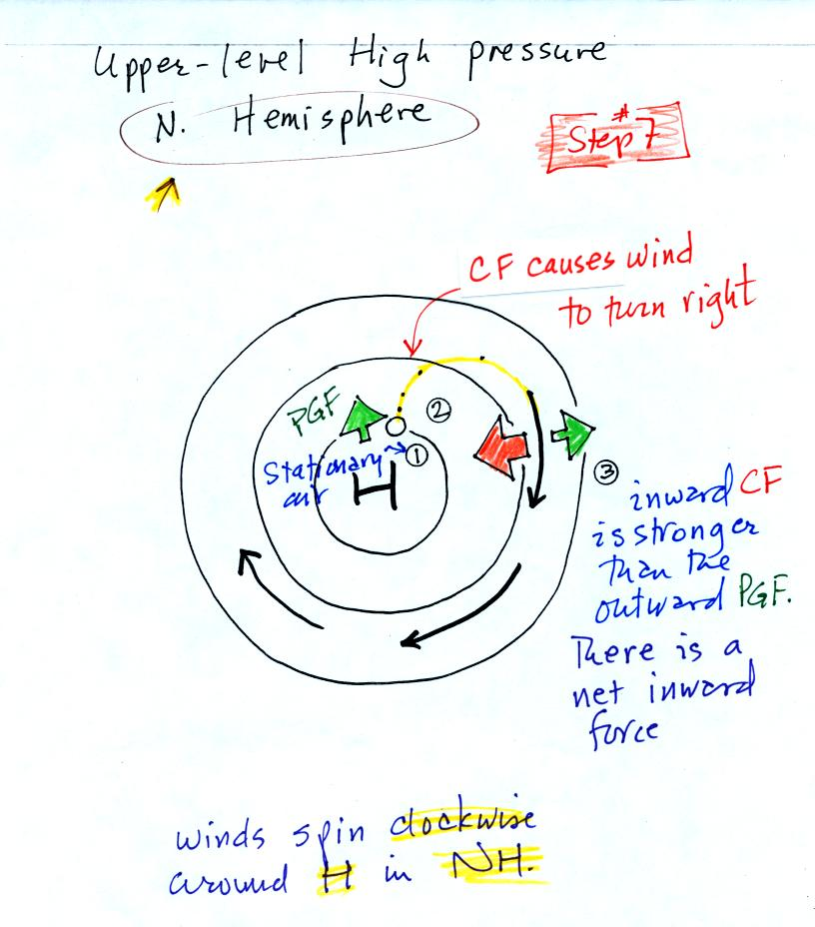
With high pressure the air starts moving outward. In this example the wind takes a right turn and ends up blowing in a clockwise direction around the high. Note there is a net inward force here just as there was with the two previous examples involving low pressure.
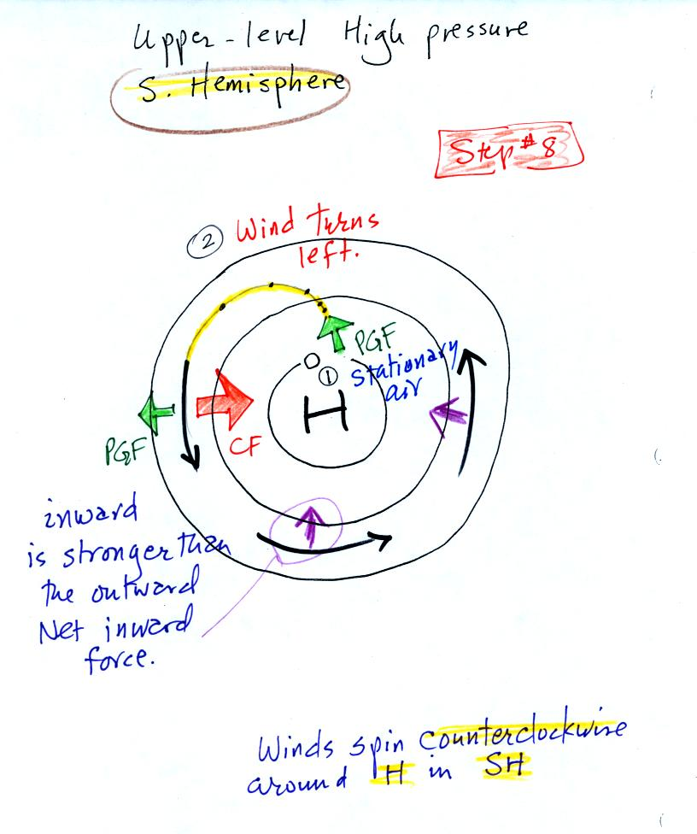
The PGF starts the stationary air moving outward. The CF causes the wind to turn left and the wind ends up blowing in a counterclockwise direction. The net force points inward

Steps 9 and 10 below cover surface winds.

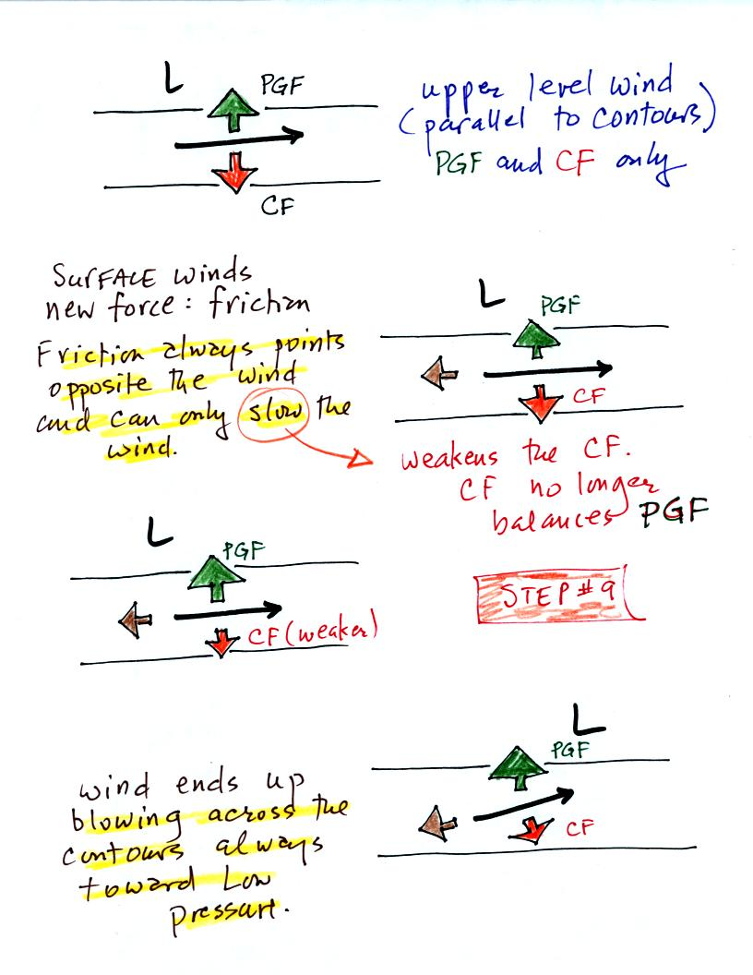
The top figure shows upper level winds blowing parallel to straight contours. The PGF and CF point in opposite directions and have the same strength. The net force is zero. The winds would blow in a straight line at constant speed.
We add friction in the second picture. It points in a direction opposite the wind and can only slow the wind down. The strength of the frictional force depends on wind speed (no frictional force if the wind is calm) and the surface the wind is blowing over (less friction over the ocean than over the land).
Slowing the wind weakens the CF and it can no longer balance the PGF. The stronger PGF causes the wind to turn and blow across the contours toward Low.
Eventually the CF and Frictional force, working together, can balance out the PGF.
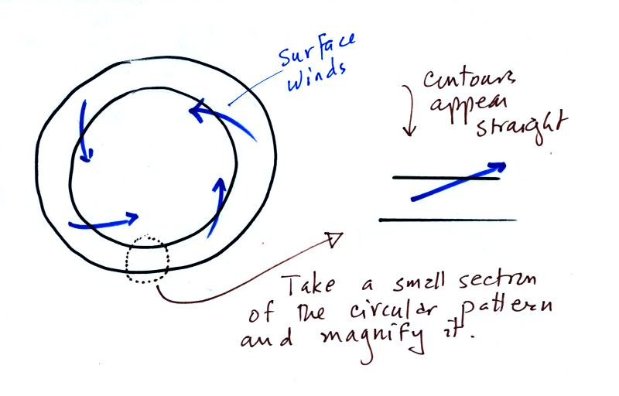
Now the transition from the straight contours above to the circular contours below might be a little abrupt. But if you zero in on a very small part of a larger circular pattern the contours look straight. The important thing to remember is that surface winds will always blow across the contours toward low. The figure above wasn't shown in class.
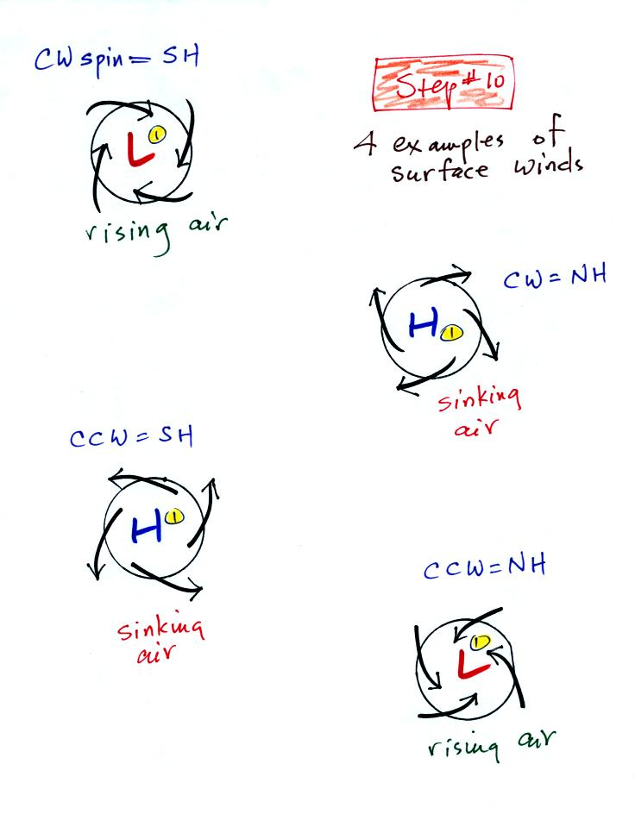
The winds are spiralling inward in the top and bottom examples. These must be surface centers of low pressure. The middle two examples are high pressure. The winds spin in the same directions around surface highs and lows as they do around upper levell highs and lows.
Converging winds cause air to rise. Rising air expands and cools and can cause clouds to form (I'll bet you're getting sick of hearing that). Diverging winds created sinking wind motions and result in clear skies.

Extra credit opportunity
You may have heard stories about how water spins in the opposite direction as it drains from a sink or a toilet in the southern hemisphere compared to the northern hemisphere. Well it's not true. We'll look at this briefly in class next Tuesday. Here is something you can do, between now and then, to earn 0.1 pts of extra credit. Flush the toilet in your house, dorm, appartment, or whatever and watch to see if the water spins clockwise or counterclockwise. Send the result to me by email or write it down on a piece of paper and turn it in next Tuesday.

