Tuesday Nov. 4, 2008
Music today was "J'ai ete au Zydeco," a selection from the Best of Beausoleil CD.
All three parts of the Quiz #3 Study Guide are now online (here, here, and here). Times and locations of the reviews are on Pt. 3 of the study guide.
The Experiment #3 reports were collected in class today together with the 1S1P Assignment #2 reports. The Experiment #2 revised reports are due in class on Thursday.
The Optional Assignment on humidity was returned in class today. Answers to the humidity assignment questions are online. "Green Cards" were also distributed to students who turned in anwers to the questions asked in class last Thursday. Answers to the Green Card questions are also online.

Class today began with a greeting (and a short story)

NATS 101 World refers to the time you spend in class two days a week. Hopefully your visit to NATS 101 World isn't an unpleasant experience.
There's a funny thing that seems to happen once or twice a semester. NATS 101 World and the Real World intersect or overlap briefly. Once or twice a semester, you'll be out in the Real World and something will grab you and pull you back into NATS 101 world.
This happened to the course instructor over the weekend. He was in his kitchen reading the Sunday newspaper when he saw the following article:
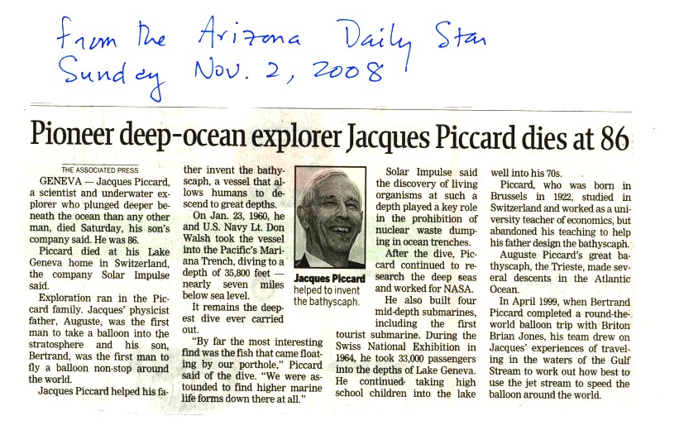
You may remembered a short video about Auguste Piccard earlier in the semester. He was part of the two man team that first traveled into the stratosphere by balloon Jacques was Auguste's son. We watched a brief video segment, at the end of class today, showing Auguste and Jacques travelling to a depth of 10,000 feet in the ocean. It was a trial run of their bathyscaph. Later Jacques and US Navy Lt. Don Walsh would descend to the deepest point in the ocean (35,800 feet). Jacques' son Bertrand was part of the two-man team that completed the first non-stop trip around the globe by balloon (a video that I will try to squeeze in between now and the end of the semester).

We'll finish precipitation formation today
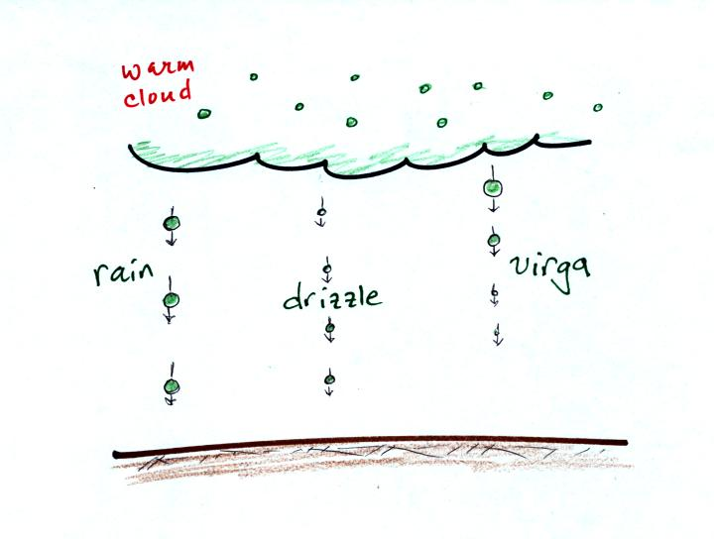
The collision coalescence process is pretty straight forward. It doesn't produce much of a variety in types of precipitation particles - really just rain. Virga is rain that evaporates before reaching the ground.
The ice crystal process on the other hand is more complex.
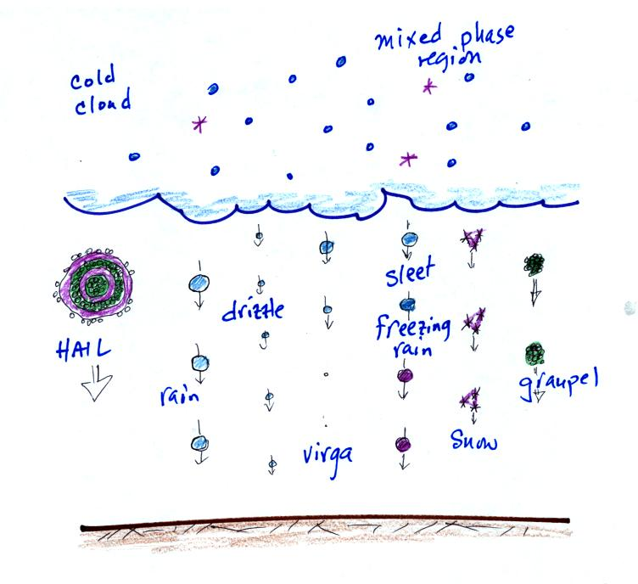
both in regards to what goes on inside the cloud and also in the types of precipitation that can fall from the cloud.
Before we look at how the ice crystal produce can produce such a variety of precipitation particles we will quickly review the process in cold clouds that gets everything started.
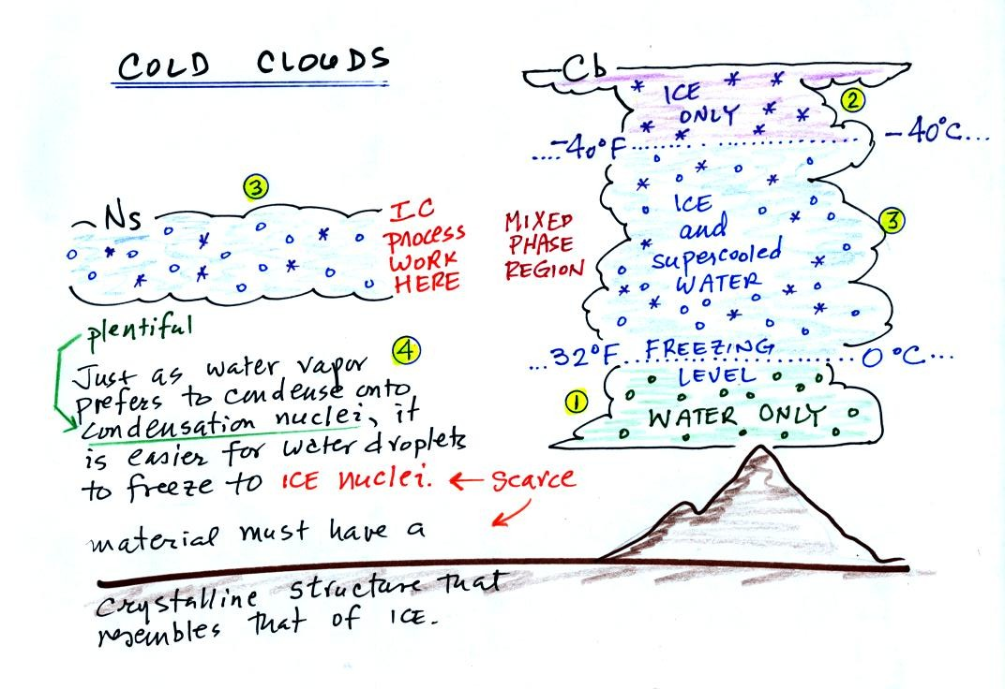
The ice crystal process operates in the mixed phase region of cold clouds, where you find both ice crystals and supercooled water droplets.
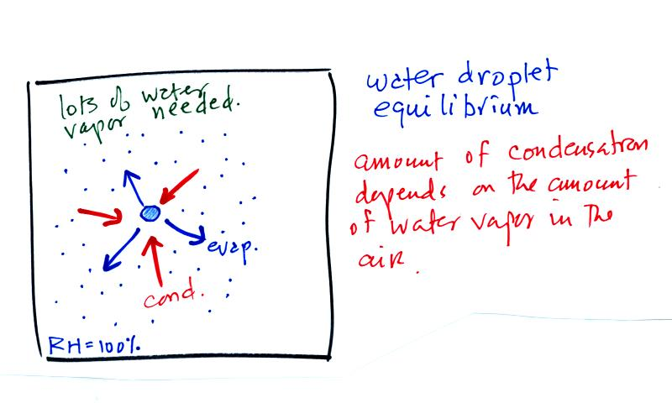
The first figure above (see p.101 in the photocopied Class Notes) shows a water droplet in equilibrium with its surroundings..The droplet is evaporating (the 3 blue arrows in the figure). The rate of evaporation will depend on the temperature of the water droplet. The droplet is surrounded by air that is saturated with water vapor (the droplet is inside a cloud where the relative humidity is 100%). This means there is enough water vapor to be able to supply 3 arrows of condensation. Because the droplet loses and gains water vapor at equal rates it doesn't grow or shrink.
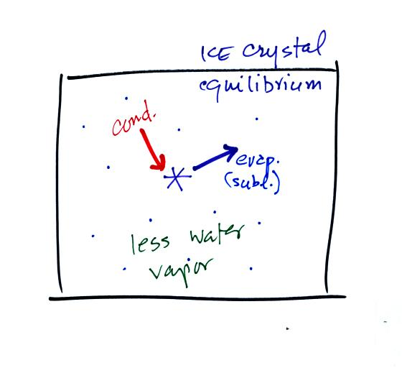
This figure shows what is required for an ice crystal (at the same temperature) to be in equilibrium with its surroundings. First the ice crystal won't evaporate as rapidly as the water droplet (only one arrow is shown). Going from ice to water vapor is a bigger jump than going from water to water vapor. There won't be as many ice molecules with enough energy to make that jump. A sort of analogous situation is shown in the figure below. The class instructor could, with a little warmup and practice jump, from the floor up and onto the seat of a chair (maybe 15 inches tall). Trust me, he could, and so could most of the people in the room. The class instructor does some stupid things in class, but he wouldn't even think about trying to jump from the floor up to the top of the cabinet (30 inches or more). There are probably only a few people in the room (members of the Women's Basketball Team perhaps) that could do that.
To be in equilibrium only one arrow of condensation is needed. There doesn't need to be as much water vapor in the air surrounding the ice crystal to supply this lower rate of condensation.
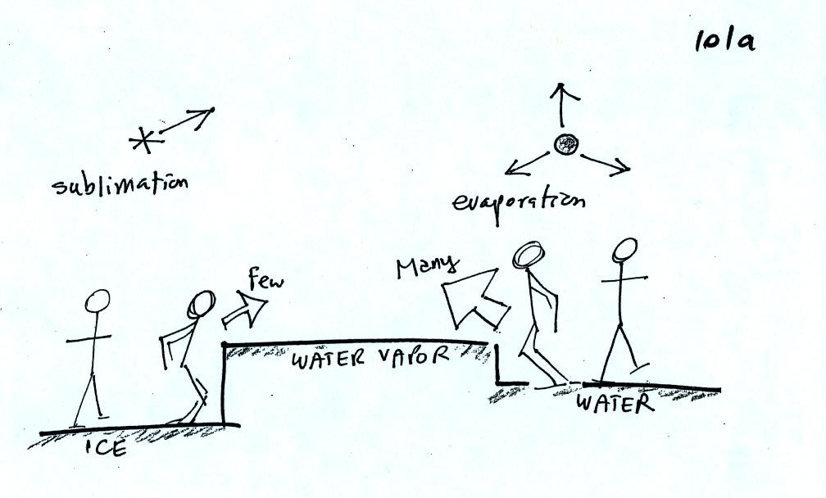
There are going to be fewer people able to make the big jump on the left just as there are fewer ice molecules able to sublimate. Going from water to water vapor is a "smaller jump" and more molecules are able to do just as more people would be able to make the shorter jump at right in the picture above.
Now what happens in the mixed phase region of a cold cloud is that ice crystals find themselves in the very moist surroundings needed for water droplet equilibrium. This is shown below.
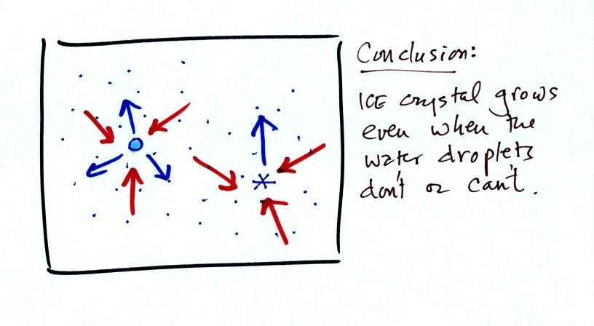
The water droplet is in equilibrium (3 arrows of evaporation and 3 arrows of condensation) with the surroundings. The ice crystal is evaporating more slowly than the water droplet. Because the ice crystal is in the same surroundings as the water droplet water vapor will be condensing onto the ice crystal at the same rate as onto the water droplet. The ice crystal isn't in equilibrium, condensation exceeds evaporation and the ice crystal will grow. That's what makes the ice crystal process work.
The equal rates of condensation are shown in the figure below using the earlier analogy.
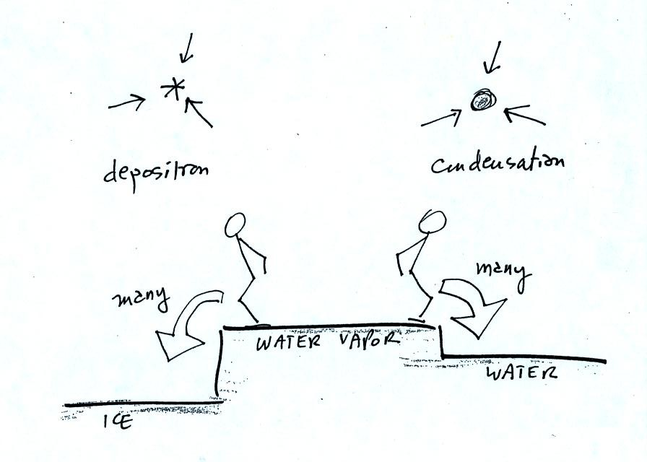
Even though he was afraid to try to jump up to the top of the counter, the instructor could jump from the counter to the floor.

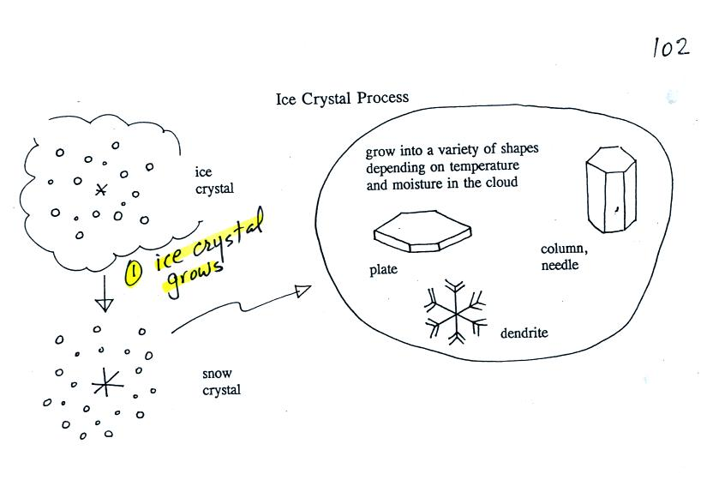
Once an ice crystal has grown a little bit it becomes a snow crystal (this figure is on p. 102 in the photocopied classnotes). Snow crystals can have a variety of shapes (called crystal habits) depending on the conditions (temperature and moisture) in the cloud. Dendrites are the most common because they form where there is the most moisture available for growth. With more raw material available it makes sense there would be more of this particular snow crystal shape.
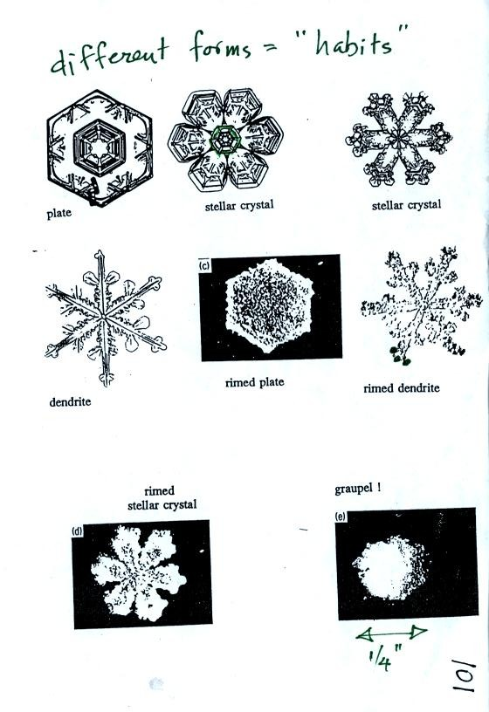
Here are some actual photographs of snow crystals (taken with a microscope). Snow crystals are usually 100 or a few 100s of micrometers in diameter (tenths of a millimeter in diameter).
You'll find some much better photographs and a pile of addtional information about snow crystals at www.snowcrystals.com
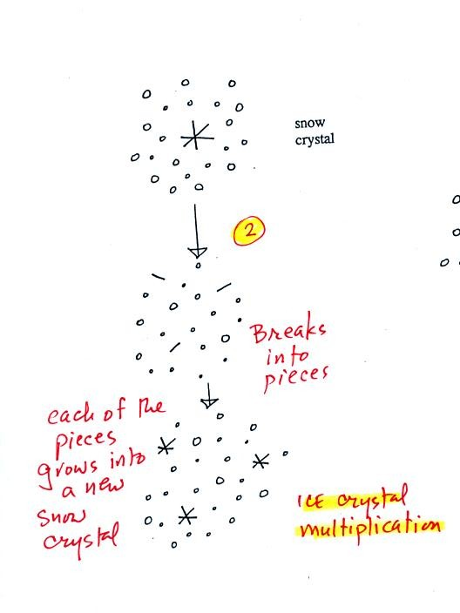
A variety of things can happen once a snow crystal forms. First it can break into pieces, then each of the pieces can grow into a new snow crystal. Because snow crystals are otherwise in rather short supply, ice crystal multiplication is a way of increasing the amount of precipitation that ultimately falls from the cloud.
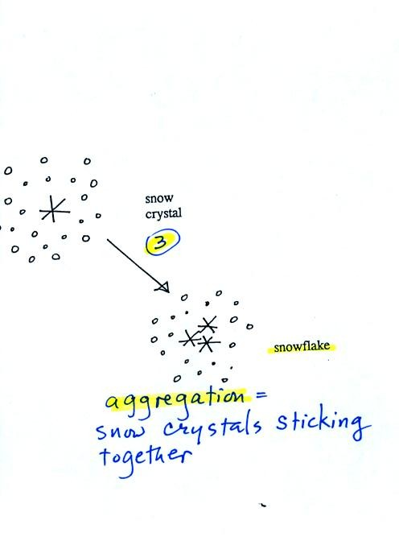
Several snow crystals can collide and stick together to form a snowflake. Snow crystals are small, a few tenths of a millimeter across. Snowflakes can be much larger and are made up of many snow crystals stuck together. The sticking together or clumping together of snow crystals is called aggregation.
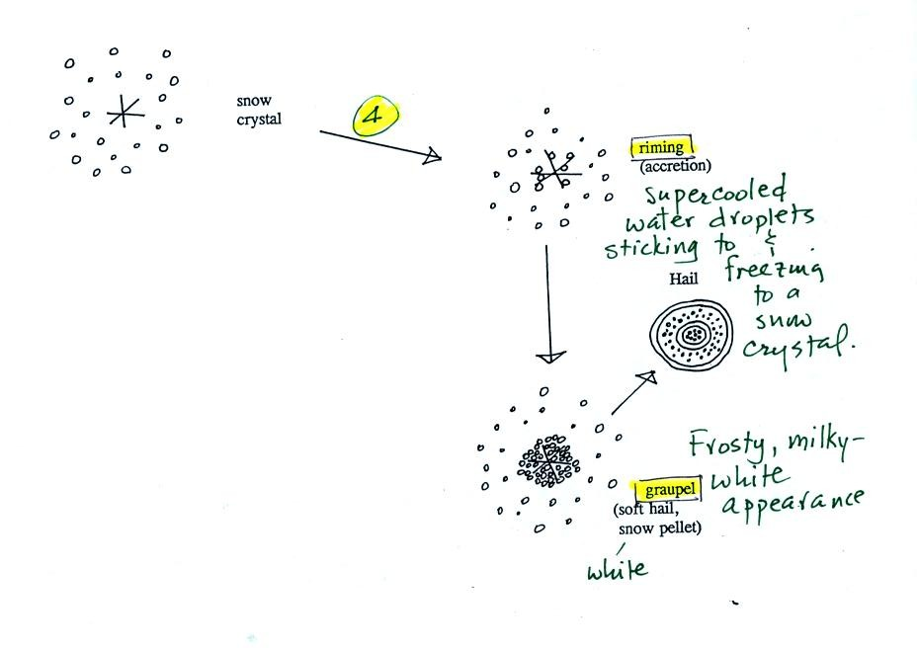
Snow crystals can collide with supercooled water droplets. The water droplets may stick and freeze to the snow crystal. This process is called riming or accretion (note it is really the same idea as collision and coalescence). If a snow crystal collides with enough water droplets it can be completely covered with ice. The resulting particle is called graupel (or snow pellets). Graupel is sometimes mistaken for hail and is called soft hail or snow pellets. Rime ice has a frosty milky white appearance. A graupel particle resembles a miniature snow ball. Graupel particles often serve as the nucleus for a hailstone.

The ice crystal process can produce a variety of precipitation particles inside the cloud. Further changes can occur once the particle falls from the cloud. The pictures were redrawn because I decided the figures on p. 103 were kind of ugly.
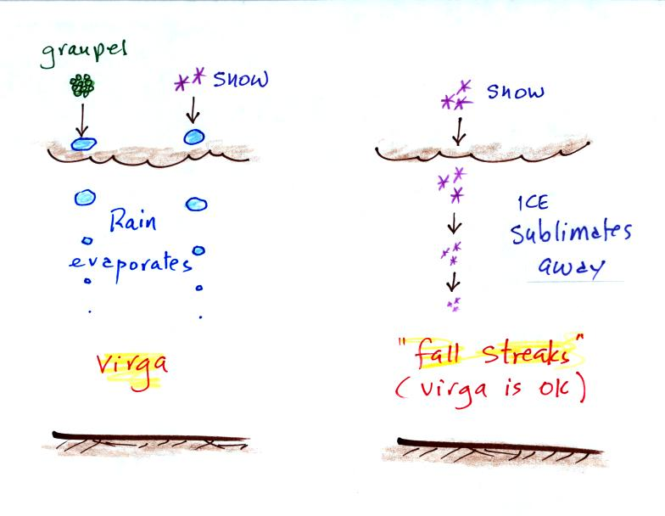
In the example above at left the ice particles (graupel or snow) first melt and then evaporate before reaching the ground. Rain that evaporates before reaching the ground is called virga.
A similar thing can happen with snow crystals or snow flakes. They sublimate away; the streamers of falling precipitation are called fall streaks (as far as I'm concerned you can use the name virga for this process since it is the same overall idea). You'll see white streamers of snow falling from high altitude cirrus clouds fairly often.
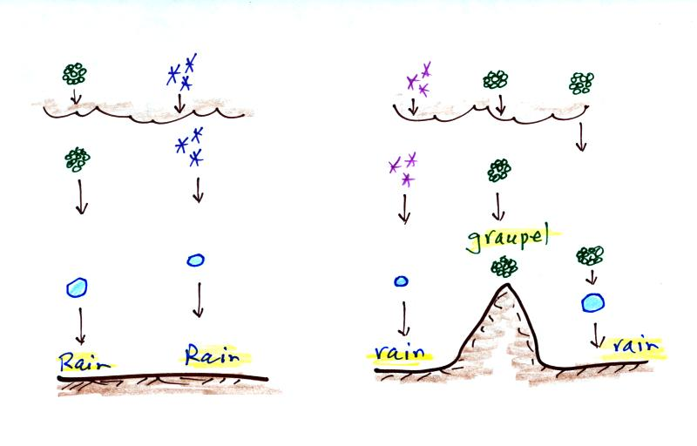
The frozen precipitation particles produced by the ice crystal process (graupel or snow) can melt before reaching the ground. This would be rain (or drizzle if the drops are small). This is where rain in Tucson comes from even in the summer. Rain in most locations at most times of the year starts out as frozen precipitation.
If you are on a mountain top you might see some of the frozen precipitation before it melts. You might see graupel falling from a summer thunderstorm, for example, while the people in the valley only observe rain.
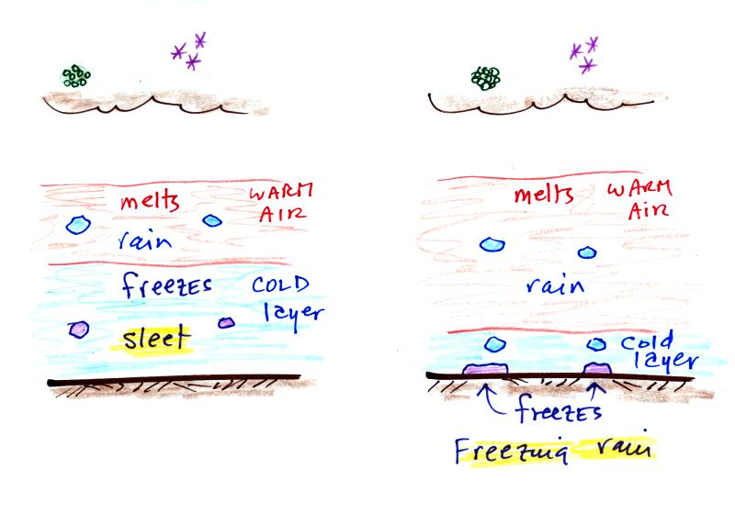
Sometimes the frozen precipitation will melt and then fall into a thick layer of cold air and refreeze. The resulting particle is called sleet (or ice pellets). Sleet is rain that freezes before hitting the ground. The clear ice in sleet is noticeably different from the frosty, milky white, rime ice in graupel.
Rain that falls into a shallow cold air layer and only freezes after reaching the ground is called freezing rain. It is nearly impossible to drive during one of these "ice storms." Sometimes the coating of ice is heavy enough that branches on trees are broken and power lines are brought down. It sometimes takes several days for power to be restored.

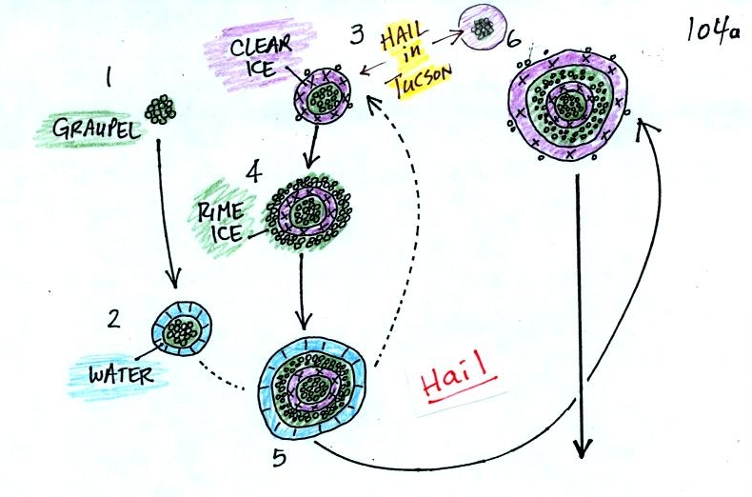
In the figure above a hailstone starts with a graupel particle (colored green to represent rime ice). The graupel falls or gets carried into a part of the cloud where it collides with a large number of supercooled water droplets which stick to the graupel but don't immediately freeze. The graupel gets coated with a layer of water (blue). The particle then moves into a colder part of the cloud and the water layer freeze producing a layer of clear ice (the clear ice, colored violet, has a distinctly different appearance from the milky white rime ice). In Tucson this is often the only example of hail that you will see: a graupel particle core with a single layer of clear ice.
In the severe thunderstorms in the Central Plains, the hailstone can pick up a new layer of rime ice, followed by another layer of water which subsequently freezes to produce a layer of clear ice.
This cycle can repeat several times; large hailstones can be composed of many alternating layers of rime and clear ice. An unusually large hailstone (around 3 inches in diameter) has been cut in half to show (below) the different layers of ice.
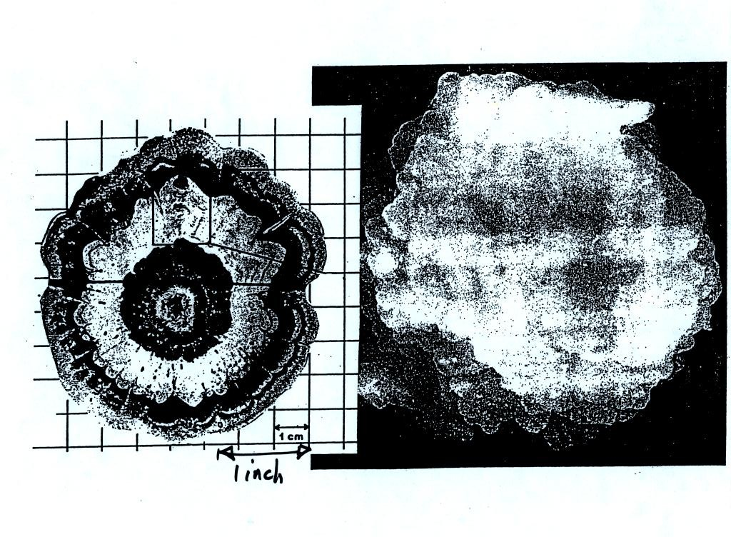

Hail is produced in strong thunderstorms with tilted updrafts.
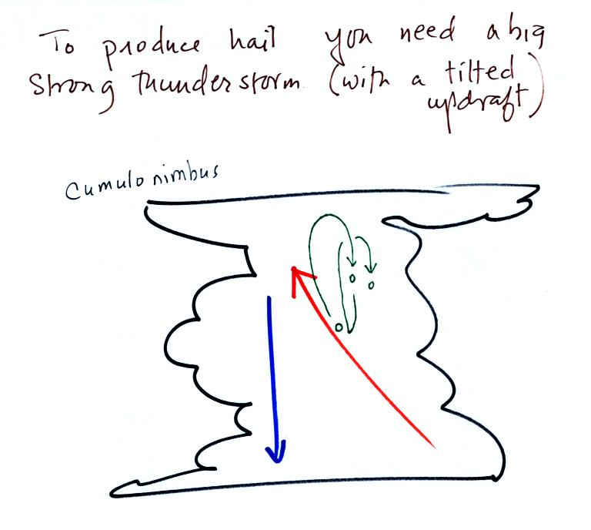
The growing hailstone can fall back into the updraft (rather than falling out of the cloud) and be carried back up toward the top of the cloud. In this way the hailstone can complete several cycles through the interior of the cloud.

