NATS 101 Name_______________________________
A fairly challenging Hidden Forces & Winds Optional Assignment
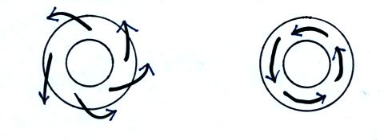
1. Does the RIGHT figure or the
LEFT figure show surface winds?.
Are these NORTHERN or
SOUTHERN hemisphere surface
winds? Are they blowing around a
center of HIGH or LOW pressure?

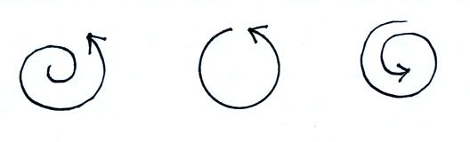

2. For each figure at right indicate
whether the net force is INward
OUTward, or ZERO. Be careful,
think about whether you would
need to pull inward or outward
or not pull at all if you had a horse
on a line and it was following each
of these paths.
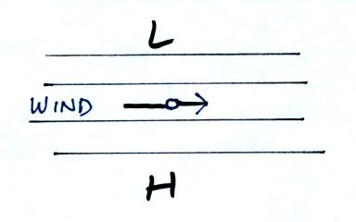

3. The wind is blowing in a straight line parallel
to the contours in the figure at right. Does the
PGF point UP, RIGHT, DOWN, or LEFT
at the point shown.

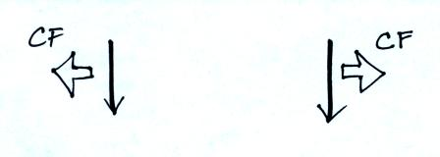
4. Which figure shows winds blowing in the southern
hemisphere? CF is the Coriolis force.

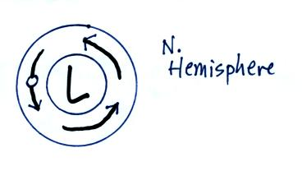
5. Show the directions of the PGF and the CF at
the point shown in the figure at right.

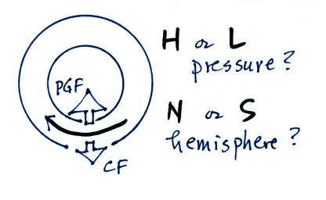
6. Does the figure show winds spinning around
HIGH or LOW pressure? Is this in the
NORTHERN or SOUTHERN hemisphere?

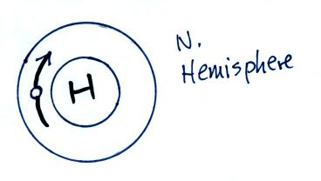

7. Show the directions of the PGF and the CF
at the point shown

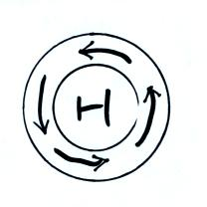

8. Are these UPPER LEVEL or SURFACE
winds? Blowing in the NORTHERN or
SOUTHERN hemisphere?
Does the net force point INWARD or
OUTWARD?

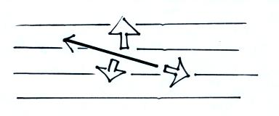
9. Identify the 3 forces (PGF, CF, or F) in the
figure. The wind is blowing toward the upper
left. Is this a NORTHERN or SOUTHERN
hemisphere weather map? (look closely, one of
the forces is perpendicular to the contours, another
is perpendicular to the wind, the 3rd points
opposite the wind)

10. Which of the following best applies? (be honest)
a. I understood this material as it was covered in class
b. I understand this material but only after reading through the online notes
c. I understand some but not all of this material
d. I don't understand this stuff at all
e. I'm not going to say

