Wednesday Oct. 29, 2008
El Cuarto de Tula was the name of the song played before class today. It was from the Buena Vista Social Club.
Answers to the Humidity Optional Assignment were handed out today. The assignments themselves will be returned on Friday.
The Quiz #3 Study Pt. 1 and Pt. 2 are now available online. The 3rd and final part should appear later this week.

Naming and identifying clouds was covered in class on Monday. This is a logical time to learn a little bit about the 2 most common types of satellite photographs. You'll find this discussed on pps 99-100 in the photocopied ClassNotes. The figures below were on a handout distributed in class.
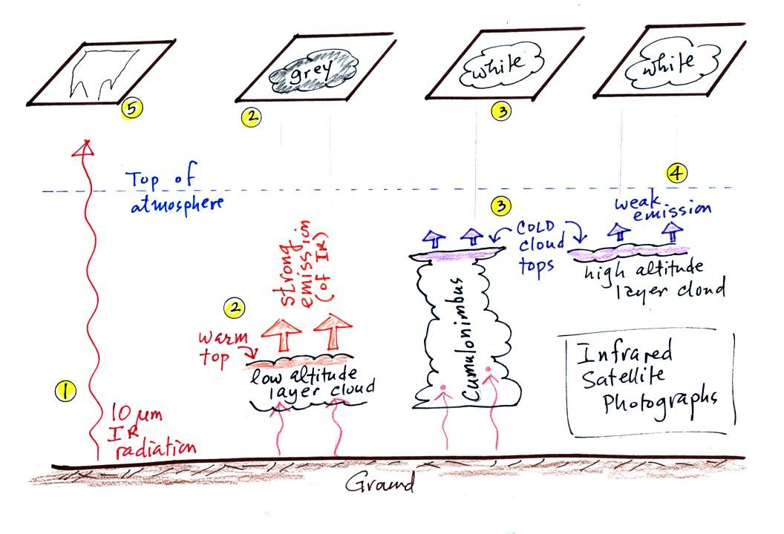
1. An infrared satellite photograph detects the 10 um IR radiation actually emitted by the ground, the ocean and by clouds. You don't depend on seeing reflected sunlight, so clouds can be photographed during the day and at night. You may recall that 10 um radiation is in the middle of the atmospheric window, so this radiation is able to pass through air without being absorbed.
2. Clouds absorb 10 um radiation and then reemit IR radiation. The top surface of a low altitude cloud will be relatively warm. Warmer objects emit IR radiation at a greater rate or at higher intensity (the Stefan Boltzmann law). This is shown as grey on an IR satellite photograph. A grey unimpressive looking cloud on an IR satellite photograph may actually be a thick nimbostratus cloud that is producing a lot of rain or snow.
3. Cloud tops found at high altitude are cold and emit IR radiation at a lower rate or at lower intensity. This shows up white on an IR photograph.
4. Two very different clouds (a thunderstorm and a cirrostratus cloud) would both appear white on the satellite photograph and would be difficult to distinquish. Meteorologists are interested in locating tall thunderstorms as they can produce severe weather.
5. The ground changes temperature during the course of the day. On an infrared satellite animation you can watch the ground change from black (afternoon when the ground is warmest) to grey (early morning when the ground is cold) during the course of a day. The ocean right alongside doesn't change temperature much during the day and remains grey throughout the day. Here's a link to an IR satellite photograph loop on the UA Atmospheric Sciences Dept. webpage.
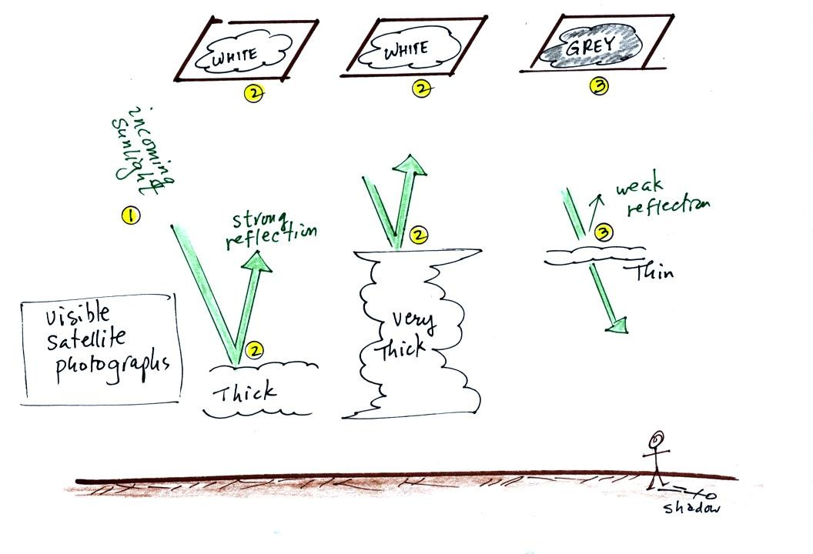
A visible satellite photograph photographs sunlight that is reflected by clouds. You won't see much on a visible satellite photograph at night. Thick clouds are good reflectors and appear white. Thinner clouds don't reflect as much light and appear grey. The low altitude layer cloud and the thunderstorm would both appear white on this photograph and would be difficult to distinquish.
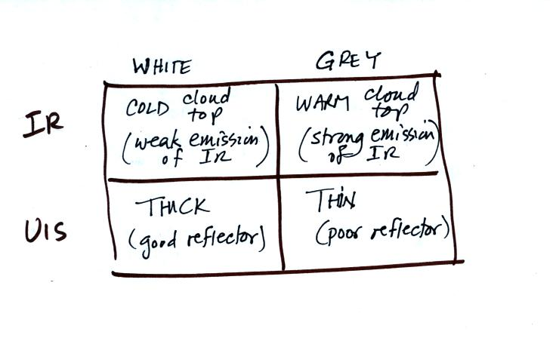
Here's a summary of what we have learned so far.
The figure below shows how if you combine both visible and IR photographs you can begin to distinquish between different types of clouds.
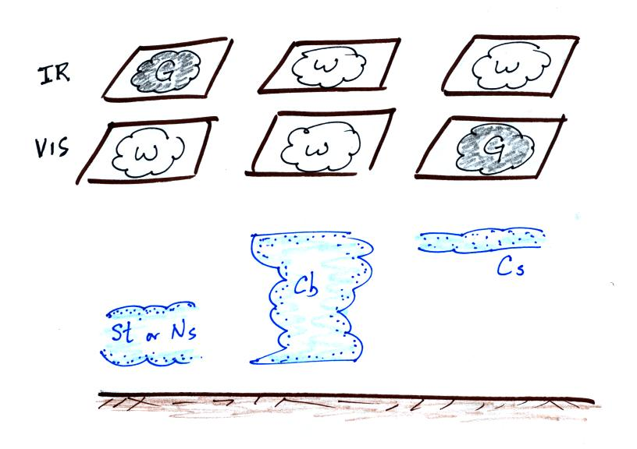

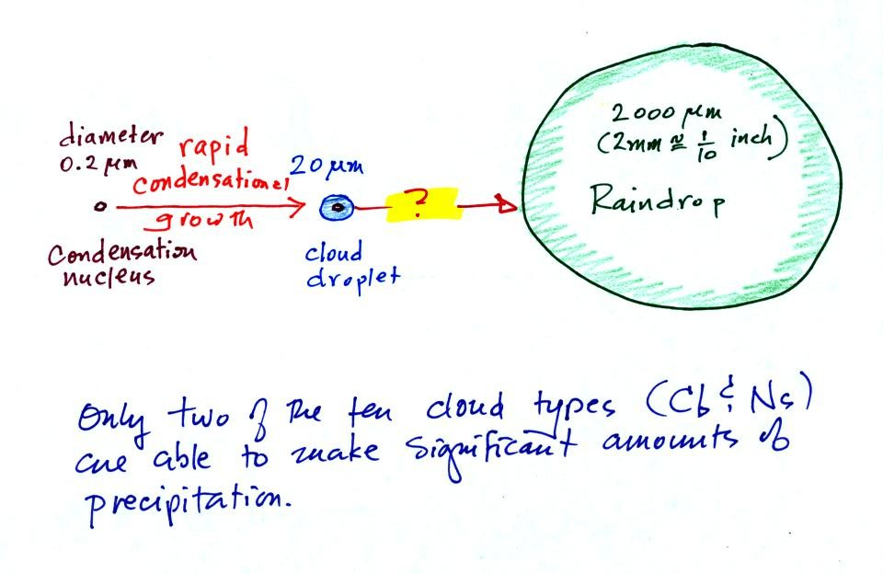
The last big topic we will cover before next week's quiz is precipitation formation and types of precipitation. Only two of the 10 main cloud types (nimbostratus and cumulonimbus) are able to produce significant amounts of precipitation.
This figure shows typical sizes of cloud condensation nuclei (CCN), cloud droplets, and raindrops (a human hair is about 50 um thick for comparison). As we saw in the cloud in a bottle demonstration it is relatively easy to make cloud droplets. You cool moist air to the dew point and raise the RH to 100%. Water vapor condenses pretty much instantaneously onto a cloud condensation nucleus to form a cloud droplet. It would take much longer (a day or more) for condensation to turn a cloud droplet into a raindrop. You know from personal experience that once a cloud forms you don't have to wait that long for precipitation to begin to fall.
Part of the problem is that it takes quite a few 20 um diameter cloud droplets to make one 2000 um diameter raindrop. How many exactly? Before answering that question we will look at a cube (rather than a sphere).
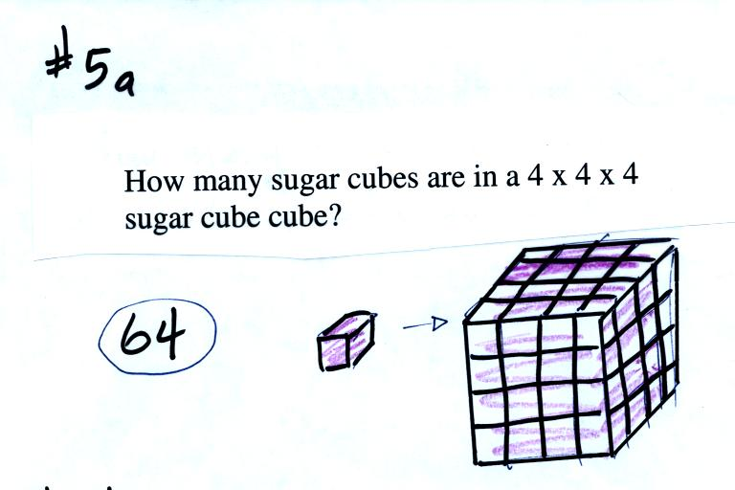
It would take 64 individual sugar cubes to make a 4 cube x 4 cube x 4 cube cube. That is because the bigger cube is 4 times wider, 4 times deeper, and 4 times taller. Volume is 3 dimensions.
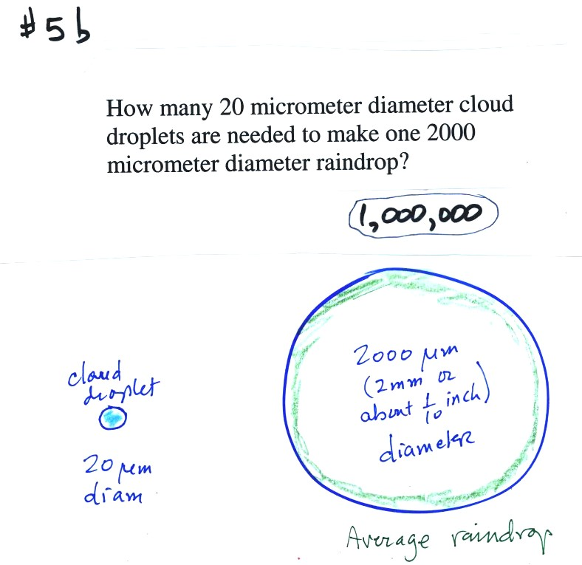
The raindrop is 100 times wider, 100 times deeper, and 100 times taller than the cloud droplet. The raindrop has a volume that is 100 x 100 x 100 = 1,000,000 (one million) times larger than the volume of the cloud droplets.
Fortunately there are two processes capable of quickly turning small cloud droplets into much larger precipitation particles in a cloud.
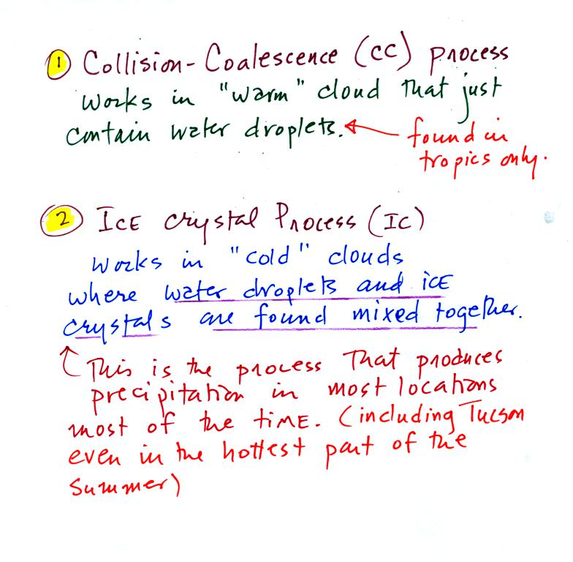
The collision coalescence process works in clouds that are composed of water droplets only. Clouds like this are only found in the tropics. We'll see that this is a pretty easy process to understand. This process will only produce rain.
The ice crystal process produces precipitation everywhere else. This is the process that makes rain in Tucson, even on the hottest day in the summer. There is one part of this process that is a little harder to understand. This process can produce a variety of different kinds of precipitation particles (rain, snow, hail, etc).

The following figures weren't covered in class on Wednesday. We'll cover this quickly at the beginning of class on Friday.
Here's what you might see if you looked inside a warm cloud with just water droplets:
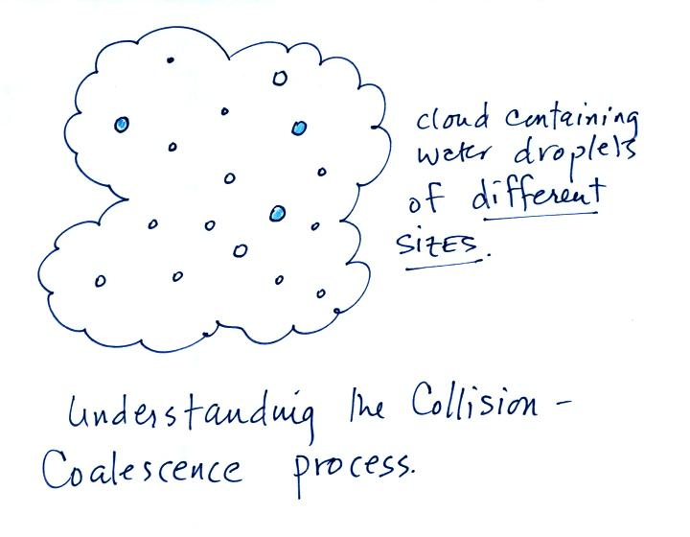
The collision coalescence process works best in a cloud filled with cloud droplets of different sizes. A short video shows that the larger droplets fall faster than the small droplets. A larger than average cloud droplet will overtake and collide with smaller slower moving ones.
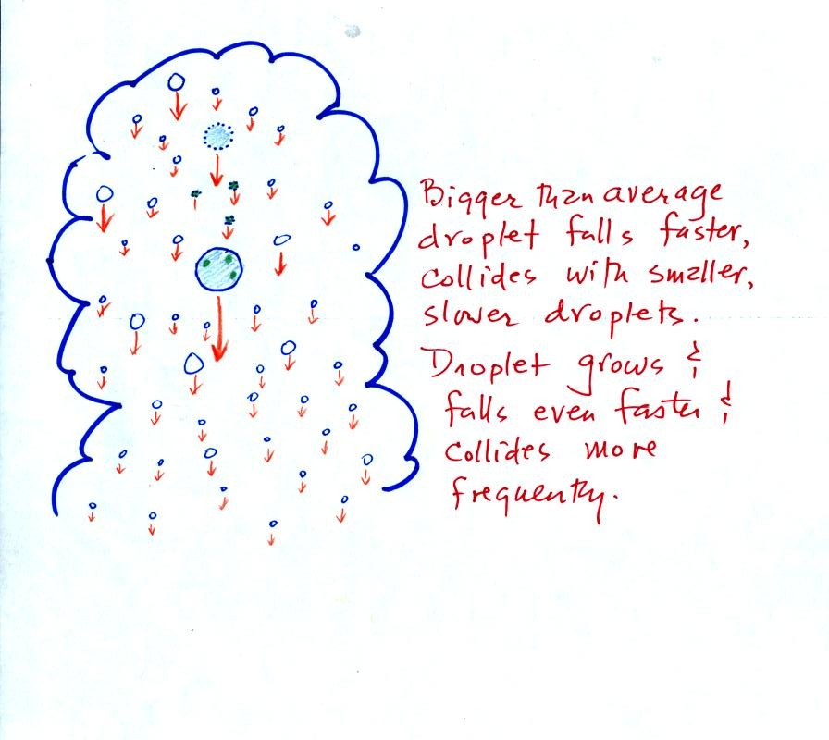
This is an accelerating growth process. The falling droplet gets wider, falls faster, and sweeps out an increasingly larger volume inside the cloud. The bigger the droplet gets the faster it starts to grow.

