Wednesday Nov. 12, 2008
The last 4 minutes of "La Vie en Rose", a recent film about Edith Piaf, was played in class today. It was an example of one of my ideas that didn't turn out as I had hoped. I thought a movie about a famous French singer would have a lot of singing. I was wrong. There were lots of short song segments. The only, mostly complete, song was the one played in class (Non Je ne Regrette Rien, here is the song from the film and here is a recording of the song sung by Edith Piaf herself in a live performance). Marion Cotillard deserved the Academy Award for her performance as Edith Piaf (she was the first person to received the Academy Award for a performance in French).
Here are the latest results from the "what direction does the water is a draining toilet spin" experiment. As of midday Thursday 12 people have reported counterclockwise spin, 7 people observed clockwise spin. Since the Coriolis force isn't involved in something like this I would expect about equal numbers of CCW and CW reports.

Now a quick review of thermal circulations. What information could you add to the figure below given just the direction of the upper level winds and knowing that the upper level winds are part of a thermal circulation.
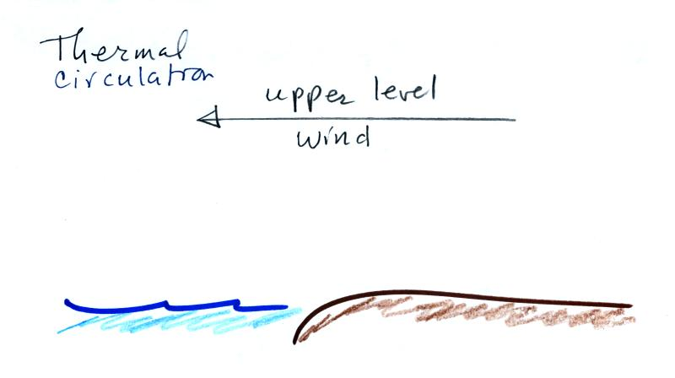
(1) The first thing to do would be to complete the circulation loop. Then if you remember that "warm air rises" you can identify the warm and cold parts of the picture that cause the thermal circulation to develop in the first place. (3) The beach is warmer than the ocean during the daytime. (4) The surface wind is blowing from the ocean toward the land and is called a "sea breeze" (the name tells you the direction the wind is coming from). The surface wind is likely to be moist since it is coming from the sea. Moist rising air could form the clouds shown at (5).
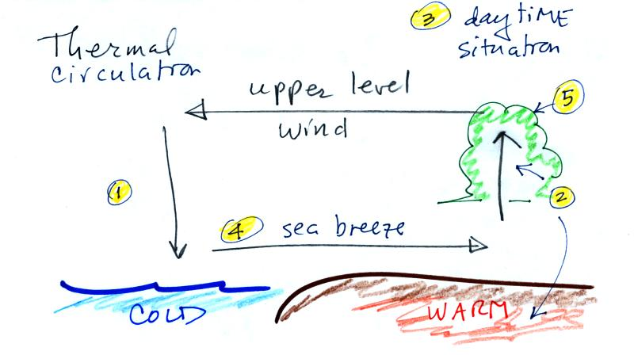

Here are some additional examples of thermal circulations or large scale circulations that resemble thermal circulations. The following 5 figures weren't shown in class.

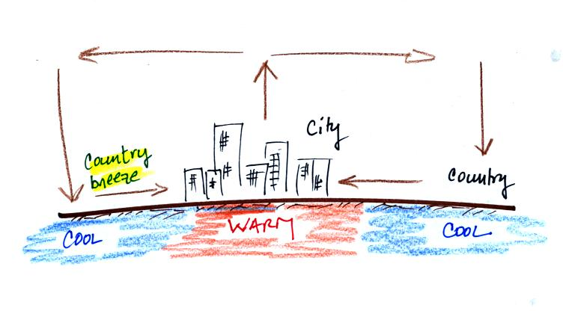
Cities are often warmer than the surrounding countryside, especially at night. This is referred to as the urban heat island effect. This difference in temperature can create a "country breeze."
The Asian monsoon (monsoon refers to a seasonal change in the direction of the prevailing winds) is a large scale circulation pattern and is much more complex than a simple thermal circulation. However you can use the thermal circulation concept to get a general understanding of what to expect at different times of the year.
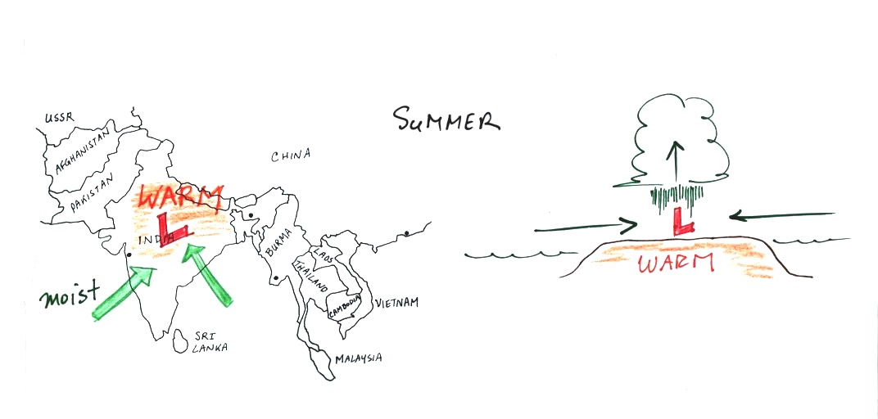
In the summer India and SE Asia become warmer than the oceans nearby. Surface low pressure forms over the land, moist winds blow from the ocean onshore, and very large amounts of rain can follow. The view above at left is from above, the view at right is from the side.
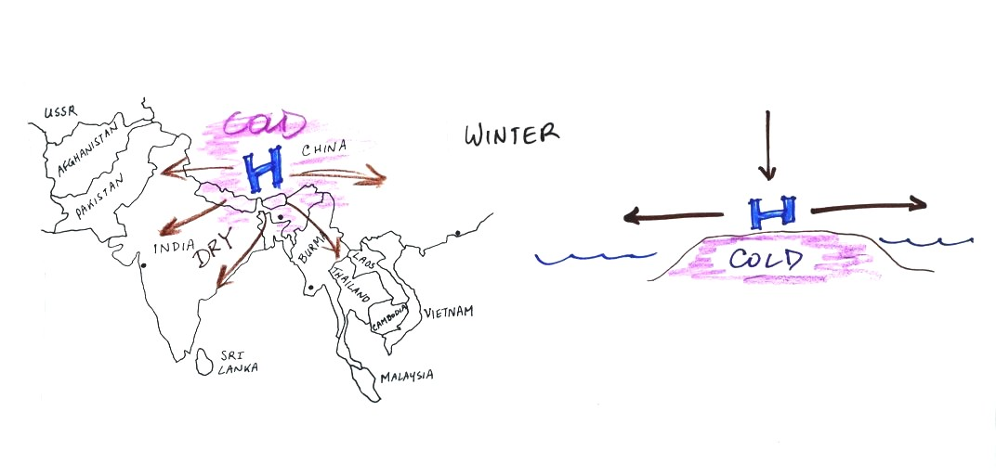
The winds change directions in the winter when the land becomes colder than the ocean.
You can also use the thermal circulation to understand some of the basic features of the El Nino phenomenon (you find a discussion of the El Nino on pps 135-139 in the photocopied Classnotes).
First here is what conditions look like in the tropical Pacific Ocean in non-El Nino years (top and side views again)
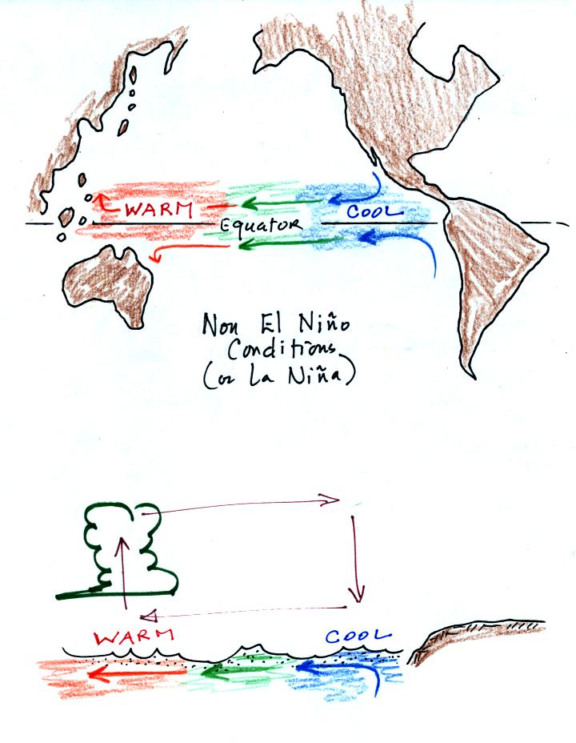
Cold ocean currents along the west coasts of N. America and S. American normally converge at the equator and begin to flow westward (see top view above). As the water travels westward it warms. Some of the warmest sea surface waters on the earth are normally found the western Tropical Pacific. A temperature gradient becomes established between the W. and E. ends of the tropical Pacific. The crossectional view above shows the normal temperature and circulation pattern found in the equatorial Pacific Ocean. You would find surface high pressure in the east and low pressure in the west. Note that the wind circulation pattern is the same as the simple thermal circulation we studied above.
Every few years El Nino conditions occur and the cold currents don't make it to the Equator. Warm water is carried from the western Pacific to the eastern Pacific
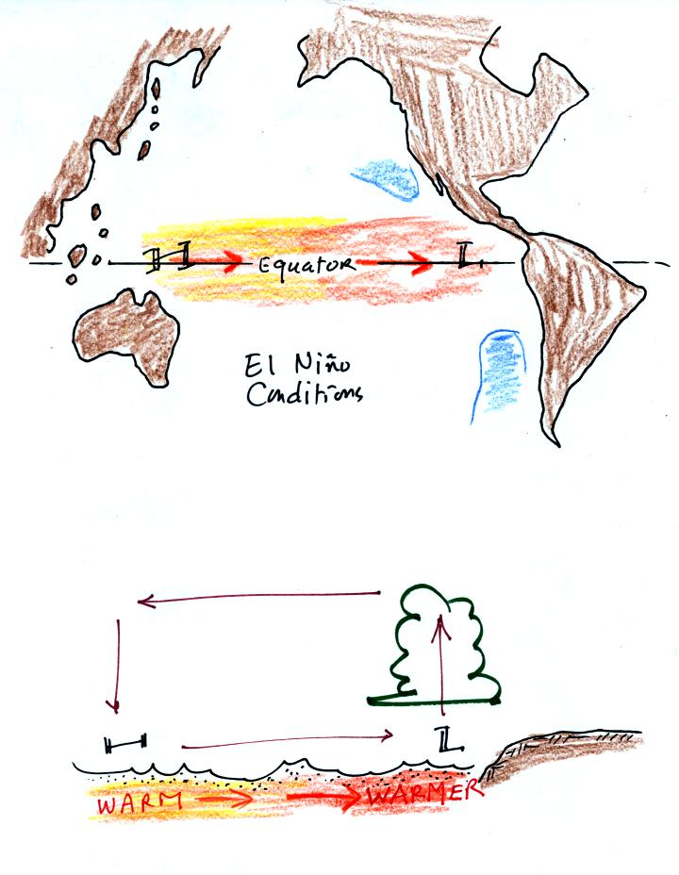
Now surface high pressure is found in the west and surface low pressure and rising air is found in the E. Pacific (the reversal in the surface pressure pattern is referred to as the southern oscillation). Indonesia and Australia often experience drought conditions during El Nino events. In the desert SW we expect slightly wetter than normal conditions (perhaps 20% wetter than normal). Wetter conditions are also found in California and in the SE US.

OK here's what we spent most of the class period on.
We'll use the thermal circulation idea to learn something about global scale pressure and wind patterns on the earth. Ordinarily you couldn't apply a small scale phenomena like a thermal circulation to the much larger global scale. However if we make some simplifying assumptions, particularly if we assume that the earth doesn't rotate or only rotates slowly, we can ignore the Coriolis force.
Some additional simplifications are also made and are listed below (p. 133 in the photocopied Classnotes)
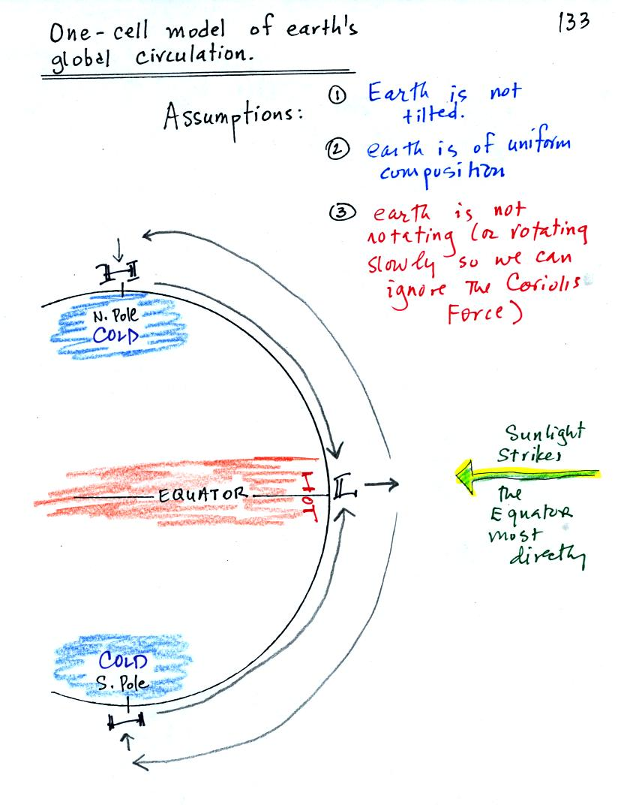
Because the earth isn't tilted, the incoming sunlight shines on the earth most directly at the equator. The equator will become hotter than the poles. By allowing the earth to rotate slowly we spread this warmth out in a belt that circles the globe at the equator rather than concentrating it in a spot on the side of the earth facing the sun. Because the earth is of uniform composition there aren't any temperature differences created between oceans and continents.
You can see the wind circulation pattern that would develop. The term one cell just means there is one complete loop in the northern hemisphere and another in the southern hemisphere.
Next we will remove the assumption concerning the rotation of the earth. We won't be able to ignore the Coriolis force now.
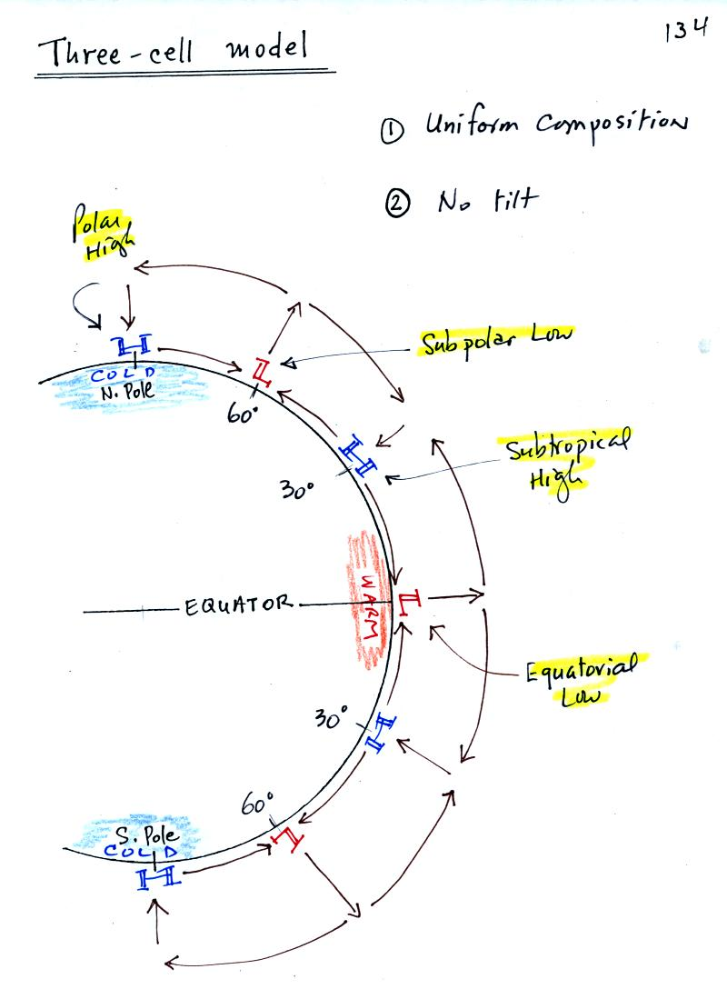
Here's what a computer would predict you would now see on the earth. Things are pretty much the same at the equator in the three cell and one cell models: surface low pressure and rising air. At upper levels the winds begin to blow from the equator toward the poles. Once headed toward the poles the upper level winds are deflected by the Coriolis force. There end up being three closed loops in the northern and in the southern hemispheres. There are surface belts of low pressure at the equator (the equatorial low) and at 60 degrees latitude (the subpolar low). There are belts of high pressure (the subtropical high) at 30 latitude and high pressure centers at the two poles (the polar highs).
We will look at the surface features in a little more detail because some of what is predicted, even with the unrealistic assumptions, is actually found on the earth.
We'll first look at surface pressures and winds on the earth from 30 S to 30 N, the tropics and subtropics. Then we'll look at the region from 30 N to 60 N, middle latitudes, where most of the US is located. The figure below was redrawn after class.
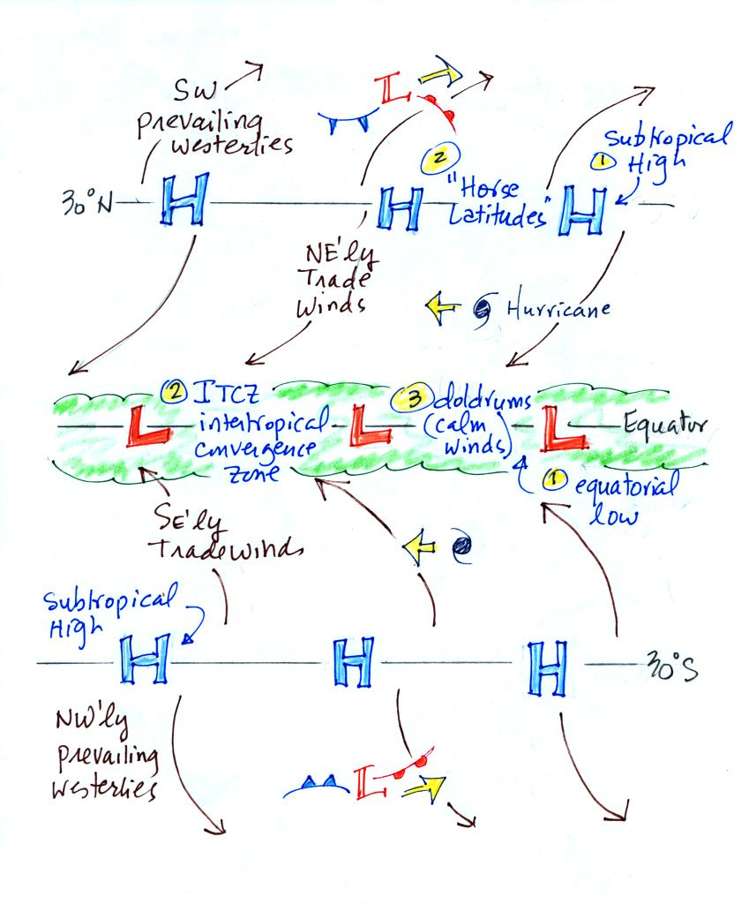
With a little study you should be able to start with a blank sheet of paper and reproduce this figure. I would suggest starting at the equator. You need to remember that there is a belt of low pressure found there. Then remember that the pressure belts alternate: there are belts of high pressure at 30 N and 30 S.
Let's start at 30 S. Winds will begin to blow from High pressure at 30 S toward Low pressure at the equator. Once the winds start to blow they will turn to the left because of the Coriolis force. Winds blow from 30 N toward the equator and turn to the right in the northern hemisphere (you need to turn the page upside down and look in the direction the winds are blowing). These are the Trade Winds (northeasterly trade winds north of the equator and southeasterly trades south of the equator). They converge at the equator and the air there rises (refer back to the crossectional view of the 3-cell model). This is the cause of the band of clouds that you can often see at or near the equator on a satellite photograph.
The Intertropical Convergence Zone or ITCZ is another name for the equatorial low pressure belt. This region is also referred to as the doldrums because it is a region where surface winds are often weak. Sailing ships would sometimes get stranded there hundreds of miles from land. Fortunately it is a cloudy and rainy region so the sailors wouldn't run out of drinking water.
Hurricanes form over warm ocean water in the subtropics between the equator and 30 latitude. Winds at these latitudes have a strong easterly component and hurricanes, at least early in their development, move from east to west. Middle latitude storms found between 30 and 60 latitude, where the prevailing westerly wind belt is found, move from west to east.
You find sinking air, clear skies, and weak surface winds associated with the subtropical high pressure belt. This is also known as the horse latitudes. Sailing ships could become stranded there also. Horses were apparently either thrown overboard (to conserve drinking water) or eaten if food supplies were running low. Note that sinking air is associated with the subtropical high pressure belt so this is a region on the earth where skies are clear (Tucson is located at 32 N latitude, so we are affected by the subtropical high pressure belt).
The winds to the north of 30 N and to the south of 30 S are called the "prevailing westerlies." They blow from the SW in the northern hemisphere and from the NW in the southern hemisphere. The 30 S to 60 S latitude belt in the southern hemisphere is mostly ocean. Because there is less friction over the oceans, the prevailing westerlies there can get strong, especially in the winter. They are sometimes referred to as the "roaring 40s" or the "ferocious 50s" (the 40s and 50s refer to the latitude belt they are found in).
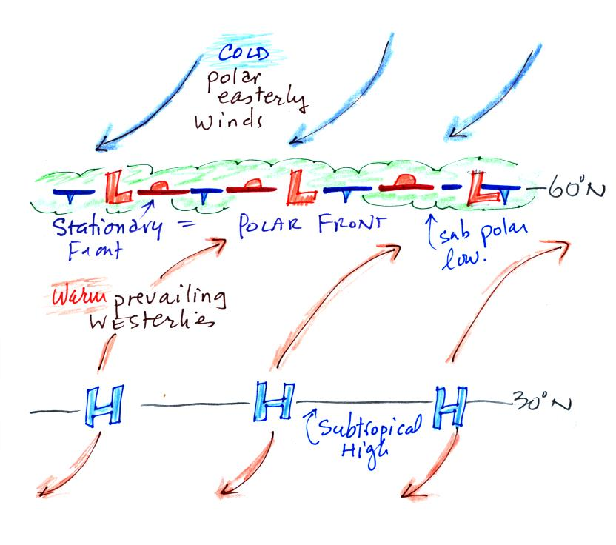
Here's the other map, it's a little simpler. Winds blowing north from H pressure at 30 N toward Low pressure at 60 N turn to the right and blow from the SW. These are the "prevailing westerlies." The polar easterlies are cold winds coming down from high pressure at the north pole. The subpolar low pressure belt is found at 60 latitude. This is also a convergence zone where the cold polar easterly winds and the warmer prevailing westerly winds meet. The boundary between these two different kinds of air is called the polar front and is often drawn as a stationary front on weather maps. A strong current of winds called the polar jet stream is found overhead. Strong middle latitude storms will often form along the polar front.

The 3-cell model predicts subtropical belts of high pressure near 30 latitude. What we really find are large circular centers of high pressure. In the northern hemisphere the Bermuda high is found off the east coast of the US, the Pacific high is positioned off the west coast. High pressure centers are found east and west of South America in the southern hemisphere.
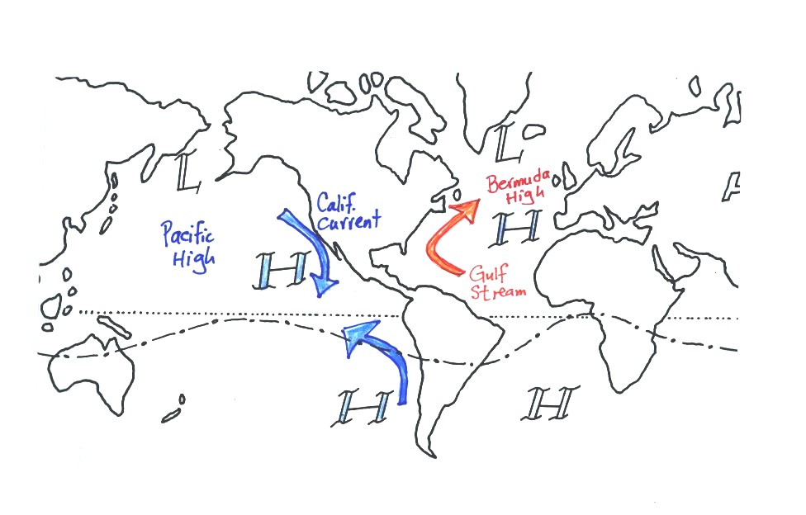
The winds that blow around these large scale high pressure centers create some of the major ocean currents of the world. If you remember that high pressure is positioned off the east and west coast of the US, and that winds blow clockwise around high in the northern hemisphere, you can determine the directions of the ocean currents flowing off the east and west coasts of the US. The Gulf Stream is a warm current that flows from south to north along the east coast, the California current flows from north to south along the west coast and is a cold current. A cold current is also found along the west coast of South America; winds blow counterclockwise around high in the southern hemisphere. These currents are shown in the picture above (not shown in class).
Circular low pressure centers, the Icelandic low (off the east coast near Iceland and Greenland in the picture below) and the Aleutian low (off the west coast near the southern tip of Alaska), are found near 60 N.

The cause of the summer monsoon in Arizona was discussed briefly (and not very well) in class. Hopefully the more carefully drawn pictures below will make this a lot clearer.
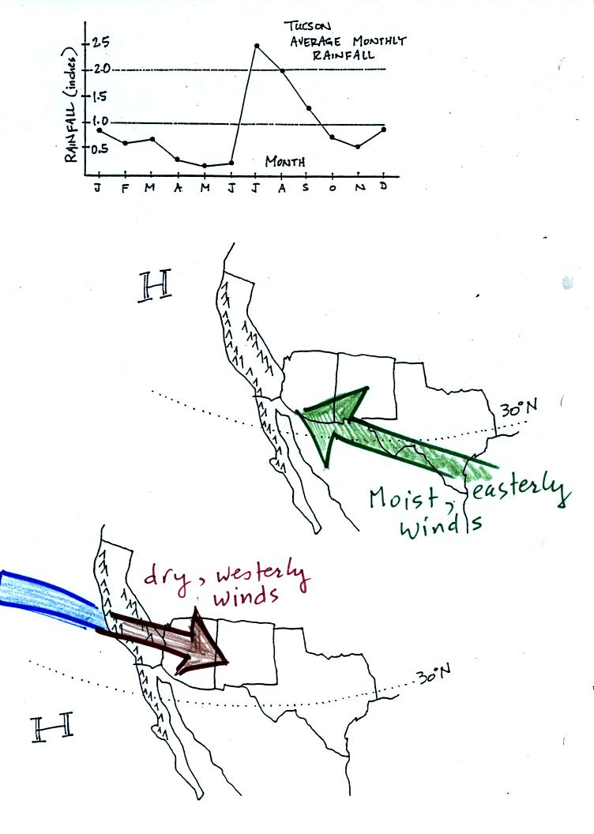
Tucson gets about 12 inches of rain in a normal year (we are well below normal this year). About half of this comes during the "summer monsoon" season. The word monsoon, again, refers to a seasonal change in wind direction. During the summer subtropical high pressure (the Pacific high) moves north of its normal position near 30 N latitude. Winds on the southhern side of the subtropical high have an easterly component. Moist air originating in Mexico and the Gulf of Mexico blows into Arizona. The sun heats the ground during the day, warm moist air in contact with the ground rises and produces convective thunderstorms.
The close proximity of the Pacific high, with its sinking air motions, is what gives California, Oregon, and Washington dry summers.
In the winter the subtropical high moves south of 30 N latitude. Winds to the north of the high blow from the west. Air originating over the Pacific Ocean loses much of its moisture as it crosses mountains in California (remember the rain shadow effect). The air is pretty dry by the time it reaches Arizona. Significant winter rains occur in Arizona when storms systems are able to draw moist subtropical air from the southwest into Arizona.

