Monday Nov. 10, 2008
The Expt. #3 reports have been graded and were returned in class today. Revised reports are due in 2 weeks, on or before Mon., Nov. 24. Please return your original report with your revised report.
Unless noted otherwise, the Expt. #4 reports were due today. It usually takes about 1 week to grade those reports.
There was an Optional Assignment hidden in the Friday Nov. 7 notes. You can still earn half credit if you turn it in on Wed.
I'm afraid that the Lottery ticket I bought over the weekend wasn't a winner. So funding is still in doubt for the end of the semester, 5-night all- expenses paid trip to Paris for two, grand prize.
1S1P Assignment #3 is now online. You can do a maximum of 2 reports. Reports are due on or before Mon., Nov. 24.

We looked at how and why surface and upper level winds blow around circular centers of high and low pressure in class last Friday. Some real world examples of where this occurs are shown in the figure below. The two largest types of storm systems, middle latitude storms and hurricanes, develop around surface low pressure. Winds spin counterclockwise around low in the northern hemisphere and clockwise in the southern hemisphere. Winds spin clockwise around "anticyclones" (high pressure) in the northern hemisphere and counterclockwise in the southern hemisphere.
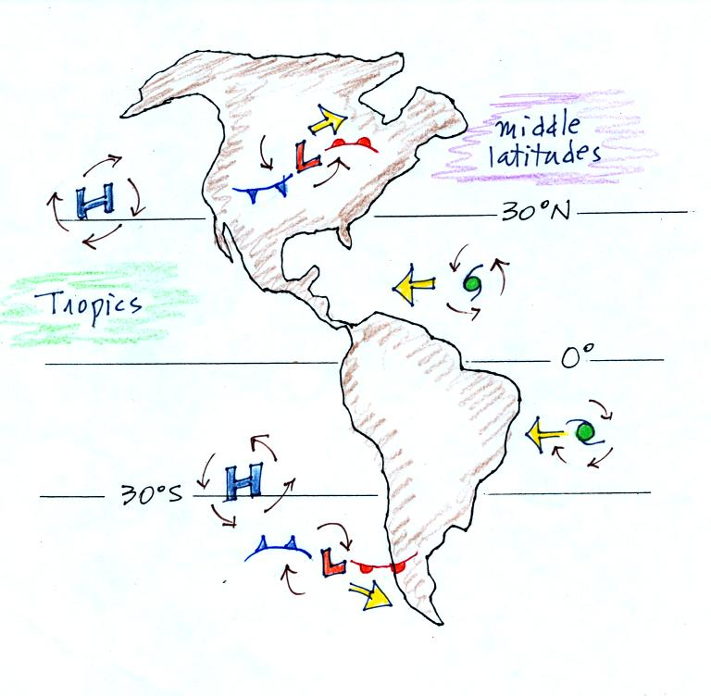
Storm systems in the tropics generally move from east to west. At middle latitudes, storm move in the other direction, from west to east. To understand why this is true we need to learn something about the earth's global scale pressure and wind patterns. This is a topic we will be getting into on Wednesday.
Spinning winds change directions in the northern and southern hemispheres because of the Coriolis force. We learned rules for the direction and strength of the Coriolis force last Friday, but didn't really learn anything about what causes it. We spent a little time in class today doing that. Most of what follows can be found on p. 122c in the photocopied ClassNotes.
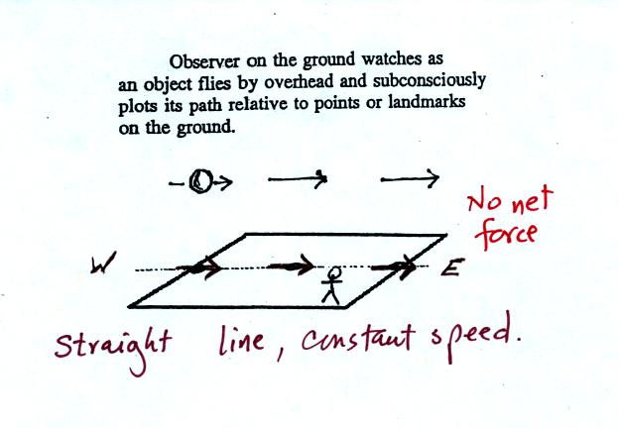
Imagine something flies over Tucson. It travels straight from west to east at constant speed. The next figure shows the path that the object followed as it passed over the city. More or less subconciously you would plot its path relative to reference points on the ground.
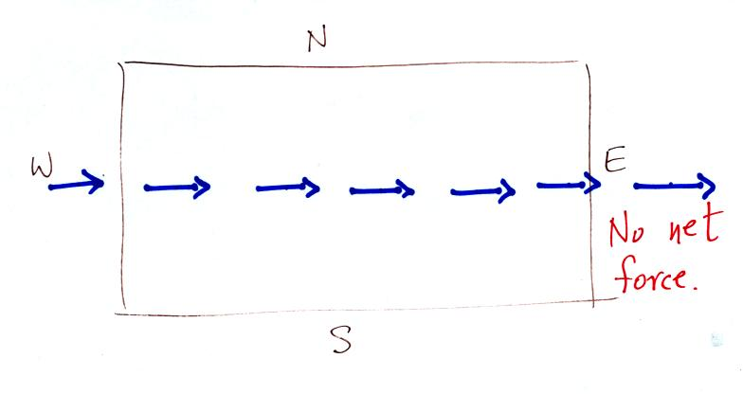
It would appear to be moving in a straight line at constant speed. You would conclude there was zero net force acting on the moving object (Newton's first law of motion).
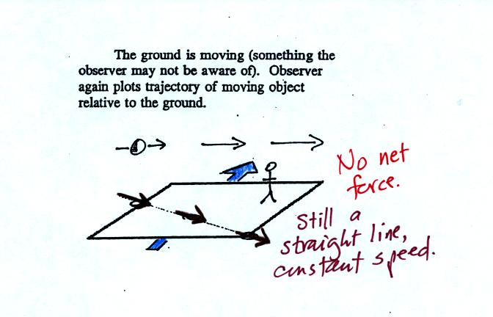
In this second picture the object flies by overhead just as it did in the previous picture. In this picture, however, the ground is moving (don't worry about what might be causing the ground to move).
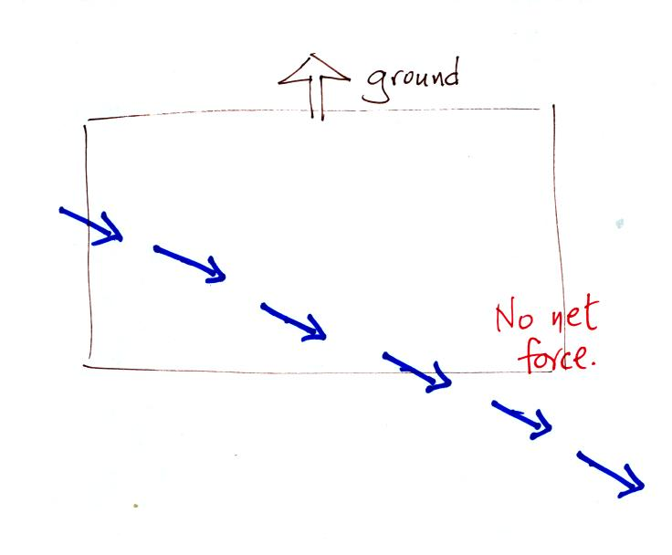
This is the path that you would see relative to the ground in this case. Even though the object flew from west to east it appears to have been traveling from the NW toward the SE because the ground was moving as the object passed overhead. Because the motion is still in a straight line at constant speed, you would conclude the net force acting on the object was zero.
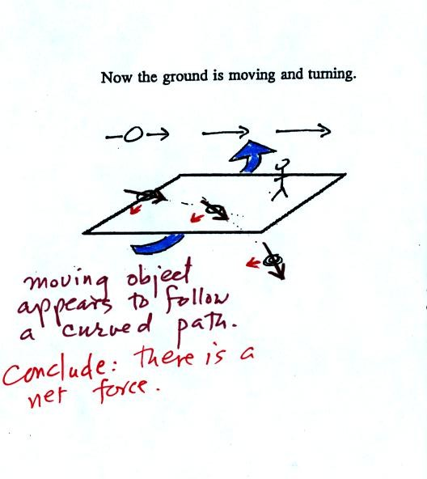
In this last figure the object flies by again from west to east. In this case however the ground is rotating.
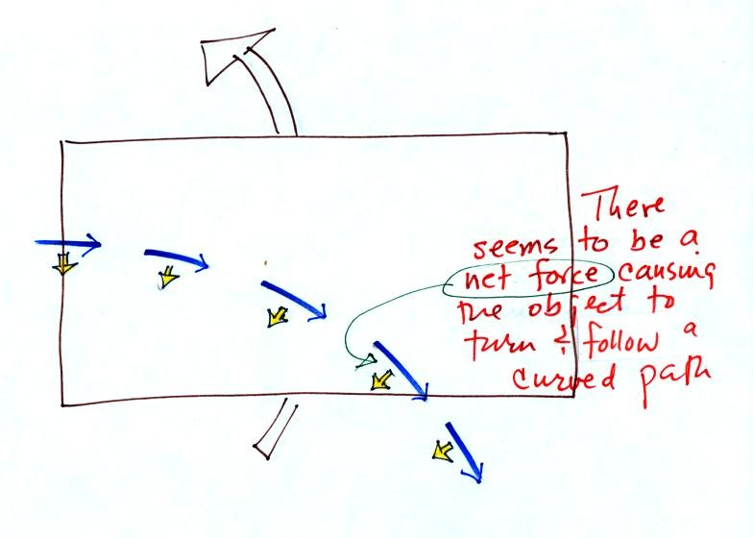
At most locations on the earth the ground IS rotating (we're just not aware of it). This is most easily seen at the poles.
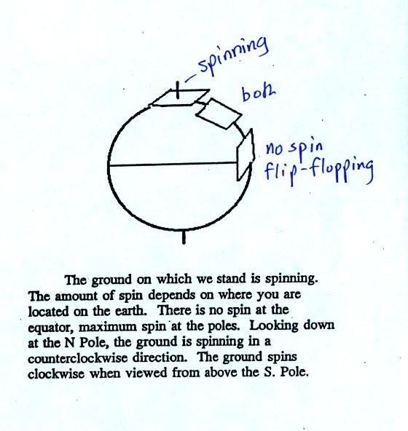
Imagine a piece of paper glued to the top of a globe. As the globe spins the piece of paper will rotate. A piece of paper glued to the globe at the equator won't spin, it will flip over. At points in between the paper would spin and flip, the motion gets complicated.
The easiest thing for us to do is to ignore the fact that the ground on which we are standing is rotating. However, if we do that we need to account for the curved paths that moving objects will take when they move relative to the earth's surface. That is what the Coriolis force does.

You might already have heard that water spins in a different direction when it drains from a sink or a toilet bowl in the southern hemisphere than it does in the northern hemisphere. You might also have heard that this is due to the Coriolis force or the Coriolis effect.
The Coriolis force does cause winds to spin in opposite directions around high and low pressure centers in the northern and southern hemisphere. The PGF starts the air moving (in toward low, out and away from high pressure) then the Coriolis force bends the wind to the right (N. hemisphere) or to the left (S. hemisphere).
Here's what you end up with in the case of low pressure:
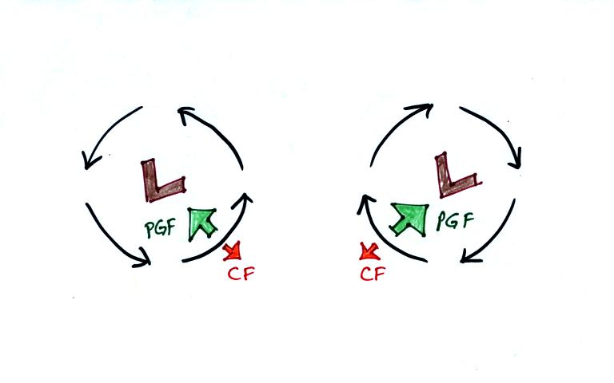
Wind motions around an upper level low. The example at left would be found in the northern (the CF is pointing to the right of the wind)? The PGF is stronger than the CF. This results in a new inward force, something that is needed for wind to blow in a circular path.
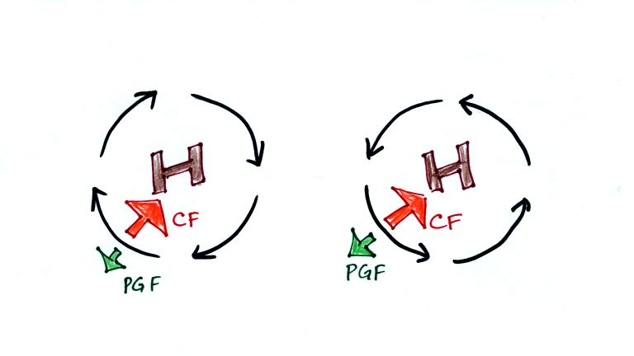
Winds also spin around high pressure. The CF is absolutely essential in this case. The CF is stronger than the PGF and the CF points inward. The CF is what provides the needed inward force needed to keep the winds blowing in a circular path.
There are situations where the PGF is much stronger than the CF; the CF can be ignored.
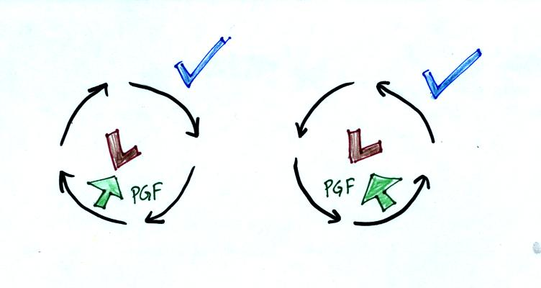
Winds can still spin around LOW. The PGF supplies the necessary net inward force. This is the case with tornadoes, for example. Tornado winds spin around a core of very low pressure.
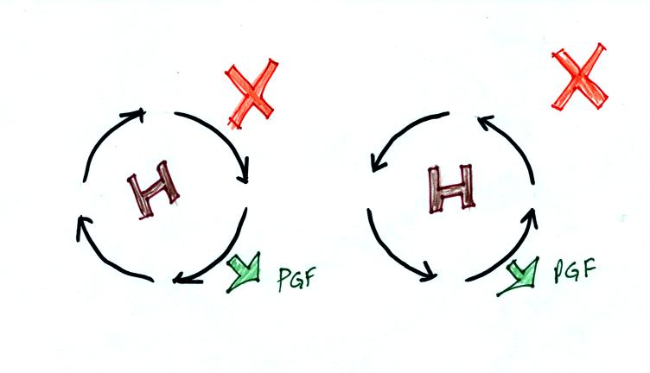
Winds can't blow around high pressure without the CF. The PGF points ouward with high pressure. Without the CF, there isn't any inward force.
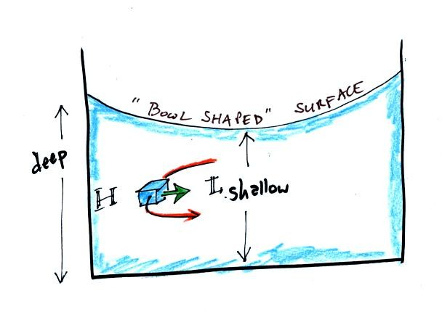
When water spins and drains from a sink or a toilet, the water is a little deeper on the outside than on the inside. This creates an inward pointing pressure difference force. There needs to be an inward force in order for the water to spin. Water can spin clockwise or counterclockwise when draining from a sink in the northern hemisphere. It can spin in either direction in the southern hemisphere also.
Now we watched a short video segment that seemed to show otherwise. Don't believe everything you see on video. The gentleman in the video was just very good at getting the draining water to spin one direction or another as he moved on opposite sides of the equator. Probably the most difficult part would be to get the water draining without spinning, which is what he was able to do when standing right on the equator.
Would you like to earn 0.1 pts of extra credit? If so click here.

Next we moved to a new topic, thermal circulations.
Differences in temperature like you might find between a coast and the ocean or between a city and the surrounding country side can create horizontal pressure differences. The horizontal pressure gradient can then produce a wind flow pattern known as a thermal circulation. These are generally relatively small scale circulations and the pressure gradient is so much stronger than the Coriolis force that the Coriolis force can be ignored. We will learn how thermal circulations develop and then apply to concept to the earth as a whole in order to understand large global scale pressure and wind patterns. You'll find the following discussion on p. 131 in the photocopied Class Notes.
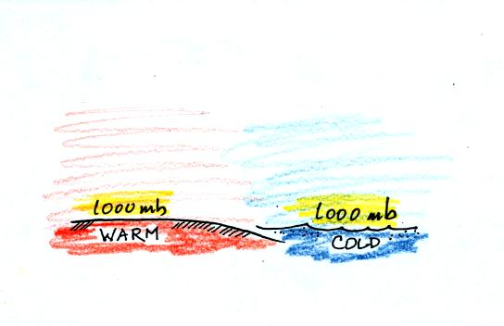
A beach will often become much warmer than the nearby ocean during the day (the sand gets hot enough that it is painful to walk across in barefeet). Pressure will decrease more slowly with increasing altitude in the warm low density air than in the cold higher density air above the ocean.
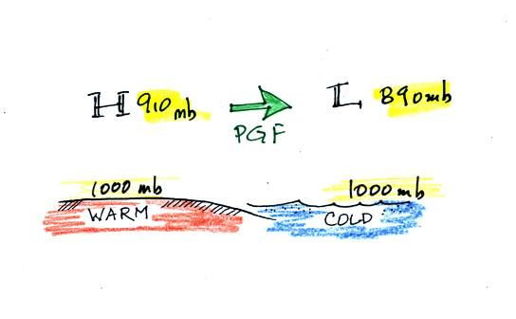
Even when the sea level pressures are the same over the land and water (1000 mb above) an upper level pressure gradient can be created. The upper level pressure gradient force will cause upper level winds to blow from H (910 mb) toward L (890 mb).
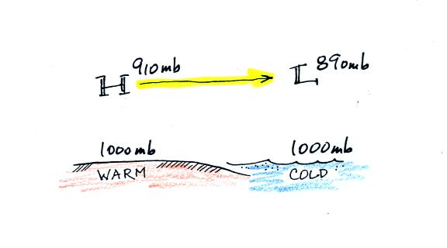
The movement of air above the ground can affect the surface pressures. As air above the ground begins to move from left to right, the surface pressure at left will decrease (from 1000 mb to 990 mb in the picture below). Adding air at right will increase the surface pressure there (from 1000 to 1010 mb).
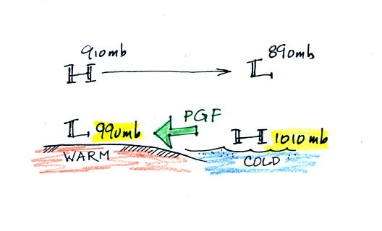
This creates a surface pressure gradient.
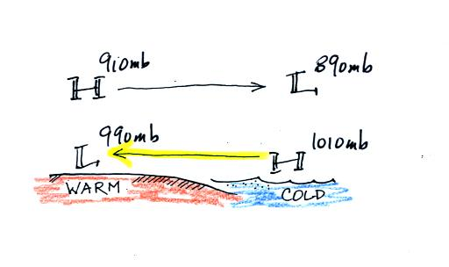
The surface winds blow from high to low. The surface winds and upper level winds are blowing in opposite directions.
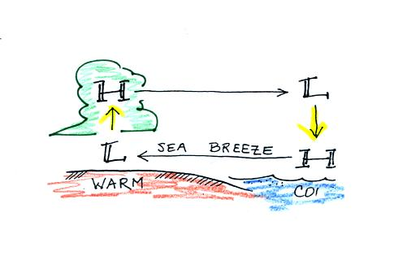
You can complete the circulation loop by adding rising air above the surface low pressure at left and sinking air above the surface high at right. The surface winds which blow from the ocean onto land are called a sea breeze (the name tells you where the winds come from). Since this air is likely to be moist, cloud formation is likely when the air rises over the warm ground.
At night the ground cools more quickly than the ocean and becomes colder than the water. The thermal circulation pattern reverses direction. Surface winds blow from the land out over the ocean. This is referred to as a land breeze.

