NAME | Venus | Earth | Mars | Jupiter | Saturn | Titan | Neptune | Triton
Picture (visible wavelengths) | 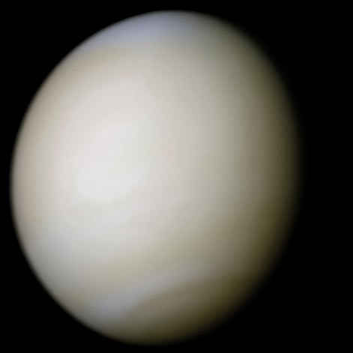 | 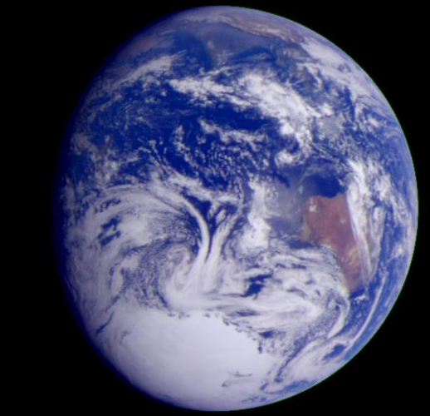 | 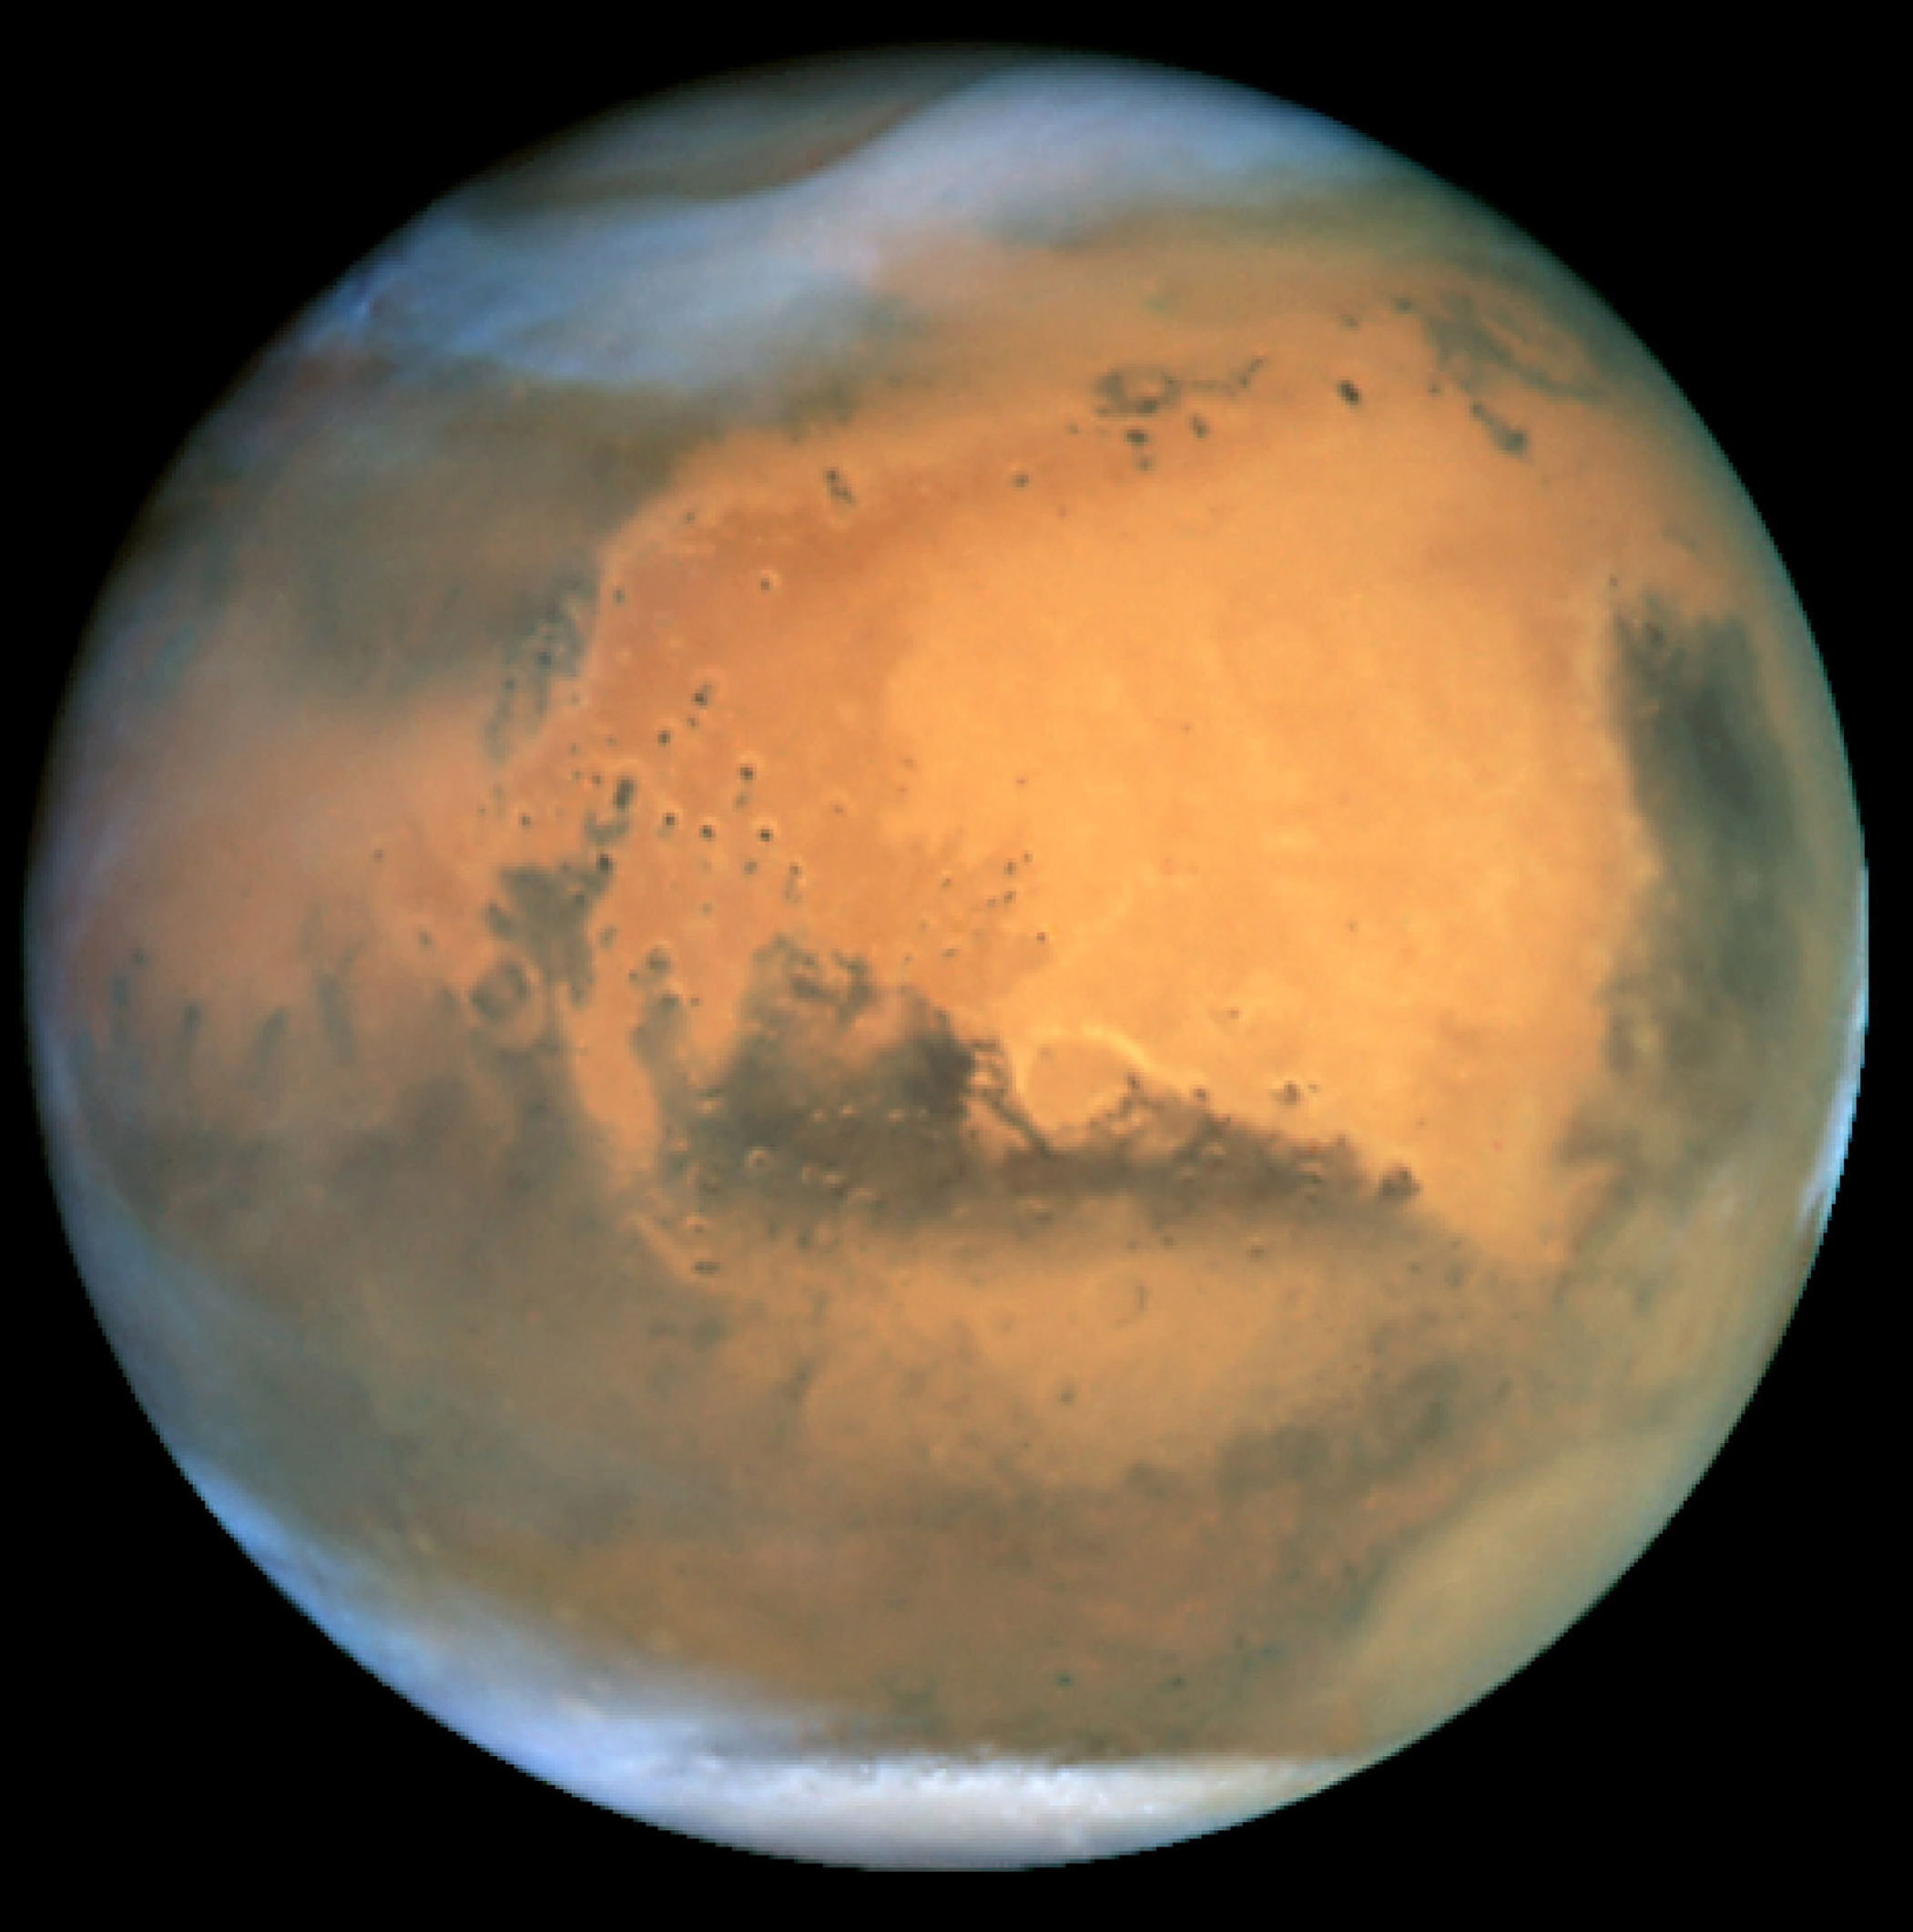 | 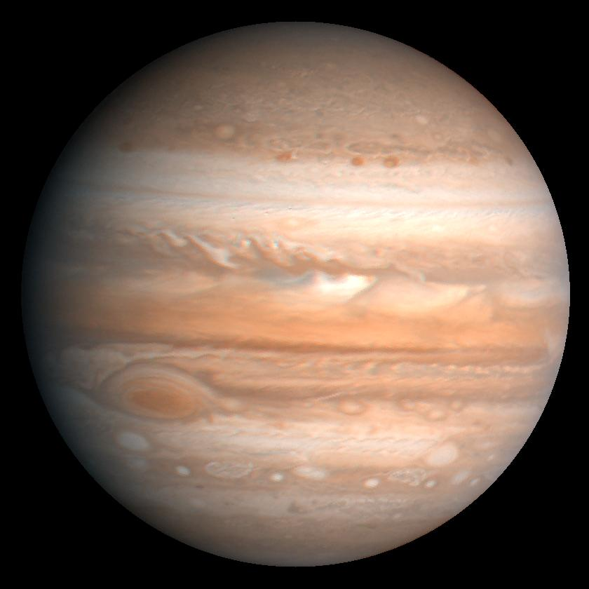 |  | 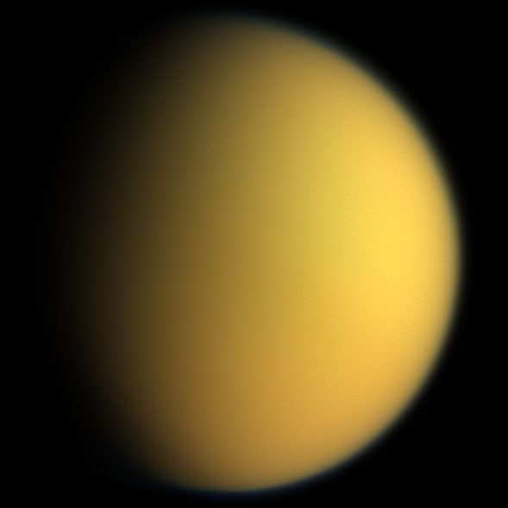
Radius (km / Radius Earth) | 6051.8 / 0.95 | 6378 / 1 | 3396 / 0.53 | 70000 | 57000 | 2576
Distance to sun (AU) | 0.72 | 1 | 1.38-1.66 | 5.15 | 9.58 | 9.58 |  | 30
Eccentricity | 0.0068 | 0.0167 | 0.09 | 0.0488 | 0.557 | 0.557
Year (Earth years) | 0.615 | 1 | 1.88 | 11.86 | 29.66 | 29.66
Day (hours) | 2802 | 24 | 24.6 | 9.925 | 10.6 | 383
Axis tilt (degrees) | 177.36 | 23.45 | 25.19 | 3.13 | 26.73 | 26.73
Density (g/cm³) | 5.204 | 5.5153 | 3.934 | 1.326 | 0.687 | 1.88
Mass (Earth mass) |  | 1 |  |  | 95.15 | 0.0225
Surf. grav. (m/s2) | 8.87 | 9.81 | 3.69 | 24.79 | 8.96 | 1.352
Albedo | 0.65 | .3 | 0.15 | 0.52 | .47 | .22
ATMOSPHERE
Major constituent | CO₂ 96.5% | N₂ 78.08% | 95.7% CO₂ | H₂ 90% | H₂ ~96% | N₂ ~97% |  | N₂
2nd Constitutent | N₂ 3.5% | O₂ 20.95% | 2.7% N₂ | He 10% | He ~3% | CH₄ ~3% |  | CO
3rd Constituent |  | Ar 1% |  |  | CH₄ ~0.4%
Trace 1 |  | H₂O 0-3%
Trace 2 (ppmv) |  | CO₂ ~385
condensible |  | H₂O | H₂O, CO₂ | H₂O, NH₃ | H₂O, NH₃ | CH₄ |  | N₂
Surface pressure (bar) | 92 | 1.013 | 0.006-0.009 |  |  |  |  | 0.000016
Surface temp (K) | 737 | 288 | 227 (186-268)
Rad. Eq. Temp. | 232 | 255 | 217 | 106 |  | 85
Tropospause min. T (K) |  |  |  | 110-115
Mean Molec Mass | 43.45 | 28.96
Scale height (km) | 15.9 | 7-8
Dry adiabat (K/km) |  | 9.8
Escape vel. (km/s) | 10.36 |  |  |  | 35.5

1 AU = 1.47e6 km

