First law of thermodynamics: Conservation of energy

The first law of thermodynamics is conservation of energy that came with the recognition that heat is a form of energy exchange and that there is internal energy in material. This is an important bridge between the large scale and small scale worlds. A way of expressing this is the change in energy in a system, ΔE, is the sum of the heat added to the system, ΔQ, and the work done on the system, ΔW.
$DE=DQ+DW$
It is important to note the convention that heat and work are defined as positive when they add energy to the system. For an isolated system, ΔQ = ΔW = 0 and E = constant.
Now the energy added to the system go into some combination of the bulk energy of the system, E_{B}, (which is large scale mechanical energy: kinetic plus potential energy) plus the internal energy of the system, U. Therefore we can write
$D\left(U+E_{B}\right)=DQ+DW$
Heat added: ΔQ

SYSTEM

Change in
internal
energy: ΔU

Work done by surroundings: ΔW
Change in bulk energy: ΔE_{B}

Consider the case when thermal effects are negligible. In this case, ΔQ and ΔU are 0 and
${DE}_{B}=DW$
In the other extreme, suppose there is no change in the Bulk energy in which case the first law takes the form
$DU=DQ+DW$
A helpful diagram is figure 13.13 from Kenneth Ford’s Classical and Modern Physics (1973).
- On the right are two forms of energy: internal energy which is disordered energy and bulk energy which is ordered energy.
- On the left are two modes of exchanging energy: heat and work.
- The arrows in the figure 4 kinds of energy transformation.
Energy conservation is maintained in each of these transformation as it must be.
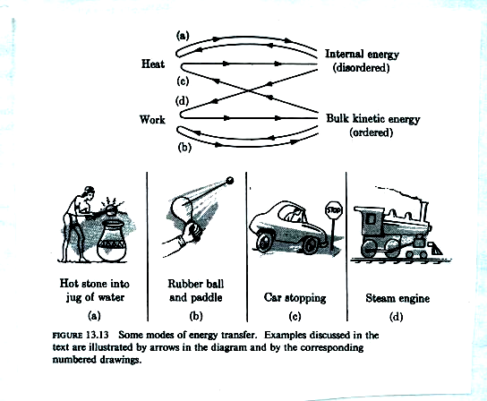
- In the first case, a hot stone is dropped in a jug of water. Clearly this is a heat transfer from the hot stone to the cooler water. So the transformation is from internal energy of one object via heat to the internal energy of another object, the water.
- In case (b), the paddle is striking the ball and doing work on the ball which also extends the rubber band creating potential energy which then does work on the ball to accelerate it back toward the paddle and repeat. These represent bulk energy of the paddle transferring energy to the bulk energy of the ball and rubber band via work.
- In case (c), the car initially has bulk kinetic energy. By hitting the brakes, the bulk kinetic energy is transformed into the internal energy of the parts in the brake system by heating the parts.
- The steam engine is one of the great early applications of thermodynamics where internal disordered energy is transformed into ordered bulk energy via work. Steam that is heated in a cylinder expands against a piston and pushes the piston outward doing work on the piston which gains kinetic energy at the expense of loss of internal energy of the steam (which means it cools as it expands).
For the steam, ΔU_{s} = ΔW_{s} where both are negative.
For the piston, ΔE_{B} = ΔW_{p} where both are positive.
From conservation of energy,
ΔW_{s} + ΔW_{p} = 0
ΔW_{p} = -ΔW_{s}
Therefore
ΔU_{s} + ΔE_{B} = 0
ΔE_{B} = -ΔU_{s}
Specific heat at constant pressure

If heat is added to a gas maintained at constant pressure, the gas expands doing work on its environment. When the expansion is slow, the bulk energy of the gas does not change so
$DU=DQ+DW$
The term on the left is the energy the system gains. The terms on the right are the energy transfer terms responsible for that energy gain.
$DQ=DU−DW$
So the heat added to the system goes into its internal energy as well as work done on the surrounding environment (which is lost from the system). The heat put into the system at constant pressure is by definition
$DQ=C_{p}N_{V}mDT$
This equation defines what we mean by specific heat at constant pressure. For a standard diatomic gas, the internal energy is given as
$DU=\frac{5}{2}N_{V}k_{B}DT$
Consider the gas as being inside a piston. The work done on the gas is minus the work the gas does on a piston while maintaining constant pressure:
ΔW = -F dx = -PA dx = -P dV
But P ΔV = N_{v} k_{B} ΔT via the ideal gas law. Therefore
ΔW = -N_{v} k_{B} ΔT
and
$DQ=C_{p}\text{Nm}DT=DU−DW=\frac{5}{2}N_{V}k_{B}DT+N_{V}k_{B}DT=\frac{7}{2}N_{V}k_{B}DT$
and
$C_{p}=\frac{7}{2}\frac{k_{B}}{m}$
and the molar specific heat at constant pressure is
$C_{p}'=\frac{7}{2}R∗$
The general form is
$C_{p}'=C_{V}'+R∗$

Wallace and Hobbs write the dQ equation as follows
$\text{dQ}=C_{V}\text{dT}+d\left(Pα\right)−α\text{dP}$
Their first substitution is dU = C_{v} dT .
As WH says, if we are dealing with a unit mass of material, the volume V is replaced by the specific volume, α, defined as α=1/ρ Therefore the work done when the specific volume increases by dα is
dW = P dα
They are also using
$d\left(Pα\right)=α\text{dP}+\text{Pd}α$
so
$Pdα=d\left(Pα\right)−α\text{dP}$
So from our equation
$DQ=DU−DW=DU+PDV$
The equation of WH should therefore be
$\text{dQ}=C_{v}\text{dT}+d\left(Pα\right)−α\text{dP}$
which is a match!
One must be extremely careful about the sign of the WORK term. It is defined as positive when work is done on the gas which increases the energy of the gas.

