The Carnot Cycle

What is a Carnot Cycle and Why do we care

Carnot was a French engineer who was trying to understand how to extract usable mechanical work from a heat engine, that is an engine where a gas or fluid is heated and used to move something. His work represented a key improvement in our understanding of thermodynamics and engines. One of his goals was to understand the efficiency of such an engine, that is the percentage of heat that is put into the engine that can be extracted as useful mechanical work.
In the cycle, heat is absorbed at a high temperature and heat is later expelled at a lower temperature and some of the enery taken in is used to do mechanical work (think “push on a piston”).
The Carnot cycle is quite relevant to atmospheric science because the atmosphere can be thought of as a Carnot cycle where solar energy (heat is absorbed) and IR energy is expelled and some fraction of the absorbed energy is used to drive atmospheric circulation (which is the mechanical work) against frictional forces.

Concept
Consider a cylinder filled with a gas (see Figure 3.19 from W&H). There are three attachments to the bottom of the cylinder. The first is a hot reservoir at a temperature, T₁. When this is attached to the piston with the gas, it holds the gas temperature equal to T₁. The second is a thermal isolator which eliminates any heat transfer creating an adiabatic process when the thermal isolator is attached to the piston. The third is a cold reservoir with temperature T₂. . When this is attached to the piston with the gas, it holds the gas temperature equal to T₂.

In terms of the Carnot Cycle, we think in terms of moving the gas’ state moving around on a pressure volume diagram as the piston is expanded and contracted.

The cycle is shown in terms of 2 types of diagrams,
- Temperature vs. Entropy and
- Pressure vs. Volume (which is used by W&H)

The Carnot cycle when acting as a heat engine consists of the following steps:

- (Reversible) isothermal expansion of the gas at the "hot" temperature, T₁ = T_{H} (isothermal heat addition).
During this step (B to C on Figure 3.20) the expanding gas does work on the piston. The gas expansion is the result of the gas absorbing a quantity ΔQ₁ of heat from the high temperature reservoir.
Note that since changes in internal energy of the gas change in proportion to temperature changes, isothermal means that the internal energy of the gas remains constant during the expansion. Recall from the 1st law of thermodynamics and energy conservation that
$DU=DQ+DW$ (1)
where ΔU is the change in the internal energy of the gas due to the change in heat, ΔQ , it receives and the work done on it, ΔW. Remember work here is defined as positive when the work is done on the gas and negative when the gas does work on (and therefore is lost to) the environment. Since ΔU is zero in the isothermal environment,
$DW\text{=-}DQ$ (2)
This means the heat added to the gas, ΔQ, goes directly into doing work done on the environment (the piston).

- Isentropic (Reversible adiabatic) expansion of the gas.
For this step (C to D on Figure) the piston and cylinder are thermally insulated, so there is no heat transfer to or from the gas. The gas continues to expand, doing work on the surroundings. The gas expansion causes it to cool to the "cold" temperature, T_{C}= T₂
No heat is added. The internal energy of the gas is used to do work on the environment.
$DU=DW$ (3)
ΔW <0 so ΔU <0 Therefore the gas cools.

- (Reversible) isothermal compression of the gas at the "cold" temperature, T_{C}. (isothermal heat rejection)
In this step (D to A on Figure), the environment (piston) does work on the gas by compressing it and reducing its volume. Again (2) applies
$DW\text{=-}DQ$ (2)
Since work is being done on the gas, ΔW > 0. Therefore ΔQ <0. This means the gas is losing quantity ΔQ₂ of heat which is flowing from the gas into the low temperature reservoir.

- Isentropic compression of the gas.
In this step (A to B in the Figure), the piston and cylinder are thermally insulated and this step is adiabatic. So as the environment does work on the gas and compresses it, (3) applies
$DU=DW$ (3)
ΔW > 0 so ΔU > 0 therefore the gas warms and its temperature rises to T_{H} = T₁.
At this point the gas is in the same state as at the start of step 1.

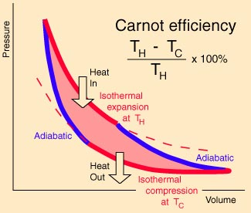

Figure 1: A Carnot cycle acting as a heat engine, illustrated on a temperature-entropy diagram. The cycle takes place between a hot reservoir at temperature T_{H} and a cold reservoir at temperature T_{C}. The vertical axis is temperature, the horizontal axis is entropy.

The energy extracted from the heat engine is the work done by the heat engine on the piston which is given by
$DW=\int_{\text{cycle}}{\text{pdV}}=\int_{1}{\text{pdV}}+\int_{2}{\text{pdV}}+\int_{3}{\text{pdV}}+\int_{4}{\text{pdV}}$ (4)
The magnitude of each of these integrals is the area under the curve on the Figure. Note that the change in the piston volume is negative for steps 3 and 4. This means the work done is the area inside of or enclosed by the 4 curves.
The change in work is also
$DW={DW}_{1}+{DW}_{2}+{DW}_{3}+{DW}_{4}$ (5)
$DW={DQ}_{1}+DU−{DQ}_{2}−DU={DQ}_{1}−{DQ}_{2}$ (6)
The changes in internal energy during the adiabatic expansion and adiabatic compression are equal in magnitude and opposite in sign because the change in internal energy is C_{v}ΔT and the changes in temperature in these two steps are equal in magnitude, |T₁-T₂|, but opposite in sign.
The efficiency of the heat engine is defined as the extractable mechanical energy divided by the heat added to the system.
$\text{efficiency}=\frac{DW}{{DQ}_{1}}=\frac{{DQ}_{1}−{DQ}_{2}}{{DQ}_{1}}$ (7)

Efficiency as a function of the reservoir temperatures

We want to write the efficiency in terms of the temperatures of the hot and cold reservoirs. To do so, we now show a key result that Q₁/Q₂ = T₁/T₂. We have shown previously that for adiabatic processes (eq. (20) from the lecture on adiabats)
$\frac{P_{B}}{P_{A}}={\left(\frac{T_{B}}{T_{A}}\right)}^{\frac{C_{p}'}{R∗}}$ (8)
We have from the ideal gas law that
$\text{PV}={\text{NR}}^{}T$ (9)
where V is the volume of the container and N is the number of molecules in the container. Since the number of molecules, N, in the container remains the same as the volume changes and R* is a constant, we plug (9) into (8) to get
$\frac{P_{B}}{P_{A}}={\left(\frac{P_{B}V_{B}}{P_{A}V_{A}}\right)}^{\frac{C_{p}'}{R∗}={\left(\frac{P_{B}V_{B}}{P_{A}V_{A}}\right)}^{C_{v}'+\frac{R∗}{R∗}}}$ (10)
This yields
$\frac{P_{B}}{P_{A}}{\left(\frac{P_{B}}{P_{A}}\right)}^{−C_{v}'+\frac{R∗}{R∗}={\left(\frac{V_{B1}}{V_{A}}\right)}^{C_{v}'+\frac{R∗}{R∗}={\left(\frac{P_{B}}{P_{A}}\right)}^{1−\frac{C_{v}'}{R∗}−1}={\left(\frac{P_{B}}{P_{A}}\right)}^{−\frac{C_{v}'}{R∗}}={\left(\frac{P_{A}}{P_{B}}\right)}^{\frac{C_{v}'}{R∗}}}}$ (11)
Raising both sides to the power R*
$V_{B}^{C_{v}'+R∗P_{B}^{C_{v}'}=V_{A^{C_{v}'+R∗}}P_{A}^{C_{v}'}}$ (12)
Using C_{p}’ = C_{v}’ + R*, and raising both sides to the power, 1/C_{v}’
$P_{B}V_{B}^{C_{p}'C_{v}'}=P_{A}V_{A}^{C_{p}'C_{v}'}=P_{B}V_{B}^{g}=P_{A}V_{A}^{g}$ (13)
where γ = C_{p}’/C_{v}’.
For the isothermal leg from B to C with T = T₁ = constant, from the ideal gas law we have
$P_{B}V_{B}=P_{C}V_{C}$ (14)
For the adiabatic leg from C to D we have from (13)
$P_{C}V_{C}^{g}=P_{D}V_{D}^{g}$ (15)
For the isothermal leg from D to A with T = T₂ = constant, from the ideal gas law we have
$P_{D}V_{D}=P_{A}V_{A}$ (16)
Combining (15) and (16) yields
$P_{D}=\frac{P_{A}V_{A}}{V_{D}}=\frac{P_{C}V_{C}^{g}}{V_{D}^{g}}$
$P_{A}=\frac{P_{C}V_{C}^{g}}{V_{D}^{g}}\frac{V_{D}}{V_{A}}$ (17)
Combining (13) and (14) yields
$P_{B}=\frac{P_{C}V_{C}}{V_{B}}=\frac{P_{A}V_{A}^{g}}{V_{B}^{g}}$
$P_{A}=\frac{P_{C}V_{C}}{V_{B}}\frac{V_{B}^{g}}{V_{A}^{g}}$ (18)
such that
$\frac{P_{C}V_{C}}{V_{B}}\frac{V_{B}^{g}}{V_{A}^{g}}=\frac{P_{C}V_{C}^{g}}{V_{D}^{g}}\frac{V_{D}}{V_{A}}$
$\frac{V_{C}^{1−g}}{V_{B}^{1−g}}=\frac{V_{D}^{1−g}}{V_{A}^{1−g}}$
and finally
$\frac{V_{C}}{V_{B}}=\frac{V_{D}}{V_{A}}$ (19)
The heat, ΔQ₁, absorbed from the warm reservoir is absorbed at constant temperature. Therefore the internal energy of the gas does not change and all of the energy absorbed goes solely into work. Therefore
${DQ}_{1}=\int_{V_{B}}^{V_{C}}{\text{pdV}}$ (20)
Rewrite pressure in terms of the ideal gas law,
${DQ}_{1}=\int_{V_{B}}^{V_{C}}{N\frac{R^{}T}{V}\text{dV}}={\text{NR}}^{}T_{1}\int_{V_{B}}^{V_{C}}{\frac{\text{dV}}{V}}$ (21)
${DQ}_{1}={\text{NR}}^{}T_{1}\text{ln}\left(\frac{V_{C}}{V_{B}}\right)$ (22)
By an analogous argument
${DQ}_{2}={\text{NR}}^{}T_{2}\text{ln}\left(\frac{V_{D}}{V_{A}}\right)$ (23)
Combining the last 2 equations and (19) yields
$\frac{{DQ}_{1}}{{DQ}_{2}}=\frac{T_{1}\text{ln}\left(\frac{V_{C}}{V_{B}}\right)}{T_{2}\text{ln}\left(\frac{V_{D}}{V_{A}}\right)}=\frac{T_{1}}{T_{2}}$ (24)

So the theoretical efficiency of a heat engine is simply
$\frac{{DQ}_{1}−{DQ}_{2}}{{DQ}_{1}}=\frac{T_{1}−T_{2}}{T_{1}}$ (25)
So the implication of (25) is that maximizing the available mechanical energy that can be extracted from the heat added to the system means maximizing the temperature at which energy is absorbed from the hot reservoir and minimizing the temperature of the cold reservoir to which heat is released.
Note that (25) represents the upper limit on efficiency and in general may not be achievable. This derivation has assumed that each of the 4 steps is reversible. Actual behavior is often not reversible due to friction for instance.

Visualization of Carnot cycle:
http://galileoandeinstein.physics.virginia.edu/more_stuff/flashlets/carnot.htm

Earth’s atmosphere as a heat engine
Earth’s atmosphere can be considered to be a heat engine. Solar energy is absorbed on average at a higher temperature than the temperature at which IR energy is emitted back to space. Therefore according to the heat engine concept, there is mechanical energy available which is used to drive the circulation of the atmosphere (and oceans). We can therefore apply (25) to the Earth.
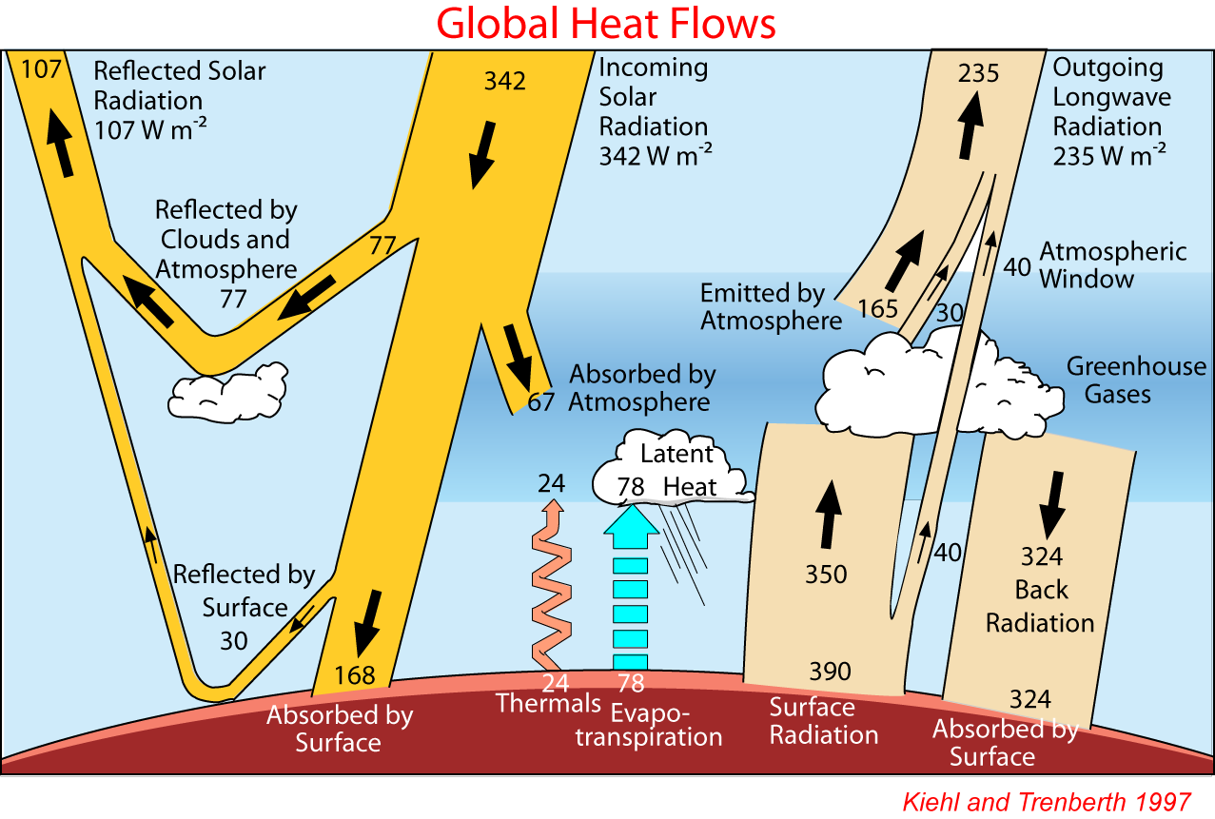
The simplest application is that sunlight is absorbed at the surface where the average temperature is 288 K and IR is emitted to space at an average temperature of 255 K. This implies the maximum efficiency of the Earth’s heat engine is (288-255)/288 = 11.5%. This is limited purely by the temperature difference between the surface and the radiative equilibrium temperature. This difference is the result of the greenhouse effect. Therefore, in this simplistic concept, the bigger the greenhouse effect, the more mechanical energy that would be theoretically be available. As a result, with global warming, the efficiency should increase. With a 4 K surface warming, the efficiency would increase to 12.7% implying circulation should become more energetic. (Same energy in but a larger fraction is available to do work).
This analysis however is too simplistic because the energy entering the atmosphere actually does not enter entirely at the surface. Of the 70% of the solar energy that striking the Earth that is absorbed, only 71% (=50%/70%) is absorbed at the surface with the rest being absorbed in the atmosphere where temperatures are cooler than the surface temperature. Some of the energy absorbed at the surface makes its way into the atmosphere via precipitation and latent heat release. That part is also absorbed at a lower temperature than that of the surface.
Furthermore, the downward IR from the atmosphere into the surface and upward IR from the surface into the atmosphere need to be considered. The 324 W/m² of downward IR from the atmosphere into the surface is emitted at a temperature of 275 K which is warmer than the radiative equilibrium temperature of 255 K. Emitting the energy from the atmosphere at a higher temperature reduces the theoretical efficiency of the atmospheric heat engine. Combining the upward and downward IR energy emission from the atmosphere yields an average emission temperature of 265.5 K. This alone reduces the theoretical maximum efficiency to (288-265.5)/288 = 7.8%.
The upward IR from the surface is absorbed in the atmosphere at some effective altitude which has an effective temperature cooler than the surface temperature likely similar to the 275K of downward emission. The temperature at which the latent heat is released might be ~3 km altitude temperature which is about 288K – 6.5K/km*3km = 268.5 K. This assumes much of the latent heat release occurs just above the boundary layer. The sensible heat is added right at the surface so 288K is appropriate. A guess as to the temperature at which the 67 W/m² of solar radiation is absorbed into atmosphere is 3 km or a temperature of ~228.5 K. The average temperature at which energy is absorbed in the atmosphere is therefore something like
$T_{\text{abs}}\text{\sim }\frac{\text{24}∗\text{288}+\text{78}∗\text{268}\text{.}5+\text{350}∗\text{275}+\text{67}∗\text{268}\text{.}5}{\text{24}+\text{78}+\text{350}+\text{67}}=\text{273}\text{.}8$
The theoretical maximum efficiency from these simple arguments is to (273.8-265.5)/273.8 = 3.0%.
Based on the rate of mechanical energy dissipation in the atmosphere, the actual efficiency is less than 1%. There is about 1-2 W/m² of mechanical energy in the atmosphere versus a heat input of 240 W/m². The relatively low number is associated with the effects above and the irreversible nature of the atmospheric heat engine which makes it less efficient.

Extractable mechanical energy
The actual extractable mechanical energy is a bit more subtle. In Earth’s atmosphere, the extractable mechanical energy comes from conversion of potential energy to mechanical energy via two sources: (1) the release of latent heat via precipitation which is moist convection (causing hot air rising and cold air sinking) and (2) release of large scale potential energy associated with large scale horizontal temperature gradients in the (baroclinic) atmosphere such that warmer air slides up and over colder air which slides down and under the warm air which releases potential energy. “Baroclinic” refers to the situation the surfaces of constant pressure and constant density are not parallel because there are horizontal temperature gradients. Barotropic is the situation where there are no horizontal temperature gradients in which case the constant pressure and density surfaces are parallel and horizontal. The classic example of this second is the large winter storms that cause the transfer of cold air from the high latitudes with warm air from low latitudes.
The mechanical energy produced by the heat engine is removed by frictional dissipation such that on Earth, half of the mechanical energy would disappear in a few days due to surface friction and turbulence in the atmosphere.
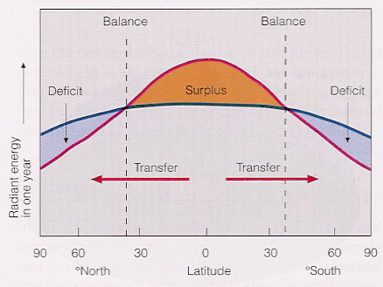

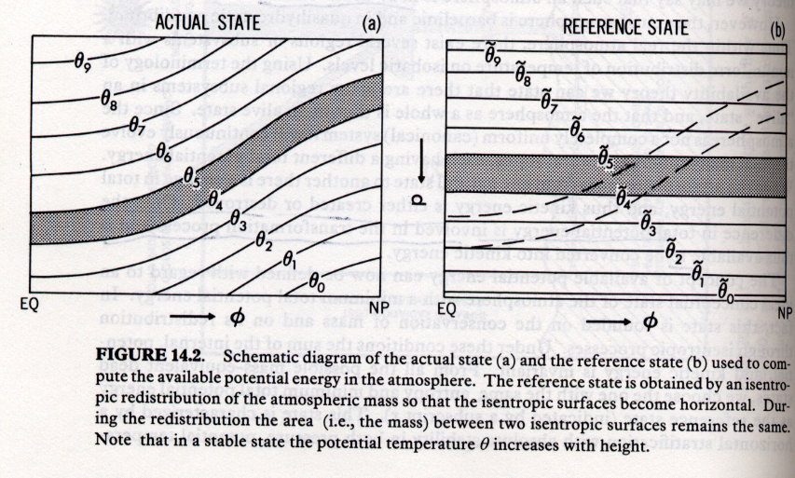
The available energy to be released from a baroclinic zone can be thought of in terms of the the potential energy in the baroclinic atmosphere relative to a barotropic atmosphere with the same average potential temperature versus height profile. Potential energy is released as the baroclinic atmosphere adjusts toward the barotropic state by having the hot air on the low latitude side move poleward and in the process slide up and over the cold air which is moving equatorward from its initial high latitude position.
Note the concept of a “dead”, stable, barotropic atmosphere like the reference state atmosphere above that contains no baroclinicity. This theoretical atmosphere could take in solar energy and get rid of it without mechanical motion. However, such an atmosphere is not actually possible at least for thick atmospheres. Such a theoretical atmosphere would have to be in pure radiative equilibium. However, the pure radiative equilibrium solution for thick atmospheres that are opaque at IR wavelengths (pressures higher than about 200 mb as we have seen from the planetary atmosphere temperature profiles early in the course) yields superadiabatic lapse rates. Superadiabatic lapse rates are unstable and therefore such atmospheres will turn over vertically which will bring the energy at lower altitudes up to altitudes where the atmosphere is no longer opaque at IR such that the atmosphere can cool radiatively to space. Such thick atmospheres must be in some form of radiative-convective equilibrium.
Such an atmosphere has baroclinicity at some scale in order to drive the circulation even if it is on a very local scale like local dry convection. Not all atmospheres have much baroclinicity on the large scale. On Jupiter for instance the temperature at the poles is almost the same as at the equator. But Jupiter is a very active atmosphere dynamically.
Large subadiabatic lapse rates in atmospheres at pressures higher than ~200 mb are an indication of latent heat release. (why?)

